UDC 004.9

Ph.D, Associate Professor Onai M.V., Master's student Cui Zicheng

National Technical University of Ukraine
"Igor Sikorsky Kyiv Polytechnic Institute"

MODIFIED KEY GENERATION METHOD FOR
ASYMMETRIC ENCRYPTION ALGORITHM RSA

Abstract

Mykola Onai, assoc.prof., PhD; Cui Cheng, student
Modified method of generation of encryption keys for asymmetric cryptosystem RSA
This paper deals with the task of accelerating the generation of encryption keys for asymmetric RSA cryptosystem with acceptable losses of cryptographic strength. The proposed modification of the classical method is aimed to increase the speed of work by increasing the prime numbers quantity which is used to generate encryption keys. A comparative analysis of the efficiency of both the classical and the modified algorithms is carried out.

Introduction

Today,asymmetric encryption algorithms are widely used in cryptographic information security systems,among which the RSA algorithm is one of the most popular[1].Common examples of use are the SSL security protocol,the SSH network protocol,the PGP cryptographic program,and the digital signature.The need to maintain the reliability of encryption with the constant growth of the computing power of modern technical means requires an increase in the length of cryptographic keys,which slows down the algorithm.This trend creates the need to speed up the algorithm.
Most existing modifications of the RSA encryption method are aimed at simplifying the mathematical apparatus underlying its operation.In particular,this includes the use of the Chinese residue theorem[2].
This paper will consider a modification of the RSA encryption method aimed at speeding up the generation of encryption keys,which is one of the most time-consuming operations of this method,by reducing the length of the primes used for this purpose.

Problem statement
The task is to create a modification of the existing RSA encryption method in order to reduce the time spent working with keys that are relevant in terms of reliability, i.e.,longer than 1024 bits, while maintaining sufficient cryptographic strength.

Analysis of the classic RSA algorithm
The classic RSA algorithm begins with the selection of a public key[3]. This key consists of a pair of integers(e,n).The number n is the product of two large primes p and q, chosen at random.The Euler function is also calculated:
φ(n) = (p–1)(q–1) (1)
The number e is an arbitrarily chosen prime number that satisfies the following conditions:e<φ(n); NSD(e,φ(n))=1.The decryption key d is also calculated-a number that is the inverse of e, i. e.
ed≡1(mod φ(n)). (2)
The numbers e and n are stored in a publicly available directory, while the numbers p and q are kept secret.Before encryption,the message M is decomposed into digital blocks mi of length less than n.Each block is encrypted separately, resulting in digital blocks ci that together form an encrypted message C transmitted over an open channel. Encryption is performed using the formula
C ≡ Me (mod n) (3)
According to Euler's theorem,a message is decrypted by raising the ciphertext C to the power ofd modulo n,i.e., M≡Cd(mod n).

Analysis of RSA algorithm modification
The proposed modified method is to increase the number of factors to calculate n. Generating a prime number of the required bit depth is one of the most time-consuming operations.Therefore, increasing their number will reduce the time to generate the public key n while maintaining the specified length.So the product n will look like this:
n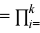1pi (4)
where k is the optimal number of multipliers that achieves the best time
performance of the algorithm. will look like (5)

Experimental studies of the modified algorithm
To verify the operation of the proposed modified asymmetric encryption method,we measured the computational speed during key generation,encryption,and decryption for a different number of prime factors from 2 to , i. e. , the bit depth of each individual factor is at least 4 digits. The results of the analysis are presented in the form of graphs.
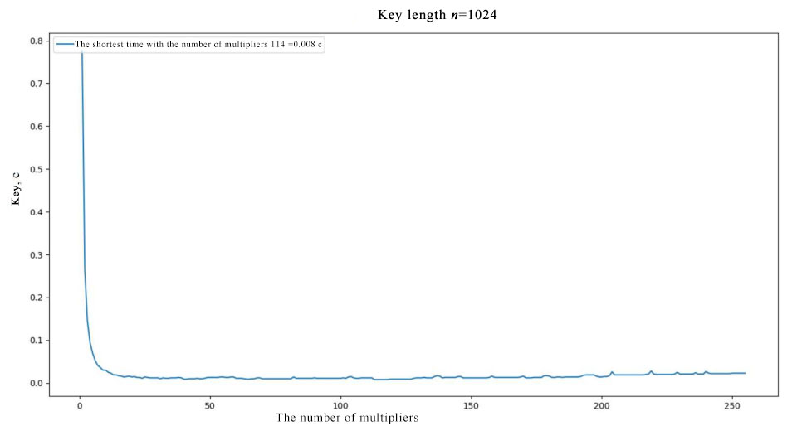
Fig. 1. Graph of dependence of the algorithm running time on the number of prime factors for a key length of 1024 bits

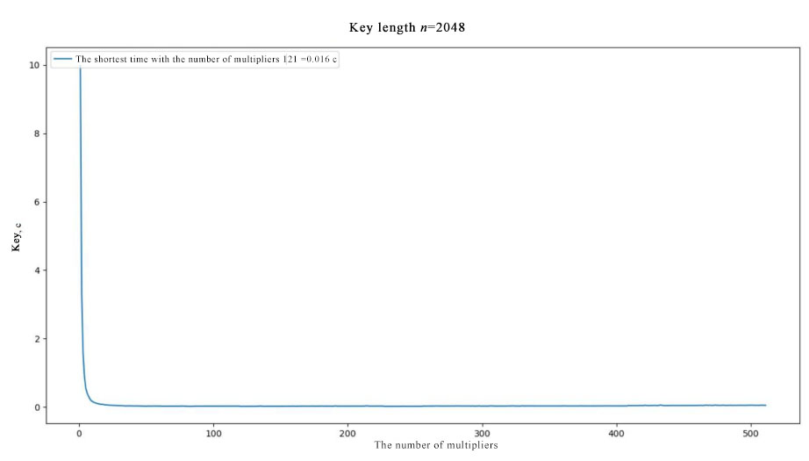

Fig. 2. Graph of dependence of the algorithm running time on the number of prime factors for a key length of 2048 bits

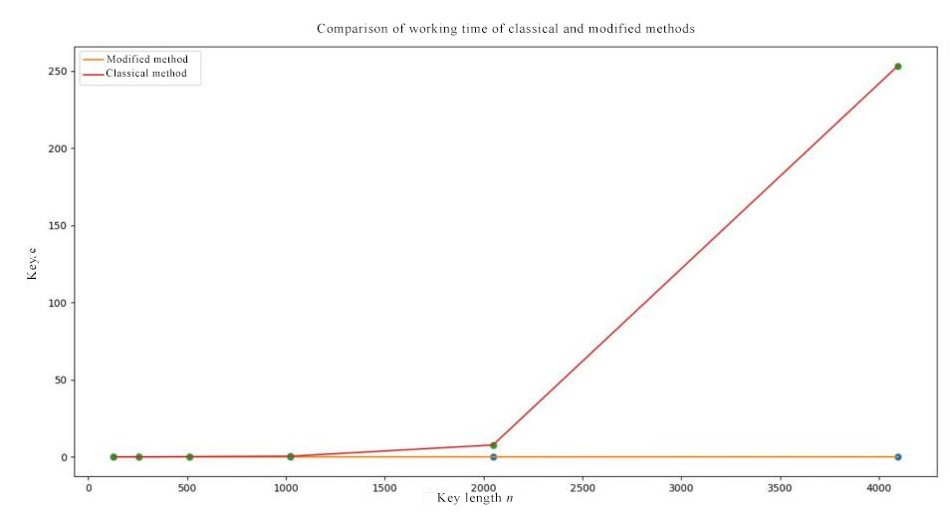
Fig. 3. Graphs of the dependence of the classical and modified algorithms on the key length

A comparison of the graphs of the classical and modified algorithms'time versus key length shows a significant increase in the speed of the modified method. For 1024 bits,the speed is 60 times faster.This figure increases with the key length.
The disadvantage of this approach is the reduced complexity of factorizing the public key n. The analysis shows that the probability of finding one of the primes p and q in the classical RSA algorithm is[4]. Then the probability of factorization of n, which is the product of k prime factors, is equal to 1–. That is, as k increases, the complexity of factorization decreases significantly.
However, excluding brute force attacks, most cryptanalysis methods are not suitable for cracking a module of more than two primes. As the number k increases, the attacks become more complex, which leads to a loss of their effectiveness, or they become unsuitable in general.
Using the data obtained, we can derive a rule for choosing the number of primes k to obtain the public key n.The lowest running times were obtained when the number of factors k was close to 100,and then began to grow very slowly. However,due to the significant loss of cryptographic strength, it is suggested to choose k close to 10,where the time measurements are already close enough to the minimum. Thus, the crypto resistance will approximately drop by a factor of 2.
Based on the results obtained, it is proposed to randomly select a number k such that k=[5;15]. To increase the cryptographic strength of the method, it is proposed to randomly select several k belonging to this range so that the prime factors pi were of different lengths. As a result, to factorize the resulting number n, it will be necessary to find an unknown number of prime factors of different lengths, which will greatly complicate this task.

Conclusions

This article proposes a modification of the existing RSA encryption method, which gives a significant time gain of 60 or more times when generating keys of large length, i.e., more than 1024 bits. Among the disadvantages of this method is the loss of cryptographic strength by a factor of 2.

Literature

- 1.Rivest R., Shamir A., Adleman L.A method for obtaining digital signatures and public-key cryptosystems,Commun.ACM-New York City:ACM,1978.
- 2.Nesterenko O.Introduction to modern cryptography. Theoretical and numerical algorithms,2011.190 p.
- 3.Asymmetric encryption methods-Module 2.Cryptographic methods of information protection in telecommunication systems and networks:textbook,2011.148 p.
- 4.D.R.Stinson. Cryptography:Theory and Practice.CRC Press LLC, 1995.-611 p.

