Національний технічний університет України
«Київський політехнічний інститут
імені ІГОРЯ СІКОРСЬКОГО»
Факультет біомедичної інженерії
Кафедра біомедичної інженерії

До захисту допущено
Завідувач кафедри
______ Владислав ШЛИКОВ

“____”______________2023р.

Дипломна робота
на здобуття ступеня бакалавра
за освітньо-професійною програмою «Медична інженерія»
спеціальності 163 «Біомедична інженерія»
на тему: «Параметризована комп’ютерна модель ортопедичного супінатора в середовищі ANSYS»

Виконав:
студент IV курсу, групи БМ-93
Ахмед Мохаммед СабріХаірі Ібрагім __________
Керівник:
Доцент каф. БМІ, к.ф.-м.н., доцент,
Соломін Андрій Вячеславович __________
Консультант з охорони праці:
Ст.викл. каф. ОПЦБ, к.т.н.
Калінчик Віталій Васильович __________
Рецензент:
Доцент каф. ББЗЛ, к.т.н., доцент,
Антонова-Рафі Юлія Валеріївна __________

Засвідчую, що у цій дипломній роботі немає запозичень з праць інших авторів без відповідних посилань.
Студент _____________
^{(підпис)}

Київ – 2023 року

National Technical University of Ukraine
“IGOR SIKORSKY Kyiv Polytechnic Institute”
Faculty of biomedical engineering
Department of biomedical engineering

Approvedfordefense
HeadoftheDepartment
___________VladyslavSHLYKOV

“ ____” ______________2023

Diploma thesis
for a bachelor's degree
under the educational and professional program "Medical Engineering"
specialty 163 "Biomedical engineering"
on the topic : “A parameterized computer model of an orthopedic supinator in the ANSYS Workbench”

Completed:
student IV year, groupБМ-93
Ahmed Mohamed Sabry Khairy Ibrahim __________
Supervisor:
Assoc. dep. BME, Ph.D., assoc. prof.
Andriy Solomin Vjacheslavovich __________
Consultant on occupational safety:
Teach.dep. OPCB, Ph.D.
VitaliiKalinchyk __________
Reviewer:
Assoc. dep. BSHH, Ph.D., assoc. prof.
Antonova-Rafi YuliaValeriivna __________

I certify that in this thesis there are no borrowings from the works of other authors without proper references.
Student _____________
^{(signature)}

Kyiv – 2023 year

National Technical University of Ukraine
“IGOR SIKORSKY Kyiv Polytechnic Institute”
Faculty of biomedical engineering
Department of biomedical engineering

Level of higher education - bachelor
Specialty 163 "Biomedical engineering"

Approvedfordefense
HeadoftheDepartment
___________VladyslavSHLYKOV

“ ____” ______________2023

TASK
for a bachelor's thesis of a student
Ahmed Mohamed Sabry Khairy Ibrahim
^{(Full Name)}
1. Topic: A parameterized computer model of an orthopedic supinator in the ANSYS Workbench_________________________________________________________

supervisor Assoc. dep. BMI, Ph.D., Assoc. prof. A. Solomin,
(surname, name, patronymic, academic degree, academic title)
approved by the order of the University № 52/23-сі on 26.05.2023.
2. Thedeadlineforstudentstosubmitabachelorthesis 09.06.2023.
3. The object of study is a computer model of an orthopedic supinator.
4. The subject of the study are the mechanical-physical and rehabilitation characteristics of the orthopedic supinator model.
5. List of tasks to be developed:
- Analysis of traditional means of designing orthopedic insteps.
- Principles of functioning of orthopedic supinators.
- Analysis and description of the prototype of the existing model of the supinator.
- Analysis of computer modeling technology.
- Construction and research of a parametrizedcomputer model of an orthopedic supinator.
6. Approximate list of graphic (illustrative) material - 38 figures and 19 tables.
7. Indicative list of publications -One scientific article in a European periodical (Germany).
8. Final deadline15.06.2023.

SCHEDULE
№ s / n | Name of stages of execution  diploma thesis | Deadline for stages  diploma thesis | Note
1 | Defining the topic of bachelor thesis. Analysis of literature sources. | 05.04.2023
2 | Development of the content and structure of bachelor thesis | 08.04.2023
3 | Analysis of the development of longitudinal flatfoot | 10.04.2023
4 | Introduction to methods of making orthopedic insoles | 12.04.2023
5 | Analysis and description of the prototype of the supinator model | 14.04.2023
6 | Acquaintance with the ANSYS modeling environment | 21.04.2023
7 | Construction of a supinator model in the ANSYS Workbench | 05.05.2023
8 | Parametrization of thesupinator model | 19.05.2023
9 | Safety and precautions | 26.05.2023
10 | Registration of bachelor thesis | 04.06.2023
11 | Getting a review and feedback | 05.06.2023
12 | Passing norm control | 07.06.2023
13 | The bachelor thesis defense | 23.06.2023

Student __________________ M. Ahmed (signature) (initials, surname)
Supervisor ___________________ A.V. Solomin
(signature) (initials, surname)

ABSTRACT

The volume of the work is 77 pages, contains 38 illustrations, 19 tables. A total of 35 sources were processed.
The relevance of the work is related to lack of modern engineering technologies for design of many types of orthopedic products, which are still based on practical experience of specialists. The work shows prospects of using software tools for mathematical modeling of functioning of such products in rehabilitation engineering.
The purpose of the work is development and research of a computer model of an orthopedic instep in the ANSYS workbench for engineering analysis of mechanical phenomena of elastic deformations in it under influence of loads.
To achieve the goal of the work, following tasks were set:
- Analysis of traditional means of constructing orthopedic insoles.
- Principles of operation of orthopedic insoles.
- Analysis and description of prototype of existing insole model.
- Analysis of computer modeling technology.
- Construction and research of a parameterized computer model of an orthopedic supinator.
The work implements a computer model of an orthopedic supinator in the ANSYS workbench, which lays the foundations of an engineering approach to design of such rehabilitation tools.
Key words: supinator, rehabilitation engineering, computer model, ANSYS.

РЕФЕРАТ

Обсяг дипломної роботи складає 77 сторінок, кількість ілюстрацій – 38, таблиць – 19, джерел за переліком посилань – 35.
Актуальність роботи пов’язана з відсутністю сучасних інженерних технологій проектування багатьох типів ортопедичних виробів, що досі ґрунтуються на практичному досвіді фахівців. В роботі показано перспективність застосування програмних засобів для математичного моделювання процесів функціонування таких виробів в реабілітаційній інженерії.
Метою роботи є розробка та дослідження комп’ютерної моделі ортопедичного супінатора в середовищі ANSYS для інженерного аналізу механічних явищ пружних деформацій в ньому під дією навантажень.
Для досягнення мети роботи були поставлені наступні завдання:
- Аналіз традиційних засобів конструювання ортопедичних супінаторів.
- Принципи функціонування ортопедичних супінаторів.
- Аналіз та опис прототипу існуючої моделі супінатора.
- Аналіз технології комп'ютерного моделювання.
- Побудова та дослідження параметризованої комп’ютерної моделі ортопедичного супінатора.
В роботі реалізовано комп’ютерну модель ортопедичного супінатора в середовищі ANSYS, що закладає засади інженерного підходу до проектування таких реабілітаційних засобів.
Ключовіслова: супінатор, реабілітаційнаінженерія, комп’ютернамодель, ANSYS.

CONTENT

LIST OF SYMBOLS, UNITS, ABBREVIATIONS AND TERMS 8
INTRODUCTION 9
SECTION 1 10
LITERATURE REVIEW 10
1.1 Types and characteristics of flat feet 10
1.2 Biomechanics of the foot 16
1.3 Orthopedic insoles 19
Conclusions to section 1 29
SECTION 2 30
MATERIALS AND METHODS 30
2.1 Materials for creating insteps 30
2.2 Production of individual insoles - insteps 37
2.3 Prototype of the supinator model 43
2.4 Choice of simulation environment 46
Conclusions to section 2 47
SECTION 3 48
SIMULATION OF PARAMETRIZED SUPINATOR IN ANSYS WORKBENCH 48
3.1 Modeling of the supinator on theplatform ANSYS Workbench 48
3.2 Modeling of physical processes of elastic deformations of the instep 54
Conclusions to section 3 59
CONCLUSIONS 60
REFERENCES 62

LISTOFSYMBOLS,UNITS,ABBREVIATIONSANDTERMS

CAE | – | Computer-aided engineering
CAD | – | Computer-aided design
FEA | – | Finite element analysis
Skin / Loft | – | Technology of 3D-drawing along two sections

INTRODUCTION

One of the common modern problems is flat feet – deformity of the foot due to the lowering of its arches. According to medical statistics, as of 2018, 24% of children under the age of two are diagnosed with this disease, 32% of children are diagnosed before the age of four, and 40% under the age of twelve.
There are many factors for the development of flat feet, but the main reasons are insufficient development of muscles and ligaments of the foot. To eliminate the disease, operations can be performed, special bandages are used, as well as wearing orthopedic shoes with orthopedic insoles –insteps (supinators).
Insteps help reduce oscillations when walking and improve blood circulation in the foot and shin, thereby preventing the development of flat feet.
The purpose of this work is: development and research of a computer model of an orthopedic instep in the ANSYS Workbench for engineering analysis of mechanical phenomena of elastic deformations in it under loads.
To achieve the goal of the work the following tasks were set:
- Analytical review of flat feet types and characteristics, traditional means of construction and principles of orthopedic insoles operation.
- Comparative analysis of existing instep models and materials used.
- Justification of the choice of computer modeling technology.
- Construction and research of a parameterized computer model of an orthopedic supinator.
The practical significance of the work is connected with possibility of optimizing parameters of material and dimensions of the instep for a specific patient, with shortening of time and cost reduction of construction stage, with possibility of using a computer model to predict features of the product’s functioning.

SECTION 1

LITERATURE REVIEW

1.1 Types and characteristics of flat feet

Flat feet – a term that means a violation of biomechanics of the foot and lower extremity as a whole, as a result of deformation of its arches [1-24].

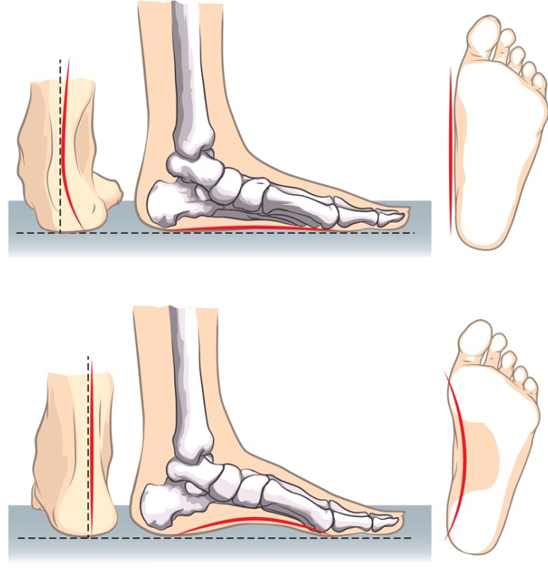
Figure 1.1 –Foot with flat feet (top), normal foot (bottom)

Flatfoot is a deformity in which the normal anatomical ratio of the foot bones is disturbed, which should normally provide cushioning. The main reason is the weakness of ligaments and muscles.
The following classification of flat feet is used:
- By origin
- In shape
Statistical data on the types of flat feet by origin:
- Static flatfoot - 82.1%. The reasons are:
- decreased muscle tone;
- foot overload due to rapid weight gain or heavy physical work;
- exhaustion of compensatory opportunities with age;
- general atrophic phenomena (poor nutrition, prolonged starvation).
- Traumatic - 6.2%. Reasons:
- the consequence of fractures of the bones of the foot and joints;
- damage to soft tissues;
- cervical injuries during childbirth.
- Paralytic - 5.7%. Reasons:
- consequence of muscle paralysis after polio and stroke;
- spinal cord disease.
- Rickets - 3.2%. Reason:
- weakness of the musculoskeletal system after rickets.
- Congenital - 2.8%. Reasons:
- heredity;
- abnormal development of bones and joints.

The foot has two arches – longitudinal and transverse. When the arches of foot are lowered, the shock-absorbing properties are lost and foot is deformed, as a result of which flat feet develop.
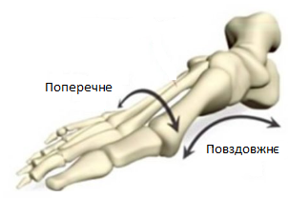
transverse
longitudinal
Figure 1.2 –Schematic representation of archesin foot

Classification of flat feet by shape:
- Longitudinal.
- Transverse.
- Mixed.
- Flat-valgus.
The first type is characterized by the compaction of the longitudinal arch and, as a consequence, the foot is completely in contact with the floor. It is possible to note a direct dependence on the patient's weight – the greater the weight, the greater load on the foot and, accordingly, the stronger severity of flat feet.
Longitudinal flatfoot is from 20 to 29%, characterized by compaction of the longitudinal arch, elongation of the foot. Longitudinal flatfoot is common among young people between ages of 16 and 25.
In the longitudinal flatfoot there are the following stages:
- Prodromal stage.
- Stage of intermittent flat feet.
- Stage of development of a flat foot.
- Stage flatfoot.
- Stage of contractural flat feet.
The prodromal stage is characterized by the time of appearance of first symptoms of the disease and manifestation of the clinical picture. Feelings of pain occur in upper arch of foot. And to support the arch of foot, the ankle muscles are involved.
The next stage, namely stage of intermittent flat feet, is characterized by increased pain in the foot and legs after light loads. The muscles are in constant tension, and in this regard, the longitudinal arch thickens during the day, and after rest comes to its original position. If the vault does not return to its original position, the next stage progresses.
At the stage of development of a flat foot, deformation of the legs is already visible, namely, the contours of navicular bone stand out near the inner edge of foot, while the heel bone deviates outward.
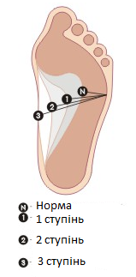
Figure 1.3 –Degrees of longitudinal flatfoot
Norm
1 stage

2 stage

3 stage
It is at this stage that there are three degrees of morbidity:
- The beginning of formation of a flat foot, with height of arch below 35 mm.
- There is a development of osteoarthritis in the joints, due to deterioration of blood circulation. The height of vault varies from 25 to 17 mm.
- Significant reduction in height of the vault – below 17 mm.

At the stages of flat-valgus foot and contractural flat feet there is a compaction of longitudinal arch and a pronounced spasm of muscles of the lower leg and foot.
At transverse deformation there is a compaction of an anterior arch, and as a result – change of the form of toes.
Transverse flatfoot occurs due to some main reasons:
- weakening of the ligaments function;
- excessive loads;
- daily use of tight shoes;
- long-term static loads.
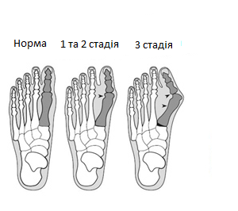
Norm 1 and 2 stage 3 stage
Figure 1.4 –Image of the stages of transverse flatfoot

Transverse flatfoot is divided into three stages:
  - Is characterized by 20% deviation of angle of big toe.
  - The deviation of big toe ranges from 20 to 40%
  - The angle of deflection is more than 40%, with severe pain in the feet and toes during exercise.
Mixed type is characterized by deformity of the foot, which includes both transverse and longitudinal flat feet. This forms a foot with a lack of depreciation, which leads to pathological changes in the human skeletal system.
The development of a combined form of flat feet can occur at any age. There are several types of flat feet:
  - Post-traumatic. Injuries to the transverse and longitudinal arch of the foot may occur as a result of limb injury.
  - Static. Occurs during prolonged physical activity and tight shoes.
  - Paralytic. Occurs due to paralysis of the leg muscles.
  - Metabolic. It develops due to a lack of essential vitamins and minerals.
Flat-valgus deformity of foot is a deformity that is the reduction of longitudinal arch against the background of dysfunction of tendon of the posterior tibialis muscle.
Feet are divided according to the degree of flat-valgus deformity:
Stage 1 - no bone deformity.
Stage 2 - mild deformity, heel bone is everted.
Stage 3 - fixed deformation.
Stage 4 - deformation at the level of the foot.

1.2 Biomechanics of the foot

The foot is a support for whole body, respectively, the violation of this foundation necessarily affects formation of the body. Changing the shape of foot not only causes a decrease in its functionality, but also, most importantly, changes the position of spine. This negatively affects the posture and general condition of the body.
The human foot consists of 26 bones of various shapes and sizes. According to bone structure the foot is divided into tarsus, metatarsus and phalanges divisions. The external morphology of foot reflects the bone structure and is divided into forefoot, midfoot and hindfoot. Forefoot include the toes and ballof the foot, midfoot– the arch of foot, andhindfoot of the sole include the heel.
Figure 1.5 shows the bones in foot.
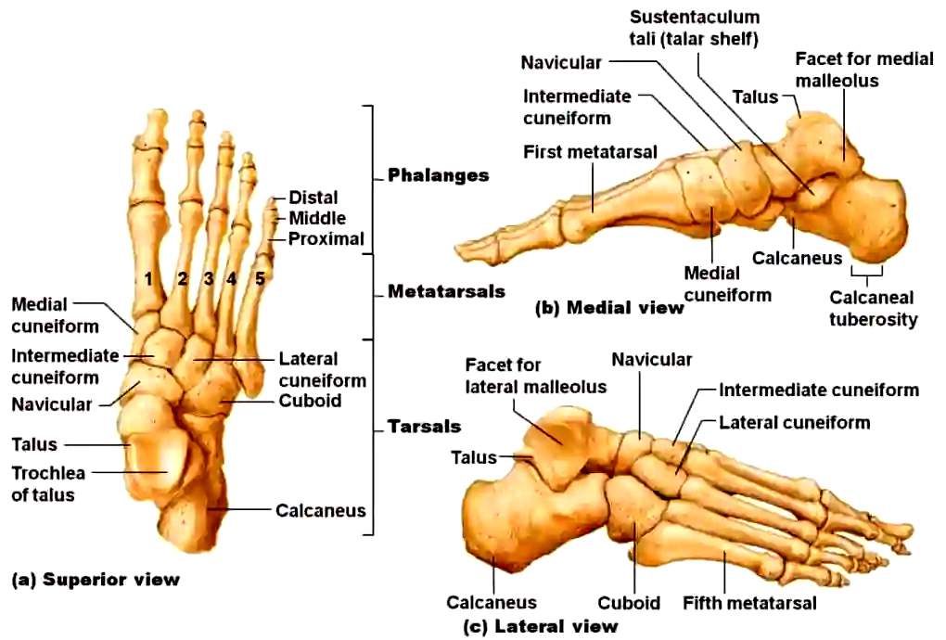

Figure 1.5 –Bones of the foot
The vaulted location of foot bones is supported by a large number of tendon ligaments. The foot performs a number of important functions in the body:
The mobility of foot allows you to adapt to the surface on which we move.
With help of foot we have the opportunity to move body forward, backward and sideways.
Shock-absorbing function, because the feet absorb most of shocks and loads that can damage body when moving.
The normal completed step cycle has two phases: support and flight.
During support phase, the foot comes into contact with ground, which is 65% of step cycle. During flight phase, the foot does not touch ground.
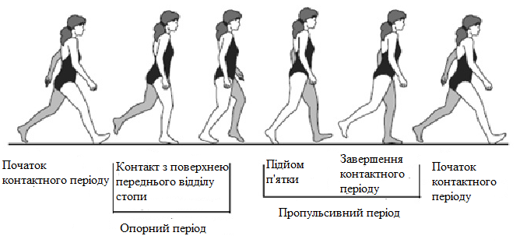
The beginning of contact period
Contact with surface of front foot

Heel rise
End of contact period
The beginning of contact period
Figure 1.6 –Step cycle

The resistance phase is divided into three periods:
- Contact period - from the touch of heel to complete contact of the whole foot with surface.
- Reference period - from complete contact with surface to the moment of blasting heel from the surface.
- Propulsive period - from the moment of separation of heel to the moment of separation oftoes from the surface.
Of all biomechanical processes, pronation and supination movements are the main ones, which divide steps into phases. The first phase is pronation - when the foot comes into contact with the surface, the arch becomes flat and dampens the shock load. The second stage, namely supination, begins with a change in the center of gravity along the trajectory of movement, involving muscles of the foot and shin.
There are two main reasons for violation of biomechanics of the foot: the deviation of pronation and the deviation of supination. Pronation is a movement in which the outer edge of foot rises with turn of sole outward.
When supination - the inner edge of foot rises, while the sole returns inward.
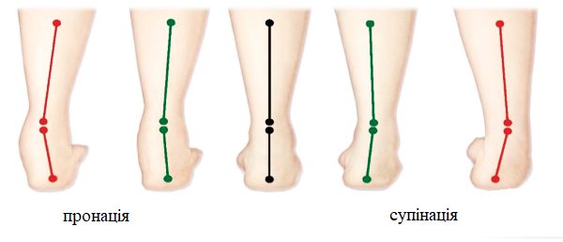
supination
pronation
Figure 1.7 –Image of pronation and supination

There are 3 types of pronation:
- Insufficient. The foot is turned inward. Load on the little toe and ring finger.
- Neutral pronation, during which the weight is evenly distributed between the entire foot and toes, with little pressure on the middle and index toes.
- Excessive - characterized by uneven weight distribution. The foot is turned outwards, the pressure is only on the thumb and index finger.
The term "hypersupination" refers to the lack of pronation, namely the amortization of the foot. The vault is too high and the foot is turned to the outside. Occurs in 2-3% of the population.
If the deformation process is in such a state that it is difficult to move, then surgery is required. In other cases, you can eliminate the cause with orthopedic shoes and orthopedic insoles.

1.3 Orthopedic insoles

Orthopedic insoles are classified by properties:
  - Orthopedic – designed to treat deformities of the foot, transverse and longitudinal arch.
  - Antibacterial – made of unique materials that protect the foot from odors, fungal diseases.
  - Therapeutic and prophylactic, aimed at treating longitudinal and transverse flat feet of different stages.
  - Massage – actively act on the main points on the foot.
Orthopedic products for the foot are used to correct foot defects – flat feet, clubfoot. Instep-raiser is an orthopedic product designed to support the arch of foot and correct its biomechanical disorders. With the right design, supinator does not interfere with muscle function.
Figures 1.8, 1.9 show scheme of orthopedic insole.

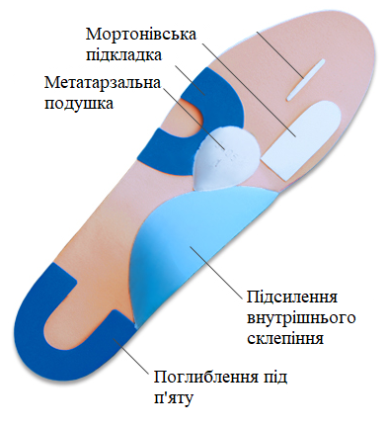
Deepening under the heel
Reinforcement of the inner vault
Metatarsal pillow
Morton substrate
Figure 1.8 –Scheme of orthopedic insole

Modern orthopedic insoles are built in the same way – in the area of inner arch the instep is modeled, the recess under heel is modeled and the rolling area is raised, the metatarsal cushion is formed in the area of the transverse arch.
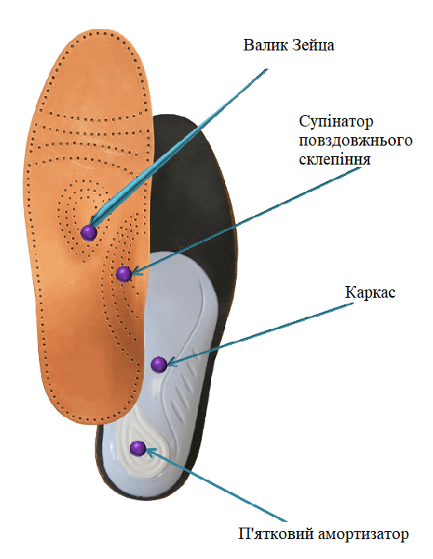
Heel shock absorber
Frame
Supinator of the longitudinal arch
Roller Zeitsa
Figure 1.9 –Image of an orthopedic insole

Depending on the functional purpose and location of corrective elements, there are 7 types of orthopedic insoles:
- VP-1 to maintain the longitudinal vault
- Detorsion VP-3 and VP-4
- To support the longitudinal and transverse vaults - PR-6, VP-6a, VP-6b.
- VP-2, VP-5 when the foot is deflected outwards.
- VP-7 and VP-8 when the foot is deflected inward.
- Insoles with shortening compensators - VP-9, individual.
- Insoles for unloading painful places - VP-10, individual.
Insole VP-1 is an anatomical insole designed to support the physiological longitudinal arch of the foot.
The insole VP-1 (Fig. 1.10) repeats the contour of foot and distributes the load evenly over the entire foot, supporting the longitudinal arch.
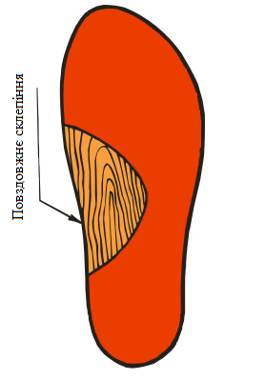
Longitudinal vault
Figure 1.10 –Insole VP-1

This insole is prophylactic to eliminate foot deformity. Made of genuine leather, and the corrective elements are made of rubber micropores.
According to medical purposes insoles VP-1 are divided into:
- initial forms of longitudinal flatfoot without pronounced vault compaction;
- minor and intermittent foot pain;
- recommended for the prevention of static flat feet;
- recommended for the prevention of people with moderate and high loads.

The VP-2 (Fig. 1.11) insole has positions for placing the heel and instep under the heel.
The orthopedic insole is aimed at correcting the flat-valgus deformity of the heel of foot, namely, eliminates its lateral deviation inward.
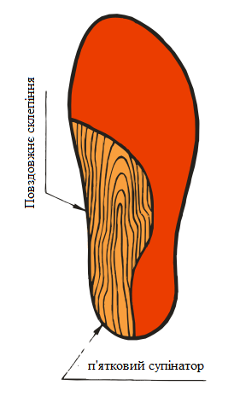
Heel supinator
Longitudinal vault
Figure 1.11 –Insole VP-2

Purpose of orthopedic insole VP-2:
- sealing of the longitudinal arch of foot with a flat-valgus foot installation;
- valgus installation of the heel of foot;
- valgus deformity of the shin joints.
- X-shaped legs.
VP-3 (Fig. 1.12) combined orthopedic insole with a longitudinal arch, supinator under heel and pronator under front of the foot.

VP-3is made of genuine leather, and the corrective elements are rubber micropores.

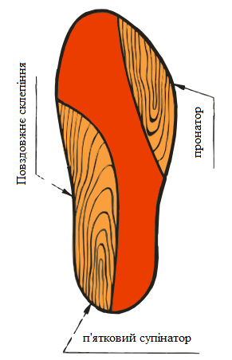
Heel supinator
Pronator
Longitudinal vault
Figure 1.12 –Insole VP-3

Use the insole according to the following medical indicators:
- pronation of the middle part and heel;
- sealing of the longitudinal vault;
- supination of the front of foot.
The VP-4 (Fig. 1.13) insole has a place for the heel, a longitudinal arch, a pronator for the front and a supinator in the heel area, as well as a hard gluing along the thumb to fix it.

hard gluing

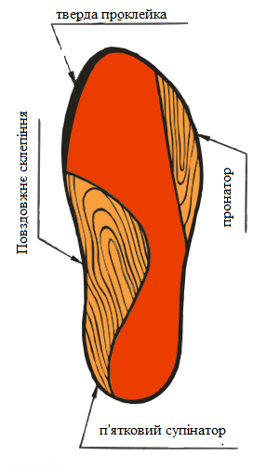
Heel supinator
Longitudinal vault
Pronator
Figure 1.13 - Insole VP-4

Insole VP-4 is made of genuine leather, with corrective elements of rubber micropores and are designed to correct:
- supination of the anterior part;
- sealing of the longitudinal arch of foot and pronation of the heel.
The VP-5 (Fig. 1.14) insole contains a longitudinal arch lining, an insole for the heel and the front section.
Insole VP-5 is made of genuine leather, with corrective elements of rubber micropores.
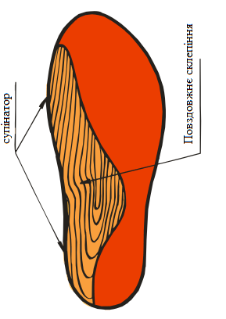
Supinator
Longitudinal vault
Figure 1.14 - Insole VP-5

VP-5 insoles are designed to eliminate the following problems:
- sealing of the longitudinal vault;
- pronation of the whole foot.
VP-6 insoles have a place for the heel section , the layout of the inner and outer longitudinal vaults and a hump for unloading voltage beams. Depending on the installation of the heel of the foot, the insole is supplemented with a heel supinator or heel pronator.
According to medical indicators, the following is prescribed:
- combined flat feet;
- transverse stratification of the anterior foot;
- sealing of the longitudinal vault;
- taking the thumb out.
Figure 1.15 shows the insole VP-6.
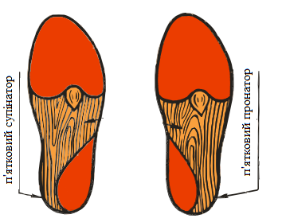
calcaneal proinator
calcaneal supinator
Figure 1.15 - Insole VP-6

The medical purpose of the VP-7 insole is as follows:
- supination of the whole foot and falling foot with varus installation.
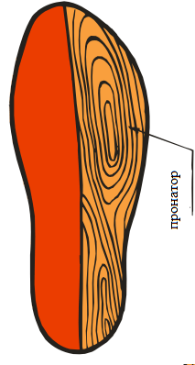
Pronator
Figure 1.16 - VP-7 insole
Figure 1.16 shows the VP-7 insole, in the design of which there is pronator around the edge of foot.
The VP-8 insole shown in Figure 1.17 has a pronator on the outer edge of the foot and a hard gluing along the big toe.
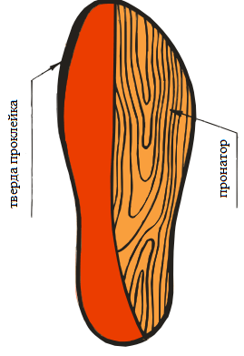
hard gluing

Pronator
Figure 1.17 - Insole VP-8
Figure 1.18 shows the insole VP -9.

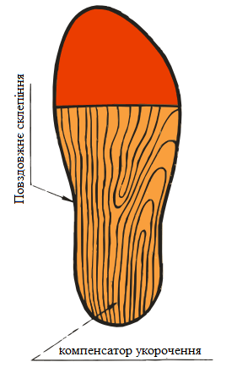
Shortening compensator
Longitudinal vault
Figure 1.18 - Insole VP-9
Medical appointment is individual according to the functional shortening of the limb.

Conclusions to section 1

Literary sources are analyzed, during which the classification of flatfoot types is described, namely - longitudinal, transverse, mixed and flat-valgus. The causes and stages of development are described.
Foot biomechanics and step cycle are described. The main biomechanical disorders of the foot have been identified - pronation and supination disorders.
The classification of orthopedic products is described and each is characterized. Orthopedic product - supinator, designed to support the arch of foot and correction of its biomechanical disorders.

SECTION 2

MATERIALS AND METHODS

2.1 Materials for creating insteps

When choosing orthopedic insoles you need to pay attention to the following indicators:
- Material.
- Size.
- Appearance. More often the classification is based on the type of orthopedic foot support:
a) rigid;
b) semi-rigid;
c) soft;
d) lack of support of the footarch.
- Method of placement.
- Height of the footarch:
a) foot with normal height;
b) foot with a small arch height;
c) foot with a large arch height.
Therapeutic insole should provide cushioning and corrective effects.
Consider one of the main indicators when choosing insoles - the material from which they are made.
    - Orthopedic insoles made of genuine leather
They are used to treat all types of flat feet and prevent statistical deformities of the foot.
Figure 2.1 shows the orthopedic insoles of the model, which are made of genuine calfskin, and thanks to the frame keep the foot in the usual anatomical position.
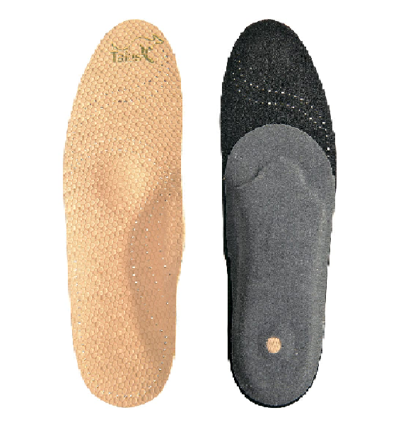
Figure 2.1 - Orthopedic frame insoles

The orthopedic leather insoles with special perforations shown in Figure 2.1 consist of:
- Shock absorbing frame.
- Soft latex roller located in the transverse arch of the foot to distribute the load.
- Shock-absorber insert under the heel to reduce shock load.
- The substrate is made of a special material Signatex, which contains activated carbon, has a bacteriostatic effect and absorbs moisture.
Sigmatex company is one of the leading independent hydrocarbon fiber converters, thanks to a wide range of textile technologies and patented technological equipment.

    - Insoles made of aeroprene material
Aeroprene is an advanced neoprene material and has all its properties:
- elasticity,
- softness,
- wear resistance,
- water resistance,
- thermal insulation characteristics.
The advantage is that aeroprene provides access and circulation of air with the help of perforation of the neoprene material.
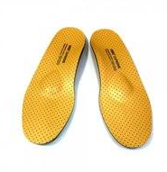
Figure 2.2 - Aeroprene insoles

Table 2.1
Technical characteristics of aeroprene
Features | Value
Density | 160 kg / m ³
Operating temperature range | -20 -100 ⁰ C
Water absorption | <5 %
Structure | Closed porous

Table 2.1 shows the technical characteristics of the aeroprene material.

- Foamed polyethylene
The relief of the footprint is formed under the pressure of the patient's weight on the preheated preform of polyethylene foam, which is placed on a hydraulic platform.
Table 2.2
Technical characteristics of foamed polyethylene
Features | Value
Density | 20-40 kg / m ³
Operating temperature range | 60-80 ⁰ C
Dynamic modulus of elasticity | 0.25-0.35 MPa
Thermal conductivity | 0.38 W/mK
Water absorption | 1-3% of the volume per month
Structure | Closed porous

Table 2.2 shows the technical characteristics of the foamed polyethylene material

However, there are a number of disadvantages of this method:
- The difference between the obtained relief of the sole of foot with a real footprint in the shoe. This disadvantage is explained by the fact that on the hydroplatform the bones of foot diverge under weight of the body, due to effect of spreading the heated mass of polyethylene foam, while in shoes there is no such effect.
- There are difficulties when heating the material, because there are no criteria for readiness of polyethylene foam. Therefore, this procedure is performed by subjective visual assessment and, as a consequence, most of the material is not used.
- The heated material in the places of greatest support is strongly condensed and ground during the formation of footprint, as a result - the elasticity and spring qualities of the insoles deteriorate.
In addition to materials for manufacture of orthopedic insoles, it is impotant materials for the manufacture of insole frames.
The material for the frames must combine several properties, namely:
- rigidity - to effectively support the longitudinal arch of foot;
- elasticity - the ability to return to starting position;
- viscosity - the frame should not be brittle.
Among the main materials for the frame are highlighted:
    - Microfiber. The microfiber consists of polyamide and polyester. High-tech material is durable and wear-resistant, has a homogeneous structure and a waterproof ability.
    - Polyph. The material has high thermal insulation properties, hygienic, non-harmful and resistant to bacteria.
Microfiber is made of fibers smaller than 1 denier, the fibers are combined toform yarn.
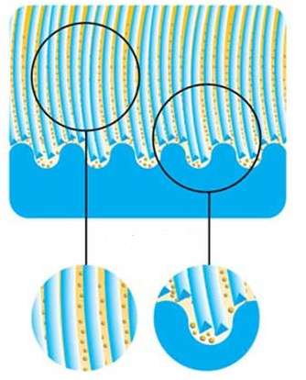
Figure 2.3 - Image of microfibers
Microfiber fibers are 0.06 μm in diameter.
Depending on components, the final form and directionof use, the following types of microfibers are distinguished:
- Micro Modal.
- Tactel.
- Meryl.
Micro Modalfiber is made of cellulose and is characterized bysoftness, strength and fine texture. Breathability and hygroscopicity allow use of fiber for manufacture of clothing and orthopedic insoles.
Tactel fiber is based on polyamide microfiber, which creates a skin effect. The texture is soft and comfortable.
Meryl fibers exceeds the characteristics and properties of Micro Modal and Tactel. Breathable, hygroscopic material has antiseptic properties because it is treated with silver ions. The material is based on polyamide microfiber.
The diameter of fibers is very small, so high-tech and precise equipment is used for production. Polyester and polyamide are prepared in advance: the polyamide threads are given a dissected shape, and the polyester is melted. After that fiber components are placed in an extruder - a machine that softens materials and gives them the desired shape.
The next step is to separate polyamide threads from the polyester. To achieve the desired effect, the output thread is cooled with water. This provides more micro gaps, which in turn provide high performance materials.
The microfiber material has following advantages:
- Adsorption properties.
- Ability to pass air.
- Durability and wear resistance. The microfiber material does not deform over time.
The disadvantage of this material is:
- Accumulation of static electricity.
- Not suitable for heat treatment.
Polyfoam is a chemically crosslinked polyethylene foam. This material has following properties:
- Thermal insulation.
- Effective protection against moisture. Due to closed structure of the polyphonic hydrophobic material.
- High resistance to deformation and rupture.
- Easy to handle due to its softness and elasticity.
- Environmentally friendly material.
- Unique texture of material that allows you to make products of any complexity.
Table 2.3
Technical characteristics of the polyphony
Features | Indexes
Density | 30 kg / m ³
Thermal conductivity coefficient | 0.038 W/mK
Modulus of elasticity | 0.5MPa
Structure | Closed porous

Table 2.3 shows the technical characteristics of the polyphony.

2.2 Production of individual insoles - insteps

According to the World Health Organization, more than 80% of the population is prone to foot disease. One of the most effective methods of prevention and correction are individual orthopedic insoles.
Unlike conventional insoles, individual orthopedic insoles have a number of advantages:
- Maintaining the longitudinal and transverse arch of foot in the correct position.
- Improving blood circulation.
- Reducing the load on joints and spine with help of cushioning properties.
- Increase of stability at loading on legs.
- Optimization of process of the musculoskeletal system.
- Minimize walking discomfort.
The main areas of application of orthopedic insoles include:
- Flatfoot.
- Diabetic foot.
- Excess body weight.
- Spinal deformity, incorrect posture.
- Osteoarthritis of joints of lower extremities.
- Pregnancy.
- Valgus deformity.
Orthopedic insoles are made taking into account the anatomical uniqueness of the foot using additional corrective properties. Correction of the arches is important for restoration of biomechanics of the musculoskeletal system. Thanks to the right supinator, it is possible to restore the cushioning functions of foot and reduce the load on joints.
Currently in usethe following methods of manufacturing orthopedic insoles:
- According to the plaster cast of foot.
- Production using blanks.
- Computer scanning with CAD / CAM technologies.
The technology of making individual orthopedic insoles using plaster casts has been used for many years and is considered obsolete due to the troublesome process.
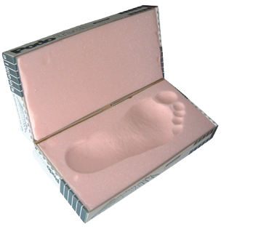
Figure 2.4 - Image with a plaster cast of the patient's leg

The patient entersthe plastic mass consisting of a special bulk material or foam, which leaves a footprint. Then the negative (impression) is filled with gypsum and allowed to harden. The insole is modeled on the received mold taking into account all anatomical components of the patient with possible corrective means.
One of the common methods of making orthopedic insoles is use of special plastic processing technology. Thanks to this technique, you can model the shape of foot in 20-30 minutes with a clear indication of deformation and the position of correction.
The method consists in use of plastic semi-finished product, which can be formed due to thermal action. The basis of the semi-finished product is a special thermoplastic. The insole is made on a flat surface that mimics the position of foot. Insoles are made on a special plantograph with Haider's measure, which includes a set of pads for different heel heights.
Figure 2.5 shows a method of making an insole using a Haider measure.
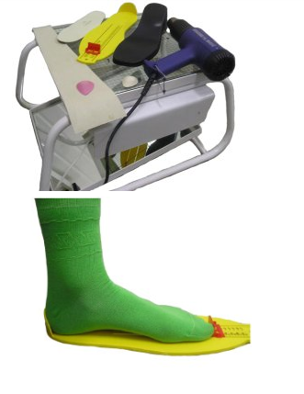
Figure 2.5 - Plantograph with Haider measure

If the patient wears shoes without heels, or the heel is up to 3 cm, the insole is made without use of pads on a flat surface, directly on the Haider gauge.
After examination, taking into account the deformation of foot and the type of footwear for patient, the type of semi-finished insole that corresponds to size of the foot is determined. On the side of sole a special hair dryer heats the semi-finished product. The distance from the hair dryer to the middle part of insole (ie, where the thermoplastic material is located) should be 5-7 cm. If the material has become plastic - this is a sign of readiness of the semi-finished product. The heated material is installed on the platform under the insole.
At a projection of a longitudinal vault the special rubber tape is put across, and in the sixth projection of diaphyses of metatarsal bones the insert for modeling of a transverse vault is established.
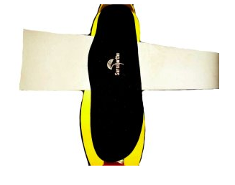
Figure 2.6 - Modeling of the insole

The heel bone and the head of the first and fifth metatarsal bones are fixed, thus setting the foot in a physiological position. An insole is modeled with help of a rubber band on the shape of foot surface. It is necessary to hold in this position for 3 minutes, during which time the thermoplastic material takes the shape of foot.
If there is a pronounced deformation, it is advisable to make a stepwise correction. The transverse vault is modeled simultaneously with the longitudinal one. Also, the transverse vault can be modeled separately after pre-heating the points of the front of insole in the projection of transverse vault.
Figure 2.7 shows a simulated transverse vault with three fulcrums - the heel, the head of the first and fifth metatarsal bones.
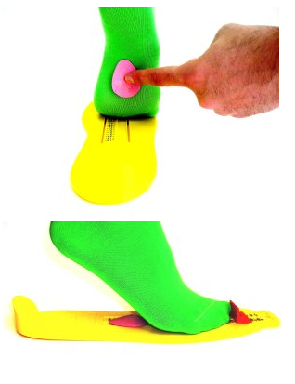
Figure 2.7 - Point modeling of the transverse vault

The advantages of this method are as follows:
- Possibility of individual modeling of the shape of footarch in the position of complete orthopedic correction.
- Step-by-step control of process.
- High quality insoles.
Computer scanning using CAD / CAM technology differs from other methods in simplicity, informativeness and safety. The method is a safe study without contraindications.
The foot is scanned on a special scanner, which is shown in Figure 2.8.
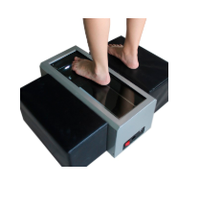
Figure 2.8 - Computer scanning

A color image of a 250,000-dot scan of the foot is displayed. Correct interpretation of the obtained results will help to establish the degree of pathology.
Diseases are determined by the following indicators:
- The coefficient of the anterior foot ranges from 0.92 to 1.08. A value less than or greater than the coefficient is considered a pathological disorder.
- Valgus and varus deformities are determined by changing the value of angle of foot in relation to the shin. The norm of the angle is 170-180.
- Indicator of coefficient of longitudinal flatfoot in the norm is 0.50-1 cm.
- The coefficient of stratification determines the transverse flatfoot. The normal value is 0.25-0.35, high or low values indicate the pathology of the arch of foot.

2.3 Prototype of the supinator model

The prototype of the instep model developed and patented by the professor of the Department of Biosafety and Human HealthVykhlyaev Y.N. was used in the work [25-27].
The prototype is based on the task of developing a long-acting supinator to bend the foot and increase the ability to adapt to the normal location of the arch and the ability to implement loads on the muscles thereby increasing the effectiveness of prevention and treatment of flat feet.According to the present invention, the problem has been solved as follows: instep, which contains a sub-vault support, equipped with a stabilizer in the form of an internal-lateral ridge and a hole for additional retention of the product's sub-vault support and heel insole. The fixing means is made in the form of a soft tape and clip. The clip is made in the form of a leg, which is freely inserted into the longitudinal channel, and the tape is tucked into the slots, which are made on the sides of the rigid-elastic heel insole.
The technical result achieved by use of all distinctive features of the proposed device is that by introducing means of fixing and stabilizing the supinators on the patient's legs and massage coating was able to increase the efficiency and convenience of their use.
Also, the effectiveness of treatment and prevention interactions due to a significant increase in the time of adaptation of foot structures in terms of bending its longitudinal and transverse bridges and creating more favorable conditions for exercise and work of the patient.
Figure 2.9 shows a general view of the instep on the left leg; in 2 images - supinator, at rest and during sleep; in 3-th image - top view.
Figure 2.10 shows the supinator in axonometry, as well as the lines of sections of the sub-arch stop in the longitudinal (A, B, C) and transverse (G, D, E) directions.

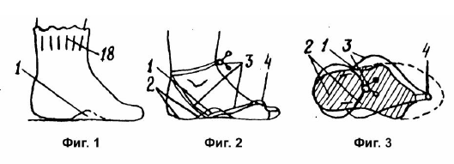
Figure 2.9 - Image of the instep according to the patent invention of Professor VykhlyaevY.N.

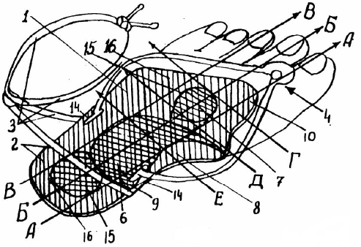
Figure 2.10 - Image of the supinator in axonometry

The supinator comprises a sub-arch stop (1) of the stabilizer (2) and a fixing means in the form of a strap (3) and a clip (4).
The sub-arch stop is made of soft elastic material that repeats the footprint of a normal foot. The foot has a stabilizing hole and bends with areas of increased stiffness, longitudinal (6) and transverse (7) bridges of the foot.
The stabilizer (2) consists of an inner-lateral and soft-spring ridge (8) and an elastic insole (9).
The clip (4) has a leg in the form of an elastic plate, which is inserted with the possibility of longitudinal movement in the channel (10) and the bearing interdigital membrane. On top of the membrane is a shaped hat, which has a slot (14) to secure the strap (3).

2.4 Choice of simulation environment

One of the leaders among CAE products of finite element analysis is the ANSYS software complex [28-34]. The direction of software code development is the implementation of many disciplinary engineering calculations. Areas of application of engineering analysis are different - from the mechanics of the deformed body and thermal analysis to the analysis of combustion, heat and mass transfer and electrodynamics.
By ANSYS-software you can solve complex structural engineering problems and make effective design decisions. With the finite element tools ( FEA ) available in the kit, you can automate the solution of problem of structural mechanics and parameterize the elements for analysis before design.
Using ANSYS Mechanical, we have the ability to import the geometry of complex assemblies, sew them optimally and apply realistic boundary conditions. After performing this pre-treatment step, analyzes can be performed to assess the strength, vibration, motion and thermal response characteristics of the system. A variety of graphical tools allow you to visualize the results of modeling, and help change the design and optimization of the product.
ANSYS program is compatible with some other design packages, with CAD systems -CATIA, Pro/ENGINEER, SolidWorks , AutodeskInventory, Workbench.
By ANSYS 12 version, with help of the Workbench platform, the whole complex can be combined into one design and calculation model. Workbench has advanced capabilities for visualizing results, including:
- scaling of the obtained results;
- display of vector fields, lines and surfaces;
- search for extreme values of the parameter and display them on the model.

Conclusions to section 2

Materials for the production of insoles, namely - from genuine calfskin, with improved material of neoprene - aeroprene and foamed polyethylene - polyethylene foam.
Materials for construction of a framework of orthopedic insoles are defined and described. The use of rigid correctors is contraindicated, because they are harmful to deformed feet. Instead, the use of elastic material - polyethylene foam, strengthens the muscles and ligaments of the foot and has properties such as flexibility, elasticity and hygroscopicity.
The software complex is describedANSYS Workbenchto build a design and calculation model of the supinator. It was determined that using the ANSYS environment with the Workbench platform you can automate and parameterize elements before designing them.

SECTION 3

SIMULATION OF PARAMETRIZED SUPINATOR IN ANSYS WORKBENCH

3.1 Modeling of the supinator on theplatformANSYS Workbench

In many tasks of rehabilitation engineering, in particular in the design and manufacture of orthopedic insoles, there is an urgent need for computer modeling of the processes of mechanical deformations under loads in these products, since the degree of deformation reflects their quality in terms of performing rehabilitation functions, and patients differ significantly in their parameters: weight, size of the feet, type of their deformations. Currently, design of insoles is based more on the practical experience of specialists than on their engineering calculations. In other engineering fields, particularly in construction and mechanical engineering, the ANSYS software environment is now used quite effectively, where calculations of computer models are carried out using finite element methods, and modern means of creating 3D models are offered. After completing the calculations, results can be presented in a user-friendly form, it is quite simple to change geometricparameters of the models, parameters of loads and materials and quickly obtain the corresponding results. In the work, it is proposed to use the ANSYS software environment for mathematical modeling of functioning processes of orthopedic insoles.
The ANSYS computer simulation environment was created for engineering analysis of complex structures in various industries, and primarily in construction and mechanical engineering. But the technologies of this environment turned out to be extremely versatile and effective, which is promising for use in many related industries.
At the same time, the problems of rehabilitation engineering require improvement in terms of the mathematical apparatus used, as they are currently based more on practical experience than on engineering calculations.
The advantages of mathematical modeling of processes implemented in rehabilitation engineering products are obvious and outline the prospects for their improvement and optimization.
The goal of creating a computer model of an orthopedic insole in the ANSYS environment is the engineering analysis of mechanical phenomena of elastic deformations in it under loads.
In the previous sections, it was shown that orthopedic insoles of various shapes and functional purposes are used for complex correction of various forms of foot deformities. The main function of insoles is mechanical lifting of the inner arch of foot and its support during movement and standing. The use of hard correctors (metal, plastic, cork, a mixture of cork crumbs with nitro varnish) is contraindicated, because they do not have elasticity and cause harm to deformed feet. Elastic correctors, along with the supporting function, perform a constant massage that strengthens the musculo-ligamentous apparatus of the foot.
In terms of structure, the real rehabilitation insole is quite complex and has several different elements depending on the type of deformation of the patient's foot. But these elements are quite similar to each other in their drop-like shape and differ in size, height of rise and location on the plane of foot. Therefore, the task of initial stage of computer modeling was formulated as an engineering analysis of deformations of such a typical droplet-shaped element. It should be noted that in some cases of the simplest deformations of foot, for example, only longitudinal flat feet, such an element fully reproduces the function of instep. In other situations, the supinator has several similar elements.
From an engineering point of view, it is clear that the most important operational characteristic for patient is the degree of deflection, that is, the deformation of instep element during walking, since this parameter is responsible for maintaining the arch of foot. But it is also clear, based on the complexity of the shape of product and estimates of deformations, which cannot be considered small, that the classical analytical means of engineering stress and deformation analysis are not applicable here. Therefore, it is promising to use the ANSYS computer simulation environment.
To create a 3D computer model of instep, the author used the powerful capabilities of the ANSYS Workbench modeling toolkit and patterns of corresponding forms from sources.
Workbench ANSYS offers tools for creating a three-dimensional model based on sketches of its intersections. In this case, first, sketches of two cross sections of the instep were reproduced using splines of curves: on the inner part of the foot in the shape of a pattern (Fig. 3.1) from sources, and on the outer part of the foot in a shape close to a straight line at the base of the sole, since the "hump" of instep element on the outside of foot goes to zero.
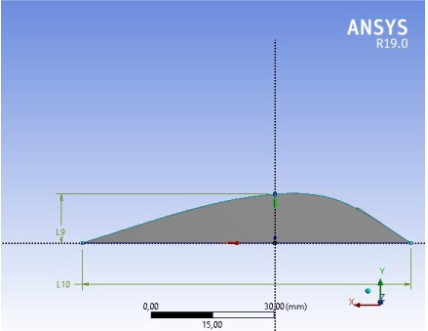
Figure 3.1 - Cross section of the instep on the inner part of foot in the shape of a pattern from sources [25-27]

Next, the dimensions on the sketch for the average patient are given. The 3D model of the drop-shaped element of the instep(Fig. 3.2) was obtained by the technology of drawing along two sections ( Skin / Loft ).
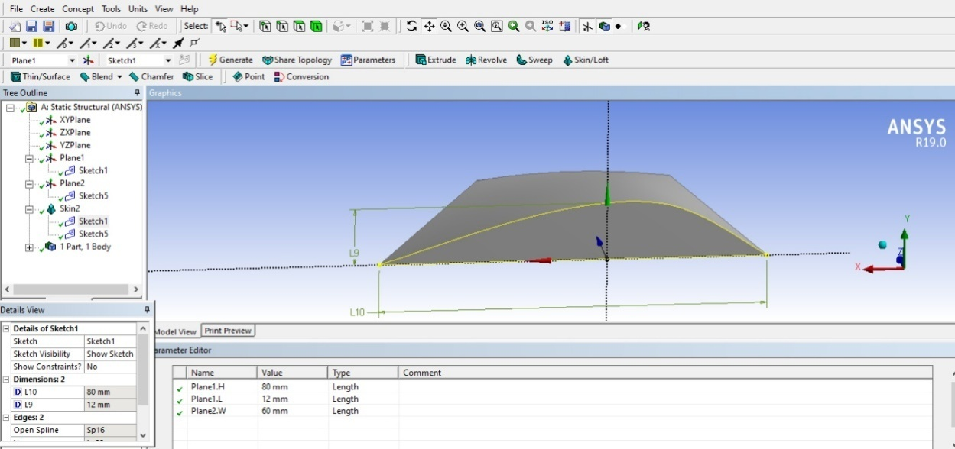
Figure 3.2 - The 3D model of the drop-shaped element of the instep

In order to provide further analysis of the functioning of instep in different conditions, the main parameters of the model are parameterized, as shown in Fig. 3.3, namely, variable parameters were created: for the cross-section length L10, the parameter H ; cross-section height L9 parameter L ; the distance between the intersections corresponding to the inner and outer parts of the leg FD1 parameter W.
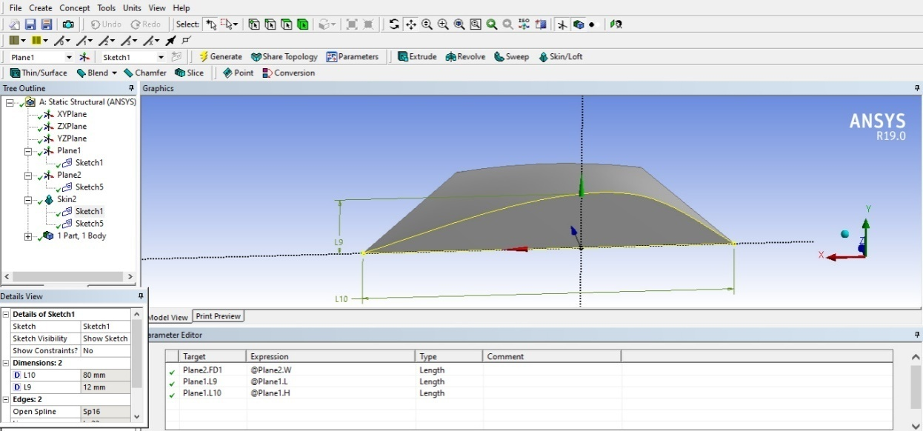
Figure 3.3 - Parameterization of the computer model of instep

Then the parameters of the material - polyethylene foam (modulus of elasticity, Poisson's ratio, specific density, etc.) are set, which are also parameterized. After that, a load is applied from above in the form of vertical pressure, i.e., the averaged patient's gravity per unit area of the instep element (also parameterized ). Boundary conditions in the form of immobility of the lower surface of model are also applied.
The next stage of building a model for numerical analysis was the imposition of a mesh of finite elements (all mesh parameters are left at default, that is, optimal from the point of view of ANSYS).
The model with an applied finite element meshis shown in Fig. 3.4.
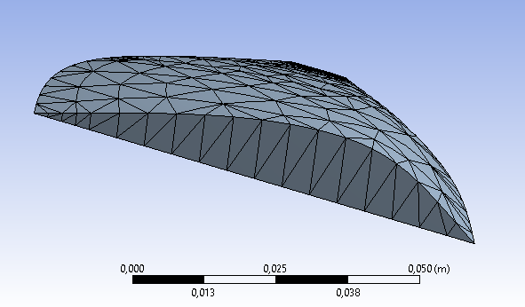
Figure3.4 - 3D model of supinator element with an applied finite element mesh

After starting the calculation process for thecreated model by Solution command of ANSYS workbench, the results of corresponding stresses, strains and other parameters of the model grid nodes are obtained, which can then be displayed in a user-friendly form. These can be appropriate tables, graphs, charts. For processing and presenting the results of calculations in a convenient form in the ANSYS workbench, there is a special powerful post-processing module that provides the possibility of additional processing of the results through user-entered formulas and code fragments or standard library functions.
Parameterization of the model refers to use of extremely effective ANSYS capabilities, which allow you to determine in advance the changing parameters that are important to the user when creating a computer model. When analyzing the behavior of an already ready model, the user can change values of such parameters and recalculate the tasks. Thus, it is possible to obtain useful dependencies, select optimal parameters in specific situations.

3.2Modeling of physical processes of elastic deformations of the instep

For example, one of the cases for presenting the results of calculations in the form of a diagram of distribution of deformations along the plane of the instep element is shown in Fig. 3.5. Here, the degree ofdeformation at the corresponding points of the plane of instep element is indicated by the color or intensity of gray. As you can see, the value of maximum deformation is highlighted on the diagram and the region where such deformation occurs is marked. This value can serve as an indicator of correctness of the design of instep, which must be elastic in all phases of patient's gait in order to perform rehabilitation functions in case of flat feet, because it is obvious that with complete deflection of the "hump" of instep, its supporting function will be reduced, with an incorrect choice of elastic parameters of the structures, it may be observed not a therapeutic, but a harmful effect of rehabilitation products.
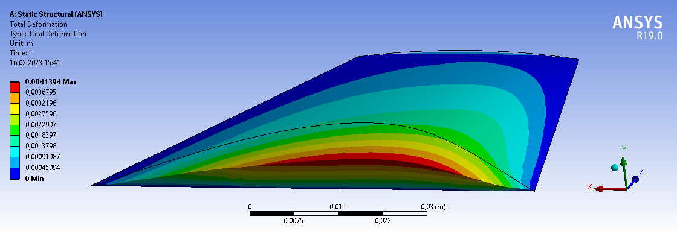
Figure 3.5 - Representation of results in the form of a distribution diagram of supinator element deformations

At the same time, it is clear that the deformation depends on many factors, such as the area and shape of the instep element, material parameters, the weight of the patient, the size of his foot, and so on.
It is the parameterization of the computer model that makes it possible to analyze the physical processes of elastic deformations and optimize the parameters of insoles, selecting them for specific patients.
As already mentioned, the following parameters were parameterized when creating the geometric part of the model: cross-section length L10 (parameter H); cross-section height L9 (parameter L); the distance between the intersections corresponding to the inner and outer parts of the foot FD1 (parameter W). In order to take into account the physical properties of material and the load values of the model (the weight of patient) at the next stage, the modulus of elasticity (Young's Modulus), Poisson's ratio (Poisson's Ratio) and the magnitude of the load fromabove in the form of vertical pressure (Pressure Y Component)were parameterized. The output parameter, which will serve as an indicator of quality of the instep design, is the value of maximum deformation under loading (Total Deformation Maximum).
Fig. 3.6shows, as an example, the interface for setting and constructing a graph of the dependence of maximum deformation of instep on its transverse dimension FD1 - parameter W.
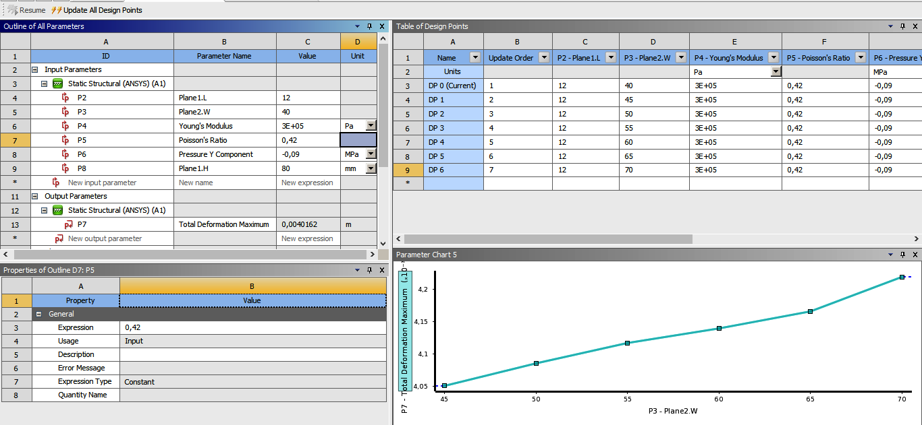
Figure 3.6 - Interface for setting and constructing a graph of the dependence of maximum deformation of instep on its transverse dimension FD1

Here, in the table on the right, an array of values of the independent parameter W is entered, then the calculation process is started, after which the final graphs of the dependence of maximum deformation of instep on this independent parameter are adjusted in the tables on the left. In the window on the right, we get the appropriate graph. Analogous settings are made to build other graphs describing the physical processes of instep deformations.
To illustrate the means of using the constructed computer model to optimize the parameters of orthopedic insoles, we present some obtained graphs.
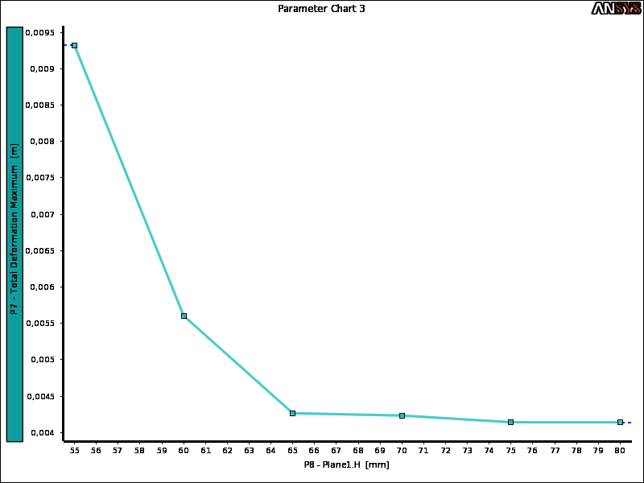
Figure 3.7 - Graph of the dependence of maximum deformation of instep on its cross-section length H

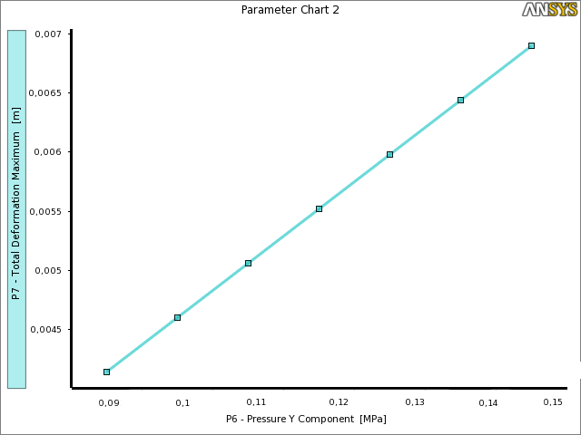
Figure 3.8 - Graph of the dependence of maximum deformation of instep on load values of the model (the weight of patient)

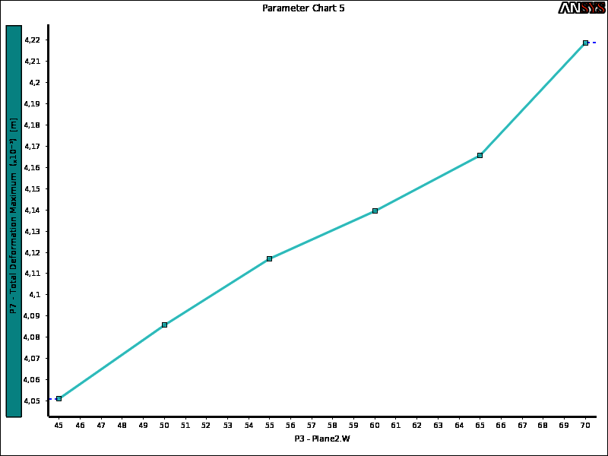
Figure 3.9 - Graph of the dependence of maximum deformation of instep on its transverse dimension W

It should be noted that these graphs illustrate the possibilities and prospects of using a computer model, because they are built only for one specific material – polyethylene foam.
In the practical application of the model, it is possible either to recalculate tasks with parameter values for a specific patient and material every time, or to build appropriate graphs and tables in advance for different parameter values.

Conclusions to section 3

A computer model of an orthopedic supinator was implemented in the ANSYS environment, which lays the foundations of an engineering approach to the design of such rehabilitation tools [35]. The demonstrated advantages of computer modeling are related to the possibility of optimizing designs and parameters of products, forecasting the peculiarities of their functioning, and reducing the cost of the development stage.
The use of the ANSYS environment is promising in solving the problems of rehabilitation engineering, where the practical experience of specialists, rather than exact mathematical calculations, dominates so far. The work shows possibility of building a model and engineering analysis of the functioning of complex orthopedic products.
The developed computer model of orthopedic supinator can serve as a basis for researching mechanical stresses and deformations of its various parts, and therefore for improving methods of its design, optimization, and setting parameters for specific patients.

CONCLUSIONS

The goal of the work has been achieved: a parameterized computer model of an orthopedic instep in the ANSYS workbench has been developed and researched, the possibility of engineering analysis of mechanical phenomena of elastic deformations in it under loads has been demonstrated.
- Literary sources were analyzed, which described the classification of types of flat feet, namely longitudinal, transverse, mixed and flat-valgus. Longitudinal flat feet makes up 20% - 29% of all foot deformities and is characterized by compaction of the longitudinal arch of the foot. It is most common among young people aged 15 to 25. Transverse flat feet ranges from 55% to 80% and is characterized by a decrease in the length of the foot. Common among women aged 35 to 50 years.
The main biomechanical disorders of the foot have been identified – disorders of pronation and supination. Orthopedic products are described – insoles, intended for maintaining the arch of the foot and correcting its biomechanical disorders. Different methods of manufacturing orthopedic insoles are characterized.
- Relevant scientific literature on the characteristics of various materials for creating insoles has been elaborated. It was determined that the use of hard correctors is contraindicated, because they are harmful to deformed feet. Instead, the use of an elastic material – polyethylene foam – strengthens the muscles and ligaments of the foot and has properties such as flexibility, elasticity and hygroscopicity. A comparative analysis of existing insole models was performed.
- The expediency of using a computer model of the patented instep design of professor Yu.M. Vikhlyaev as a prototype was analyzed and substantiated.
The simulation environment is defined – the ANSYS program with the Workbench platform for modeling and visualization of results with the possibility of changing parameters.
- A parameterized computer model of an orthopedic supinator was built in the ANSYS environment.
Computational and graphical experiments were carried out, during which the dependences between the instep parameters were determined.
The perspective of using computer modeling to improve technologies for the production of rehabilitation products has been demonstrated.
It is advisable to continue the research in the direction of complicating instep models, researching their dynamic characteristics.

REFERENCES

- Landorf K.B., Keenan A.M., Herbert R.D. Effectiveness of foot orthoses to treat plantar fasciitis: a randomized trial. Arch Intern Med. 2006. Vol. 166. pp. 1305-1309.
- Pfeffer G., Bacchetti P., Deland J., Lewis A., Anderson R., Davis W. Comparison of custom and prefabricated orthoses in the initial treatment of proximal plantar fasciitis. Foot Ankle Int. 1999. Vol. 20(4). pp. 214-221.
- Chia J., Suresh S., Kuah A., Ong J., Phua J., Seah A. Comparative trial of the foot pressure patterns between corrective orthotics, Formthotics, bone spur pads and flat insoles in patients with chronic plantar fasciitis. Ann Acad Med Singapore. 2009. Vol. 38(10). pp. 869-875.
- Hsi W., Lai J., Yang P. In-shoe pressure measurements with a viscoelastic heel orthosis. Arch Phys Med Rehabil. 1999. Vol. 80. pp. 805-810.
- Leung, A.K. Biomedical gait evaluation of the immediate effect of orthotic treatment for flexible flat foot / A.K. Leung, A.F. Мак., J.H. Evans // Prosthet. Orthot. Int. 1998. - Apr. 22(1). - P. 25 - 34.
- Miller, C.D. Effekt of corrective rearfoot orthotic on ground reaction forcer during ambulation / C.D. Miller, V.J. Suman // Mayo Clin. Proc. -1996. Aug., 71(8). - P. 757 - 762.
- Suk, F.F. Pathology of foot / F.F. Suk // J. Bone. It. Surg. 1997. -№4.-P. 618-627.
- Hill CL, Gill TK, Menz HB, Taylor AW. Prevalence and correlates of foot pain in a population-based study: the North West Adelaide health study. J Foot Ankle Res 2008; 1 (2).
- Irving DB, Cook JL, Young MA, Menz HB. Impact of chronic plantar heel pain on health-related quality of life. J Am Podiatr Med Assoc 2008;98(4):283-9.
- Badlissi F, Dunn JE, Link CL, Keysor JJ, McKinlay JB, Felson DT. Foot musculoskeletal disorders, pain, and foot-related functional limitation in older persons. J Am Geriatr Soc 2005:53(6): 1029-33.
- Irving DB, Cook JL, Menz HB. Factors associated with chronic plantar heel pain: a systematic review. J Sci Med Sport 2006;9:11-22.
- McMillan AM, Landorf KB, Barrett JT, Menz HB, Bird AR. Diagnostic imaging for chronic plantar heel pain: a systematic review and meta-analysis. J Foot Ankle Res 2009:2(32).
- McPoil TG, Martin RL, Cornwall MW, Wukich DK, Irrgang JJ, Godges JJ. Heel pain-plantar fasciitis: clinical practice guidelines linked to the international classification of functioning, disability, and health from the orthopaedic section of the American physical therapy association. J Orthop Sports Phys Ther 2008;38(4):1-18.
- Landorf KB, Keenan AM, Herbert RD. Effectiveness of foot orthoses to treat plantar fasciitis: a randomized trial. Arch Intern Med 2006;166:1305-9.
- Pfeffer G, Bacchetti P, Deland J, Lewis A, Anderson R, Davis W, et al. Comparison of custom and prefabricated orthoses in the initial treatment of proximal plantar fasciitis. Foot Ankle Int 1999;20(4):214-21.
- Chia J, Suresh S, Kuah A, Ong J, Phua J, Seah A. Comparative trial of the foot pressure patterns between corrective orthotics, Formthotics, bone spur pads and flat insoles in patients with chronic plantar fasciitis. Ann Acad Med Singapore 2009;38(10):869-75.
- Hsi W, Lai J, Yang P. In-shoe pressure measurements with a viscoelastic heel orthosis. Arch Phys Med Rehabil 1999;80:805-10.
- McPoil TG, Cornwall MW. Effect of insole material on force and plantar pressures during walking. J Am Podiatr Med Assoc 1992;82:412-6.
- Hong WH, Lee YH, Chen HC, Pei YC, Wu CY. Influence of heel height and shoe insert on comfort perception and biomechanical performance of young female adults during walking. Foot Ankle Int 2005;26(12):1042-8.
- Redmond AC, Landorf KB, Keenan AM. Contoured, prefabricated foot orthoses demonstrate comparable mechanical properties to contoured, customised foot orthoses: a plantar pressure study. J Foot Ankle Res 2009;2(20).
- Murphy DF, Beynnon BD, Michelson JD, Vacek PM. Efficacy of plantar loading parameters during gait in terms of reliability, variability, effect of gender and relationship between contact area and plantar pressure. Foot Ankle Int 2005;26(2):171-9.
- Bumfield JM, Few CD, Mohamed OS, Perry J. The influence of walking speed and footwear on plantar pressures in older adults. Clin Biomech 2004; 19(1 ):78-84.
- Kogler GF, Solomonidis SE, Paul JP. In vitro method for quantifying the effectiveness of the longitudinal arch support mechanism of a foot orthosis. Clin Biomech 1995;10(5):245-52.
- Kogler GF, Solomonidis SE, Paul JP. Biomechanics of longitudinal arch support mechanisms in foot orthoses and their effect on plantar aponeurosis strain. Clin Biomech 1996;ll(5):243-52.
- Супинаторстопыпролонгированногодействия// ПатентУкраины № 17592. 1997/Вихляев Ю.Н., Некрашевич О.И., Сичов С.О., [and other]
- Вихляєв Ю.М. Корекціяфункціональногостанустудентівтехнічнимизасобами: Монографія. - НТУУ «КПІ», 2006. - 308 с.
- Вихляєв Ю.М. Особливостіфізіотерапевтичнихвпливівнавідновленнястопи і гомілкипідлітків-спортсменів. Науковийчасопис НПУ ім. М.П.Драгоманова. Серія №15. Вид-во НПУ ім. М.П.Драгоманова. 2018. Вип. 3к (97) 18. С.111-114.
- Stolarski T., Nakasone Y., Yoshimoto S. Engineering Analysis with ANSYS Software. – Butterworth-Heinemann, 2018. – 553 p.
- Madenci E., Guven I. The Finite Element Method and Applications in Engineering Using ANSYS. – Springer, 2015. – 663 p.
- Jack Zecher,Fereydoon Dadkhah. ANSYS Workbench Tutorial with Multimedia CD Release 12. Schroff Development Corporation. 2009. 256 p.
- Bryan J. Mac Donald. Practical Stress Analysis with Finite Elements (2nd Edition). Glasnevin Publishing. 2011. 402 p.
- Tamma Kumar K., Namburu Raju R. Recent advances, trends and new perspectives via enthalpy-based finite element formulations for applications to solidification problems. International journal for numerical methods in engineering. 1990. Vol. 30. pp. 803-820.
- Robert D. Cook. Finite Element Modeling for Stress Analysis. Wiley. 1995. 336 p.
- Wriggers, VuVan, Stein. Finite element formulation of large deformation impact-contact problems with friction. Computers and structures. 1990. Vol. 37, pp. 319-331.
- Ahmed M. Optimization of parameters of orthopedic rehabilitation products using computer simulation / Solomin A., Getun G., Ahmed M. // Modern engineering and innovative technologies. – Karlsruhe, Germany, 2023. – issue.25, part.2 – p.118-122.

