МІНІСТЕРСТВО ОСВІТИ І НАУКИ УКРАЇНИ
НАЦІОНАЛЬНИЙ ТЕХНІЧНИЙ УНІВЕРСИТЕТ УКРАЇНИ
«КИЇВСЬКИЙ ПОЛІТЕХНІЧНИЙ ІНСТИТУТ ІМЕНІ ІГОРЯ СІКОРСЬКОГО»

Iryna Simkova, Iryna Kozubska,
Kateryna Tuliakova, Alina Medvedchuk

PROFESSIONAL ENGLISH FOR BIOMEDICAL ENGINEERING STUDENTS

Рекомендовано Методичною радою КПІ ім. Ігоря Сікорського як навчальний посібник для здобувачів ступеня бакалавра за освітньою програмою «Медична інженерія» спеціальності 163 «Біомедична інженерія» та «Фізична терапія» спеціальності 227 «Фізична терапія, ерготерапія»

Київ
КПІ ім. Ігоря Сікорського
2021

Рецензенти: | Калашнікова Л.Є., к. біол.н., доцент, факультет біомедичної інженерії, кафедра біомедичної інженерії  Ставицька І.В., к. пед. н., доцент, факультет лінгвістики, кафедра англійської мови технічного спрямування №2  Чіжова Н.В., викладач, факультет лінгвістики, кафедра англійської мови гуманітарного спрямування №3
Відповідальний  редактор | Лавриш Ю.Е., д. пед. н., доцент, завідувач кафедри англійської мови технічного спрямування № 2, факультет лінгвістики

Гриф надано Методичною радою КПІ ім. Ігоря Сікорського (протокол № 7 від 13.05.2021 р.)
за поданням Вченої ради Факультету лінгвістики (протокол № 10 від 26.04.2021 р.)

Електронне мережне навчальне видання

Сімкова Ірина Олегівна, д. пед. н., проф.
Козубська Ірина Геннадіївна, к. філол. н., доц.
Тулякова Катерина Робертівна, к. пед. н.
Медведчук Аліна Володимирівна, к. пед. н., доц.

PROFESSIONAL ENGLISH
FOR BIOMEDICAL ENGINEERING STUDENTS
Навчальний посібник

Professional English for biomedical engineering students: Англійська мова для студентів біомедичної інженерії: [Електронний ресурс]: навч. посіб. для студ. спеціальності 163 «Біомедична інженерія», 227 «Фізична терапія, ерготерапія» / І.О. Сімкова, І.Г. Козубська, К.Р. Тулякова, А.В. Медведчук; КПІ ім. Ігоря Сікорського. – Електронні тестові дані (1 файл, 5,85 Мбайт). – Київ : КПІ ім. Ігоря Сікорського, 2021. – 180 с.

АНОТАЦІЯ. Навчальний посібник забезпечує аудиторну та самостійну роботу студентів третього курсу факультету біомедичної інженерії. Видання складається з восьми розділів (Units), які охоплюють професійно орієнтовані теми (Topics): “Introduction to biomedical engineering”, “Robotics in biomedical and healthcare engineering”, “Tissue engineering”, “Medical Imaging”, “Nanotechnology in biomedical engineering”, “Rehabilitation engineering”, “Biomaterials”, “Genetic engineering”. Розроблені вправи спрямовані на забезпечення знань, розвиток і удосконалення навичок і вмінь у читанні, говорнні, аудіюванні, письмі та перекладі, а також покращення лексичних та граматичних знань, навичок і умінь студентів. Завданням посібника є сприяння розширенню професійного тезаурусу студентів та підвищення мотивації студентів до автономного навчання.

© І.О. Сімкова, І.Г. Козубська, К.Р. Тулякова, А.В. Медведчук, 2021
© КПІ ім. Ігоря Сікорського

CONTENTS

ПЕРЕДМОВА | 4
UNIT 1 INTRODUCTION TO BIOMEDICAL ENGINEERING | 6
UNIT 2 ROBOTICS IN BIOMEDICAL AND HEALTHCARE ENGINEERING | 20
SELF-ASSESSMENT (UNITS 1-2) | 34
UNIT 3 TISSUE ENGINEERING | 40
UNIT 4 MEDICAL IMAGING | 49
SELF-ASSESSMENT (UNITS 3-4) | 62
UNIT 5 NANOTECHNOLOGY IN BIOMEDICAL ENGINEERING | 66
UNIT 6 REHABILITATION ENGINEERING | 79
SELF-ASSESSMENT (UNITS 5-6) | 92
UNIT 7 BIOMATERIALS | 97
UNIT 8 GENETIC ENGINEERING | 106
SELF-ASSESSMENT (UNITS 7-8) | 120
GRAMMAR REFERENCE | 125
GLOSSARY | 135
VIDEO AND AUDIO SCRIPTS | 141
APPENDIXES | 150
KEYS | 155
REFERENCES AND LINKS | 175

ПЕРЕДМОВА

Навчальний посібник запропоновано для забезпечення підготовки бакалаврів спеціальності 163 «Біомедична інженерія» та 227 «Фізична терапія, ерготерапія» і розроблено для студентів ІІІ курсу факультету біомедичної інженерії відповідно до навчальної програми. Посібник передбачає забезпечення знань, формування навичок і розвиток вмінь студентів працювати з іншомовною літературою за фахом, збагачення лексичного запасу та підготовку до ефективного професійно орієнтованого спілкування.
Укладений посібник відповідає вимогам робочої програми з кредитного модуля “Англійська мова професійного спрямування» дисципліни «Іноземна мова професійного спрямування”, забезпечує 45 годин аудиторних та індивідуальних занять у першому семестрі і 45 годин аудиторних та індивідуальних занять у другому семестрі та передбачає роботу студентів з текстами, відеоматеріалами, лексичними й граматичними вправами, розробленими до тем професійного спрямування. Посібник містить сучасні автентичні професійно орієнтовані матеріали з біомедичної інженерії, адаптовані для студентів факультету біомедичної інженерії.
Навчальний посібник складається з восьми розділів: “Introduction to biomedical engineering”, “Robotics in biomedical and healthcare engineering”, “Tissue Engineering”, “Medical imaging”, “Nanotechnology in biomedical engineering”, “Rehabilitation engineering”, “Biomaterials”, “Genetic engineering”.
Кожну тему розкрито в текстах, пов’язаних з фахом, і розроблено вправи до цих текстів (некомунікативні, умовно-комунікативні, комунікативні). Усі розділи містять відео/аудіо завдання з вправами.
Розроблені вправи спрямовані на поглиблення знань, розвиток вмінь та формування навичок у читанні, говорінні (діалогічному і монологічному), аудіюванні, письмі та перекладі, а також покращення лексичних знань (широкого діапазону лексики повсякденного, гуманітарного та професійно-орієнтованого спрямування). Крім того, представлено комплекс граматичних вправ, узгоджених з тематикою посібника, для удосконалення знань з граматики: Relative clauses, Reported speech, Passive voice, Describing function of an item, Conditionals, Comparison with adjectives and adverbs, Questions and answers, Predictions: will, may, might.
До глосарію включено основні лексичні терміни галузі біомедичної інженерії, що зустрічаються у посібнику.
У процесі роботи з посібником студенти мають одержати необхідний рівень англомовної професійно орієнтованої комунікативної компетентності, яку складають мовні та мовленнєві знання, навички і вміння, необхідні майбутнім фахівцям з біомедичної інженерії.
Перевагами посібника є сприяння розширенню професійного тезаурусу студентів галузі біомедичної інженерії, формування інтересу до англомовного професійно орієнтованого спілкування та підвищення мотивації студентів до навчання і здобуття майбутньої професії, а також доступність цього посібника через Інтернет мережу.
UNIT 1
AN INTRODUCTION TO BIOMEDICAL ENGINEERING
1 LEAD-IN
Do the quiz below and compare your results with a partner.
1 What does the prefix bio- mean?
a biology
b life
c medical
d animals

5 A person who has had a limb removed is an
a amputee
b biomedical engineer
c prosthetic
d prototype
7 Which of the following is an example of a Cochlear Implant?
a  b 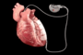 c  d 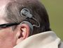

(Retrieved from borrowed from https://quizizz.com/admin/quiz/5de679bd714e07001fef896b/biomedical-engineering-vocabulary-and-more)
2 LISTENING
2.1 Discuss. What are the most essential skills a biomedical engineer should have?
2.2 Watch the video “Studying Biomedical Engineering” (https://www.youtube.com/watch?v=pOLnTkIqk9M) where undergraduate students of Queen Mary University of London talk about their experience of studying Biomedical Engineering at the School of Engineering and Materials Science and answer the questions:
1 How many people are speaking?
2 What things do they like about their studying?
2.3 Watch the video again and define who each statement is about.
1 He / She is the president of the Women’s Engineering Society.
2 He / She is a massager.
3 He / She is doing the same kind of models as aerospace mechanical students but also is learning about cells and different parts of the body.
4 He / She likes to try and solve problems we have with our bodies: hip replacements, knee replacements, prosthetic implants, etc.
5 He / She enjoyed all the projects they were given, especially the one with a minimally invasive device.
6 He / She thinks that educational institutions should be not only a place of academic excellence but also a welcoming and relaxed environment.
7 He / She thinks that if you are into biology, technology, and engineering and if you like learning how things work you must think of becoming a biomedical engineer.
2.4 Work in groups of 3-4. Discuss what you like about your studying biomedical engineering.

3 READING
3.1 Read the text and choose the most appropriate headline from three possible options:
1 The magic of biomedical engineering
2 What is biomedical engineering?
3 How to become a biomedical engineer
3.2 Look at the words in bold and explain their meaning.
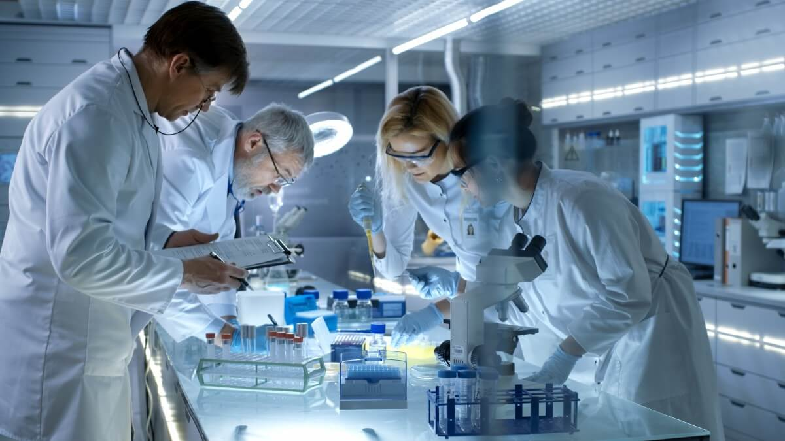
(Retrieved from https://studyinternational.com/news/develop-life-changing-technologies-with-these-biomedical-engineering-courses/)

Aspects of mechanical engineering, electrical engineering, chemical engineering, materials science, chemistry, mathematics, and computer science and engineering are all integrated with human biology in biomedical engineering to improve human health, whether it be an advanced prosthetic limb or a breakthrough in identifying proteins within cells. Biomedical engineering now encompasses a range of fields of specialization including bioinstrumentation, bioimaging, biomechanics, biomaterials, tissue engineering and regenerative medicine, clinical engineering, rehabilitation engineering.

Such a variety of fields opens many opportunities for biomedical engineers.
They design instruments, devices, and software used in healthcare; develop new procedures using knowledge from many technical sources; or conduct research needed to solve clinical problems. They frequently work in research and development or quality assurance. Biomedical engineers design electrical circuits, software to run medical equipment, or computer simulations to test new drug therapies. In addition, the design and build artificial body parts, such as hip and knee joints. In some cases, they develop the materials needed to make the replacement body parts. They also design rehabilitative exercise equipment.
(Retrieved from Biomedical Engineering: Bridging medicine and technology and https://www.mtu.edu/biomedical/department/what-is/ and Introduction to biomedical engineering; https://navigate.aimbe.org/why-bioengineering/areas-of-specialization-in-bioengineering/)
3.3 Define the sentences as True (T) or False (F).
1 The possibilities of medicine have greatly changed in recent years.
2 The major factor in the extension of people’s life and their health improvement is the development of computer technology.
3 There is a range of speciality areas within the field of biomedical engineering.
4 Biomechanics uses and develops imaging techniques to provide information on the two and three-dimensional structure in order to understand, diagnose and treat disease.
5 Rehabilitation engineering develops devices that help people recover from physical and cognitive impairments.
6 Biomedical engineers frequently work with patients in hospitals.
7 The main role of a biomedical engineer is to serve society.
3.4 Make notes under specific headings.

PROGRESS IN BIOMEDICAL ENGINEERING
FIELDS OF BIOMEDICAL ENGINEERING

BIOMEDICAL ENGINEERING APPLICATIONS

RESPONSIBILITIES AND OPPORTUNITIES OF BIOMEDICAL ENGINEER

4 VOCABULARY
4.1 Insert the following words in the gaps. Translate the sentences.
adjust; naturally occurring; expectancy; sweeping; skilled; encompasses; tools

1 Life ……….. increased and you can expect to live longer than your grandparents.
2 The growth of biomedical engineering is supported by advances in biological science, which have created new opportunities for the development of ………… for diagnosis of and therapy for human disease.
3 Biomedical engineering now …………. a range of fields of specialization and it opens many opportunities for biomedical engineers.
4 Biomedical engineers install, …………, maintain, repair, or provide technical support for biomedical equipment.
5 Biomedical engineer is a profession, not just a …………. technical service.
6 For your parents, the changes in medicine have been even more ………. than for you.
7 Biomaterials is the study of ……………. or laboratory-designed materials that are used in medical devices.
4.2 Find the words in the text above to match the definitions.
1 ___________ thin discs of plastic or glass that the person puts on the surface of their eyes to correct vision.
2 ___________ a group of cells, in close, proximity, organized to perform one or more specific functions.
3 __________ a condition in which you are not able to use a part of your body or brain normally.
4 __________ the maintenance of a desired level of quality in a service or product, esp. by means of attention to every stage of the process of delivery or production.
5 __________ a complete path around which electricity can flow.
6 ___________ a structure in the human body at which two parts of the skeleton are fitted together.
5 GRAMMAR
Relative clauses
Study these examples:
Rehabilitation engineering is the study of engineering and computer science to develop devices.
The devices assist individuals recovering from or adapting to physical or cognitive impairment.
We can join these sentences like this:
Rehabilitation engineering is the study of engineering and computer science to develop devices that assist individuals recovering from or adapting to physical or cognitive impairment.
The part in bold is a relative clause. It adds important information – defining or telling us exactly which devices are. In the relative clause, you replace The devices with which. Which is used for things.
Now study these examples:
Such a variety of fields opens many opportunities for biomedical engineers.
They design instruments, devices, and software used in healthcare.
We can join these sentences like this:
Such a variety of fields opens many opportunities for a biomedical engineer who designs instruments, devices, and software used in healthcare.
Who is used for a person or people.

Go to Grammar reference p. 125 and learn more about relative clauses.
5.1 Underline nine relative clauses in the following text.
Biomedical Engineering Innovations
In July 2001, a group of surgeons from Louisville, Kentucky managed to implant a new-generation artificial heart in a patient.
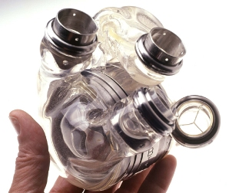
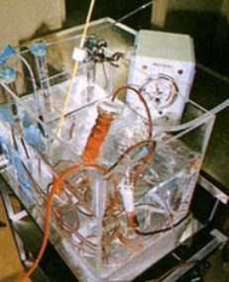
Thus people who use the invention are able to grip objects of different shapes, for example, coffee mug handles.
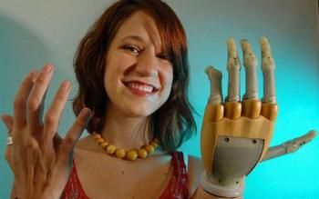
The bionic eye is the work of researchers from the University of Washington in Seattle who managed to mix for the first time an elastic contact lens with an imprinted electronic circuit.
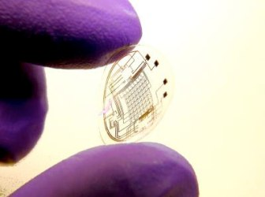
The invention allows the wearers to see the world by superimposing computerized pictures onto their natural view.
(Retrieved from http://biomedikal.in/2011/07/top-10-biomedical-engineering-innovations-in-last-decade/)

5.2 Make definitions of each person or device in column A of the table by matching them with the information in column B. Use who or which.

A | B
A massage therapist | delivers fluids, such as nutrients and medications, into a patient’s body in controlled amounts;
A pacemaker | treats clients by using touch to manipulate the soft-tissue muscles of the body;
A clinician | visits people in their homes in order to give them advice on medical care, for example, advising new parents on how to look after their baby;
An infusion pump | detects movement;
An inhaler | delivers medicines into the lungs through the work of a person’s breathing;
A general practitioner | is placed under the skin in your chest to help control your heartbeat;
A practice manager | is trained in general medicine and treats patients in a local community rather than at a hospital;
A telescope | works as a caregiver of a patient in a hospital, skilled nursing facility, clinic, or patient’s home;
A health visitor | consists of a thin tube with lenses, that you look through in order to examine areas inside the body during an operation;
A motion sensor | is in charge of running and organizing a practice, for example, by managing the staff, dealing with financial matters, etc.

5.3 Complete the sentences with who, which, where, when, or whose.
1 BME students like to solve problems …………. people have with their bodies: hip replacements, knee replacements, prosthetic implants, and others.
2 John is a 25-year-old patient …………. sustained massive head trauma and neurological injury in a motorcycle accident.
3 I’m the president of the women’s engineering society ………… we do a lot of social experiences.
4 Cecilia Bavolek, the patient, ………… heart was connected to the machine for 45 minutes, was able to recover fully.
5 We live in an age ………… the public health infrastructure, its growth and its development are critical to our collective health.
6 For most people, however, it is John Heysham Gibbon …………. name is mainly associated with the invention of the first heart-lung machine.
7 That was the moment ………… the doctors had to make an important decision – to turn off Mr. Perry’s pacemaker or not.
8 Wison Greatback was an electrical engineer …………. helped develop the first implantable pacemaker, …………… has helped a lot of people.
6 WRITING
Write an informal email (150-180 words) to your foreign friend and tell him/her about the profession you have chosen and your university studying. These questions can help you to write.
1 What is biomedical engineering?
2 What field of engineering would you like to specialize in and why?
3 What do you like/dislike about your studying biomedical engineering at university?
Tips for writing an informal email to a friend
1 You can start an informal email with Hi…… .
2 Make sure you answer any questions that were asked.
3 Use informal vocabulary like phrasal verbs (e.g. to get together, to catch up) to create a friendly tone.
4 Before you sign off, close the email with a phrase like Looking forward to seeing you! Or Good luck with your studying!
5 End with Love, (for close friends and family) or Take care, before signing your name on the next line.
(Retrieved from https://learnenglish.britishcouncil.org/sites/podcasts/files/LearnEnglish-Writing-B2-An-informal-email-to-a-friend.pdf)
7 SPEAKING
Discuss the following questions in groups.
1 Do you agree with the statement that nowadays people are healthier and more active than they were some decades ago?
2 What biomedical engineering inventions do you consider to be the most important to society? Why?
3 What is a biomedical engineer’s role in a healthcare facility?
Check yourself! Read key words of unit 1 and first give definitions of these terms (use Glossary to help you) and then translate them into Ukrainian.
LIMB (n.) JOINT (n.)
ARTIFICIAL HIP (n.) ENDEAVOR (n.)
ADMINISTER (v.) ELECTRICAL CIRCUIT (n.)
SWEEPING (adj.) LIFE EXPECTANCY (n.)
OBSTETRICS (n.) QUALITY ASSURANCE (n.)
ENCOMPASS (v.) IMPAIRMENT (n.)
CELLULAR (adj.) TISSUE (n.)
UNIT 2
ROBOTICS IN BIOMEDICAL AND HEALTHCARE ENGINEERING
1 LEAD-IN
Look at the pictures below and discuss different applications of robotics in biomedical and healthcare engineering. What other applications do you know?
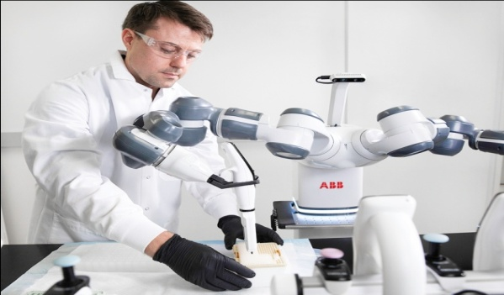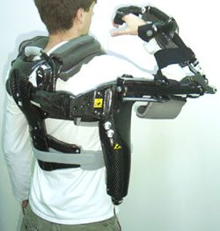
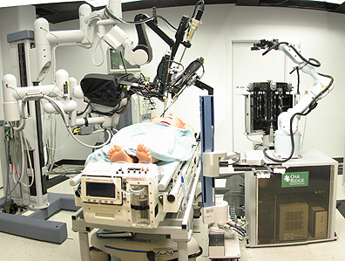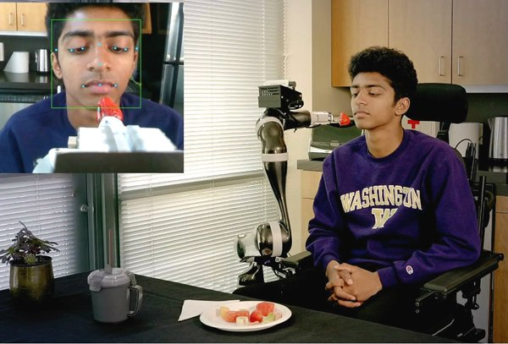
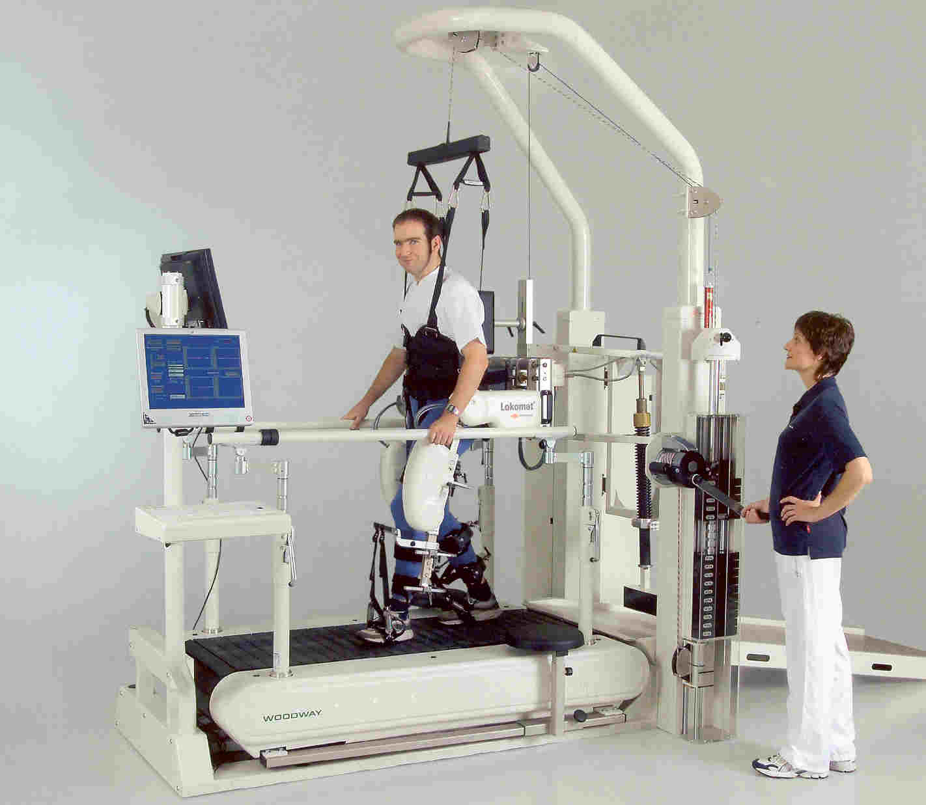
(Retrieved from https://new.abb.com/news/detail/37301/abb-demonstrates-concept-of-mobile-laboratory-robot-for-hospital-of-the-future; http://myexs.ru/2012/03/; https://www.umms.org/rehab/health-services/therapeutic-technology/lokomat-therapy; https://tectales.com/bionics-robotics/ada-assistive-robot-learns-to-feed.html) https://www.pinterest.com/pin/221591244145146206/)

2 LISTENING
2.1 Look at the picture of the Da Vinci robot and label three main components of it. What are they used for?

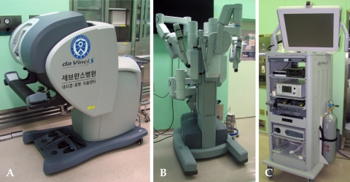
(Retrieved from https://www.researchgate.net/figure/Three-components-of-the-da-VinciR-surgical-system-A-the-surgeons-console-B-a-cart_fig1_23689677)

2.2 Watch a video about the Da Vinci Surgical robot (https://www.youtube.com/watch?v=QksAVT0YMEo) and choose the correct answer.
1 Three network components comprise the da Vinci Surgical System: an ergonomic surgeon console, a patient-side cart with four interactive robotic arms, and ………. .

a a huge display
b a high-definition 3d vision system
c tiny wristed instruments
2 The precisely controlled micro-movements of the da Vinci instruments are enabled by ……….. .
a the computer processors of the system
b sophisticated graphics
c vision cart
3 The Da Vinci EndoWrist instruments are designed with a unique wristed architecture that provides seven degrees of freedom for a range of motion greater than even ……… .
a the human eye
b the human ear
c the human wrist
4 This proprietary design enables surgical maneuvers impossible with conventional ……… .
a surgical instruments
b laparoscopic tools
c operation procedure
5 Da Vinci provides a streamlined surgical experience that benefits the hospital, the surgeon, the OR team, and most importantly ………. .
a the personnel
b the disease
c the patient
2.3 Discuss the questions.
1 Do you think the Da Vinci robot is safe?
2 Should you let a robot do your surgery?
3 Do you agree with the quote of Dr. John Santa, medical director at Consumer Reports Health “This is a technology that is costing the healthcare system hundreds of millions of dollars and has been marketed as a miracle – and it’s not. It’s a fancier way of doing what we’ve always been able to do”. Why (not)?
3 READING
3.1 Read the text about the latest research news – designing soft and sensitive robotic fingers – and define the sentences as True (T) or False (F).
1 To develop a more human-like robotic gripper, it is necessary to provide sensing capabilities to the fingers.
2 Scientists have relied on the use of moisture sensors to develop gripping techniques.
3 Scientists' work represents a big step toward safer and more dexterous robotic handling, which will extend the applications of robots to different fields.
4 New technology allows for light bends by adjusting the air inlet pressure.
5 The main disadvantage of traditional sensors is flexibility.
6 In the production of robotic fingers 3D printing uses one-component material.
7 Piezoelectric sensor does not require a power supply due to the fact that it is powered by the sun.
8 The technology developed by researchers can be used to improve the perception of captured objects.
Getting the right grip: Designing soft and sensitive robotic fingers
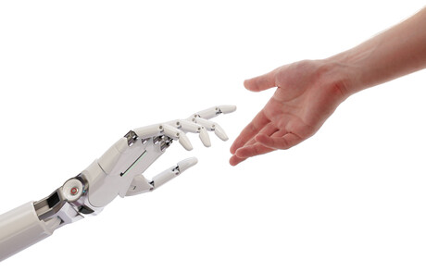
(The picture is retrieved from https://www.processonline.com.au/content/factory-automation/news/new-sensors-make-for-soft-and-sensitive-robotic-fingers-1590420400)
Although robotics has reshaped and even redefined many industrial sectors, there still exists a gap between machines and humans in fields such as health and elderly care. For robots to safely manipulate or interact with fragile objects and living organisms, new strategies to enhance their perception while making their parts softer are needed.

(Retrieved from https://www.sciencedaily.com/releases/2020/12/201210112044.htm)
3.2 Read the text again. Choose the correct answer.
1 The implementation of new robotics technologies is essential for
a astrophysical research
b detecting the pressure inside the piezoelectric sensor
c simulation of movement similar to human
d reducing the perception of brittle material
2 The main development problem is that
a installation of traditional sensors on human fingers
b soft gripper has poor coordination
c the safety of the electrical installation does not allow its use in health care
d proprioception technologies can only be applied to metallic materials
3 The new soft grip design developed by Associate Professor Mengying Xieuses presented
a technologies of one-material 3-D printing
b rigid mechanical plates
c sensors with a sense of their own movements and position
d silicone materials for increased tactility
4 How does the soft finger work?
a The water sensor creates a voltage difference between the electric field and the water
b A piezoelectric sensor inserted into the vacuum layer creates a pressure difference
c Several layers of metal stacked on top of each other create friction, and then current
d It bends easily depending on the intensity
5 What is the advantage of the printing system?
a prototyping process becomes easy to implement and integrate
b the dynamic behaviour of the system becomes arbitrary and fast
c the system becomes electrically stable
d multi-layer material allows for circular movements
4 VOCABULARY
4.1 Complete the sentences with the words in italics.
leveraged grippers stiffness-tuning proprioception rigid
1 One of the main challenges in the design of soft robotic ………… is integrating traditional sensors onto the robot's fingers.
2 Traditional sensors are …………. and compromise the mechanical characteristics of the soft parts.
3 In their latest study published in Nano Energy, scientists at Ritsumeikan University, Japan, successfully used multi-material 3D printing technology to fabricate soft robotic fingers with a built-in ………….. sensor.
4 The scientists …………… the phenomenon as a sensing mechanism for the robotic finger.
5 The use of multi-material 3D printing allowed the researchers to easily integrate the sensing and ………….. mechanisms into the design of the robotic finger itself.
4.2 Read the sentences and fill in the gaps with the words (a-d).
1 Scientists make a big ………... in the development of soft robotic grippers by integrating sensing mechanisms into 3D printable fingers.
2 In the field of health care there still exists a ………… between machines and humans.
3 Building a safe and dexterous robotic gripper with human-like …………. is currently one of the most important goals in robotics.
4 In their ………… study scientists successfully used multi-material 3D printing technology to fabricate soft robotic fingers with a built-in proprioception sensor.
5 By vacuum jamming multiply stacked ……….. of a bendable material can be made rigid by sucking out the air between them.
6 Both functions combined enable a three-finger robotic gripper to ………. grasp and maintain hold of any object by ensuring the necessary force is applied.
7 Their design strategy offers ……….. advantages and represents a large step toward safer and more capable soft robots.
8 A single piezoelectric layer was included among the ……….. jamming layers as a sensor.
9 Self-powered built-in sensors will ………… the barriers to robotic applications that currently rely on powered sensors to monitor conditions.
10 Existing soft grippers are usually designed with a single type of proprioceptive ………….; either pressure or finger curvature.

1 | a. | jump | b. | movement | c. | step | d. | leap
2 | a. | space | b. | gap | c. | link | d. | connection
3 | a. | capabilities | b. | competence | c. | capacities | d. | power
4 | a. | best | b. | newest | c. | big | d. | latest
5 | a. | covering | b. | layers | c. | levels | d. | piles
6 | a. | fast | b. | well | c. | properly | d. | best
7 | a. | quantitative | b. | numerous | c. | fair | d. | greatly
8 | a. | tissue | b. | tube | c. | vacuum | d. | plate
9 | a. | stop | b. | break | c. | encompass | d. | eliminate
10 | a. | sensation | b. | sensibility | c. | sense | d. | sensibilization
5 GRAMMAR
5.1 Transform the quotes from the text into reported speech.
Reported Speech
- When we report speech, we often move the sentences back (backshift)/forwards, e.g. present simple – past simple; present continuous – past continuous, present perfect – past perfect, will – would.
- The verb tenses can either change or remain the same in up-to-date reporting and when reporting is a general truth or law of nature.
- Some words and time expressions change according to the meaning of the sentence: now – then, at that time; today, tonight – that day, that night; yesterday – the day before, the previous day; tomorrow – the next day, the following day; this week – that week, ago – before; here – there.

Go to Grammar reference p. 126 and learn more about reported speech.
5.2 Transform the direct speech into reported speech.
1 Bill Gates: “Robotics and other combinations will make the world pretty fantastic compared with today”.
2 Bruce Dickinson: “Engineering stimulates the mind”.
3 Elon Musk: “I don’t spend my time pontificating about high-concept things; I spend my time-solving engineering and manufacturing problems”.
4 Jeffrey Abrams: “Robotics are beginning to cross that line from absolutely primitive motion to motion that resembles animal or human behaviour”.
5 Colin Angle: “The way that the robotics market is going to grow, at least in the home, is that we’ll have a number of different special purpose robots”.
6 Colin Angle: “The reason it has taken so long for the robotics industry to move forward is that people keep trying to make something that is cool but difficult to achieve rather than trying to find solutions to actual human problems. Technology can be extremely expensive if you don’t focus”.
7 John Glenn: “I think sometimes we will go to Mars and I think we’ll explore it with humans sometimes, but I think it’s really wise to do all the robotic exploration ahead of time and learn as much as possible”.
8 Martin Rees: “I hope that by 2050 the entire solar system will have been explored and mapped by flotillas of tiny robotic craft”.
5.3 Find one mistake in each sentence and correct it.
1 Professor Warwick said that factory workers provide the key to a vaccine for smallpox two years before.
2 The teacher said that drinking water will be by far the best way to lose weight.
3 The doctor told the patient that he would have serious complications if he doesn’t take the prescribed pills.
4 He said that robotic carts may be seen moving through hospital corridors carrying supplies.
5 She said that her husband had changed his eating habits last month.
6 The reporter said that cardiovascular diseases are being the biggest killer amongst diseases globally.
7 He said that antibiotics have increased the average life expectancy in the developed world.
8 She said that scientists were developing new ways to treat disease with cells now.
6 WRITING
Advantages / disadvantages essay
6.1 Consider the model structure of the essay. Then complete the guidelines for writing an essay with the words in the box.
Advantages and Disadvantages Essay Structure
Introduction
- Paraphrase the statement sentence (question);
- Outline main ideas.
Main body
- Present advantages with detail and examples;
- Present disadvantages with detail and examples.

Conclusion
- Summarize the main points and state your opinion.

personal opinions, examples, notes, beginning, logical order

1 Sort out the facts – make ________ of all the relevant information you have on the subject.
2 Plan your argument – organise your notes and arrange the ideas in a ________ .
3 Give your essay an appropriate _________ . Describe what you’re planning to say.
4 Decide how many paragraphs you need for your argument. Each paragraph should discuss one point. Use ________ to support your arguments.
5 Write a logical conclusion. Though the style of the essay is generally formed and

impersonal, this might be the place to include some _________ .
(Clare & Wilson, 2011)
6.2 Look at the useful expressions and linking words for an advantage/disadvantage essay in Appendix 1 p. 150. Choose some of them and put them in the correct place in the table.
INTRODUCE ADVANTAGES
INTRODUCE DISADVANTAGES
CONTRASTING IDEAS
ADDITIONAL REASONS
PERSONAL OPINION/CONCLUSION

6.3 Using ideas discussed in this unit and the results of the survey conducted among 12,000 people across 12 countries (https://www.pwc.com/gx/en/industries/healthcare/publications/ai-robotics-new-health/survey-results.html), write an essay (120-150 words) describing the advantages and disadvantages of using robots in healthcare and state your personal opinion on it. Consider the model structure of the essay and useful expressions.
7 SPEAKING
In pairs, discuss the advantages and disadvantages of four main types of robots used in healthcare.

- Surgical robots
- Exoskeletons
- Care robots
- Hospital Robots
8 TRANSLATION PRACTICE
8.1 Match the word with its translation.
1 | gripper | a | виготовляти, виробляти
2 | proprioception | b | твердість, жорстокість
3 | piezoelectric sensor | c | посилений
4 | to fabricate | d | п’єзоелектричний сенсор
5 | reinforced | e | вакуумне здавлювання
6 | stiffness | f | пропріосепція, кінестезія
7 | vacuum jamming | g | кисть (робота)

8.2 Translate the following sentences into Ukrainian.
5 Social robots may encourage patients to comply with treatment regiments or provide cognitive engagement, keeping patients alert and positive
Check yourself! Read key words of unit 2 and first give definitions of these terms (use Glossary to help you) and then translate them into Ukrainian.

GRIPPER (n.) AIR INLET (n.)
FRAGILE (adj.) PROPRIOCEPTION (n.)
RIGID (adj.) REINFORCED (adj.)
INFLATION (n.) STIFFNESS (n.)
LEVERAGE (v.)

SELF-ASSESSMENT (UNITS 1-2)
VOCABULARY AND GRAMMAR
1 Complete the collocations with the words from the box.
healthcare delivery, vision, biological processes, expectancy, tissues and organs, limitations, impairments, proprioception sensor, gripper, 3D vision system

1 provide clear ________
2 life ________
3 to explore ________
4 to regenerate ________
5 to optimize ________
6 physical and cognitive ________
7 high-definition ________
8 soft robotic ________
9 to overcome ________
10 built-in ________
(2 points for each correct answer / 20 points)

2 Rewrite the sentences using relative clauses. Use the words in italics and the words in the box.
that who (2) which (2) when where

1 This is a micro-nano robot. It allows us to study the fundamental problems at the cellular level owing to its precise positioning and manipulation ability.
This is a micro-nano robot ________________________________________ .
2 Yesterday I met a biomedical engineer. He specializes in tissue engineering.
Yesterday I met a biomedical engineer _______________________________ .
3 Bioinstrumentation uses electronics, computer science, and measurement principles to develop different devices. They are used in the diagnosis and treatment of medical problems.
Bioinstrumentation uses electronics, computer science, and measurement principles to develop different devices, _______________________________ .
4 Rehabilitation equipment is for patients. They want to regain back the energy and strength to do many usual things again.
Rehabilitation equipment is for patients _____________________________ .
5 It was 2007. David Gow invented the iLimb device.
It was 2007 __________________________________________________ .
6 Did you visit the University of Washington in Seattle? Researchers created the bionic eye there.
It is University of Washington in Seattle ____________________________ .
7 Dr. Kenneth Matsumura developed a new bio-artificial liver. It became a new approach in creating an artificial liver.
Dr Kenneth Matsumura developed a new bio-artificial liver ____________ .
(2 points for each correct answer / 14 points)
3 Transform the quotes into reported speech.
4 Peter Agre: “John Hopkins introduced me to two defining events in my life: commitment to biomedical research and meeting my future wife, Mary”.
5 William Henry Danforth: “St. Louis has always been a great center for medicine. It has been a leader in the nation since the early part of the 20th century”.
(Retrieved from https://www.brainyquote.com/topics/biomedical-quotes)
(2 points for each correct answer / 10 points)
READING
4 Read the text and define the statements as True (T) or False (F).
(2 points for each correct answer / 10 points)

Biorobotics
Such devices may also be used to measure the state of disease, track progress or offer interactive training experiences that can speed recovery from an injury or
stroke.
(Retrieved from https://www.embs.org/about-biomedical-engineering/our-areas-of-research/biorobotics/)

5 Find words or phrases in the text that match meanings 1-5.
1 a lack or shortage (paragraph 1) ________
2 disease or dysfunction of one or more peripheral nerves, typically causing numbness or weakness (paragraph 2) ________ ________
3 an exam used to detect changes or abnormalities in the large intestine (colon) and rectum (paragraph 3) ________
4 the science and technology of transmitting and understanding information through touch (paragraph 4) ________
5 a surgical cut made in skin or flesh (paragraph 4) ________
(2 points for each correct answer / 10 points)
TRANSLATION
6 Translate the following sentences into English.
1 Швидкий прогрес роботизованої техніки відкриває нові можливості для біомедичної та медичної техніки.
2 Пристрій було імплантовано людині, яка страждала від серцевої нестачі.
3 Таке різноманіття галузей відкриває багато можливостей для біомедичних інженерів.
4 Завдяки біомедичній інженерії тривалість життя людей значно зросла.
5 Біомедичні інженери розробляють та створюють штучні частини тіла, такі як тазостегнові та колінні суглоби.
6 Хірургічна система ДаВінчі – це найдосконаліша платформа для малоінвазивної хірургії, доступна сьогодні у світі.
7 Це нове дослідження допоможе людству подолати невиліковні хвороби.
8 Кардіостимулятор – це пристрій, який поміщається під шкіру в грудях, щоб допомогти контролювати серцебиття.
(2 points for each correct answer / 16 points)

WRITING
7 Write the abstract (50-80 words) to the text “Biorobotics”.
(20 points)
Total: 100 __________

UNIT 3
TISSUE ENGINEERING
1 LEAD-IN
Study this figure. What branch of biomedical engineering is shown here? Try to explain the process depicted in the picture.
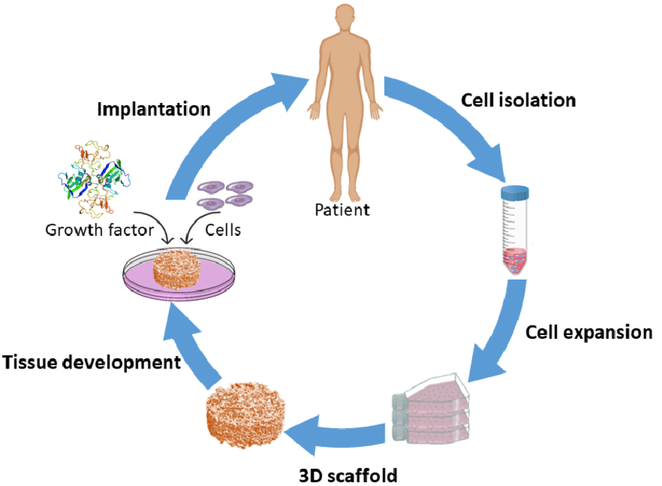
(Retrieved from https://www.researchgate.net/figure/Schematic-of-the-scaffold-based-tissue-engineering-approach_fig1_338482022)
2 LISTENING
2.1 Read the questions and answer as many of them as you can. Then watch a video about tissue engineering (https://www.youtube.com/watch?v=7Q3S6q97FiU) to check your answers or to find the answers to these questions:
1 How is tissue engineering also called?
2 What is the ultimate goal of tissue engineering?
3 What are the four important factors tissue engineering relies on?
4 Where can the cells be harvested from?
5 What are the examples of tissue and organs that have been successfully tissue-engineered and implanted into humans?
2.2 Watch a video again. Fill in the gaps with one to three words:
Tissue engineering refers to the attempt to create functional human tissue from 1…………… in a laboratory. Its ultimate goal is to be a cure, not merely treatment – by repairing or replacing tissues and organs that fail due to disease, 2………. …………, congenital abnormalities, or 3 ………… ……….. .
The supporting structures can be derived from donor tissue from natural or synthetic 4 …………. made to order for their strength or endurance.
Biomolecules can be added directly, or coaxed from the cells that take up residence on the 5………… . Sometimes the scaffolds dissolve over time, but others remain to provide support to the organ.
Some examples of tissues and organs that have already been successfully tissue-engineered and implanted in humans include 6 …………. , 7 ……… …………., skin grafts, 8 …………. and even a full 9 ……….. .
2.3 Decide whether the following statements are true (T) or false (F). Justify your answer.
1 The goal of tissue engineering is to treat traumatic injury.
2 Tissue Engineering relies on such factors as the right cells, the right environment, the right biomolecules, physical and mechanical forces.
3 The cells can be directly harvested from the target organ.
4 The supporting structures can be derived from donor tissue solely.
5 The scaffolds may fade away gradually.
3 READING
3.1 You are going to read the text about Tissue Engineering and Regenerative Medicine. Do you think there’s any difference between these two branches of science? If yes, what is it?

Tissue Engineering and Regenerative Medicine
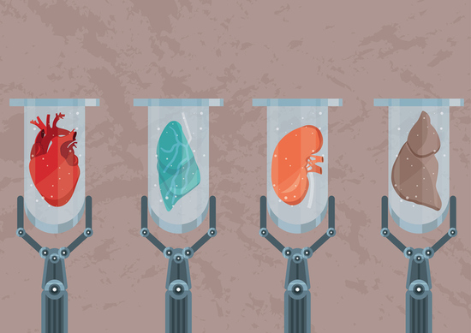
(Retrieved from https://www.regenervate.com/whats-the-difference-between-regenerative-medicine-and-tissue-engineering/)
Regenerative medicine is a broad field that includes tissue engineering but also incorporates research on self-healing – where the body uses its own systems, sometimes with help foreign biological material to recreate cells and rebuild tissues and organs. The terms “tissue engineering” and “regenerative medicine” have become largely interchangeable, as the field hopes to focus on cures instead of treatments for complex, often chronic, diseases.
How do tissue engineering and regenerative medicine work? Cells are the building blocks of tissue, and tissues are the basic unit of function in the body. Generally, groups of cells make and secrete their own support structures, called extra-cellular matrix. This matrix, or scaffold, does more than just support the cells; it also acts as a relay station for various signaling molecules. Thus, cells receive messages from many sources that become available from the local environment. Each signal can start a chain of responses that determine what happens to the cell. By understanding how individual cells respond to signals, interact with their environment, and organize into tissues and organisms, researchers have been able to manipulate these processes to mend damaged tissues or even create new ones.
The process often begins with building a scaffold from a wide set of possible sources, from proteins to plastics. Once scaffolds are created, cells with or without a “cocktail” of growth factors can be introduced. If the environment is right, a tissue develops. In some cases, the cells, scaffolds, and growth factors are all mixed together at once, allowing the tissue to “self-assemble.”
Another method to create new tissue uses an existing scaffold. The cells of a donor organ are stripped and the remaining collagen scaffold is used to grow new tissue. This process has been used to bioengineer heart, liver, lung, and kidney tissue. This approach holds great promise for using scaffolding from human tissue discarded during surgery and combining it with a patient’s own cells to make customized organs that would not be rejected by the immune system.
Currently, tissue engineering plays a relatively small role in patient treatment. Supplemental bladders, small arteries, skin grafts, cartilage, and even a full trachea have been implanted in patients, but the procedures are still experimental and very costly. While more complex organ tissues like heart, lung, and liver tissue have been successfully recreated in the lab, they are a long way from being fully reproducible and ready to implant into a patient. These tissues, however, can be quite useful in research, especially in drug development. Using functioning human tissue to help screen medication candidates could speed up development and provide key tools for facilitating personalized medicine while saving money and reducing the number of animals used for research.
(Retrieved from https://www.nibib.nih.gov/science-education/science-topics/tissue-engineering-and-regenerative-medicine)
3.2 Match the two halves of the sentences.
1 | Tissue engineering | a and tissues are the basic unit of function in the body.
2 | This matrix, or scaffold, does more than just support the cells; | b it also acts as a relay station for various signaling molecules.
3 | Supplemental bladders, small arteries, skin grafts, cartilage, and even a full trachea | c researchers have been able to manipulate these processes to mend damaged tissues or even create new ones.
4 | Cells are the building blocks of tissue, | d refers to the practice of combining scaffolds, cells, and biologically active molecules into functional tissues.
5 | By understanding how individual cells respond to signals, interact with their environment, and organize into tissues and organisms, | e have been implanted in patients, but the procedures are still experimental and very costly.

3.3 Find and correct one factual mistake in each sentence.
1 Artificial skin and heart are examples of engineered tissues that have been approved by the FDA.
2 Groups of cells make and secrete their own support structures, called intracellular matrix.
3 The process often begins with building a scaffold from a limited set of sources, proteins, and plastics.
4 A tissue develops in any environment.
5 Nowadays tissue engineering plays a great role in patients’ treatment.
4 VOCABULARY
4.1 Complete the extract using the correct form of the word in brackets.
Examples of tissues that are candidates for tissue engineering include skin, cartilage, heart, and bone. The 1 (produce)………… of skin substitutes has played an important role in 2 (improve) ………… the success of skin graft surgeries, especially for complex wounds such as burns. Substitute tissues of the renal system, including urinary bladders and urethras, have also been 3 (engineer) ………… and 4 (transplant) ………… successfully, thereby broadening therapeutic opportunities for 5 (complicate) …………. renal disorders. Scaffolds and bioartificial tissues are 6 (be) ………. investigated for their use in the 7 (develop) ………….. of functioning bioartificial limbs; the first such limb to be successfully developed – a rat leg with functioning muscles and veins – was reported in 2015.
4.2 Find words in the text which match these definitions.
1 a framework or structural element that holds cells or tissues together
2 any of a class of nitrogenous organic compounds which have large molecules composed of one or more long chains of amino acids and are an essential part of all living organisms
3 a type of cell that can produce other cells which are able to develop into any kind of cell in the body
4 a strong, flexible substance in your body, especially around your joints and in your nose
5 the part of a body where urine is stored until it leaves the body
6 a substance, such as a vitamin or a hormone, which is required for the stimulation of growth in living cells
(Retrieved from https://www.britannica.com/science/tissue-engineering)
5 GRAMMAR
5.1 Read the text “Tissue Engineering and Regenerative Medicine” again and find 5 examples of passive structures.

Rule: We form the passive with subject + the verb be (in the present, past, or other tenses) + past participle.

Go to Grammar reference p. 127 and learn more about the passive.
5.2 Complete the sentences with present or past passive.
1 The term “tissue engineering” _____ _________ in the late 1980s. (introduce).
2 Mouse embryonic stem cells ____ widely ________ to create genetically modified mice. (use).
3 The dividing cells _____ _________ in the crypts, with the stem cells lying near the base of each crypt. (locate).
4 In 2008 scientists used mesenchymal stem cells to bioengineer a section of the trachea that _____ _________ into a woman whose upper airway had been severely damaged by tuberculosis. (transplant).
5 The opacity may be the result of disease or injury, but, if the clouded cornea ____ _________ and _________ by a corneal transplant, normal vision can result. (remove, replace).
6 The surgery of kidney transplantation is straightforward, and the patient ____ ___ ________ fit by dialysis with an artificial kidney before and after the operation. (can keep).
7 The patient ____ usually ________ drugs that depress immune responses and prevent the graft from being rejected. (give).
8 In the years immediately following the first transplant, numerous heart allografts ___ _________ at medical centres throughout the world. (perform).
9 Transplant rejection ____ generally _________ by cell-mediated responses. (cause).
5.3 Underline the correct alternative.
1 Tissue engineering and regenerative medicine are concerned / are being concerned / was concerned with the replacement or regeneration of cells, tissues, or organs to restore normal biological function.
2 Therapies and technologies are been improved / have been improved / have been improving by scientists and clinicians.
3 To fabricate soft robotic fingers with built-in proprioception sensor 3D printing technology are successfully used / was successfully used / had successfully used in the latest studies.
4 These polymers should to be / had be / can be biodegradable, enabling gradual replacement of the scaffold by the cells seeded in the graft as well as by host cells.
5 Millions of people had treated / have been treated / were been treated with some form of tissue-engineered devices, yet the field is in its infancy.
6 WRITING
Search on the Internet about the benefits and risks in Tissue Engineering and write a summary (100-120 words) of what you learned about it.
7 SPEAKING
7.1 Work in pairs. Discuss ethical considerations of tissue engineering. Present your ideas to the whole class.
7.2 Case Study “Looking toward a Medical Future”. Read the situation below and discuss the questions in italics in a group of 3-4. Share your opinions with the rest of the class.
When Anthony mentions that he is researching regenerative medicine, the man becomes very interested and starts asking a lot of questions. Anthony ends up talking to the man for nearly an hour and explains to him the potential therapies which could be developed from his research.
The man then says that he would want to undergo these experimental therapies even if it meant he would only live a couple more years. Anthony then realizes that this man is in a wheelchair (a divider prevented him from seeing this sooner), and that the man is willing to do anything to regain his ability to walk. Anthony explains that his research is many years away from human testing, but the man says he would sign up for any testing, even if it wasn’t safe.
As a scientist, what are Anthony’s ethical responsibilities when discussing his research? Does a person so desperate for a cure truly understand the consequences associated with experimental treatments? Is it wrong to provide hope for these individuals, especially considering that many therapies are years away from being used in humans?
(Retrieved from https://www.scu.edu/ethics/focus-areas/more/engineering-ethics/engineering-ethics-cases/looking-toward-a-medical-future/)
Check yourself! Read key words of unit 3 and first give definitions of these terms and then translate them into Ukrainian. Use Glossary to help you.

SCAFFOLD (n.) GROWTH FACTOR (n.)
STEM CELL (n.) BLADDER (n.)
SKIN GRAFT (n.) CARTILAGE (n.)
SECRETE (v.) MESENCHYMAL (adj.)
OPACITY (n.) CORNEA (n.)
ALLOGRAFT (n.)

UNIT 4
MEDICAL IMAGING
1 LEAD-IN
In pairs, discuss the following questions:
1 What is medical imaging?
2 What examples of medical imaging do you know?
3 Is there a potential danger from medical imaging devices?
2 LISTENING
2.1 Work in pairs. Predict the correct alternative in sentences 1-6. Then watch a video about how an MRI machine works (https://www.youtube.com/watch?v=nFkBhUYynUw) and check your answers.

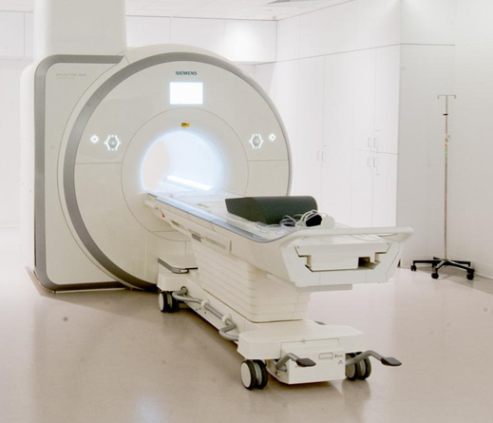
(Retrieved from https://my.clevelandclinic.org/health/diagnostics/4876-magnetic-resonance-imaging-mri)
1 MRI is a medical imaging device commonly used to examine the bones / soft tissues of the human body.
2 Small parts of the hydrogen / oxygen atoms act like tiny magnets and are very sensitive to magnetic fields.
3 The computer / gradient adjusts the magnetic field into smaller sections of different magnetic strengths to isolate specific body parts.
4 Normally the water molecules inside us are arranged randomly / orderly.
5 To create an image of a body part, for example, the brain, the machine focuses on the high-energy / low-energy water molecules.
6 By taking images of the body in each section of the magnetic field the computer produces a final three-dimensional / two-dimensional image of the organ which doctors can analyze to make a diagnosis.
2.2 Fill in the gaps with one to three words.
The key components of an MRI machine are the magnet, 1 ……… ………., gradient, and a computer. The MRI scanner is one of the main 2 ………... ……….. that doctors use to examine inside our bodies. The first step in taking an MRI scan is to use a big magnet to produce a 3 …………. ………… ……….. around the patient. The gradient 4 ……….. the magnetic field into smaller sections of different magnetic strengths to isolate specific body parts. Normally the water 5 ………… inside us is arranged randomly. But when we lie inside the magnetic field most of our water molecules move at the same rhythm or 6 …………. as the magnetic field. The ones that don’t move along the magnetic field are called 7 ………… water molecules.
2.3 Work in pairs. Take turns to describe how an MRI machine works using the words in the box.

magnet radio waves gradient computer water molecules
magnetic field low-energy imaging software three-dimensional image

3 READING
3.1 Match medical imaging techniques with their definitions:
1 | X-rays | a technology that uses radio waves and a magnetic field to provide detailed images of organs and tissues
2 | Computed Tomography | b use ionizing radiation to produce images of a person’s internal structure by sending beams through the body
3 | Magnetic Resonance Imaging | c area of radiology that uses very small amounts of radioactive materials to examine organ function and structure
4 | Ultrasound | d an imaging technique that combines multiple X-ray images taken from different angles
5 | Nuclear medicine | e uses high-frequency sound waves to create images of the inside of the body
Radiography (X-rays)
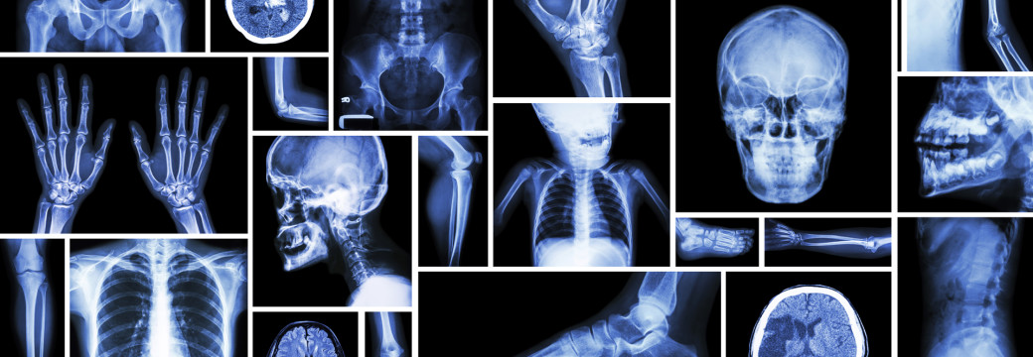
( Retrieved from http://toradiology.com/tor/service/x-ray-radiography/)

X-ray radiation 2 ______________________; conventional X-ray imaging, angiography and fluoroscopy.
Computed tomography (CT)
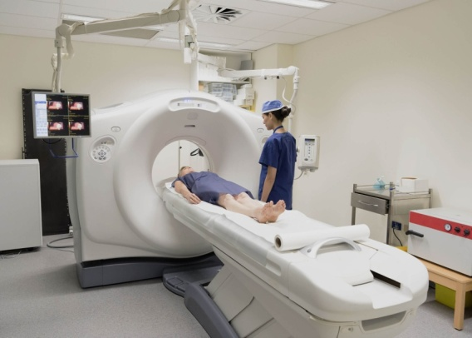

(Retrieved from https://www.qldxray.com.au/services/computerised-tommography-ct/general-ct/)

Magnetic Resonance Imaging (MRI)
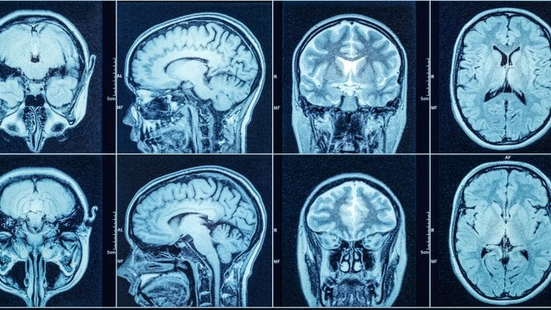
(Retrieved from https://medicai.io/mri-scan-magnetic-resonance-imaging/)
Ultrasound
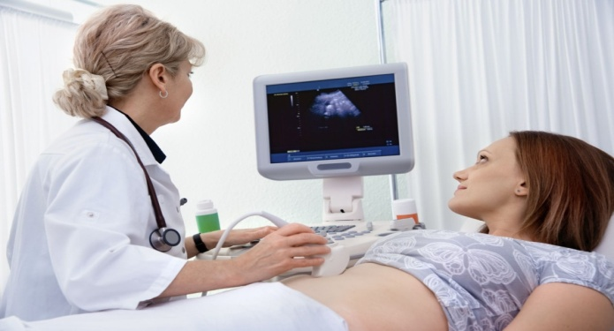
(Retrieved from https://us.edm-imaging.com/2017/09/04/five-tips-safe-ultrasound-exam/)
Ultrasound has different applications, it can be used for therapy and muscle stimulation or as a diagnostic tool in medical imaging using an ultrasonographer. Diagnostic ultrasound, also known as medical sonography or ultrasonography, uses high frequency sound waves to create images of the inside of the body. The ultrasound machine sends sound waves into the body and 5 _______________________. Ultrasound technology can also produce audible sounds of blood flow, allowing medical professionals to use both sounds and visuals to assess a patient’s health.The function of ultrasound is to evaluate: pregnancy, abnormalities in the heart and blood vessels, organs in the pelvis and abdomen, symptoms of pain, swelling and infection.
Nuclear medicine
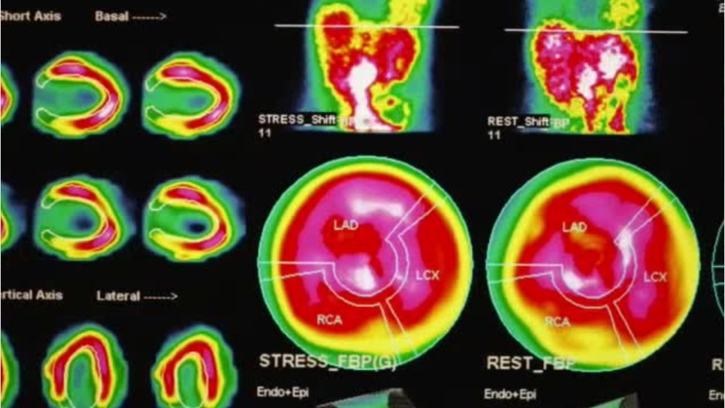
(Retrieved from https://www.mynextmove.org/profile/summary/29-2033.00)
(Retrieved from https://www.fda.gov/radiation-emitting-products/radiation-emitting-products-and-procedures/medical-imaging; https://www.cocir.org/our-industry/medical-imaging.html)
3.2 Choose from (A-F) the one which best fits each space (1-6).
A by showing the difference between normal and diseased tissues
B gives different information about the area of the body being studied or treated
C molecular imaging can be combined with CT or MRI images
D can generate three kinds of medical images
E is able to convert the returning sound, echoes into a picture
F provide greater information than regular X-rays
3.3 Define the sentences as True (T) or False (F).
1 Computed Tomography is the oldest and most commonly used medical imaging technique.
2 There are several types of radiography.
3 The type of radiation in the MRI technique generates images of bones and cartilages.
4 Medical sonography uses high-frequency sound waves to create images of the inside of the body.
5 PET is often used to evaluate pregnancy.
6 PET and SPECT are specific technologies within nuclear medicine.
7 CT is used for detecting Alzheimer’s disease and Multiple Sclerosis.
4 VOCABULARY
4.1 Fill in the correct word(s) from the list below. Use the word(s) only once. Find Ukrainian equivalents to the following English sentences.
angiographies, organs in the pelvis and abdomen, ionizing radiation,magnetic field, neurological diseases, certain particles

English equivalent | Ukrainian equivalent
X-rays use …………. to produce images of a person’s internal structure by sending beams through the body.
Contrast agents are commonly used in combination with CT scans to perform …………. and other specific tissue examinations.
MRI is a technology that uses radio waves and a ………. to provide detailed images of organs and tissues.

The function of ultrasound is to evaluate: pregnancy, abnormalities in the heart and blood vessels, ……………. , symptoms of pain, swelling and infection.
PET and SPECT generate images that reveal the metabolism of the body, or the behaviour of …………, but cannot generate images of the anatomical structures.
PET and SPECT are often used as diagnostic and follow up images for …………. such as Alzheimer’s and Multiple Sclerosis, cancer, heart disease.

4.2 Match the words with similar meaning and translate them.

injury | bump
lungs | matter
abdomen | pulmones
swelling | damage
chest | belly
substance | breast

5 GRAMMAR
Describing the function of an item
We can describe the function of an item in a number of ways. Study these examples.

Using the Present simple
Conventional X-ray imaging generates an image of a localised part of the body, which will be analysed for anatomical abnormalities.
Used to-infinitive, Used for+-ing form
CT scans are often used to evaluate: organs in pelvis, chest and abdomen, colon health, presence of tumours, pulmonary embolism, abdominal aortic aneurysms, spinal injuries, cardiology.
MRI is often used for evaluating: blood vessels, breasts, major organs.
Emphasizing the function
The function of Ultrasound is to evaluate: pregnancy, abnormalities in the heart and blood vessels, organs in the pelvis and abdomen, symptoms of pain, swelling and infection.

5.1 Match each item in Column A with its function in Column B. Then describe its functions in two ways.
contrast agent | produce a final three-dimensional image of the organ which doctors can analyze to make a diagnosis
X-ray tube | detect photons (subatomic particles) emitted by a radionuclide in the organ or tissue being examined
PET scanner | encode the signal spatially
computer | receive electrical energy and convert it into two forms: x-radiation and heat
magnetic field gradient | magnify very small details with high resolving power due to the use of electrons as the source of illumination
electron microscopy | improve pictures of the inside of the body produced by x-rays, computed tomography, magnetic resonance imaging, and ultrasound

5.2 Find on the Internet applications of other medical imaging techniques given below. Finish the sentences.
1 Elastography is used to ………………… .
2 Photoacoustic imagingis used ………………….. .
3 Echocardiography is used ………………………. .
4 Functional near-infrared spectroscopy is used …………………….. .
5 Magnetic particle imaging is used ………………………………… .
6 Endoscopy is used…………………………… .
7 Tactile imaging is used ………………………….. .
8 Thermography is used to …………………………….. .
6 WRITING
6.1 Study the information about an ultrasound machine that makes images of internal parts of the body. Use it to complete the short description below.
Main components | Function
transducer probe | generates, transmits, and receives high-frequency sound waves
piezoelectric crystals | produce sound waves when current is applied across them
Computer
CPU (Central Processing Unit) | processes the data from the transducer to produce an image
the hard disk storage device | stores the image along with patient details and other information
LCD monitor | displays the image
keyboard | allows the operator to key in patient details and other information
printer | prints the image

An ultrasound machine is used to 1 _______________ . It consists of a transducer probe, computer, LCD, monitor, keyboard, and 2 ________ _________ . The probe contains 3 _________ _________ which 4 _________ _________ . The computer includes the CPU which 5 ________ ________ . This is displayed on 6 __________ . It also contains a hard disk which 7 _________. This information is keyed in by the 8 ____________ . Images can be printed or copied to DVDs.
(Glendinning, 2011)
6.2 Find out about CAT scanners (CT scanners) and write your own description in the same way.
7 SPEAKING
In groups of three discuss the questions:
1 Which medical imaging technique is most dangerous to use repeatedly, and why?
2 Explain why ultrasound imaging is the technique of choice for studying fetal growth and development.
3 What type of radiation does a CT scanner do?
4 What is the function of magnets in MRI?
5 PET relies on radioactive substances administered several minutes before the scan. How is PET used in chemotherapy?
8 TRANSLATION PRACTICE
Translate the following sentences into Ukrainian:
Check yourself! Read key words of unit 4 and first give definitions of these terms (use Glossary to help you) and then translate them into Ukrainian.
GRADIENT (n.) MAGNET (n.)
ULTRASOUND (n.) MRI (Magnetic resonance Imaging) (n.)
CT (Computed Tomography) (n.) NUCLEAR MEDICINE (n.)
ANGIOGRAPHY (n.) PELVIS (n.)
COLON (n.) PROBE (n.)
TRANSDUCER (n.)

SELF-ASSESSMENT (UNITS 3-4)
VOCABULARY AND GRAMMAR
1 Complete the collocations with the words from the box.
sound waves, cavity, imaging technique, factors, system, medical treatment, molecules, agent, medicine, scaffold

1 effectiveness of ________ ________
2 medical ________ ________
3 the oral ________
4 contrast ________
5 high frequency ________ ________
6 biologically active ________
7 regenerative ________
8 to build a ________
9 growth ________
10 immune ________
(2 points for each correct answer / 20 points)
2 Complete the sentences with present or past passive.
1 Tissues from all sorts of organs ___ _______ by researchers. (create)
2 Blood movement ___ ________ by J. Singer in 1959. (introduce)
3 Scaffolds ___ ________ from biocompatible, biodegradable polymers. (make)
4 The sound science ___ _______ by Pythagoras in 600 BC. (present)
5 Some tissue types ___ _______ in the lab prior to implantation. (grow)
6 Adult stem cells ___ _______ from several types of cells, including blood, bone, muscle, skin, brain and liver cells. (derive)
7 CT scan ___ ________ in the 1970s. (develop)
(2 points for each correct answer / 14 points)

3 Read the sentences and find one grammatical mistake in each of them. Correct mistakes.
(2 points for each correct answer / 10 points)
4 Read the text and define the sentences as True (T) or False (F).
1 A pacemaker is implanted under a patient’s skin to help manage irregular heartbeats.
2 Modern pacemakers consist of three parts.
3 Bivent is a pacemaker for people with severe heart failure.
4 A pacemaker also regulates your body’s digestive system and controls the stomach and small intestine.
5 All pacemakers can be bought and implanted once in a life.
(2 points for each correct answer / 10 points)
What is a pacemaker?
A pacemaker is an electrically charged medical device. Your surgeon implants it under your skin to help manage irregular heartbeats called arrhythmias.

(Retrieved from https://www.healthline.com/health/heart-pacemaker)
5 Give short answers to these questions:
1 How are two parts of a pacemaker called?
2 How are arrhythmias where a heartbeat is too fast called?
3 How are arrhythmias where a heartbeat is too slow called?
4 What does CRT stand for?
5 What negative consequences can a bad heartbeat cause?
( 2 points for each correct answer / 10 points)
6 Translate the following paragraph which consists of 8 sentences into Ukrainian.
(Retrieved from https://www.healthline.com/health/heart-pacemaker#procedure)
(2 points for each correct answer / 16 points)

7 Write a short description (80-100 words) of one of the medical imaging techniques (X-rays, computed tomography, MRI, ultrasound, etc.).
(20 points)
Total: 100 _________

UNIT 5
NANOTECHNOLOGY IN BIOMEDICAL ENGINEERING
1 LEAD–IN
1.1 Answer the following questions.
1 What technology do biomedical engineers use?
2 How is nanotechnology used in biotechnology?
3 What does a nanotechnology engineer do?
4 Does nanotechnology have a future?
5 What are the benefits of nanotechnology?
1.2 Match terms with their definitions.
1 NANOTECHNOLOGY | a is a small localized object to which can be ascribed several physical or chemical properties such as volume, density, or mass
2 PARTICLE | b is one-billionth of a meter or 1/1000 of a micrometer
3 NANOMETER | c is the use of matter on an atomic, molecular, and supramolecular scale for industrial purposes

1.3 Complete the text with the words from the box. Give the title of it.

detect durable fabrics
reactions food metals
resistance industrial

(Retrieved from https://www.iberdrola.com/innovation/nanotechnology-applications)
2 LISTENING
2.1 Insert the following words in the sentences. Translate them into Ukrainian.
information fluids
upside technology
detects molecular

1 A sheet of paper is about 100,000 nanometres thick and it's basically atomic and _____ level.
2 Nanotechnology comprises Science Engineering and _____ conducted at the nanoscale.
3 Robots that literally swim through your bloody _____ and could be used to deliver drugs in Hydra way.
4 As the technology will get more advanced it has the possible possibility to turn healthcare _____ down.
5 Devices could be programmed into gathering _____ about certain body parts.
6 The nanorobot will send others their smartphone about the changes it _____ in the body.
2.2 Listen to the lecture (3:40) about 4 ways how nanotechnology will change Our Lives. Say if these statements true (T) or false (F). Explain your answers (https://www.youtube.com/watch?v=dn2UjBIsrcI ).
1 British sculptor Millard Vegan created microscope chairs on needles.
2 A nanometre is a hundred times smaller than the length of an end of the needle.
3 The speaker liked French animation where creators imagined the human body as construction where soldiers floated through the human.
4 There were bad and good heroes in the Animation.
5 Specific microboots are designed to swim through non-Newtonian fluids like the bloodstream around your lymphatic system.
6 With the help of Nanotechnology we can collect medical data with ordinary diagnostic devices throughout our bodies.
7 Programmable nanoparticles could deliver insulin to initiate cell growth and regenerate tissue at a target location.
8 Programmable nanoparticles that attack cancer cells can do harm to regular cells.
2.3 Listen to the second part (from 3:40) of the video and complete the sentences with one word. Give the title of this extract.
Nanotechnology has made it possible for researchers to collect in depth data on the human _____ . By using nanoscale diamond particles the brains activities are converted into frequencies of _____ that can be registered by external sensors allowing _____ to study the brain in much greater detail. With a microscopic size of just a billionth of a millimetre, nanoparticles are able to cross the blood-brain barrier and access the brain's _____ areas. They have also shown tremendous potential in being a useful alternative to diagnosing and treating _____ diseases.
3 READING
3.1 Look through the paragraphs and choose suitable titles (A-F) for them out of the given ones. Two of them are extra titles.
A NANOTECHNOLOGY AND SAVING ENERGY
B EXAMPLES AND APPLICATIONS OF NANOTECHNOLOGY
C APPLICATIONS AND POSSIBILITIES OF NANOTECHNOLOGY
D NANOTECHNOLOGY AND ITS HISTORY
E INVESTMENTS IN THE UNITED STATE
F NANOTECHNOLOGY IN THE FUTURE
NANOTECHNOLOGY
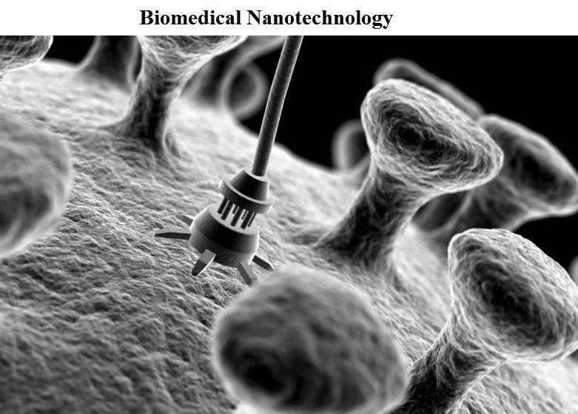
(Retrieved from https://menafn.com/1100149094/Biomedical-Nanotechnology-Report-on-Global-and-United-States-Market-Status-and-Forecast-by-Players-Types-and-Applications)
3 Nanotechnology and nanomaterials can be applied in all kinds of industrial sectors. They are usually found in these areas:
Some nanoparticles have also been used to enhance pharmaceutical products such as sunscreen.
(Retrieved from https://www.iberdrola.com/innovation/nanotechnology-applications)

3.2 Answer the following questions:
1 Can you name the well-known applications of nanotechnology?
2 When did nanotechnology start to develop?
3 Why does the technological branch manipulate the molecular structure of materials?
4 What main properties of graphene do you know?
5 Who and when was the first to speak about the applications of nanotechnology?
6 Why is graphene ideal for flexible touchscreens?
7 Where can some nanomaterials be used in medicine?
8 Can we speak only about advantages of the nanotechnology?
3.3 Complete the following sentences with the ideas from the text:
1 Carbon nanotubes are close to replacing silicon as a material for _____ .
2 _____ of nanotechnology and concerns related to its commercialisation could hamper market expansion.
3 Nanotechnology includes areas such as _____ .
4 These are many applications of nanotechnology, a discipline _____ .
5 Nanomaterials are able to attack cancer cells selectively without _____ .
6 Nanotechnology is expected to grow globally, driven by technological advances, increased government support, _____ .
4 VOCABULARY
4.1 Find English equivalents to the following Ukrainian word expressions from the text.
невидимі частинки
боротися з раковими клітинами
гігантські можливості
модифікований вуглець
наночастки
поліпшити ранню діагностику
атакувати вибірково
збільшити державну підтримку

4.2 Find synonyms from the text to the words in the table and translate them into Ukrainian. Make up 5 sentences with them.

English phrase or word | Synonym from the text | Sentence
make better
medical care
affliction
restrictively
improve
become larger, evolve
give a help

4.3 Fill in the correct word(s) from the list below. Use the word(s) only once. Translate these sentences into Ukrainian.

silicon marketed double
organic fuel steel transparent

1 The graphene is modified carbon harder than _____, lighter than aluminium, and almost _____.
2 With the 21st century, nanotechnology consolidated and was _____.
3 Nanotechnology includes areas such as micro-manufacturing, _____ chemistry, and molecular biology.
4 Carbon nanotubes are close to replacing _____ as a material for making smaller, faster, and more efficient microchips.
5 A new semiconductor makes it possible to manufacture solar panels that _____ the amount of sunlight converted into electricity.
6 Nanotechnology also lowers costs, produces stronger and lighter wind turbines, improves _____ efficiency.
5 GRAMMAR
Conditionals
Conditionals are clauses introduced with If. The main types of conditionals are Type 0, Type 1, Type 2, and Type 3.
Conditional clauses consist of two parts: the if-clause (hypothesis) and the main clause (result). When the if-clause comes before the main clause, the two clauses are separated with a comma. When the main clause comes before the if-clause, then no comma is necessary.

Go to Grammar reference p. 129 and learn more about conditionals.
5.1 Put the verbs in brackets into the correct tense.
1 She would have come to the conference about the future of nanotechnology if we ...had invited... (invite) her.
2 If scientists _______(not develop) a new semiconductor, it wouldn’t have been possible to manufacture solar panels that double the amount of sunlight.
3 Were I you, I _______ (think) about health and safety risks of nanotechnology.
4 Joan _______ (not be able to) prepare a presentation about the properties of some nanomaterials if she doesn’t work hard.
5 Had I heard the news about new nanomaterials, I _______ (tell) you immediately.
6 Nanotechnology_______ (produce) stronger and lighter wind turbines, if the government decides to use it.
7 Nanomaterials _______ (be able to) attack cancer cells selectively without harming other healthy cells if the laboratory has proper devices.
8 She would have stayed at home if she ...................... (know) that lecture about micro-manufacturing, organic chemistry, and molecular biology would be so boring.
5.2 Choose the correct word or expression.
1 The team will demonstrate how nanobots delivered molecules that trigger cell suicide in leukemia and lymphoma cells on the condition that / unless they have free time.
2 Even if / But for his help, a new semiconductor wouldn’t have been invented.
3 Unless / Provided they get government support, they won't be able to work on nanoparticles that can synthesize potential cancer drugs.
4 Try to be here tomorrow, and / otherwise we miss the chance to work on nanoparticles.
5 Supposing / Providing we went to London, can we speak to researchers of a molecular payload?
6 In case of / On condition that more than 18 billion dollars are invested, this sector will turn into a driver of economic growth and competitiveness.
7 You will be successful in the case of / as long as you use graphene as modified carbon because it is harder than steel.
6 WRITING
6.1 Write a summary of the text “NANOTECHNOLOGY” in 100 words. Use Appendix 2 p. 150.
6.2 You recently attended a lecture about the innovative applications of nanotechnology. Write a letter in 120-150 words to tell your penfriend about it. Use a picture below and include the following:
• who you went with
• what event you went to
• why you chose this event
• what you liked about it
• what you didn't like about it
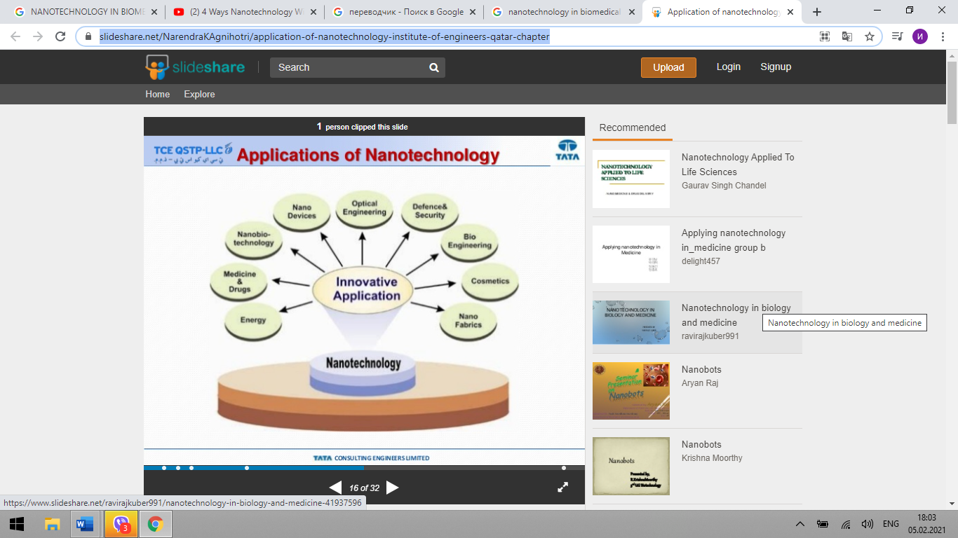
(Retrieved from https://www.slideshare.net/NarendraKAgnihotri/application-of-nanotechnology-institute-of-engineers-qatar-chapter)

7 SPEAKING
7.1 Complete the table and prepare to speak about the advantages and disadvantages of nanotechnology. Use a picture, information from the internet, and phrases to exchange your ideas with your partner.
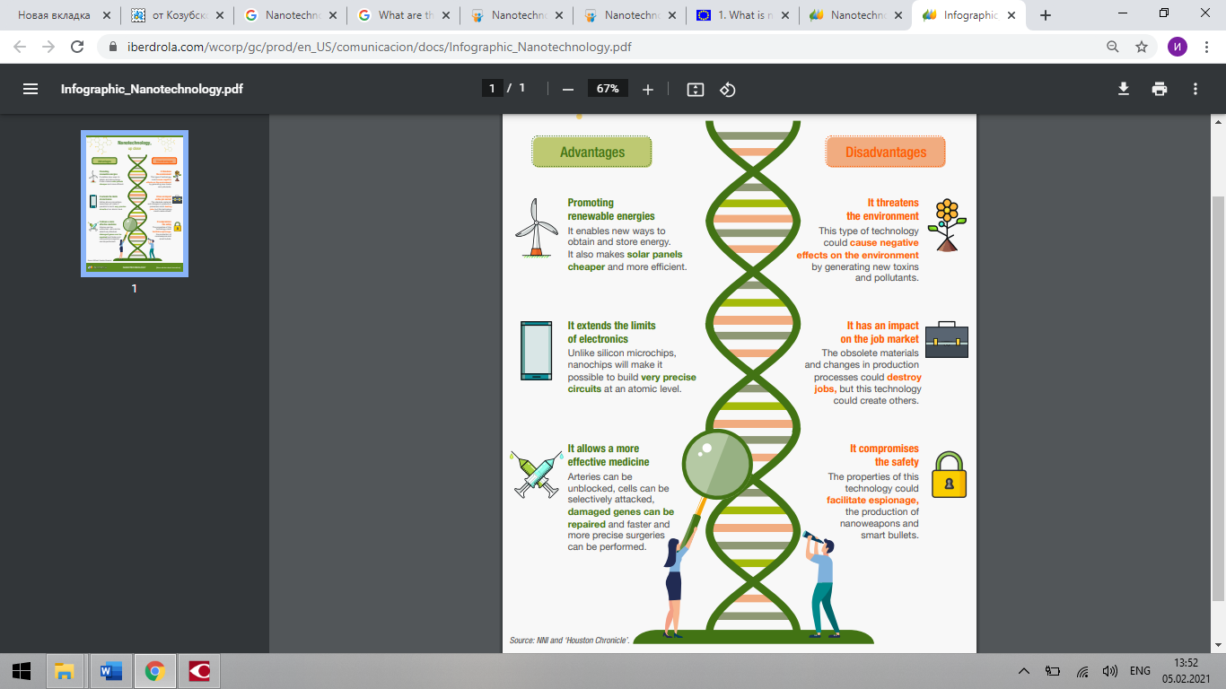
(Retrieved from https://www.iberdrola.com/wcorp/gc/prod/en_US/comunicacion/docs/Infographic_Nanotechnology.pdf)

Nanotechnology is beneficial to society because…. | Nanotechnology is harmful to society because…
Using nanotechnology, materials can effectively be made stronger, lighter, more durable, more reactive… | Nanoparticles can be used for drug delivery purposes, either as the drug itself or as the drug carrier. The product can be administered orally, applied onto the skin, or injected.

7.2 You are a participant in the conference that promotes scientific contacts and discussions between scientists of different scientific fields from around the world. Make a dialogue. Work in pairs.
Student A: You are a scientist in the sphere of nanotechnology and your direction is NANO-ELECTRONICS.
Student B: You are a scientist in the sphere of nanotechnology and your direction is BIOMEDICINE.
Ask each other about:
- the latest nanotechnology research which is the most important
- the period which is spent on the research and implementation
- nanotechnological developments that have already entered the daily life of people
7.3 Describe the picture where you can see the application of nanotechnology in medical engineering.
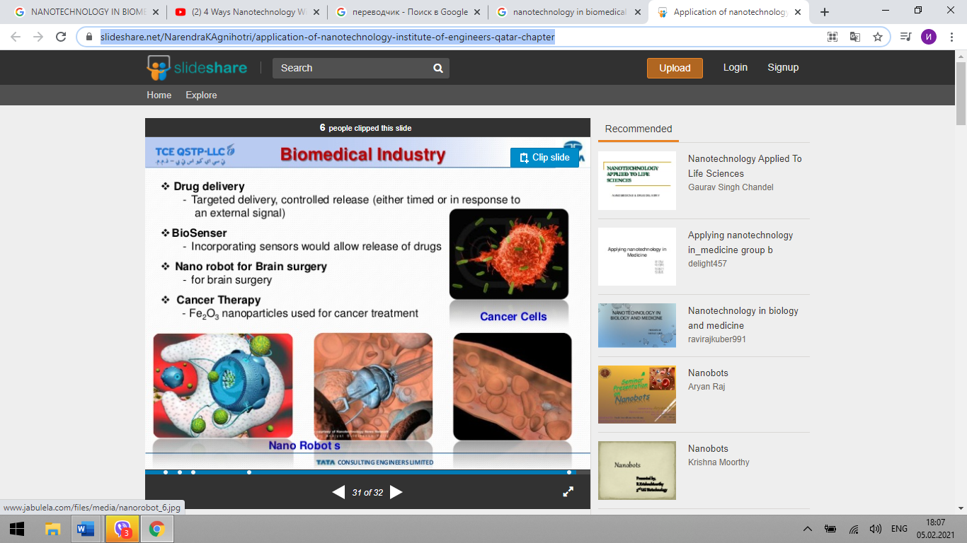 | Biomedical industry  diagnosis  drug delivery systems  biomedical devices  nanomaterials  nanoparticles  transport properties
(Retrieved from https://www.slideshare.net/NarendraKAgnihotri/application-of-nanotechnology-institute-of-engineers-qatar-chapter)

Check yourself! Read key words of unit 5 and first give definitions of these terms (use Glossary to help you) and then translate them into Ukrainian.

INTRINSIC (adj.)
NANOPARTICLE (n.)
NANOTECHNOLOGY (n.)
SEMICONDUCTOR (n.)
NEURODEGENERATIVE (adj.)
HAMPER (v.)

UNIT 6
REHABILITATION ENGINEERING
1 LEAD-IN
1.1 Look at the pictures and discuss the following questions:
1 What is rehabilitation engineering?
2 What is assistive technology? Give examples of assistive technologies.
3 What is the role of a rehabilitation engineer?

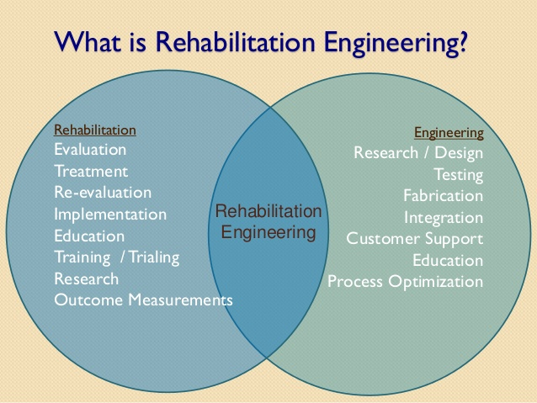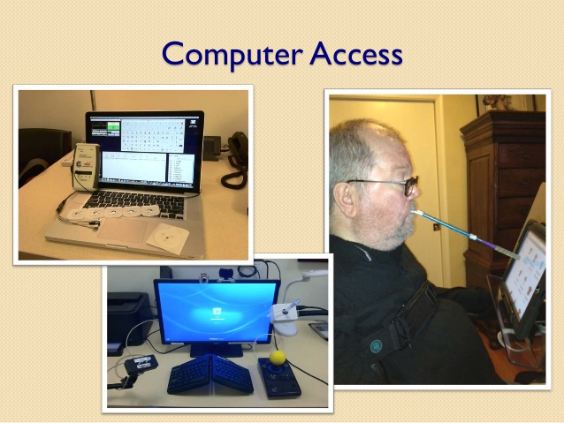
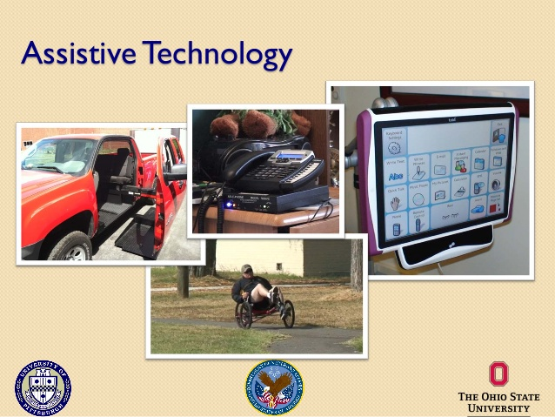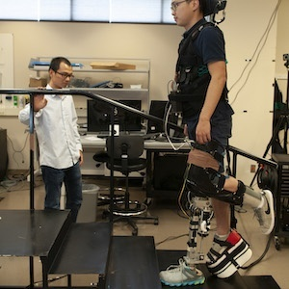
(Retrieved from https://www.slideshare.net/BenSalatin/rehabilitation-engineering-in-clinical-practice-ground-rounds2015-48726613 and https://bme.unc.edu/research-lab/neuromuscular-rehabilitation-engineering-lab/)

2 LISTENING
2.1 Discuss in pairs what robotic technologies are used in rehabilitation engineering now and what is the future of rehabilitation with robotic technologies.
2.2 Watch the video “Changing the future of rehabilitation with robotic technologies” and define the sentences as True (T) or False (F).
2.3 Listen again and fill in the gaps.
This lightweight prototype uses a small motor to control hip, knee, and ankle joints 1 ………….. . It looks like something out of a Hollywood movie, but it’s actually simple to use. First, the leg is secured, then the robot simulates walking reintroducing a range of motion to 2 ………….. leg strength and function. This robotic exoskeleton helps mobilise a patient’s 3 ………… …………. after surgery, speeding up recovery time. Constructed on a 3D printer, it fits on to the patient’s injured hand, using a 4 ………….. . A customised recovery program is delivered extending the injured tendons and improving the range of 5 …………. .
3 READING
3.1 Discuss. How has rehabilitation technology changed the world? Has it made it a better place? Why?
3.2 Look at the words in the box. Which of them are related to rehabilitation engineering? How?
assistive devices inhaler
obstetrics to regain functions
prosthetics to restore mobility
impairment 3D printing
cochlear implant artificial limbs
scaffold cells
wheelchair MRI

3.3 Read the text and match the halves of the sentences:

1 Rehabilitation engineers design and build devices and systems ……… | a from impaired movement, such as following a stroke.
2 Sophisticated brain computer interfaces allow a severely disabled individual ……….. | b to treat organ function in the case of a spinal cord injury.
3 Smart rehabilitation robotics aid mobility training in individuals suffering ……….. | c to operate computers and other devices simply by thinking about the task they want to perform.
4 This is an area where researchers continue to make advances in design and function …………. | d to meet a wide range of needs that can assist individuals with mobility, communication, hearing, vision and cognition.
5 Recent developments in neuromodulation of the peripheral nervous system offer the promise ………. | e to better mimic natural limb movement and user intent.

What is rehabilitation engineering?

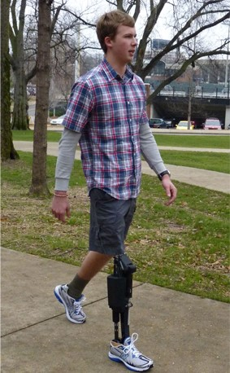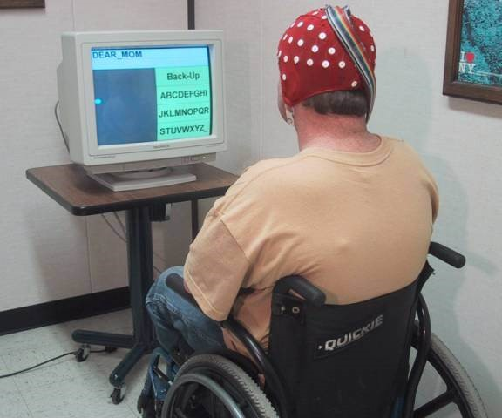

Rehabilitation Engineering is the use of engineering principles to 1) develop technological solutions and devices to assist individuals with disabilities and 2) aid the recovery of physical and cognitive functions lost because of disease or injury.
Rehabilitation engineers design and build devices and systems to meet a wide range of needs that can assist individuals with mobility, communication, hearing, vision and cognition. These tools help people with day-to-day activities related to employment, independent living and education.
Rehabilitation engineering may involve relatively simple observations of how individuals perform tasks, and make accommodations to eliminate further injuries and discomfort. On the other end of the spectrum, rehabilitation engineering includes sophisticated brain computer interfaces that allow a severely disabled individual to operate computers and other devices simply by thinking about the task they want to perform.
Rehabilitation engineers also improve upon standard rehabilitation methods to regain functions lost due to congenital disorders, disease (such as stroke or joint replacement) or injury (such as limb loss) to restore mobility.
Ongoing research in rehabilitation engineering involves the design and development of innovative technologies and techniques that can help people regain physical or cognitive functions. For example:
- Rehabilitation robotics, to use robots as therapy aids instead of solely as assistive devices. Smart rehabilitation robotics aid mobility training in individuals suffering from impaired movement, such as following a stroke.
- Virtual rehabilitation, which uses virtual reality simulation exercises for physical and cognitive rehabilitation. These tools are entertaining, motivate patients to exercise, and provide objective measures such as range of motion. The exercises can be performed at home by a patient and monitored by a therapist over the Internet (known as tele-rehabilitation), which offers convenience as well as reduced costs.
- Physical prosthetics, such as smarter artificial legs with powered ankles, exoskeletons, dextrous upper limbs and hands. This is an area where researchers continue to make advances in design and function to better mimic natural limb movement and user intent.
- Advanced kinematics, to analyze human motion, muscle electrophysiology and brain activity to more accurately monitor human functions and prevent secondary injuries.
- Sensory prosthetics, such as retinal and cochlear implants to restore some lost function to provide navigation and communication, increasing independence and integration into the community.
- Brain computer interfaces, to enable severely impaired individuals to communicate and access information. These technologies use the brain’s electrical impulses to allow individuals to move a computer cursor or a robotic arm that can reach and grab items, or send text messages.
- Modulation of organ function, as interventions for urinary and fecal incontinence and sexual disorders. Recent developments in neuromodulation of the peripheral nervous system offer the promise to treat organ function in the case of a spinal cord injury.
- Secondary disorder treatment, such as pain management.
(Retrieved from https://www.nibib.nih.gov/science-education/science-topics/rehabilitation-engineering)
3.4 Read the text again and choose the correct answer (A-D) to the following questions.
1 What does rehabilitation engineering do?
A design and develop materials that are suitable for use within the human body;
B develops technological solutions and devices to assist individuals with disabilities;
C develops tools and equipment that are used to diagnose and treat diseases;
D find users for medical products in hospitals and other healthcare facilities.
2 What functions can innovative technologies and techniques help people regain?
A physical
B cognitive
C physical and cognitive
D mental
3 What is an area where researchers continue to make advances in design and function to better mimic natural limb movement and user intent?
A virtual rehabilitation
B advanced kinematics
C brain-computer interfaces
D physical prosthetics
4 What are examples of sensory prosthetics?
A retinal and cochlear implants
B artificial legs with powered ankles
C exoskeletons, dextrous upper limbs, and hands
D muscle implants
5 What technologies use the brain’s electrical impulses to allow individuals to move a computer cursor or a robotic arm that can reach and grab items, or send text messages?
A modulation of organ function
B virtual rehabilitation
C brain-computer interfaces
D advanced kinematics
4 VOCABULARY
4.1 Match the words (1-6) with their definitions (a-f). Translate them into Ukrainian.
1 cognition | a the cylindrical bundle of nerve fibres and associated tissue which is enclosed in the spine and connects nearly all parts of the body to the brain, with which it forms the central nervous system
2 congenital | b the inability to prevent urine or faeces coming out
3 stroke | c the mental action or process of acquiring knowledge and understanding through thought, experience, and the senses
4 dextrous | d (of a disease or physical abnormality) present from birth
5 incontinence | e demonstrating neat skill, esp. with the hands
6 spinal cord | f the sudden death of brain cells due to lack of oxygen, caused by blockage of blood flow or rupture of an artery to the brain.
4.2 Fill in the gaps with the derivatives of the words in capitals.
1 …………. (ASSIST) technology enables and promotes inclusion and participation, especially of persons with disability, 2 ………… (AGE) populations, and people with non-communicable diseases. The primary purpose of assistive products is to maintain or improve an individual’s functioning and independence, thereby 3 …………. (PROMOTE) their well-being. They enable people to live 4 ………….. (HEALTH), productive, independent and dignified lives, and to participate in education, the labour market and civic life.
One billion people need assistive products today and more than two billion people around the world are 5 ………….. (EXPECT) to need at least one assistive product by 2030. While anyone may need an assistive product at some time in their life, they are most often 6 ………… (REQUIRE) by adult and children with disability, older people and people with chronic health conditions such as diabetes and dementia.
Examples of assistive products include 7 ……… (HEAR) aids, wheelchairs, spectacles, prostheses and devices that support memory, among many others. While supporting independence and well-being, these products can also help to prevent or reduce the effects of 8 ………….. (SECOND) health conditions, such as lower limb amputation in people with diabetes. They can also reduce the need and impact on 9 …………. (CARE) and mitigate the need for formal health and support services. Moreover, access to appropriate assistive products can have a tremendous impact on community development and economic 10 ………… (GROW).
5 GRAMMAR
Comparisons with adjectives and adverbs
For comparison, adjectives and adverbs have got two forms: the comparative and the superlative. We use the comparative form + than to compare two people, things, etc.
For example: With the advances in speech synthesis, TTS technology is more accurate and lifelike than ever.
Certification is a faster way for current teachers to qualify to teach this growing population.

We use the + superlative form to compare one person, thing, etc. with more than one person, thing, etc. in the same group.
For example, FM systems are the best choice for children with sensorineural hearing loss.

Go to Grammar reference p. 130 to learn more about comparisons with adjectives and adverbs.
5.1 Complete the sentences with an appropriate comparative or superlative form of the adjective and adverb in brackets.
1 Assistive technology may also make your job as a caregiver …………. and ………….. . (easy, enjoyable)
2 ……… devices are often easier to use, less expensive, and easier to repair and maintain than ………… devices are. (simple, complex)
3 Because these agencies do not sell equipment, they are a …………. source of information than is contacting manufacturers directly. (trustworthy)
4 Rehabilitation engineering is ………….. recognised overseas, Brown said, particularly in North America. (widely)
5 As these technologies become …………., and as they are connected through wireless communication, more possibilities than we could have ever have imagined will open up to advance the science. (smart)
6 One of the ………….. examples is the impact on lower limb motor functions, leading to walking limitations and participation restrictions in daily life activities. (common)
7 Cardiovascular disease are the ………… killer amongst diseases globally. (big)
5.2 Choose the correct answer.
1 The most / more important method used to restore the diminished functions and increase joint mobility is physical therapy, which includes active and passive movements.
2 These devices induce quicker recovery and are effectivest / more effective at restoring proper biomechanics and improving muscle function.
3 Probably the uniquest / most unique advantage of these devices arises from their versatility.
4 Wearable sensors combined with the software allow the patient to perform exercises in a motivated and with correct form, ensuring a more effective and fastest / faster recovery.
5 North America was the larger / largest market for rehabilitation products with a share of 34.2% in 2016 and is expected to continue its dominance during the forecast period.
6 WRITING
6.1 Read a paragraph below. Look at the bar chart which shows how demand for assistive products has boosted and is going to grow. Write a short description (80-100 words) of the information in the chart by selecting and reporting the main features. Make comparisons where possible. Use predictions for the missed information. See Top Tips for Writing below.

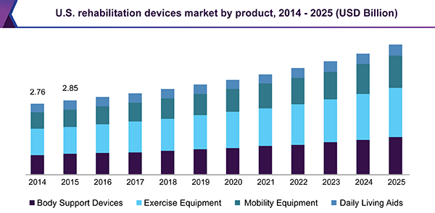
(Retrieved from https://www.grandviewresearch.com/industry-analysis/rehabilitation-products-market)

Top Tips for Writing
1. The first paragraph is short. It should simply say what the chart shows and where and when it describes.
2. Avoid repeating words. Instead, use other words with the same or similar meanings.
3. Describe the trends you can see. Use numbers from the chart.
4. To sum up, highlight the most important things the information shows. You can also say what is likely to happen in the future.
5. Don’t try to explain the chart. In this type of exam question, you just have to describe what happened, not say why it happened.
(Retrieved from https://learnenglishteens.britishcouncil.org/skills/writing/intermediate-b1-writing/describing-bar-chart)
6.2 Write the abstract to the text “What is biomedical engineering?” (5 sentences / 50 words). Use Appendix 2, p. 156.
7 SPEAKING
7.1 You are going to give a lecture on Rehabilitation Engineering. Prepare for the presentation. Use Appendix 3, p. 152.
7.2 Role-play an interview between a rehabilitation engineer and a journalist who wants to write an article for a biomedical engineering magazine. Discuss the following issues.
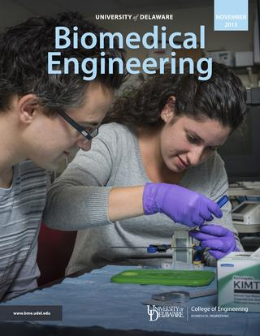
(Retrieved from https://issuu.com/udengineering/stacks/0ca42fe8d6bf41cdaf7d8ae60976e1c7)

- The state of rehabilitation engineering.
- The challenges a rehabilitation engineer face today.
- Innovative technologies and techniques can help people regain physical and cognitive functions.
- Assistive technologies are in great demand now.
- The future of rehabilitation engineering.
Check yourself! Read key words of unit 6 and first give definitions of these terms (use Glossary to help you) and then translate them into Ukrainian.

COGNITION (n.)
CONGENITAL (adj.)
STROKE (n.)
DEXTROUS (adj.)
INCONTINENCE (n.)
SPINAL CORD (n.)
TENDON (n.)
REGAIN (v.)

SELF-ASSESSMENT (UNITS 5-6)
VOCABULARY AND GRAMMAR
1 Complete the collocations with the words from the box.
implants, with disabilities, biology, nervous system, computer interfaces, market expansion, nanotubes, chemistry, limbs

1 individuals ________ ________
2 sophisticated brain ________ ________
3 upper ________
4 retinal and cochlear ________
5 peripheral ________ ________
6 organic ________
7 molecular ________
8 carbon ________
9 neurodegenerative ________
10 to hamper ________ ________
(2 points for each correct answer / 20 points)
2 Choose the correct answer.
1 If rehabilitation engineers design and building new devices, they will assist / would assist individuals with their mobility, communication, hearing, vision, and cognition.
2 If you had had severe hearing loss, you will benefit / would have benefited from a cochlear implant.
3 Even is / But for his participation, a new medical device wouldn’t have been invented.
4 Were I you, I would think / would have thought of ordering new contact lenses.
5 In case of / On condition that this medical company gets 10 billion dollars, special equipment for hospitals will be bought.
6 If you’re dehydrated, your body would slow down / will slow down its calorie-burning process.
7 If they had conducted a clinical trial, they would have known / would knowwhether or not the drug is truly effective.
(2 points for each correct answer / 14 points)
3 Complete the sentences with an appropriate comparative or superlative form of the adjective and adverb in brackets.
1 What is the ________ ________ (substantial) breakthrough in nanotechnology?
2 Exoskeletons are getting ________ (light), ________ (smart), and ________ ________ (useful) in a range of industries, including healthcare.
3 Currently, the ________ ________ (promising) consequence of the application of nanotechnology, with respect to medicine, is of drug delivery.
4 Graphene is super-strong – even ________ (strong) than diamond.
5 Two of the ________ ________ (important) discoveries of the 20th century were the development of lasers and fiber optics.
(2 points for each correct answer / 14 points)
READING
4 Read the text and define the sentences as True (T) or False (F).
1 The practice of drug delivery has changed undramatically in the past few decades but some changes are anticipated in the near future.
2 Many drugs have unacceptable side effects due to the drug interacting with healthy tissues that are not the target of the drug.
3 Drug delivery systems control either the rate at which a drug is released or the location in the body where it is released.
4 An oral drug for seasonal allergies can be the reason of patient’s drowsiness or an upset stomach.
5 A common way to decrease side effects and drug toxicity and maximize a treatment’s impact is administering drugs locally rather than systemically.
(2 points for each correct answer / 10 points)
Drug delivery systems
1 Drug delivery systems are engineered technologies for the targeted delivery and/or controlled release of therapeutic agents.
2 Drugs have long been used to improve health and extend lives. The practice of drug delivery has changed dramatically in the past few decades and even greater changes are anticipated in the near future. Biomedical engineers have contributed substantially to our understanding of the physiological barriers to efficient drug delivery, such as transport in the circulatory system and drug movement through cells and tissues; they have also contributed to the development several new modes of drug delivery that have entered clinical practice.
3 Yet, with all of this progress, many drugs, even those discovered using the most advanced molecular biology strategies, have unacceptable side effects due to the drug interacting with healthy tissues that are not the target of the drug. Side effects limit our ability to design optimal medications for many diseases such as cancer, neurodegenerative diseases, and infectious diseases.
4 Drug delivery systems control the rate at which a drug is released and the location in the body where it is released. Some systems can control both.
5 Clinicians historically have attempted to direct their interventions to areas of the body at risk or affected by a disease. Depending on the medication, the way it is delivered, and how our bodies respond, side effects sometimes occur. These side effects can vary greatly from person to person in type and severity. For example, an oral drug for seasonal allergies may cause unwanted drowsiness or an upset stomach.
6 Administering drugs locally rather than systemically (affecting the whole body) is a common way to decrease side effects and drug toxicity while maximizing a treatment’s impact. A topical (used on the skin) antibacterial ointment for a localized infection or a cortisone injection of a painful joint can avoid some of the systemic side effects of these medications. There are other ways to achieve targeted drug delivery, but some medications can only be given systemically.
(Retrieved from https://www.nibib.nih.gov/science-education/science-topics/drug-delivery-systems-getting-drugs-their-targets-controlled-manner)
5 Find words or phrases in the text that match meanings 1-5.
1 the system that circulates blood and lymph through the body, consisting of the heart, blood vessels, blood, lymph, and the lymphatic vessels and glands (paragraph 2) ________
2 a secondary, typically undesirable effect of a drug or medical treatment (paragraph 3) ________
3 resulting in or characterized by degeneration of the nervous system, esp. the neurons in the brain (paragraph 3) ________
4 a smooth oily substance that is rubbed on the skin for medicinal purposes or as a cosmetic (paragraph 6) ________
5 a hormone used in the treatment of arthritis, allergies, and some skin diseases (paragraph 6) ________
(2 points for each correct answer / 10 points)
TRANSLATION
6 Translate the paragraph which consists of 6 sentences into Ukrainian.
Telehealth is broadly defined as the use of communications technologies to provide health care at a distance. Telehealth often involves remote monitoring of blood pressure, heart rate, and other measurements obtained by a device worn by the patient and electronically sent to medical personnel. Teleconsultations allow a physician in a remote area to receive advice from a specialist at a distant location about special or complex patient conditions. Remote patient monitoring enables patient monitoring outside of clinical settings, such as in the home. Patients use or wear sensors that wirelessly collect and transmit physiological data to health professionals. It can

significantly improve an individual’s quality of life.
(Retrieved from https://www.nibib.nih.gov/science-education/science-topics/telehealth)
(2 points for each correct answer / 12 points)
WRITING
7 Write the abstract (50-80 words) to the text “Drug delivery system”.
(20 points)
Total: 100 _________

UNIT 7
BIOMATERIALS
1 LEAD-IN
Look at the picture and discuss the questions:
1 What are biomaterials?
2 What are biomaterials used for?
3 How important are biomaterials to biomedical engineering?
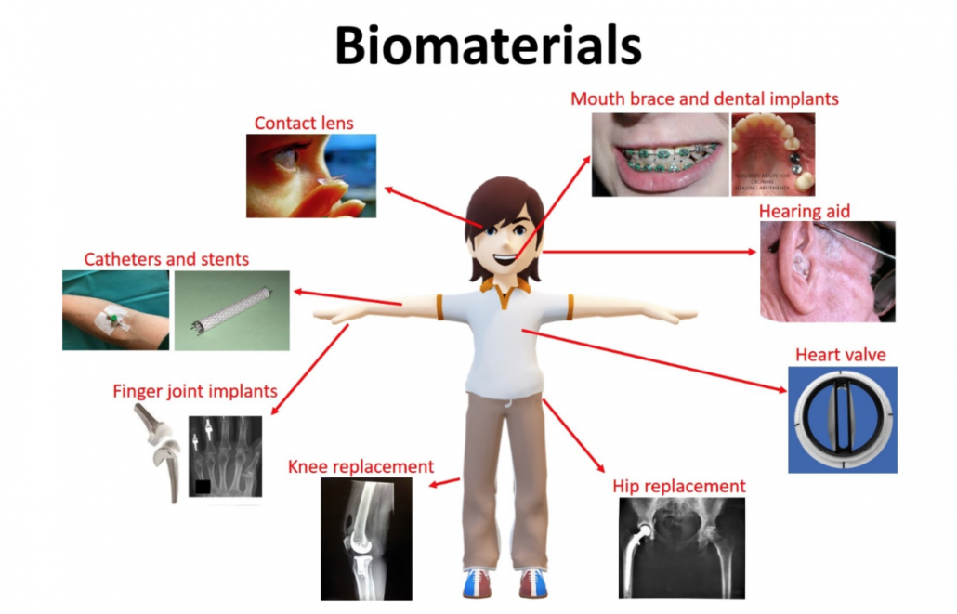
(Retrieved from https://indiveni.re/biomaterials/)

2 LISTENING
2.1 You are going to watch a video where an expert talks about biomaterials for regenerative medicine and therapeutics. Look at his five statements. Guess what the missing words are.
1 Biomaterials are materials that are designed and developed to interact with the __________ .
2 Things like ______ ________ and _______ ________ have been able to get people up on their feet and get them moving around.
3 Except for regenerative medicine biomaterials also can be used in _________.
4 Tiny particles can be injected into the body and they can hunt out cancer cells and kill them without killing those _________ _________ around them.
5 Biomaterials as tine particles can also go as far as going to the brain and helping regenerate neurons and to treat diseases such as __________ or __________disease.
2.2 Watch a video (https://www.youtube.com/watch?v=0n59eLrd09k) and check. Then watch it again and answer the questions.
1 What examples of biomaterials does the speaker mention?
2 Why are biomaterials a key part of regenerative medicine?
3 What is bounce bioglass and what is its function?
4 How can biomaterials be used in therapeutics?
5 What can tiny particles regenerate in the brain?
2.3 Look through the words and their definitions. Make up your own sentences with each of them.
non-invasive – (of medical procedures) not involving the introduction of instruments into the body;
untapped (potential) – not yet exploited or used;
bone marrow – a soft fatty substance in the cavities of bones, in which blood cells are produced;
probe – a blunt-ended surgical instrument used for exploring a wound or part of the body;
cartilage – firm, flexible connective tissue found in various forms in the larynx and respiratory tract, in structures such as the external ear, and the articulating surfaces of joints.

3 READING
3.1 You are going to read the text about biomaterials. Look at the highlighted words, explain what they mean, and translate them. Use Glossary to help you.
BIOMATERIALS
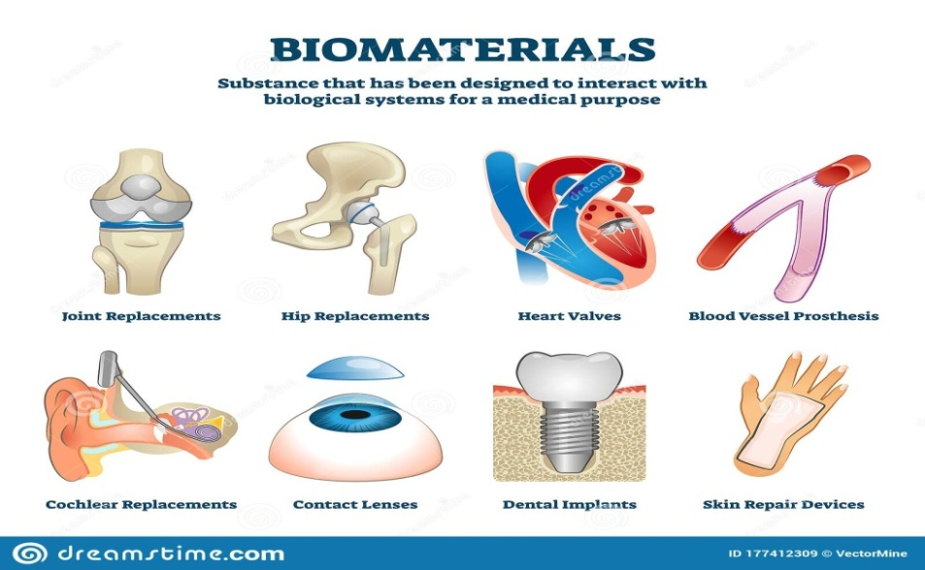
(Retrieved from https://www.dreamstime.com/biomaterials-vector-illustration-labeled-organ-replacement-collection-set-biomaterials-vector-illustration-labeled-organ-image177412309)
Doctors, researchers, and bioengineers use biomaterials for the following broad range of applications: medical implants, including heart valves, stents, and grafts; artificial joints, ligaments, and tendons; hearing loss implants; dental implants; and devices that stimulate nerves; methods to promote healing of human tissues, including sutures, clips, and staples for wound closure, and dissolvable dressings; regenerated human tissues, using a combination of biomaterial supports or scaffolds, cells, and bioactive molecules. Examples include a bone regenerating hydrogel and a lab-grown human bladder; molecular probes and nanoparticles that break through biological barriers and aid in cancer imaging and therapy at the molecular level; biosensors to detect the presence and amount of specific substances and to transmit that data. Examples are blood glucose monitoring devices and brain activity sensors; drug-delivery systems that carry and/or apply drugs to a disease target. Examples include drug-coated vascular stents and implantable chemotherapy wafers for cancer patients.
(Retrieved from https://www.nibib.nih.gov/science-education/science-topics/biomaterials; https://www.biolinscientific.com/blog/what-is-a-biomaterial)
3.2 Define the sentences as True (T) or False (F).
1 Biomaterials are only natural materials that are used in medical applications to support, enhance, or replace damaged tissue or a biological function.
2 The scientific area of biomaterials science as we know it today started around the 60s.
3 Metals, ceramics, plastic, glass, and even living cells and tissue all can be used in creating a biomaterial.
4 Biomaterials are not often biodegradable and bio-absorbable.
5 Heart valves, stents, grafts, artificial joints, ligaments, tendons, hearing loss implants, dental implants are all examples of medical implants.
3.3 Choose the correct answer.
1 How long have attemptes to replace or fix damaged or diseased body parts existed for?
a some decades
b hundreds of years
c thousands of years
d millions of years
2 What dental implants were used in the Mayan era?
a nutshell
b nacre from seashells
c ivory
d tusks
3 What sciences does the field of biomaterials combine?
a medicine, biology, physics, chemistry, tissue engineering, materials science
b medicine, physics, nanotechnology, materials science
c biology, chemistry, physics, materials science, biomechanics
d medicine, chemistry, tissue engineering, biology, cellular engineering
4 For what applications are sutures, clips, and staples used?
a to detect the presence and amount of specific substances
b to aid in cancer imaging and therapy at the molecular level
c to carry drugs to a disease target
d for dissolvable dressings and wound closure
5 How are biomaterials that are eliminated gradually from the body after fulfilling a function called?
a bio-absorbable
b resorbable
c degradable
d biobased
4 VOCABULARY
4.1 Find word(s) in the unit which match these definitions.
1 A stitch or row of stitches holding together the edges of a wound or surgical incision ___________
2 A short band of tough, flexible, fibrous connective tissue that connects two bones or cartilages or holds together a joint ___________
3 A piece of material used to cover and protect a wound _________
4 (Of a substance or object) capable of being decomposed by bacteria or other living organisms __________
5 A tubular support placed temporarily inside a blood vessel, canal, or duct to aid healing or relieve an obstruction ___________

4.2 Write the nouns related to these adjectives from the text above.
1 medical _____________
2 biological ____________
3 futuristic _____________
4 dental _______________
5 stainless-steel ____________
6 dissolvable _______________
7 bioactive ________________
8 vascular ________________

5 GRAMMAR
Questions and Answers
The ability to ask proper questions is closely connected with the ability to receive important information. That’s why making questions is very important in every sphere of human life including professional activities. There are different types of questions in the English language, such as questions with yes/no answers, Wh- questions, subject questions, question tags.

Go to Grammar reference p. 132 to learn more about making questions.
5.1 Find and correct the mistakes in the questions below. Three of the questions are correct.
1 What the ancient Egyptians used as a suture as far back as 2000 B.C.?
2 What a pacemaker consists of?
3 Who did develop these innovative materials?
4 Do some biomaterials make use of living cells for better assimilation into the body?
5 Is immunomodulation be an adjustment of the immune response to the desired level?
6 How long does a biomedical device last?
7 What does allow damaged tissue to regenerate and heal?
8 Can biomaterials be used to control stem cell fate and function?
5.2 Put the words in the correct order to make questions. Answer them.
1 different / biological / biomaterial / from / Is / a / material / ?
2 is / What / bioactivity ?
3 biomaterials / dental / drug / How / used / are / in / delivery / applications / and / surgery / ?
4 common / world / aging / What / in / diseases / the / are / ?
5 biocompatible / materials / Are / technologies / ceramics / inorganic / glass-ceramics / obtained / using / cements / glasses / and / of/ ?
6 WRITING
6. 1 Choose a headline of the latest biomaterials news and write six questions asking information you would like to know about the story. Give your questions to another student.
Biodegradable 3D-Printed Stents for Treating Radiation Esophagitis
Novel Cardiac Patch Could help Treat Myocardial Infarction Effectively
New Biomaterials Eliminate Risk of Infection, Facilitate healing Processes
6.2 Look at the questions and write a short news report (100-150 words). Search on the Internet the information about the news (https://www.azom.com/materials-news.aspx?CatID=13).
Tips for writing a news report
A good news report will give readers all the key information (why? what? how? when? etc.) in a clear and concise way.
What? The specific event that took place.
Who? The people involved.
Where? Places.
When? Date and time.
Why? Reasons for the event taking place.
How? Connecting the facts.
7 SPEAKING
Work in groups and follow instructions 1 - 4 below.
1 Think of one subject in bioengineering each that you know a lot about. Write your topics on a piece of paper.
biomaterials, assistive technology, CT imaging, tissues
2 Exchange papers with another group.
3 Brainstorm questions to ask the other group about their subjects.
How many years ago were the first biomaterials applied?
What assistive technologies are used for people after stroke?
4 Take turns to ask and answer the questions.

Check yourself! Read key words of unit 7 and first give definitions of these terms (use Glossary to help you) and then translate them into Ukrainian.

NACRE (n.) UNTAPPED (adj.)
CATGUT (n.) DISPOSAL (n.)
MOLDED (adj.) SUTURE (n.)
BIODEGRADABLE (adj.) STENT (n.)
LIGAMENT (n.) STAPLE (n.)
BONE MARROW (n.) DRESSING (n.)
WAFER (n.)

UNIT 8
GENETIC ENGINEERING
1 LEAD-IN
Look at the quotes about genetic engineering and discuss them in pairs. Explain the meaning of each quote, agree / disagree with it, justify your opinion.
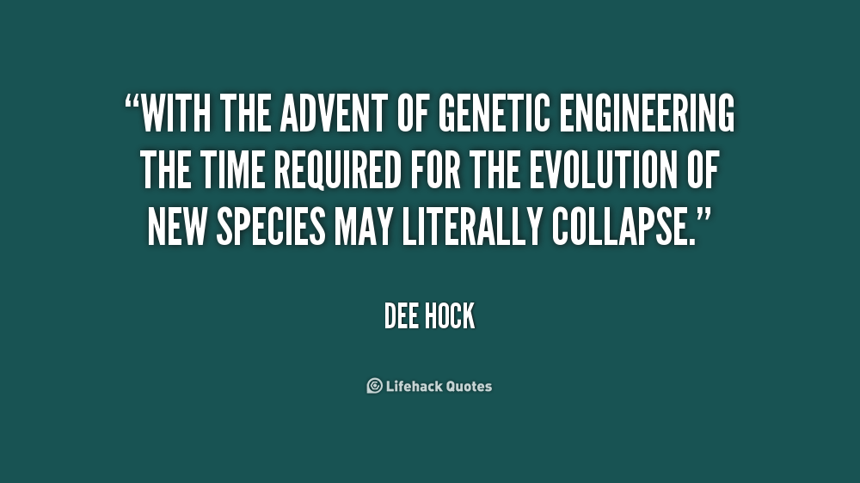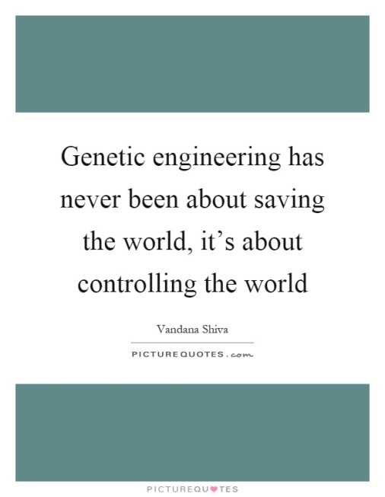

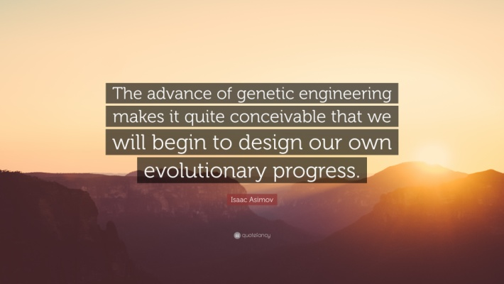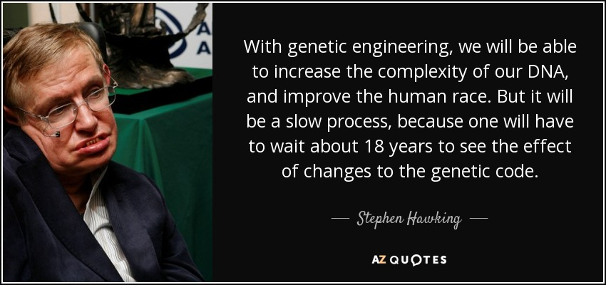
(Retrieved from https://www.azquotes.com/quote/126770; https://www.quotemaster.org/genetic+engineering+in+humans; https://quotefancy.com/quote/832945/Isaac-Asimov-The-advance-of-genetic-engineering-makes-it-quite-conceivable-that-we-will)

2 LISTENING
2.1 Read the questions and discuss them. Then listen to the audio (https://www.genome.gov/genetics-glossary/Genetic-Engineering) and check your answers.
1 When was the term “genetic engineering” first introduced in our language?
2 What did recombinant DNA start with?
3 What does “genetic engineering” mean?
2.2 Listen again and complete the sentences.
Genetic Engineering has evolved to an enormous field where whole 1 ……….. can be 2 ………… and moved from cell to cell, to cell using variations of techniques that all would come under genetic engineering as a very broad definition. To me, genetic engineering, broadly defined, means that you are taking pieces of DNA and 3 …………… them with other pieces of DNA. [This] doesn't really happen in 4 ………….., but is something that you engineer in your own laboratory and 5 …………... . And then taking what you have engineered and propagating that in any number of different organisms that range from bacterial cells to 6 …………. cells, to plants and animals.
2.3 Match the words with their definitions. Use Glossary to help you. Translate the words into Ukrainian.

WORD | DEFINITION | TRANSLATION
1 recombinant | a a thin glass tube closed at one end, used to hold small amounts of material for laboratory testing or experiments
2 genome | b any unicellular fungus that reproduces vegetatively by budding or fission, including forms such as candida that can cause disease
3 test tube | c to breed specimens of (a plant or animal) by natural processes from the parent stock
4 to propagate | d the haploid set of chromosomes in a gamete or microorganism, or in each cell of a multicellular organism
5 yeast | e relating to or denoting an organism, cell, or genetic material formed by recombination

3 READING
3.1 Read statements 1-6 about genetic engineering. Do you think they are true (T) or false (F)? Then read the text and check your answers.
1 Many organisms, from bacteria to plants and animals, have been genetically modified for academic, medical, agricultural, and industrial purposes.
2 Genetic engineering is possible because the genetic code and the structure of DNA are different among all life forms.
3 Scientists can insert a gene from one organism into the genome of another, resulting in a transgenic organism.
4 Molecular biology research often inserts transgenes – foreign genes – into bacteria and viruses to study gene function and expression.
5 Genetic engineering has great potential and there aren’t any concerns about it.
What is genetic engineering?

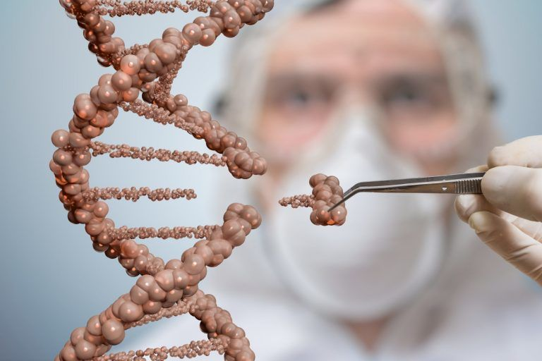
(Retrieved from https://www.biologyonline.com/tutorials/genetic-engineering-advantages-disadvantages )

(Retrieved from https://www.jove.com/science-education/10806/what-is-genetic-engineering)
3.2 Read the questions and choose the correct answer.
1 How is the CRISPR/Cas 9 also called?
A “knockout”
B “molecular scissors”
C “knockin”
D “recombination”

2 What DNA is called recombinant?

A DNA was taken from an animal
B DNA derived from a plant
C DNA has grown in a lab
D DNA combined from different sources

3 How is the organism that receives a gene from another organism called?

A GMO
B SCID
C CRISPR
D HIV
4 What were the first organisms to be genetically engineered?
A viruses
B fungi
C bacteria
D protozoa
5 What technique provides a cure or treatment for some serious and otherwise untreatable genetic diseases?
A holistic therapy
B gene therapy
C neurotherapy
D somatic psychotherapy
6 What are transgenes?
A natural genes
B synthetic genes
C foreign genes
D modifying genes
7 What is a major ethical concern in genetic engineering?
A genetically modified crops
B transgenic goats
C genome editing
D human genome editing

4 VOCABULARY
4.1 Make word collocations and check them in the text. Translate them into Ukrainian.

1 innate, prokaryotic | a from one organism into the genome of another
2 to be coopted | b for editing genetic information
3 the method relies | c for other practical purposes
4 to insert a gene | d in the transgenic organism
5 to result | e the line
6 the first organisms | f immune response
7 a treatment | g to be genetically engineered
8 can also be used | h on homologous recombination
9 to draw | j by the offsprings
10 to be inherited | k for serious and untreatable genetic diseases

4.2 Complete the sentences with the correct word(s) in italics.
synthetic, protein, host cells, plants, food supply, pest resistance, scientific research
1 While genetic engineering has definite benefits, ethical concerns surround modifying humans and our _________ _________.

5 GRAMMAR
Prediction: will, may, might
Study these examples:
1 Recent and future advances in genetic engineering will continue to impact both human health and well-being.
2 Society might overcome diseases by tweaking individual genomes or selecting specific embryos to avoid health problems.
3 But it may also give rise to “superhumans” who are optimised for certain characteristics.

When we are talking about future developments, we use will for things that are certain. We use may and might for things which are possible. (There is a little difference between may and might in written English).
Note these short forms used in spoken English:
won’t = will not
mightn’t = might not
Go to Grammar reference p. 133 to learn more about predictions with the modal verbs will, may, might.
5.1 Complete the sentences using modal verbs will, may/might, or their negative forms. The phrases in brackets will help.
5.2 Write your own predictions about the topics below for ten years in the future. How can genetic engineering change these issues? Then compare your predictions with your partner. Try to reach an agreement.
- genetically engineered children
- people’s health
- people’s life span
- lack of food
- environment

6 WRITING
An opinion essay

One way to organise an opinion essay is as follows:
- An introductory paragraph – state the topic and give your opinion.
- The main body of the essay (two or three paragraphs). When you make a point, give a reason and/or example.
- A conclusion – you restate your opinion using different words.
Use the following linking words and phrases in an opinion essay: firstly, to start with, in the first place, secondly, thirdly, furthermore, for example, as an example, in contrast, this shows, this proves, as opposed to this, instead, in my opinion, to conclude, to sum up,

6.1 You are going to write an opinion essay. Read the statement “Genetic Engineering has not delivered on any of its promises for human health benefits. There are a lot of failures scattered at the side of the road (Margaret Mellon)”. Do you agree with the quote? With a partner decide if you agree or not, and think of three to four reasons.
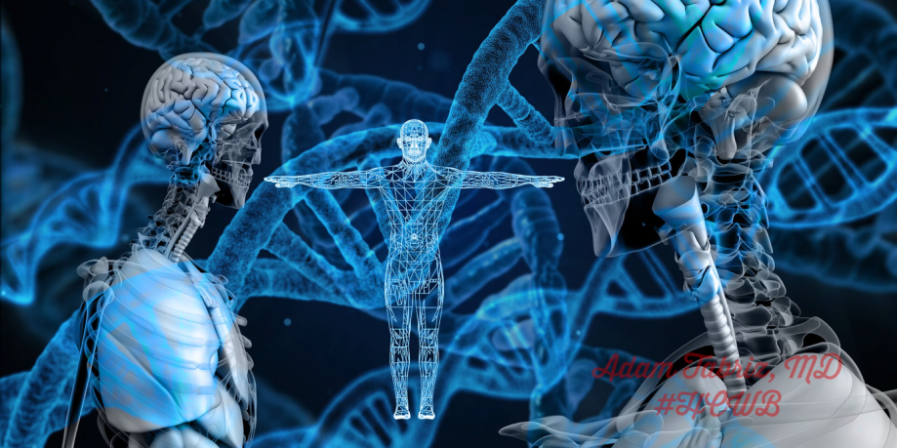
(Retrieved from https://medium.com/writers-guild/the-ethical-dilemma-of-genetic-engineering-d80aa6dc678b)
6.2 Write an opinion essay (150-180 words). Follow the structure described above and use appropriate linking words and phrases to structure your essay and justify your opinion.
7 SPEAKING

7.1 Work in pairs. Read the following ethical dilemma and discuss it in pairs.

Ethical Dilemma

(Retrieved from http://cdmgenetics.blogspot.com/2016/01/ethical-dilemma.html )

7.2 Genetic Engineering Debate.
You will work in debate groups (5-6 students), assigned to one of the following controversial topics, and will find out whether you are arguing FOR (pro) or AGAINST (con) the topic. After discussing the topics in groups each team will have a chance for a two-minute talk which must consist of an opening statement, rebuttal, a closing statement. For more information on debates see Appendix 4 p. 153.
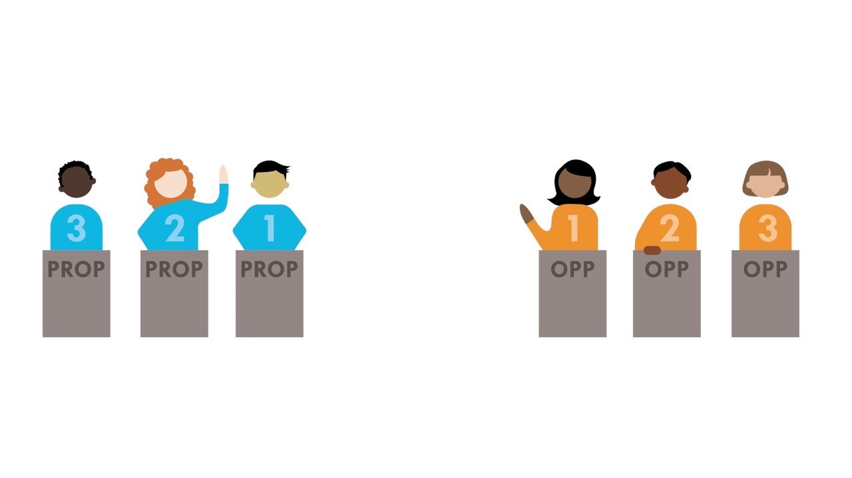
(Retrieved from https://www.asf.edu.mx/learning/events/asomex-debate-tournament/debating)

1 Cloning (of humans and animals)
2 Genetically modified foods
3 Genetic screening (of adults)
4 Use of human stem cells to grow tissues
5 “Designer babies” (genetic screening and selection of fetuses)
6 Gene therapy (replacing genes that don’t work with ones that do)

NOTE! When you are in the audience, you will need to complete a debate response answering the questions:
1 What are the two strongest arguments for the technology?
2 What are the two strongest arguments against the technology?
3 Do you think we should be using this technology and why?
(Retrieved from https://studylib.net/doc/6868832/genetic-engineering-assignment-and-debate)

7.3 As a whole class activity discuss which team had the best debating skills. Justify your opinion.

Check yourself! Read key words of unit 8 and first give definitions of these terms (use Glossary to help you) and then translate them into Ukrainian.

DNA (n.) GENOME (n.)
YEAST (n.) PROPAGATE (v.)
TEST TUBE (n.) RECOMBINANT (adj.)
NUCLEOTIDE (n.) INNATE (adj.)
PROKARYOTIC (adj.) COOPT (v.)
HOMOLOGOUS (adj.) ENDOGENOUS (adj.)
TRANSGENIC (adj.) GERMLINE (n.)
OFFSPRING (n.)

SELF-ASSESSMENT (UNITS 7-8)
VOCABULARY AND GRAMMAR
1 Complete the collocations with the words from the box.
cells, one’s disposal, device, modified, into the body, response, the data, concern, valves, monitoring devices

1 genetically ________
2 immune ________
3 host ________
4 ethical ________
5 to introduce ________
6 to have sth ________
7 heart ________
8 blood glucose ________
9 to transmit ________
10 non-invasive ________
(2 points for each correct answer / 20 points)
2 Write the questions for the following sentences.
1 Biomaterials play an integral role in medicine today.
(yes/no question) ________________________________________ .
2 The field has grown significantly in the past decade due to discoveries in tissue engineering and regenerative medicine.
(Wh-question) ___________________________________________ .
3 Genetic engineering is possible because the genetic code and the structure of DNA are universal among all life forms.
(Wh-question) ___________________________________________ .
4 The organism that receives the DNA is considered a genetically modified organism.
(Tag question) ___________________________________________ .
5 Scientists introduced the human insulin gene to produce synthetic insulin that is used by people with diabetes.
(Subject question) _________________________________________ .
(3 points for each correct answer / 15 points)
3 Complete the sentences using modal verbs will, may / might, or their negative forms. The phrases in brackets will help.
(2 points for each correct answer / 10 points)
READING
4 Read the text and define the sentences as True (T) or False (F).
1 Genetically modified animal was one of the most scientific discoveries since humans discovered fire.
2 Genetically modified foods have appeared in 2000s.
3 Genetic engineering has evolved at a fast pace in the relatively short period of time since Mintz and Jaenisch conducted their unsuccessful experiment.
4 The field of genetic engineering will raise ethical and moral questions to which there are no clear answers.
5 Genetic engineering could totally alter the way we live – both positively and negatively.
(2 points for each correct answer /10 points)

A short history overview on genetic engineering
In 1974, the first ever genetically modified animal was created by Beatrice Mintz and Rudolf Jaenisch. At the time, it was hailed as one of the most important scientific discoveries since humans discovered fire. The success of the experiment raised the question of whether human cloning would soon be possible – an ethical question of monumental importance.
It would take another seven years until four more scientists were able to modify a mouse which was able to transfer the altered gene (transgene) on to its offspring – the next great leap forward, and the one that would really open up the field of genetic engineering to endless possibilities.
Genetic engineering has developed at a quickening pace in the relatively short period of time since Mintz and Jaenisch conducted their successful experiment. By the middle of the 1990s, genetically modified foods were being sold in supermarkets, the most famous being the Flavr Savr tomato, which was engineered to have a longer shelf-life. Now, crops are genetically engineered to be able to survive in conditions they wouldn’t normally be able to handle; genetically modified organisms are used to study gene function; and hormones, vaccines and other life-saving drugs are created through the practice.
But genetic engineering hasn't, and won't, stop there. The speed of change over the last fifty or so years in the field raises ethical and moral questions to which there are, as of yet, no clear answers. How we as a species solve these problems will tell us not only something about the global landscape of moral decision-making, but will define precisely where the human race will end up over the next few generations. It's not an exaggeration to say genetic engineering could totally alter the way we live – and these changes won't necessarily be positive.
(Retrieved from https://newengineer.com/blog/the-future-of-genetic-engineering-1383253)
5 Give short answers to the following questions.
1 When was the first genetically modified animal created?
2 What question was raised with the success of the genetically modified animal experience?
3 What animal was able to transfer the transgene onto its offspring?
4 Why are crops genetically engineered?
5 What was the most famous food which engineered to have a long shelf life?
(2 points for each correct answer / 10 points)
6 Translate the sentences into English.
1 Титан є класичним матеріалом для медичних імплантів завдяки своїй біосумісності та механічним властивостям.
2 Нержавіюча сталь широко використовується як для ортопедичних, так і для серцево-судинних імплантів.
3 З появою генної інженерії вчені тепер можуть змінити спосіб побудови геномів для припинення певних захворювань, які виникають в результаті генетичної мутації.
4 Нові організми, створені за допомогою генної інженерії, можуть створити екологічну проблему.
5 Лікування багатьох захворювань людини вимагає хірургічного втручання і такі процедури передбачають використання матеріалів чужорідних до тіла.
(3 points for each correct answer / 15 points)
7 WRITING
Write an essay (150-180 words) on one of the topics:

1 Genetic engineering and ethical issues.
2 Biomaterials and their applications.
(20 points)
Total: 100 ___________

GRAMMAR REFERENCE
UNIT 1
Relative clauses
We use a relative clause as a means of joining two pieces of information together within one sentence.
Rehabilitation engineering is the study of engineering and computer science to develop devices.
The devices assist individuals recovering from or adapting to physical or cognitive impairment.
Relative clause: Rehabilitation engineering is the study of engineering and computer science to develop devices that assist individuals recovering from or adapting to physical or cognitive impairment.

Such a variety of fields opens many opportunities for biomedical engineers.
They design instruments, devices, and software used in healthcare.
Relative clause: Such a variety of fields opens many opportunities for a biomedical engineer who designs instruments, devices, and software used in healthcare.
In relative clauses, we use the relative pronouns who when a subject is a person, or which when a subject is an object (device).
Also, some other relative pronouns may be used to join the main clause and the relative clause: where for places, when for times, whose for possessions (it means “of which or of who”).
There are two types of relative clauses: defining and non-defining.
Defining relative clause
This tells us information about an object (device) or a person that identifies them.
This is a clinic that specializes in optical spectroscopy and microscopy. (= there are several clinics, and this is one that specializes in optical spectroscopy and microscopy).
There’s a neural engineer who conducts research with me. (=there are several neural engineers, and he/she is the one that conducts research with me)
In defining relative clauses we can use that instead of which or who. This is a clinic which/that specializes in optical spectroscopy and microscopy. There’s a neural engineer who/that conducts research with me.
Non-defining relative clause
This tells us supplementary information about an object (device) or person. The relative pronoun who or which is always preceded by a comma.
This is a clinic, which specializes in optical spectroscopy and microscopy. (= there is only one clinic, and it happens to specialize in optical spectroscopy and microscopy).
There’s a neural engineer, who conducts research with me. (= there is only one neural engineer, and he/she works with me). We cannot use that instead of who or which.
UNIT 2
Reported Speech
We can report people’s words by reported speech. Reported speech is the exact meaning of what someone said, but not the exact words. We do not use quotation marks in reported speech. We can either use the word that after the introductory verb (say, tell, etc.) or we can omit it.
Verb tenses and time expressions change in reported speech, e.g. present simple – past simple: “The rapid progress of robotic technique provides new opportunities for biomedical engineering”, George said – George said (that) the rapid progress of robotic technique provided new opportunities for biomedical engineering ; present continuous – past continuous: “She is conducting a research at the momen”, Paul said – Paul said (that) she was conducting research at the moment; present perfect – past perfect; “I’ve already made a ward round”, a doctor said – A doctor said (that) he had already made a ward round; past simple – past simple or past perfect: “Scientists proposed a new study method”, he said. – He said (that) scientists (had) proposed a new study method; past continuous – past continuous or past perfect continuous: “I was working on a new project”, Tina said – Tina said (that) she was working/had been working; will – would: “They’ll go to the lab after an operation”, a manager said – A manager said (that) they would go to the lab after an operation. The past perfect and past perfect continuous remain the same.
The verb tenses can either change or remain the same in up-to-date reporting and when reporting is a general truth or law of nature.
Some words and time expressions change according to the meaning of the sentence: now – then, at that time, immediately; today, tonight – that day, that night; yesterday – the day before, the previous day; tomorrow – the next day, the following day; this week – that week, last week – the week before, the previous week, next week – the week after, the following week, ago – before; here – there.
Certain modal verbs change as follows:
Will – would, can – could, may – might, shall – should, must – must/had to, needn’t – needn’t/didn’t need to/didn’t have to.
In Type 1 conditionals tenses change in reported speech as follows: the present simple becomes past simple in the if-clause and will becomes would in the main clause.
In Type 2 and Type 3 conditionals tenses do not change.
UNIT 3
Passive Voice
We form the passive with the verb to be and the past participle of the main verb.
We use the passive when:
1 the person who carries out the action is unknown, unimportant, or obvious from the context. (Artificial organs are designed specifically for the patient.)
2 when the action itself is more important than the person who carries it out, as in news headlines, newspaper articles, formal notices, instructions, advertisements, processes, etc. (Another method to create new tissue uses an existing scaffold. The cells of a donor organ are stripped and the remaining collagen scaffold is used to grow new tissue.)
If we want to say who does/did the action, we use by. The first implantable pacemaker was developed by Wilson Greatback.
Present Simple | am, is, are+V3  New discoveries in medicine are made
Present Continuous | am, is, are + being+V3  New discoveries in medicine are being made
Past Simple | was, were + V3  New discoveries in medicine were made
Past Continuous | was, were + being + V3  New discoveries in medicine were being made
Future Simple | will + be + V3  New discoveries in medicine will be made
Present Perfect | have, has + been + V3  New discoveries in medicine have been made
Past Perfect | had + been + V3  New discoveries in medicine had been made
Future Perfect | will + have + been + V3  New discoveries in medicine will have been made
Modal verbs | modals + be + V3  New discoveries in medicine should be made

The present perfect continuous, the future continuous, the past perfect continuous, and the future perfect continuous are not normally used in the passive.
UNIT 4
Describing the function of an item
We can describe the function of an item in a number of ways. Study these examples.
Using the Present simple
Conventional X-ray imaging generates an image of a localised part of the body, which will be analysed for anatomical abnormalities.
Used to-infinitive, Used for+-ing form
CT scans are often used to evaluate: organs in the pelvis, chest, and abdomen, colon health, presence of tumours, pulmonary embolism, abdominal aortic aneurysms, spinal injuries, cardiology.
MRI is often used for evaluating: blood vessels, breasts, major organs.
Emphasising the function
The function of Ultrasound is to evaluate: pregnancy, abnormalities in the heart and blood vessels, organs in the pelvis and abdomen, symptoms of pain, swelling, and infection.
UNIT 5
Conditionals
Conditionals are clauses introduced with if. The main types of conditionals are Type 0, Type 1, Type 2, and Type 3.
Type 0 Conditionals (general truth). They are used to express something which is always true.
If-clause – If + present simple
Main clause – present simple
Example: If you heat water to 100 degrees, it boils.
Type 1 Conditionals (real present). They are used to express real or very probable situations in the present or future.
If-clause – If + present simple/present cont./present perfect/present perfect cont.
Main clause – future/can/may/must/should/could + present bare infinitive
Example: If the students work hard, they’ll become highly qualified biomedical engineers.
Type 2 Conditionals (unreal present). They are used to express imaginary situations which are contrary to facts in the present and, therefore, are unlikely to happen in the present or future.
If-clause – If + past simple or past continuous
The main clause – would/could/might + present bare infinitive
Example: If you read scientific journals, you would know how to genetic engineering works.
Type 3 Conditionals (unreal past). They are used to express imaginary situations which are contrary to facts in the past. They are also used to express regrets or criticism.
If-clause – If + past perfect/past perfect continuous
The main clause – would/could/might + perfect bare infinitive
Example: If the patient had known about the side effects of these drugs he would never buy them.
We can form conditionals by using words/expressions such as unless, providing / provided that, so / as long as, on condition (that), what if, suppose / supposing, but for, otherwise (=if not), in case of, etc.

UNIT 6
Comparisons with adjectives and adverbs
one-syllable adjectives | add -er | fast | faster
one-syllable adjectives ending in -e | add -r | safe | safer
two-syllable adjectives ending in -y | change –y to -ier | easy | easier
adjectives with two or more syllables | more + adjectives | realistic | more realistic
irregular adjectives |  | good  bad  far | better  worse  farther/further

Computers are faster today.
This report is more realistic.
When we compare two things or situations directly, we use the comparative + than.
The programs today are more sophisticated than in the past.
Comparative adverbs
adverbs with the same form as adjectives | add –er  add -r | fast  late | faster  later
 | change -y to -ier | early | earlier
adverbs ending in  -ly | more + adverb | slowly | more slowly
irregular adverbs |  | good  bad  far | well  worse  farther/further

We use less with adjectives and adverbs of two or more syllables to mean the opposite of more.
Computers were less powerful in the past.
They worked less efficiently.
We can add much before comparative adjectives and adverbs to suggest a stronger comparison.
These sales figures are much worse than I expected.
That report was written much more recently than this one.
(Retrieved from Technology, p. 115).

UNIT 7
Questions and Answers
- Yes / No questions begin with an auxiliary or modal verb (is, are, do, does, can, etc.) which is followed by the subject. Use ASI (Auxiliary, Subject, Infinitive) to remember word order in this type of question. Auxiliary verb corresponds to the tense of the main verb in the sentence. We usually answer these questions with Yes or No. For example, Were biomaterials used thousands of years ago? – Yes, they were. Do doctors use vascular stents to treat patients? – Yes, they do. Did he develop this technology? – No, he didn’t.
- Wh- questions begin with a question word such as who, what, where, when, etc. We put the auxiliary or modal verb before the subject. Use QUASI (Question word, Auxiliary, Subject, Infinitive) to remember word order in this type of question. For example: When did the doctors use the first biomaterials? – Sixty years ago. What is bioactivity? – It is the capacity of a specific molecular entity to achieve a defined biological effect.
- Subject Questions are questions we ask when we want to know the subject of the sentence. These questions usually begin with the words who, whose, what, or which. The verb is in the affirmative form. For example: Who developed this device? What allows damaged tissue to regenerate and heal?
- Question tags are short questions at the end of statements. They are mainly used in speech when we want to confirm something or when we want to find out if something is true or not. Question tags are formed with the auxiliary or modal verbs from the main sentence and the appropriate subject pronoun. For example, Throughout history, there are plenty of recordings of foreign material being more or less successfully introduced into the body, aren’t there? Doctors, researchers, and bioengineers use biomaterials for a broad range of applications, don’t they?
UNIT 8
Prediction: will, may, might
will
We use will to talk about future developments that we are certain about.
Positive:
What is certain is that people will be able to make decisions about their lives in ways that were impossible in the past. (= subject + will + infinitive)
Negative:
This process will not be easy. (= subject + will not(won’t) + infinitive)
Questions:
How will big data analytics be used in genetic engineering?
Will every country need to have its own regulatory guidelines for human genetic engineering? (= (question word +) will + subject + infinitive)
may and might
We use may and might when we are less certain about future developments, i.e. when we think that something is possible rather than definite. May is more formal than might, but there is little difference in the level of the possibility they contain.
Positive:
Purging of stem cell transplants may / might become routine to reduce contamination with tumour cells. (= subject + may/might + infinitive)
Negative:
Brain implants may not / might not challenge the typical ways we think about human augmentation. (= subject + may/might + not + infinitive)
We can use the short form mightn’t in spoken English, but there is no short form for may not.
Questions:
Might it apply to reproduce cells and embryos? (= Might + subject + infinitive).
How might brain implants impact autonomy and personal identity? (= question word + might + subject + infinitive)

GLOSSARY
administer (v.) – to manage and be responsible for the running (implementation, use) of sth.
air inlet (n.) – the amount of air drawn in
allograft (n.) – a tissue graft from a donor of the same species as the recipient but not genetically identical
angiography (n.) – examination by x-ray of blood or lymph vessels, carried out after the introduction of a radiopaque substance
artificial hip (n.) – a kind of prosthesis (synthetic body part) that typically consists of two or more components
biodegradable (adj.) – (of a substance or object) capable of being decomposed by bacteria or other living organisms and thereby avoiding pollution
bladder (n.) – the part of a body where urine is stored until it leaves the body
bone marrow (n.) – the soft fatty substance inside human or animal bones.
cartilage (n.) – a strong, flexible substance in your body, especially around your joints and in your nose
catgut (n.) – a material used for the strings of some musical instruments, made of the dried twisted intestines of sheep or horses (but not cats)
cellular (adj.) – connected with the cells of a plant or animal
cognition (n.) – the mental action or process of acquiring knowledge and understanding through thought, experience, and the senses
colon (n.) – the main part of the large intestine, which passes from the caecum to the rectum and absorbs water and electrolytes from food which has remained undigested
congenital (adj.) – (of a disease or physical abnormality) present from birth
contact lenses (n.) – thin discs of plastic or glass that the person puts on the surface of their eyes to correct vision
coopt (v.) – adopt (an idea or policy) for one's own use
cornea (n.) – the transparent skin covering the outside of your eye
СТ (Computed Tomography) (n.) – a medical imaging technique that uses computer-processed combinations of multiple x-ray measurements taken from different angles to produce tomographic (cross-sectional) images of a body, allowing the user to see inside the body without cutting
dextrous (n.) – demonstrating neat skill, esp. with the hands
disposal (n.) – the action or process of using something
DNA (deoxyribonucleic acid) (n.) – deoxyribonucleic acid, a self-replicating material that is present in nearly all living organisms as the main constituent of chromosomes. It is the carrier of genetic information
dressing (n.) – a piece of material used to cover and protect a wound
electrical circuit (n.) – a complete path around which electricity can flow
encompass (v.) – to include different types of things
endogenous (adj.) – growing or originating from within an organism
fragile(adj.) – easily broken or damaged
genome (n.) – the haploid set of chromosomes in a gamete or microorganism, or in each cell of a multicellular organism
germline (n.) – a series of germ cells each descended or developed from earlier cells in the series, regarded as continuing through successive generations of an organism
gradient (n.) – simply a loop of wire or thin conductive sheets on a cylindrical shell that lies just inside the bore of an MRI scanner
gripper (n.) – a device which enables the holding of an object to be manipulated. A gripper can be attached to a robot or it can be part of a fixed automation system
growth factor (n.) – a substance, such as a vitamin or a hormone, which is required for the stimulation of growth in living cells
hamper (v.) – hinder or impede the movement or progress of
homologous (adj.) – (of organs) similar in position, structure, and evolutionary origin but not necessarily in function
impairment (n.) – a condition in which you are not able to use a part of your body or brain normally
incontinence (n.) – the inability to prevent urine or faeces coming out
inflation (n.) – to swell or distend with air or gas
innate (adj.) – inborn, natural
intrinsic (adj.) – belonging naturally; essential
joint (n.) – a structure in the human body at which two parts of the skeleton are fitted together
leverage (v.) – use something to maximum advantage
life expectancy (n.) – the length of time that a living thing, especially a human being, is likely to live
ligament (n.) – a short band of tough, flexible fibrous connective tissue which connects two bones or cartilages or holds together a joint
limb (n.) – an arm or leg of a person or animal
magnet (n.) – a piece of iron or other material which has its component atoms so ordered that the material exhibits properties of magnetism, such as attracting other iron-containing objects or aligning itself in external magnetic field
mesenchyme (n.) – a loosely organized, mainly mesodermal embryonic tissue which develops into connective and skeletal tissues, including blood and lymph
molded (adj.) – shaped to fit by or as if by altering the contours of a pliable mass (as by work or effort)
MRI (Magnetic Resonance Imaging) – a method by which medical staff can get a picture of soft parts inside a patient’s body using a powerful magnetic field
nacre (n.) – mother-of-pearl
nanoparticle (n.) – usuallydefinedas a particleofmatterthatisbetween 1 and100 nanometres (nm) indiameter
nanotechnology (n.) – the use of matter on anatomic, molecular, and supramolecular scale for industrial purposes
neurodegenerative (adj.) – resulting in or characterized by degeneration of the nervous system, especially the neurons in the brain
nuclear medicine (n.) – the branch of medicine that deals with the use of radioactive substances in research, diagnosis and treatment
nucleotid (n.) – a compound consisting of a nucleoside linked to a phosphate group
obstetrics (n.) – the area of medicine that deals with pregnancy and the birth of babies
offspring (n.) – a person's child or children
opacity (n.) – the quality of lacking transparency or translucence
pelvis (n.) – the large bony frame near the base of the spine to which the legs are attached by humans
probe (n.) – the handheld “camera” used by sonographer to transmit the sound waves into the appropriate area of the body
prokaryotic (adj.) – relating to, or being a typically unicellular organism lacking a distinct nucleus and membrane-bound organelles
propagate (v.) – to breed specimens of (a plant or animal) by natural processes from the parent stock
proprioception (n.) – syn. kinesthesia, the sense of self-movement and body position
quality assurance (n.) – the maintenance of a desired level of quality in a service or product, esp. by means of attention to every stage of the process of delivery or production
recombinant (adj.) – relating to or denoting an organism, cell, or genetic material formed by recombination
regain (v.) – obtain possession or use of (something, typically a quality or ability) again after losing it
reinforced (adj.) – strengthened or supported, especially with additional material
rigid (adj.) – unable to bend or be forced out of shape, not flexible
scaffold (n.) – a framework or structural element that holds cells or tissues together
secrete (v.) – produce and discharge (a substance)
semiconductor (n.) – a solid substance that has a conductivity between that of an insulator and that of most metals, either due to the addition of an impurity or because of temperature effects
skin graft (n.) – a piece of skin transplanted to a new site on a patient’s body or to a different individual
spinal cord (n.) – the cylindrical bundle of nerve fibres and associated tissue which is enclosed in the spine and connects nearly all parts of the body to the brain, with which it forms the central nervous system
staple (n.) – a piece of thin wire with two short right-angled end pieces which are driven by a stapler through sheets of paper to fasten them together
stem cell (n.) – a type of cell that can produce other cells which are able to develop into any kind of cell in the body
stent (n.) – a splint placed temporarily inside a duct, canal, or blood vessel to aid healing or relieve an obstruction
stiffness (n.) – the extent to which an object resists deformation in response to an applied force
stroke (n.) – the sudden death of brain cells due to lack of oxygen, caused by blockage of blood flow or rupture of an artery to the brain
suture (n.) – a stitch or row of stitches holding together the edges of a wound or incision (n.) – a surgical cut made in skin or flesh
sweeping (adj.) – affecting many things or people; large
tendon (n.) – a flexible but inelastic cord of strong fibrous collagen tissue attaching a muscle to a bone
test tube (n.) – a thin glass tube closed at one end, used to hold small amounts of material for laboratory testing or experiments
tissue (n.) – a group of cells, in close, proximity, organized to perform one or more specific functions
transducer (n.) – a device that converts variations in a physical quantity, such as pressure or brightness, into an electrical signal, or vice versa
transgenic (adj.) – relating to or denoting an organism that contains genetic material into which DNA from an unrelated organism has been artificially introduced
ultrasound (n.) – a medical imaging technique that uses high-frequency sound waves to produce images of structures within your body
untapped (adj.) – (of a resource) not yet exploited or used
wafers (n.) – small discs about the size of a 5p coin
yeast (n.) – any unicellular fungus that reproduces vegetatively by budding or fission, including forms such as candida that can cause disease

VIDEO / AUDIO SCRIPTS
UNIT 1
Studying biomedical engineering
Bijoy: My name is Bijoy and I’m a third-year biomedical engineer.
Eleanor: I’m Eleanor Camba and I’m studying biomedical engineering and I’m in my fifth year.
Rima: I’m Rima Baken. I study biomedical engineering. I’m a massager.
Daniel: My name is Daniel Osheneeme. I live in London and I’m studying biomedical engineering.
Bijoy: So, a lot of the courses just general engineering but I like to think of it as using engineering like applications and engineering mindset and problem-solving to like try and solve the problems we have with our bodies: hip replacements, knee replacements, prosthetic implants, things like that just the sort of help quality of life get better for people.
Rima: I particularly enjoyed the group projects so I feel that with working in a group and given a task we get to share our skills with everyone and then we learn from each other.
Daniel: Like, I’m doing the same kind of modules as aerospace mechanical students but also I’m learning about cells and I’m learning about different parts of the body.
Bijoy: Think about 20, about 20 hours you’re in every week that’s split up into a sort of lectures. There’re these things called PBLs – problem-based learning that’s when you take all the information you’ve learned from the lectures and then you go into a smaller classroom with a smaller group and then go through it with someone question by question.
Eleanor: So, I’m the president of the women in engineering society, so we do a lot of social experiences, a lot of academics and industry or links and we try and make it a place that’s fun but not too academic.
Rima: I enjoyed the whole actual projects we’ve been given so this year, for example, we were given a minimally invasive device for emphysema sleep in patients so we had just formed a device and design it and give it a software that was quite interesting.
Daniel: This for me feels like what an educational institution should be like, it should be somewhere, okay, yes, academic excellence is what is the aim but also in a very welcoming and in a very understanding relaxed environment.
Eleanor: I also think it’s a really good opportunity to try new things that you’re not really given if you just go straight into a job.
Bijoy: If you’re into biology, if you’re into learning about the human body and you’re also into sort of technology and engineering and like learning how things work, then I would really recommend looking into biomedical engineering because that’s exactly what it is.
UNIT 2
The Da Vinci Surgical System
The Da Vinci Surgical System is the most advanced platform for minimally invasive surgery available in the world today. The integration of high-resolution 3D vision, wristed instruments, and intuitive motion control enable the da Vinci surgeon to transcend the limitations of conventional surgical technologies. Three network components comprise the da Vinci Surgical System: an ergonomic surgeon console, a patient-side cart with four interactive robotic arms, and a high-definition 3d vision system. Seated at the console The Da Vinci surgeon views a remarkably clear 3D image of the surgical field. The system scales filters and translates the movements of the surgeon’s hands on the master controllers – to four interactive robotic arms on the patient cart. The precisely controlled micro-movements of the da Vinci instruments are enabled by the computer processors of the system. These dedicated processors perform millions of safety checks over the course of a procedure for enhanced surgical precision and control. The Da Vinci EndoWrist instruments are designed with a unique wristed architecture that provides seven degrees of freedom for a range of motion greater than even the human wrist. This proprietary design enables surgical maneuvers impossible with conventional laparoscopic tools. The system requires that every surgical maneuver is under the direct control of the surgeon. Redundant safety checks prevent autonomous movement of the instruments for the robotic arms. The Da Vinci S Surgical System moves surgery forward with a new level of technical capability that enables minimally invasive surgery in complex procedures as never before. Da Vinci provides a streamlined surgical experience that benefits the hospital, the surgeon, the OR team and most importantly the patient.
UNIT 3
What is tissue engineering?
Tissue engineering (also called “Regenerative Medicine”) refers to the attempt to create functional human tissue from cells in a laboratory. Its ultimate goal is to be a cure, not merely a treatment – by repairing or replacing tissues and organs that fail due to disease, genetic errors, congenital abnormalities, or traumatic injury.
Tissue Engineering relies on four important factors: the right cells to do the job, the right environment, such as a scaffold, to support the cells, the right biomolecules, like growth factors, to make those cells healthy and productive, and physical and mechanical forces to influence the development of the cells.
The cells can be directly harvested from the target organ, developed from precursor – or stem-cells, or taken from lines grown in the lab all, ideally, from the patient, as that limits problems with rejection.
The supporting structures can be derived from donor tissue or from natural or synthetic polymers made to order for their strength or endurance.
Biomolecules can be added directly or coaxed from the cells that take up residence on the scaffold. Sometimes the scaffolds dissolve over time, but others remain to provide support to the organ.
Some examples of tissues and organs that have already been successfully tissue-engineered and implanted in humans include bladders, small arteries, skin grafts, cartilage, and even a full trachea.

UNIT 4
How does an MRI machine works?
MRI is a medical imaging device commonly used to examine the soft tissues of the human body. Let’s meet the machine. The key components are the magnet, radio waves, gradient, and a computer. Our bodies are made up of 60% water and water is magnetic. Each of the billions of water molecules inside us consists of an oxygen atom bonded to two hydrogen atoms. We know it as H2O. Small parts of the hydrogen atoms act like tiny magnets and are very sensitive to magnetic fields.
MRI stands for magnetic resonance imaging and an MRI scanner is one of the main diagnostic tools that doctors use to examine inside our bodies. The first step in taking an MRI scan is to use a big magnet to produce a unified magnetic field around the patient. The gradient adjusts the magnetic field into smaller sections of different magnetic strengths to isolate specific body parts. For example, the brain. Normally the water molecules inside us are arranged randomly. But when we lie inside the magnetic field most of our water molecules move at the same rhythm or frequency as the magnetic field. The ones that don’t move along the magnetic field are called low-energy water molecules. To create an image of a body part, for example, the brain, the machine focuses on the low-energy water molecules. Radio waves move at the same rhythm or frequency as the magnetic fields in an MRI machine. By sending radio waves that match or resonate with the magnetic field the low-energy water molecules absorb the energy they need to move alongside the magnetic field. When the machine stops emitting radio waves the water molecules that had just moved along the magnetic field release the energy they had absorbed and go back to their position. This movement is detected by the MRI machine and the signal is sent to a powerful computer, which uses imaging software to translate the information into an image of the body. By taking images of the body in each section of the magnetic field the machine produces a final three-dimensional image of the organ which doctors can analyze to make a diagnosis.

UNIT 5
4 Ways how nanotechnology will change our lives
We are living at the dawn of the nanomedicine age. Nanoparticles, nanodevices will soon operate as precise drug delivery systems, cancer treatment tools or tiny surgeons.
Let me introduce you to the brave new world of nanotechnology in healthcare. You're watching the channel of the medical teacher.
You might remember a few years ago British sculptor Millard Vegan went viral with his microscope chairs on needles, look how small they are compared to even a common housefly. But compared to the nanometer, the basic unit of measurement in nanotechnology these are still huge. A nanometer is a million times smaller than the length of an end. A sheet of paper is about 100,000 nanometers thick. It's basically atomic and molecular level. When I was a kid one of my favourite TV series was a French animation. Once upon a time I found it fascinating how the creators imagined the human body as construction where tiny cars floated through the human veins and bacterias – the tiny monsters – tried to attack innocent screaming lady cells while white blood cells defended the body as well-trained soldiers.
Now imagine that all this could happen in real life. Nanotechnology comprises Science Engineering and Technology conducted at the nanoscale. And we are more advanced than you think.
For example, researchers from the Max Planck Institute have been experimenting with exceptionally micro-sized smaller, than a millimeter, robots that literally swim through your bloody fluids and could be used to deliver drugs in a higher-targeted way.
These scallop-like microbots are designed to swim through non-Newtonian fluids like the bloodstream around your lymphatic system or across the slippery goo the surface of your eyeballs. And as this technology will get more advanced it has the possibility to turn healthcare upside down.
Take a look at a few more examples of nanotechnology that has the potential to revolutionize the way we collect medical data with nano-sized diagnostic devices throughout our bodies. We'll be able to detect chemical changes on the spot. These devices could be programmed into gathering information about certain body parts levels of toxins and other substances and report back to medical professionals port or its hosts.
In the future, it might become a reality that the nanorobot sends others their smartphone about the changes it detects. This allows for the detection of diseases and real-time tracking of a patient's health status.
Imagine programmable nanoparticles which could help tackle the day-to-day miseries of chronic conditions like diabetes. For example, they could deliver insulin to initiate cell growth and regenerate tissue at a target location. They could also be programmed to bring certain substances to cells or could be injected into the blood stream to seek out and remove damaged cells or grow new cells.
The traditional method for curing cancer is chemotherapy. That's usually described as a carpet bombing of the body. In many cases, it kills the cancer cell but it is also a side effect of killing regular cells which makes patients extremely sick and susceptible to other conditions. But programmable nanoparticles that attack cancer cells directly without damaging other tissues could mean a revolution in cancer treatment. It's more like a tomahawk precision missile. It would be an amazing addition to our arsenal against cancer.
(3:40)
Nanotechnology has made it possible for researchers to collect in-depth data on the human brain. By using nanoscale diamond particles the brain's activities are converted into frequencies of light that can be registered by external sensors allowing researchers to study the brain in much greater detail. With a microscopic size of just a billionth of a millimeter, nanoparticles are able to cross the blood-brain barrier and access the brain's remote areas. They have also shown tremendous potential in being a useful alternative to diagnosing and treating neurological diseases. According to optimistic futurists, nanomedicines like smart drugs lead to the prevention of illnesses evening making a superhuman. But it's time for the medical community regulators and the public to start to catch up because the nanofuture is upon us.
UNIT 6
Changing the future of rehabilitation with robotic technologies
Curtinnovation is using advanced robotic technologies to change the future of rehabilitation. Dr Lei and his team of PhD students have created robotic prototypes, which will one day help medical professionals the world over. The team engineered this robotic leg exoskeleton to help people with spinal cord injuries regain movement. This lightweight prototype uses a small motor to control hip, knee, and ankle joints simultaneously. It looks like something out of a Hollywood movie, but it’s actually simple to use. First, the leg is secured, then the robot simulates walking reintroducing a range of motion to regain leg strength and function. This robotic exoskeleton helps mobilise a patient’s finger tendons after surgery, speeding up recovery time. Constructed on a 3D printer, it fits on to the patient’s injured hand, using a touchscreen. A customised recovery program is delivered extending the injured tendons and improving the range of motion. Combining virtual reality with robotics is another exciting Curtin project. VR programs are being designed to help older patients regain balance and stability. This robotic stability platform prototype guides patients through gentle balance exercises. Early studies suggest that immersing the mind at a virtual world can improve rehabilitation and movement. It’s just another example of Curtinnovation in action.

UNIT 7
Biomaterials for regenerative medicine and therapeutics
Biomaterials are materials that are designed and developed to interact with the body. Usually, the implant materials but also as sensors or probes for non-invasive diagnosis. They’ve revolutionized our lives especially as we age. Things like hip replacements and knee replacements have been able to get people up on their feet and get them moving around. But there’s so much untapped potential. Biomaterials are a key part of regenerative medicine and that’s because they can be designed or developed to recruit and guide cells in the body to heal tissues that wouldn’t be healed by any other means. An example is our bouncy bioglass. This has been 3D printed such that its chemistry and architecture guide cells and recruit them from the bone marrow to produce high-quality cartilage. Now the important thing is that they can bounce and their bouncing means that they can be implanted straight into the joints and get patients up and moving around quickly. But biomaterials also can be used in therapeutics. They can be used as tiny particles to deliver or even replace conventional drugs. These tiny particles can be injected into the body and they can hunt out cancer cells and kill them without killing those healthy cells around them. They can also go as far as going to the brain and helping regenerate neurons and to treat diseases such as Alzheimer’s or Parkinson’s disease. It’s really important for us that we work with clinicians such as those in the medical school here in Imperial and medical device companies in order to make sure these new developments are going to get through to the clinic to where they’re going to help people.
UNIT 8
Genetic engineering is a term that was first introduced into our language in the 1970s to describe the emerging field of recombinant DNA technology and some of the things that were going on. As most people who read textbooks and things know, recombinant DNA technology started with pretty simple things--cloning very small pieces of DNA and growing them in bacteria--and has evolved to an enormous field where whole genomes can be cloned and moved from cell to cell, to cell using variations of techniques that all would come under genetic engineering as a very broad definition. To me, genetic engineering, broadly defined, means that you are taking pieces of DNA and combining them with other pieces of DNA. [This] doesn't really happen in nature, but is something that you engineer in your own laboratory and test tubes. And then taking what you have engineered and propagating that in any number of different organisms that range from bacterial cells to yeast cells, to plants and animals. So while there isn't a precise definition of genetic engineering, I think it more defines an entire field of recombinant DNA technology, genomics, and genetics in the 2000s.

APPENDIXES
APPENDIX 1
USEFUL EXPRESSIONS AND LINKING WORDS FOR ADVANTAGES / DISADVANTAGES ESSAY

- To introduce points for and against: Firstly; First of all; To start / begin with; Secondly; We must look at both sides of the question…; On one hand…; On the other hand…; One point / argument in favour of…/ against…; Although; A further common criticism of…/It could be argued that…; It is (often / widely / generally) claimed / suggested / argued / maintained / believed that …; Some / many /most people / experts support / oppose the view that…; People are in favour of / against…; As well as that; And another thing is…; The main / the greatest advantage of … is…; Another negative aspect of …; The most important advantage is …; The most important disadvantage is ….;
- Conclusion and opinion: In conclusion, on balance, all things considered, taking everything into account / consideration, to conclude, to sum up, all in all; it is my belief / opinion that, I strongly believe / feel / think that …, I am convinced that…, I am inclined to believe that …, I do (not) agree that / with…; As far as I’m concerned; In general.
APPENDIX 2
SUMMARY PLAN
1. The title of the article. | The article is headlined…  As the title implies the article describes ...
2. The author of the article, where and when the article was published. | The author of the article is…  The author’s name is ...  The author’s name is not mentioned ...  The article is written by…  It was published in … (on the Internet).  It is a newspaper (scientific) article (published on March 10, 2012 / in 2010).
3. The main idea of the article. | The main idea of the article is…  The article is about…  The article is devoted to…  The article deals (is concerned) with…  The article touches upon the issue of…  The purpose of the article is to give the reader some information on…  The aim of the article is to provide the reader with some material on…
4. The contents of the article. Some facts, names, figures.
  The author starts by telling (the reader) that…
  The author (of the article) writes (reports, states, stresses, thinks, notes, considers, believes, analyses, points out, says, describes) that… / draws the reader’s attention to...
  Much attention is given to…
  According to the article…
  The article goes on to say that…
  It is reported (shown, stressed) that …
  It is spoken in detail about…
  From what the author says it becomes clear that…
  The fact that … is stressed.
  The article gives a detailed analysis of…
  Further, the author reports (writes, states, stresses, thinks, notes, considers, believes, analyses, points out, says, describes) that… / draws the reader’s attention to...
  In conclusion, the author writes (reports, states, stresses, thinks, notes, considers, believes, analyses, points out, says, describes) that… / draws the reader’s attention to...
  The author comes to the conclusion that…
  The following conclusions are drawn: …
5. Your opinion. | I found the article (rather) interesting (important, useful) as / because…  I think / In my opinion, the article is (rather) interesting (important, useful) as / because…  I found the article too hard to understand / rather boring as / because…

(Retrieved fromhttps://portal.tpu.ru/SHARED/z/ZEREMSKAYA/Pic/Tab/Annotation_plan.pdf)

APPENDIX 3
TIPS FOR PRESENTATION
1. Contain no more than 12 slides.
2. Last no more than 15-20 minutes.
3. Use a font size of no less than 30 points.
4. Rehearse and practice the presentation.
5. Start Strongly. The beginning of your presentation is crucial. You need to grab the audience’s attention and hold it (tell a short story, give a question, quotes, humour, remarkable facts, show an image, etc.).
6. State the objectives of the presentation at the beginning of the presentation.
7. Smile and make eye contact with your audience.
8. Use your body language.
9. Summarize the presentation.
10. DO NOT READ THE PRESENTATION!!!

USEFUL PHRASES AND VOCABULARY
Introduction
What I’d like to present to you today is ……….. .
The subject/topic of my presentation is …………
In my presentation, I would like to report on ………….
Today’s topic is of familiar interest to those of you who …………
What I want to show you is ……………
Presenting main points
I’ve divided my presentation into three (main) parts.
In my presentation, I’ll focus on ……
First, I’ll be looking at ….., second ………, and third ………
I’ll begin / start off by……. . Then I’ll move on to …….. .
Then / next / after that……
I’ll end with …….
Explaining a visual
To illustrate this, let’s have a closer look at ………
As you can see here ………
First, let me quickly explain the graph,
Conclusion
Well, this brings me to the end of my presentation.
That covers just about everything I wanted to say about….
Just to summarize the main points of my talk…..
To conclude / In conclusion, I’d like to …….
To sum up, we ……….

APPENDIX 4
USEFUL DEBATE VOCABULARY

Stating an opinion
- In our opinion...
- We (don’t) think that…
- The way we see it...
- If you want our honest opinion.... According to the other side/ our opponents…
- According to me...
- As far as I'm concerned...
- Our position is the following…
Sequencing :
- Firstly…, secondly…, our third point is that…
- The first good reason to… is that… ; next ; what’s more ; moreover….
- To begin, we think that… ; in addition, you have to know that… ; last but not least….
- The first point I would like to raise is this…
- Here’s the main point I want to raise…
- I’d like to deal with two points here. The first is…
“I’m listening to the other side”.
- I see your point, but I think…
- Yes, I understand, but my opinion is that…
- That’s all very interesting, but the problem is that…
- I’m afraid I can’t quite agree with your point.
- I think I’ve got your point, now let me respond to it.
- We can see what you’re saying. Here’s my reply…
Disagreeing:
- Excuse me, but that’s not quite correct.
- Sorry, I just have to disagree with your point.
- Let me just respond to that, please.
- I’d like to take issue with what you just said.
- We said that… but the other side has not replied to our point.
- I’d like to focus on two points that the other side has failed to address.
- There are two issues our opponents have failed to dispute, namely…
- We pointed out that…
- Our opponents have claimed that…
- To recap the main points…
- Let’s sum up where we stand in this debate.
- In summary, we want to point out that…

KEYS
UNIT 1
1 LEAD-IN
1 b 2 b 3 c 4 a 5 a 6 a 7 d 8 c 9 c 10 b
2 LISTENING
2.2
1 4 people are speaking 2 problem-based learning, group projects, social experiences within an engineering society, relaxed environment, a good opportunity to try new things.
2.3
1 Eleanor 2 Rima 3 Daniel 4 Bijoy 5 Rima 6 Daniel 7 Bijoy
3 READING
3.1
2
3.2
See Glossary
3.3
1 T 2 F 3 T 4 F 5 T 6 F 7 T
4 VOCABULARY
4.1
1 expectancy 2 tools 3 encompasses 4 adjust 5 skilled 6 sweeping 7 naturally occurring
4.2
1 contact lenses 2 tissue 3 impairment 4 quality assurance 5 electrical circuit 6 joint
5 GRAMMAR
5.1
1 some of which are already helping patients worldwide
2 who suffered from heart failure
3 which has headquarters
4 that the patient can wear on the belt
5 which is known as the iLIMB
6 who use the invention
7 who decided to come up with a totally new approach in creating an artificial liver
8 that makes use of liver cells
9 who managed to mix for the first time an elastic contact lens with an imprinted electronic circuit.
5.2
A massage therapist is a person who treats clients by using touch to manipulate the soft-tissue muscles of the body.
A pacemaker is a device that is placed under the skin in your chest to help control your heartbeat.
A clinician is a person who works as a caregiver of a patient in a hospital, skilled nursing facility, clinic, or patient’s home.
An infusion pump is a device, which delivers fluids, such as nutrients and medications, into a patient’s body in controlled amounts.
An inhaler is a device that delivers medicines into the lungs through the work of a person’s breathing.
A general practitioner is a person who is trained in general medicine and treats patients in a local community rather than at a hospital.
A practice manager is a person who is in charge of running and organizing a practice, for example, by managing the staff, dealing with financial matters, etc.
A telescope is a device that consists of a thin tube with lenses, that you look through in order to examine areas inside the body during an operation.
A health visitor is a person who visits people in their homes in order to give them advice on medical care, for example, advising new parents on how to look after their baby.
A motion sensor is a device that detects movement.

5.3
1 which 2 who 3 where 4 whose 5 where 6 whose 7 when 8 who, which
UNIT 2
2 LISTENING
2.1
A – the surgeon’s console B – a cart with robotic arms C – an electric tower holding video and air inflation equipment
2.2
1 b 2 a 3 c 4 b 5 c
3 READING
3.1
1 T 2 F 3 T 4 T 5 F 6 F 7 F 8 T
3.2
1 C 2 B 3 C 4 B 5 A
4 VOCABULARY
4.1
1 grippers 2 rigid 3 proprioception 4 leveraged 5 stiffness-tuning
4.2
1 d 2 b 3 a 4 d 5 b 6 c 7 b 8 c 9 d 10 a
5 GRAMMAR
5.1
1 Prof. Xie said that their work suggested a way of designing sensors that contributed not only as sensing elements for robotic applications but also as active functional materials to provide better control of the whole system without compromising its dynamic behaviour.
2 Prof. Xie indicated that self-powered built-in sensors would not only allow robots to safely interact with humans and their environment, but also eliminate the barriers to robotic applications that relied on powered sensors to monitor conditions.

5.2
1 Bill Gates said that robotics and other combinations would make the world pretty fantastic compared with that day.
2 Bruce Dickinson said that engineering stimulates/stimulated the mind.
3 Elon Musk said that he didn’t spend his time pontificating about high-concept things; he spent his time solving engineering and manufacturing problems.
4 Jeffrey Abrams said that robotics were beginning to cross that line from absolutely primitive motion to motion that resembled animal or human behaviour.
5 Colin Angle said that the way that the robotics market was going to grow, at least in the home, was that they’d have a number of different special purpose robots.
6 Colin Angle said that the reason it had taken so long for the robotics industry to move forward was that people keep trying to make something that was cool but difficult to achieve rather than trying to find solutions to actual human problems. The technology could be extremely expensive if you didn’t focus.
7 John Glenn said that he thought sometimes we would go to Mars and he thought we would explore it with humans sometimes, but he thought it was really wise to do all the robotic exploration ahead of time and learn as much as possible.
8 Martin Rees said that he hoped that by 2050 the entire solar system would have been explored and mapped by flotillas of tiny robotic craft.
5.3
1 had provided / provided 2 would 3 didn’t take 4 might
5 the month before / the previous month 6 are 7 had increased 8 then
SELF-ASSESSMENT (UNITS 1-2)
1
1 provide clear vision 2 life expectancy 3 to explore biological processes 4 to regenerate tissues and organs 5 to optimize healthcare delivery 6 physical and cognitive impairments 7 high-definition 3D vision system 8 soft robotic grippers 9 to overcome limitations 10 built-in proprioception sensor
2
1 This is a micro-nanorobot that allows us to study the fundamental problems at the cellular level owing to its precise positioning and manipulation ability.
2 Yesterday I met a biomedical engineer who specializes in tissue engineering.
3 Bioinstrumentation uses electronics, computer science, and measurement principles to develop different devices, which are used in the diagnosis and treatment of medical problems.
4 Rehabilitation equipment is for patients who want to regain back the energy and strength to do again what they usually are doing every day.
5 It was 2007 when David Gow invented the iLimb device.
6 Did you visit the University of Washington where researchers created the bionic eye.
7 Dr Kenneth Matsumura developed a new bio-artificial liver, which became a new approach in creating an artificial liver.
3
1 Dr Mohsin Tiwana said that projects they had completed demonstrated what they knew”.
2 Leroy Chiao said that the biggest technical challenge to sending astronauts on farther and longer missions was biomedical, How did they keep them healthy?”
3 Kenneth Frazier said that the business of biomedical research was mostly about failure. Few projects they commissioned would ultimately result in success. But every study they did contribute to the body of knowledge and brought science and society closer to a solution”.
4 Peter Agre said that John Hopkins had introduced him to two defining events in his life: commitment to biomedical research and meeting his future wife, Mary”.
5 William Henry Danforth said that St. Louis had always been a great centre for medicine. It had been a leader in the nation since the early part of the 20th century.
4
1 F 2 T 3 F 4 T 5 T
5
1 deficiency 2 peripheral neuropathy 3 colonoscopy 4 haptics
5 incision
6
1 The rapid progress of robotic techniques provides new opportunities for biomedical and healthcare engineering.
2 The device was implanted in a man who suffered from heart failure.
3 Such a variety of fields opens many opportunities for biomedical engineers.
4 Thanks to biomedical engineering life expectancy has increased significantly.
5 Biomedical engineers design and build artificial parts such as hip replacements and knee joints.
6 The DaVinci surgical system is the most advanced platform for minimally invasive surgery available in the world today.
7 This new study will help humanity overcome incurable diseases.
8 Pacemaker is a device that is placed under the skin in your chest to help control your heartbeat.
UNIT 3
2 LISTENING
2.1
1 regenerative medicine
2 Its ultimate goal is to be a cure not merely a treatment by repairing or replacing tissues or organs that fail due to disease, genetic errors, congenital abnormalities, or traumatic injury.
3 4 important factors: the right cells; the right environment; the right biomolecules; physical and mechanical forces
4 The cells can be harvested from the target organ, developed from precursor or stem-cells, or taken from lines grown in the lab all, ideally, from the patient, as that limits problems with rejection.
2.2
1 cells 2 genetic errors 3 traumatic injury 4 polymers 5 scaffold
6 bladders 7 small arteries 8 cartilage 9 trachea

2.3
1 F 2 T 3 T 4 F 5 T
3 READING
3.2
1 d 2 b 3 e 4 a 5 c
3.3
1 Artificial skin and cartilage are examples of engineered tissues that have been approved by the FDA.
2 Group of cells make and secrete their own support structures, called extra-cellular matrix.
3 The process often begins with building a scaffold from a wide range of sources, proteins, and plastics.
4 A tissue develops if the environment is right.
5 Nowadays tissue engineering plays a relatively small role in patient treatment.
4 VOCABULARY
4.1
1 production 2 improving 3 engineered 4 transplanted 5 complicated 6 being 7 development
4.2
1 scaffold 2 protein 3 stem cell 4 cartilage 5 bladder
6 growth factor
5 GRAMMAR
5.1
Some examples of passive voice:
1 Once scaffolds are created, cells with or without a “cocktail” of growth factors can be introduced.
2 In some cases, the cells, scaffolds, and growth factors are all mixed together at once.
3 The cells of a donor organ are stripped and the remaining collagen scaffold is used to grow new tissue.
4 This process has been used to bioengineer heart, liver, lung, and kidney tissue.
5.2
1 was introduced 2 are used 3 are located 4 were transplanted
5 was removed and replaced 6 can be kept 7 is usually given
8 were performed 9 is caused
5.3
1 are concerned 2 have been improved 3 was successfully used
4 can be 5 have been treated
UNIT 4
2 LISTENING
2.1
1 soft tissues 2 hydrogen 3 gradient 4 randomly 5 low energy
6 three-dimensional
2.2
1 radio waves 2 diagnostic tools 3 unified magnetic field 4 adjusts
5 molecules 6 frequency 7 low-energy
3 READING
3.1
1 b 2 d 3 a 4 e 5 c
3.2
1 B 2 D 3 F 4 A 5 E 6 C
3.3
1 F 2 T 3 F 4 T 5 F 6 T 7 F
4 VOCABULARY
4.1
ionizing radiation, angiographies, magnetic field, organs in the pelvis and abdomen, certain particles, neurological diseases

4.2
injury – damage
lungs – pulmones
abdomen – belly
swelling – bump
chest – breast
substance – matter
5 GRAMMAR
5.1
Contrast agents are used to improve pictures of the inside of the body produced by x-rays, computed tomography, magnetic resonance imaging, and ultrasound.
The X-ray tube is used to receive electrical energy and convert it into two forms: x-radiation and heat.
PET scanner is used to detect photons (subatomic particles) emitted by a radionuclide in the organ or tissue being examined.
A computer is used to produce a final three-dimensional image of the organ which doctors can analyze to make a diagnosis.
Magnetic field gradient is used to encode the signal spatially.
Electron microscopy is used to improve pictures of the inside of the body produced by x-rays, computed tomography, magnetic resonance imaging, and ultrasound.
5.2
Elastography is used to map the elastic properties and stiffness of soft tissue.
Photo acoustic imaging is used to detect regions with high optical absorption which means diseased tissue can be imaged with high contrast in the presence of surrounding healthy tissue.
Echocardiography is used to produce live images of your heart.
Functional near-infrared spectroscopy is used for neural engineering.
Magnetic particle imaging is used to measure the 3-D location and concentration of nanoparticles.
Endoscopy is used to examine a person’s digestive tract.
Tactile imaging is used for tissue characterization (elasticity, structure, boundaries, blood vessel detection).
Thermography is used to detect heat patterns and blood flow in body tissues.

SELF-ASSESSMENT (UNITS 3-4)
1
1 effectiveness of medical treatment 2 medical imaging technique 3 the oral cavity 4 contrast agent 5 high frequency 6 biologically active molecules 7 regenerative medicine 8 to build a scaffold 9 growth factors 10 immune system
2
1 are created 2 was introduced 3 are made 4 was presented 5 are grown 6 are derived 7 was developed
3
1 is used for / perform 2 used for / promote 3 allows 4 is used 5 used
4
1 T 2 F 3 T 4 F 5 F
5
1 pulse generator, leads 2 tachycardia 3 bradycardia 4 cardiac resynchronization therapy 5 fatigue, fainting or light headedness, shortness of breath, damage to vital organs, eventual death
6
Імплантація кардіостимулятора зазвичай триває одну-дві години. Ви отримаєте заспокійливий засіб для розслаблення та місцевий анестетик для знеболення місця розрізу. Ви можете повернутися додому того ж вечора, або ви можете залишитися в лікарні на ніч. Перш ніж повернутися додому, лікар переконається, що кардіостимулятор запрограмований належним чином для потреб вашого серця. Ваш лікар може перепрограмувати пристрій за необхідності під час подальших зустрічей. Протягом наступного місяця слід уникати жорстких фізичних вправ і підйому важкого. Вам також може знадобитися приймати безрецептурні ліки від будь-якого дискомфорту. Запитайте у своїх лікарів, які засоби для зняття болю є для вас найбільш безпечними.

UNIT 5
1 LEAD-IN
1.1
1 Biomedical Engineers use a variety of tools, materials, and technology in their daily activities. Tools include cardiac pacemakers or other implantable devices, cardiac device analyzers and testing equipment, fatigue testers, MRI and CT scanners, spine simulators, ultrasound scanners, and physiological recorders.
2 These hybrid nanostructures are used to make biosensors or to image certain body parts. Nanostructures can also be engineered to incorporate them into body systems by altering their solubility in water, compatibility with biological material, or recognition of biological systems.
3 A nanotechnology engineer seeks to learn new things that can change the face of health, science, technology, and the environment on a molecular level. They test for pollutants, create powders to enrich our foods and medicines, and study the smallest fragments of DNA.
4 In the future, nanotechnology could also enable objects to harvest energy from their environment. New nano-materials and concepts are currently being developed that’s how the potential for producing energy from movement, light, variations in temperature, glucose, and other sources with high conversion efficiency.
5 Numerous prospective benefits for health and the environment are offered by nanotechnology, with engineered nanomaterials being developed for renewable energy capture and battery storage, water purification, food packaging, environmental sensors, and remediation, as well as greener engineering and manufacturing.
1.2
1 c 2 a 3 b

1.3
1 industrial 2 food 3 metals 4 reactions 5 detect 6 resistance 7 fabrics 8 wrinkle 9 durable
2 LISTENING
2.1
1 molecular 2 technology 3 fluids 4 upside 5 information 6 detects
2.2
1 T 2 F 3 F 4 T 5 T 6 F 7 F 8 T 9 F
2.3
Brain, light, researchers, remote, neurological
3 READING
3.1
1 C 2 D 3 B 4 F
3.2
1 Invisible particles that fight cancer cells, faster microprocessors that consume less energy, batteries that last 10 times longer, or solar panels that yield twice as much energy. These are just some of the many applications of nanotechnology, a discipline with all the ingredients to turn into the next industrial revolution.
2 This field, which flourished between the 60s and 80s, has surged in the last two decades with a booming global market.
3 To change their intrinsic properties and obtain others with revolutionary applications.
4 This is the case of graphene-modified carbon harder than steel, lighter than aluminium, and almost transparent – or nanoparticles used in areas such as electronics, energy, biomedicine, or defence.
5 In 1959 the American Nobel prize and physicist Richard Feynman was the first to speak about the applications of nanotechnology at the California Institute of Technology.
6 Graphene's properties make it an ideal candidate for the development of flexible touchscreens.
7 The properties of some nanomaterials make them ideal for improving the early diagnosis and treatment of neurodegenerative diseases or cancer. They are able to attack cancer cells selectively without harming other healthy cells. Some nanoparticles have also been used to enhance pharmaceutical products such as sunscreen.
8 There are bright and dark spots in the future of nanotechnology.
3.3
1 making smaller, faster, and more efficient microchips and devices, as well as lighter, more conductive, and stronger quantum nanowires
2 the environmental, health, and safety risks
3 micro-manufacturing, organic chemistry, and molecular biology
4 with all the ingredients to turn into the next industrial revolution
5 harming other healthy cells
6 increased private investment and growing demand for smaller devices
4 VOCABULARY
4.1
невидимі частинки | invisible particles
боротися з раковими клітинами | to fight cancer cells
гігантські можливості | gigantic possibilities
модифікований вуглець | modified carbon
наночастки | nanoparticles
поліпшити ранню діагностику | to improve early diagnosis
атакувати вибірково | to attack cancer cells selectively
збільшити державну підтримку | to increase government support

4.2
make better – improve, medical care – treatment, affliction – diseases, restrictively – selectively, to improve – to enhance, become larger, evolve – to grow, give a help – support.

4.3
1 transparent 2 marketed 3 organic 4 silicon 5 double 6 fuel
5 GRAMMAR
5.1
1 had invited 2 had not developed 3 would think 4 will not be able to 5 would have told 6 will produce 7 will be able to 8 had known
5.2
1 on condition that 2 But for 3 Provided 4 otherwise 5 Supposing 6 On condition 7 as long as
UNIT 6
2 LISTENING
2.1
1 F 2 T 3 T 4 F 5 T 6 F
2.2
1 simultaneously 2 regain 3 finger tendons 4 touchscreen 5 motion
3 READING
3.3
1 d 2 c 3 a 4 e 5 b
3.4
1 B 2 C 3 D 4 A 5 C
4 VOCABULARY
4.1
1 c 2 d 3 f 4 e 5 b 6 a

4.2
1 assistive 2 aging 3 promoting 4 healthy 5 expect 6 required 7 hearing 8 secondary 9 carers 10 growth
5 GRAMMAR
5.1
1 easier, more enjoyable
2 simpler, more complex
3 more trustworthy
4 more widely
5 smarter
6 most common
7 the biggest
5.2
1 the most important 2 more effective 3 the most unique 4 faster 5 largest
SELF-ASSESSMENT (UNITS 5-6)
1
1 individuals with disabilities 2 sophisticated brain computer interfaces 3 upper limbs 4 retinal and cochlear implants 5 peripheral nervous system
6 organic chemistry 7 molecular biologies 8 carbon nanotubes
9 neurodegenerative diseases 10 to hamper market expansion
2
1 will assist 2 would have benefited 3 but for 4 would think 5 on condition 6 will slow down 7 would have known
3
1 most substantial 2 lighter, smarter, more useful 3 most promising 4 stronger 5 most important
4
1 F 2 T 3 F 4 T 5 T
5
1 circulatory system 2 side effects 3 neurodegenerative 4 ointment
5 cortisone
6
Телездоров’я широко розглядається як використання комунікаційних технологій для надання медичної допомоги на відстані. Телездоров’я часто передбачає дистанційний контроль артеріального тиску, частоти серцевих скорочень та інші вимірювання, отримані за допомогою пристрою, який носить пацієнт і надсилається електронним способом медичному персоналу. Телеконсультації дозволяють лікарю у віддаленому районі отримувати поради від спеціаліста у віддаленому місці щодо особливих або складних станів пацієнта. Віддалений моніторинг пацієнта дозволяє здійснювати моніторинг пацієнта поза клінічними установами, наприклад, вдома. Пацієнти використовують або носять датчики, які бездротово збирають та передають фізіологічні дані медичним працівникам. Це може значно покращити якість життя людини.

UNIT 7
2 LISTENING
2.1
1 body 2 hip replacements and knee replacements 3 therapeutics 4 healthy cells 5 Alzheimer’s, Parkinson’s
2.2
1 The implant materials, sensors, probes for non-invasive diagnosis.
2 Because they can be designed or developed to recruit and guide cells in the body to heal tissues that wouldn’t heal by any other means.
3 This is an example of biomaterials. It has been 3D printed such that its chemistry and architecture in guide cells and recruit them from the bone marrow to produce high-quality cartilage. The important thing is that they can bounce and their bouncing means that they can be implanted straight into the joints and get patients up and moving around quickly.
4 They can be used as tiny particles to deliver or even replace conventional drugs.
5 Neurons
3 READING
3.1
1 body 2 hip replacement and knee replacement 3 therapeutics 4 healthy cells 5 Alzheimer’s and Parkinson’s
3.2
1 F 2 T 3 T 4 F 5 T
3.3
1 c 2 b 3 a 4 d 5 a
4 VOCABULARY
4.1
1 suture 2 ligament 3 dressing 4 biodegradable 5 stent
4.2
1 medical application
2 biological function
3 futuristic nuance
4 dental implants
5 stainless-steel hips
6 dissolvable dressings
7 bioactive molecules
8 vascular stents
5 GRAMMAR
5.1
1 What did the ancient Egyptians use as a suture as far back as 2000 B.C.?
2 What does a pacemaker consist of?
3 Who developed these innovative materials?
4 correct
5 Is immunomodulation an adjustment of the immune response to the desired level?
6 correct
7 What allows damaged tissue to regenerate and heal?
8 correct
5.2
1 Is biomaterial different from biological material? (Yes, it is)
2 What is bioactivity? (The capacity of a specific molecular entity to achieve a defined biological effect)
3 How are biomaterials used in dental applications, surgery, and drug delivery? (dental implants, artificial hips, biosensors)
4 What diseases are common in the aging world? (Bone and cardiovascular diseases)
5 Are biocompatible inorganic materials obtained using technologies of ceramics, types of cement, glasses, and glass-ceramics? (yes, they are)
UNIT 8
2 LISTENING
2.1
1 In the 1970s.
2 Recombinant DNA started with pretty simple things – cloning very small pieces of DNA and growing them in bacteria.
3 Genetic engineering, broadly defined, means that you are taking pieces of DNA and combining them with other pieces of DNA.
2.1
1 genomes 2 cloned 3 combining 4 nature 5 test tubes
2.3
1 e 2 d 3 a 4 c 5 b
3 READING
3.1
1 T 2 F 3 T 4 T 5 F
3.2
1 B 2 D 3 A 4 C 5 B 6 C 7 D
4 VOCABULARY
4.1
1 f 2 b 3 h 4 a 5 d 6 g 7 k 8 c 9 e 10 j
4.2
1 food supply 2 scientific research 3 synthetic 4 protein 5 host cells 6 pest resistance 7 plants
5 GRAMMAR
5.1
1 may 2 will 3 will 4 may not/might not 5 might/may 6 will 7 may not/might not

SELF-ASSESSMENT (UNITS 7-8)
1
1 genetically modified 2 immune response 3 host cells 4 ethical concern 5 to introduce into the body 6 to have sth at one’s disposal 7 heart valves
8 blood glucose monitoring devices 9 to transmit the data 10 non-invasive device
2
1 Do biomaterials play an integral role in medicine today?
2 When has the field grown due to discoveries in tissue engineering and regenerative medicine?
3 Why is genetic engineering possible?
4 The organism that receives the DNA is considered a genetically modified organism, isn’t it?
5 Who introduced the human insulin gene to produce synthetic insulin that is used by people with diabetes?
3
1 will 2 may/might 3 will 4 will 5 may not/might not
4
1 T 2 F 3 F 4 T 5 T
5
1 in 1974 2 whether human cloning would soon be possible 3 mouse
4 to be able to survive in conditions they wouldn’t normally be able to survive
5 FlavrSavr tomato
6
1 Titanium is a classical material for medical implants thank its biocompatibility and mechanical properties.
2 Stainless steel is widely utilized in both orthopedic and cardiovascular implants. 3 With the advent of genetic engineering, scientists can now change the way genomes are constructed to terminate certain diseases that occur as a result of genetic mutation.
4 New organisms created by genetic engineering can present an ecological problem.
5 The treatment of many human disease conditions requires surgical interventions and such procedures involve the use of materials foreign to the body.

REFERENCES AND LINKS

1. ABB demonstrates the concept of a mobile laboratory robot for the hospital of the future. (2019). Retrieved February 21, 2021 from https://new.abb.com/news/detail/37301/abb-demonstrates-concept-of-mobile-laboratory-robot-for-hospital-of-the-future.
2. ADA: Assistive robot learns to feed. (2019). Retrieved December 8, 2020 from https://tectales.com/bionics-robotics/ada-assistive-robot-learns-to-feed.html.
3. Annotation plan. (n.d.). Retrieved December 21, 2020 from https://portal.tpu.ru/SHARED/z/ZEREMSKAYA/Pic/Tab/Annotation_plan.pdf.
4. An informal email to a friend. (n.d.). Retrieved February 2, 2021 from https://learnenglish.britishcouncil.org/sites/podcasts/files/LearnEnglish-Writing-B2-An-informal-email-to-a-friend.pdf.
5. Areas of specialization in biomedical engineering (n.d.). Retrieved November 5, 2020 from https://navigate.aimbe.org/why-bioengineering/areas-of-specialization-in-bioengineering/.

6. Biomaterials. (n.d.). Retrieved February 1, 2021 from https://indiveni.re/biomaterials/.

7. Biomaterials. (n.d.). Retrieved December 8, 2020 from https://www.dreamstime.com/biomaterials-vector-illustration-labeled-organ-replacement-collection-set-biomaterials-vector-illustration-labeled-organ-image177412309.

8. Biomaterials. (n.d.). Retrieved January 18, 2021 from https://www.nibib.nih.gov/science-education/science-topics/biomaterials.
9. Biomedical engineering and more. (n.d.). Retrieved October 16, 2020 from https://quizizz.com/admin/quiz/5de679bd714e07001fef896b/biomedical-engineering-vocabulary-and-more.
10. Biomedical Quotes. (n.d.). Retrieved November 25, 2020 from https://www.brainyquote.com/topics/biomedical-quotes.
11. Biorobotics. (n.d.). Retrieved October 18, 2020 from https://www.embs.org/about-biomedical-engineering/our-areas-of-research/biorobotics/.
12. Clare, A., & Wilson, JJ. (2011). Speak out. Intermediate. Students book. Harlow, England: Pearson.
13. DaVinci (n.d.). Retrieved November 4, 2020 from https://www.researchgate.net/figure/Three-components-of-the-da-VinciR-surgical-system-A-the-surgeons-console-B-a-cart_fig1_23689677.
14. DaVinci surgery – How it works. (2016). Retrieved December 12, 2020 from https://www.youtube.com/watch?v=QksAVT0YMEo.

15. Debating. (n.d.). Retrieved February 2, 2021 from https://www.asf.edu.mx/learning/events/asomex-debate-tournament/debating.

16. Describing a bar chart. (n.d.). Retrieved January 3, 2021 from https://learnenglishteens.britishcouncil.org/skills/writing/intermediate-b1-writing/describing-bar-chart.
17. Develop life-changing technologies with these biomedical engineering courses. (2020). Retrieved November 16, 2020 from https://studyinternational.com/news/develop-life-changing-technologies-with-these-biomedical-engineering-courses/.

18. Dooley, J. & Evans, V. (1999). Grammarway 4. Newbury, Berkshire, England: Express Publishing.

19. Drug delivery systems. (n.d.). Retrieved October 3, 2020 from https://www.nibib.nih.gov/science-education/science-topics/drug-delivery-systems-getting-drugs-their-targets-controlled-manner.

20. Edvardsson, M. (2018). What is a biomaterial? Retrieved December 7, 2020 from https://www.biolinscientific.com/blog/what-is-a-biomaterial.

21. Genetic Engineering. (2016). Retrieved November 17, 2020 from http://cdmgenetics.blogspot.com/2016/01/ethical-dilemma.html.

22. Genetic Engineering Advantages and Disadvantages. (n.d.). Retrieved January 18, 2021 from https://www.biologyonline.com/tutorials/genetic-engineering-advantages-disadvantages.

23. Genetic engineering assignment and debate. (n.d.). Retrieved November 6, 2020 from https://studylib.net/doc/6868832/genetic-engineering-assignment-and-debate.
24. Getting the right grip: Designing soft and sensitive robotic fingers. (2020). Retrieved September 4, 2020 from https://www.sciencedaily.com/releases/2020/12/201210112044.htm.

25. Glendinning, E.H. (2011). Technology. Oxford, UK: Oxford University Press.
26. Hewings, M., & S. Haines (2015). Grammar and Vocabulary for advanced. Cambridge, England: Cambridge university press.
27. How does an MRI machine works? (2019). Retrieved December 7, 2020 from https://www.youtube.com/watch?v=nFkBhUYynUw.
28. Lokomat therapy. (n.d.). Retrieved November 25, 2020 from https://www.umms.org/rehab/health-services/therapeutic-technology/lokomat-therapy.
29. Looking toward a medical future. (2015). Retrieved November 21, 2020 from https://www.scu.edu/ethics/focus-areas/more/engineering-ethics/engineering-ethics-cases/looking-toward-a-medical-future/.
30. Magnetic Resonance Imaging. (n.d.). Retrieved September 26, 2020 from https://my.clevelandclinic.org/health/diagnostics/4876-magnetic-resonance-imaging-mri.
31. Medical Imaging. (2018). Retrieved November 15, 2020 from https://www.fda.gov/radiation-emitting-products/radiation-emitting-products-and-procedures/medical-imaging.
32. Medical Imaging. (n.d.). Retrieved November 15, 2020 from https://www.cocir.org/our-industry/medical-imaging.html.
33. MRI Scan – Magnetic Resonance Imaging. (n.d.). Retrieved October 16, 2020 from https://medicai.io/mri-scan-magnetic-resonance-imaging/.
34. Nanotechnology: a small solution to big problems. (n.d.). Retrieved November 26, 2020 from https://www.iberdrola.com/innovation/nanotechnology-applications.
35. Nanotechnology and industrial applications. (2014). Retrieved November 5, 2020 from https://www.slideshare.net/NarendraKAgnihotri/application-of-nanotechnology-institute-of-engineers-qatar-chapter.
36. Nanotechnology, up close. (n.d.). Retrieved February 1, 2020 from https://www.iberdrola.com/wcorp/gc/prod/en_US/comunicacion/docs/Infographic_Nanotechnology.pdf.
37. Neuromuscular rehabilitation engineering lab. (2019). Retrieved January 12, 2021 from https://bme.unc.edu/research-lab/neuromuscular-rehabilitation-engineering-lab/.
38. New sensors make for soft abd sensitive robotic fingers. (2020). Retrieved December 12, 2020 from https://www.processonline.com.au/content/factory-automation/news/new-sensors-make-for-soft-and-sensitive-robotic-fingers-1590420400.
39. Nuclear Medicine technologies. (n.d.). Retrieved November 5, 2020 from https://www.mynextmove.org/profile/summary/29-2033.00.
40. Pacemaker. (n.d.). Retrieved October 6, 2020 from https://www.healthline.com/health/heart-pacemaker.
41. Rehabilitation Engineering in clinical practice. (n.d.). Retrieved November 15, 2020 from https://www.slideshare.net/BenSalatin/rehabilitation-engineering-in-clinical-practice-ground-rounds2015-48726613.
42. Rehabilitation engineering. (n.d.). Retrieved December 8, 2020 from https://www.nibib.nih.gov/science-education/science-topics/rehabilitation-engineering.

43. Rehabilitation Equipment Market Size, Share&Trends Analysis Report By Product Type, (Daily Living Aids, Mobility Equipment, Exercise Equipment, Body Support Devices), By Application, By End-use, By Region, And Segment Forecasts, 2018 – 2025. Retrieved December 23, 2020 from https://www.grandviewresearch.com/industry-analysis/rehabilitation-products-market.
44. Schematic of the scaffold-based tissue engineering approach. (n.d.). Retrieved January 5, 2021 from https://www.researchgate.net/figure/Schematic-of-the-scaffold-based-tissue-engineering-approach_fig1_338482022.
45. Studying Biomedical Engineering. (2018). Retrieved November 24, 2020 from https://www.youtube.com/watch?v=pOLnTkIqk9M.

46. Tabriz, A. (2019). The ethical dilemma of genetic engineering. Retrieved November 6, 2020 from https://medium.com/writers-guild/the-ethical-dilemma-of-genetic-engineering-d80aa6dc678b.
47. 5 tips for a sage transvaginal ultrasound exam. (2017). Retrieved January 5, 2021 from https://us.edm-imaging.com/2017/09/04/five-tips-safe-ultrasound-exam/.
48. Tissue engineering and regenerative medicine. (n.d.). Retrieved November 17, 2020 from https://www.nibib.nih.gov/science-education/science-topics/tissue-engineering-and-regenerative-medicine.
49. Tissue engineering. (n.d.). Retrieved December 21, 2020 from https://www.britannica.com/science/tissue-engineering.
50. TOP 10 – Biomedical engineering innovations in the last decade. (2011). Retrieved December 21, 2020 from http://biomedikal.in/2011/07/top-10-biomedical-engineering-innovations-in-last-decade/.
51. 4 ways nanotechnology will change our lives. (2018). Retrieved October 25, 2020 from https://www.youtube.com/watch?v=dn2UjBIsrcI.
52. What is biomedical engineering? (n.d.). Retrieved December 8, 2020 from https://www.mtu.edu/biomedical/department/what-is/.

53. What is genetic engineering? (n.d.). Retrieved January 18, 2021 from https://www.jove.com/science-education/10806/what-is-genetic-engineering.
54. What’s the difference between regenerative medicine and tissue engineering? (n.d.). Retrieved October 16, 2020 from https://www.regenervate.com/whats-the-difference-between-regenerative-medicine-and-tissue-engineering/.
55. What is Tissue Engineering? (2016). Retrieved November 25, 2020 from https://www.youtube.com/watch?v=7Q3S6q97FiU.
56. X-ray (Radiography). (n.d.). Retrieved November 25, 2020 from http://toradiology.com/tor/service/x-ray-radiography/.

