MINISTRY OF EDUCATION AND SCIENCE OF UKRAINE
NATIONAL TECHNICAL UNIVERSITY OF UKRAINE
“IGOR SIKORSKY KYIV POLYTECHNIC INSTITUTE”

Nataliia Saienko, Inna Akhmad

Professional English
for Future Electrical Engineers

Recommended by Igor Sikorsky KPI Methodological Council
as a study e-book for undergraduate students of
specialty 141 “Electricity, electrical engineering and electromechanics”

Kyiv
Igor Sikorsky KPI
2020
Reviewers: Irina Simkova, Headof the Department of English Language
for Humanities#3, Dr.Sc.(Education), Igor Sikorsky KPI

Oksana Semyda, Ph.D., Associate Professor, Igor Sikorsky KPI,
Faculty of Linguistics, the Department of English for Engineering #1

Serhii Burian, Ph.D., Associate Professor, Igor Sikorsky KPI,
Faculty of Automation of Electromechanical Systems and the Electric Drive

Chief editor: Oksana Semyda, Ph.D., Associate Professor, Igor Sikorsky KPI,
Faculty of Linguistics, the Department of English for Engineering # 1

Approved by Igor Sikorsky KPI Methodological Council (protocol # 7 dated 27.02.2020 )
after submission of Scientific Council of the Faculty of Linguistics
(protocol # 5 dated 18.12.2019)

The Study Electronic Book

Nataliia Saienko, Ph.D., Professor
Inna Akhmad, Ph.D., Associate Professor

Professional English
for Future Electrical Engineers

Saienko, N. & Akhmad, I. (2020). Professional English for Future Electrical Engineers:
E-book for undergraduate students of specialty 141“Electricity, electrical engineering and electromechanics”. – Kyiv: Igor Sikorsky KPI.

ABSTRACT. This coursebook is recommended for classroom work with second year students of the Electric Power Engineering and Automatics Department. The main goal of the publication is to develop English speaking skills, listening, reading, writing, as well as developing and improving translation skills. The book consists of fourteen units and five appendices which comprise real professional topics for teaching engineers. In addition, there are worksheets useful for group work. This e-book corresponds to the requirements of the study program of credit modules within the discipline “Foreign Language”.

© Nataliia Saienko, Inna Akhmad, 2020
© Igor Sikorsky KPI, 2020

Contents

Preface 4
UNIT I. SCIENCE IN UKRAINE 5
UNIT 2. ELECTRIC CURRENT 17
UNIT 3. ELECTRIC CIRCUIT 26
UNIT 4. CONDUCTORS AND INSULATORS 34
UNIT 5. EMF AND RESISTANCE 41
UNIT 6. GENERATORS 49
UNIT 7. AN ENGINEERING STUDENT 57
UNIT 8. MY FACULTY 64
UNIT 9. POWER TRASMISSION 71
UNIT 10. TRANSFORMER 80
UNIT 11. ELECTRIC MOTOR 89
UNIT 12. MAGNETOHYDRODYNAMIC GENERATOR . 97
UNIT 13. NUCLEAR POWER PLANT 104
UNIT 14. FUTURE SOURCES OF ENERGY 116
APPENDIX A. GRAMMAR GUIDE 127
APPENDIX B. USEFUL PHRASES FOR DISCUSSION, COMPOSITION 143
APPENDIX C. SPECIALTY INFO 149
APPENDIX D. VISUALS 158
APPENDIX E. LETTER OF REQUEST 161
References. 163

Preface

English for future electrical engineers aim to help learners improve their competence in all communication skills: speaking, reading, listening, writing, translation.
The material is organised in the way that students will learn more effectively if they are actively and personally involved in the classroom and out-of-class activities.
English for future electrical engineers consists of fourteen units and five appendices. Each unit includes: lead-in, reading and vocabulary, language in use, translation, speaking, listening and writing tasks and up-to-date authentic texts to develop all language skills.
Information-rich cognitive material and a variety of lexical tasks will help to increase students' motivation to learn English during both practical classes and homework.
The authentic information for units has been taken from different printed and electronic sources, so the list of references is presented. Unfortunately, I have been unable to trace some articles and would appreciate any information which would enable us to do so. While developing the material I have shared a lot of experience with students, colleagues and friends. I would like to express my thanks to them all for their participation, suggestions and comments, and hope that you will also share that pleasure I had by working on the course.
The coursebook is recommended for the English language classroom work as well as for independent students’ activities at the Electric Power Engineering and Automatics Department, Igor Sikorsky KPI.
We hope that this book will be practical and motivating for your students.

innakhmad737@gmail.com for questions

UNIT I. SCIENCE IN UKRAINE
Lead-in 
1. Read and answer the following questions.
1.The Cossack nobleman Pylyp Orlyk signed a pact in 1710 that is often considered to have been the first document of its kind . What sort of document was it?  - A bill introducing  national conscription  - A constitution  - A legal decree that defined women as human beings instead of a personal property.  - A charter establishing fundamental human rights | 2. Ukraine is estimated to account for around one–fifth of the world's commercial–grade iron ore. It is also estimated that it has a quarter of the world's reserves of one mineral. What material is it?  - Magnesium  - Silver  - Manganese  - Copper | 3. The blue and yellow colors of the Ukrainian national flag are meant to invoke which of the following?  - Peace and prosperity  - Silver and gold metals  c)The Black Sea and  sandy Crimean beaches  d)Clear sky and fields  of grain
4. The capital and largest city in Ukraine is …  - Pripyat  - Kyiv  - Rakhiv  d) Odessa | 5. Which major river on which Kiev stands runs the length of central Ukraine?  - The Danube River  - The Alma River  - Dnieper River  d) The Pripyat River | 6. Which disaster took place on 26th April 1984 near Pripyat in Ukraine?  - Chernobyl Disaster  - Three Mile Island  - Windscale Fire  - Goiania Accident
7. By which country is Ukraine bordered by to the north and east ?  - Romania  - Moldova  - Russian Federation  - Poland | 8. What is Kiev metro station Arsenalnaya known for?  - This station is famous for the world's longest escalator  - It was the deepest  subway station in the world.  c)It is still the only subway station in the world with easy access for the disabled.  d)It was the first station in the world to be designed as nuclear vault. | 9. What is the national currency in Ukraine ?  - The hryvnia  - The Ukrainian euro  - The Ukrainian krona  d)The Ukrainian zloty

For more difficult challenge visit http://www.csmonitor.com/World/2013/1202/How–much–do–you–know–
about–Ukraine–Take–our–quiz
2. Look at the picture. Name the objects the picture is made of. How do these objects relate to science? Write 4 –5 sentences in different tenses expressing your ideas on the topic “Science”.
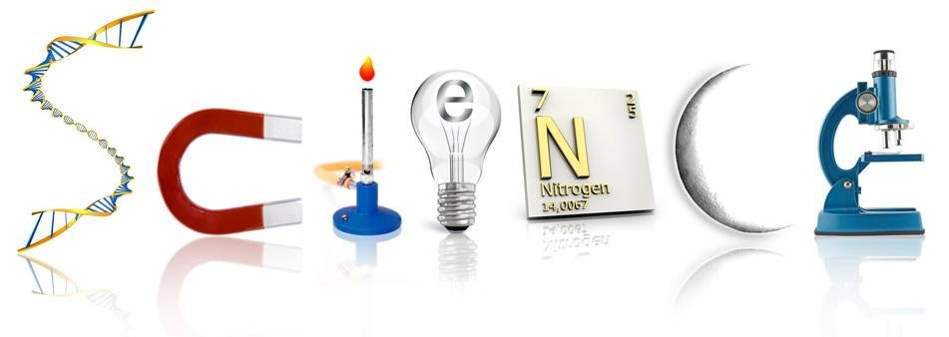

Reading and vocabulary
3. Look at the vocabulary table and check dictionary for spelling and translation of unknown words. Divide them into groups listed below.
Branches of science  (Noun) | Characteristics (Adjective or  Adverb+Adjective) | Action (Verb) | People  (Noun)

electrical welding bridge –building cybernetics  technician cryobiology  geochemistry  renowned  artificial establish microbiology decline  inventor scholar | of sciences materials  integrate humanities mitigate ecologically  designer candidates  sound comprise comply  directly related geologist enrich  science pilot | high –tech mobile natural sciences mechanics portable remote controlled  eminent assure  beneficial affect elect  scientific  implement | experiment gain researcher invent research scientist  discover  remain technical increase produce mutual  launch

4. Before reading the text, try to guess what statements are true and what are false. Then read the text and correct the wrong ones.
- The National Academy of Sciences of Ukraine being the main establishment and cornerstone of Ukrainian science is headed by Academician Yevgen Paton.
- Scientific potential of Ukraine exceeded one and a half thousand scientific institutions and organizations at the beginning of the 21st century.
- The Ukrainian scholars have been trying to cope with the consequences of the Chornobyl Nuclear Power Plant disaster for more than fifteen years.
- The Ministry of Education and Science of Ukraine deals with the governmental management of scientific researches, school activities, etc.
- A lot of Ukrainian scientific articles and publications are translated into foreign languages.

5. Read the text about the types of electricity. Write down two interesting facts you consider to be important. Compare your notes with other students
SCIENTIFIC POTENTIAL OF UKRAINE
Science is a major factor enabling Ukraine to ranked among the advanced countries of the world in the 21st century. Six state academies are leaders of Ukrainian science: the National Academy of Sciences of Ukraine, the Ukrainian Academy of Agricultural Sciences, the Academy of Medical Sciences, the Academy of Jurisprudence, the Academy of Educational Sciences and the Academy of Arts. The Ministry of Education and Science of Ukraine is responsible for the government management of scientific and university activities.
A legal document for the creation of the Academy of Sciences of Ukraine was approved by the Council of Ministers and signed by the Hetman of Ukraine Pavlo Skoropadsky on November 14, 1918. The first academicians were: linguist Stepan Smal –Stotsky, historians Dmytro Bahaliy and Orest Levytsky, biologist Mykola Kashchenko, geologists Volodymyr Vernadsky and Pavlo Tutkovsky mechanic Stepan Tymoshenko, lawyer Fedir Taranovsky. Mykhailo Hrushevsky was invited to become a president of the Academy, but he refused. The Constituent Assembly which took place on November 27, 1918 elected the Academic President Volodymyr Vernadsky, while Ahathanhel Krymsky became the permanent secretary.
Ukraine is proud to adhere to global scientific standards in math, mechanics, physics, computer science, materials science and a number of other trends directly related to the manufacture of high-tech science - more intensive products in addition requested by foreign scientific institutions and industrial companies. For example, a single pilot plant has been built, which simulates the effect of space on spacecraft. Germany and China have purchased the plant and the European Space Agency is using it for research. In collaboration with an American aerospace company, the Institute of Electrical Welding is developing a procedure for producing new materials using the technique of high-speed electron beam evaporation and condensation of matter under vacuum. Researchers from the Institute of Cryobiology and Cryomedicine have organized the production of competitive biological preparations.
During the years of independence, Ukraine has made fundamental progress in the social sciences and humanities. Ukrainian researchers have been involved in the study of scientific, technological, economic, medical and social aspects for more than a dozen years with the aim of mitigating the consequences of the Chornobyl nuclear power plant disaster, transforming the devastated Unit 4 into an ecologically sound system and creating an international test field in the affected area to study the impact of radiation on the environment. Ukrainian science successfully strives to integrate into the international scientific community. Each year, dozens of Ukrainian scientific monographs are published abroad. Many Ukrainian scientific journals are translated into foreign languages. The National Academy of Sciences of Ukraine, headed by academician Borys Paton, its world-renowned president, remains the home of these research institutions.
Taken from: http://hi–tech.org.ua/ukrainian–science/

- Find a translation of the following words:
to attach | скликати
to promote | подолати
to overcome | сприяти
to convene | прикріпити
ignorance | вказати на
to point out | ігнарувати
to dream of | покласти край
to put an end to | мріяти
to assign | відсталість
backwardness | призначити

7. Read the text and change sentences by omitting the construction “it is…/was… that/who” (see App. A)
Serhiy Korolyov is one of the most famous Ukrainian scientist and designer of space rocket systems. He was born in the city of Zhytomir into the family of a teacher.
He is known for being an exceptional creator of practical space engineering. Since 1927, he has worked in the aeronautical industry. He graduated from the Moscow Bauman Higher Technical School in 1930 without giving up his job and the same year left a flight school in Zhytomir. That solicitous man was Korolyov who was one of the founders of modern space engineering. It is Korolyov who trained many scientists and engineers who now direct work in research institutes and design offices specializing in the field of space engineering - rocket.
It was in 1933 that the first experimental rockets were manufactured and tested. It was Korolyov who participated in the work. From 1957, the first Earth satellites in the world were put into orbit using the systems he had designed. It is the spacecraft in which man first flew in the space that was built under his direction. It is Serhiy Korolyov who is one of the most remarkable Ukrainians whose name will remain in the history of world civilization.

Language in Use
8. Find the synonyms and group them up. Make up a short story about any scientific discovery or research using them.
purpose, investigation, to get, field, to reach, sphere, to receive, objective, target, research, to attain, goal, to achieve, aim, area, to gain, branch, to attain.
9. Complete the sentences with the correct forms of the adjectives in
brackets.
1. New York is ___(large) city in the USA.
2. It is not so ____(cold) in winter in the Crimea as in Kharkiv.
3. ____(Few) people live in Poltava than in Kharkiv.
4. Freedom Square in Kharkiv is ____(large) in Europe.
5. The Thames is ____(deep) river in the United Kingdom.
6. The University of Oxford is one of ____(old) universities in the world.
7. English is _____(easy) than Russian.
8. Traveling by plane is _______(fast) but ____(expensive) way of traveling.

10. Choose the correct answer to complete the sentences.
1. Do you study _____ (any, some) foreign languages?
2. Have you got _____ (any, some) questions?
3. You can take _____ (any, some) book you like.
4. I couldn’t speak ____ (any, some) foreign languages when I traveled
abroad.
5. Can you see _______ (anybody, somebody) there?
6. They didn’t tell us _______ (anything, something) about their trip.
7. I think I can do ________ (anything, something) for you.
8. ______ (any, some) students participated in the conference.
Translation
11. Choose the correct translation.
1. Ukrainian scientists split the nucleus of an atom, built the first elementary particle accelerator, discovered heavy water, heavy isotopes of oxygen and hydrogen, founded the schools of mathematics, chemistry, world renowned physics, biology and physiology.
а) Це саме українські вчені поділили атома за допомогою першого прискорювача елементарних частинок, винайшли важку воду, важкі ізотопи кисню і водню, заснували всесвітньо відомі школи математики, хімії, фізики, біології та фізіології.
b) Саме українськи вчені першими зробили поділ ядра атома, виявили важку воду побудувавши перший у світі прискорювач елементарних частинок, важкі ізотопи кисню і водню та заснували всесвітньо відомі школи математики, хімії, фізики, біології та фізіології.
с) Українські вчені розділили ядро атома, побудували перший прискорювач елементарних частинок, виявили складну воду, важкі ізотопи кисню і водню, заснували всесвітні заклади математики, хімії, фізики, біології та фізіології.
d) Тільки українські вчені змогли розділити атом та побудуваті перший прискорювач елементарних частинок у 20-ому столітті, а також виявили важку воду, важкі ізотопи кисню і водню, відвідали всесвітньо відомі школи математики, хімії, фізики, біології та фізіології.

2. Great minds are united under the Ukrainian Academy of Sciences created in 1919.
- Великі розуми України які об’єднались у 1919 році, заснували Академії Наук України.
- Великі розуми України заснували Академії Наук України у 1919 році.
- Великі уми обєднані Академією Наук України, заснованій в 1919 році.
- Величні розуми обєднують Академію Наук України з 1919-го року.

3. Nowadays, the efforts of Ukrainian scientists are aimed at solving the most complicated problem of healing the people who suffered as a result of the accident at the Chernobyl nuclear power plant.
- У теперішній час зусилля українських вчених спрямовані на вирішення найбільш складної проблеми лікування людей, які постраждали в результаті аварії на Чорнобильській атомній електростанції.
- У наш час усі сили українських вчених кинуті на усунення найбільш важких проблем у лікуванні людей, які постраждали в результаті аварії на Чорнобильській атомній електростанції.
- На сьогоднішній день зусилля українських вчених спрямовані на усунення найбільшої спроблеми щодо допомоги людям, які постраждали в результаті аварії на Чорнобильській атомній електростанції.
- Сьогодні українські вчені спрямовують зусилля на рішення важливої проблеми щодо лікування людей, які постраждали в результаті аварії на Чорнобильській атомній електростанції.
4. Ukrainian science successfully strives to integrate into the international scientific community.
- Українська наука робить успішні кроки для інтеграції в міжнародну наукову спільноту.
- Українська громада робить успішні зусилля для прийняття в міжнародну наукову спільноту.
- Українська наука робить деякі зусилля для потрапляння в міжнародну наукову спільноту.
- Українська наука зробила успішні зусилля у сфері інтеграції в міжнародну наукову спільноту.
5. Ukrainian scientists are working on problems that include the world of elementary particles, controlled thermonuclear synthesis, new types of electric generators and others.
- Українські вчені які працюють над проблемами світу винайшли елементарні частки, контрольований термоядерний синтез, найновіші типи генераторів тощо.
- Українські вчені працюють над важливими проблемами сьогодення, які включають в себе сферу елементарних часток, які контрольовані термоядерню реакцією найновіших генераторів тощо.
- Українські вчені працюють над проблемами, які включають світ елементарних часток, контрольований термоядерний синтез, найновіші типи генераторів тощо.
d)Українські вчені планують працювати над проблемами, які будуть включати світ елементарних часток, контрольованого термоядерного синтезу, найновіших типів генераторів тощо.

Speaking and listening
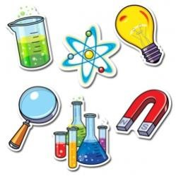
13. Imagine that Ukrainаn scientists have an opportunity to choose one scientific sphere to develop in and get funding for (e.g. nucelar power station, electrical cars, non-tradidional sources of energy).
What could it be? Please, give as many ideas as possible and grounding for them.
Make the exerciese in written form or in a form of dialogue with your partner.
Use the phrases from App. B.
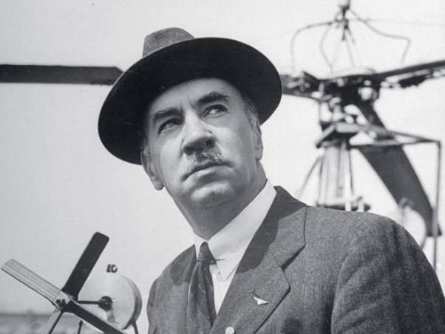
14. Read the text about Igor Sikorsky and make up a diologue. Express your emotions by using specific words you have learned in unite 1.
Igor Ivanovich Sikorsky was a well-known Ukrainian-American scientist, designer and inventor of aircraft. Today, one of the most popular Ukrainian scientists in the world personifies the successful development of three types of contemporary aircraft. Four-engine biplanes, giant seaplanes and multi-purpose helicopters appeared thanks to this legendary aircraft designer.
Igor Sikorsky was born in Kiev, Ukraine. He emigrated to the United States in 1919. His first aircraft, the S-2 Sikorsky, built in his country in 1910. One year later his sixth model, which was named the S-6, set a world record for cruising speed with two passengers. From 1912 till 1914, Igor Sikorsky was the first to built the four-engine biplane "Le Grand", then he improved model "Ilya Muromets".
After emigration, Sikorsky founded his own company "Sikorsky Aero Engineering Corporation" in 1923, where he successfully manufactured various types of planes and helicopters, which made him popular worldwide.
For his significant contribution to world aviation, Sikorsky has received more than 80 honorable awards, prizes and diplomas.
15. Watch the video “Ukrainian scientists develop technology of welding in surgeries” and try to understand the topic they were talking about then fill in the columns describing the contribution of Ukrainian engineers to medicine as shown in the video fragment.

What | Who | Where | When | How | Why

16. Imagine you are a young scientist who is helping Boris Paton Anatolii Makarov, Genadiy Marinsky. Make up dialogues with your partner or write down a short essay (7-10 sentences) about Ukrainien science, medical development, electric welding in diffentent brances of science etc. and dramatize them.

17. Make a report or presentation about your first impressions of being a student of the KPI – Alma Mater of many Ukrainian scientists.

Writing
18. Write a letter (120-150 words) to your foreign friend about Ukrainian scientists and their contribution. Use the words and expressions you have learnt in the unit.
Paragraph 1
present the topic and your opinion
Paragraph 2
series of arguments supporting your point of view with
reasons/justifications/results
Paragraph 3
opposing argument with reasons/justifications/results
Paragraph 4
summarise all the arguments for and restate your opinion

UNIT 2. ELECTRIC CURRENT
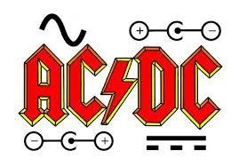
Lead-in
- Look at the picture and make up
dialogues giving your ideas on what is depicted.

2. Practise reading of the following words.
- coulomb /ku:lm/  - ampere / /  - charge / /  - circuit / /  - scientist / / | - conductive / /  - current //  - voltage / /  - fluid / /  - ordinary / /

Vocabulary
3. Link the words with their synonyms and their Ukrainian equivalents.
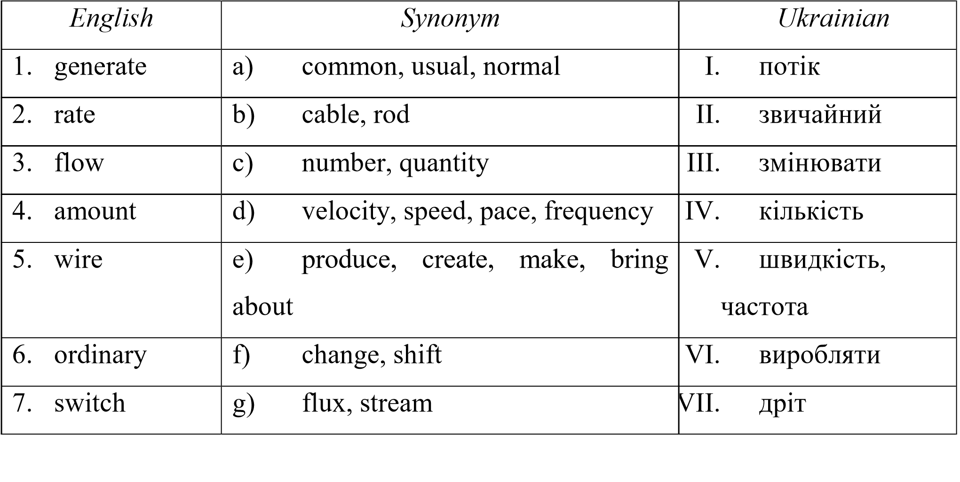

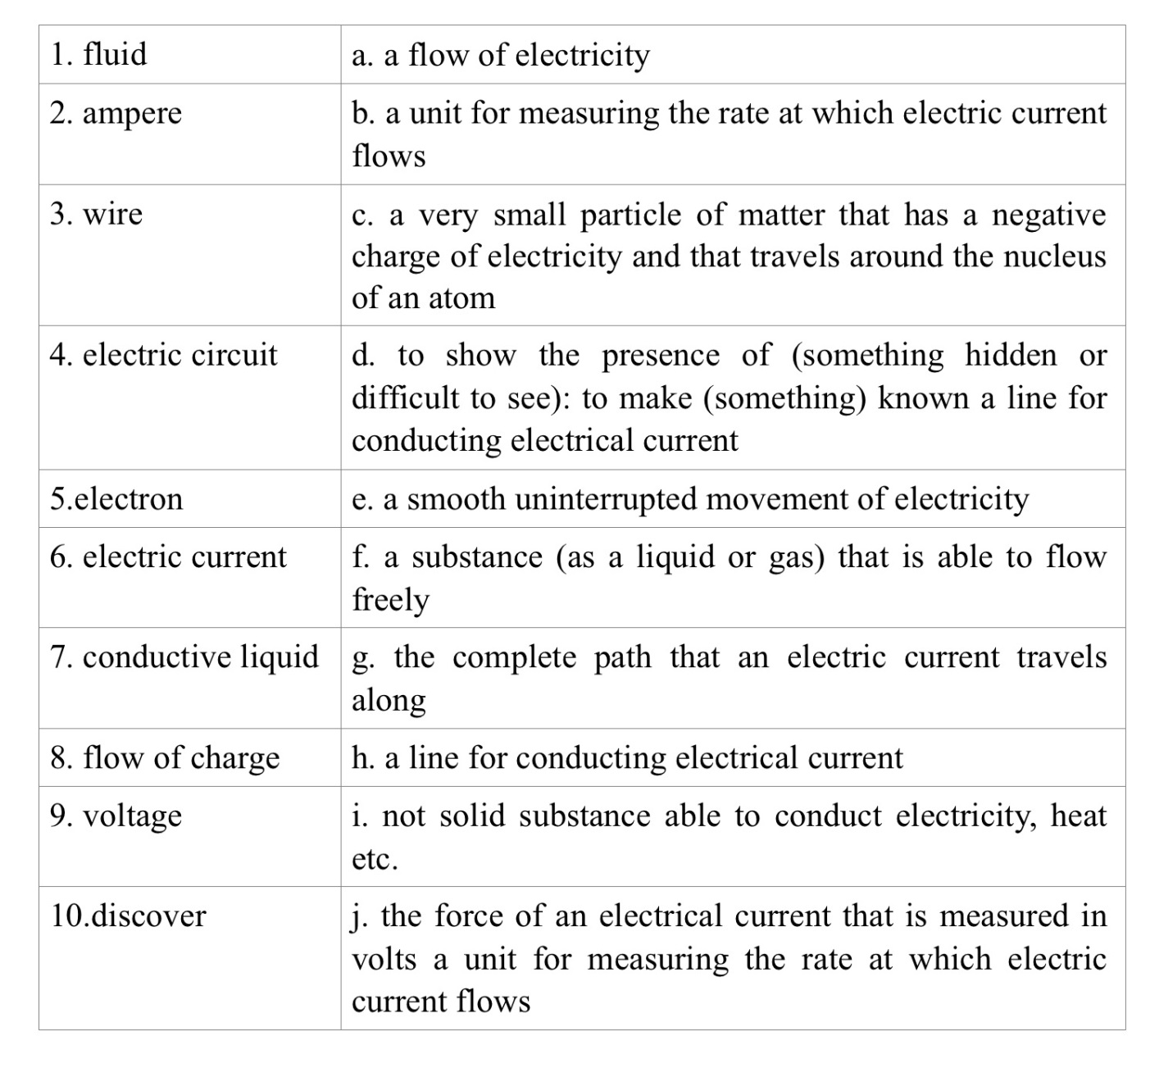
4. Match the terms with their definitions.
Reading and translation
5. Before reading the text, think and answer such questions.
  - What is electricity?
  - How is electricity produced?
6. Decide whether the following statements are true or false and correct them if necessary.
ELECTRIC CURRENT. Part 1
Electric current is the flow of charge. If the current in a wire is one ampere, one coulomb of charge passes through a point in the wire in one second. The unit ampere is a shorter way of saying "coulomb per second".
Benjamin Franklin first used the terms "positive" and "negative" to describe the charge. He believed that electricity was a type of fluid. He thought that positive objects had too much and negative objects had too little. According to Franklin's theory, the extra fluid from a positive object naturally flowed to a negative object. The flow stopped when each object had the right amount of fluid and became neutral. Due to Franklin's work, the direction of electric current is defined as going from positive to negative. Long after Franklin's work, scientists discovered the direction in which electrons travel in a circuit from negative to positive, opposite the way current was defined earlier.
We always define the current as going from positive to negative. For ordinary electrical circuits, it doesn't matter that the negative electrons really move the other way. In a conductive liquid such as salt water, positive and negative charges can move to create current.
Taken from: http://www.allaboutcircuits.com
7. Translate the words and their derivatives.
1)  2)  3)  4)  5)  6)  7)  8) | Electric – electricity – electron  A charge – to charge – charged  Conduct – conductor – conductive  A flow – to flow – flowing  A move – movement – moving  A wire – to wire – wireless  Science – scientific – scientist  To direct – direction – directable | - To define – definition – definite  - To discover – discovery – discoverer  - Magnetism – magnetic – magnet  – magnetisability  - To alternate – alternating –  alternately – alternation  13)Current – currentless – currently  14)To leak – leakage – leaking

8. Read the second part of the text “Electric current” and make a plan for its retelling.
ELECTRIC CURRENT. Part 2
Electric current is measured in units called amps (A), or amps, for short. The unit is named in honor of André – Marie Ampère (1775 - 1836), a French physicist who studied electricity and magnetism.
A small battery powered flashlight uses about 1/2 amp of electrical current. Examine a battery and you will find a positive end and a negative end. The positive end of an AA, C or D battery has a raised bump and the negative end is flat. The electric current of a battery leaves the positive end and returns in the negative end. The amount of electrical current flowing from the positive end of the battery should always be the same as the amount of current flowing through the negative end. You can imagine this rule in your mind with steel balls flowing through a tube. When you push one in, one comes out. The speed at which the balls flow in equals the speed at which they flow out.
Electric current does not leak out from wires the same way that water sometimes escapes from a hose or pipe. Eectric forces are so strong that the current stops immediately if a circuit is broken.
The current from of a battery is always in the same direction, from positive to negative of the battery. This type of current is called direct current or direct current.
Although the letters "DC" represent "direct current", the abbreviation "DC" is used to describe both voltage and current. A continuous tension is that which remains the same sign over time. The positive terminal remains positive and the negative terminal remains negative.
Your home electrical system uses alternating current or AC. The alternating current constantly changes direction. For large amounts of electricity, we use alternating current because it is easier to generate and transmit over long distances. All of the power lines you see above carry alternating current. Other countries also use alternating current. An alternating current or voltage reverses the sign, usually 50 times per second in Ukraine. In the electrical system used in the United States and other countries, the current reverses the direction 60 times per second, so the wall outlets are at a different voltage. When you visit Asia, Africa or the United States, you need special adapters to use the electrical devices you bring from Ukraine.
Taken from:http://www.cpo.com/pdf
9. Use the prompts to complete the questions and try to answer. Change the form of the verb if necessary.
1. first/ a /source /Who/ of/ continuous /produced/ current /source?
2. between /Who/ the/ difference/ between/ the/ /and / determined/ the /static/ charges/ current?
3. can/ What/ you/ say / an / about /electron?
4. carry /Where/ electric / does/ a /wire/ an / current?
5. unit /whom /was/ the / of / After /current /named?
6. did /What / Amper /suppose?

English focus
10. Look at the picture and try to explain the difference between two types of current?
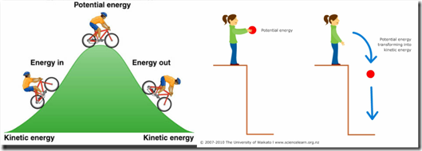

11. Fill in the gaps with suitable words or word combinations given (wires, alternating, rate, circuit, same, transmit, negative/positive).
1._____ the current constantly changes direction. 2. The electric current from a battery flows out of the _____ end and returns to the ____ end. 3. The electric forces are so strong that the current stops immediately if ____ is broken. 4. The ____ at which the balls enter is equal to the speed at which they exit. 5. We use alternating current because it is easier to _____ over long distances. 6. Electric current does not escape from ____. 7. A DC voltage is one that remains the sign ____ over time.
12. Make questions and ask your groupmates. Let him/her answer them.
1. …electricity a form of energy?
2. …a negatively charged electron move to the positive?
3. …first applied alternative current?
4. …is a.c. used?
5. … liquids conduct current?
6. …you say about electrolytes?
13. Translate the following sentences into English and pay attention to the use of modals.
- Сучасний прилад працює в нашій фізичній лабораторії.
- Ріхман виготовив перший електричний вимірювальний прилад.
- Щоб отримати постійний струм, нам необхідно мати його джерело.
- Пірометр застосовується для вимірювання температури плавких металів.
- Дослідники припускали, що струм може протікати в обох напрямках.
- В давні часи було досить небезпечно проводити досліди з атмосферною електрикою.
- Очевидно, що матеріал, через який проходить електричний струм, називається провідником.
- Вчені перетворили сонячну енергію на електричну.
- Людина використовує різні електричні прилади у повсякденному житті.
- Українські вчені внесли великий вклад у розвиток науки.
Speaking and listening
14. a) Before watching the video “Timeline electricity” discuss the following questions with your partner.
- Who discovered the source of current?
- Which discovery do you consider to be the most important in electrical sphere?
- What electrical device can you name?

15. Match the following statements and make sentences.
The electric current is | The flow of electrons in one direction
Lightning is | Electricity at rest
Potential energy is | The energy of motion
Kinetic energy is | A discharge of electricity
The direct current is | The energy of position
Static electricity is | The flow of moving electrons

16. Would you like to live in 19th century and be the pioneer in discovery of electricity? Make a short dialogue with your friend (partner).
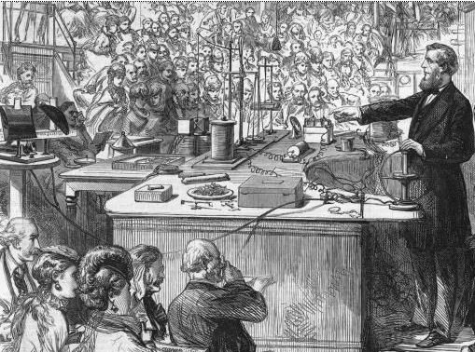
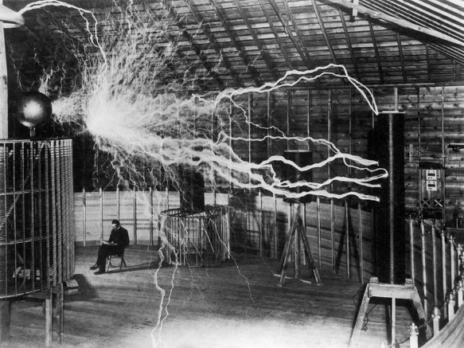

17. Student A. You are Thomas Edison. You have just met your old friend Nikola Tesla (Student B) in Italian café. Discuss with your partner advantages and disadvantages of direct and alternative currents. Consider the options your partner offers.
Thomas Edison (Direct current ) | Nikola Tesla (Alternating current)
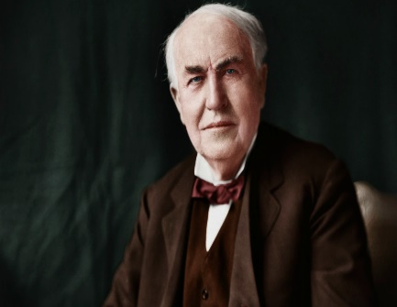 | 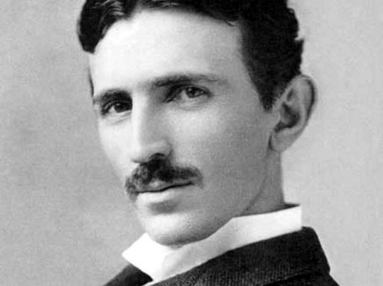
Pros  - Most of electric power consumed in DC. Electric Motor , heating element, electronics, Electric Car and virtually any all electrical machineries consumes electricity in DC.  - A digital control system can be easily implemented to assure accurate and instant control of the active power flow.  - When we integrate DC power line to any existing AC power grid, DC power can generate very fast modulation and can damp the oscillation effect hence of the AC System, thus maintain the stability of the whole system.  Cons :  - Much more complex to set up larger systems above 3kW as multiple strings are required in parallel, plus string fusing.  - More expensive to set up for systems above 5kW as multiple higher voltage solar charge controllers are required.  - Lower efficiency when powering large AC loads during the day due to the conversion from DC-DC-AC. Many solar controllers are not compatible with modern lithium batteries battery management systems (BMS). | Pros  - Efficient Power Transmission  - Gives Power Generation  - Made Power Consumption Possible  - Supplies Better Lighting  - Lower in Cost and Available  Cons :  - Expensive in Cars  Critics posit that AC, when used in cars, can be impractical in terms of costs. Today, Tesla Model S cars give potential car buyers the option to convert AC to DC when charging.  - Need for Insulation  People who are not in favor of Alternating Current argue that high voltages that are essential to supply fixed power supply from AC require increased insulation, which in turn, increase the difficulty of handling it safely. This makes it more dangerous to work with AC than DC.  - AC Generator Issues  For the easy conversion of AC into varied voltages, AC needs to run electrons back and forth.  - Causes Heat and Spark  Opponents of the of AC power say that it is prone to heating and sparking that can potential fires and electric shock. This is because AC generators need to produce high currents.  - Need for Inverters
17. Student A. You are Thomas Edison. You have just met your old friend Nikola Tesla (Student B) in Italian café. Discuss with your partner advantages and disadvantages of direct and alternative currents. Consider the options your partner offers.
Writing
18. Write the essay (120-150 words) about electricity and the way we use it. Use the phrases from the unit.

UNIT 3. ELECTRIC CIRCUIT
Lead-in
1. Practise reading of the following words.
1. | Refrigerator / / | 2. | Socket /sa:kə/
3. | Electricity / / | 4. | Hose /ho:z/
5. | Routine /ru:ti:n/ | 6. | Appliances /əplīən(t)s/
7. | Circuit // | 8. | Muscles / /
9. | Jolt / / | 10. | Fuse /fju:z/
11. | Overload / / | 12. | Capacity / /
2.Match the terms with their definitions.
1. Electron | a. a substance, usually a liquid, which electricity can pass through
2. Static charge | b. an electromotive force or potential difference expressed in volts
3. Electric current | c. an electrical circuit that is not complete
4. Electrolyte | d. a complete electrical circuit through which current can flow when a voltage is applied
5. Direct current | e. a minute particle having a negative electric charge
6. Alternating current | f. a circuit in which electrical devices are connected so that the current flows from one device to another
7. Voltage | g. a safety device in an electric circuit that contains a piece of wire which melts and opens the circuit when there is a fault
8. Electric circuit | h. a stationary electric charge as opposed to electric currents
9. Open circuit | i. a conductor or conductors designed to carry electricity or an electrical signal over large distances
10. Closed circuit | j. a flow of electric charge through a conductor
11. Series circuit | k. a circuit that provides two or more paths for the passage of the current so that part of the current flows through one part, and part through another
12. Parallel circuit | l. an electric current flowing in one direction only
13. Short circuit | m. an electric current that periodically reverses direction
14. Fuse | n. a circuit in which the current is allowed to return to the source of supply without control
15. Transmission line | o. a complete path which carries the current from the source of supply to the load and then carries it from the load back to the source

Reading and translation
3. Read and translate the text. Make a plan for its retelling.

ELECTRIC CIRCUITS. Part 1
An electrical circuit is a complete path traveled by electricity. A good example of a circuit is that of an electric toaster. The bread is toasted by radiators which convert electrical energy into heat. The circuit has a switch that turns on when the lever on the side of the toaster is lowered. When the switch is turned on, electrical current enters one side of the plug from the wall outlet and passes through the toaster and out the other side of the plug.
The wires in electrical circuits are similar in some ways to pipes and hoses that carry water. The wires act as pipes for the electric current. The current enters the house on the supply wire and exits on the return wire. The big difference between wires and water pipes is that you can't get electricity to leave a wire like water comes out of a pipe. If you cut a water line, the water drains. If you cut a wire, the electric current stops immediately.
Circuits are not limited to devices, wires and devices built by people. The first experience humans have had with electricity was in the natural world. Here are some examples of natural circuits:
- The nerves in your body are an electrical circuit that transmits messages from your brain to your muscles.
- The tail of an electric eel makes a circuit when it stuns a fish with an electric shock.
- The Earth makes a gigantic circuit when lightning carries electric current between the clouds and the ground.
Taken from: http://www.cpo.com/pdf
Language in Use
4. Fill in the correct preposition then choose any three phrases and make sentences using Complex Object/Subject.
- To switch … a light
- conditions that
- To be made … wires
- To carry messages ... brain …
- To path … the fuse muscles
- To be similar ….
- The difference … wires and
- To be connected … series water pipes
5. Find English words and word –combinations according to their Ukrainian equivalents (you can go across and down).
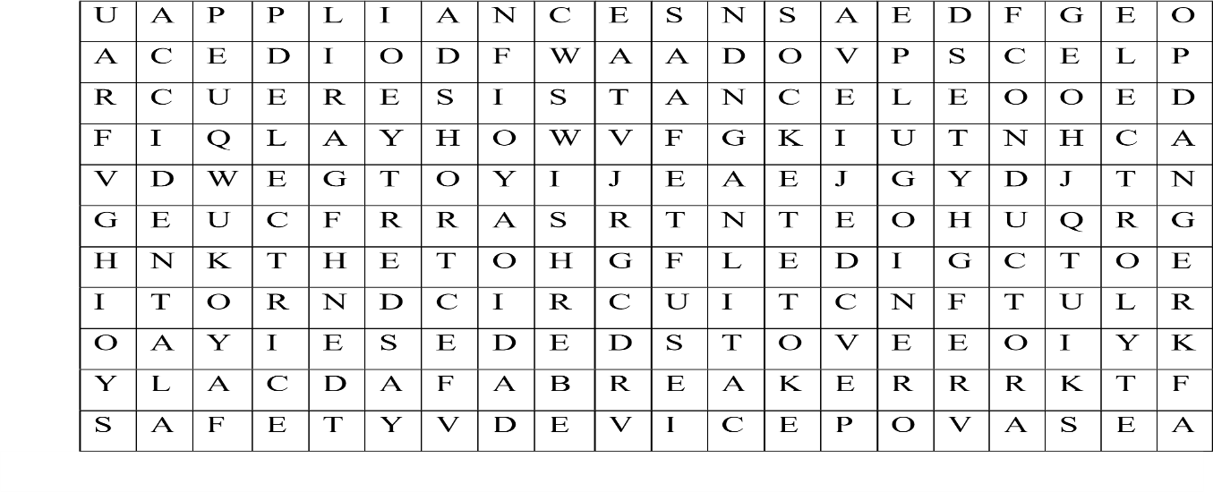
1. коротке замикання | 2. розетка (роз’єм) | 3. безпека
4. провідник | 5. електроліт | 6. небезпека
7. побутове електрообладнання | 8. електрична вилка | 9. прилад
10. випадково | 11. автоматичний вимикач | 12. опір
13. вимикати (відключати) | 14. «пробка» (плавкий запобіжник) | 15. розетка

6. Study the table. Then copy the symbols and practice their understanding in the game http://www.tutorvista.com/physics/animations/electric –circuit – symbols –animation. Draw a simple circuit using these symbols and describe it.
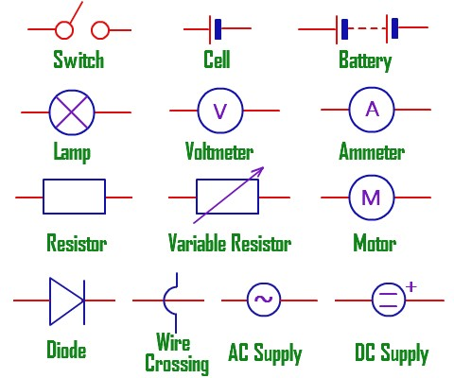
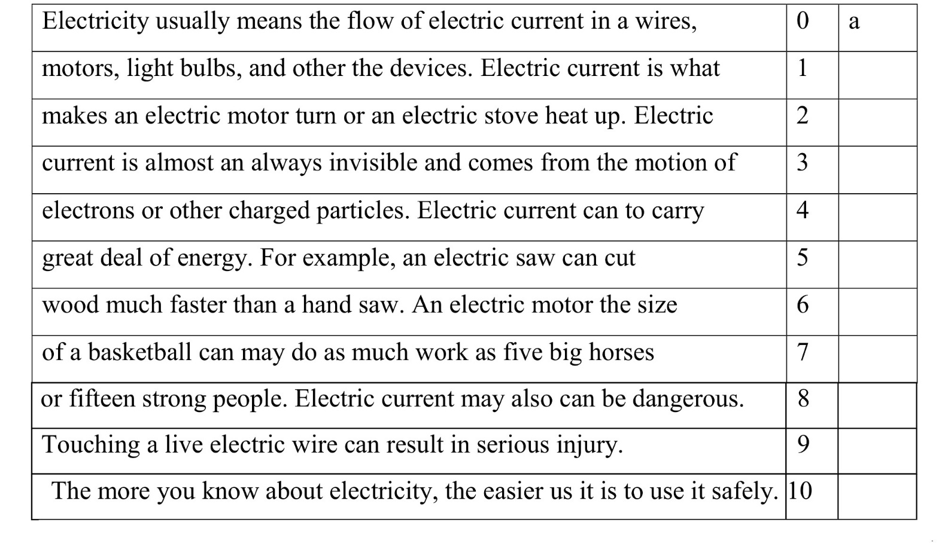
7. Look through the text and find the odd word. Some lines are correct.

8. Translate the words and their derivatives.
- To convert – converted – converter – convertible  - To carry – carrying – carrier  - To stun – stunned – stunning  - Fault –faulty – faultless  - To connect – connection – connected – | - Safety – safe – unsafe  - To pass – passage – impassable  - To overload – overloading – overloaded  - Produce – production – productive  - Fuse – fussed – diffuse – diffusion disconnected

Reading
9. Read the second part of the text “Electric circuits” and translate.

ELECTRIC CIRCUITS. Part 2
There are different types of electrical circuits such as: open circuits, closed circuits, series circuits, parallel circuits and short circuits.
Understanding the difference between the following circuit connections is not difficult at all. When electrical devices are connected so that current flows from one device to another, they are supposed to be connected in series. Under such conditions, the current flow is the same in all parts of the circuit, since there is only one path along which it can flow. The bell-shaped electrical circuit is considered to be a typical example of a series circuit. The parallel circuit provides two or more channels for the flow of current. The circuit is divided so that part of the current flows through one path and part through another.
Home appliances and electrical outlets are connected in many parallel circuits. The lamps in your room and in your home are usually connected in parallel. Each circuit has its own fuse or circuit breaker which stops the current if it exceeds the safe quantity, generally 15 or 20 amps. If you turn on too many devices in the same circuit at the same time, the circuit breaker or fuse cuts the current. To restore power, you must first disconnect all or part of the appliances. Then switch the tripped circuit breaker (in newer homes) or replace the blown fuse (in older homes). Fuses are also used in car electrical systems and in electrical devices such as televisions.
We will now turn our attention to the short circuit sometimes called "the short circuit". The short circuit is produced when current can return to the power source without control and without doing the job we want it to do. The short circuit is often the result of a cable or wire fault. Under certain conditions, the short circuit can cause a fire because the current flows where it was not supposed to flow. If the current flow is too large, a fuse must be used as a safety device to stop the current flow.
The fuse must be placed in each circuit where there is a risk of overloading the line. Then all the current to be sent will pass through the fuse.
When a short circuit or overload causes more current to flow than the load capacity of the wire, the wire becomes hot and ignites the insulation. If the current flow is greater than the load capacity of the fuse, the fuse blows and opens the circuit.

Taken from:http://www.cpo.com/pdf
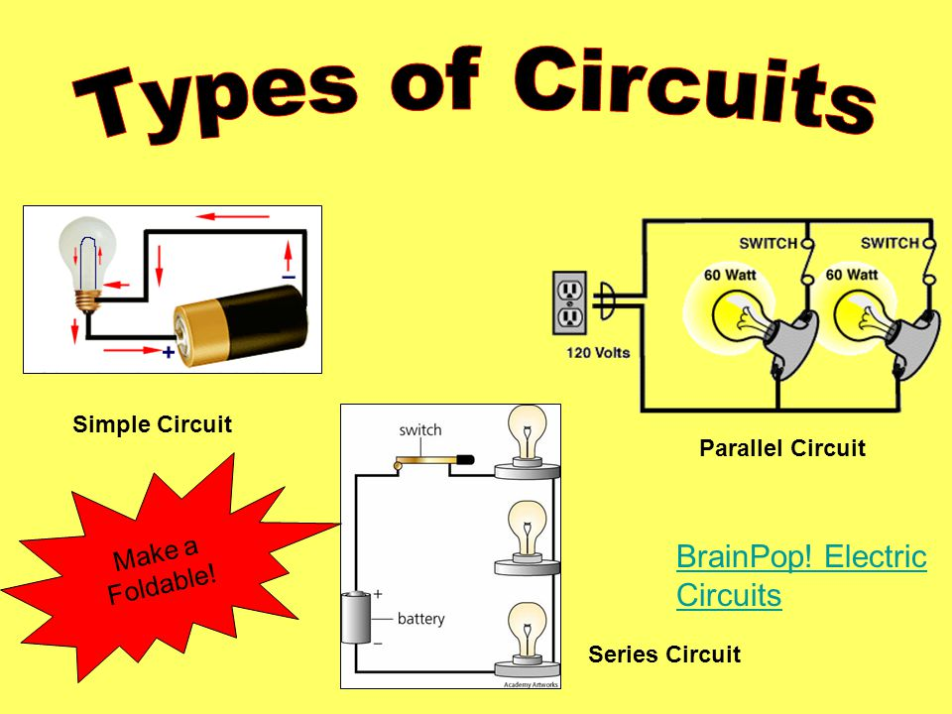
10. Make a short dialogue with your groupmate about diffent types of electric circuits using words from the text above.
Language in use
11. Fill in the blanks with suitable words or word combinations given below.
circuit breakers, appliances, structure, short circuit, power, outlet.
Houses have electrical wiring carrying 1) _____ to run household 2) ____. These systems have 3)_____ to interrupt power if a dangerous 4) _____ occurs. Usually, this short circuit is in an appliance that is plugged into an electric 5) ______. Sometimes the short circuit is in the house wiring itself, which creates a fire hazard in the walls of the 6)_____.
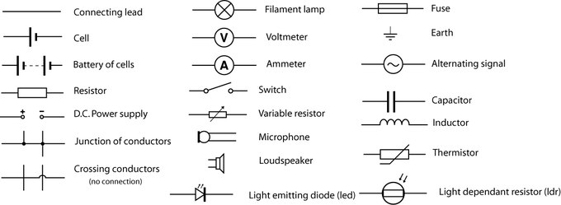
12. At the picture you can see electric circuit symbols. Explain to your partner what is each symbol responsible for?

13. Translate the sentences paying attention to the Complex Object with the Participle.
- We have already mentioned this connection as the most common one.
- Bohr recognized the substance as having a high conductivity.
- He conceived valence as being a property of atoms and to be a constant for each element.
- We may think of this fault as being just the reason for the fire alarm switching on.
- Franklin considered bodies had specific fluid being the conductor of electricity.
- He regards this concept as being not a simple one.
- Electrocardiogram seems to be the graph of measuring current flow in the body.
- I had others consider my opinion.

Speaking
14. Students have plenty of experience using everyday household appliances that rely on electric circuits for their operation (mobile phones, iPods, etc). Imagine your life without electric circuit, how would you exist without all gadgets.

15. Draw circuits with the following characteristics and sign all the components.
- A series circuit with a battery, a switch and two bulbs.
- A parallel circuit with a battery, a switch and three resistors.
- A series circuit with a battery, a two –way switch, a bulb and a bell.
- A parallel circuit with a battery, a bell, a motor and a voltmeter.

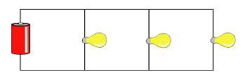
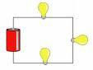
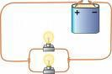
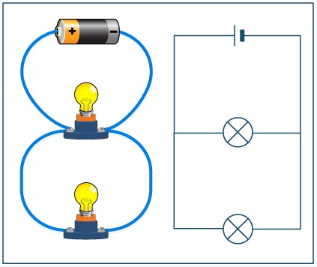
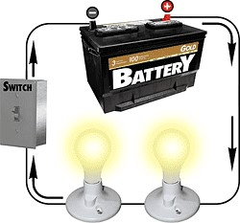
16. Think about the circuits you see. Choose one and describe it naming all electric circuit symbols.
b)

d)

e)
a)
c)

Writing
17. Have you ever had electrical accidents at home? How did you fix that? Write a short summary (100-120 words).

UNIT 4. CONDUCTORS AND INSULATORS
Lead-in and vocabulary
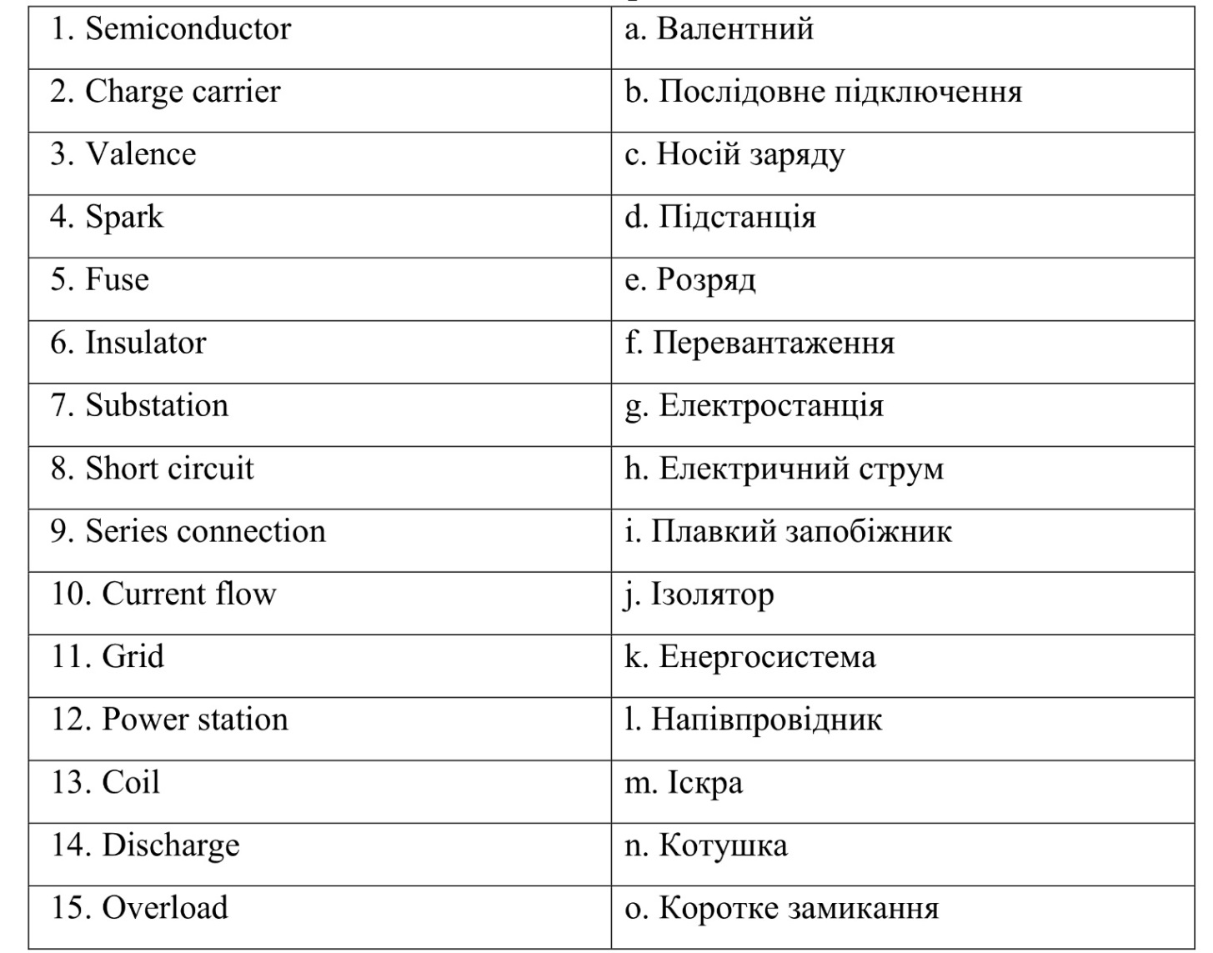
- Match the terms with their Ukrainian equivalents.

2.Find the pairs of opposite notions.
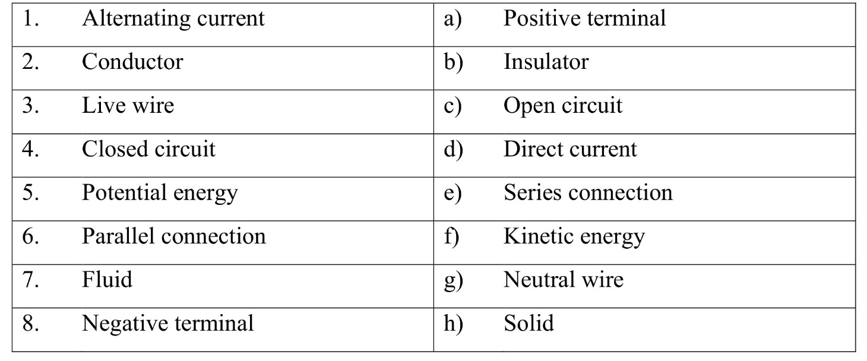
Reading and listening
3. Watch the presentation “Conductors and insulators”. Read the text to find out more about conductive/non –conductive materials. Make a plan for retalling.

CONDUCTORS AND INSULATORS
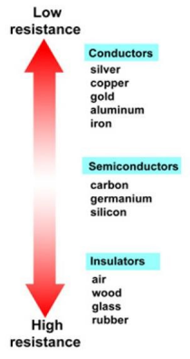
Current flows easily through certain materials, such as copper, called conductors. A conductor can conduct or transport electrical current. Most metals are good conductors. Other materials, such as rubber, glass and wood, do not allow current to pass through them easily. These materials are called insulators because they isolate or block the flow of current. Some materials are found between the conductors and the insulators. These materials are called semiconductors because their capacity to transport current is greater than that of an insulator but less than that of a conductor. Computer chips, televisions and portable radios are among the many devices that use semiconductors. You may have heard of a region of California called "Silicon Valley". Silicon is a semiconductor commonly used in computer chips. An area south of San Francisco is called Silicon Valley because there are many semiconductor and computer companies.
No material is a perfect conductor or insulator. A certain amount of current will always flow through any material if a voltage is applied. Even copper (a good conductor) has some resistance. Figure 1 shows how the resistances of various conductors, semiconductors and insulators compare.
Conductors and insulators are necessary materials in human technology. For example, a wire has one or more conductors inside and insulation on the outside. An electrical cable can have twenty or more conductors, each separated from the others by a thin layer of insulation. The insulating layer prevents other wires or other objects from being exposed to the current and voltage carried by the conductive core of the wire.
If an excess charge is placed on an insulator, it will stay where it is placed and there will be a concentration of charge in this area of the object. However, if an excess charge is placed on a conductor, similar charges will repel and spread over the surface of the object.
When two conductors are brought into contact, the total load on them is shared between the two. If the two conductors are identical, then each conductor will end up with half of the total load.
Taken from: http://www.cpo.com/pdf
4. Read the text again and make a plan or picture formulating main ideas from the text.

5. On this picture you can see conductors and insulators. Try to explain to your groupmate the way these objects are used in everyday life.
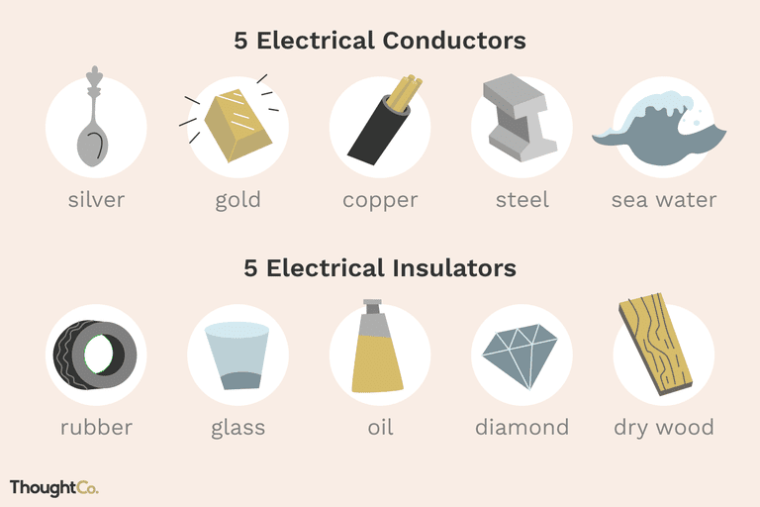

6. Read the sentences in English and translate them into Ukrainian.
- Важливо зупинити електричний струм, коли є загроза перевантаження лінії.
- Ми знаємо, що вчені зробили великий внесок у світовий розвиток науки.
- Вчені представили нові машини для випробувань та вимірювальні прилади.
- Перше джерело постійного струму сконструйоване Вольтом у 1800 році.
- Ці електричні пристрої можуть працювати довгий час за умови, що вони будуть зроблені з високоякісного матеріалу.

Language in Use
7. Choose the words that are most nearly the same in meaning to the bold ones and explain them:
- transmit – send, transfer, promote, support
- invent – create, devise, develop, find
- powerful – great, strong, effective, long
- carry – include, conduct, bring, occupy
- store – keep, follow, confirm, make
- perfect –good, past, ideal, super

- Divide all these pictures into two columns
Conductors Insulators
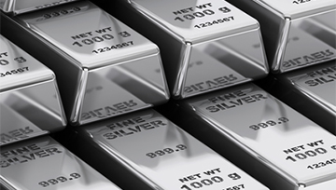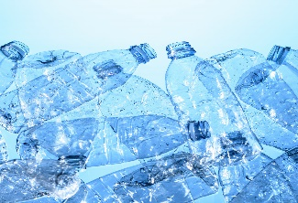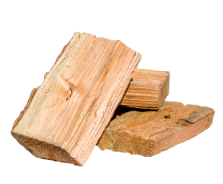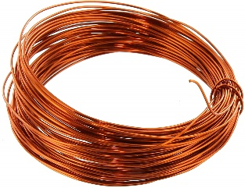
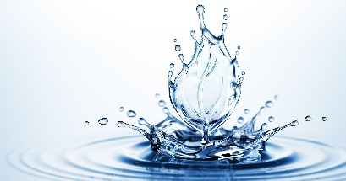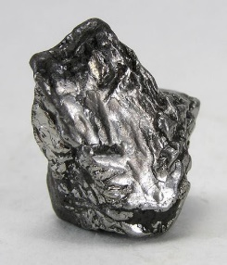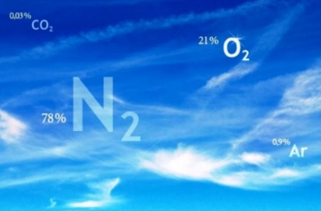
Language focus
- Translate the following words and words combinations using vocabulary and write down 5-6 sentences.

Отримані дані, нуковий досвід, найбільш широко використовується, найкоротший шлях, розетка, побутові прилади, один з найкращих ізоляторів/провідників, матеріал, дріт, особливість даного матеріалу, подібний до.

10. Put words in columns for meaning
Electrical Conductors |  | Electrical Insulators
- Silver  - …  - …  - …  - … | - …  - …  - …  - …  - … | - Rubber  - …  - …  - …  - … | - …  - …  - …  - …  - …
Iron, Air, Dry wood, Oil, Mercury, Platinum, Glass, Seawater, Pure water, Dry cotton, Copper, Steel, Diamond, Concrete, Plastic, Gold, Aluminum, Asphalt

11.Put the words in the correct order to make up sentences.
- Water/weakly /insulator/pure/dirty/is/conducts/an/ while/water.
- good conductors / are/ neither/nor/ good insulators/ Most materials.
- readily/so/top/and/gain/electrons/ lose/they/ Metals/the list/ of /conductors.
- also /affects /conductivity/Temperature.
- when /Most metals/and /are better /conductors/cool/less/efficient conductors /when/ hot.
- heating /can /The flow /of /electrical current /to/ the /of /a conductive /material/ lead.
- conductors/ become/ at/extremely/ low temperatures/ Some/ superconductors.
- have /free /on /its /Conductors surface /which/ allows /current /to /pass /through/electrons.

12. Read the sentences and choose the correct answer.
- Hydrogen can …… as fuel in transport, industry and home.
- be using b) use c) be used d) uses
- Next year this magazine …… some articles on the use of his discovery.
- publishes b) will publish c) published d) will be publishing
- Coal- and oil-powered industries excite ugly pollutants; nuclear generators ….
- is not b) does not c) do not d) did not
- Why …. additional supplies of energy ….?
- do need b) have needed c) are needed d) is need
- Heat is known to pass from a … body to a colder one.
- hot b) hotter c) hottest d) more hot
- Our aim is …. this task as soon as possible.
- to be accomplished b) to accomplish c) accomplishing
d) accomplished
- At present they ….. various aspects of this problem.
- are studying b) were studying c) study d) have studied
- In order to produce electricity more economically the generators …. be as large as possible.
- may b) can c) must d) should
- What ….. the electrons to flow along the wire?
- causes b) does cause c) cause d) are causing
- Ernest Rutherford conducted a series of experiments which ….. to the modern concept of the atom.
- lead b) led c) are leading d) leads

Speaking and reading
13. Summarize all your knowledge you have learned at the lesson about conductors and insulators and make a short dialogue on the topic “Conductors and insulators are vital for electicity existance”.

14. Engineers can also make jokes. Read and translate the following jokes discuss them in pairs.
- A chemist, a biologist and an electrical engineer had all been sentenced to death and were on death row waiting to go to the electric chair.
Finally, the day had arrived. The chemist was due to go first.
As he strapped him in, the executioner asked him, "Do you have anything you want to say?"
The chemist replied, "No," so the executioner flicked the switch but nothing happened. According to this State's law, if an execution attempt fails, the prisoner has to be released. So the chemist was unstrapped and allowed to walk free.
It was the biologist's turn next.
As he was being strapped in, the executioner asked him, "Do you have anything you want to say?"
The biologist replied, "No, just get on with it" so the executioner flicked the switch, but once again nothing happened. So, just like the chemist, the biologist was released.
Then the electrical engineer was brought forward.
The executioner asked him, "Do you have anything you want to say?"
The engineer replied, "Yes. If you swap the red and the blue wires over, you might just make this thing work."

- A superconductor walks into a bar. The bartender says, "Get out! We don't serve your kind here."
The superconductor left without resistance.
- One day, a tuba player wanted to torture the drummer behind him, so he hid one of the drummer’s sticks. After looking around for a few minutes, with a frantic, wide-eyed expression, the drummer fell to his knees, flung his arms wide, and screamed to heaven: “Finally! The miracle, after all these years! I’m a Conductor!”

Writing
15. Make a research and write a letter (120-150 words) to your friend in any English–speaking country telling about :
- advantages and disadvantages of china/rubber insulators;
- advantages and disadvantages of copper/aluminium conductors in domestic use.
UNIT 5. EMF AND RESISTANCE
Lead-in and vocabulary
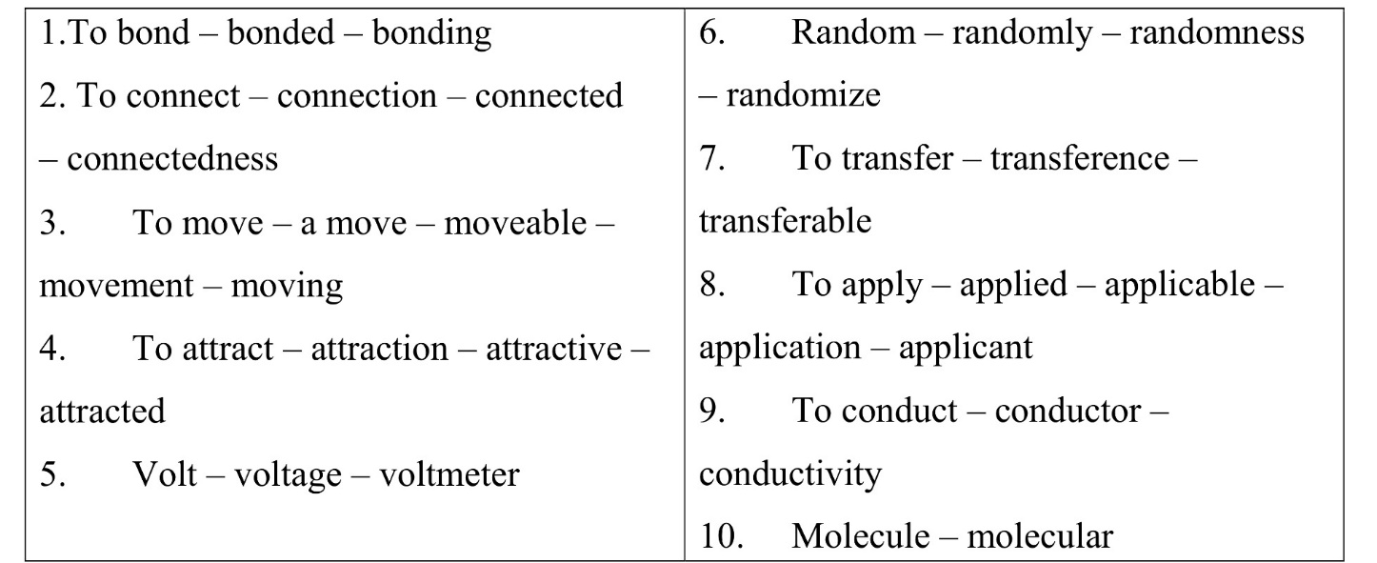
- Translate the words and their derivatives.

2. Match the terms with their definitions.
1.Repel | a) the smallest unit into which any substance can be divided without losing its own chemical nature, usually consisting of two or more atoms
2.To bounce | b) firm or hard : not having the form of a gas or liquid
3.Solid | c) to be joined together
4.To be bonded | d) a material or object that allows electricity or heat to move through it
5.Velocity | e) to move in one direction, hit a surface (such as a wall or the floor), and then quickly move in a different and usually opposite direction
6.Randomly | f) to pull to or draw toward oneself or itself
7.Conductor | g) to force (something) to move away or apart
8.To drift | h) quickness of motion
9.Attract | i) without definite aim, direction, rule, or method
10.Molecule | j) to move slowly especially over water or through the air
Reading
3. Put the words in the correct order to make questions and try to answer them before reading the text.
- which / do /atoms /bond /conditions/ together /by /sharing /electrons /Under?
- does /solid/ of /copper /act /in/ piece / some /ways /How?
- In /which/ case /the / electrons/ do /bounce/ around/ at /high/ speed/ free/?
- which/ case /are/ In / the/ free/ electrons /attracted /to /the /positive/ terminal/ and/ repelled/ by/ the /negative/ terminal /free?
- do /electrons/ not/ move /Why/directly/ from/ one/ end /of/ the /wire /to/ the /other/ end?
- do / bounce/ off/ the / electrons/ atoms /When?
- creates / What /electric /current?
- explains/ how/ What /wires/ heat/ up/ when/ current / passed/ is / through/ copper /atoms?
- is /a /good /conductor/ What / of /and /electricity/heat?
- the/ which /conditions/ do/ all /the/ free/ Under / electrons/ in / wire/ start/ drifting?
- Read and translate the text.

EMF AND RESISTANCE
Suppose there is a movement of electrons through the wire, say from point A to point B. What does this mean? This means that there is an excess of electrons at point A. Unless there was an electric current flow between A and B in any direction, it would mean that the first and the second were at the same potential. Of course, the larger the potential difference, the greater the flow of electrons.
When you measure the potential difference between (or between) the terminals of a battery, you measure the "electromotive force" (emf) of the battery. This is the amount of potential energy available to the battery to pass the charges through the circuit. This potential driving energy is equal to the total drops of potential energy in the circuit. This means that the voltage across the battery is equal to the sum of the voltages in the circuit.
When the atoms of a metal (like copper) are together, they all bond together by sharing electrons. In some ways, a solid piece of copper acts like a single huge molecule. Some valence electrons can move freely anywhere in copper. The copper atoms with the remaining electrons are bonded together and remain fixed in place.
If a copper wire is not connected to a battery, the free electrons rebound at high speed. They have no average movement because as many go in one direction as in the other. However, free electrons move energy very efficiently, so metals are good conductors of heat as well as electricity.
If a battery is connected through a copper wire, the free electrons are attracted to the positive terminal and repelled by the negative terminal. However, the electrons do not move directly from one end of the wire to the other because the copper atoms are on the way. Instead, the electrons bounce off the atoms while slowly moving towards the positive end of the battery. The electric force created by the battery voltage creates a slow drift speed in a direction above the random bounce of the electron. This slow drift speed is what creates an electric current. The rebound transfers some energy from the drift movement to the copper atoms. This explains how the wires heat up when current flows through them.
With a 1.5 volt battery, the drift speed is slower than a turtle, a few millimeters per second. So why does the bulb light up instantly? The electrons carrying current in a wire do not come from the battery. Current flows because the voltage of a battery moves electrons that are already in the wire.
This is why a bulb lights up as soon as you activate the switch. A copper wire contains many electrons bouncing at random. Without applied voltage, as many electrons bounce in one direction as in the other. There is no net flow of electrons and no electric current. When a voltage is applied, all of the free electrons in the wire begin to drift due to the electrical force.
Taken from: http://www.cpo.com/pd/
5. Decide whether the following statements are true or false and correct them if necessary
- A flow of electric current between two points can be only in one direction
- The potential difference affects the electron flow.
- The voltage between two batteries is the same as in the circuit.
- When atoms of a metal are together they all bond together by sharing a negative particle.
- The free electrons bounce around at high speeds, if a copper wire is not connected to a battery.
- A copper wire contains many positive particles bouncing randomly around.
- When a voltage is applied all free electrons in the wire start drifting the path of least resistance.

Language in use
6. Make the sentences with the following words.
bond, drift, repel, solid, conductor, bounce, velocity, attract randomly, molecule

7. Match the items from the two columns to make word combinations.
Then make sentences with these word combinations and the word provided
- Random  - Battery  - Copper  - Drift  - Light  - Free/valence  - Electric  - Single/huge  - Positive/negative  - Average | a.  b.  c.  d.  e.  f.  g.  h.  i.  j. | Bouncing  Velocity  Bulb  Voltage  Terminal  Molecule  Atom/wire  Force  Motion  Electrons

8. Translate the following sentences into English.
- Тверді частинки міді в деяких випадках поводяться, як цілісні молекули
- Як-відомо, валентний електрон може безперешкодно рухатись у будь –якому напрямку в межах речовини.
- Неметали зазвичай являються поганими провідниками тепла та електроенергії.
- Вільні електрони дуже ефективно переміщують енергію.
- Вільний електрон завжди притягується до позитивного полюса та відштовхується від негативного.
- Електричний струм виникає внаслідок повільної дрейфової швидкості.
- Усім відомо, що у мідному дроті міститься багато хаоточних електронів, які стрибають у різних напрямках
- Електричний струм протікає через те, що напруга від батареї змушує електрони рухатись.

Language focus
9. Put the words in the correct order to make the sentences about EMF and decide whether of them are true or false.
- /atoms /of /a /metal/ they/ (like copper) /are/ When / free, // all /bond /together /by /sharing/ electrons.
- /some /ways/ a/ solid /piece /single / of /copper / In /acts /like /a //huge /molecule.
- valence /electrons /cannot / where/ move /freely/ any/ Some/ within/ the/ copper.
- a /copper/ wire /is /not /connected/ to /a/ battery/ If / the/ free/ bounce/ around /at /high /speeds/ electrons.
- Meare /good / of/ heat /as well as/ Metals / conductors /electricity.
- The/ electrons/ the/ atoms /while /slowly /making/ bounce /off / their/ way/ toward /the /negative /end /of /the /battery.
- drift /velocity /is/ what /creates /electrical / The /slow /current.
- because/the /voltage/ from/ a /battery/ Current/ flows/ makes /electrons/ move /that /are/ already/ in /the /wire.
- electrons /bouncing/ randomly/ A /copper/ wire /contains /many /around.
- When the/ free /electrons /in /the /wire/ start /a /voltage/ is/ applied/ all/ drifting /because/ of/ the /slow /velocity.

10. Make the sentences on topic EMF using the following word combinations.
- In the same manner.
- As well as
- As a result
- In spite of
- For this reason
- Generally speaking
- Under consideration
- On the basis
11. Match the words in line a) with their synonyms in line b)
try | accomplish
computer geek | build up
architect | programmer
construct | achieve
actualize | combine
put together | advise
manage | test
guide | creator

Listening and speaking
12. Watch the video “EMF and resistance”. Write down the key words and than make a short dialogue with your partner due to the words you have written down.
13. Explain the Nikola Tesla’s quote below in your own words.
“What we now want is closer contact and better understanding between individuals and communities all over the earth, and the elimination of egoism and pride which is always prone to plunge the world into primeval barbarism and strife... Peace can only come as a natural consequence of universal enlightenment...”
― Nikola Tesla

14. Work in pairs. Choose one of them and discuss with your partner.
1. Name the main components
2. Try to explain how does it work
3. Tell your partner where can it be used in our everyday life
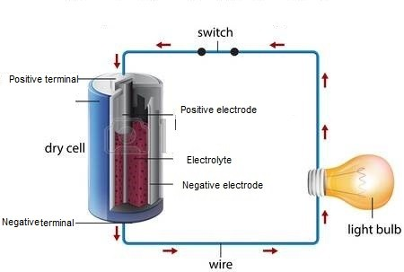
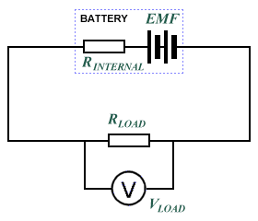
Writing.
15. Look at the pictures. Choose any of them. What dangers can you see? Make sentences using the 1st conditional.
e.g. If someone opens the door, the woman will fall off the chair.
- 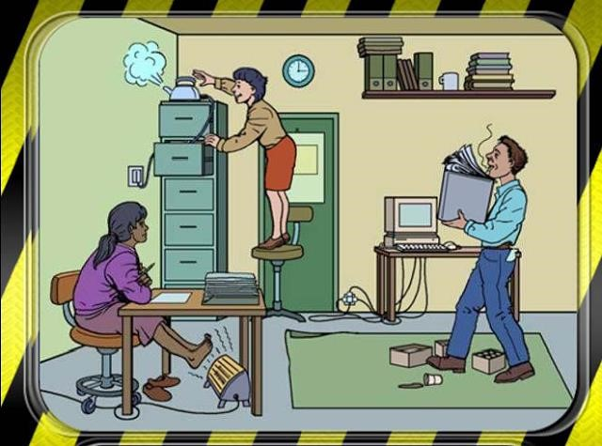

- 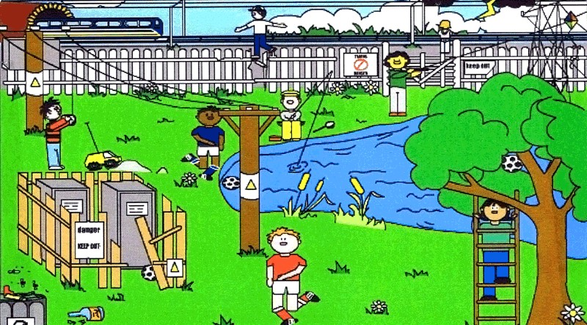

UNIT 6. GENERATORS
Lead-in and vocabulary
1. Find the synonyms and translation to the words.
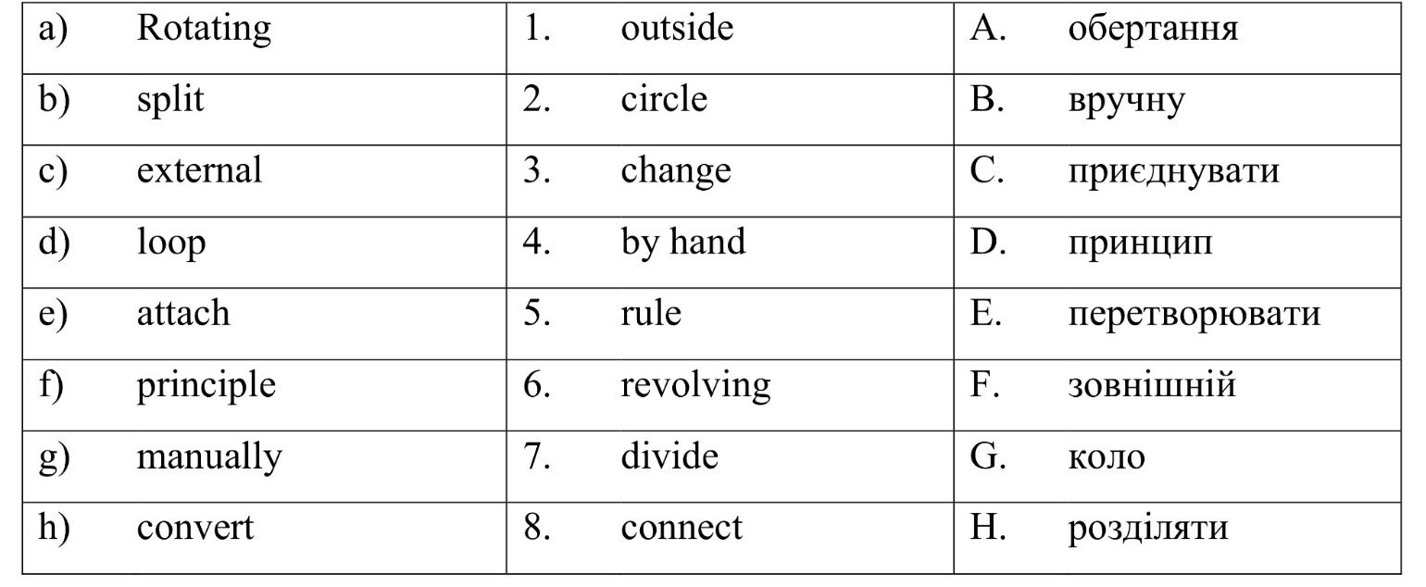
2. Find the definition to the term.
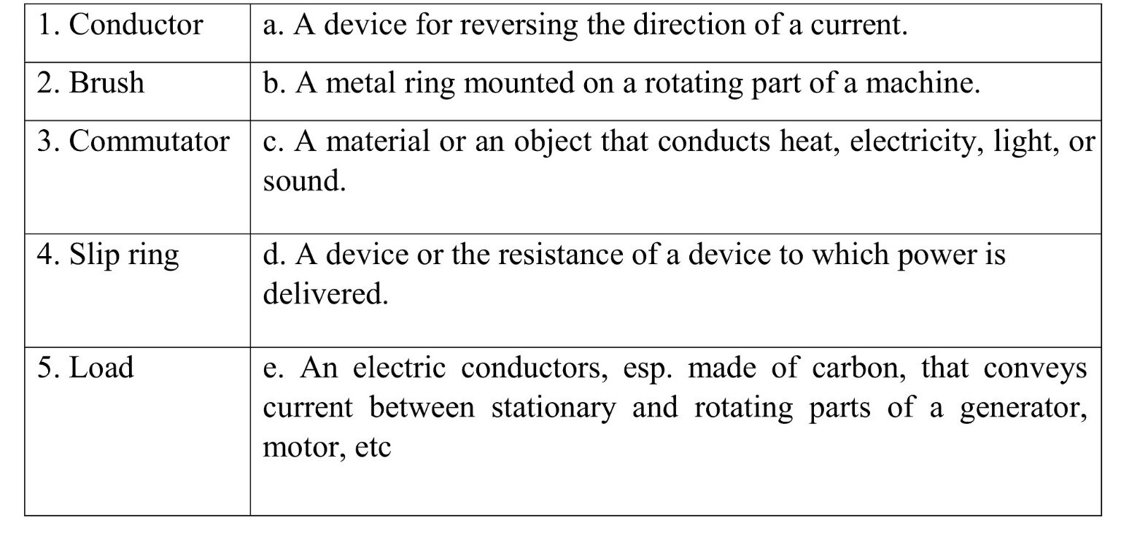

Reading and translation
3. Look through the text and decide what picture is for AC generator and what is for DC generator.
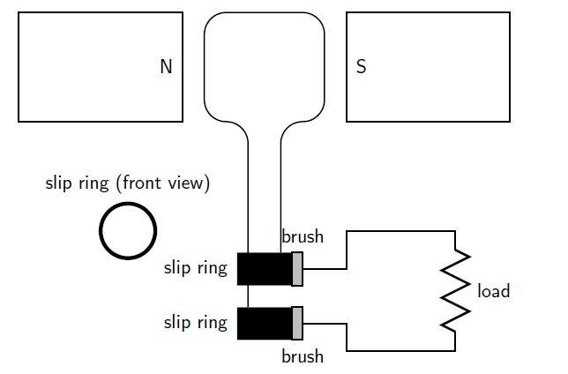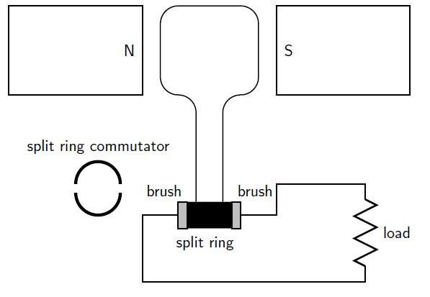

4. Read and translate the text

GENERATORS
The principle of the rotation of a conductor in a magnetic field is used in electricity generators. A generator converts mechanical energy into electrical energy. The coil-shaped conductor is connected to a ring. The conductor is then manually rotated in the magnetic field, generating an alternating FEM. The slip rings are connected to the load via brushes. If a machine is designed to rotate a magnetic field around a set of fixed wire coils with the rotation of a shaft, an alternating voltage will be produced across the wire coils during the rotation of this shaft, in accordance with the Faraday's law on electromagnetic induction. This is the basic operating principle of an AC generator.
In an alternating current generator, the two ends of the coil are each attached to a slip ring which comes into contact with the brushes when the coil rotates. The direction of the current changes with each half-turn of the coil. When one side of the loop moves to the other pole of the magnetic field, the current there changes direction. The two slip rings of the AC generator allow the current to change direction and become an alternating current.
AC generators are also called alternators. They are found in cars to charge the car battery. A DC generator is constructed in the same way as an AC generator, except that there is a slip ring divided into two parts, called a switch, so that the current in the external circuit does not change direction. The split ring switch adapts to the change in direction of the current in the loop, creating a direct current passing through the brushes and outgoing to the circuit.

Taken from: http://qatemplates.everythingscience.co.za
- Make the sentences with the words from bold.

Improvement, founded, advancement, substantial, generators, diminished, inventions, license, motor, decisive

Language in Use
- Match the verbs of column A and nouns of column B to make terminological phrases:
B
А

Connect | Voltage
Drive | Wire
Generate | Turbines
Oppose | Resistance
Measure | Homes
Transform | Current
Contain | Information
Heat | Electricity

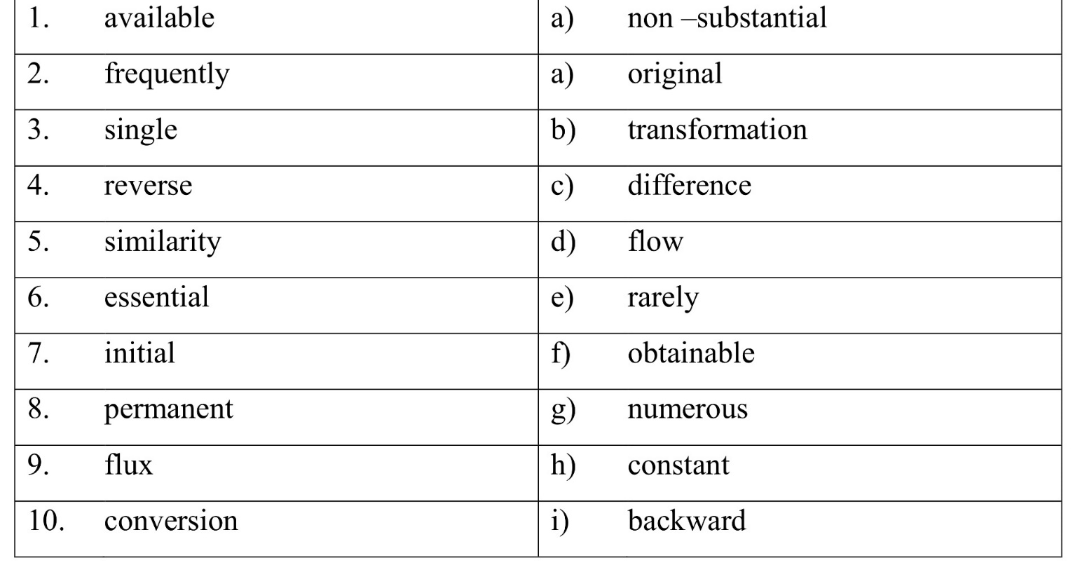
7. Match the synonyms or antonyms. Then make up sentences about electricity and generators using comparative structures

8. Make the dialogue with the words from the bold:
conductor, bounce, velocity, randomly, molecule, attract, bond, drift, repel, solid

Language focus
9. Put the words in the correct order to make sentences .
1) talks /about /large/ The /speaker/ plant /generator.
2) He/ uses/ for/showing /tesla /magnet /Faraday’s /discovery.
3) A /simple /generator /container /with/made /of /a /plastic / many /turns /of/ wire/ and/ magnet/can/ produce /voltage /about /30 /volts.
4) The /voltage/ generated/ in /the /coil /is /dependent /on/ the /the /coil /is /dependent/ rate /magnets/ move.
5) The/ meter /connected /to /the /direct/ voltage/generator /first /shows.
6) The/ switch/ in /the /the/ polarity/ of /the/generator/ circuit/ changes/ pole.
7) The / voltage /capacitor /strengthens /the .
8) with/ thousands/ turns /of/ wire/ can /produce/ The /generator/ on/ the/ table / 5 volts of DC.
9) shown /can /charge /mobile /phone /or/ The /generator /power /radio.
10) to /a /hand /crank /motor A/ windmill /is /connected .
10. Now read the terms and connect them with their definitions.
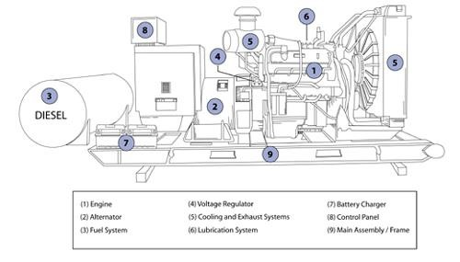
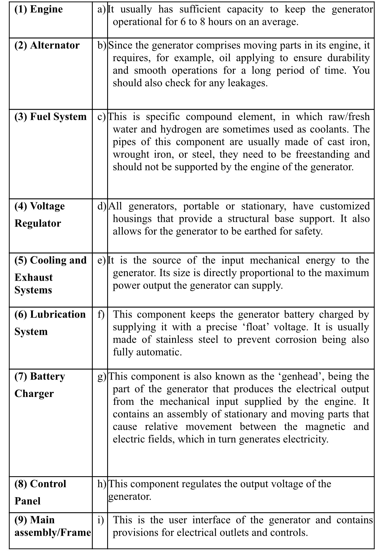

Taken from: http://www.dieselserviceandsupply.com
Reading and speaking
11. There are so many types of generators. Read the article about random number generator and the way it works. In pairs discuss the difference between pseudo-random number generators and true random number generators. Make the plan for its retelling.
Random numbers are useful for a variety of purposes, such as generating data encryption keys, simulating and modeling complex phenomena, and selecting random samples from larger data sets. They have also been used aesthetically, for example in literature and music, and are of course still popular for games and games of chance. When we discuss unique numbers, a random number is a number that is taken from a set of possible values, each of which is also likely, that is, a uniform distribution. When discussing a sequence of random numbers, each number drawn must be statistically independent of the others.
Pseudorandom number generators (PRNG)
As the word "pseudo" suggests, pseudo-random numbers are not random as you would expect, at least not if you are used to cutting rolls or lottery tickets. Essentially, PRNGs are algorithms that use mathematical formulas or simply precalculated arrays to produce sequences of numbers that seem random. A good example of a PRNG is the linear congruential method. Much research has focused on the theory of pseudo-random numbers, and modern algorithms for generating pseudo-random numbers are so good that the numbers look exactly like they were really random.
Generators of real random numbers (TRNG)
Compared to PRNG, TRNG extract the randomness of physical phenomena and introduce it into a computer. You can imagine it as a dice connected to a computer, but generally people use a physical phenomenon easier to connect to a computer than a dice. However, there are many ways to get real randomness on your computer. A very good physical phenomenon to use is a radioactive source. The times when a radioactive source decays are completely unpredictable, and they can be easily detected and entered into a computer, thereby avoiding any buffering mechanism in the operating system. Another suitable physical phenomenon is atmospheric noise, which is fairly easy to pick up with a normal radio. You can also use background noise from an office or laboratory, but you'll have to pay attention to the patterns. Your computer's fan can contribute to background noise, and since the fan is a rotary device, the noise it produces is likely to be not as random as atmospheric noise.

12. Decide whether the following statements are true or false and correct them if necessary.
1. Random numbers are used only in several spheres and not so useful in general.
2. Random numbers found their niche in art as well.
3. Pseudo-random numbers are not fully randomized.
4. PRNGs extract randomness from physical phenomena and introduce it into a computer.
5. Modern algorithms don’t make pseudo-random number look like a fully randomized one.
6. The mechanism of true random number generators totally differs from PRNGs mechanism.
7. Only one way of getting true random numbers exists.
8. Another suitable physical phenomenon for generating a pseudo-random numbers is atmospheric noise.
9. Background noise from an office or laboratory can also be used for generating true random numbers
10. The noise from your computer fan doesn't provide a reliable way to generate true random numbers.

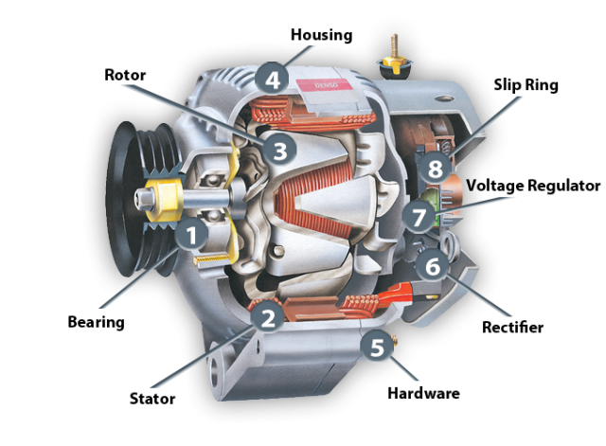
13. A. Work in pairs. Look at this generator. Before reading the text make a guess in what sphere this generator is used.
A motor generator or portable generator is the combination of an electric generator and a motor (main motor) mounted together to form a single piece of equipment. This combination is also called the generator set or generator set. In many contexts, the engine is taken for granted and the combined unit is simply called a generator. In addition to the engine and generator, engine generators generally include a fuel supply, a constant engine speed regulator (regulator) and a generator voltage regulator, cooling and exhaust systems and a lubrication system. Units larger than about 1 kW often have a battery and an electric starter; very large units can start with compressed air either to an air-driven starter or introduced directly into the engine cylinders to initiate engine rotation. Backup generator sets often include an automatic start system and a transfer switch to disconnect the load from the power source in the event of a power failure and connect it to the generator.
Motor-generators are used to supply electrical energy in areas where utility electricity (central station) is not available, or where electricity is only needed temporarily. Small generators are sometimes used to supply electricity to power tools on construction sites. Trailer-mounted generators provide temporary lighting, sound amplification systems, rides, etc.
B. After reading the text discuss this generator and the way it can be used with your partner.
C. Make a dialoge
Student A : Imagine that you went for a ride at night. You started your car and noticed that the headlights were dim. You decided to call your friend for advice.
Student B : Your friend asked you for the advice. Help him to make a right decision.

Speaking and listening
14. a) Watch the video “Generators” and discuss key moments with your friend.
Give the extended answer to the question: Why does the speaker mention a clockwork mechanism?

15. Work in pairs or small groups. Make a dialogue and present the answers to the following questions.
- Explain the basic principle of an AC generator in which a coil is mechanically rotated in a magnetic field. Draw a diagram to support your answer.
- Explain how a DC generator works. Draw a diagram to support your answer. Also, describe how a DC generator differs from an AC generator.

Writing
17. Write a semi-formal letter (appr. 150 words) to a youth magazine “Engineer’s site” (choose one of the topics)
a) Asking for explanation of generator’s usage in everyday life.
- Sharing what you have learnt about generators.
- Comparing AC and DC generators in industrial and domestic use.

UNIT 7. AN ENGINEERING STUDENT
Lead-in
1. Group work. Divide into two groups, in 10 minutes each makes a sequence of as many words and questions as you can think of to topic “Engineer”.
E.g. engineer – develop – discovery – ….
Vocabulary
2.Words 1-10 all appear in the text. Match them with their definitions a-j.
Deduce the meanings of any words you don’t know from the context.

# | Term | Definition
1 | - Electromagnet | - an opposition to the flow of alternating current caused by the inductance and capacitance in a circuit rather than by resistance;
2 | - switchgear |  | - something resilient used as a rest, support, or shock absorber;
3 | - reactance |  | - a set of electronic components that perform a particular function in an electronic system;
4 | - cushion |  | - another name for valve;
5 | - circuit |  | - a strong inert material bonded to a plastic to enhance its strength, stiffness, and resistance to impact;
6 | - reinforcement |  | - unobstructed space required for occasional removal of parts of equipment;
7 | - clearance |  | - the graduated margin of an arc or circle in an instrument for measuring angles, as that part of a marine sextant carrying the altitude scale;
8 | - tube |  | - a magnet consisting essentially of a coil of insulated wire wrapped around a soft iron core that is magnetized only when current flows through the wire;
9 | - wire |  | - a single bare or insulated metallic conductor having solid, stranded, or tinsel construction, designed to carry current in an electric circuit;
10 | limb |  | - any of several devices used for opening and closing electric circuits, esp those that pass high currents

Language in use
3. A. Translate the following words as verbs and nouns
Change, mention, manufacture, telephone, base, result, rule, design, place, state, approach.
B. Give the degrees of comparison the following words
Useful, high, long, big, much, good, far, difficult, great, little, small, many.

Reading and translation
4. Read and translate the text. Make a plan for its retelling.

ENGINEERING IN MODERN WORLD
Engineering supports human progress. Engineering is about the practical delivery of scientifically informed solutions for major challenges and opportunities in a rapidly changing world.
Engineers take scientific discoveries and practically apply them. Their work literally creates the fabric of society, be it the buildings in which we live and work, the energy that drives our world, or the transportation networks we use every day.
Engineering is so diverse; it is sometimes difficult for the public to see a common thread between their exploits. At one end of the scale, engineers are responsible for the large-scale design and construction of the Large Hadron Collider and, on the other, for the many applications of nanotechnology. Engineering creates breathtaking but sustainable new buildings on the horizons of major cities around the world, while bringing clean water and sanitation to remote and poor villages. Then there is the communications revolution, creating a growing sense of global community, allowing billions of people to access information and services and create new business opportunities.
Taken from: http://www.engineeringthefuture.co.uk/matters/default.aspx
- Ask questions to the parts of the sentences in bold.

Language in use and reading
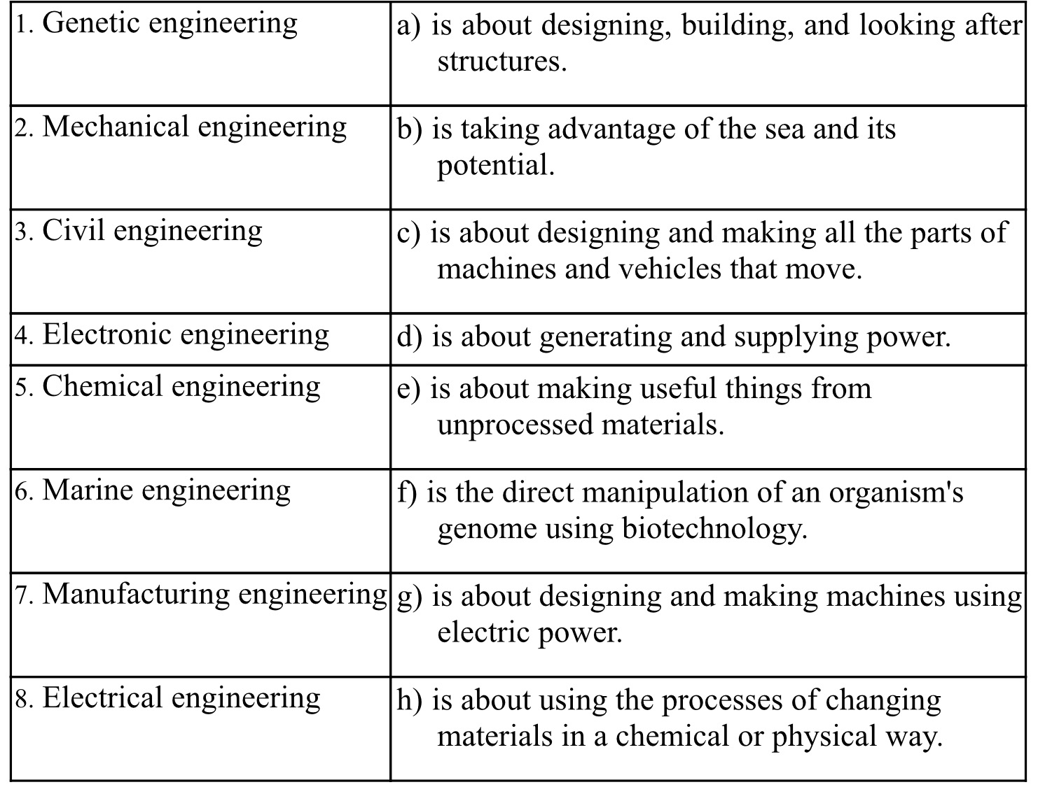
- Match the term withits definitions.

7. A In pairs, look at the picture and discuss the following questions.
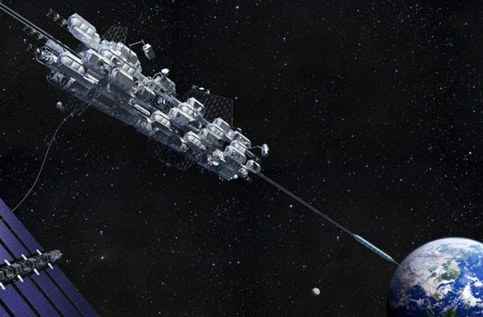
How do you think a space elevator would work?
What could it be used for?
What technical challenges would it face?
How seriously do you think the concept of space elevators is being taken at present?

B Find out more information on the inernet about an elevator which connects the earth’s surface to space and compare it to your answers in Exercise 8a.

8. Match the verbs from to the definitions.
connecting | carried (objects, over a distance)
raise | hold something firmly / bear its weight
transported | climb down
support | provided with energy / moved by a force
attached | joining
ascend | driven / have movement directed
descend | fixed
powered | climb up
controlled | lift / make something go up

9. Try to remember what you have learned about these famous scientists. Discuss in pairs what are they famous for?
Isaac Newton Henry Ford Wilber and Orville Wright Archimedes
Leonardo da Vinci James Watt Nicolaus Otto Nikola Tesla

Language focus and listening
10. A Complete the following tips on emphasising technical advantages using the words in the box.
conventional eliminated enhanced reduced superior
When describing technical advantages, it's useful to emphasise ...
A(l)______-performance, compared with the older model of the same product.
B negative issues that have been(2) ______-,or completely (3) ______.
C special features that differentiate the technology from (4) ______ systems.
D performance levels that make the technology(5) ______-to the competition.
B Stefan, an engineer, is briefing some sales colleagues on the advantages of a new pump design. Listen to the briefing and match the tips (a-d) in Exercise 11a to the extracts (l -4). 1-5 CD
Extract I______ Extract 2______ Extract 3______ Extract 4 ______

11. Match the words in to the synonyms.
considerably dramatically entirely exceptionally highly totally

I ______/______ = completely
2 ______/______ = significantly
3 ______/______ = extremely

12. James, an engineer, is giving a talk on space elevators. Complete his notes using the correct form of the verbs
Power transport attached ascend connecting raised support
Space Elevators
  - Challenge of (1) connecting a satellite to earth by cable is significant.
  - To (2)______its own weight, and be securely (3) ______at each end, cable would need phenomenal strength-to-weight ratio.
  - How could vehicles be (4) ______ into space, up cable?
  - Self-contained energy source problematic, due to weight (heavy fuel or batteries required to (5) ______vehicle).
  - Two possible ways round problem.
- Transmit electricity wiressly. But technique only at research stage.
- Solar power. But would only allow vechicle to (6) ______slowly. Not necessarily a problem, as car could be controlled remotely, allowing it to (7) ______payloads unmanned.
13. Analyse the following sentences paying attention to the subject and predicative clauses and translate them.
- The main thing that attracts your attention when you enter out lab is that it is equipped with the most modern devices.
- When this branch of industry first appears is difficult to say
- The main difference between Ukrainian higher education and other countries is that education in our country is free of charge.
- The most important feature of the English language is that it has a fixed word order.
- The profession of an engineer requires a special training is a well-known fact.

14.Watch the video “What is engineering?” then write down a short review. Try to add some information in your own words.

Writing
16. Write an essay on topic «What does it mean to be a good engineer?» Try to explain how to become the best specialist.



UNIT 8. MY FACULTY
Lead-in

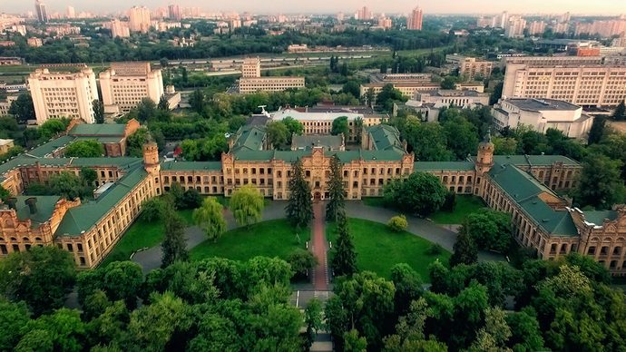
1. Look at the picture and try to explain the meaning of word «faculty».

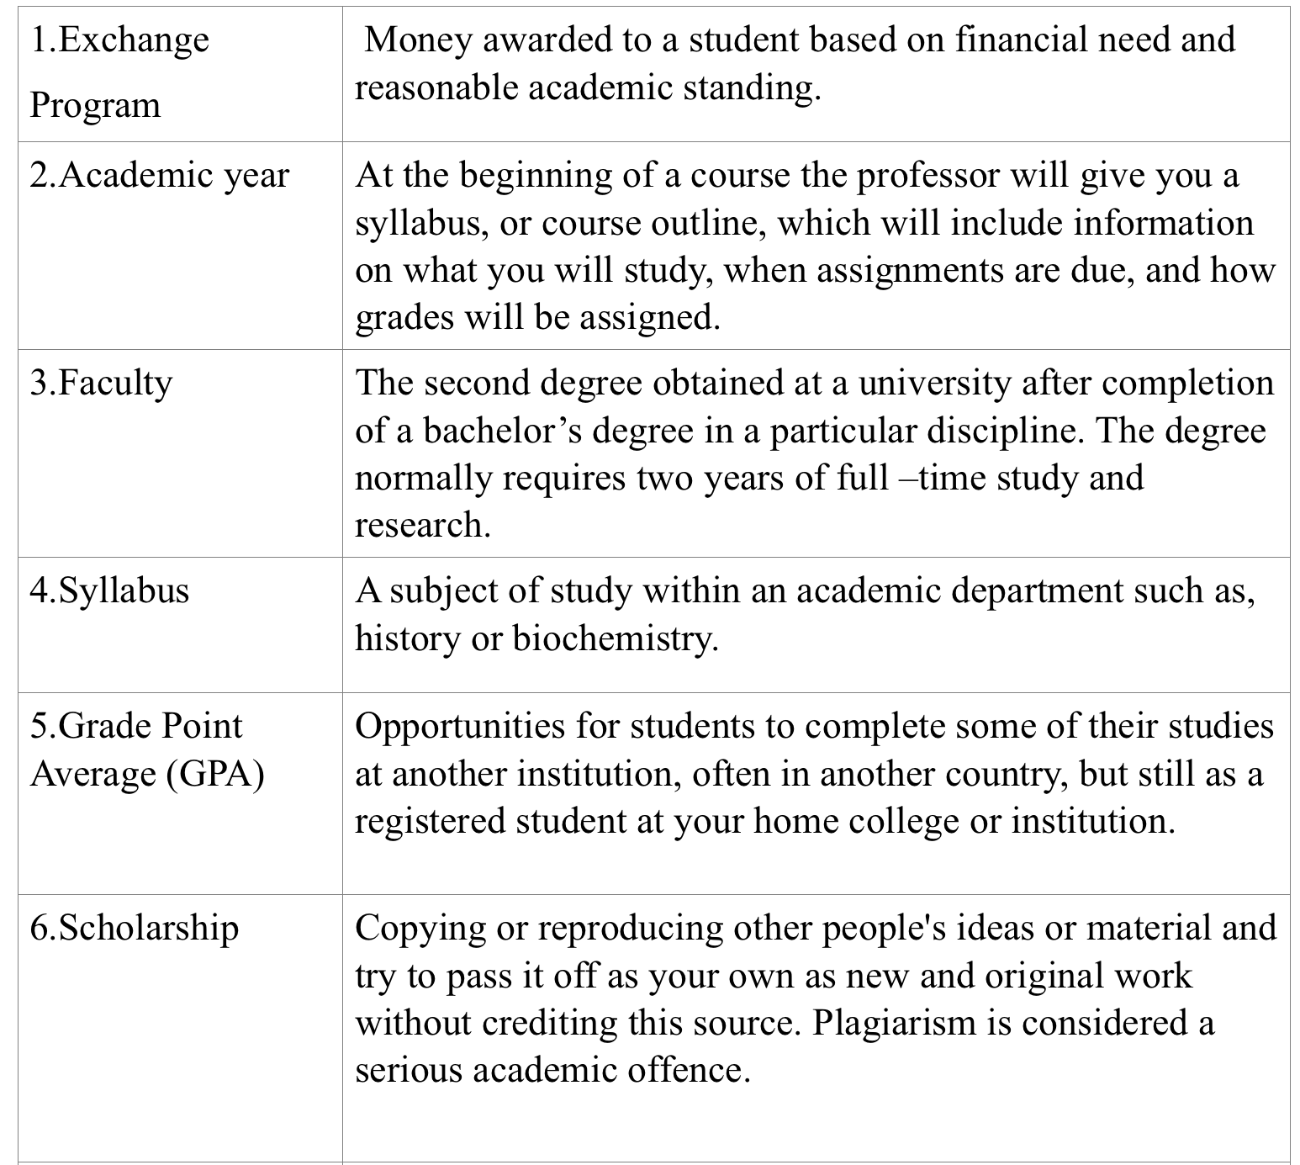
2. Make as many words as possible from the name of your faculty (Electric power engineering and automation).
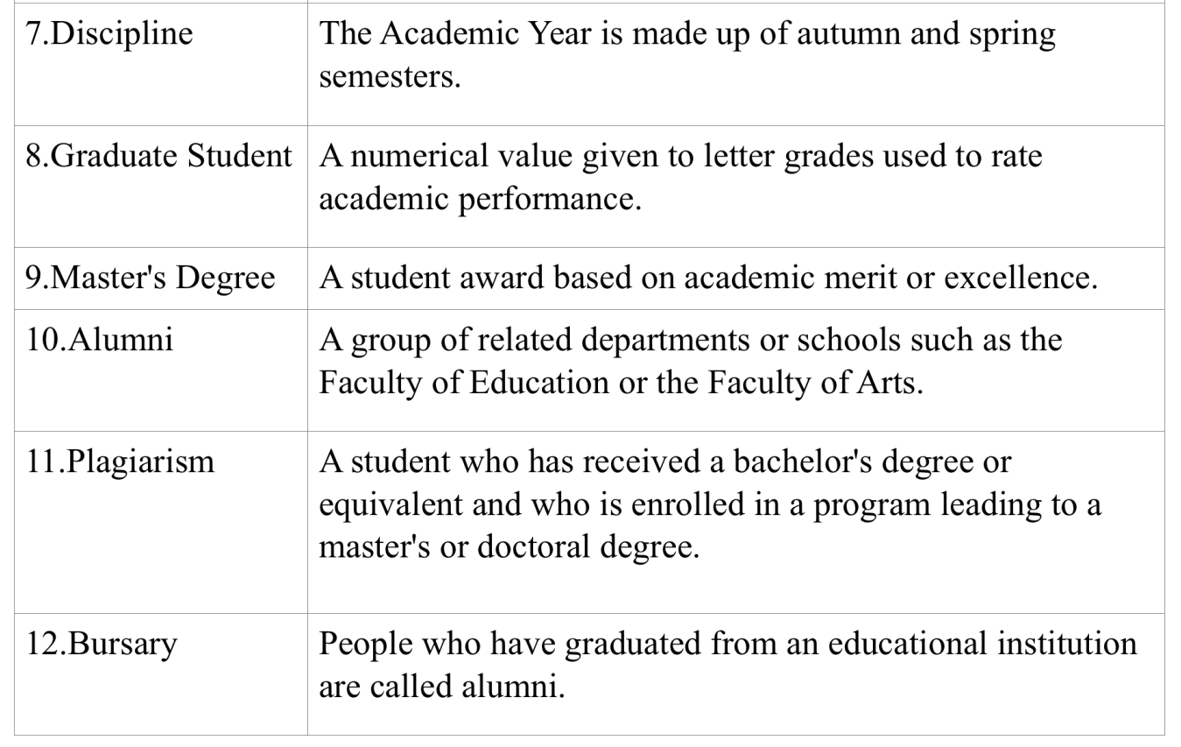
Language in use and reading
3. Look at the words and phrases and match them with their explanation.
1.Exchange  Program | Money awarded to a student based on financial need and reasonable academic standing.
2.Academic year | At the beginning of a course the professor will give you a syllabus, or course outline, which will include information on what you will study, when assignments are due, and how
 | grades will be assigned.
3.Faculty | The second degree obtained at a university after completion of a bachelor’s degree in a particular discipline. The degree normally requires two years of full –time study and research.
4.Syllabus | A subject of study within an academic department such as, history or biochemistry.
5.Grade Point Average (GPA) | Opportunities for students to complete some of their studies at another institution, often in another country, but still as a registered student at your home college or institution.
6.Scholarship | Copying or reproducing other people's ideas or material and try to pass it off as your own as new and original work without crediting this source. Plagiarism is considered a serious academic offence.
7.Discipline | The Academic Year is made up of autumn and spring semesters.
8.Graduate Student | A numerical value given to letter grades used to rate academic performance.
9.Master's Degree | A student award based on academic merit or excellence.
10.Alumni | A group of related departments or schools such as the Faculty of Education or the Faculty of Arts.
11.Plagiarism | A student who has received a bachelor's degree or equivalent and who is enrolled in a program leading to a master's or doctoral degree.
12.Bursary | People who have graduated from an educational institution are called alumni.

4. Link the words and make 3 sentences.
to point out | потребувати
to attach | сприяти
to need | додавати
to put an end to | підкреслювати
to allot | виховувати
to dream of | надавати
to bring up | покласти кінець
to promote | здобувати

5. Decide in what cases we use "make" or "do". Make your own short sentences with make – or do. 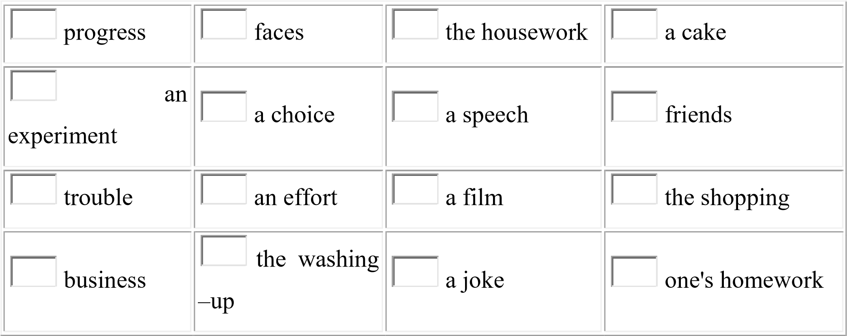

6. Make nouns derived from the verbs.
To use – | To apply – | To measure –
To generate – | To create – | To discuss –
To observe – | To provide – | To equal –

7. Insert an active or a passive infinitive from the list below.
- She was delighted … to the party.
- She was delighted … her friends to the party.
- I hate … you but I can’t make a research on my own.
- She hated … with questions concerning the cost of her education at the university.
- The room … as a lab should be lit enough.
- His intention is … this room as a lab.
- She was anxious for us … her faculty choice.
- Her faculty choice should …
(to invite, to use, to praise, to bother)

8. Before watching the video skim the text and answer the questions:
- Is the text informative or entertaining?
- Does it tell about power engineering and its theoretical use?
- Are there any famous scientists mentioned?
Now watch the video “RTU” about scientific research at Riga Technological University. What research was mentioned on video?

Language focus and reading

9. Read the text about your department (see App.C) and translate it.
Then retell it.

10. Read the text about one of the most popular engineering competitions. Translate it and write 10 questions to the text.
BEST, Board of European Students of Technology is a constantly growing non-profit and non-political organization. Since 1989, we have offered communication, cooperation and exchange opportunities for students from all over Europe.
BEST strives to help European technology students to orient themselves more internationally, by achieving a better understanding of European cultures and developing their capacities to work on an international basis. Therefore, we create opportunities for students to meet and learn from each other through our academic and non-academic events and educational symposia. "Learning is the master", but the end goal is a good place to work, which is why we offer services like an international career center to broaden the horizons of choice on the labor market.
Our priority is to offer high quality services to students from all over Europe. Thus, we manage to bring all the partners closer to the triangle "student - business - university".
The BEST Engineering European competition (EBEC) is the largest real-time engineering competition organized by the Board of European Students of Technology (BEST), which brings together the best European engineering students. With EBEC, the BEST project aims to develop the skills of the participants, not only theoretical knowledge but also their practical knowledge which will help them to solve the problems that humanity faces every day. The project brings together students, universities, companies and NGOs (non-governmental organizations).
Students are invited to participate in these two categories:
Team design: is a category that competitors can use their practical skills to design. Competitors must build a functional device related to a given technical problem in limited time and resources.
Case study: is the category on analytical and economic skills. The CS category is a more conceptual competition which consists in solving a theoretical, technical or managerial problem occurring in real life or in industry. Participants develop hypothetical solutions without actually building any device or assembling certain materials, but using the information provided.
Taken from: http://www.best.eu.org/index.jsp

11. Decide whether the following statements are true or false and correct them if necessary.
- The main aim of BEST, Board of European Students of Technology is a political propaganda
- BEST help European students of technology to improve their understanding of European cultures and to develop capacities to work on an international basis so they become more internationally minded.
- Therefore BEST create opportunities for the students communicate with each other online through academic and non –academic events.
- The final goal of this program is to help you to make a strong international carrer, therefore they offer some options to broaden the horizons for the choice on the job market.
- Their priority is to offer high quality services for students all over Europe. Thus, they manage to bring all students, colleagues from company and university in the triangle closer.
- EBEC is the biggest real –time based engineering contest conducted by Board of BEST gathering best European students of engineering.
- With EBEC Project BEST aims to develop participants theoretical skills by taking part in online conferences.
- Team design: is a category which competitors have an opportunity to use their practical skills to design.
- The main aim of CS category is to improve your analytic and economic skills.
- CS category is more about theoretical skills

Speaking
12. You are a participant of Specialty Fair. Make up a slogan, and a short announcement and a collage about your specialty.

13. You can be chosen as one to be taken into the special group flying to another planet for colonization. Prove that you are the most necessary specialist in power engineering and automatics.

Writing
14. Make some notes for your speech to any of the above mentioned faculties and departments asking more details on their timetable, curriculum, requirements and possibilities for foreign students (see App.E)

15. Write a semi-formal letter to a member of the UK engineering organization that deals with your speciality. Explain the reason you want to become an engineer and why should this company employ you. (150 words)
UNIT 9. POWER TRASMISSION
Lead-in
1. Match English words and word –combinations and their Ukrainian equivalents. Memorize them.
transmission | підсилення світла
light amplification | цінний
beam of light | місцезнаходження
consumer | примусове випромінювання
locality | тепловий промінь
to reflect | передача (електроенергії)
stimulated emission of radiation | розсіюватись
wavelength | відбивати
to scatter | споживач
heat ray | пучок світла
valuable | довжина хвилі

Vocabulary
2. Translate words and their derivatives.
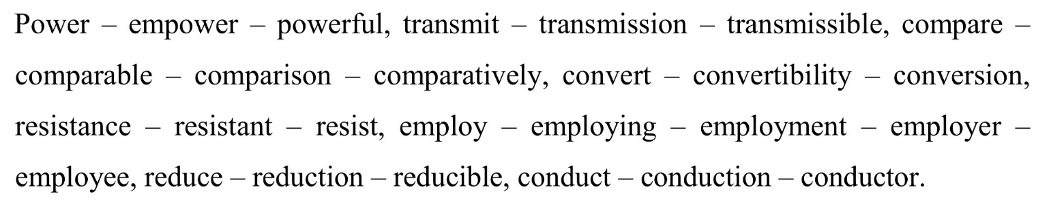
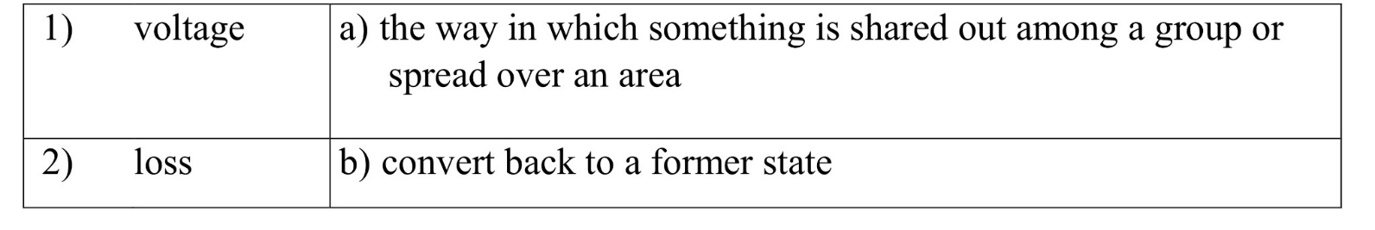
3. Match words with their definitions.

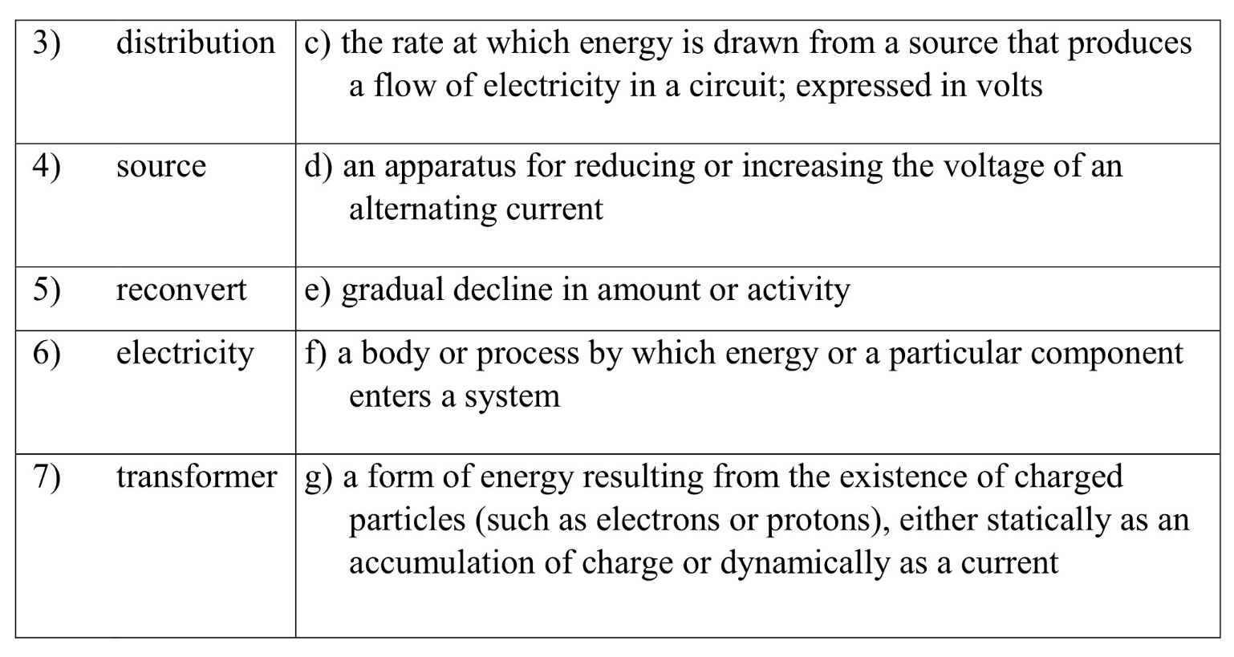
Reading and translation
4. Put the words in the correct order to make the sentences. Decide whether of them are true or false.
1) / could be/ carried /far /away / Power /always/ from /its /source.
2) into/ mechanics /is /transmitted/ over/ The /electrical /energy /converted hundreds/ of/ kilometers.
3) The /growth/ in / is /linked /to /the /use /of /transformers, generators/ and/ motors / /electricity /production.
4) is/ precious/ because /it / Electricity/ is /rare.
5) plants/ are /located / Usually / large/ power/ in /backyards.
6) Transmission / homes/ and /businesses /with / lines/ are/ used /to/ supply/ electricity.
7) Large/ electrical/ at/ very/ high/ voltages /transmission /lines /operate /.
8) The/ wires /are /because /it/ is/ safer/ to /transmit/supported /high /on/ the/ towers/ electricity/ this/ way.
9) When/ electrical / directly /to/ the/ consumer/ energy/ is/ produced / it is /transmitted.
10) system/ could be /reduced /by /using /transformers/ The /current /in /the/ transmission/.
5. Read and translate the text.

POWER TRANSMISSION
It is said that about a hundred years ago, power was never transported far from its source. The transmission range was later extended to a few kilometers. And now, in a relatively short period of time, electrical engineering has accomplished so much that it is entirely possible, at will, to convert mechanical energy into electrical energy and transmit it over hundreds of kilometers. and more in any direction. Then, in an appropriate locality, electrical energy can be converted to mechanical energy whenever it is desirable. It is not difficult to understand that the above process was made possible by generators, transformers and motors as well as other necessary electrical equipment.
Electricity is a precious form of energy because electrical energy can be easily moved over great distances. You would not want a large power plant in your garden! A large power plant converts millions of watts of chemical or nuclear energy into electricity. Transmission lines carry electricity to homes and businesses, often hundreds of kilometers away.
Overhead power lines use a much higher voltage than 120V. Indeed, the losses due to the resistance of the wires depend on the current. At 100,000 volts, each ampere of current carries 100,000 watts of power, against 120 watts per ampere of domestic electricity. Large electrical transmission lines operate at very high voltages for this reason. The wires are supported high on the towers because such high voltages are very dangerous. Air can become conductive over distances of one meter at high voltage.
It goes without saying that as soon as electrical energy is produced at the power plant, it must be transmitted by wire to the substation and then to the consumer. However, the longer the wire, the greater its resistance to the passage of current. On the other hand, the higher the resistance offered, the greater the heat losses in the electrical wires. These undesirable losses can be reduced in two ways, that is, either the resistance or the current can be reduced.
It is easy for us to see how we can reduce the resistance: it is necessary to use a better conductive material and wires as thick as possible. However, these threads are calculated to require too much material and therefore will be too expensive. Can the current be reduced? Yes, it is entirely possible to reduce the current in the transmission system by using transformers. In fact, the waste of useful energy has been considerably reduced due to the high voltage lines. It is well known that a high voltage means a low current, a low current in turn leads to a reduction of heat losses in the electric wires. However, it is dangerous to use very high voltage energy for anything other than transmission and distribution. For this reason, the voltage is always reduced again before using the current.

Taken from: http://www.cpo.com/pdf

6. Translate the sentences from English Ukrainian into Ukrainian .
- Слід нагадати, що українські вчені вже давно вирішули проблему передачи енергії за допомогою лазеру.
- Бажано використати всі види енергії для отримання електрики.
- Чим силінише магнітне поле, тим більший струм.
- Тепер можна вважати наше дослідження завершеним.
- Цей винахід збільшит ККД машини.
- Чим меньше труба, тим меньше води проходить крізь неї.

7. Put the statements in the correct order with the help of the diagram below. The diagram shows the distribution of power from power station to consumer.
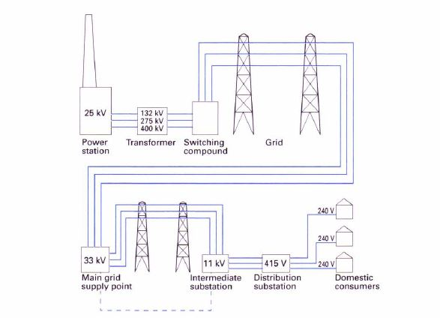
a.It is fed to substations.
b. It is stepped up by a transformer to high voltages for long-distance distribution.
c. It is distributed via the grid to supply points.
d. It is distributed to the domestic consumer.
e. Electricity is generated at the power station at 25 kV.
f. It passed via the switching compound to the grid.
g. It is distributed via overhead or underground cables to intermediate substations.

8. A Choose the appropriate synonyms for given words
plan fluctuation crucial identical carry out necessity
transform rule concept apparatus compose rank
Convert, similar, important, level, device, strategy, implement consist, principle, need, idea, oscillation.
B Choose the appropriate antonyms for given words
emit transferred alternating current inverter inconsiderable long consume destroy disconnected constant find secondary insulator
Variation, important, produce, direct current, absorb, lost, create, main, conductor, short, rectifier, coupled.
9. Make verbs from the following nouns.
Meaning – Emission – Development –  Direction – | Motion –  Reflection –  Heat – Release –

Language focus
10. Decide whether the following statements are true or false and correct them if necessary. Find out more information in web if its necessary.
- A laser is an object that absorbs beams of light which can travel very long distances.
- The laser concept had come up a century before – in stories of science fiction.
- Normal light contains many wavelengths and colors.
- Electrons don’t need to move from a lower level to a higher level around the atom in order to emit a photon, a particle of light.
- Its imposiible to create a laser beam without mirrors.
- An active medium can exist in any phase of matter.
- An energy source consumes the light that you need to excite the electrons
- Colored light is produced by protons that reflect off the mirrors and stimulate other electrons by travelling back and forth.
- Lasers are used almost in all spheres of life.
- Because laser light can travel very long distances, astronomers have an opportunity to use laser beams to discover alien life.

- Translate the following sentences
  - Чим сильніше магнітне поле, тим сильніший струм.
  - Чим вище швидкість руху між магнітним полем та провідником, тим більший струм
  - Чим менша труба, тим менше води проходить крізь неї
  - Чим більший струм, який протікає через провідник, тим вища температура цього провідника.

12. Add the prepositions from the box, some of which will have to be used several times, and change the verbs into the gerund.
about; against; at; for; in; of; on; to; with

- She is good/bad ………………………..…. (work) with students.
- He is angry ………………………..………….. (lose) his notebook.
- Professor X. is disappointed ………………………….. (see) such a bad report.
- The instruments are famous ……………………………………….. (give) reliable performance.
- The company is interested ………………………………….. (hire) him.
- This is the advantage …………………….. (use) underground cable.
- Special clothing protects against the danger………….. (be) exposed to radiation.
- He was accused ……………………………….. (plagiarize) from the internet.
- The research group concentrates ………….. (develop) applications for new
composites.
- Students have to cope ……………….. (solve) many problems.
- Medical interns have to get used ………………………….. (work) long hours.
- They decided ……………………….……….. (use) non-recyclable materials.

Listening and speaking
13. Watch the video “Power transmission”. Put the words in the correct order to make the questions and answer them.
- electricity/ made /Where /is?
- to /produce/ electricity/ What /are/ basic/ sources from?
- powerful /force /of/ What /is /the /most / elecrticity?
- transmission / What/ is/ a/ tower?
- towers /made / What /are/ transmission /of?
- porcelain/ used /for /on / What/ is/ transmission /lines?
- touch / aren’t /they Ground /wires/ are /safe /to?
- from /the /power /station /to /your /house/ Does/ electricity/ travel /straight ?
- What / mean /“to step down electricity” does /it ?
- wires /insulated Are /transmission?

14. Divide into two groups. Each group describes the process of power generation and distribution according with the pictures below. Use the phrases from the table.
- 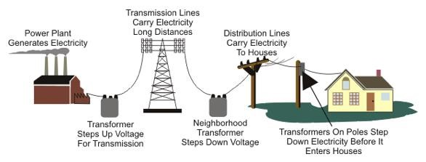

- 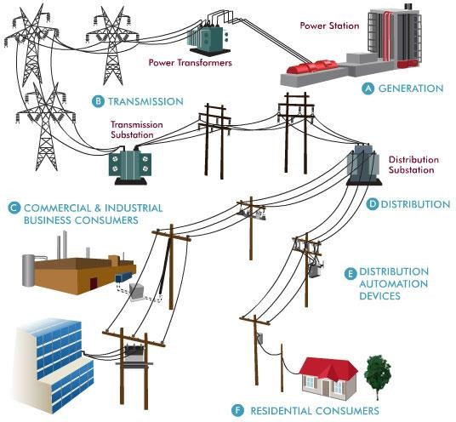
feed to substations, step up by a transformer to high voltages, distribute via the grid to supply points, domestic consumer, the switching compound to the grid, via overhead or underground cables.

Writing

15. Laser was predicted as a future technology by H.G. Wells in his book «The War of the Worlds» in 1898. Imagine that it’s the year 2100. What kind of technology do you think will exist? Write 10 sentences of your answer.

16. Write a summary on a type of laser that you can introduce at the conference on power transmission potential.(120-150 words)

UNIT 10. TRANSFORMERS
Lead-in
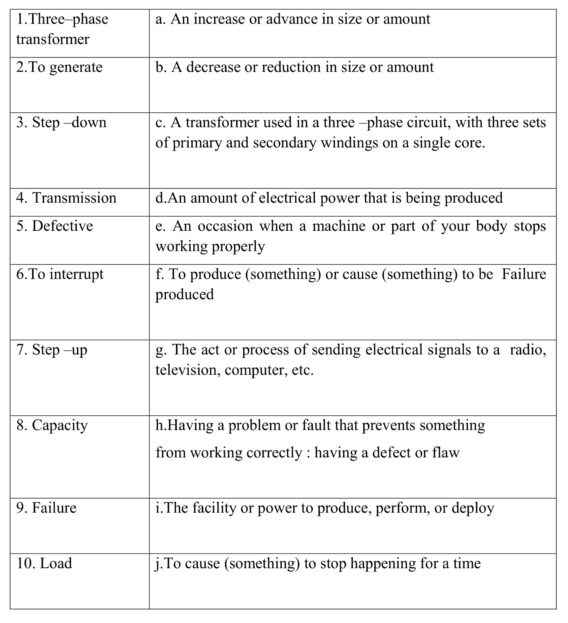
1. Match terms with their definitions

3. Match items from the two columns to make word combinations and use them in sentences of your own.
- Distribution Power
- Initial Transformer
- Network Parts
- Outdoor Capacity
- Medium Size
- Reduced Substation
- Rotating Cost
- Three –phase Service
- Electrical Purposes
- Utilization Installation

4 . Write down the synonyms to the following words and word combinations.
- Power plant | Cable
- Effect | Frequency
- Clamp | Power station
- Cord | Switch
- Rate | Substance
- Electricity | Battery
- Appliance | Phenomenon
- Accumulator | To connect
- Commutator | To convert
- Shunt connection | Direct current
- Defect | Terminal
- To transform | Power
- Continuous current | Fault
- Material | Parallel connection
- To link | Device

Reading and translation
5. After reading the text below decide whether the following statements are true or false and correct them if necessary.
1. A transformer usually comprises an iron core, two windings and some continuously moving parts.
2. When an alternating current is applied to the terminals of the primary winding, the device behaves like a choking-coil.
3. In actual practice, the applied voltage is very slightly greater than the induced e.m.f. in the secondary windings.
4. The number of volts per turn in the primary winding equals the number of volts per turn in the secondary one.
5. The turns ratio and the voltage ratio are completely different.
6. An ideal transformer has both primary resistance and reactance in series with its primary winding and both secondary resistance and reactance in parallel with its secondary winding.
7. In an actual transformer the no-load current has neither active nor reactive component.
8. The turns ratio in the primary and secondary windings are directly proportional to the current ratio in the primary and secondary windings.
An actual transformer may be represented, for purposes of explanation, as consisting of an ideally perfect transformer, having no losses or magnetizing current, together with various additions to allow for these effects.

Fig.13. Equivalent Circuits of a Transformer

Fig. 13. represents such an ideal transformer having a resistance, R₁, and a
reactance X₁, in series with its primary winding, and a resistance, R₂, and a reactance, X₂, in series with its secondary winding. The no-load current has both an active and a reactive component. The latter is the magnetizing current of the iron core, I_{m}, and is represented in the diagram by the current flowing through an additional reactance, while the active component, I_{c}, supplying the iron losses in the core, is represented by the current flowing through an additional resistance. The vector resultant of I_{m} and I_{c} is I₀, which is the total no-load current of the transformer. The secondary current is I₂, and the component of the primary current that neutralizes I₂ is I'₁. The total primary current, I₁, is the vector sum of this component, I'₁, and the no-load current, I₂. The turns in the primary and secondary windings are T₁ and T₂ respectively, and are so related that
The flux I is the useful flux linking both primary and secondary windings. The
induced secondary e.m.f. is E₂, this being slightly greater than the secondary terminal
voltage, V₂, since the secondary resistance, R₂, and the secondary reactance, X₂, cause voltage drops of I₂R₂ and I₂X₂ in phase and in quadrature with the current, I₂, respectively. The back induced e.m.f., E₁, is related to E₂ by the formula

The primary applied voltage, V₁, is again slightly larger than E₁, on account of the
voltage drops caused by the primary resistance, R₁, and the primary reactance, X₁.
These again bring about voltage drops of I₁R₁ and I₁X₁ in phase and in quadrature
with the primary current, I₁, as before.

6. Find in the text what the following letters stand for.
1. R1 ___________________
2. R2 ___________________
3. X1 ___________________
4. X2 ___________________
5. Im ____________________
6. Ic ____________________
7. I0 ____________________
8. I1 ____________________
9. I'1 ____________________
10.I2 ____________________
11.I`₂ ____________________
12.T₁____________________
13.T₂____________________
14.E₂____________________
15.E₁____________________
16.V₁____________________

7. Translate the following sentences into English.
1. Кажуть, що цей прилад описано в попередній статті.
2. Здається, ця рідина має інші властивості.
3. Змінній струм міняє свій напрямок.
4.Трифазний трансформатор необхідно використовивати для сбільшення напруги.
5. Існують різні види трансформаторів.
6. Трансформатор - це електромагнітний апарат, призначений для перетворення змінного струму однієї напруги в змінний струм іншої напруги.

8. Read the text about Transformer, then circle the answer a),b),c),d) which best fits the space.
A transformer is a machine that ____(1) electrical energy from one circuit to another through electromagnetism. They make ____(2) an important part of electrical systems.
Transformers can come in ____(3) different sizes, from a very small transformer hidden inside a stage microphone, for ____(4), to big ones that ____(5) hundreds of tons and are used in power energy systems.
The main reason to use a transformer is to transform the power of one voltage into the power of ____(6) voltage. More voltage is easier to be transmitted over long distance, but less voltage is easier to be used ____(7) home.
The various ____(8) of transformers include: autotransformer (used to connect systems operating at different voltage), polyphase transformers, leakage transformers (____(9) in toys and doorbells), resonant, audio (used ____(10) loudspeakers and telephones) and instrument transformers.

- a- moving b- movable c- moves d- moved
- a- up b-over c-down d-less
- a- many b- much c- abundance d- more
- a - instant b- instance c- understand d- instead
- a - weight b- weighing c- weighs d- weigh
- a - any b- else c- another d- more
- a- in b- over c- at d- inside
- a- types b- type c- typing d- type’s
- a - use b- usage c- using d- used
- a - at b- in c- to d- over

Language focus and speaking
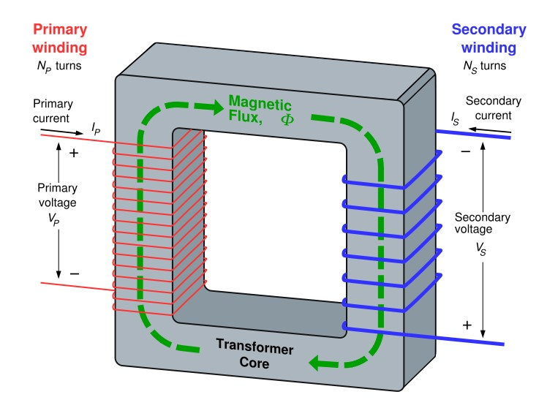
9. Look at the picture and describe the principle of transformer core construction and operation.

10. Do a short research on the application of three –phase transformers. Discuss it with your groupmates in the form of reports or interviews with an engineer working with three phase transformers.

11. Answer the questions.
- Що таке трансформатор?
- Для чого трансформатор використовується ?
- Чи може трансформатор бути пошкоджений блискавкою?
- З яких деталей складається трансформатор?
- Скільки обмотки є в трансфоматорі ?
- Яке призначення крокового трансформатора?
- Чи працює трансформатор на постійному тоці?
- Чи використовуються трансформатори і в побуті, і в промисловості?
- Який вид трансформатора використовується для передачі та використання електроенергії?
- Які переваги трифазних трансформаторів?
- Які недоліки трифазних трансформаторів?
12) Де можна застосувати трифазні трансформатори?
12. Complete the sentences with the words in bold.
break, kick, pick up, press, pull, switch on, touch

- The passenger activates the ticket machine by touching the screen.
- You switch on the phone by ______ _______ the handset and _____ the green button.
- The user starts the outboard motor by _____ the handle of the cord.
- The rider starts the outboard motor by _______ the battery and ____ the lever downwards.
- The burglar activates the alarm by _____ the laser beam.

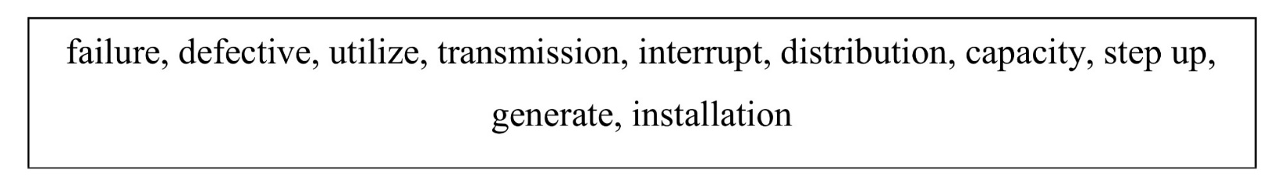
- Translate the following words and make the sentences.

14 Speaking.
Discuss with your partner all types of transformers, where they can be used, their advantages and disadvantages.
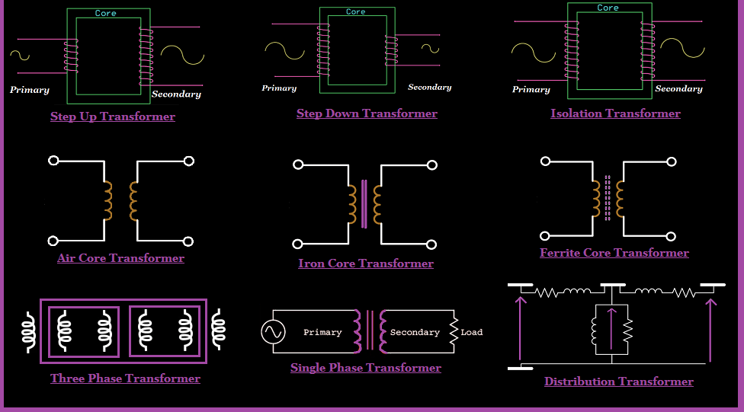
Writing
15. Look through the presentation “Types of transformers” and write a short summary on the topic “Transformers and their usage in everyday life” (120-150).

UNIT 11. ELECTRIC MOTORS

Lead-in
1. What is the difference between electrical engine and internal combustion engine How do you think will electrical engines/motors fully replace internal combustion engine? Share your opinions with your groupmate.

Vocabulary

2.Match the terms with their translations.
starting torque | пусковий струм
shunt winding | застосовувати
starting current | паралельна обмотка
armature | обмотка
brush | перетворювати
running conditions | (електрична) щітка
to transform = to convert | перемикач, комутатор
series winding | швидкість руху
winding | пусковий момент
to employ = to utilize | якір
commutator | послідовна обмотка
innumerable | незліченний, численний
magnetic coil | соленоїд, обмотка/котушка електромагніту
rate of motion | умови експлуатації, робочий режим

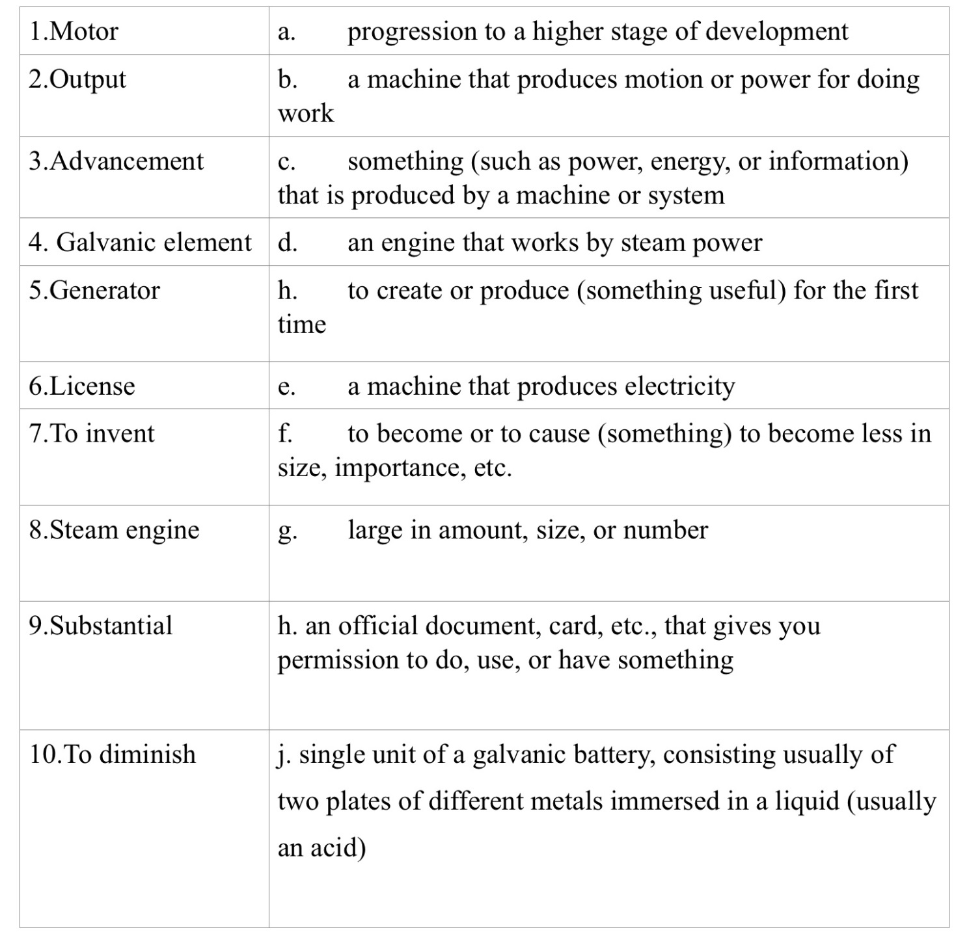
3. Match the terms with their definitions.

Language in use and reading
4. Read a short text on the history of electric motors, make the plan for its retelling.
Most people would say that they don't see an electric motor every day, like they do with a light bulb or a phone. This is because electric motors are not like that. These are simpler things that are found in many devices. The purpose of an engine is to transform electrical energy into mechanical energy. It takes electricity and turns it into energy that we can use.
An electric motor uses magnetism and electric currents to operate. There are two types of motors: alternating current (AC) motors and direct current (DC) motors. These types of motors use the same parts as a basic electric motor, using only two different types of current.
The motors started with electromagnets. In 1831 Michael Faraday successfully built the first electric motor. Joseph Henry was working with engines at that time. Henry and Faraday are both credited with building the first experimental electric motors. In 1837 Charles Grafton Page worked on improving the electric motor and created his own model. In 1887, Nikola Tesla introduced the alternating current (AC) motor. All other motors to date have used direct current. Now AC motors are easier to use than DC motors.
Today engines are used everywhere. They are used in cars and many household appliances. Even though many people don't recognize everything it does, the electric motor has become a very useful invention.

Taken from: http://targetstudy.com/knowledge/invention

5. Complete the texts with the given words.

are made up is placed is composed consists are wound is mounted are used
A transformer (1) ______________ of two coils, a primary and a secondary. The coils (2) ____________ on a former which (3) _______________ on a core. The coils (4) _____________ of a number of loops of wire. The core (5) _______________ of thin pieces of soft iron. U- and T-shaped pieces (6) ______________. The former (7) __________________ on the leg of the T.

is made up known as is connected consists

called known is placed
A simple dc motor (8) ____________ of a field magnet and an armature. The armature (9) ______________ between the poles of the magnet. The armature (10) _______________ of a loop of wire and a split ring (11) ________________ as a commutator. The loop (12) _________________ to the commutator. Current (13) _____________ to the motor through carbon blocks (14) ________________ brushes.

6. Match the items from two columns to make word combinations.
Make questions to which these word combinations are answers.
E.g. In other words, how do we call the usage of a device or thing in practice? –
Practical application.
1. Electric | a) Engine
2. Undisputed | b) Element
3. Practical | c) Features
4. Output | d) Influence
5. Historical | e) Design
6. Contemporary | f) Improvement
7. Substantial | g) Context
8. Design | h) Power
9. Significant | i) Application
10. Galvanic | j) Motor
11. Steam | k) Fact

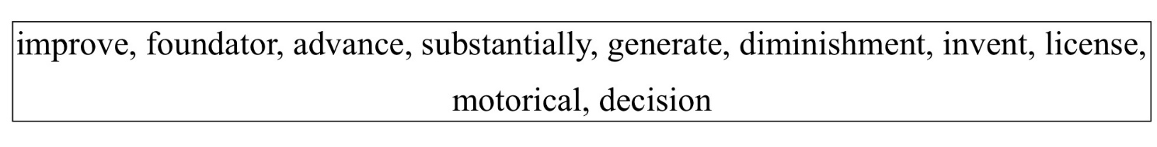
7. Make sentences with words from the list below:

8. Read the sentences and choose the correct answer.
1. I live in a large family, but my grandfather lived in a ……… family.
a) large b) larger c) most large d) largest
2. We have only little time for this exercise, but during the examination we'll have even ……… time.
a) little b) more little c) less d) the least
3. The ……… the current, the ……… the magnetic field.
a) large/strong b) larger/strong c) largest/stronger d) larger/stronger
4. She listened to them while they … .
a) was talked b) were talking c) did talked d) is talking
5. Look! The boy … the hill.
a) climbing b) climbs c) is climbing d) was climbing
6. I … at this school for ten years.
a) were studying b) studied c) have been studying d) has been studying
7. Three people are reported to have been injured ……… the explosion.
a) with b) in c) from d) off
8. Scientists … a new planet.
a) had just discovered b) has just discover c) have just discover d) have just discovered
9. The building ……… by fire yesterday.
a) to be damaged b) have damaged c) is damaging d) was damaged
10. I met Jane while I … on the beach.
a) walking b) walked c) was walking d) were walking

Language focus and listening
9. Watch the video “Motor and Generator” and fill in the table for comparing motors and generators.
 | Generator | Motor
Year of creation
Inventor
Parts
Principle of work
Usage

10. Read the extract from the talk and, in pairs, discuss the following questions.
... electrical charge is extremely difficult to store in large amounts, you can't just charge up huge batteries. So we use an innovative technique to store up power potential during off-peak periods.
1. Why do you think this is such a major issue for power stations?
2 Can you suggest what innovative technique is used to solve the problem?

11. Helen goes on to describe the solution to the problem. Listen to the talk and make notes on pumped storage. CD 8.7
Prepare a short talk on the operation of a pumped storage hydroelectric power station for visitors to the power generation company. Use your notes from Exercise b and the words in the box. Student A, you are an electrical engineer; Student B, you are a visitor on a tour of the plant. In pairs, give your talk and ask and answer questions. Swap roles and practise again.
gravity high level low level mountain pumps reservoir turbines

12. Work in pairs.
Student A is a seller of generators and Student B is a seller of motors. Students should present their products in the best way possible using information they found out in the unit.

13. Why electric engine is better than internal combustion engine?
We all know that internal combustion engine needs oil to work. Oil production is a very risky business. That is why offshore oil platforms are covered by extensive safety regulations and design standards. ln pairs, discuss the main hazards that oil platform workers face and suggest some safety precautions that need to be taken.
Isobel, a Health and Safety specialist, is speaking to newly recruited oil platform technicians on a training course. Listen to the introduction to her talk and answer the following questlons. CD 7.5
1 What kinds of regulation will the course deal with?
2 What examples does the trainer give?
3 What important point is emphasized

14. Complete the following groups of synonyms using the words in bold.
legislation compulsory permited stipulated contravene comply with
1 illegal / banned / forbidden/prohibeted
2 allowed /authorised/______
3 adhere to / conform to / ______ ______
4 stated/ ______
5 break (the law) / breach (regulations)/ ______ (regulations)
6 laws / regulations/ ______/ legal ______/ personal
7 obligatory /______

15. A. ln pairs, discuss the factors that cause mains electricity consumption to vary.
B. Helen, an electrical engineer at a power station, is giving a talk to a group of visiting investors. Listen to the talk and note the five factors that influence electricity consumption.CD 8.5
  - ________
  - ________
  - ________
  - ________
  - ________

Writing
16. Read again the text Electric Motors and write a letter of request to the Technical Library of the KPI asking for more details on any type of motor or more information on the history of motors (160 words).

UNIT 12. MAGNETOHYDRODYNAMIC GENERATORS
Lead-in and vocabulary
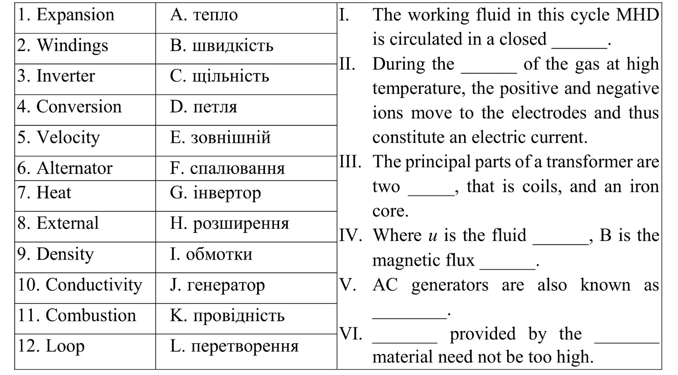
1. Match the words with the translation and sentences they can be used in.
2. Translate the words and their derivatives.
1. to convert – converted – conversion
2. to conduct – conductor – conduction
3. to cycle –cycling –recycle
4. exhaust – exhauster – exhaustibility
5. atmosphere – atmospheric – atmospherically
6. to pressurize – pressurized – pressurizing

Reading and speaking
3. Read the text about Laser-Powered MHD Generators for Space Application. Discuss with your partner this energy conversion method which can be used on the moon. Is it possible to realize or not, explain your point of view?
Magnetohydrodynamic energy conversion (MHD) systems of pulsed laser assisted detonation (LSD), plasma MHD and liquid metal MHD (LMMHD) types are evaluated for their potential as laser power converters. space based electrics. These systems offer several advantages as energy converters over current chemical, nuclear and solar devices, including high conversion efficiency, simple design, high temperature operation, high power density and high reliability. Among these systems, the liquid metal MHD system of the Brayton cycle seems to be the most attractive. However, more research is needed to extend this technological base to space applications and to establish the technology required to couple laser energy to the system as efficiently as possible. It is recommended to continue research on each of the three types of systems.
4. As we started to speak about the moon, let’s check out some urban legends about moon landings. Several people sure that the moon landings didn't really take place and were filmed.
In photos taken of astronauts on the moon, why are no stars visible in the sky?
In film footage, why is the flag planted on the surface of the moon seen moving slightly?
Why do photos of astronauts' footprints appear to be on a wet surface and not in dry dust?
Why is no blast crater caused by engine thrust during the landing visible below the module?
5. S Caroline and Renato, two colleagues at an engineering firm, are talking about the moon landings during a coffee break. Listen to the conversation and compare what they say with your ideas from Exercise 4 CD_9.6

6. Read the text about MHD systems translate it and make a plan for its retelling.
Among the MHD systems considered for spacepower application are
1. Pulsed systems in which gas breakdown, heating, and flow depend on the initiation of an LSD wave
2. Plasma systems (pulsed or continuous wave (CW)) where the laser radiation is used to heat an existing plasma either prior to its introduction into the MHD generator or during its flow through the generator
3. Liquid-metal systems (pulsed or CW) in which the laser radiation heats the liquid metal or the carrier medium (or both) prior to mixing and introduction into the MHD generator

Pulsed LSD Systems
Maxwell and Myrabo studied MHD pulsed laser systems in detail based on the generation of LSD waves. Figure 2 is a diagram of a pulsed LSD MHD generator. Two modes of energy generation are possible in this configuration. In mode 1, power is generated when the LSD wave passes through the generator at a high speed. In mode 2, energy is generated when the high temperature plasma remaining in the plenum chamber is evacuated by the generator. Figure 3 shows the physical process of the power cycle for mode 1. The cycle is started with an LSD wave being ignited at the exhaust port of the MHD generator and propagating to a high speed conductivity "slug" immediately behind the LSD wave provides smooth operation for MHD power generation.
Plasma system
A second option for space-based laser-based MHD generators is to use the incoming laser beam to heat an existing low temperature plasma to higher temperatures before it flows into the MHD channel. In this system, the laser radiation is absorbed by the free electrons through the reverse bremsstrahlung. Electron-ion thermalization occurs quickly, so that the plasma passing through the generator is in equilibrium. The intensity of the laser beam must be kept below the breakdown threshold in order to prevent the formation and propagation of LSD waves along the laser beam.
Metal-liquid systems
The concept of the liquid metal magneto-hydrodynamic generator (LMMHD) was developed at the National Laboratory of Argonne in 1969-1970. This concept has demonstrated that LMMHD systems can be manufactured with rather attractive efficiencies (40 to 90 percent). The LMMHD two-phase generator system, which uses two working fluids, a thermodynamic fluid (gas or vapor) and an electrodynamic fluid (liquid metal), is more flexible to couple at different heat source temperatures than the MHD plasma system. Unlike the MHD plasma system, which requires a high temperature, LMMHD systems can effectively use heat source temperatures as low as 450 K (ref. 35) since liquid metal provides conductivity in the generator and ionization doesn’t is not necessary.

7. Form a group of three and imagine that each of you came up with his own idea how to convert energy in space. Try to explain the way it works.

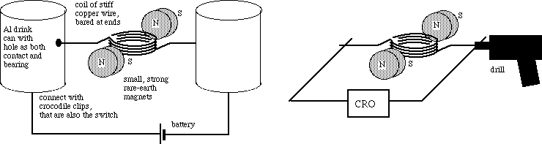
8. Look at the picture and try o explain the way this mechanism works. You can search the internet for some extra information.

9. Read the text Magnetic monopoles and decide whether the following statements are true or false and correct them if necessary.
Even if a magnet would have a north pole and a south pole, these two poles cannot be separated from each other. A monopole - if such a thing exists - would be a fundamentally different new type of magnetic object, acting as an isolated north pole, not attached to a south pole, or vice versa.
Paul Dirac observed in 1931 that, because electricity and magnetism have a certain symmetry, just as quantum theory predicts that individual positive or negative electric charges can be observed without the opposite charge, isolated South or North magnetic poles should be observable. The first results of using these models to estimate the number of monopolies created in the big bang contradicted cosmological observations - monopolies would have been so abundant and massive that they would have long since stopped the expansion of the universe. However, the idea of ​​inflation succeeded in solving this problem, creating models in which monopolies existed but were rare enough to be consistent with current observations.

- A north pole and a south pole cannot be separated from each other. | True / False
2. Paul Dirac observed a magnetic discharge in 1931. | True / False
3. Quantum theory predicts that individual positive or negative electric charges can’t be observed without the opposing charge. | True / False
4. The initial results contradicted scientific researches. | True / False
5. The idea of inflation wasn’t successful in solving this problem. | True / False

Language focus

10. Look at the sentences, put the phrases in right order.

Advantages of MHD Generation
1) circulating there is, and no mechanical part of mobile working fluid Here only This makes the operation reduced to zero and the mechanical losses more reliable.
2) is maintained working fluid the walls of MHD The temperature of.
3) It has a full power level, the ability to reach almost directly.
4) MHD generators is much lower than the price of conventional generators.
5) the other conventional MHD than most efficiency, which has a higher or unconventional generation method.
11. Read the description of the two cycles and choose a right title for each paragraph. Discuss these two cycle types and decide which one is more promising.

Open Cycle MHD System Closed Cycle MHD System
A) The working fluid in this MHD cycle circulates in a closed loop. Therefore, in this case, an inert gas or a liquid metal is used as the working fluid to transfer the heat. Liquid metal generally has the advantage of high electrical conductivity, hence the heat supplied by the combustion material need not be too high. Unlike the open loop system, there is no inlet and outlet for atmospheric air.
B) In this cycle of the MHD system, atmospheric air at very high temperature and pressure passes through the strong magnetic field. The coal is first treated and burned in the combustion chamber at an elevated temperature of about 2700 ° C and a pressure of about 12 atm with air preheated by the plasma.

Taken from: http://electrical4u.com/

12. Look at the picture and try to explain the difference between these two kinds of generators.
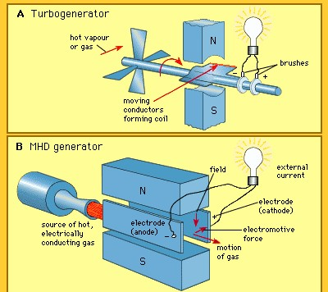

13. Complete the sentences with the right word combination. Translate the sentences.
with the result as a result results resulted in the results resulted from

1. We discussed ... got. 2. When the electric current flows along the conductor, the heat ... 3. Faraday's experiments ... a great discovery. 4. Almost all bodies expand ... with heating. 5. Faraday has conducted different experiments with magnetic coils, threads and needles with different .... 6. In a cell, the potential difference is maintained by chemical action; copper has a higher potential than zinc ... that a positive current of electricity flows from copper to zinc. 7. The possibility of designing the first MHD power plants ... the study of MHD energy conversion.
14. Look at the table and describe two types of MHD generation. Use information from task 8.
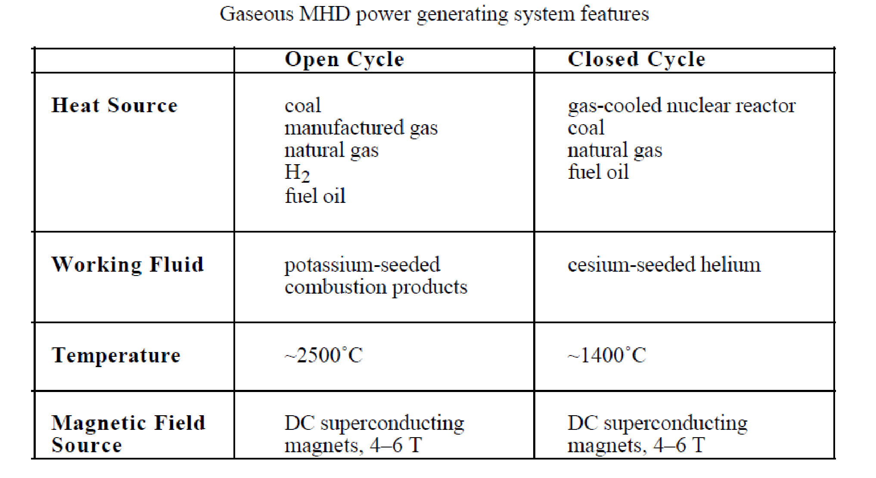
Taken from: http://electrical4u.com/

Writing
15. Imagine that you are taking an online course at SRM University. As part of your study, you are downloading PowerPoint presentations, but this time the ppt file was damaged. Go through the “MHD” presentation and write a letter of request to Prof. Mc.Antrold for a copy of the presentation (120-150 words).
UNIT 13. NUCLEAR POWER PLANTS
Lead-in and vocabulary
1. Spend a minute writing down all the different words you associate with nuclear power. Share your words with your partners and talk about them. Together put the words in different categories
(Positive / Negative / Neutral).
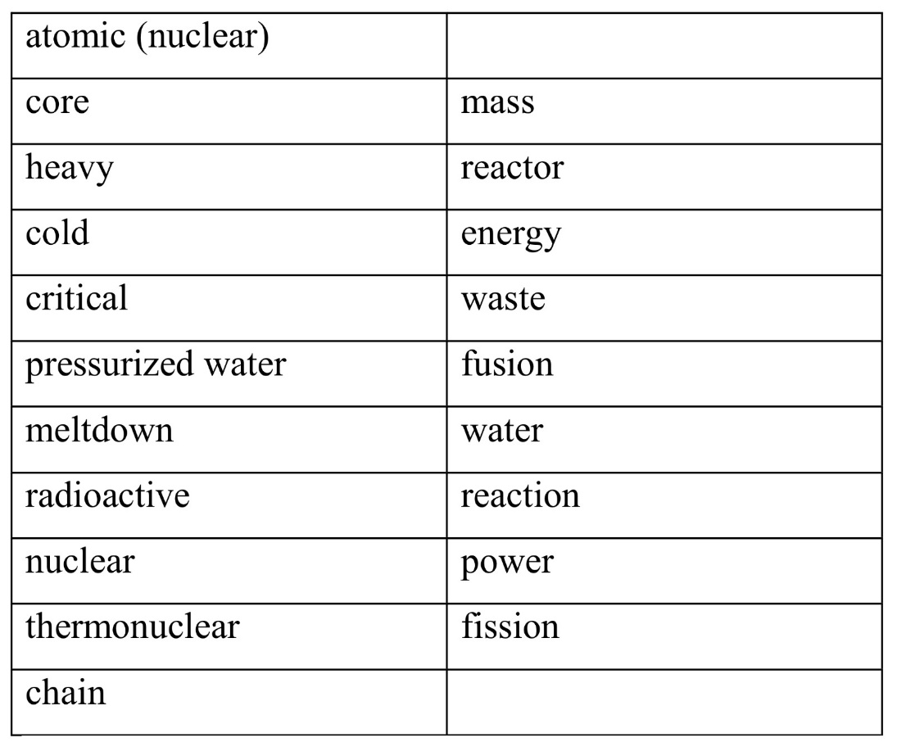
2. Look at the two columns. Some words in the first column can be combined with words in the second more than once, but some may not be combined at all. Write down the list of all possible words and word combinations and use the dictionary to translate them.

3. Watch the presentation “Nuclear power” (press Play to watch the animation) and do the task on Slide 4. Copy sentences in your copybook and define the parts of speech in each sentence.

Reading and language focus
4. Before you read the text agree or disagree to the statements below. Read the text to get the right answers.

1. Nuclear energy evokes both hopes and fears in humans.
2. There are generators and engines in a nuclear power plant.
3. It was impossible to control the temperature level in Fukushima due to a water leak.
4. In 2009, atomic energy represented 41% of the world's electricity production.
5. There are over a hundred nuclear power plants in the United States.
6. The difference between the nuclear power plant and the coal power plant is the method of heating the water.
7. Uranium is a very rare element on Earth.
8. When an operator wants the uranium core to produce more heat, the control rods are immersed in the uranium bundle.
9. A beam of uranium acts as a very deep source of heat energy.
10. People have used steam for hundreds of years.

NUCLEAR POWER
Nuclear energy is the energy contained in atoms. This energy can be released as heat from a chain reaction in a radioactive element such as uranium. Nuclear power plants use this heat to produce steam, which drives turbines to generate electricity.
Nuclear fuel is by far the most energy-consuming of all these natural resources, which means that we can extract more heat and electricity from it than an equivalent amount of anything else. As an example, consider a piece of coal and a piece of natural (unenriched) uranium, both weighing the same thing (1 kg) and both extracted and isolated directly from the earth. If we could extract all the energy from the coal, it would operate a 100 W bulb for about 4 days. With uranium, we could operate the bulb for about 180 years. This type of energy density could solve problems such as huge coal mines, huge gas and oil fields, trains loaded with fuel and large wind or solar parks. Nuclear reactors also do all of this without releasing pollutants into the environment.
But why are we still using coal, or something else for that matter?
The reactors that we have designed and built so far to split atoms and release energy are mostly large, complicated and expensive. Once built, operating the reactor costs very little (buying a few tonnes of uranium every 4 years is much cheaper than buying weekly coal trains).
The relatively small amount of nuclear fuel that enters reactors becomes radioactive nuclear waste when it leaves. The nature of radioactive waste is terrifying for everyone - - you can't see it, smell it or taste it, but it can be an invisible killer. This waste is not released to the environment, and nuclear scientists know how to turn this waste into something that degrades over several centuries (rather than hundreds of millennia), but the processes developed to date are costly and difficult.
Nuclear power is seen as dangerous due to the accidents in Fukushima, Chernobyl and Three Mile Island.
Taken from: http://www.edfenergy.com/energyfuture

5. Use the clues to solve the crossword:
Across
1. Penetrating rays which are better stopped or protected by a dense material.
2. Splitting atoms into small pieces.
3. Become larger in quantity, size, extent or intensity.
4. An uncharged elementary particle with a mass slightly greater than that of the proton, and found in the nucleus of each atom heavier than hydrogen.
5. (two words), this part of the nuclear power plant eliminates excess heat from the circulating water circuit of the reactor.
6. A rotary motor made up of a series of curved blades on a rotary shaft, generally turned by water or steam.
7. A radioactive element used to manufacture nuclear energy and nuclear weapons.
8. A possible source of danger.
9. Highly shielded container used to store and / or ship radioactive material.
10. A self-sustaining reaction in which the fission of the nuclei of one generation of nuclei produces particles which cause the fission of at least an equal number of nuclei of the next generation.
11. The smallest particle of an element that cannot be split or broken apart by chemical means.
12. The decrease in the amount of radioactive material over time.
13. An elementary nuclear particle with a positive electric charge located in the nucleus of an atom.
Down
1. having a high mass per unit volume.
2. the weight or force produced when something presses or pushes against something else.
3. An instrument for detecting and measuring radiation.
4. One millionth of a curia.
5. Spent fuel stored inside a nuclear power plant is used in this area.
6. One of the main concerns with nuclear power plants is what to do with _____.
7. Type of dangerous and powerful energy produced by radioactive substances and nuclear reactions.
8. A repeated series of events or actions.
9. Control ____ of a neutron absorbing material (such as boron carbide) is used to regulate the rate of nuclear fission in a reactor.
10. The point at which a nuclear reaction is self-sustaining.
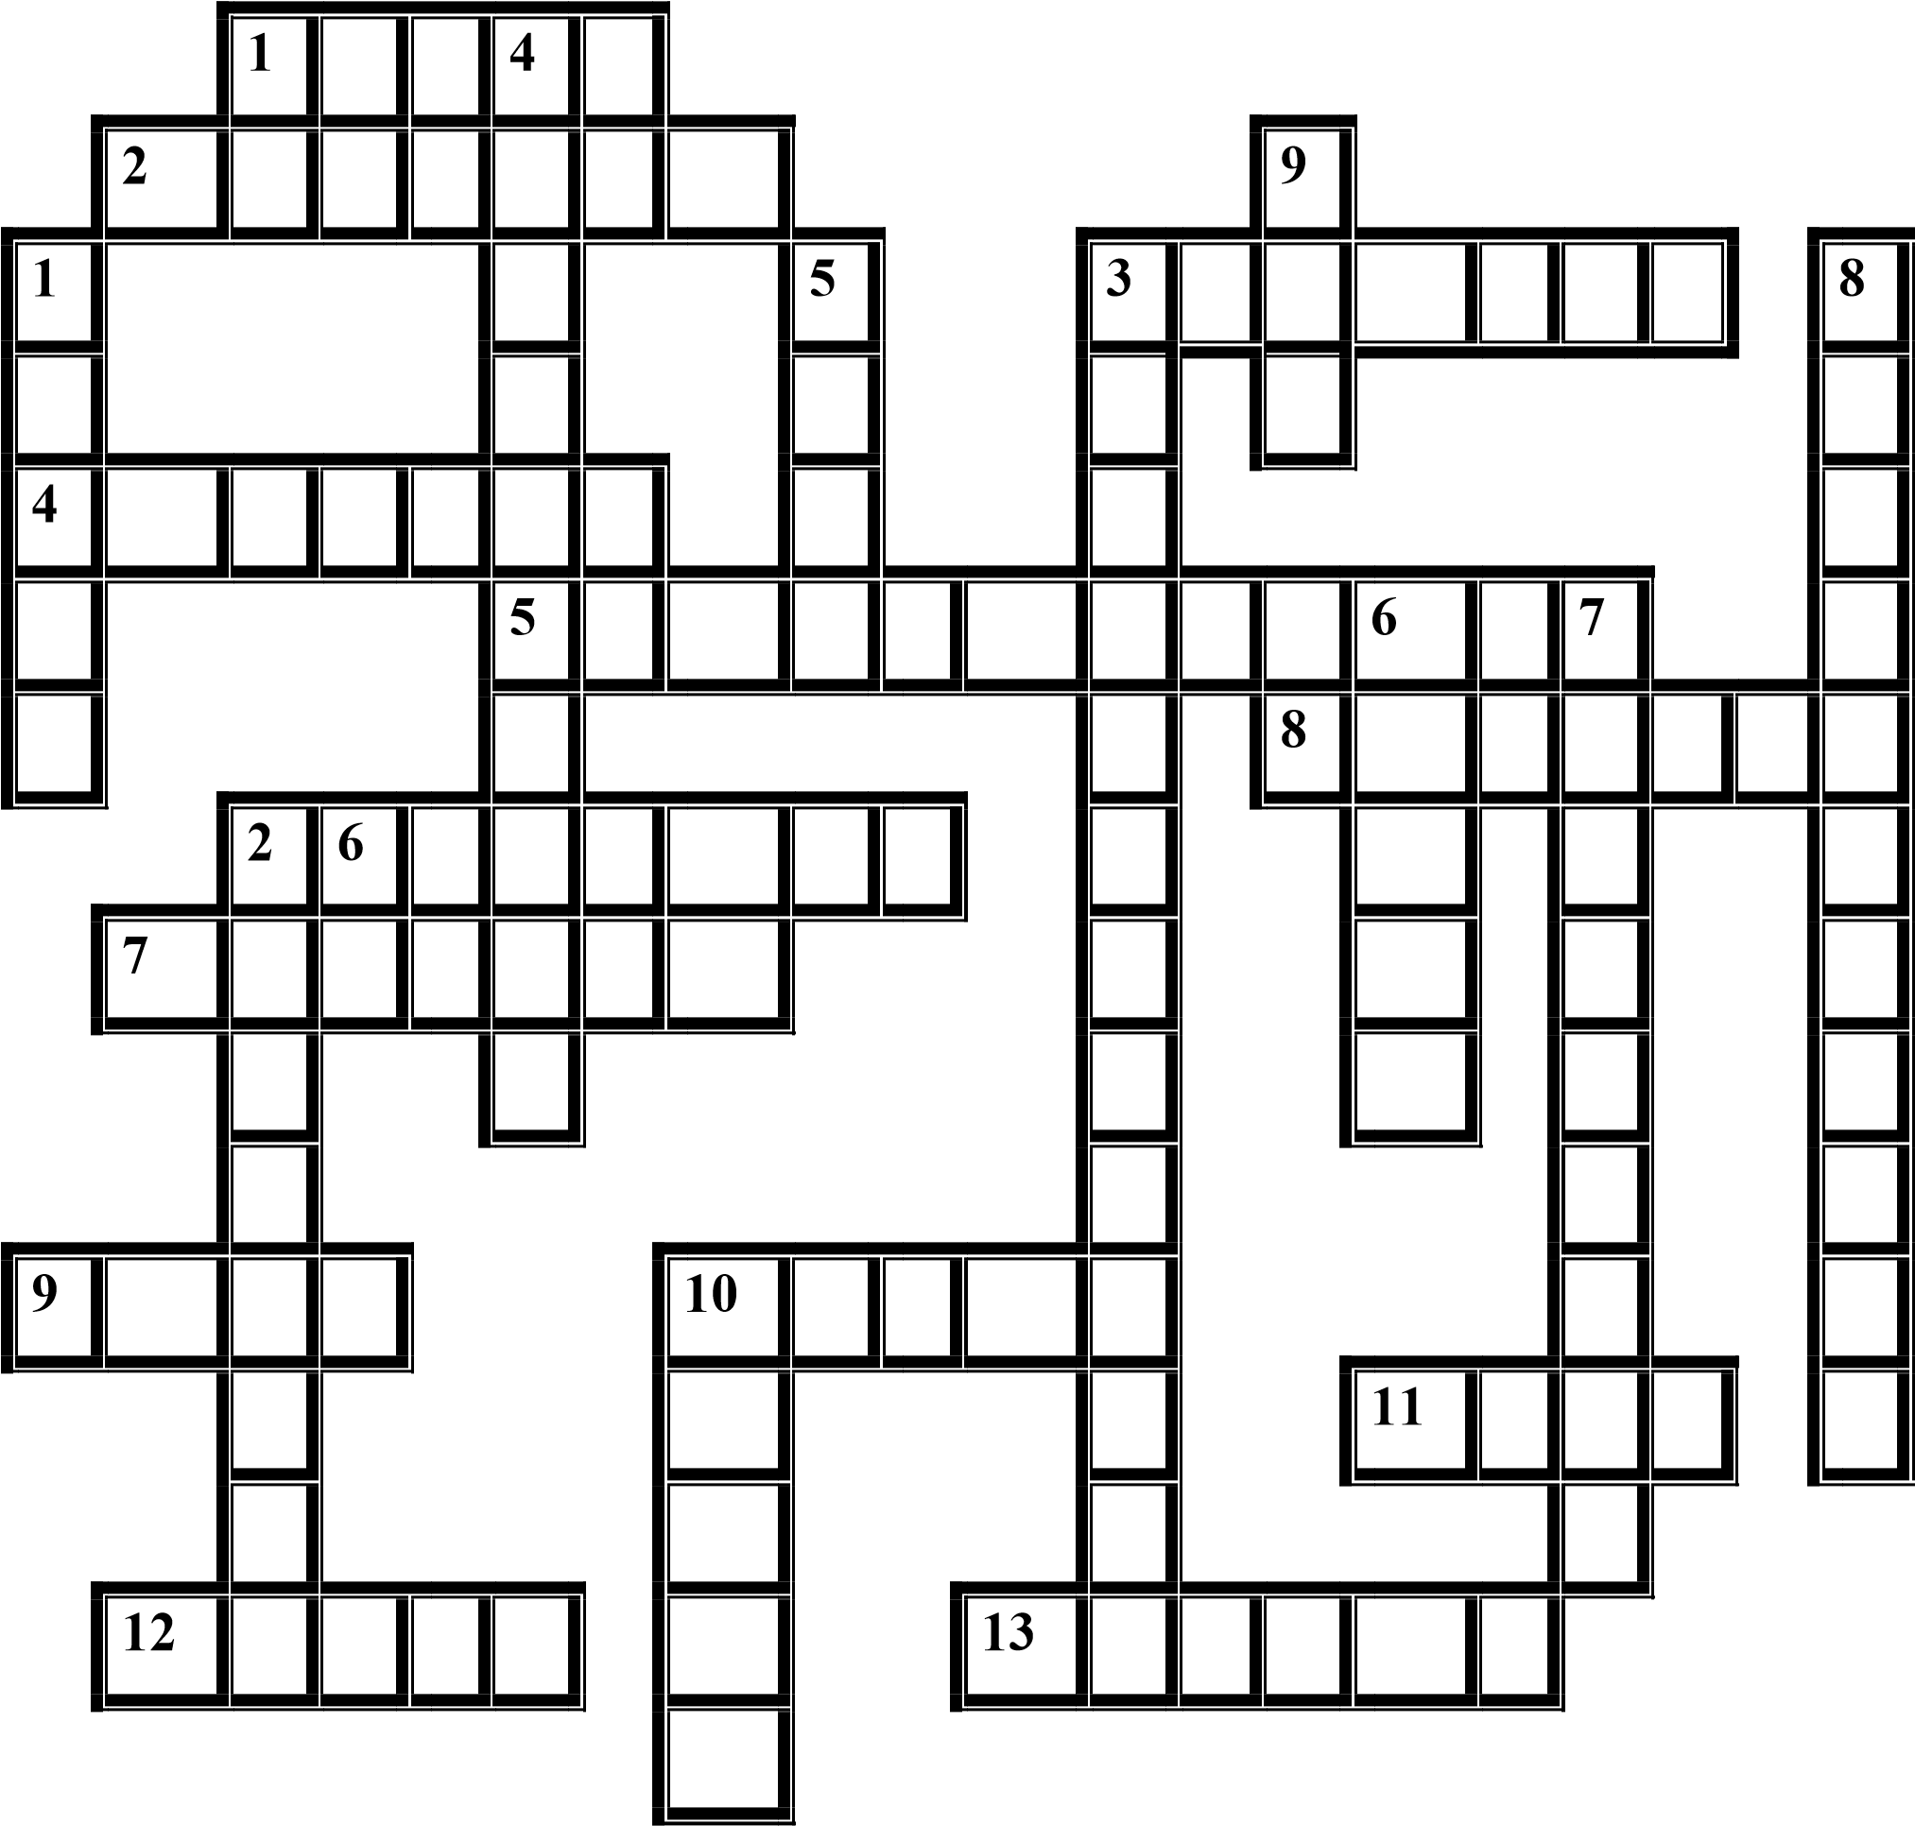
6. Pair work. Take turns comparing the types of reactors in Ukrainian nuclear power plants.

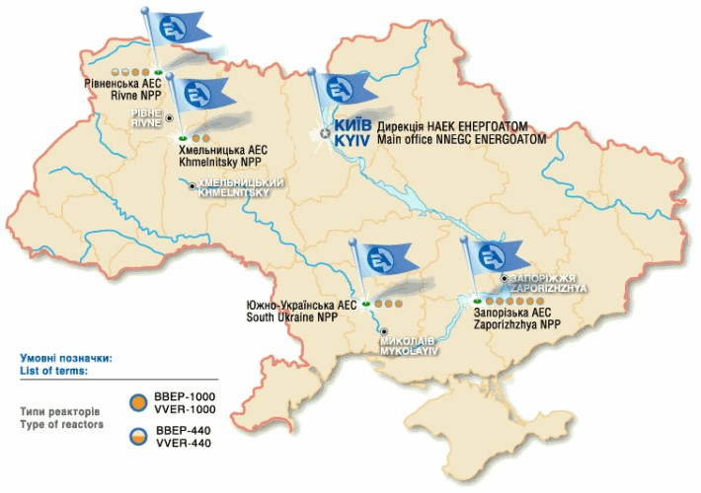
7. Watch the first minute (up to 1.01) of the "Nuclear Energy" video fragment. Choose the correct variant for the gap.
1. Nuclear power plants generate electricity worldwide.
a) 13
b) 300
c) 30
2. Nuclear power production is ____ in the way that fossil fuel power plants generate electricity.
capable
b) similar
c) simple
3. Nuclear power plants provide ____, 24 hour secure electricity.
a) glean
b) steam
c) clean
4. In most power plants, some form of energy is used to ____ transform water into steam.
in the heat
b) hit
c) knitting
5. The steam driven turbine is coupled to _____.
a) magnet
b) electronic tycoon
c) electromagnet
6. Although ____ is the same, there is a key difference between ____ nuclear power and other power plants. a) mode, facilities
b) model, faculties
c) model, installations
Reading and Listening

8. Watch and listen carefully to the whole video and tick the words and phrases you have heard.
1) Discuss | 2) Rich high temperatures | 3) Top priority
4) Carbon –free | 5) To prevent under heating | 6) Heat production
7) Feature few redundant layers | 8) Condenser | 9) Metal rods
10) Fuel assembling | 11) Absorbs all atomic particles | 12) Electricity consuming equipment
13) Key difference | 14) Accident | 15) Slightly difference
16) Run off | 17) Clean, safe, unsecure energy | 18) Liquid water
19) Chain reaction | 20) Stop fishing process | 21) Reactor core
22) Escaping | 23) Fossil fuels | 24) Programming
25) Right future | 26) Form of motion | 27) Models for use

9. After watching the video for the third time, write a plan for the story, which should include some key phrases from task 8. Present it to classmates as rhetorical questions / tags or a monologue.
10. Read the text and answer the questions
Why nuclear energy must be part of the energy solution?
At the end of the 16th century, when the rising cost of firewood forced ordinary Londoners to reluctantly switch to charcoal, Elizabethan preachers objected to a fuel they literally believed to be the Devil's droppings. The coal was black, after all, dirty, found in underground layers - down to hell in the center of the earth - and smelled strongly of sulfur when it burned. The transition to charcoal, in houses which generally lacked chimneys, was already quite difficult; The open condemnation of the clergy, although certainly justified from an environmental point of view, has complicated and delayed the rapid resolution of an urgent problem of energy supply.
For too many environmentalists concerned about global warming, nuclear power is the devil's excrement today. They condemn it for its production and use of radioactive fuels and for the supposed problem of disposing of its waste. In my opinion, their condemnation of this efficient, low-carbon source of basic energy is inappropriate. Far from being the Devil's droppings, nuclear energy can be, and should be, a major part of our rescue from a warmer and more weather-destroying world.
Like all sources of energy, nuclear power has advantages and disadvantages. What are the advantages of nuclear energy? First and foremost, as it produces energy by nuclear fission rather than chemical combustion, it generates basic electricity without emitting carbon, the villainous element of global warming. The transition from coal to natural gas is a step towards decarbonization, since the combustion of natural gas produces about half of the carbon dioxide from burning coal. But the transition from coal to nuclear energy is radically decarbonising, because nuclear power plants only release greenhouse gases by the auxiliary use of fossil fuels during their construction, extraction, processing, maintenance and decommissioning - about as much as solar energy, which is about 4 to 5% as much as a natural gas power plant.

1.In the early 16th century the cost of firewood increased greatly which forced ordinary Londoners to switch reluctantly to coal.
2. Coal was black, after all, dirty, found in layers underground — that is why coal seemed to be a heal substance.
3. Switching to coal, in houses that usually lacked chimneys, was hard enough.
4. For too many environmentalists concerned with global warming, nuclear energy is today’s Devil’s excrement as well as it was with coal in 16th century.
5. They don’t like nuclear energy for its production and use of radioactive fuels and for the supposed problem of disposing of its waste.
6. Far from being the Devil’s excrement, nuclear power can’t be the only one rescue from a hotter, more meteorologically destructive world.
7. Nuclear fission generates baseload electricity with output of carbon, the villainous element of global warming.
8. Switching from coal burning to natural gas burning guarantee much less carbon output than switching to nuclear fission
9. The most radical decarbonizing could be accomplished only by switching from coal to nuclear power.
10. Nuclear power plants release greenhouse gases only during their construction

11. Rosana, the assistant manager at a Dorian Food Processing plant, is chairing the weekly Health and Safety meeting. Listen to four extracts from the meeting and match each extract (a-d) to an agenda item (l -7). CD 7_1
A_______ C_______
B_______ D_______
12. Listen again and match the words from the meeting (l -8) to the definitions (a-h).
confined spaces | burns the skin
C02 detector | contact (with a danger)
exposure | sources of ignition
irritant | small areas without ventilation
toxic | measures carbon dioxide
corrosive | poisonous
flammable | causes skin to react
naked flames/sparks | catches fire easily

Language in use and translation
13. There are lines that have a mistake (wrong verb form or odd word).
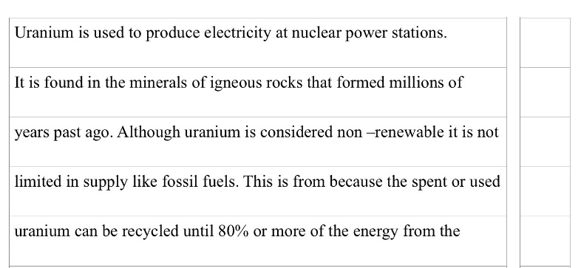
Write these words in the box and explain your choice.

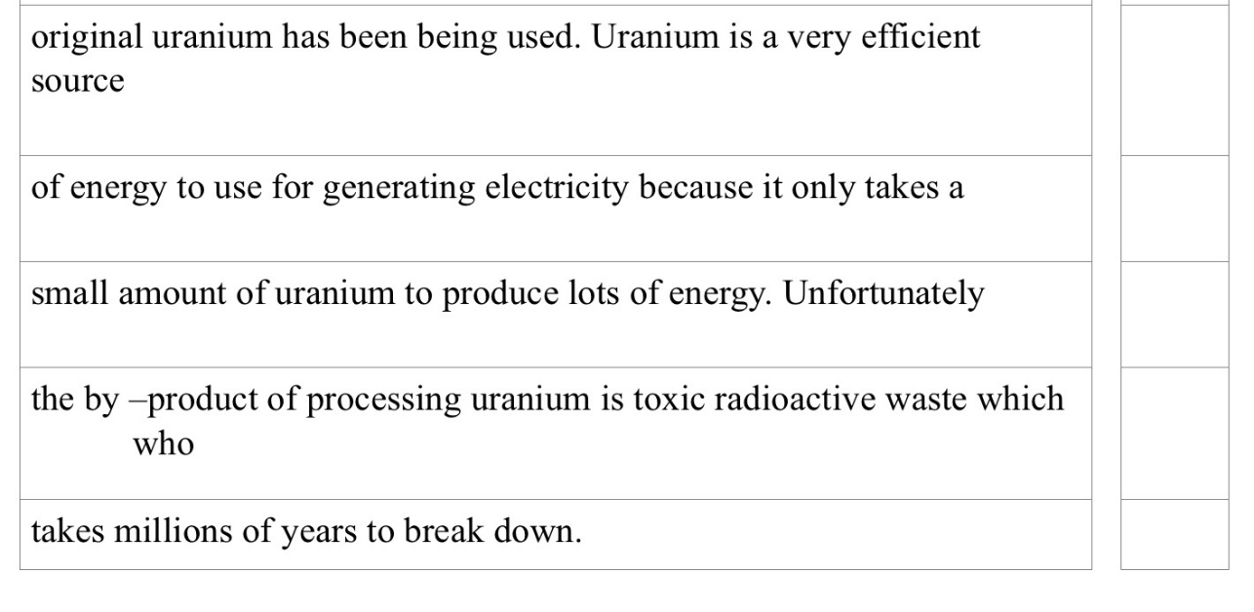
Taken from:http://www.sustainableschools.sa.edu.au/files/

Speaking
14. ln pairs, discuss what is meant by the items on the Health and Safety meeting agenda.
Dorian Food Processing
Health & Safety Meeting Agenda
Wednesday l6 April, Conference Room, 2.00pm - 4.00
To: RM, MA, DB, SM, BP, LJ
Chair: Rosana Martinez
1 Hazardous substances & Personal Protective Equipment
2 Harmful gases/fumes 6 asphyxiation hazards
3 Fire/Explosionhazards
4 Machinery: guards and safety devices
5 Access ways, guardrails and emergency exits
6. Electrical installations
7 Noise hazards

15. Work in pairs. Look at the picture and ask yourself questions about the structure of the nuclear power plant.
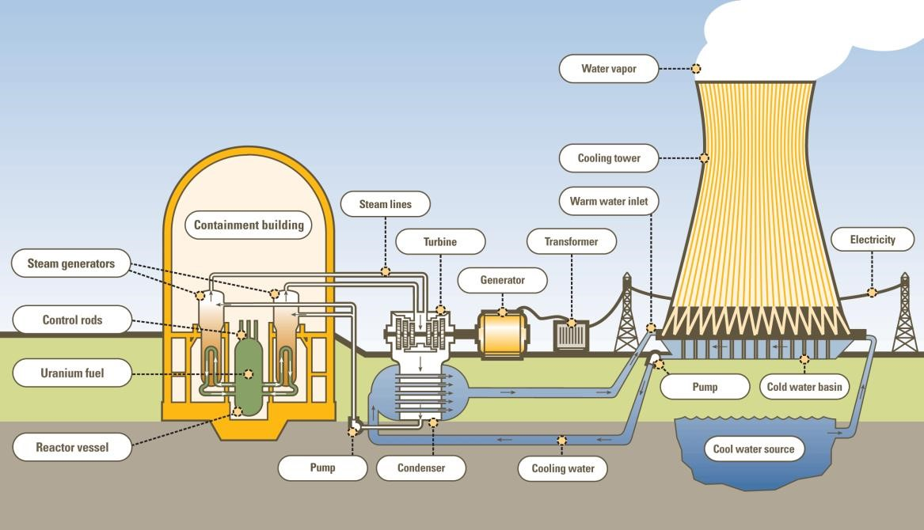

16. You will play a role in televised debates on the issue of nuclear energy. Choose the roles: nuclear scientist, young engineer, nuclear power plant manager, nuclear power plant workers, citizens, environmental scientists, Greenpeace activists, presenter. Think about the pros and cons of nuclear power and discuss it from different perspectives.

Writing
17 You have just read the article about nuclear power and saw the statement that nuclear power releases less radiation into the environment than any other major energy source. Do you agree with this statement or not ? Write down your thoughts. (120-150 words).

UNIT 14. FUTURE SOURCES OF ENERGY
Lead-in
1. Look at the picture. What is the difference between renewable and non-renewable energy sources? Why is it so important to develop renewable energy sources?
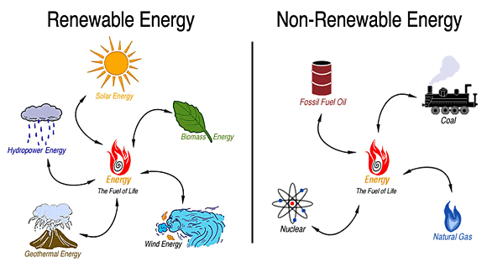

2. Read the statements. Give titles to two “scales” and look for phrases to add to the scales. Comment on the quotes.
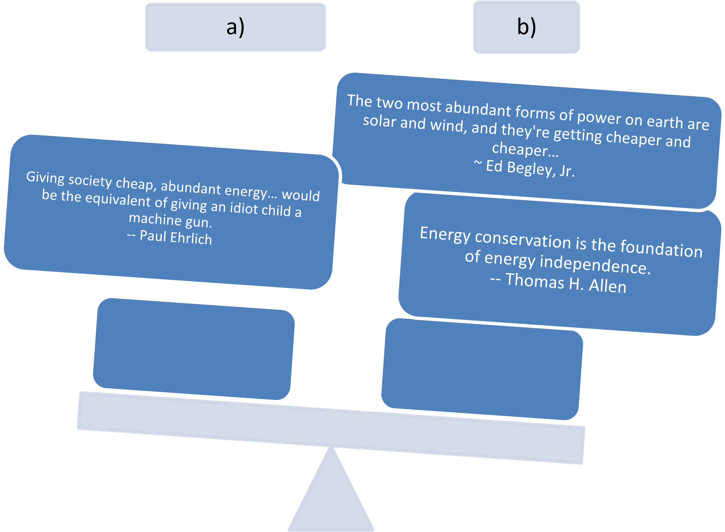

Vocabulary
3. Match words with their translation.
1. impact | A. буйок
2. tidal | B. транспортні засоби
3. capture | C. берег
4. desalination | D. величезний, значний
5. buoy | E. житловий
6. shore | F. відходи
7. tremendous | G. припливний
8. vehicles | H. зловити, захопити
9. residential | I. опріснення
10. waste | J. вплив
Language focus and reading
4. Describe the diagram. Use comparative structures and Passive Voice.

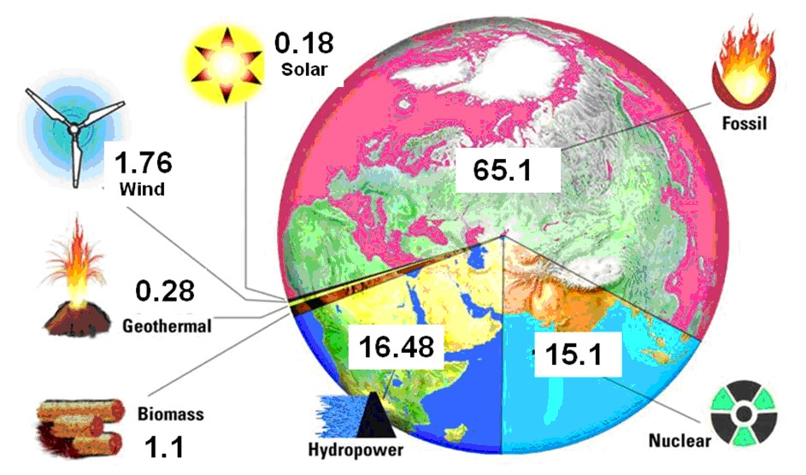
This is the diagram of Power Generation by Type 17,530 GWhin in 2005. Think what changes have happened since that time.

5.Read the text about Energy Production , then circle the answer a),b),c),d) which best fits the space.
It was ____ (0) coal that produced the energy to power the factories of the largest _____ (1) manufacturers, such as Britain and Germany. The coal miners worked long _____ (2) hours in dark and cold coal mines to bring this black rock above the ground. They called it ____ (3) gold. Texas, Saudi Arabia, Kuwait and Venezuela: these are only ____ (4) of the places where oil was found. Today, big oil ____ (5) is still spending millions of dollars on oil. Sometimes they do not ___ (6) oil underground. They find gas. But gas can also be used as energy. It is a good source of energy for ____ (7) and cooking. By building large dams to control water, millions of kilowatts of electricity can be produced. Country ____ (8) Sweden and Norway derive most of their electricity from hydroelectric power.
In the future, much of our energy could come from the sun. In some countries, solar _____ (9) on the roof can already provide enough solar energy for a house in winter and summer. Even a light wind can provide enough energy to power the lights and most electrical _____ (10) at home.
0. | a – who | b – whose | c – that | d - this
 | a- country | b- countries | c- counties | d- county
 | a- hard | b- heavy | c- difficult | d- weighty
 | a- black | b- white | c- brown | d- yellow
 | a- some | b- few | c- any | d- much
 | a- companion | b -companies | c- company | d- compartment
 | a- find | b- fond | c- found | d- founded
 | a- heat | b- hot | c- heating | d- warming
 | a- as | b- same | c- liked | d – similar
 | a- collections | b- collectors | c – collects | d – collecting
 | a- mechanisms | b- settings | c - appliances | d- techniques
6. Read the text, translate it and match the titles to each paragraph.
Hydrogen Hydroelectricity Tidal Power Wind Power Solar Power
Wave Power
1. This energy can be generated by tidal current generators or by dams. The energy generated by tidal generators is generally more environmentally friendly and has less impact on established ecosystems. Similar to a wind turbine, many tidal current generators rotate underwater and are driven by dense, rapidly moving water.
2. This type of energy is the transport of energy by the waves of the ocean surface and the capture of this energy to carry out useful work - for example for the production of electricity, the desalination of water or pumping water (in tanks). The power of the waves is distinct from the power of the tides and the constant vortex of ocean currents. Rising and falling waves move the buoy-like structure, creating mechanical energy that is converted into electricity and transmitted to shore on a submerged transmission line.
3. It has enormous potential as a fuel and energy source, but the technology to realize this potential is still in its infancy. Hydrogen is the most common element on Earth - for example, water is two-thirds of hydrogen - but in nature it is always found in combination with other elements. Once separated from other elements, hydrogen can be used to power vehicles, replace natural gas for heating and cooking, and to generate electricity.
4. Photovoltaic (PV) Solar energy harnesses the sun's energy to generate electricity. In recent years, solar installations have also started to develop in residential areas, with governments offering incentive programs to produce "green" energy.
5. This power is the conversion of wind energy by wind turbines into a useful form, such as electricity or mechanical energy. Large-scale wind farms are generally connected to the local electricity transmission network with small turbines used to supply electricity to isolated areas. Wind farms on agricultural land or pasture have one of the lowest environmental impacts of any energy source.
6. Hydroelectricity is the electricity produced by hydroelectricity, that is, the production of electricity by the use of the gravitational force of falling or flowing water. It is the most used form of renewable energy. Once a hydroelectric complex is built, the project produces no direct waste. While many hydroelectric projects supply public electricity grids, some are created to serve specific industrial enterprises.
Taken from: http://listverse.com/2009/05/01/

Speaking and listening

7. Mike, Loreata and Hanif, engineers at a wind turbine constructor, are discussing performance and suitability issues relating to offshore wind turbines. Listen to the conversation and answer the following questions. СD 10_1
- What wind turbine component are engineers discussing?
- What is the big problem with offshore installations?
- What are the two types of building materials compared?
- Why are coastal defenses mentioned?
- What does Hanif do about regular maintenance?
- What comparison should be made with regard to service life?
8. Link the words with their explanations
appropriate/suitable | the right solution for a particular situation
consistent/reliable | good enough for the intended function
cost-effective/economical | performs a function well
effective | works quickly and well
efficient | makes the most of resources, isn't wasteful
sufficient/adequate | doesn't break down, always performs in the same way

9. Make the following words negative by adding the prefixes in- or un-

  - Adequate inadequate
  - Appropriate _________
  - Consistent _________
  - Economical _________
  - Effective _________
  - Efficient _________
  - Reliable _________
  - Sufficient _________
Suitable _________
10. The following information is from the website of Sigma Power, a company that advises businesses and governments on wind energy projects. Complete the text using the words from exercise 7.

1. The fact that wind turbines do not consume fuel and waste very little energy is clearly a fundamental advantage. But how effective are they? Key figures
2. Obviously, wind turbines must be located on relatively windy sites to operate. From a meteorological point of view, what types of geographic locations are the most_________?
3. Turbines are usually placed at the top of tall towers, where wind speeds are higher, making them more_________. What other positioning factors influence performance?
4.The wind turbines rarely operate continuously, due to the fact that the wind speeds are_________. How important is the impact of varying weather conditions on electricity generation capacity?
5. The transmission of electricity over long distances is inherently _________, due to the loss of power from overhead or underground power lines. Learn more about the benefits of local power generation
6. The production capacity of wind turbines is generally _________ to be able to count on 100%. What percentage of the total production capacity can wind turbines realistically provide?
7.Some of the first wind turbines were _________, suffering from failures caused by inaxial stresses resulting from higher wind loads on the upper blade. However, this problem has been resolved on modern units. Learn more about the technical evolution of wind turbines
11. You are engineers at Sigma Power. The marketing manager has asked you to provide technical answers for the FAQ section of the company's website. The FAO section is mainly intended for potential customers who plan to install wind turbines on their sites - factories, office complexes, hospitals and university campuses. In pairs, discuss the following questions and write the answers for the website using the information in the fact file and your own knowledge.
What is the big advantage of having a wind turbine on my site?
How reliable are wind turbines as an energy source, given that weather conditions are variable?
What types of sites are best suited for wind turbines, compared to natural factors such as hills, coast, and height above sea level?
What is the most suitable location for my wind turbine, based on local site characteristics, such as trees and building?
Reading and speaking
12. Read the the text “Renewable Energy” and answer the questions below. Make the plan for retelling. Renewable Energy
Renewable energy is energy from natural sources - such as sunlight, wind, rain, tides and geothermal heat - which are renewable (naturally filled). If we compare the energy production processes, it turns out that there are several fundamental differences between renewable energies and fossil fuels. The process of producing petroleum, coal or natural gas is a difficult and complicated process which requires many complex equipment, physical and chemical processes.
On the other hand, alternative energy can be widely produced with basic equipment and natural processes. Wood, the most renewable and available alternative energy, burns the same amount of carbon it would release if it were broken down naturally.
In 2006, about 18% of global energy production came from renewables, with 13% coming from traditional biomass and 3% from hydroelectricity. New renewables (modern biomass, wind, solar, geothermal, and biofuels) make up another 2.4% and are growing very fast.

- What is renewable energy produced from?
  - sun, tides, geothermal heat
  - wind, sunlight, rain, tides and geothermal heat
  - oil, sunlight, tides

- What are the differences between renewable energy and fossil fuels?
  - basic
  - difficult
  - unlike

- What does the process of producing oil, coal, or natural gas fuel require?
  - complex equipment, physical and chemical processes
  - complex furnishing, physical and chemical processes
  - complex equipment, electrical and mechanical processes

- What is the most renewable and available alternative energy?
  - coal
  - carbon
  - wood

- At the beginning of the XXI century the percentage of new renewables is…
  - degrading
  - growing
  - made up

Task 13. Read the second part of the text “Future sources of energy” and answer the questions below. Make the plan for retelling.
FUTURE SOURCES OF ENERGY. PART 2.
Radiant energy is the energy of electromagnetic waves. The Methernitha
The community in Switzerland currently has 5 or 6 functional models of autonomous battery-free devices which exploit this energy. Magnifying transmitter of Nikola Tesla, T. Henry
The radiant energy device from Moray, the EMA engine from Edwin Gray and the Testatika machine from Paul Baumann all operate on radiant energy. This form of natural energy can be recovered directly from the environment or extracted from ordinary electricity by the method called fractionation.
Geothermal energy is a very powerful and efficient way to extract renewable energy from the earth through natural processes. Geothermal energy is cost effective, reliable and environmentally friendly, but was previously geographically limited to areas near the boundaries of the tectonic plates. Recent technological advances have greatly expanded the range and size of viable resources, especially for direct applications such as home heating. Geothermal energy offers some scalability: a large geothermal power plant can power entire cities while smaller power plants can power rural villages or heat individual houses.
Biomass, as a renewable energy source, refers to biological material that can be used as fuel or for industrial production. In this context, biomass refers to plant materials grown to generate electricity or produce, for example, waste such as dead trees and branches, garden clippings and wood chips, and it also includes materials plants or animals used for the production of fibers, chemicals or heat. Biomass can also include biodegradable waste which can be burned as fuel. Industrial biomass can be grown from many types of plants, including miscanthus, switchgrass, hemp, corn, poplar, willow, sorghum, sugar cane and a variety of species. trees, ranging from eucalyptus to oil palm (palm oil).

Taken from: http://listverse.com
1. What devices operate on radiant energy?
2. What is a degree of scalability?
3. Which community has successfully used radiant energy?
4. What are the sources of biomass?
5. What type of energy was previously limited geographically to areas near the boundaries of tectonic plates?
14. Choose any energy source. Do not name it but answer “yes” or “no” to questions from your classmates. Students should try to guess what you have chosen. In turn.
Possible questions: does it depend on the geographic position? Is it a renewable / non-renewable source? Does it need large areas of land?
15. Search the Internet and make a list of resources that deal with future sources of energy. Write down their slogans and their main ideas / solutions. Share your results with your classmates in the form of a presentation.
Listening and English in use

16. Translate the sentences, define whether they contain Gerund, Participle or Infi native.
1. / sources/ of /energy/ by /storing /chemical/ Plants/ are/ useful/radiation /from /the /sun.
2. / the /price/ of/ uranium /would have/ little/ effect / The/ increase /in/ on the overall/ cost/ of /nuclear/ energy/ doubling /the /cost of/ natural/ uranium /would/ increase/ the total /cost /of /nuclear /energy /by 5%.
3. / of the wire /we/ reduce /the /resistance /to /current /flow/ By increasing/the /cross /section/.
4. passing /from /most /to /least, / Although /they/ speak/ of /the /current /as electricians /know/ the /electrons /which/ pass /from/ least/ to/ most.
5. electricity /systematic/ observations/ and /experiments/ were/ To/ prove /that /lightning /is /atmospheric / necessary.
6. the/ field/ becomes /strong/ and/ the/ electrons/ produce/ As/ the /voltage/ is /increased/ /additional/ ions/ by /collision.
7. potential /difference/ the/ students /compared/ After /measuring /the / the /results/ obtained.
8. and /copper /to be the best/ conductors/ of/ Electricians/ consider/ silver /electricity.
9. wood/ can/ be /burned /directly/ for / Vegetation/ and/ energy/ such /as /fossil/ fuels/ or/ processed /to/ form /alcohols.
10. the /best/ conductors /of/ Metals/ are /electricity/ minerals/ being/ rather/ bad/ conductors.
11. of /electricity /silver /and /copper /being /the /best There /are /many /good /conductors /of /all.
12. to be /a very/ efficient/ generator /The/ designed /machine/ has /proven.
13. Two/ parallel /conductors /electric/ circuit /have/ forming /an /a /relatively/ weak/ self-induction/ because/ the/ flux /which /is /connected /to /it/ is/ weak.
14. in /one /part /of/ the/ transistor/ circuit /are known/ to/ Variations /in /the/ current /flowing /cause /corresponding/ changes/ in the other part /of the circuit.
15. to/ as /energy /efficiency/ is/ the/ objective/ of /efforts /to /reduce /the /amount /of energy/ required/ to /provide /products /and /services / Efficient /use /of energy/ sometimes /simply/ referred.
16. garbage/ produces /methane/ captured/ When/ decomposed/ in /the /pipes /and /then /burned /to/ generate /electricity.
Writing
17. Write an essay on one of the statements (120-150 words):
A. I know that nuclear is better than fossil fuels when it comes to carbon dioxide, but nuclear power is by no means clean. We don't know what to do with the waste we already have and it seems to me a bad idea to do more when we have so many cleaner options like wind and solar. - Sheryl Crow
B. Hydrogen is the most common element in the universe and has the potential to become an inexpensive energy source for neighborhoods, light and heavy vehicles and industry. - Charlie Dent

APPENDIX A. GRAMMAR GUIDE TENSES

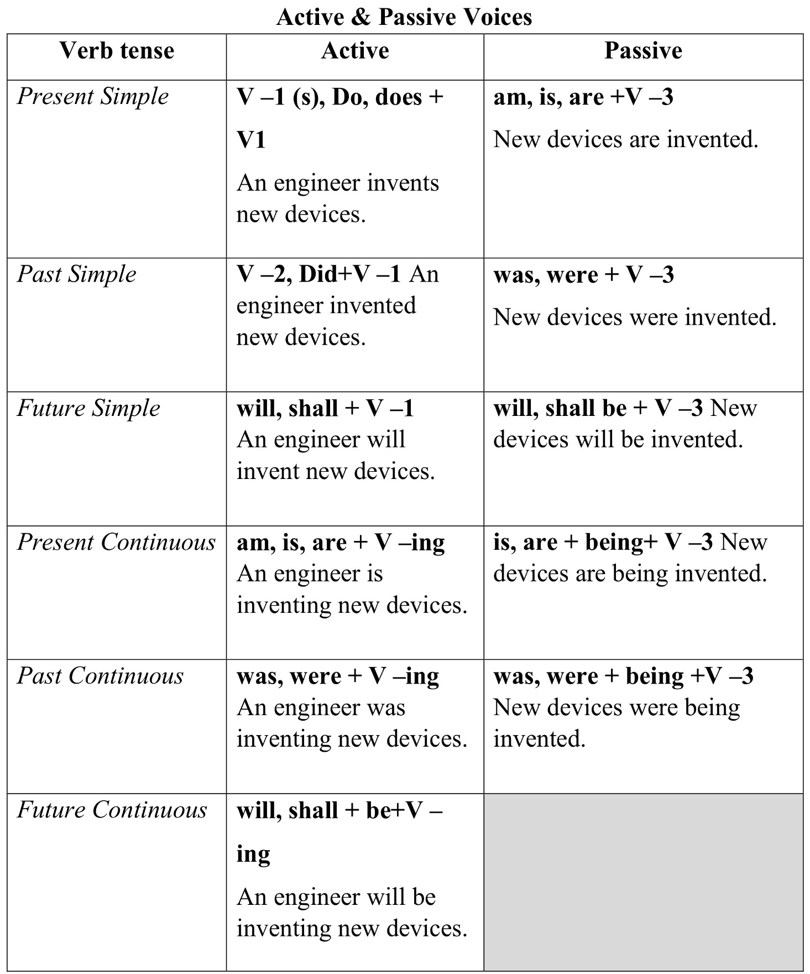

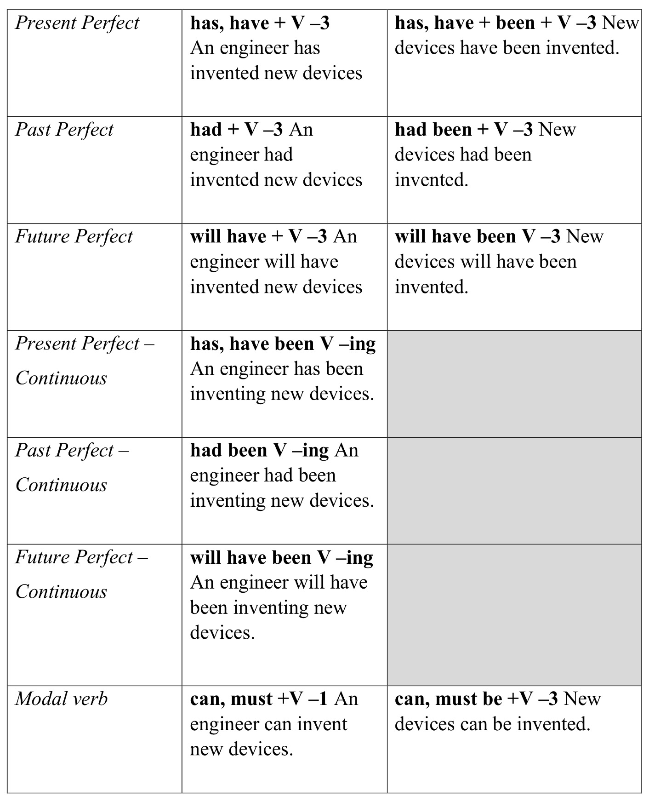

FORMS OF INFINITIVE
Form of infinitive | Active | Passive
Indefinite | to create to come | to be created
Continuous | to be writing to be coming | _______
Perfect | to have created to have come | to have been created
Perfect Continuous | to have been solving to have been coming | ________

INFINITIVE OR –ING FORM
Verb + –ing :
stop, delay, fancy, consider, admit, miss, involve, finish, postpone, imagine, avoid, deny, risk, practise, enjoy, suggest, mind, give up, put off, carry on, go on, keep on, can´t help /laughing/, dislike, can´t stand.
verb + to:
offer, decide, hope, deserve, attempt, promise, agree, plan, aim, afford, manage, threaten, refuse, arrange, learn, forget, fail, seem, appear, tend, pretend, claim, decide, dare, want, ask, help, expect, beg, tell, remind, force, enable, teach, order, warn, invite, persuade, make, let. both –ing + infinitive:
begin, start, intend, continue, bother, love, like, hate, can´t bear /no difference in meaning difference in meaning: advise, recommend, encourage, allow, permit, forbid:
verb + –ing /without an object/ verb + object + to:
I recommend waiting I recommend you to wait
remember + –ing = I did it and now I remember /I remember posting the letter/ remember – to…= not to forget or to realise /please remember to post the letter/ regret + –ing = I am sorry about what I did /I regret saying it/ regret + to…= I´m sorry that I have to…/We regret to inform you…/ go on + –ing = continue /He went on talking/ go on + to.. = do or say something new /After discussing it he went on to talk about economy/
try + –ing = testing /try pressing the button try + to.. = attempt, effort /I tried to move the table/ need + –ing = something needs to be done /the floor needs cleaning/ need + to.. = it is necessary /I need to take more exercise/ NOTE: would is followed by infinitive: I would like to go.
I would like to have done something= I regret I couldn´t do it

CONDITIONALS – SUBJUNCTIVE MOOD
Zero Conditional | First Conditional
If + Present Simple, Present Simple  - General truths  e.g. If/Whenever ice melts, it becomes water.  - Rules  e.g. If you wave a red flag, it means danger. | If + Present Simple, will/can + infinitive  e.g. If I win the lottery, I will travel around the world.  Unless I win the lottery, I will not/ won’t travel around the world.  (I don't know if I win but there is a possibility)
Second Conditional | Third Conditional
If + Past Simple, would/could + infinitive  e.g. If I won the lottery, I would travel around the world.  (But I didn't win the lottery, and it’s very unlikely that I will win) | If + Past Perfect, would/could + have + PP  e.g. If Christopher Columbus hadn’t discovered America, the history of the world would have been different.  (But he had discovered America and it’s impossible to change)

Mixed conditionals

 | If clause | Main clause
Type 2 | If he was doing his laboratory work all day, | he will get good mark tomorrow. | Type 1
Type 2 | If I were rich, | I would have bought a new computer. | Type 3
Type 3 | If an engineer had been asked to participate | he would go to that competition tonight. | Type 2

WISHES
 | Form | Use
I wish (if only) (wish/regret about the present) | + Past Tense | wish/regret about the present situation we want to be different
I wish I were in another place now (It’s a pity I am not)
I wish (If only) (wish/regret about the present) | + could + bare infinitive | wish/regret in the present concerning lack of ability
I wish I could speak fluent English. (but I can’t)
I wish (if only)  (Regret about the past) | + Past Perfect | regret that something  happened or didn’t happen in the past.
I wish I had prepared my homework. (but I didn’t)

TENSE CHANGE – IN – INDIRECT SPEECH
DIRECT SPEECH |  | INDIRECT SPEECH
PRESENT TENSE
PRESENT SIMPLE changes into PAST SIMPLE
She said, “He goes to school daily”  They said, “We love our country”  He said, “He does not like computer” |  | He said that she went to school daily. They said that they loved their country He said that he did not like computer.
PRESENT CONTINUOUS changes into PAST CONTINUOUS
He said, “He is listening to the music.”  She said, “I am washing my clothes.” |  | He said that he was listening to the music.  She said that she was washing her clothes.
PRESENT PERFECT changes into PAST PERFECT
She said, “He has finished his work”.  He said, “I have started a job.”  I said, “she have eaten the meal.”  They said, “We have not gone to New  York.” | She said that he had finished his work.  He said that he had started a job.  I said that she had eaten the meal. They said that they had not gone to New York.
PRESENT PERFECT CONTINUOUS changes into PAST PERFECT
CONTINUOUS
He said, “I have been studying since 3 o’clock”  She said, “It has been raining for three days.”  I said, “She has been working in this office since 2007.” |  | He said that he had been studying since  3 o’clock.  She said that it had been raining for three days.  I said that she had been working in this office since 2007.

PAST TENSE
PAST SIMPLE changes into PAST PERFECT
He said to me, “You answered correctly.”  John said, “They went to cinema.”  He said, “I made a table.”  She said, “I didn’t buy a car.” |  | He told me that I had answered correctly.  John said that they had gone to cinema.  He said that he had made a table.  She said that she had not bought a car.
PAST CONTINUOUS changes into PAST PERFECT CONTINUOUS
They said, “We were enjoying the weather.”  He said to me, “ I was waiting for you.”  I said, “It was raining.”  She said, “I was not laughing.” |  | They said that they had been enjoying. He said to me that he had been waiting for me.  I said that it had been raining.  She said that she not been laughing.
PAST PERFECT changes into PAST PERFECT (tense does not change)
She said, “She had visited a doctor.”  He said, “I had started a business.”  I said, “she had eaten the meal.”  They said, “We had not gone to New  York. ” |  | She said that she had visited a doctor.  He said that he had started a business.  I said that she had eaten the meal. They said they had not gone to New York.
FUTURE TENSE
FUTURE SIMPLE TENSE WILL changes into WOULD
He said, “I will study the book.” She said, “I will buy a computer.”  They said to me, “We will send you gifts.”  I said, “I will not take the exam.” |  | He said that he would study the book.  She said that she would buy a computer.  They said they would send you gifts.  I said that I would not take the exam.
FUTURE CONTINUOUS TENSE
WILL BE changes into WOULD BE
I said to him, “ I will be waiting for him.”  She said,” I will be shifting to new home.”  He said, “I will be working hard.”  He said, “He will not be flying kite.” | I said to him that I would be waiting for him. She said that she would be shifting to a new home.  He said that he would be working hard.  She said that he would not be flying kites.
FUTURE PERFECT TENSE WILL HAVE changes into WOULD HAVE
He said, “I will have finished the work.” She said, “They will have passed the examination.”  He said, “I will have gone.” |  | He said that he would have finished the work.  She said that they would have passed the examination.  He said that he would have gone.

Note: The tense of reported speech may not change if reported speech is a universal truth though its reporting verb belongs to past tense.

Examples
Direct speech: An engineer said, “The device is broken.”
Indirect Speech: An engineer said that the device was broken.
Direct speech: A lab assistant said, “Water boils at 100⁰ Centigrade.”
Indirect Speech: Lab assistant said that water boils at 100⁰ Centigrade.
(Tense didn’t change because reported speech is a universal truth though its reporting verb belongs to past tense)
INDIRECT SPEECH FOR SENTENCES WITH MODALS “CAN, MAY, MUST”

Present modals are changed to past modals
Direct Speech Indirect Speech
Indirect speech for sentences having MODALS: “can, may, must, should, ought to” CAN changes into COULD
He said, “I can drive a car” He said that he could drive a car.

She said, “He can repair the pump.” She said that he could repair the pump. They said, “We can climb on a hill” They said that they can climb on a hill. MAY changes into MIGHT
He said, “I may buy a computer.” He said that he might buy a computer.
She said, “He may visit a doctor.” She said that he might visit a doctor.
They said, “They may go to zoo.” They said that they might go to zoo.

MUST changes into HAD TO
He said, “I must work hard.” He said that he had to work hard.
She said, “They must carry on their She said that they had to carry on their experiment.” experiment.
I said to him, “You must learn the test – I said that he had to learn the test –taking taking strategies.” strategies.

INDIRECT SPEECH FOR SENTENCES HAVING MODALS “SHOULD, OUGHT TO, MIGHT, WOULD, AND COULD” The modal will not change in indirect speech
Direct Speech | Indirect Speech
Would
They said, “We would apply for a visa.”  He said, “I would start a business.” | They said that they would apply for visa.  He said that he would start a business.
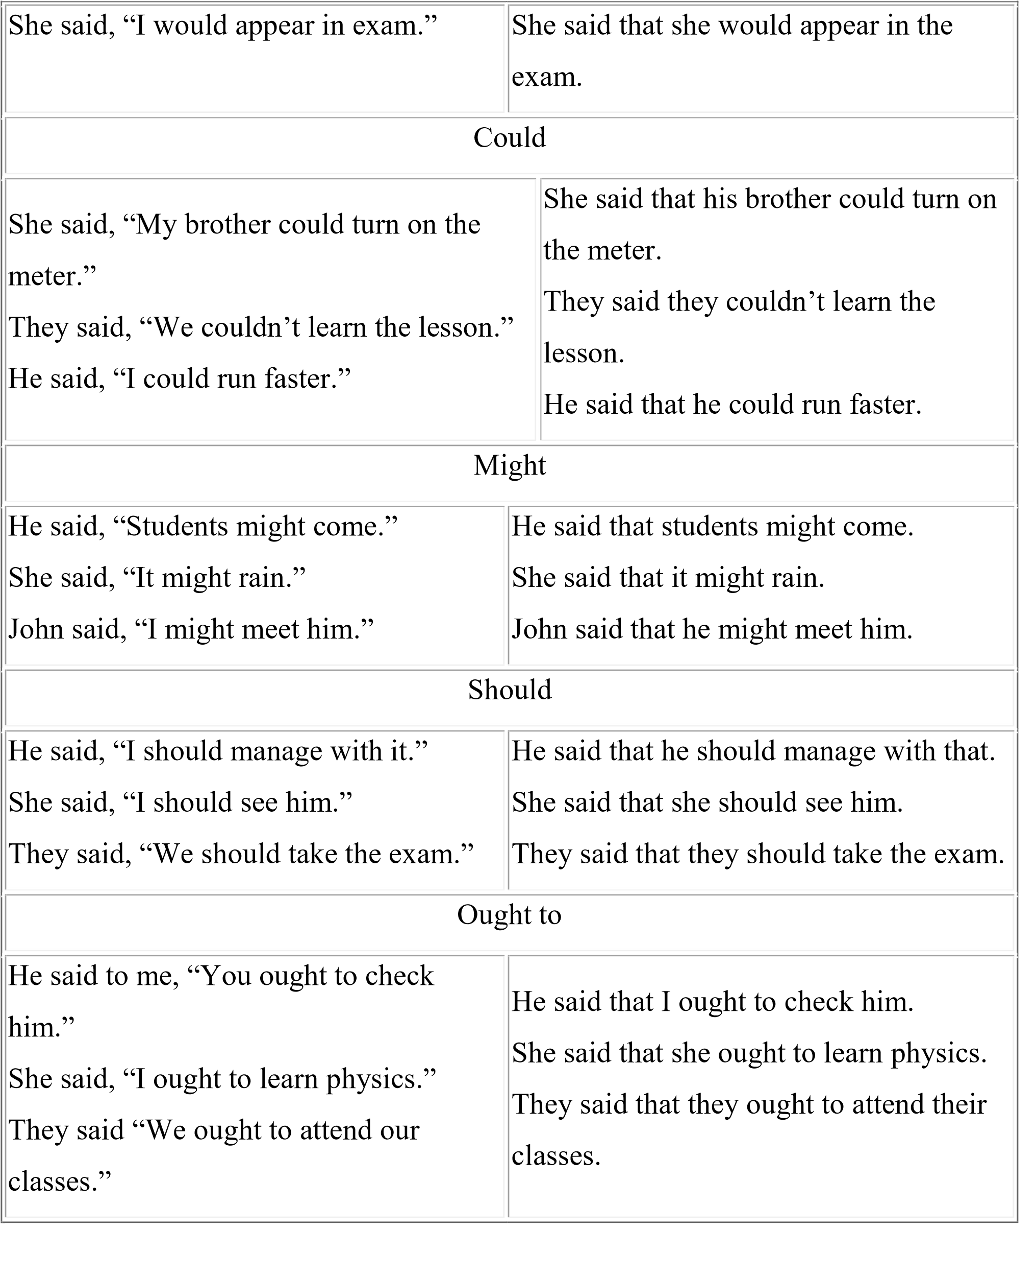

EXCLAMATORY AND IMPERATIVE SENTENCES IN INDIRECT SPEECH
Imperative sentences in indirect speech.
A sentence which expresses command, request, advice or suggestion is called the imperative sentence.
For example • Open the door. Please help me. • Learn your lesson.
To change such sentences into indirect speech, the word “ordered” or “requested” or “advised” or “suggested” or “forbade” or “not to do” is added to reporting verb depending upon the nature of the imperative sentence in reported speech.
Examples
Direct speech: She said to him, “You should work hard for exam” Indirect Speech: He suggested working hard for exam.
Direct speech: They said to him, “Do not tell a lie.” Indirect Speech: They told him not to tell a lie.
Direct speech: The teacher said to the students, “Do not waste time.” Indirect Speech: The teacher advised the students not to waste time.

Exclamatory sentences, in indirect speech
Sentence which expresses the state of joy, sorrow or wonder is called the exclamatory sentence.
For example Hurrah! We won the match. Alas! I failed the test.
To change such sentences, the words “exclaimed with joy”, “exclaimed with sorrow” or “exclaimed with wonder” are added in the reporting verb depending upon the nature of the exclamatory sentence in indirect speech.
Examples.
Direct speech: He said, “Hurrah! I won a prize.”
Indirect Speech: He exclaimed with joy that he had won a prize.
Direct speech: She said, “Alas! I failed in exam.”
Indirect Speech: She exclaimed with sorrow that she failed in the exam.
Direct speech: He said, “Oh no! I missed the train.”
Indirect Speech: He exclaimed with sorrow that he had missed the train.

MAKE OR DO

Work, Jobs and Tasks do the housework  do your homework do a good job do your chores | Speaking and Sounds make a noise  make a comment make a speech make a suggestment
Solo sports and tasks do homework; do an exercise; do  exercises; do math; do a sum; do sums; do crossword puzzles; do morning  gymnastics; do morning exercises; do  push-ups; do aerobics; do athletics; do something; do nothing; do anything; do everything | Produce a reaction make your eyes water make you happy make you smile
Non-specific Activities do something do nothing  do everything  do anything | Plans and Decisions make a decision make a plan  mae a choise  make arrangments
to do some studying to do some writing to do the accounts to do the cleaning to do the dishes  to do the ironing  to do the laundry to do the math |  | to make a call  to make a deal to make a fire  to make a fortune  to make a presentation to make a threat to make believe to make friends
to do the maximum to do the minimum  to do the paperwork to do the shopping  to do the vacuuming to do time  to do work  to do your best  to do your duty to do your hair |  | to make fun  to make changes  to make progress  to make sense to make time  to make a mess  to make a mistake  to make the bed to make sure

THE COMPARISON OF ADJECTIVES
Monosyllabic adjectives are compared with –er, –est.
positive | comparative | superlative
strong | stronger | strongest
late | later | latest
big | bigger | biggest
thin | thinner | thinnest
Disyllabic adjectives ending with y, er, ow, le are compared with –er, –est.
positive | comparative | superlative
easy | easier | easiest
happy | happier | happiest
narrow | narrower | narrowest
All the other adjectives are compared with more, most.
positive | comparative | superlative
careful | more careful | most careful
difficult | more difficult | most difficult
tired | more tired | most tired
terrible | more terrible | most terrible
Special adjectives can be compared with –er, –est or more, most.
positive | comparative | superlative
common | commoner / more common | commonest / most common
likely | likelier / more likely | likeliest / most likely
pleasant | pleasanter / more pleasant | pleasantest / most pleasant
polite | politer / more polite | politest / most polite
quiet quieter / more quiet |  | quietest / most quiet
sure surer / more sure |  | surest / most sure
subtle subter / more subtle |  | subtlest / most subtle
simple simpler / more simple  Irregular forms |  | simplest / most simple
positive comparative |  | superlative
good better |  | best
bad worse |  | worst
much more |  | most
many more |  | most
little less |  | least

APPENDIX B. USEFUL PHRASES FOR DISCUSSION, COMPOSITION AND REPORT MAKING
1) Introducing a point - First of all I'd like to point out ...
- The main problem is ...
- The question of ...
- Speaking of ...
- What we have to decide is ...
2) Enumeration of points
- First of all, I’d like to say ... - In addition to that ...
- Moreover, ...
- Furthermore, ...
- Another example of this is ...
- First, second, third ...
- Finally, ... 3) Stating something as a fact - As everyone knows ...
- It is generally accepted that ...
- There can be no doubt that ...
- It is a fact that ...
- Nobody will deny that ...
- Everyone knows that ...
4) Expressing a personal opinion - It seems to me that ...
- I have the feeling that ...
- I feel that ...
- I'm absolutely convinced that ...
- You can take it from me that ...
- I think/don't think that ...
- In my opinion, ...
- Well, if you ask me ...
- As I see it ...
- The way I see it, ...
- Personally, I believe/suppose/ feel (that) ...
- I'm convinced that ...
5) Expressing pros and cons
- There are two sides to the question.
- On the one hand ..., on the other hand ...
- An argument for/in favour of/against is ...
- While admitting that ... one should not forget that ...
- Some people think that ..., others say that ...
6) Expressing doubt
- I'm not sure if ...
- I'm not convinced that ...
- I wonder if you realize that ...
- I doubt that.
7) Expressing disagreement - I don't agree with you about ... - I can't accept your view that ...
- I'm of a different opinion.
8) Expressing support - You're quite right.
- You've got a good point there. - ... has nothing to do with my argument. - I couldn't agree with you more. - That's not relevant.
- You took the words right out of my 11) Drawing conclusions and summing up
- That's a very important point. mouth.
9) Giving reasons - The reason for this is (that) ...
- I base my argument on ...
- I tell you all this because ...
10) Keeping to the point
- It would be more to the point if ...
- Come to the point.
- That's not the problem.
- What we are discussing is ...
Expressing opinion: | As far as I’m concerned …  It seems to me …  I (strongly) believe that …  The way I see it …  I am convinced that …  Without a doubt, …
Defending your opinion: | What I am trying to say is …  Yes, but what I really mean is …
Asking for opinion: | What do you think about …  Are you sure that …  What’s your opinion on …
Agreeing with another opinion: | I agree with that.  That’s a good point.  You put that very well.
Disagreeing with another opinion: | I don’t agree with that.  I can’t see your point.

- The obvious conclusion is ...
- Last but not least ...
- The only alternative (left) is ...
- The only possible solution/conclusion is ...
- Summing up, I'd like to say that ...
- In conclusion we can say that ...
- To cut a long story short, ...
- Just to give you the main points again,
...

That might be true, but … That’s not the point here.
The problem with your point of view is that …
Clarifying (making sure that you understand sth. correctly): | So, you are saying that …  Can I just check that I understand you correctly? You mean that …  Did you want to say that …
Giving in: | All right, then.  I take that back.

Introducing the subject | - | I'd like to start by...
 | - | Let's begin by...
 | - | First of all, I'll...
 | - | Starting with...
 | - | I'll begin by...
Finishing one subject... | - | Well, I've told you about...
 | - | That's all I have to say about...
 | - | We've looked at...
 | - | So much for...
...and starting another | - | Now we'll move on to...
 | - | Let me turn now to...
 | - | Next...
 | - | Turning to...
 | - | I'd like now to discuss...
 | - | Let's look now at...
Analysing a point and giving recommendations | -  -  - | Where does that lead us?  Let's consider this in more detail...  What does this mean for ABC?
 | - | Translated into real terms...
Giving an example | - | For example,...
 | - | A good example of this is...
 | - | As an illustration,...
 | - | To give you an example,...
 | - | To illustrate this point...
Dealing with questions | - | We'll be examining this point in more detail later on...
 | - | I'd like to deal with this question later, if I may...
 | - | I'll come back to this question later in my talk...
 | - | Perhaps you'd like to raise this point at the end...
 | - | I won't comment on this now...
Summarising and concluding | -  - | In conclusion,...  Right, let's sum up, shall we?
 | - | I'd like now to recap...
 | - | Let's summarise briefly what we've looked at...
 | - | Finally, let me remind you of some of the issues we've covered...
 | - | If I can just sum up the main points...
Ordering | - | Firstly...secondly...thirdly...lastly...
 | - | First of all...then...next...after that...finally...
 | - | To start with...later...to finish up...

APPENDIX C. SPECIALTY INFO

Electric Power Stations

The Department trains electrical engineers in specialty Electric Power Stations for work concerned with operation and design of different types of power plants: thermal, atomic, hydraulic and electric power plants operating from non-traditional energy sources such as solar, wind, tidal and geothermal power stations.
The training of graduates in different spheres of technical disciplines allows them to work in electrical systems and associations, at different power plants, at the design organizations, scientific and research institutes and to be engaged in power plant reliability issues and electrical systems, operation and maintenance of electrical equipment, design of power plants, design and maintenance of automated design systems, automation of mode control for power plants (automated control systems for power plants and power consumption of industrial facilities , powerful electric drive, compression of gas pipelines).
The department trains students according to individual plans, which can include problems with the use of personal computers for developing and deciding problems in electrical engineering, the use of power sources recovery, insulation and cable equipment, diagnostics of equipment, construction and use of trainers based on modern computer systems for training operating and dispatching staff for power plants. This leads to the need to have good knowledge and skills in English. Thus, students learn specific terms, subjects and themes in English that may be useful in their specialty.
• Priority directions of the department's scientific research;
• Ecological power system and energy saving technology;
• Methods of developing a choice of power supply modes in
conditions of indistinct information;
• Creation of methods and expert systems for an estimation of the technical conditions of the power supplies of electrical equipment;
• Control of technological processes and equipment during the production of electrical energy.
This developing sphere needs effective communication skills to cooperate with foreign specialists. Many patents and documents for new inventions by students and faculty staff are also written in English. For this and for many other reasons, it is clear and obvious that the emphasis is on students who acquire the necessary knowledge and skills of the language. The textbooks and other materials, used during the learning process, focus on the grammatical structures and vocabulary, characteristic of scientific and technical activity, in which students are involved during their stay at university and in their future professional life.
The grammar material, which students learn, includes a wide range of subjects, from modal verbs and parts of speech to unfinished forms of verbs and their complexes. The specific vocabulary includes semantic fields such as electrical systems, energy, electrical engineering, etc.
Textbooks and other learning materials include both Ukrainian and foreign.
Student studies are divided into classroom work and self-study work and projects. They also write articles in English for publication in order to participate in various conferences and meetings, related to their specialty.

Electric Networks and Systems
The Department trains electrical engineers in specialty Electric Networks and Systems for work on the operation and design of electrical networks and systems of different voltage classes, to work in distribution services and computing centers of large power systems, associations of production power, design and scientific research institutes.
The training of graduates allows them to work in electrical systems and associations, in different power plants, design organizations, scientific research institutes and to be engaged in the problems of analysis and optimization of normal and emergency operational modes of united power systems, increasing of technical and economic indixes of the operation modes of voltage electrical networks of different types, calculation of local electrical networks, choice of parameters for compensating devices installed in distributive networks on the basis of modern computer and microprocessors facilities.
The Department has up-to-date equipment - a technical and laboratory base, which can flexibly correspond to an educational process complicated by the training of foreign specialists for the needs of their national engineering. One of the main directions of the department's scientific activity is the design of installation for diagnostics of oil filled power equipment in 110–1150 kV voltage substations.
Recently completed scientific works of the department:
• Methods and models for researching development processes for system failures during computer training.
• Priority directions of the department's scientific research;
• Research of survivability of modern electric power systems of Ukraine in conditions of extreme situations;
• Development of computer systems for a choice of optimal circuits for the development and optimization of the operating modes of electrical networks with high pressure voltage.
This developing sphere needs effective communication skills to cooperate with foreign specialists. Many patents and documents for new inventions by students and faculty staff are also written in English. For this and for many other reasons, it is clear and obvious that the emphasis is on students who acquire the necessary knowledge and skills of the language. Textbooks and other materials, used during the learning process, focus on the grammatical structures and vocabulary, characteristic of scientific and technical activity, in which students are involved during their stay at university and in their future professional life.
The grammar material, which students learn, includes a wide range of subjects, from modal verbs and parts of speech to unfinished forms of verbs and their complexes. The specific vocabulary includes semantic areas such as the operation and design of electrical networks and systems of different voltage classes, for work in distribution services and data centers of large electrical systems, power associations of production, scientific research and design institutes, etc.
Textbooks and other learning materials include both Ukrainian and foreign.
Student studies are divided into classroom work and self-study work and projects. They also write articles in English for publication in order to participate in various conferences and meetings, related to their specialty.

High Voltages Technique

Students specializing in the High voltage engineering and Electrophysics program study a broad range of phenomena and processes in solid, liquid and gas media media high electric field constraints. The program put emphasis on advanced knowledge and understanding of the physical, mathematical and material science aspects of high voltage technology. In addition, they complete coreclass sequences in energy engineering, computer science and economics.
Students receive education in the following areas: insulation of high voltage equipment; electromagnetic compatibility; lightning protection; grounding; diagnostics and design of high voltage equipment; evaluation and extension of lifetime of electric power equipment and grounding systems; related modern electrical engineering issues, such as laser technology, fluid power and X –ray equipment; economy.
The graduates of the program, prepared according to the national and international professional standards, are ready for productive work in electric power generation, transmission and distribution (both commercial and residential); construction and maintenance organizations; commercial units dealing with electric equipment; as well as in research and development centers.
Priority orientations of the department's scientific research:
• Creation of systems of the experimental stand systems and realization of tests of space devices;
• Analysis of the over voltages and development of means of protection from their influence.
This developing branch needs effective communication skills to cooperate with foreign specialists. Many patents and documents for new inventions by students and faculty staff are also written in English. For this and for many other reasons, it is clear and obvious that the emphasis is on students who acquire the necessary knowledge and skills of the language. Textbooks and other materials, used during the learning process, focus on the grammatical structures and vocabulary, characteristic of scientific and technical activity, in which students are involved during their stay at university and in their future professional life.
The grammar material, which students learn, includes a wide range of subjects. The specific vocabulary includes semantic areas such as the operation and design of electrical networks and systems of different voltage classes, for work in distribution services and data centers of large electrical systems, production power associations etc. Students have in- class work and self-study assignments and projects; write articles in English to have them published in order to take part in different conferences and meetings related to their specialty.

Automation in Electric Power Systems

The Department trains electrical engineers in specialty Control systems of production and distribution of power electric energy for work in electrical power systems, at control centers and scientific research institutes.
The training of graduates in different spheres of technical disciplines enables them to decide up –to –date scientific and technical problems in the field of automation of production, distribution and consumption of electrical energy on the basis of wide use of modern computing and micro-processing facilities.
Educational and scientific complex of the Department includes six scientific study and research laboratories equipped with IT and microprocessing infrastructures, automated devices and relays, means of remote information and control of the distribution of electrical systems.
The main scientific trend of the Department is the development and inculcation of theoretical foundations and technical means, algorithmical and information support and software for control of complicated power systems.
The Department provides training for technical personnel and brains not only for Ukraine, but also for foreign countries.
Recently completed scientific work of the department:
• Search for distributive electrical networks for the high speed transfer of information in control systems of electrical power supply and information networks of common usage;
• Development of digital relays; methods and means of power system protection, automation and control of the electrical network; modeling of processes in the electrical system for protection and control;
• Automatic frequency and power-frequency control; voltage control systems. Power automatic systems.
Priority directions of the department's scientific research:
• Information technologies in perspective, complex automation devices, communication system;
• Ecological clean power energetics and energy saving technologies. Wind power plants with energy storage elements.
Effective communication skills are necessary to cooperate with foreign specialists or getting deeper knowledge of specialties and specific items. Many patents and documents for new inventions by students and faculty staff are also written in English. For this and for many other reasons, it is clear and obvious that the emphasis is on students who acquire the necessary knowledge and skills of the language. Textbooks and other materials, used during the learning process, focus on the grammatical structures and vocabulary, characteristic of scientific and technical activity, in which students are involved during their stay at university and in their future professional life. Textbooks and other learning materials include both Ukrainian and foreign. Students’ studies are divided into in class work and self-study assignments and projects. They also write articles in English for publication in order to participate in various conferences and meetings, related to their specialty.
The grammar material, which students learn, includes a wide range of topics, from modal verbs and parts of speech to unfinished forms of verbs and their complexes. The specific vocabulary includes such semantic fields as automation of the production, distribution and consumption of electrical energy, etc.

Electric Drive and Automation of Industrial Plants and Technological
Complex
The Department trains electromechanical engineers in specialty Electric Drive and Automation of Industrial Plants and Technological Complexes providing two specializations: general technical and robotic installations.
During study, students, in addition to general technical education, get basic training in theory of automatic control and in theory of electric drive, electronics, engineering and programming IT, modeling, technical means of automated electrical drive and automated technological processes, including means of microprocessing and systems.
The program for this specialty provides special courses on electrical drive control systems, program control, automated electrical drives of general industrial mechanisms, flexible productions, metalworking robots for machine building, as well as the electromechanical and mechanics of robotic mechanisms.
A wide range of multidisciplinary knowledge and a high request for industry graduates are based on the fact that electrical drives and electromechanical systems provide electromechanical energy conversion of more than 60% of all energy produced in different branches of industry, transportation systems, agriculture and military applications.
The Department has great experience in training engineers and scientific brains for foreign countries in Europe, Asia, Africa, Central America and South America. Priority orientations of the department's scientific research:
• Theory and practice of complex electromechanical systems of automatic control with the increase of technical, economic and qualitative parameters on the basis of rotary and linear motion motors;
• Theory of electrome chanical systems with extreme energy savings
automatic control of continuous transport;
• Energy saving algorithms for vector management of asynchronous motors.
This developing sphere needs effective communication skills to cooperate with foreign specialists. Many patents and documents for new inventions by students and faculty staff are also written in English. For this and for many other reasons, it is clear and obvious that much emphasis is put on students acquiring necessary knowledge and skills of the language. Textbooks and other materials, used during the learning process, focus on the grammatical structures and vocabulary, characteristic of scientific and technical activity, in which students are involved during their stay at university and in their future professional life.
The grammar material, which students learn, includes a wide range of subjects, from modal verbs and parts of speech to unfinished forms of verbs and their complexes. The specific vocabulary includes semantic areas such as electrical drive control systems, program control, automated electrical drives of general industrial mechanisms, flexible productions, metal working robots for machine building, as well as electromechanics and mechanics of robotic mechanisms, etc.

APPENDIX D. VISUALS
Image to task 12, Unit 6

Taken from: http://www.ebvintage.ca/itm/ 1
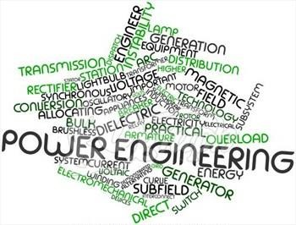
Taken from: http://www.shutterstock.com/pic-106501907/
Students A
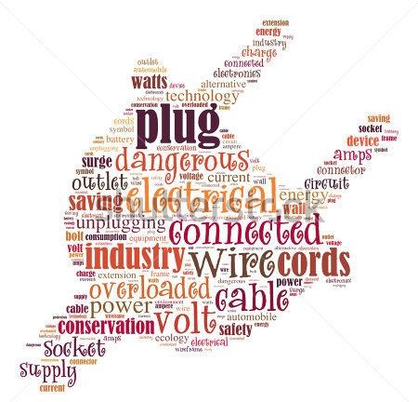
Taken from: http://www.shutterstock.com/pic-106501907/

Students B

APPENDIX E. LETTER OF REQUEST
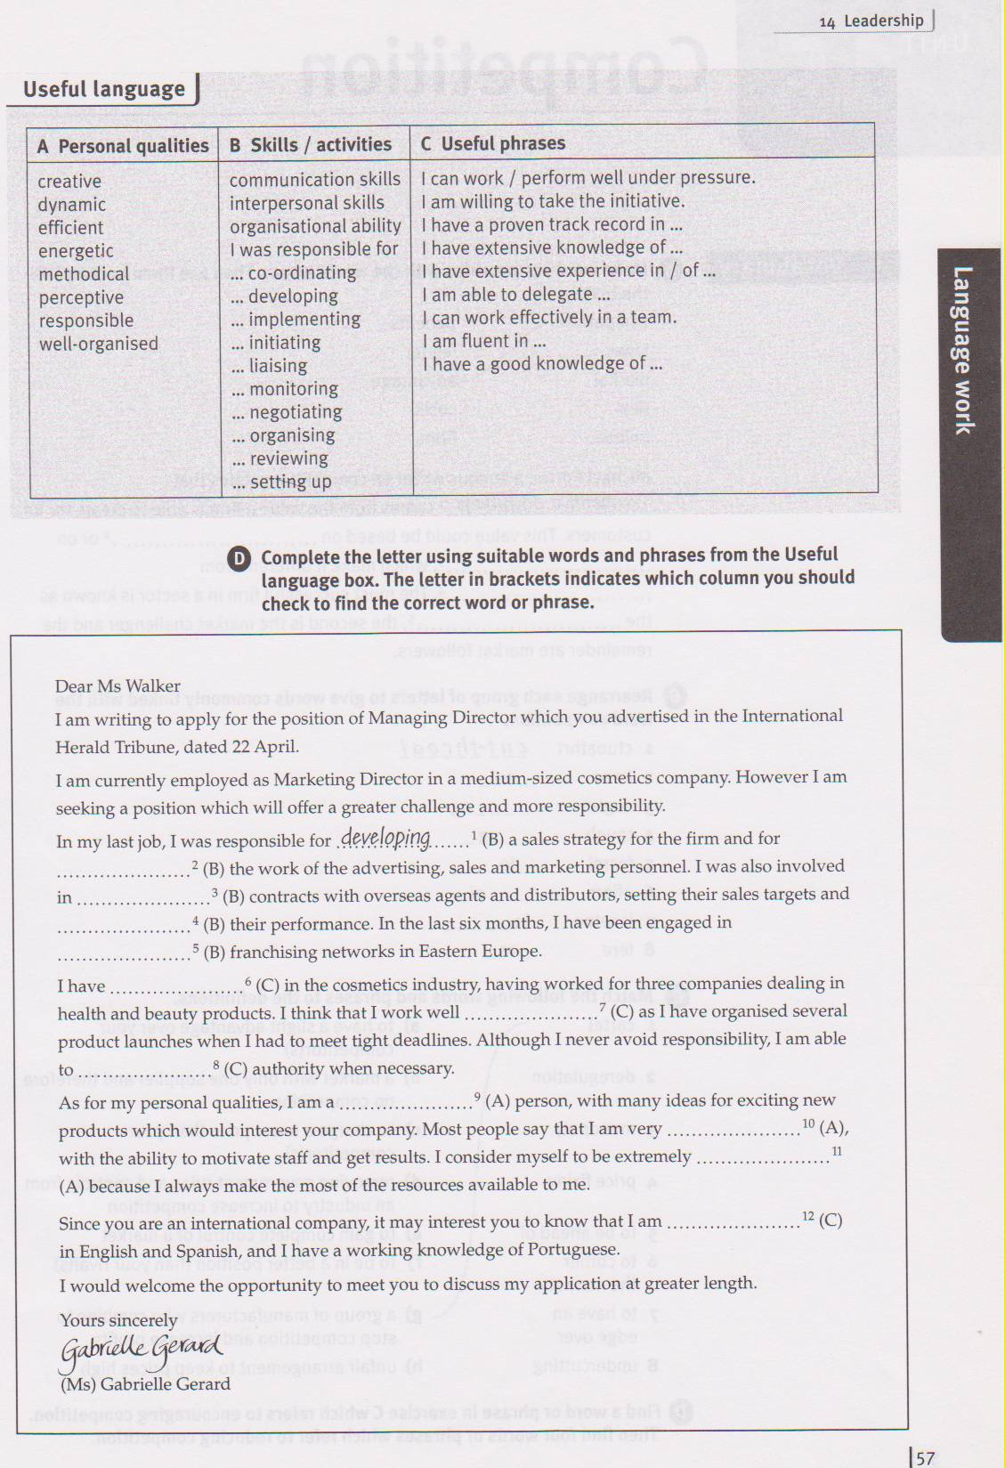

8 Sue Circle
Smithtown, CA 08067
135-511-226
john.donaldson@emailexample.com
November 8, 2019
Mr. George Gilhulie
Times Union
65 Delaware Road
Hatfield, CA 08065
Dear Mr. Gilhulie,
I am writing to apply for a programmer position advertised in the Times Union. As requested, I enclose a completed job application, my certificate, my curriculum vitae and three recommendations.
The position is very attractive to me, and I believe that my solid technical experience and training make me a very competitive candidate for this position. My main strengths that will support my success in this position include:
• I have successfully designed, developed and maintained applications for live use.
• I constantly strive for excellence.
• I provide an exceptional contribution to customer service for all customers.
Having a bachelor's degree in computer programming, I have a full understanding of the full life cycle of software development projects. I also have experience of learning and applying new technologies as needed. I would be grateful if you would consult my CV for more information on my experience.
You can contact me at any time by email: john.donaldson@emailexample.com or by mobile phone 135-511-226.
Thank you for your time and attention. I look forward to discussing this job opportunity with you.
Sincerely yours
Signature
John Donaldson

References

- Department of Engineering [Електронний ресурс] – Режим доступу: http://www3.eng.cam.ac.uk/DesignOffice/mdp/electric_web/AC/AC_1.html
- Electricity[Електроннийресурс]Режимhttp://www.songsforteaching.com/science/professorboggs/electricity.htm
- Cambridge dictionary (2019). Retrieved from: https://dictionary.cambridge.org/

- Boitnott, B. (2019). – 7 Business Risks Every Business should plan for. – Retrieved from:https://www.americanexpress.com/en-us/business/trends-and-insights/articles/7-business-risks-every-business-should-plan-for/

- How Does a Generator Create Electricity? [Електронний ресурс] – Режим доступу:http://www.dieselserviceandsupply.com/How_Generators_Work.aspx
- Hsu T.C. Physics A First Course [Електронний ресурс] – Режим доступу: http://www.northernhighlands.org/cms/lib5/NJ01000179/Centricity/Domain/214/cp_ physics/online_textbook/pfc_student_ebook_2008.pdf.
- Kuphaldt T.R. (2006). Lessons In Electric Circuits, Volume I – DC [Електроннийресурс]Режимдоступу:http://www.allaboutcircuits.com/pdf/DC. pdf.
- Kyiv Polytechnic Institute. [Електронний ресурс] – Режим доступу: http://en.wikipedia.org/wiki/Kyiv_Polytechnic_Institute
- Lasers – Powerful Beams of Light [Електронний ресурс] – Режим доступу: http://www.english –online.at/science/lasers/laser –powerful –beam –of –light.htm
- MHD Generation or Magneto Hydro Dynamic Power Generation [Електронний ресурс] – Режим доступу: http://electrical4u.com/mhd –generation –or –magneto – hydro –dynamic –power –generation/
- Motor types – AC motor [Електронний ресурс] – Режим доступу:
- http://techinventory.blogspot.com/2014/01/motor–types–ac– motor.html#axzz3KIWU1HiP
- Nuclear energy [Електронний ресурс] – Режим доступу: http://www.edfenergy.com/energyfuture/nuclear
- Official page of BEST organization [Електронний ресурс] – Режим доступу: http://www.best.eu.org/index.jsp
- Top 10 Renewable Energy Sources [Електронний ресурс] – Режим доступу: http://listverse.com/2009/05/01/top –10 –renewable –energy –sources
- Ukrainian science. [Електронний ресурс] – Режим доступу: http://hi– tech.org.ua/ukrainian –science/
- Classroom management and discipline [Eлектронний ресурс] – Режим доступу:http://mvnu.edu/ncate/NCATE_standards/standard_1/2007_2008_syllabi/ PEL/PEL6073s.pdf
- Учебные пособия по тестированию ПО для начинающих (2019, August 7) Retrieved from https://www.youtube.com/watch?v=goaZTAzsLMk&t=420s

Video materials
- Electromotive Force [Eлектронний ресурс] Режим доступу: https://www.youtube.com/watch?v=cbSKkrzdXe4
- Follow Electricity's Journey Through the Transmission System. [Eлектронний ресурс] – Режим доступу: https://www.youtube.com/watch?v=TQg2Y0kp2vI
- How nuclear energy works [Eлектронний ресурс] – Режим доступу:
- https://www.youtube.com/watch?v=VJfIbBDR3e8
- Magnetism: Motors and Generators [Eлектронний ресурс] – Режим доступу: https://www.youtube.com/watch?v=d_aTC0iKO68
- Scientific research at RTU: Faculty of Power and Electrical Engineering[Eлектроннийресурс]Режимдоступу:https://www.youtube.com/watch?v=MHofY4c_66Y
- Simple Electricity Generator [Eлектронний ресурс] – Режим доступу: https://www.youtube.com/watch?v=0OHmMVBLXTI
- Timeline electricity [Eлектронний ресурс] Режим доступу: https://www.youtube.com/watch?v=6p5WXzrYYiI
- Ukrainian scientists develop technology of welding in surgeries – Press TV
- News [Eлектронний ресурс] –Режим доступу:
- https://www.youtube.com/watch?v=WjAm_dPZJC8
- What is engineering. [Eлектронний ресурс]Режим доступу:
- https://www.youtube.com/watch?v=bipTWWHya8A

