National Technical University of Ukraine
«Igor Sikorsky Kyiv Polytechnic Institute»
Faculty of Informatics and Computer Engineering
Department of Computer Engineering

"On the rights of the manuscript" "Protection is allowed"
UDC Head of Department
Stirenko S.G.
(signature) (initials, surname)
" " 2020

Master's Thesis

specialty: 123. Computer Engineering____________
(code and title of training or specialty)
Specialization: 123. Computer systems and networks_________________
on the topic: Test of Informatics Security System Based on Kali Linux

Completed: Student (s) 6 course, group ІО-84mn
^{(group code)}
Sager Fairouz Fadel
^{(Full Name)} ^{(signature)}
Supervisor Prof., Doctor of Technical Sciences, Prof. Korniyenko B.Y.
(position, academic degree, academic title, surname and initials) (signature)
Consultant
^{(section name)} (position, academic title, academic degree, surname, initials) ^{(signature)}
Reviewer
(position, academic degree, academic title, academic degree, surname and initials) (signature)

I certify that in this master's thesis there are no borrowings from the works of other authors without corresponding references.
Student
^{(signature)}

Kyiv-2020

National Technical University of Ukraine
«Igor Sikorsky Kyiv Polytechnic Institute»

Faculty (Institute) Computer science and computer engineering
^{(full name)}
Chair Computing
^{(full name)}
Higher education level - the second (master's) in educational and professional program
Specialty 123. Computer Engineering
^{(code and name)}
Specialization 123. Computer systems and networks________
^{(code and name)}

APPROVED
Head of Department
Stirenko SG
(signature) (initials, surname)
«» 2020 years

TASK
for the master's thesis of the student
Sager Fairouz Fadel
^{(Full Name)}
1. Thesis topic Test of Informatics Security System Based on Kali Linux _____
Supervisor of the thesis Prof., Doctor of Technical Sciences, Ph.D. Korniyenko BY
(surname, first name, patronymic, academic degree, academic title)
approved by university order of «28» October 2019 № 3770-c
2. The term of submission of the thesis by the student __________
3. Object of study methods and means of computer network protection, methods of testing computer network security
4. The subject of the study computer network security hardware
5. The list of tasks to be completed:
analysis of modern application software for emulation of information security system;
development of information security system and its practical implementation;
setting up the network equipment of the created information security system;
testing and assessing the security level of the information security system .______
6. Consultants of the dissertation sections:
Section | Surname, initials and position of consultant | Signature, date
Section | Surname, initials and position of consultant | task published | task accepted
7. Date of issue of the assignment
Calendar plan
# S / n | The name of the stages of the master's thesis | Deadline  stages of the dissertation | Note
1 | Clarification of the problem statement | 02/15/2020 | Done
2 | Analysis of literary sources | 16.02.2020-  02/27/2020 | Done
3 | Rationale for the choice of solution | 28.02.2020-  03/03/2020 | Done
4 | Collection of information | 04.03.2020-  03/09/2020 | Done
5 | Data analysis and classification | 10.03.2020-  03/14/2020 | Done
6 | Acquaintance with application software for building information security system | 03/15/2020 | Done
7 | Development of information security system, and its practical implementation | 16.03.2020-  03/27/2020 | Done
8 | Setting up the network equipment of the information security system | 28.03.2020-  02.04.2020 | Done
9 | Testing and evaluation of security level of the built-in information security system | 03.04.2020-  04/20/2020 | Done
9 | Design and printing of explanatory note | 21.04.2020-  04/27/2020 | Done
10 | Design of presentation | 28.04.2020-3.05.2020 | Done
11 | Receiving reviews from opponents | 04/05/2020 | Done
12 | Preparation for protection in the SEC | 05.05.2020-  05/15/2020 | Done

Student ______________ ____________________
(signature) (initials, surname)
Supervisor of the thesis
(signature) (initials, surname)

ABSTRACT

for a master's thesis
made on:Test of Informatics Security System Based on Kali Linux
student: Sager Fairouz Fadel

The work consists of an introduction and four sections. Total workload:82 main text sheets,26illustrations, 23tables. In preparation used literature from40different sources.
Topicality.For the qualitative training of qualified specialists in the design, construction and technical support of computer networks, which would meet the modern security requirements, special systems of information protection are needed - laboratories, which could test and practically evaluate the quality of the built network for its resistance to cyber threats.
The high cost of components for building and testing various configurations of a secure network based on cisco networking equipment does not allow small companies to build an information security system that can test the configuration of their network equipment and security policies for their vulnerability to computer attacks. network.
The purpose and objectives of the study. The purpose of the master's thesis is to create an information security system for testing network security and to determine methods for testing the information security system.
To achieve the goal of the study set and solved the following tasks:
- substantiate the need to build a virtual information security system;
- to characterize modern platforms for emulation of computer networks and to make benchmarking;
- choose software for building a virtual information security system;
- to build and test the information security system based on GNS3 application software and to prove its effectiveness;
- conduct vulnerability assessment of information security system;
- test the information security system.
Object of study -methods and means of computer network protection, methods of testing computer network security.
Subject of study - computer network security hardware.
Research Methods.To achieve the goals set in the master's work, the simulation and analysis of a secure computer network were used.
The scientific novelty of the results obtained is to develop an information security system based on application software, which can be used as a laboratory for testing the security of the network with a rapid change in the configuration of resources.
Personal contribution of the applicant. The master's research is a self-performed work that reflects the author's personal approach and personally obtained theoretical and applied results related to the problem of modeling and analysis of a secure computer network. The purpose and objectives of the study were formulated jointly with the scientific supervisor.
Practical value.The results obtained can be used in future research in the following areas:
- improvement of computer network information security systems;
- analysis and forecasting of threats to computer networks;
- testing of security of computer networks.

Posts:

Keywords
Computer Network, Information Security Systems, Threat, Kali Linux.

CONTENT
SECTION 1. METHODS AND MEANS OF PROTECTION OF INFORMATION 11
1.1 Information Security Threats …….13
1.2 Types of Threats
1.3 Methods and means of protection of information
1.3.1 General characteristics of means and methods of protection
1.3.2 Protection of information from accidental threats
1.3.3 Protect your computer system against unauthorized interference 24
1.4 Cryptographic information security techniques and firewalls 27
  - Firewall
1.5.1 Firewall principles
1.6 Types of firewalls
1.7 Electronic-digital signature
SECTION 2. GNS3-based INFORMATION PROTECTION SYSTEM 25
2.1. Characterization of the concept of cybersecurity 25
2.2. Rationale for building a cyber security virtual application ground based on application software 27
2.2.1. GNS3 (Graphical Network Simulator). 29
2.2.2. UNetLab (Unified Networking Lab, UNL) emulator. 30
2.2.3. Summary of functionality of platforms for emulation of computer networks. 31
2.3. Network equipment and principles of its configuration 32
2.3.1. Firewall. 32
2.3.2. Router. 34
2.4. Software 36
2.4.1. Hping3. 36
2.4.1. Zenmap. 37
2.4.2. Wireshark. 37
2.5. Conclusions to the section 38
SECTION 3. PRACTICAL IMPLEMENTATION OF THE CYBER SECURITY LANDBOOK BASED ON GNS3 SOFTWARE 39
3.1. Preparatory stage 39
3.2. Description of network devices 40
3.2.1. Description of network topology and network device tasks. 41
3.2.2. Cisco ASA 5520 Specifications. 41
3.2.3. Cisco 3745 Specifications. 42
3.3. Setting up network devices 42
3.3.1. Cisco ASA 5520 Configuration. 42
3.3.2. Configure the Cisco 3745 Router. 46
3.4. Check your network settings 47
3.5. Network scanning 52
3.6. Network stress test 54
3.7. Conclusions to the section 58
SECTION 4. METHOD OF TESTING THE INFORMATION PROTECTION SYSTEM ON THE BASE OF CYBER SECURITY POLYGON 60
4.1. Methods of testing the security of the AU 60
4.1.1. Methods of quantitative assessment of information system risks 61
4.1.2. Methods of qualitative assessment of information system risks 64
4.1.3. Methods using mixed risk analysis assessment 66
4.2. Determination of the method of risk analysis in the context of the constructed cyber security landfill 69
4.3. Testing cybersecurity information security system by iRisk method 70
4.3.1 Cisco IOS Arbitrary Command Execution Vulnerability Vulnerability (CVE-2012-0384). 76
4.3.2. Cisco Access Control Bypass Vulnerability Vulnerability (CVE-2012-1342) 77
4.3.3. EternalBlue vulnerability (CVE-2017-0144). 78
4.3.4 Meltdown Vulnerability (CVE-2017-5754). 80
4.3.5. SPECTRE vulnerability (CVE-2017-5753, CVE-2017-5715). 81
4.4. Conclusions to the section 85
Conclusions 87
References 90

INTRODUCTION

Today, with the development of information technology, it is impossible to imagine people's lives without the use of computers to process information. Computers combine data processing systems to process vast amounts of information, collect data, share files, share programs, and compute resources. The main tendency that characterizes the development of modern information technologies is the increase in the number of computer crimes and related theft of confidential and other information, which lead to denials of access, withdrawal from the normal functioning of enterprises and organizations that carry numerous material losses. Therefore, the question of protection of information and computer systems and networks is urgent.
Specialized cybersecurity training sites are required for the qualitative training of qualified computer network design, construction and technical support staff, who can test and evaluate practically the quality of the network being built against its cyber threats.
The high cost of components for building and testing various configurations of a secure network based on cisco networking equipment does not allow small companies to build a cybersecurity site that can test the configuration of their network equipment and security policies for their vulnerability to computer network attacks. .
The relevance of the thesis is to develop an information security system based on application software that can be used as a training laboratory for testing the settings of network devices and training professionals in the field of networks.

1. METHODS AND MEANS OF PROTECTION OF INFORMATION
The problem of information security arose from the creation of a common information space and the use of computers and computer networks in all spheres of life and life. From calculating the amount on a personal computer calculator to comprehensive data collection from entire computer networks and drawing statistical conclusions.
The protection of information in computer systems should be understood as the regular use of tools and methods, the adoption of measures to ensure the systematic reliability of information stored and processed in computer systems.
Under the object of protection is information or its medium or information process in relation to which you want to set the desired, based on the problem, the security level.
The protection of electronic information prevents the following types of information threats:
- tracking information;
- unauthorized access by unauthorized users;
- misuse;
- damage;
- destruction;
- distortion;
- copying;
- locking.
In order to provide protection against the above threats, the computer system must implement protection in:
- information carriers;
- technical processing tools;
- means of transmission;
- processing methods;
- databases.
Information security is called the protection of information from unauthorized introduction, conversion and destruction, as well as the protection of resources from the impact aimed at violating their performance. Information security is achieved by ensuring the confidentiality, integrity, and reliability of the data being processed, as well as the accessibility and integrity of the components and resources of the computer system.
Privacy is roughly equivalent to privacy. Confidentiality measures are taken to prevent confidential information from being accessed by people who are in the wrong state and to actually receive such information: Access should be restricted to those who have the right to view the data. It is also common knowledge that data are classified according to the amount and type of damage that could be done if they were inadvertent. More or less rigid measures can be implemented according to these categories.
Integrity - Supports consistency, accuracy and validity of data throughout its life cycle. Data should not be altered during transit and steps must be taken to ensure that the data cannot be altered by third parties (for example, in the event of a breach of confidentiality). These include file access rights and user access controls. Version control can be used to prevent inadvertent changes or accidental deletion by authorized users. In addition, some means should be used to detect any changes to data that may result from non-human events, such as electromagnetic pulses or server crashes. Some data may include checksums, even cryptographic checksums, for integrity checks.
Authenticity is a property of information that is expressed in its strict ownership of the entity that originates it or the entity from which that information is received.
The best way to ensure accessibility is through careful maintenance of all hardware, immediate hardware repair, and maintenance of a properly functioning, conflict-free operating system environment. It is also important to maintain all necessary system updates. It is equally important to ensure adequate communication throughput and to prevent bottlenecks. Redundancy, switch-to-failure, RAID clusters, even with high availability, can reduce the serious impact of hardware issues. Rapid and adaptive disaster recovery is important for worst-case scenarios; this ability depends on the existence of a comprehensive disaster recovery plan. Guarantees against loss of data or interruptions in connection should include unforeseen events such as natural disasters and fire. To prevent data loss from such cases, the backup can be stored in a geographically isolated location, possibly even in a fireproof, waterproof safe. Additional hardware or security software, such as firewalls and proxies, can protect against downtime and inaccessible data through malicious actions such as denial-of-service attacks and network interference [1].

Information security threats
In order to ensure effective protection of information, it is necessary to first and foremost consider and analyze all factors that may be a threat to information security.
The threat in the context of computer security is about anything that can cause serious damage to the computer system. A threat is something that can or may not happen, but can cause serious harm. Threats can lead to attacks on computer systems, networks and more. Threats are the potential to turn vulnerabilities into attacks on computer systems, networks, and more. They can jeopardize the systems and business computers of individuals, so vulnerabilities need to be addressed so that malicious users cannot break into the system and cause harm.
Threats can include everything from viruses, trojans, backdoors to direct hacking attacks. Often, the term "mixed threat" is more accurate, since most threats involve multiple exploits. For example, a hacker could use a phishing attack to gain information about a network and get into the network [2].
By nature occurrence distinguish:
- natural threats caused by the effects on the COP of objective physical processes or natural phenomena;
- artificial security threats caused by human activity.
According to the position of the source of threats. The source of threats can be located:
- outside the controlled area of ​​the COP;
- within the controlled area of ​​the COP;
- directly in the COP.
The degree of impact on the COP distinguish:
- passive threats that, when implemented, do not change anything in the structure and content of the COP (data copy threat);
- active threats that, when exposed, alter the structure and content of the COP.
- by stages of access of users or programs to COP resources:
- threats that may occur during access to COP resources;
- threats that occur after permitting access (unauthorized use of resources).
At the current location of information in the COP:
- the threat of access to information on external storage devices, such as copying data from a hard disk;
- threat of access to information in the memory (unauthorized access to memory);
- the threat of access to information circulating in communication lines (through illegal connection).
By way of accessing COP resources:
- threats that use the direct standard way of accessing resources through illegally obtained passwords or through the unauthorized use of terminals by legitimate users;
- threats that use a hidden non-standard way of accessing COP resources to bypass existing security features.
The degree of dependence on the activity of the COP distinguish:
- threats that occur regardless of COP activity (theft of storage media);
- threats that only occur during data processing (virus spread).

Types of threats
Threats that are not related to the deliberate actions of the attackers and occur at random times are called accidental or unintentional. The mechanism of incidental threats is generally well understood, with considerable experience in counteracting these threats.
Natural disasters and accidents can lead to the most devastating consequences for the COP, as the latter are subject to physical destruction, information is lost or access to it becomes impossible.
Failures and failures of complex systems are inevitable. As a result of failures and failures, the efficiency of the hardware is broken, data and programs are destroyed and distorted, the algorithm of the devices operation is broken.
Errors in the development of the COP, algorithmic and software errors lead to consequences, similar consequences of failures and failures of technical means. In addition, these errors can be exploited by attackers to influence the resources of your computer system.
Security errors occur in 65% of cases as a result of errors by users and service personnel. Incompetent, negligent or negligent performance of functional duties by employees leads to destruction, breach of integrity and confidentiality of information.
Deliberate threats are related to the deliberate actions of the offender. This class of threats has not been studied enough, is very dynamic and is constantly updated with new threats.
Spying and sabotage techniques and tools are most commonly used to obtain information about a security system for the purpose of penetration into the COP, as well as for theft and destruction of information resources. Such methods include eavesdropping, visual surveillance, theft of documents and machine data carriers, theft of programs and attributes of the security system, the collection and analysis of machine media waste, arson.
Unauthorized access is when someone accesses a website, program, server, service, or other system using someone else's account or other methods. For example, if someone kept guessing the password or username for an account that was not logged in until they had access, it would be considered as unauthorized access. Unauthorized access can also occur if the user tries to access an area of ​​the system to which they do not have access. When trying to access this area, they will be denied access and may see unauthorized access. The most common violations are:
- password interception - performed by specially designed programs;
- «masquerade "- performing any action by one user on behalf of another;
- unlawful use of privileges - seizure of privileges of legitimate users by the offender.
The process of processing and transmission of information by technical means of the COP is accompanied by electromagnetic radiation into the surrounding space and the guidance of electrical signals in the communication lines. They have been given the names of electromagnetic radiation and guidance. With the help of special equipment, signals are received, allocated, amplified and can either be visible or recorded in memory devices. Electromagnetic radiation is used by attackers not only to obtain information but also to destroy it [3].
A major threat to the security of information in the COP is the unauthorized modification of the algorithmic, software and technical structures of the system, called "bookmark". As a rule, "bookmarks" are implemented in specialized systems and are used either to directly malicious influence on the COP, or to provide uncontrolled login.
One of the main sources of security threats is the use of special programs, commonly known as "malware". These programs include:
- "Computer viruses" - similar to the flu virus, designed to spread from host to host and have the ability to replicate themselves. Similarly, just as influenza viruses cannot reproduce without a cell node, computer viruses cannot reproduce and spread without programming, such as a file or document. In more technical terms, a computer virus is a type of malicious code or program written to change the way a computer works and is intended to spread from one computer to another. The virus works by inserting or attaching itself to a legitimate program or document that supports macros to execute its code. During operation, the virus can cause unpredictable or damaging effects,
- "Worms" are malware programs whose main function is to infect other computers while remaining active on infected systems. A computer worm is a self-replicating malware that duplicates itself for distribution to uninfected computers. Worms often use parts of the operating system that are automatic and invisible to the user. For worms, it can usually be noticed only when their uncontrolled replication consumes system resources, slows or stops other tasks;
- "Trojan horses" in computer technology are programs that seem harmless but actually harmful. Unexpected changes to your computer settings and unusual activity, even when the computer is in the Sleep state, indicate that the Trojan is on the computer. A Trojan horse may also be called a Trojan horse virus, but this is technically incorrect. Unlike a computer virus, a Trojan horse cannot copy itself, and it cannot spread without the help of the end user.
This is why attackers should use social engineering tactics to get the end user to execute the Trojan. Typically, malware is hidden innocent electronically or downloaded for free. When a user clicks on an email attachment or downloads a freeware application, malware hidden inside is transmitted to the user's computing device. Once in the system, malicious code can perform any task that an attacker has designed to perform.
In addition to the security threats mentioned above, there is also the threat of information leakage, which is becoming an increasingly significant security issue every year. In order to effectively deal with leaks, you need to know how they occur.
The four major types of leakage account for the vast majority (84%) of incidents, with half of this proportion (40%) accounting for the most popular threat - media theft. 15% is insider. This category includes incidents caused by actions of employees who had legal access to information. For example, an employee did not have access to the information, but was able to bypass security systems. Or the insider had access to the information and brought it outside the organization. A hacker attack also accounts for 15% of the threats. This large group of incidents includes all the leaks that have occurred as a result of an external invasion. The hacking intrusion is not too high due to the fact that the intrusions themselves have become less noticeable. 14% accounted for web leaks. This category includes all leaks related to the publication of sensitive information in public places, such as the global networks. 9% is a paper leak.
A paper leak is any leak that has occurred as a result of printing confidential information on paper. 7% are others.
Included in this category are incidents that have failed to determine the exact cause, as well as leaks, which were made known after the fact, after the use of personal information for illegal purposes.
In addition, phishing is currently actively developing - a type of social engineering attack that is often used to steal user data, including login information and credit card numbers. This occurs when the attacker, disguised as a trusted person, cheats the victim in an email, instant message, or text message. The recipient is then deceived by clicking on a malicious link, which can lead to the installation of malicious software, freezing the system as part of an on-demand attack or the disclosure of sensitive information. An attack can have devastating results. For individuals, this includes unauthorized purchases, theft of funds or identification of theft. In addition, phishing is often used to gain a foothold in corporate or government networks as part of a larger attack, such as an event, developing on a constant threat. In this latter scenario, workers are compromised to circumvent security perimeter, distribute malware indoors, or gain privileged access to protected data [3].
Regardless of the specific nature of specific types of threats, information security must maintain integrity, confidentiality, accessibility. Threats to breach of integrity, confidentiality and accessibility are primary. Breach of integrity involves any intentional alteration of information stored in the COP or transmitted from one system to another. Breach of privacy can lead to situations where the information becomes known to someone who does not have the authority to access it. The threat of unavailability of information occurs whenever deliberate actions by other users or attackers block access to some COP resource.
Another type of information security threats is the threat of disclosure of COP parameters. As a result of its implementation does not cause any damage to the information processed in the COP, but this significantly increases the possibility of manifesting primary threats [4].

Methods and means of protection of information

General characteristics of means and methods of protection

Countering numerous threats to information security involves the integrated use of various methods and measures of organizational, legal, engineering, software, hardware, cryptographic nature, etc.
Organizational security measures include a set of actions for the selection and verification of personnel involved in the preparation and operation of programs and information, strict regulation of the process of development and operation of the COP.
Legal measures and remedies include the laws in force in the country, regulations governing the rules for handling information and liability for their violation.
Engineering and technical means of protection are quite diverse and include physical, technical, hardware, technological, software, cryptographic and other means. These tools provide the following boundaries of protection: controlled territory, building, premises, individual devices together with media [5].
Software and hardware protection are directly used in computers and computer networks, containing various electronic, electromechanical devices built into the COP. Special software packages or individual programs implement security features such as delimiting and controlling access to resources, logging and analyzing ongoing processes, events, users, preventing possible devastating effects on resources, and more. The essence of cryptographic protection is to reduce (transform) the information to an implicit view using special algorithms or hardware and related code keys.

Protection of information from accidental threats

To block (parry) accidental security threats in the CS, a set of tasks must be solved. Duplication of information is one of the most effective ways to ensure the integrity of information. It protects information from both accidental threats and intentional influences. Not only non-removable media or custom-designed media, but also conventional removable machine media may be used to duplicate information. Common methods of duplication of data in the COP are the use of dedicated memory areas on the working disk and mirrored disks (hard disk with information identical to that on the working disk) [6].
Reliability is an attribute of any component associated with a computer (software, or hardware, or network, for example) that is consistently executed according to its specifications. It has long been considered one of three related attributes to consider when designing, purchasing, or using a computer product or component. Reliability, accessibility, and serviceability are, for short, considered important aspects for designing into any system. A theoretically reliable product is absolutely free from technical errors; however, in practice, suppliers often express the percentage of product reliability as a percentage. Evolutionary products (those that have evolved through multiple versions over a considerable period of time) are generally considered more reliable, because that previous issues had been fixed. For example, IBM z / OS (the operating system for their S / 390 series servers) has a reputation for reliability since it has evolved from a long line of previous MVS and OS / 390 operating systems. , schemes. There are three basic approaches to creating fault-tolerant systems:
- simple redundancy (use of devices, blocks, units, circuits, only as backup);
- interfering coding of information (working information is supplemented with special control information code, which allows to identify errors and correct them);
- creation of adaptive systems that preserve the working state of the COP while reducing the efficiency of operation in cases of element failure.
Blocking erroneous operations. Malfunctions in the operation of the COP can be caused not only by accidental failures of hardware and software, but also by errors of users and maintenance personnel. For blocking of erroneous actions, hardware and software are used, such as locking toggle switches, fuses, means of blocking the recording on magnetic disks and others [7].
Optimization. One of the main areas of information security is to reduce the number of user and staff errors, and to minimize the effects of these errors. To achieve these goals, you need:
- scientific organization of labor;
- education and training of users and staff;
- analysis and improvement of the processes of human-CS interaction.
Minimize damage. Natural disasters cannot be prevented, but in many cases the consequences of such phenomena can be reduced. The minimization of the consequences of accidents and natural disasters for COP objects can be achieved by: correctly selecting the location of the object (far from the places where natural disasters are possible); accounting for possible accidents and natural disasters during the design and operation of the COP; organization of timely notification of possible accidents; training of personnel to deal with natural disasters and accidents, methods of elimination of their consequences.

Protect your computer system from unauthorized interference

The main means of protection against intruders is the introduction of the so-called AAA, or 3A (authentication, authorization, administration).
Authorization (authorization, authorization) is a procedure by which a user recognizes and logs, allowed by the system administrator, to computing resources (computers, drives, folders, peripherals) upon logon.
Authorization is performed by the program and includes identification and authentication.
Identification is a logical entity that is used to identify a user on a software, system, website, or in any general IT environment. It is used on any IT-enabled system to identify and distinguish users who access or use it. The user ID can also be called a username or user ID.
Authentication is the process of determining who or what is, in fact, who or what it declares itself to be. Authentication technology provides access control for systems by verifying that user credentials match the credentials in the authorized users database or on the authentication server. Users are usually identified with the user ID, and authentication is performed when the user provides credentials, such as a password that matches that user ID. Most users are most familiar with the use of a password, which, as a piece of information that should only be known to the user, is called a knowledge authentication factor. The most commonly used methods of authorization are methods based on the use of passwords (secret character sequences). You can set the password to run the application, select actions on your computer or on the network. In addition to passwords, plastic cards and smart cards can be used for authentication.
Administration is the registration of a user's actions on the network, including his attempts to access resources. For timely termination of unauthorized actions, to monitor compliance with the established access rules, it is necessary to ensure that all accesses to secure computer resources are collected, recorded and requested on a regular basis. The main form of registration is the programmatic maintenance of special logs, which are files on external media.
Most often, information leaks occur through unauthorized copying of information. This threat is blocked by:
- methods that make it difficult to read the copied information. Based on the creation in the process of recording information on the corresponding drives such features (non-standard markup, formatting, media, installation of electronic key), which do not allow to read the received copy on other drives that are not part of the protected COP. In other words, these methods aim at ensuring compatibility of drives only within a given COP;
- methods that impede the use of information. Complicate the use of copied programs and data. The most effective means of protection in this respect is the storage of information in the form of cryptographic methods transformed. Another method of counteracting the unauthorized execution of copied programs is to use the control unit of the program placement environment. It is created when you install the program and includes the characteristics of the environment in which the program is hosted, as well as a means of comparing these characteristics. The characteristics are those of a computer or a storage medium.
To protect the COP from a variety of malware (viruses), special antivirus tools are being developed.
An antivirus program is a class of programs designed to prevent, detect, and remove harmful infections on individual computing devices, networks, and IT systems. Originally designed to detect and remove viruses from computers, antivirus software can also protect against a variety of threats, including other types of malware, such as keyloggers, browser hijackers, Trojan horses, worms, rootkits, spyware, advertising programs, botnets and requirements. There are several types of antivirus software:
- scanners or phage programs are programs for searching files, memory, boot sectors of the virus signature discs (the unique code of this particular virus), checking and treating files;
- monitors (kind of scanners) - check the RAM when booting the operating system, automatically check all files at the moment of opening and closing them, to prevent the opening and recording of a file infected with the virus; blocks viruses;
- immunizers - prevent infection of files, detect suspicious actions at the computer, characteristic of the virus at an early stage (before reproduction) and send the user a corresponding message;
- auditors - remember the initial status of programs, directories before infection and periodically (or at the request of the user) compare the current state with the original;
- Doctors - not only find infected files, but also "treat" them, ie remove the body of the virus program from the file, returning the files to their original state;
- Blockers - Track events and intercept suspicious activity (malware generated), disallow action, or request permission from the user.

Cryptographic information security techniques and firewalls

An effective means of counteracting various threats to information security is the closure of information by cryptographic transformation. As a result of such conversion, the protected information becomes inaccessible for direct access and use by persons without authority. By type of impact on the source information cryptographic methods are divided into the following types.
Encryption is a method by which plaintext or any other type of data is converted from a readable form to a coded version that can only be decoded by another object if they have access to the decryption key. Encryption is one of the most important methods of securing data, especially for protecting data transmitted over networks. Encryption is widely used on the Internet to protect user information transmitted between the browser and the server, including passwords, billing information, and other personally identifiable information. Organizations and individuals also commonly use encryption to protect sensitive data stored on computers, servers, and mobile devices such as phones or tablets.
Steganography is a method of protecting computer data transmitted through telecommunications channels by hiding a message in plain text, an image or sound in a file container. Allows you to hide not only the content stored or transmitted, but also the very fact of storing or transmitting private information. The hidden file can be encrypted. If someone accidentally detects a hidden file, the encrypted information will be perceived as a malfunction of the system.
Encoding - Replacing meaningful constructions of source information (words, sentences) with codes. Codes can be used as a combination of letters, numbers. Special encodings or dictionaries that are kept secret are used for coding and reverse conversion. Encoding is widely used to protect information from distortions in communication channels.
The purpose of compression is to reduce the amount of information. At the same time, compressed information cannot be read or used without conversion. Given the availability of compression and reverse conversion tools, these methods cannot be considered as reliable means of cryptographic information conversion. Therefore, compressed files are further encrypted.
Dissection is the fact that the array of protected data is divided (cut) into such elements, each of which does not separately allow to reveal the contents of the protected information. The data elements selected in this way are spread over different zones of the RF or located on different media.
Electronic digital signature (EDS) is a mathematical method used to verify the authenticity and integrity of a message, software, or digital document. The digital equivalent of handwritten signature or stamped digital signature gives you much more security and is designed to address the issue of fraud and digital communication. Digital signatures may provide additional guarantees as to the origin, identity and status of the electronic document, transaction or message and may confirm the informed consent of the signer. In many countries, including the United States, digital signatures are considered as legally binding as traditional signatures. The United States Government Publishing House publishes electronic versions of the budget,
To block threats originating from the public system, you use a special software or hardware, known as a firewall (ME) or firewall. The IU allows you to split the overall network into two parts or to implement a set of rules that determine the conditions for passing data packets across borders from one part of the common network to another. Sometimes, network security completely blocks the inside traffic, but allows internal users to connect freely with the outside world. Usually MEs protect the internal network of an enterprise from intrusions from the global Internet. The firewall performs four major functions:
- filtering data at different levels;
- the use of screening agents (proxy servers), which are proxy programs that provide a connection between the subject and the access object, and then transmit the information, performing control and registration;
- address translation - intended to hide from real subscribers real internal addresses;
- special events logging. The analysis of records allows to record attempts of violation of the established rules of exchange of information on a network and to detect the attacker.

Firewall
In general, a computer firewall is a program that prevents unauthorized access to or from a private network. Firewalls are tools that you can use to increase the security of computers connected to the network, such as the local area network or the Internet. They are an integral part of a comprehensive security system for your network.
The firewall completely isolates your computer from the Internet, using a "wall of code" that checks every single "packet" of data as it arrives from either side of the firewall - inbound or outbound - to determine whether to skip or block packages.
Firewalls have the ability to further enhance security by providing granular control over the type of system functions and processes that have access to network resources. These firewalls can use different types of signatures and host conditions to allow or disable traffic. Although they may sound difficult, firewalls are relatively easy to install, configure, and operate.
Most people consider the firewall to be a device installed on the network and it controls the traffic that passes through the network segment.
However, you can have a host based on firewalls. This can be done on systems such as ICF (Internet Connection Firewall). Basically, the two firewalls work the same: stop the invasion and provide a reliable method of access control policy. In a simple definition, firewalls are nothing more than a system that protects your computer.

How the Firewall works

Firewalls thoroughly analyze inbound traffic based on predefined rules and filter out traffic coming from unsecured or suspicious sources to prevent attacks. Firewalls guard traffic at the point of entry of a computer called ports where information is exchanged with external devices. For example, "source address 172.18.1.1 is allowed to reach point 172.18.2.1 via port 22."
Think of IPs as homes and port numbers as rooms in a home. Only trustees (outbound addresses) are allowed to enter the home (destination address) at all and then filter further so that people in the home can access only certain rooms (destination ports), depending on whether they are the owner, the child or the guest. The owner is allowed in any number (any port), and children and guests are allowed to a certain set of numbers (specific ports).

Types of Firewall

Firewalls can be both software and hardware, though it is best to have both. A software firewall is a program installed on each computer that regulates traffic through port and application numbers, and a physical firewall is a piece of equipment installed between your network and the gateway.
Packet filtering firewalls, the most common type of firewall, examine packets and prevent them from passing unless they comply with a predefined set of security rules. This type of firewall checks the source and destination IPs of the packet. If the packets match the rules of the "allowed" rule on the firewall, then they will trust the login to the network.
Packet filtering firewalls fall into two categories: state and non-public. Firewalls without passports investigate packets independently and lack context, making them easy targets for hackers. In contrast, stateful firewalls store information about previously transmitted packets and are considered much more secure [8].
Although packet filtering firewalls can be effective, they ultimately provide very simple protection and can be very limited - for example, they cannot determine whether the content of a request sent will adversely affect the application. If a malicious request allowed from a trusted source address deletes the database, the firewall will not be able to find out. Next-generation firewalls and proxy firewalls are more equipped to detect such threats.
Next Generation Firewalls (NGFW) combine traditional firewall technology with additional functionality such as encrypted traffic checking, intrusion prevention systems, antivirus and more. In particular, it includes deep packet checking (DPI). Although base firewalls only consider packet headers, deep packet validation checks the data in the packet itself, allowing users to more effectively identify, classify, or stop packets with malicious data.
Proxy firewalls filter application-level network traffic. Unlike the main firewalls, the proxy mediates between the two end systems. The client must send a request to the firewall, where it is then evaluated against a set of security rules and then allowed or blocked. In particular, proxy firewalls track traffic for Layer 7 protocols such as HTTP and FTP, and use both a status check and deep packet to detect malicious traffic.
Network address network firewalls allow multiple devices with independent network addresses to connect to the Internet using the same IP address while keeping hidden individual IP addresses. As a result, intruders who scan the network for IP addresses cannot capture specific details, providing greater security against attacks. NAT firewalls are similar to proxy firewalls as they mediate between a group of computers and external traffic.
Multi-Layer Validation (SMLI) firewall blocks filter packets in network, transport, and application layers, comparing them to known, trusted packets. Like NGFW firewalls, SMLI also checks the entire packet and only allows them to pass if they pass each layer separately. These firewalls investigate packets to determine the status of the communication (thus the name) to make sure that all initiated communications occur only with reliable sources.

Electronic-digital signature

A digital signature is a process that ensures that the contents of a message are not changed during transportation.
When the server digitally signs the document, a one-sided hash (encryption) of the contents of the message is added using a pair of public and private keys.
The recipient can still read it, but the process creates a "signature" that can only decrypt the server's public key. The recipient, using the public key of the server, can then check the sender as well as the integrity of the contents of the message.
Whether it's an e-mail, an online order, or a watermark photo on eBay, if the transfer arrives but the digital signature does not match the public key of the digital certificate, the recipient knows that the message has been modified.

2 GNS3-based cyber security landfill

2.1. Characterization of the concept of cybersecurity

To understand the concept of cyberfield, it is necessary to define such concepts as "cyberspace", "cybersecurity", "cybersecurity", "critical infrastructure". To date, a number of laws and regulations of various levels are in force in Ukraine covering the problems of ensuring the state's cybersecurity. For the most part, the domestic legal and regulatory field in the field of information (cyber) security operates in terms of definitions of which are virtually nonexistent [6].
At present, there is no clear formulation of terms such as cyberspace, cybersecurity, cybersecurity, so each of the relevant departments and scientific institutions interprets these concepts freely. To define these terms, we will use the draft Law of Ukraine “On the Fundamental Principles of Cybersecurity of Ukraine” [7], which defines the legal and organizational bases for these terms.
In particular, cyberspace is defined as an environment (virtual space) that enables (serves) implementationcommunications and / or implementation of public relations, formed as a result of functioning of compatible (connected) communication systems and provision of electronic communications using the Internet and / or other global data networks [7].
Cybersecurity is the protection of the vital interests of man and citizen, society and the state in cyberspace, which ensures sustainable development of the information society and digital communication environment, timely detection, prevention and neutralization of real and potential threats to national security of Ukraine in cyberspace.
The concept of "cyber defense" in accordance with this bill is explained as a set of organizational, regulatory, technical and other measures of prompt detection, response, prevention, prevention, neutralization of cyber incidents and cyber attacks, elimination of their consequences and restoration of stability and reliability of the functioning of communication systems.
Cyber ​​Threat - The existing and potentially possible phenomena and factors that threaten Ukraine's vital national interests in cyberspace have a negative and / or diminishing impact on Ukraine's cybersecurity, cybersecurity and cybersecurity facilities.
Critical Infrastructures - Enterprises, institutions and organizations, irrespective of ownership, which are most important to the economy and industry, the functioning of society and the safety of the population and the failure or destruction of which can have a negative impact on the national security and defense of Ukraine, naturally environment, lead to large financial losses and significant casualties [7].
The concept of "cyberfield" is not defined as such, however, when using this term means a specially designed closed computer system for practical modeling and testing it for resistance to cyber threats without any risk to the external network.
For example, the National Cyber ​​Security Center of the Czech Republic provides its own definition of the term "cyberfield" as an environment for research and development of new methods of protecting critical infrastructure from cyberattacks. The main task of a cyberfield is to collide with real cyber attacks and to solve similar incidents in the future [8].

2.2. Rationale for building a cyber security virtual application ground based on application software

The main problem to be solved in building a cybersecurity site that will consist of real equipment is the high cost of components for building a secure network. Sometimes, even if the company has all the necessary equipment, it will most likely be involved in the operation of its own network and will not be provided for testing, temporary reorganization of the network, etc. For small companies, building a computer for training purposes, for testing different configurations of network equipment, configuring it flexibly, or testing different security policies on this equipment, is virtually impossible, as it requires considerable financial costs
Therefore, it was decided to build a secure computer network on the basis of a special platform emulator, which allows you to virtualize various network equipment and create on their basis a complete virtual network. For example, a software application Cisco Packet Tracer is a simulator and can only simulate network configurations, but the topology implemented with it has limited functionality since, in essence, only the system and interface are simulated. [9] Therefore, as a platform for building a secure network, you must use a full-fledged emulator that allows you to run a full-fledged network device model and run the original software. The emulator runs a real Cisco IOS operating system, thus launching a fully featured network device, whether it be a router or switch or firewall. That is, by launching this network equipment will be available all the features that are on the real equipment. It is also possible to run a multi-vendor (heterogeneous) network to build a scheme, where there will be not only Cisco network devices, but also Juniper, Microtik, Check Point [10]. Also, to build a complete secure virtual computer network, the ability to add a full workstations and servers to the network is required.
You can now use one of the two platforms that are most suitable for building a secure virtual network: UNetLab (Unified Networking Lab, UNL) or GNS3 (Graphical Network Simulator-3). First, both emulators are completely free, unlike the same VIRL or Boson NetSim, and secondly, they have similar functionality with certain features. The main disadvantage of these emulators is the inability to use wireless networking devices in the topology, thus eliminating the possibility of building and testing wireless networks.

2.2.1. GNS3 (Graphical Network Simulator).
GNS3 is a graphical network emulator that allows you to simulate a virtual network from network equipment of more than 20 different manufacturers on a local computer, connect a virtual network to a real computer [11], add a full-fledged computer to the network, support third-party programs for analyzing network packets. , including Wireshark. There is also support for SolarWinds Response Time Viewer, which accepts stored traffic dumps and analyzes network response time and data volumes, as well as representing what applications and resources were detected in the dump being analyzed. Depending on the hardware platform on which GNS3 will be used, it is possible to build complex projects consisting of Cisco, Cisco ASA, Juniper routers, and servers running network operating systems. For ease of testing, support for virtualization programs is implemented immediately after installation, allowing you to add a virtual machine to the network and perform appropriate network tests, including VMware and VirtualBox. GNS3 is actually a graphical shell for Dynamips, it also has full support for QEMU and Cisco IOU, so it inherits all the advantages and disadvantages of each technology.
Dynamips runs on most Linux systems, Mac OS X and Windows, allowing you to emulate the hardware of routers, directly downloading and interacting with real Cisco IOS images. The main purpose is tests and experiments with different versions of Cisco IOS, configuration verification before use on real equipment, as a training laboratory.
The main advantages of Dynamips:
- It uses a real IOS image rather than a partial emulation of some of its capabilities.
- Ability to work in hypervisor mode, to distribute the load of emulation on several computers.
- Capture traffic on interfaces using the PCAP library (for example, using Wireshark).
- Connection of emulated network equipment to a real network.
- The main disadvantages are:
- High system requirements, since a real image of IOS is loaded into memory.
- Inability to fully emulate Catalyst switches and some router models due to the large number of ASICs in them. [12]
QEMU is free open source software for emulating hardware across platforms. UnetLab, like GNS3, uses QEMU to emulate ASA, ASAv, IPS, and L2 switches that do not emulate Dynamips. The advantage of using QEMU in Unetlab is that there is no limitation on the RAM, as well as the number of connections for QEMU compared to GNS3, which has a limit of 2 GB and 16 connections of different emulated devices [13].
Cisco IOU (Cisco IOS on UNIX) is a Cisco internal company emulator. Top of page Installed on top of UNIX, running on Linux (iOS on Linux) is possible. The emulator has virtually full support for both L3, L2 and devices, with low CPU requirements (RAM requires a lot). There are no restrictions on boards and interfaces. In the settings you simply specify how much and what you need [14]. Both GNS3 and UnetLab are supported.

2.2.2. UNetLab (Unified Networking Lab, UNL) emulator.
UNenLab (Networking Lab Unified, UNL) is a multi-vendor and multi-user environment for creating and modeling multiple labs that allows you to simulate a virtual network from routers, switches, security devices, and connect it to a real network, connect a virtual machine from virtually any - what operating system or real computer [15]. Allows you to use both Cisco images (Dynamips emulator) and Juniper or QEMU components. In addition, multiplayer functionality has emerged since UNetLab 0.9.54. On the same virtual machine, each authorized user can create their own stands independently, as well as collaborate with a common stand shared by multiple users at the same time.
Key Features:
- It is a completely free product.
- Web based interface. In this regard, there is no need to install a custom client.
- Allows you to model virtual networks from switches, routers, security devices, and more. Only computer or server resources are limited.
- Almost full support for L2 level switches (due to the Arista Veos switch, which is fully compatible with Whitefish).
- It can be installed on both a physical server and VMware VMs, VMware Workstation, VMware ESXi using Vsphere vClient and more.
- Multi-user functionality allows unlimited use of UNetLab as a networking laboratory in educational institutions.

2.2.3. Summary of functionality of platforms for emulation of computer networks.
Today, there are three Cisco VIRL, GNS3, and UNetLab hardware emulators that allow you to build a secure computer network and perform high quality testing. Table 2.5. a comparison of the disadvantages and advantages of each. The main disadvantage of these emulators is the inability to emulate wireless network devices, as a consequence - the inability to include them in the network topology, which significantly narrows the functionality of the cyber security site, as there is no possibility of testing a large number of network attacks on wireless networks and protection against them.

Table 2.1
Comparative feature of emulator functionality
Features | Cisco VIRL | GNS3 | UNetLab
Support for Serial interfaces | - | + | +
Support for optional Cisco networking equipment | + | + | +
Support for other vendors | - | + | +
Out-of-Band Management | + | - | +
Multi-platform platform | + | - | +
Easy to deploy | + | + | -
Restrictions on network connections | - | + | +
Customer support | + | + | -
Cost | - | + | +
Emulation of wireless network devices | - | - | -

2.3. Network equipment and principles of its configuration

2.3.1. Firewall.
A firewall is a set of hardware or software that controls and filters the network packets that pass through it at different levels of the OSI model in accordance with the specified rules.
The main task of a firewall is to protect computer networks or individual nodes from unauthorized access. Also, network screens are often called filters, since their main task is not to skip (filter) packets that do not fit the criteria defined in the configuration [16].

2.3.1.1. Cisco ASA Firewall Configuration Principles.
Cisco ASA is a hardware firewall with stateful inspection. ASA is able to work in two modes: routed (router mode by default) and transparent (transparent firewall when ASA works as a bridge with filtering).
In routed mode, each ASA interface is configured with an IP address, mask, security level, interface name, and the interface must be forced to "raise", as by default all interfaces are "disabled by admin".
The security level parameter is a number from 0 to 100 that allows you to compare 2 interfaces and determine which one is more secure. The parameter is used qualitatively, not quantitatively, meaning only the ratio "more or less". By default, traffic that goes "out", that is, from a high-security interface to a lower-security interface, is skipped, the session is remembered, and only the responses to those sessions are skipped. By default, traffic going "inside" is forbidden.
Thus, firewalling occurs between logical interface vlan. As a rule, the level of security of the interfaces is selected in such a way as to match the logical topology of the network to the maximum. The topology itself is a security zone and rules of interaction between them. The classic scheme is to assign different interfaces to different levels of security. No one forbids making the level of security at different interfaces the same, but by default, traffic between such interfaces is prohibited. The parameter nameif (nameif) subsequently allows the settings not to be the physical name of the interface, but its name, which can be selected in such a way that it means its destination (inside, outside, dmz, partner).
Interfaces with the same security level do not have firewalling, only routing. Therefore, this approach is applicable to interfaces related to the same logical security zone.
As with any router (ASA is also, as it uses a routing table to transmit packets) networks, configured interfaces are automatically included in the routing table with the label "connected", however, provided that the interface itself is in up state. Packets are routed between these networks automatically.
Those networks that ASA itself does not know need to be further described. It is necessary to specify the interface, which should look for "next-hop", because ASA itself does not do such a search (unlike the usual cisco router).
The routing table only has one route in the destination network, unlike classic routers, where up to 16 parallel paths can be used. The default route is manually set. If the ASA does not have a record in the routing table of the packet destination, it rejects the packet.
ASA, like most cisco devices, provides several methods of remote control. The simplest and not the most dangerous is telnet. More secure command line access is provided by ssh. However, in order to provide access to ssh, in addition to explicitly specifying which hosts can be accessed, it is also necessary to specify the RSA keys needed to encrypt user data. By default, the ssh user uses a pix user and a password specified by the passwd command [17].
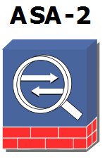

Figure 2.1 Graphic designation of the security device in GNS3
The Cisco ASA 5500 Multifunctional Software and Hardware Complex is designed to address multiple tasks at once - delimiting access to network resources, protecting against attacks, protecting interactions with remote territories, blocking viruses, worms, spyware and other malicious software, spam and "malware" attacks . This is achieved by combining the best-in-class security features in one device - the Cisco Pix Firewall, the Cisco IPS Attack Prevention System, and the Cisco VPN 3000 Concentrator. The Cisco Adaptive Identification and Mitigation (AIM) modular architecture enhances the security capabilities of the Cisco ASA 5500 with new features (as new integrated modules develop) - email and web traffic control (URL filtering), antivirus, antispam, anti-phishing, Network Admission Control etc.
Key features:
- Management using Cisco Adaptive Security Device Manager
- VLAN support
- Support for fault-tolerant configurations (Active / Standby and Active / Active)
- Support for Risk Rating, Meta Event Generator alarm management mechanisms
- Support for OSPF, PIM, IPv6, QoS
- Support for virtual and transparent ITUs
- Cisco WAAS Support
- Control of protocols and applications (web, e-mail, FTP, voice and multimedia, DBMS, operating systems, GTP / GPRS, ICQ, P2P, etc.)
- Protection against buffer overflow attacks, RFC violations, anomalies, address swaps
- SSL and IPSec VPN organization
- Display viruses, worms, and malware in HTTP, FTP, SMTP, and POP3
- Syslog to ACL Correlation mechanism
- Controls up to 8 network interfaces

2.3.2. Router.
A router is a packet data network device designed to integrate network segments and elements thereof and to transmit packets between them based on any rules. Routers operate on the network (third) layer of the OSI model. Typically, the router uses the destination address specified in the packet header and determines the routing table by which the data should be transmitted. If the routing table does not have a route described for the address, the packet is discarded.
There are other ways to determine the packet forwarding route when, for example, a sender address is used, top-level protocols are used, and other information contained in the network layer packet headers. Often, routers can transmit sender and recipient addresses, filter the transit data stream based on certain rules to restrict access, encrypt / decrypt transmitted data [18].

2.3.2.1. Features of configuring Cisco routers.
First of all, the physical connection is configured and the interface settings are configured. This step involves setting up physical interfaces - port speed, duplex, flow control, creating EtherChannel, creating 802.1Q sub-interfaces when using a VLAN on a network.
Next, configure the router IP addresses. The local interface and global router interfaces are configured.
The next step is to configure the routing features:
- routing settings, including static and dynamic routing
- setting up DHCP address automation, including dynamic pooling, static bindings;
- NAT address conversion settings - dynamic and static port forwarding rules;
- configuring secure access, including a list of physical interface access and a list of virtual ports;
- users, authorization, privileged mode;
- setting up an access control list (ACL);
An Access Control List (ACL) is a sequential list of permission or prohibition rules that apply to higher-level addresses or protocols. ACLs allow you to effectively control incoming and outgoing network traffic. ACL lists can also be configured for all network routing protocols.
An ACL list is a series of IOS commands that determine whether a router sends packets or drops them based on the information in the packet header. ACLs do the following to limit network traffic to improve network performance. Access control lists provide a basic level of security regarding network access. ACLs can open part of a network on one node and close it on other nodes.
ACLs filter traffic based on traffic type.
Access control lists sort the nodes to determine if you need access to network services. ACLs allow or deny access to certain file types, such as FTP or HTTP [19].

End of form

2.3.3. Router
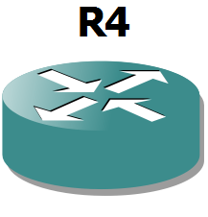

Fig.2.2 Graphical designation of the router in GNS3
A router is used to implement packet forwarding on the network, combining network segments and their structural elements. For the average user, the router is a network routerdevicethat connects betweenlocal area networkandthe internet. Often, the router is not limited to simply transferring data between interfaces, and also performs other functions: protects the LAN from external threats, restricts access of LAN users to Internet resources, distributesIPsencryptstraffic and much more. Routers work on the network layer of the model OSI: can forwardpackagesfrom one network to another. The router uses to send packets in the right directionrouting tablestored in memory.Routing tablemay be static or dynamicrouting. In addition, routers can broadcast sender and recipient addresses (eng.NAT, Network Address Translation), filtering the transit data stream based on certain rules to restrict access, encrypt / decrypt transmitted data, and more. Routers cannot transmit broadcast messages such asARP-request. The router can be a dedicated device as well as a regular devicecomputerThe router typically uses the recipient's address specified in the data packets and determines the route by which the data is to be transmitted using the routing table. If the routing table does not have a route described for the address, the packet is discarded [16].
There are other ways to determine the packet forwarding route when, for example, a sender address is used, top-level protocols are used, and other information contained in the network layer packet headers. Often, routers can transmit sender and recipient addresses, filter transit data streams based on certain rules to restrict access, encrypt / decrypt transmitted data, etc. As a router, it can act as a specialized hardware device (a typical representative - Cisco products), and ordinarycomputerthat performs the functions of a router. There are several software packages (mostly kernel based)Linux) that can be used to turn a PC into a high-performance and versatile router.
- amount of RAM;
- data transmission protocols;
- routing protocols;
- the presence of expansion slots;
- number of interfaces;
- remote control;
- compliance with standards;
- possibility of installation in a telecommunication rack.
The Cisco 3700 series of routers are designed for remote offices that require a high level of service integration. The Cisco 3700 offers a wide range of network and voice interfaces in one compact device and can significantly improve the quality of voice and data traffic. Using this platform, users are provided with new High-Performance Extension Modules (HDSMs) and Service Modules (AIMs) to provide a device that integrates high-performance routing / switching with WAN support. Cisco 3700 provides a solution capable of supporting a large number of traditional telephony devices together with IP telephony devices. Using 16- or 36-port EtherSwitch modules with Inline Power support, analog and digital interfaces, and Cisco IOS voice capabilities allow you to combine PBX telephony and data communications into one network. Significant cost savings are achieved by financing one solution rather than two concurrent ones and, accordingly, by reducing deployment costs, technical support and staff training.
Features of Cisco 3700.
Cisco 3700 Series modular routers use interface cards compatible with the Cisco 1600, 1700, 2600, 3600 series. Network modules can be upgraded. LAN / WAN support, a large number of slots for NM and HDSM modules installation, and the presence of AIM and WIC expansion slots allow flexible change of hardware configuration depending on customer requirements. Flexibility of configuration of standard and IP-telephony, possibility of gradual transition from traditional to IP-telephony due to compatibility of more than 90% of traditional tel public telephone equipment and systems TDM PBX, and voice gateways support a large number of analog and digital system z'yednan.Operatsiyna Cisco IOS, which is used in routers 3700 series, according to his ability to close the set in the series 2600 and 3600. Quality of service, bandwidth management, network security mechanisms, along with ongoing Cisco IOS updates, provide an effective solution for building computer networks. The Cisco 3700 Series routers have increased AIM (2) and WIC (3) slots. Custom built-in expansion slots to support additional hardware services, WAN and backup connections increase productivity and deliver more flexible solutions. Increased memory, up to 32 MB Compact Flash and 128 MB DRAM. Support for High Density Service Modules (HDSM) high performance services and represents a higher density of ports. The Cisco 3700 Series routers have increased the number of AIM (2) and WIC (3) slots. Custom built-in expansion slots to support additional hardware services, WAN and backup connections increase productivity and deliver more flexible solutions. Increased memory, up to 32 MB Compact Flash and 128 MB DRAM. Support for High Density Service Modules (HDSM) high performance services and represents a higher density of ports. The Cisco 3700 Series routers have increased the number of AIM (2) and WIC (3) slots. Custom built-in expansion slots to support additional hardware services, WAN and backup connections increase productivity and deliver more flexible solutions. Increased memory, up to 32 MB Compact Flash and 128 MB DRAM. Support for High Density Service Modules (HDSM) high performance services and represents a higher density of ports.Resiliency: Redundant Power Supply (external to Cisco 3725, built-in Cisco 3745) support - Reduces unstable running time.
Installation of IP telephony calls on the router (Survivable Remote Site Telephony). If you lose your central office connection, remote offices can use the Cisco 3700 to connect locally.
Hot swap mode (3745 only), NM modules, RPS, fan can be replaced while the router is running. Replaceable NMs should be identical in functionality.
Support for motherboard hardware updates, I / O boards, power supplies, and fan power (3745 only) greatly increases maintenance capabilities.
Cisco Works2000 and Cisco View. Allows you to control all components of a network device, such as network modules and WAN interface cards, from a single network management station that caters to multiple devices, which reduces the cost of operation.
Cisco Voice Manager. A Java-based management tool reduces the cost of installing and managing multi-service solutions.
Cisco Call Manager. The Cisco 3700 supports Cisco Call Manager using the H.323 protocol. MGCP support will be added in the next Cisco IOS releases.

2.3.4. Switchboard
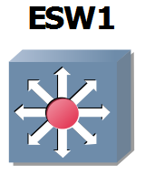

Fig.2.3 Graphical designation of the switch in GNS3
For connecting multiple nodescomputer networkwithin one segment switches are used.Unlikedistributing hubtraffic from one connected device to all the others, the switch only transmits data directly to the recipient. This enhances network performance and security, saving other segments of the network from having to (and being able to) process data that is not intended for them.The switch works onchannel levelOSI models, and so in the general case can only connect the nodes of one network on theirs MAC addresses. To connect multiple networks based onnetwork layerto serverouters. The switch stores in memory a table indicating the correspondingMAC addressesport nodeswitch. When the switch is turned on, this table is empty, and it works in training mode. In this mode, the data coming to anyportare transmitted to all other ports of the switch. The switch analyzes the frames and determines the MAC address of the sender host and places it in the table. Subsequently, if one of the switch ports receives a frame destined for the host whose MAC address is already in the table, then that frame will be transmitted only through the port specified in the table. If the MAC address of the receiving host is not yet known, the frame will be duplicated across all interfaces. Subsequently, the Switch builds a complete table for all its ports, and as a result, traffic is localized. There are three waysswitching. Each of these is a combination of parameters such as wait time and transmission reliability.
- Store and Forward. The switch reads all the information in the frame, checks it for errors, selects a switch port, and then sends it to itframe.
- Cut-through. The switch reads only the destination address in the frame and then executes itswitching. This mode reduces transmission delays, but there is no error detection method.
- Fragment-free or hybrid. This mode is a modification of the through mode. The transfer is performed after the collision fragments are filtered (64-byte frames are processed by store-and-forward technology, others by cut-through technology).
The main indicators of the switch characterizing its performance are:
- throughput;
- delay of transmission of a frame, directly depends on throughput;
- amount of RAM;
- Internal address table size.
Since most modern switches are quite powerful, these characteristics are more similar to them. In our case, we are interested in the following requirements for switches:
- possibility of installation in a telecommunication rack;
- configurable;
- remote control;
- VLAN support;
- number of Fast Ethernet ports;
- number of Gigabit Ethernet ports.

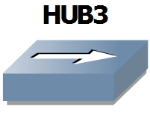
2.3.5. Concentrator

Fig.2.4 Graphic designation of the hub in GNS3
Used to increase the number of ports and as an intermediate device between subnets.

2.3.6. Virtual Personal Computers (VPCs)
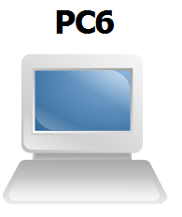

Fig.2.5 Graphic designation of virtual end users in GNS3
Virtual PCs, for emulation of PCs with basic networking functions. Allow using a minimum of resources to simulate end-user machines

2.4. Kali Linux
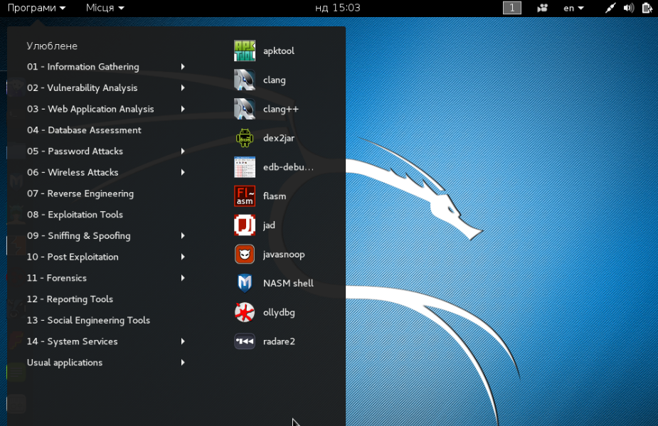
Fig.2.6 Kali Linux Software Sections
Kali Linux is an advanced Linux distribution for penetration testing and security audits.
Features of Kali Linux
Kali is a complete re-build of BackTrack Linux, fully complying with Debian development standards. All the new infrastructure was revised, all the tools were analyzed and packed, and we switched to Git for our VCS [18].
- More than 300 penetration testing tools: After reviewing each tool that was included in BackTrack, we removed a large number of tools that either do not work or duplicate other tools with similar functionality.
- Free and always free: Kali Linux, like its predecessor, is completely free and always will be. You will never have to pay for Kali Linux.
- Git Open Source Tree: We are die-hard supporters of open source software and our development tree is open to anyone and all sources are open to anyone who wants to customize or rebuild packages.
- FHS Compatible: Kali was designed to adhere to the Filesystem Hierarchy Standard, allowing all Linux users to easily find executables, support files, libraries, etc.
- Wide support for wireless devices: We have built Kali Linux to support as many wireless devices as possible, allowing it to work properly with a wide variety of hardware devices and making it compatible with numerous USB and other wireless devices.
- Special kernel patched from injection: As pentesters, developers often need to audit wireless networks, so our kernel includes the latest patches.
- Secure development environment: The Kali Linux development team consists of a small group of trustees who can record packages and interact with repositories only when using several secure protocols.
- GPG signed packages and repositories: All Kali packages are signed by each individual developer when they are created and recorded and repositories subsequently sign packages.
- Multilingualism: Although pentest tools are usually written in English, we have made sure that Kali has genuine multilingual support that allows most users to work in their native language and find the tools they need to work.
- Configurability: We fully understand that not everyone will agree with our design solutions, so we have made it possible for our users to customize Kali Linux as easily as possible to their taste.
ARMEL and ARMHF support: ARM systems are becoming more and more widespread and inexpensive, and we knew we needed to make Kali support for ARM systems, resulting in working installations for ARMEL and ARMHF systems. Kali Linux has ARM repositories integrated with the main distribution.

2.5. Software

2.5.1. Hping3.
Hping3 is a free packet generator and analyzer for TCP / IP protocol. Hping, where in fact, one of the must-haves for security audits and firewall and network testing, was used to perform the Idle Scan scanning technology, which is now implemented in the Nmap port scanner. Like most tools used in computer security, hping3 is useful for security experts and is used for:
- traceroute / ping / probe (trace / ping / probing) hosts;
- testing firewall rules;
- testing of IDS (intrusion detection systems);
- network research;
- network stress testing;
- TCP / IP study (hping was used in AFAIK online courses);
- writing real-world applications related to TCP / IP testing and security;
- automation of traffic filtering tests;
- creation of a working model of exploits;
- studies on network validation and security when emulating complex TCP / IP behavior [20];

2.5.2. Zenmap.
Zenmap is the official GUI for Nmap Security Scanner. Zenmap is an open source utility for network exploration and security testing. It was designed to scan large networks quickly, although it handles single targets perfectly. Zenmap uses raw IP packets in the original ways to determine which hosts are available on the network, what services (application name and version) they offer, what operating systems (and OS versions) they use, what types of packet filters / firewalls they use, and dozens of other features . While Zenmap is commonly used for security audits, many network and system administrators find it useful for routine tasks such as controlling network structure, managing service start-up schedules, and keeping a host or service running [21].
Nmap output is a list of scanned targets with additional information about each, depending on the options you specify. The key information is the "table of important ports". This table contains the port number, protocol, service name, and status. The status can be open, filtered, closed, or unfiltered. Open means that the application on the target machine is ready to connect / accept packets to this port. Filtered means that a firewall, network filter, or other network interference is blocking the port, and Nmap cannot set this port open or closed. Closed ports are not associated with any application, so they can be opened at any time.

2.5.3. Wireshark.
Wireshark is a network traffic analyzer. His job is to intercept network traffic and display it in detail. Wireshark can intercept the traffic of various network devices by displaying its name (including wireless devices). Support for a particular device depends on many factors, such as the operating system, and has many protocol decoders (TELNET, FTP, POP, RLOGIN, ICQ, SMB, MySQL, HTTP, NNTP, X11, NAPSTER, IRC, RIP, BGP, SOCKS 5 , IMAP 4, VNC, LDAP, NFS, SNMP, MSN, YMSG and others). Wireshark allows you to store and open previously stored network traffic. System administrators use it to troubleshoot network problems, developers use it to debug network applications,

2.6. Conclusions to the section

In this section of the diploma work the concepts of terms "cyberspace", "cybersecurity", "cybersecurity", "cyber security polygon" were described, the possibility of building a virtual cyber security polygon on different platforms - virtual network emulators was considered, conclusions were drawn on each floor and each group was evaluated. the disadvantages of each. GNS3 was chosen to build a virtual cyber security landfill based on the virtual network emulator, despite some disadvantages, such as the lack of multi-user support and the limited availability of QEMU network connections, which can be neglected. For all other characteristics, this emulator is ideally suited to implement on its basis a full-fledged virtual network, configure it for any needs and perform full testing, except for the use of wireless networks and devices. Software for testing the built-in cyber security training ground is considered.

SECTION 3

Practical implementation of a cybersecurity training ground based on GNS3 application software

3.1. Preparatory stage

To build a GNS3 application-based cyber security training site, a distributed, enterprise-grade, simplified computer network topology was selected using a single Cisco ASA 5520 firewall that divides the company's network into a demilitarized zone, an internal and an external network. The zonal model is quite flexible, the interfaces are assigned to the zones, and the check policy is the traffic transmitted between the zones. The network topology built in GNS3 is shown below (Figure 3.1).
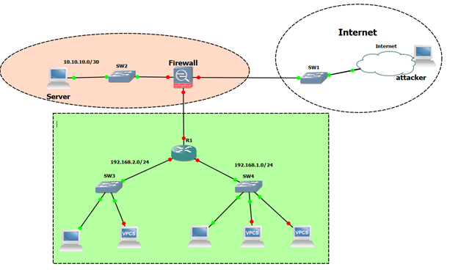
Fig. 3.1. Network topology in GNS3
The following is a virtual routing table that lists the above network topology broken down into subnets, lists all network devices, their interfaces with each IP address, subnet mask, and default gateway (Table 3.1).
Table 3.1
Virtual network routing table
Device | Interface | IP address | Subnet mask | The default gateway
Cisco ASA 5520 | Gig0 | 192.168.125.130 | 255.255.255.0/24 | 192.168.125.1
Cisco ASA 5520 | Gig1 | 20.20.20.1 | 255.255.255.252/30 | -
Cisco ASA 5520 | Gig2 | 10.10.10.1 | 255.255.255.252/30 | 10.10.10.2
R1 | Fa0 / 0 | 20.20.20.2 | 255.255.255.252/30 | 20.20.20.1
R1 | Fa1 / 0 | 192.168.2.1 | 255.255.255.0/24 | -
R1 | Fa2 / 0 | 192.168.1.1 | 255.255.255.0/24 | -
Internet |  | 192.168.158.1 | 255.255.255.0/24 | -
Head PC | Mayor. adapt | 192.168.2.10 | 255.255.255.0/24 | 192.168.2.1
Substitute PC | Mayor. adapt | 192.168.2.11 | 255.255.255.0/24 | 192.168.2.1
Works_1-PC | Mayor. adapt | 192.168.1.10 | 255.255.255.0/24 | 192.168.1.1
Works_2-PC | Mayor. adapt | 192.168.1.11 | 255.255.255.0/24 | 192.168.1.1
Works_3-PC | Mayor. adapt | 192.168.1.12 | 255.255.255.0/24 | 192.168.1.1
Server | Mayor. adapt | 10.10.10.2 | 255.255.255.252/30 | 10.10.10.1

3.2. Description of network devices

In this topology, the following network devices use the Cisco ASA 5520 firewall (firewall hostname), Cisco 3745 router (hostname R1), and network switches (SW1, SW2, SW3, SW4) to build a cyber security site. The loopback interface (Internet) is used to provide access to the virtual network. Also, two virtual machines were added to the network on Windows XP SP3 (Head-PC, Work_1-PC) to simulate real computers on the network. Virtual PC Simulator (VPCS) is used to simulate other PCs on the network, which uses a small amount of PC resources to build a cyber security site, since we use our own computer to use VCPS. VCPS creates virtual interfaces for its operation and uses only 2 UDP ports - one for transmitting information, the other for reading [24]. VCPS has some limited functionality, but it saves PC resources. Worker and substitute workstations are emulated just by VCPS.

3.2.1. Description of network topology and network device tasks.

The management network and the employee network are located on the Gig1 interface of the Firewall, and the traffic between them is the responsibility of the R1 router. Cisco ASA configures NAT to prevent and restrict requests from outside to internal hosts. For more convenient firewall management and monitoring features, HTTPS connection to ASDM is configured. Accessing Cisco ASDM directly from a Web browser from any Java-enabled network computer, gives security administrators the ability to quickly and securely access Cisco ASA security devices and have functionality similar to a console connection. To securely connect to R1 remotely, it configures SSH version 2, and prohibits all other non-SSH connections. In the demilitarized zone is a Server that performs both Web server and FTP server functions. The web server is accessible to executives and employees, as well as from the Internet. Users can access the Internet only on port 80 and ftp. Other ports are closed. From the Internet, access is only available on the Website and only on the 80th port.

3.2.2. Cisco ASA5520 Specifications.

The Cisco ASA 5500 Series is the latest multifunctional device that utilizes the most advanced information security technologies, combining proven Cisco products: firewall, network intrusion prevention, network antivirus and VPN services. The Cisco ASA 5520 can enhance application security by installing network worm blocking capabilities and a high-performance intrusion prevention system using AIP SSM, as well as a full-featured malware protection service using CSC SSM.

The Cisco ASA 5520 has the following specifications [24]:

▪ Bandwidth: 225 Mbps

VP Simultaneous VPN sessions: 750

▪ Simultaneous SSL VPN Scripts: 750

▪ Interfaces: Four 10/100/1000 Ethernet ports, control port, two USB ports3.2.3.Cisco 3745 Specifications.
The Cisco 3745, a high-performance router with a modular architecture, enables integrated data, voice and fax solutions across TCP / IP networks. Has the following specifications:
- Compartments for network modules: 4 pcs.
- Compartments for WAN Interface Cards (WIC): 3 pcs.
- Local Area Network (LAN) ports: 2 10/100 Ethernet
- Backup power is possible
- Performance is 225,000 packs / second.
Possible modules for Cisco 3700 series routers are LAN, WAN, combined network, voice, and service modules [25].

3.3. Setting up network devices

3.3.1. Cisco ASA 5520 Configuration.
- We enter the privileged mode and the global configuration mode and specify the host name:
enable
configure terminal
hostname ASA
- Specify password for privileged mode:
enable password Qwmnbvcx12
- Create a local administrator, which is later required for Cisco Adaptive Security Device Manager:
username admin password ciscocisco privilege 15
- We set up Traffic inspection - the procedure required to operate the most important principle of ASA, namely Statefull Packet Filtering. For example, to allow FTP traffic, it is sufficient for us to allow 21 ports, all other ASA child connections will be allowed automatically. We apply global traffic inspection policies globally to your device:
match default-inspection-traffic
policy-map type inspect dns preset_dns_map
parameters
message-length maximum client auto
message-length maximum 512
policy-map global_policy
class inspection_default
inspect dns preset_dns_map
inspect ftp
inspect h323 h225
inspect h323 ras
inspect rsh
inspect rtsp
inspect esmtp
inspect sqlnet
inspect skinny
inspect sunrpc
inspect xdmcp
inspect sip
inspect netbios
inspect tftp
inspect ip-options
inspect icmp
service-policy global_policy global
- We configure the firewall interfaces according to the routing table and assign a security level to each of them. By default for the outside security-level 0 interface, and for the inside 100:
interface gigabitethernet 0
ip address dhcp
no shutdown
nameif outside
exit
interface gigabitethernet 1
nameif inside
ip address 20.20.20.1 255.255.255.0
no shutdown
exit
interface gigabitethernet 0
nameif DMZ
security level 50
ip address 10.10.10.1 255.255.255.0
no shutdown
exit
- We set default routes:
route outside 0.0.0.0 0.0.0.0 192.168.158.2
route inside 192.168.1.0 255.255.255.0 20.20.20.2
route inside 192.168.2.0 255.255.255.0 20.20.20.2
route dmz 10.10.10.0 255.255.255.0 10.10.10.2
- For each subnet we create our object (object), we attach for each object our subnet for each of the subnets we enable the dynamic NAT function, that is, when translating addresses the translation table in ASA is initially empty and starts to populate after the traffic passes through the inter-network. screen:
object network HEAD
subnet 192.168.2.0 255.255.255.0
nat (inside, outside) dynamic interface
nat (inside, DMZ) dynamic interface
exit
object network DEPARTMENS
subnet 192.168.1.0 255.255.255.0
nat (inside, outside) dynamic interface
nat (inside, DMZ) dynamic interface
exit
object network DMZ
subnet 10.10.10.0 255.255.255.0
static (DMZ, outside) tcp interface www 10.10.10.2 www netmask 255.255.255.255
exit
- We turn on https access and prescribe who can access ASDM
http server enable
http 192.168.1.0 255.255.255.0 inside
- We create an access list according to the above ports for internal users and bind it to the interface inside:
access-list EMPLOYEES extended permit tcp 192.168.0.0 255.255.255.0 any eq www
access-list EMPLOYEES extended permit tcp 192.168.0.0 255.255.255.0 host 10.10.10.2 eq ssh
access-list EMPLOYEES extended permit tcp 192.168.0.0 255.255.255.0 any eq ftp
access-list EMPLOYEES extended permit icmp 192.168.0.0 255.255.255.0 any
access-group EMPLOYEES in interface inside
- Configure port-mapping, ie redirect requests to a single IP address and 80 outside port to the IP address:
access-list REMOTE extended permit tcp any host 10.10.10.2 eq www
access-group REMOTE in interface outside
- Save settings:
copy run disk0: /. private / startup-config

3.3.2. Configure the Cisco 3745 Router.
- We enter the privileged mode and the global configuration mode and specify the host name:
configure terminal
hostname R1
- We configure the ability to connect to the router via SSH and disable telnet, while specifying a minimum password length of 10 characters, give 3 attempts to authorize - otherwise the connection will break, set the encryption keys RSA, key length 1024 bits:
ip domain-name 3745router.local
security passwords min-length 10
user NotAdmin privilage 15 secret MyTestCiscoPass
enable secret Qwerty! 23456
crypto key generate rsa modulus 1024 label testkey
ip ssh time-out 10
ip ssh authentication-retries 3
line vty 0 15
transport input ssh
login local
exit
login delay 5
login block-for 30 attempts 3 within 60
- We configure the R1 interfaces according to the routing table and "raise" them, as well as configure the default route:
int fastethernet 0/0
ip address 20.20.20.2 255.255.255.0
description To_ASA
no shutdown
exit
int fastethernet 1/0
ip address 192.168.2.1 255.255.255.0
description To_Head
no shutdown
exit
int fastethernet 2/0
ip address 192.168.1.1 255.255.255.0
description To_Departments
no shutdown
exit
ip route 0.0.0.0 0.0.0.0 20.20.20.1
exit
- Save the router configuration:
copy running-config startup-config

3.4. Check your network settings

To test the performance of the built-in cybersecurity site, we will check the success of traffic passing from a networked Work_1-PC virtual machine to Server. We will check the connection with the help of the ping utility computer program, this is shown in Fig. 3.2.
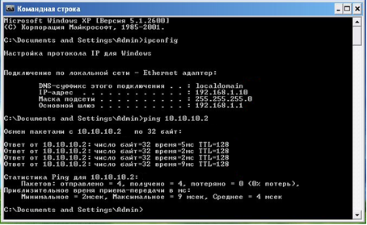
Fig. 3.2 Checking the Work_1-PC and Server connection
Open a local website and go to the ftp server. To do this, the Server is installedCerberus FTP Server and the FTP server and the HTTP server configured on it, for which pre-loaded test files and web pages are uploaded, are shown in Fig. 3.3 and fig. 3.4.
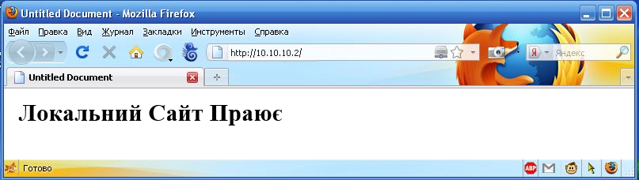
Fig. 3.3 Opening the Web page of a local HTTP server
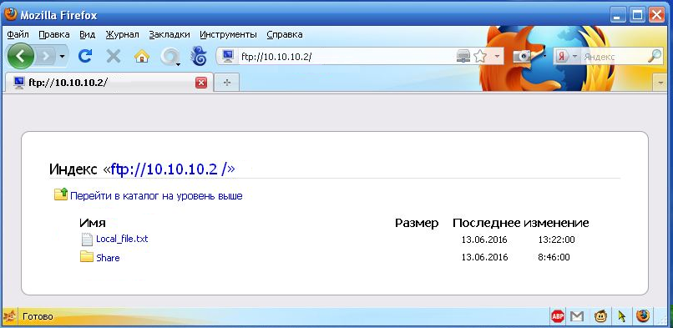
Fig. 3.4 Opening an ftp server
To test your Internet connection, use tracert and trace the route to Google's DNS server, which will display information about all the intermediate routers through which the data passed to the destination node, including R1 with IP address 192.168.1.1 , the Firewall 20.20.20.1 firewall, and the loopback interface of the computer running GNS3 192.168.125.1, this is shown in Fig. 3.5.
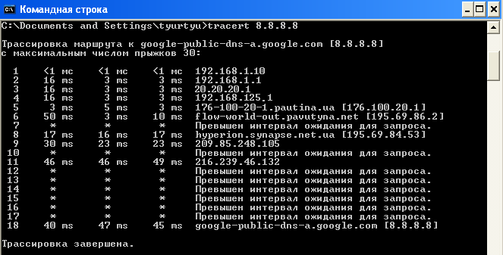
Fig. 3.5 Tracing the route to Google DNS servers
To test the configured connection to the Cisco 3745 SSH router, use the PuTTY SSH client, connect to R1 and switch to privileged mode, as shown in Figure 3.6 and Figure 3.7.
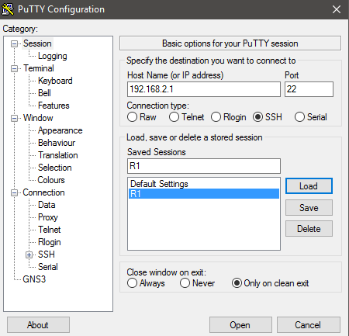
Fig. 3.6 Connection to R1 via SSH
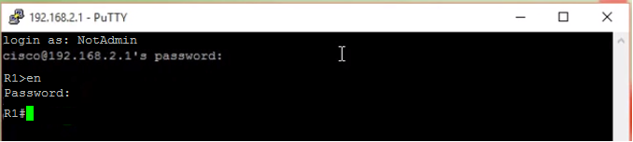
Fig. 3.7 Logging on to the privileged router R1 via SSH
Let's run the Cisco ASDM Firewall GUI, which needs to be pre-installed with the Java Runtime Environment, all the previous settings are described above. To install ASDM on the ASA 5520, you use an ftp server from which ASDM itself is loaded into flash memory. The connection is via secure HTTPS protocol, in particular you need to go to the configured interface with the HTTPS server from which the launcher is installed and Cisco ASDM starts running Figure 3.8. When connected to ASA through the browser, an ASDM-launcher is downloaded, which must be started. Next you need to authorize as shown in fig. 3.9 After which we get ASA access with a GUI, which can be used to remotely control it, since all the same functions as from the console are available, the Cisco ASDM interface is shown in fig. 3.10. The setting of the rules for the delimitation of access to the network using the lists of access control and NAT is shown in Fig. 3.12 and 3.13, respectively.
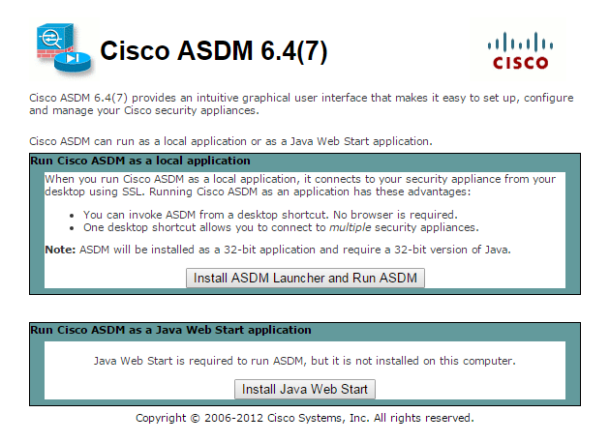
Fig. 3.8 Connecting to Cisco ASA over HTTPS
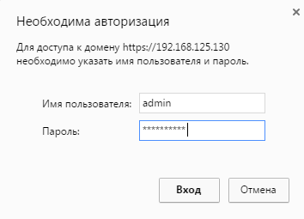
Fig. 3.9 Cisco ASA Authorization via ASDM-launcher
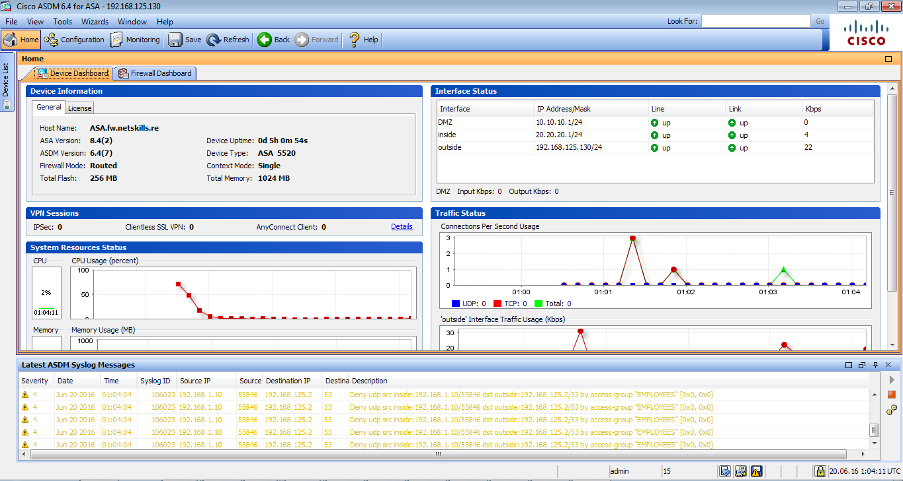
Fig. 3.11 Cisco ASDM Interface
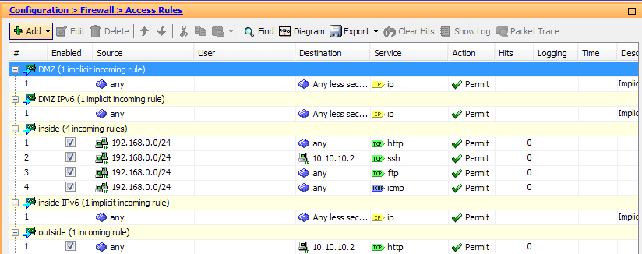
Fig. 3.12. Cisco ASA Access Delimitation Rules are configured
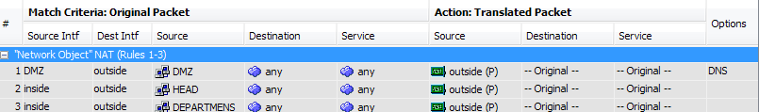
Fig. 3.13 Setting NAT on the Cisco ASA 5520

3.5. Network scanning

Zenmap - the official Graphical user interface (GUI) for Nmap Security Scanner, a network scanner and a port scanner - has been selected for network scanning. Crawl ranges are selected for scanning to save time. WAN information has been collected, as a result of NAT configuration, only the configured Cisco ASA interface is displayed, as shown in Figure 3.14.
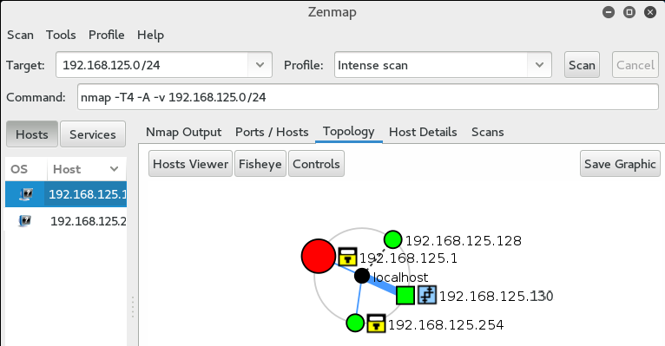
Fig. 3.14 Scanning a LAN from an External Network
If an attacker has access to the network from the inside, he or she will be able to scan the network topology and identify potential vulnerabilities. The utility allows you to determine which hosts are available on the network (the scanned network topology is shown in Figure 3.15), the version of the operating system, what services are running on them, the names of the running applications and port numbers and states, for example, if you do not forbid a standard connection to a router on a network telnet protocol, then Zenmap detects this, the result is shown in fig. 3.16.
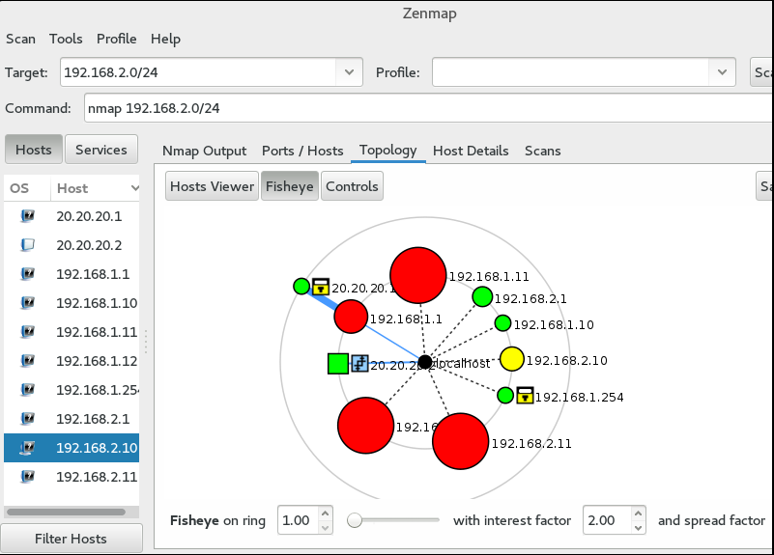
Fig. 3.15 Scanning the LAN from the Inside
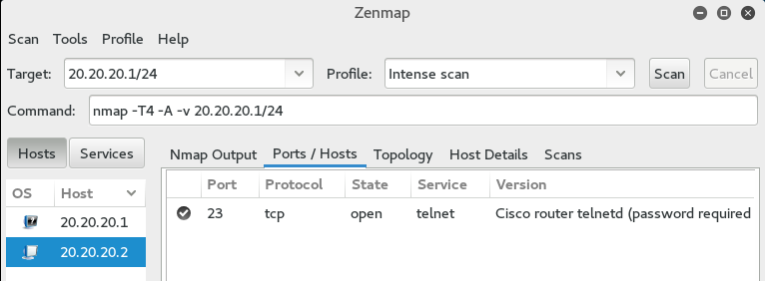
Fig. 3.16 Scanning Cisco 3745 Router with Telnet On
In general, after a detailed scan of the network device, we will have the result of Cisco 3745 utility with Telnet enabled, Zenmap utility made assumptions about the operating system, found an open port, determined the network address, as shown in fig. 3.17.
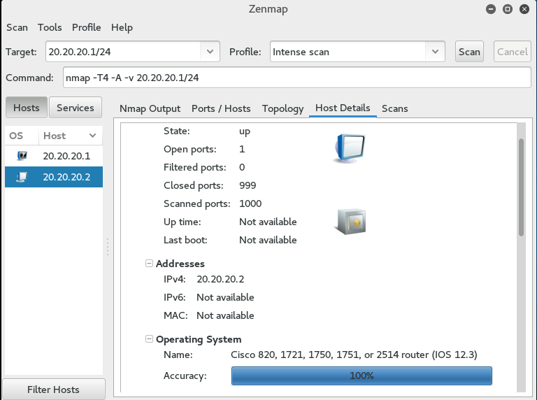
Fig. 3.17 Details of the scanned Zenmap host
Cisco ASA has scan protection functionality, particularly if the messages contain the same source address, this message may indicate baseline data collection or port scan attempt, and the IP packet is rejected by ACL, as shown in Figure 3.18.
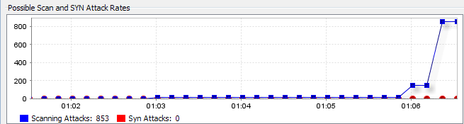
Fig. 3.18 Cisco ASA Declined Packet Statistics During Network Scanning

3.6. Network stress test

In computer terminology, a denial of service (DoS) attack or a distributed denial of service (DDoS) attack is an attempt to make machine resources inaccessible to users. Although the costs, motives, and goals of DoS differ, its core nature remains unchanged - interrupting or suspending the service of a host connected to the Internet for an indefinite period or indefinitely.
One of the common methods of attack is to saturate the target machine with external connection requests, so it cannot respond to legitimate traffic or respond so slowly that it is essentially unavailable.
Syn-Flood Attack is an attack in which the SYN initiator puts out a fake Source IP-address or ignores responses from the Syn + Ack server. When you open thousands of such half-sessions, you are consuming server resources that you have to memorize each of the parameters and can eventually refuse.
For DoS, we use hping3's built-in Kali Linux build using random DoS source IPs. The given program without GUI, for execution of Syn-Flood Attack attack the following commands are selected, as shown in fig. 3.19:
▪ hping3 - the name of the application.
▪ -c 10000 - Number of packages to send.
▪ -d 120 - The size of each packet to be sent to the target machine.
▪ -S - Only send SYN packets.
▪ -w 64 - TCP window size.
▪ -p 80 - Destination port, you can use any port.
▪ -flood - Send packets as fast as possible without worrying about displaying incoming packets (Syn-Flood Attack).
Rand -rand-source - Use random source IP addresses. You can also use -a or -spoof to hide the hostname
▪ 192.168.125.130 - The target IP address or IP address of the target machine. You can also use the site address. [22].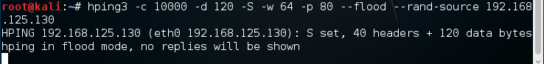
Fig. 3.19 hping3 DoS attack
Cisco ASA automatically broadcasts packets that arrive at 80 ports to the server, and when attacked by a resource failure, this causes an additional load on the server, causing denial of access for ordinary users.
Proping the network without load result is shown in Fig. 3.20 and the network under load Fig. 3.21. We also use the Wireshark program to analyze the network packets of Ethernet and other networks (sniffer) to analyze the DoS attack. By filtering the traffic heard between the attacker and Cisco ASA by Wireshark by ICMP, you can see that due to the DoS attack, a load is created on the Cisco ASA, which creates queues for processing requests and replies come with some delay or response is absent at all, as shown in Figure 3.22.
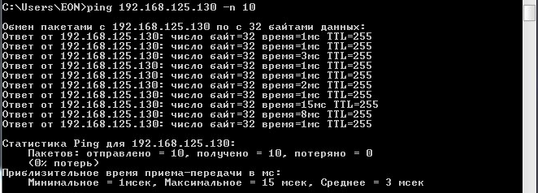
Fig. 3.20 Network ping without load
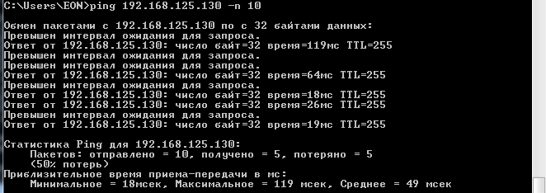
Fig. 3.21 Network ping at 10,000 packets / second
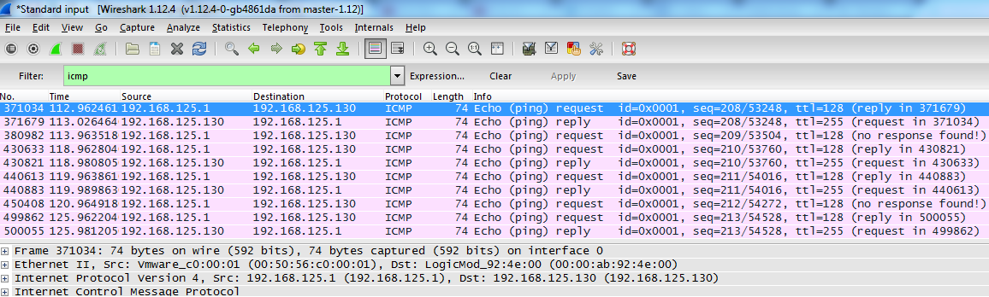
Fig. 3.22 Filtered ICMP traffic during a DoS attack
To resolve this issue, ASA uses TCP SYN Cookies: ASA protects the server and does not broadcast all connections to it. Instead of memorizing all these half sessions, the ASA responds to each of them, but the actual connection to the server only occurs when a 3rd Ack response is received. Embryonic-conn-max 5 means that the maximum will be a resolution of up to 5 half connections. The following settings are required:
access-list outside_mpc line 1 extended permit tcp any object dmz-server real
class-map no-syn-flood-class
match access-list outside_mpc
policy-map NO-SYN-FLOOD
no-syn-flood-class
set connection conn-max 0 embryonic-conn-max 5 per-client-max 0 per-client-embryonic-conn-max 0 random-sequence-number enable
service policy NO-SYN-FLOOD interface outside
No additional settings at Syn-Flood attack we have 1625 active connections to the server, which causes a denial of service, as shown in Figure 3.23.
If you apply the settings data ASA will create a separate queue of half sessions that will not be able to dramatically affect the server's robot, as a result we only5 half-connections, as shown in Fig. 3.24 and demonstrates the effectiveness of protecting a given type of attack when properly configured firewall.
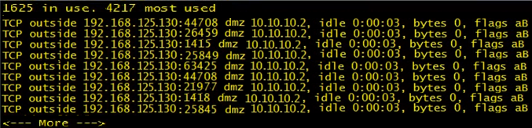
Fig. 3.23 Active sessions with SYN-flood attack without security settings
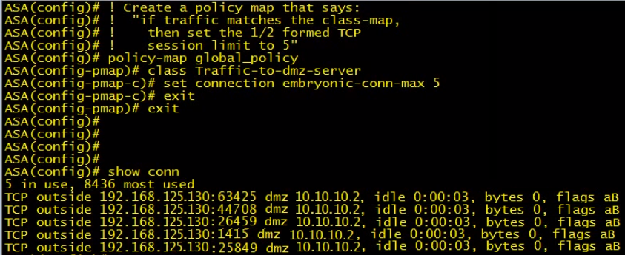
Fig. 3.24 Active sessions for a SYN-flood attack with its security settings

3.7. Checking the work of the created network
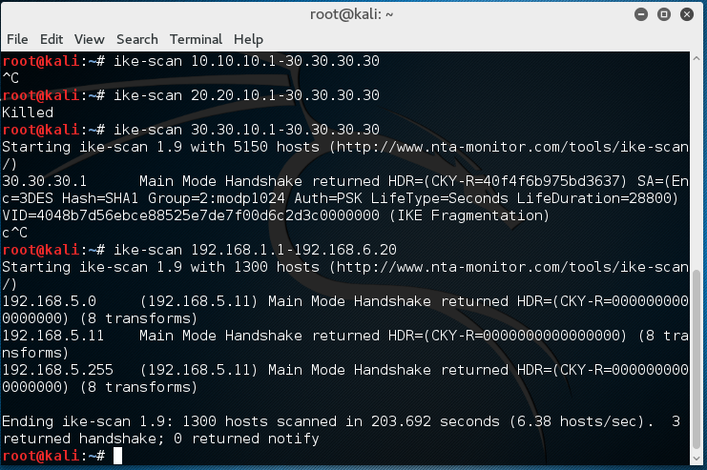
Fig.3.25 Collecting information about the network from the "Internet"
The range of IP addresses used was scanned to reduce the search time. If the IP addresses are unknown, the search may take several hours.
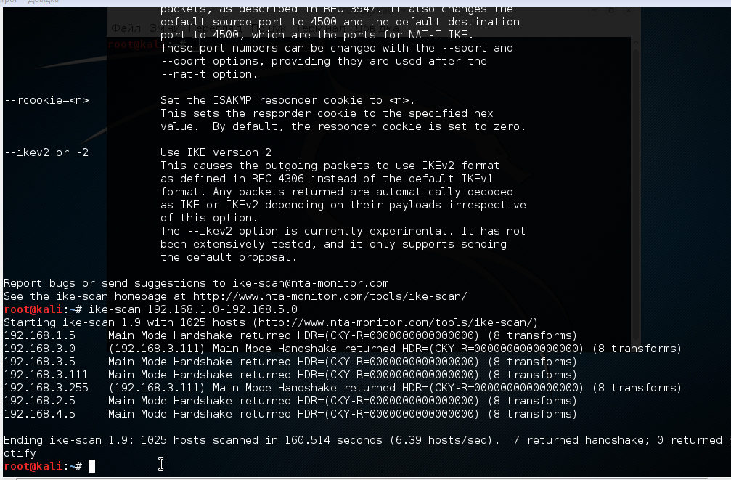
Fig.3.26 Scanning the network from the inside with ike-scan utility from the middle of the network
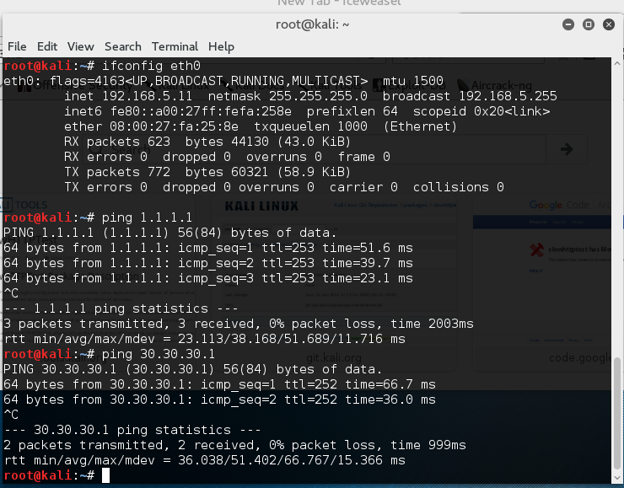
Fig. 3.27 The Internet and the internal ace interface are pinged
GNS3 has the ability to connect to a real network, the following figure shows the route tracing from a connected PC to our virtual network.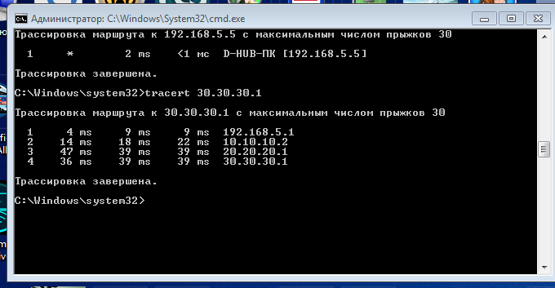
Fig.3.28 Tracing the route from the external PC to the ace

3.8. Conclusions to the section

This section develops and implements a cybersecurity topology based on GNS3 application software. The computer network topology consists of a Cisco ASA 5520 firewall that divides the company network into a demilitarized zone, an internal and an external network. Cisco 3745 router configures routing between employee networks and management and remotely connects to secure SSH protocol version 2. In the demilitarized zone, a Web server is set up that can be accessed from an external network (Cisco ASA automatically transmits packets to it via 80 port to the server) and from the internal network. Also configured is an FTP server that can only be accessed from the internal network. Cisco ASA has set up static NAT to access a local server from the Internet, as well as the lack of access to the internal network from the outside and the graphical interface of Cisco ASDM firewall control. Network settings checked.
To test the built-in cybersecurity site, the network and ports of the network devices were scanned from the outside using the Zenmap utility as a result of ASA and NAT settings, the scan gave nothing but the found IP address of the external ASA interface, and the scan from the inside, which resulted in information being collected internal network including the internal Cisco ASA interface.
With hping3 utility, a network stress test was implemented - Syn-Flood server failure attack was based on an attempt to initialize a large number of concurrent TCP connections due to a SYN packet with a non-existent return address. The counteraction to this attack was implemented.

SECTION 4

Testing method of information security system based on cyber security

4.1. Methods of testing the security of the AU

To test the IP information security system, information risk analysis is periodically conducted to identify threats to information security and, in turn, to use and implement appropriate measures to neutralize them. Currently, there are and are being used various information risk analysis techniques, the main difference being the quantitative or qualitative risk assessment scales. The advantages and disadvantages of which are given in Table 4.1.
In quantitative risk techniques, estimation is given by numerical value, as the input data is usually used accumulated statistics on incidents. However, the lack of sufficient statistics leads to a decrease in the adequacy of the evaluation results.
Qualitative techniques are more common, but they use simplified scales that contain levels of risk. Risk assessment is based on an expert survey. Today, there are many risk analysis techniques, the most commonly used of which are:
- quantitative methods: RiskWatch, Digital Security, ISRAM, iRisk;
- qualitative methods: Facilitated Risk Analysis Process (FRAP), National Institute of Standards and Technology (NIST)
- techniques that use mixed assessment: CRAMM, Microsoft Security Assessment Tool (MSAT), GRIF, hierarchy analysis method (AHP - Analytic hierarchy process);
To determine the optimal method of testing the information security system, it is necessary to perform a comparative analysis of the methods and to determine the optimal method in the context of the constructed cybersecurity site.

Table 4.1
Methods of information risk analysis
 | Quantitative methods
Advantages | - Allows you to evaluate the quantitative consequences of incidents  - The analysis of costs and benefits in the selection of security  - Rather characterizes the risk
Disadvantages | - The measurement scale is determined depending on the scope and accuracy of the information hazard assessment  - The results of the analysis may be inaccurate and unclear  - The result of the assessment must be of a qualitative description  - Quantitative analysis is generally more expensive, requiring more experience and state-of-the-art tools
 | Qualitative methods
Advantages | - Qualitative methods allow you to identify high risk areas in the short term and at no great expense.  - The analysis is relatively easy and cheap
Disadvantages | - Do not allow the use of probabilities and the presentation of results by numerical values  - It is more difficult to analyze the benefits gained from choosing a particular remedy  - The results obtained are of general nature, similar to approximation

4.1.1. Methods of quantitative assessment of information system risks
The RiskWatch method is one of the most powerful methods of quantitative analysis of an information security system. The goal implements risk assessment in four stages:
- Determining the type of network being investigated, the method contains templates for different types of organization, as well as basic information security requirements. The templates contain a list of resources that need protection and their major vulnerabilities, likely losses, threats to information security, and the minimum information security measures required.
- A detailed description of all the characteristics of the system under study, including assets, potential losses, and incidents. At this stage the probability of realization of threats is determined, which is determined by estimating their frequency. The methodology includes a compiled statistical database of estimates of the frequency of implementation of each type of threat, globally, as well as locally according to your region. The developers of this methodology themselves calculate the specific coefficients that determine the percentage of impact of the threat on assets and resources involved.
- The third stage is a quantitative assessment of the risks. Estimates the cost of implementation of the information security system, the cost of retention, its period of operation (life cycle).
- In the fourth stage, risk assessment reports are generated, which may include the total amount of losses per year, and contain the ROI, which characterizes the effectiveness of the AU information security spending and the resulting claims.
This method is ideally suited if a risk analysis is to be carried out at the software-technical level of protection, without taking into account organizational and administrative factors. The disadvantages include the cost of a license, which is $ 125,000 for companies.
The Digital Security method is characterized by the fact that it is based on two main models of risk assessment: the model of information flows, as well as the model of threats and vulnerabilities. The first model of risk assessment is performed by constructing a model of the investigated AU, in which the means of protection are considered, the interaction between different resources and at its heart are the rules of differentiation of access. The second model of assessment is characterized by the analysis of threats to resources and assets, as well as the analysis of vulnerabilities through which these threats can be implemented. The probability of realization of threats, their relevance and their magnitude of impact are evaluated [22].
Information security risk analysis method (ISRAM) - uses questionnaires to evaluate risk factors and calculates the level of risk in the form of a product of the likelihood of a threat and its consequences. According to this methodology, the risk level ranged from 1 to 25 and is calculated by the following formula:
$Risk= \left[\frac{\sum_{m}{T_{1}\left({\sum_{i}{w}}_{i}p_{i}\right)}}{m}\right]*\left[\frac{\sum_{n}{T_{21}\left(\sum_{j}{w_{j}p_{j}}\right)}}{n}\right]$ (4.1)
In formula (4.1), the value i shows the number of the question used to estimate the likelihood of the threat, j the number of the question used to evaluate the consequences of the threat, m and n - the number of experts involved in the survey pi and pj quantitative values ​​selected Answers to questions with numbers i and j, T1 and T2 are scales that are used to estimate the likelihood of threats and their consequences.
The iRisk method is formally one of the simplest assessments of the quantitative risks of information security of the AU. In general, it is calculated by the following formula:
$iRisk= \left(Vulnerability*Threat\right)-Controls$ (4.2)
where Vulnerability is a vulnerability assessment, Threat is a threat assessment, Control is an assessment of security measures. This technique uses another Common Vulnerability Scoring System v3.0 (CVSS V3) technique to evaluate vulnerabilities. In assessing the threat, the likelihood of realization of the threat and the extent of its impact are evaluated. The measure of the impact of the threat is estimated by the indicators of losses. To assess the likelihood of a particular threat being used, 2 indicators are used: ARO - the expected number of threat implementations during the year, as well as the level of knowledge and required level of access of the offender in the AU.
Formally, the calculation is not a complicated formula, however, because the methodology itself contains a common CVSS vulnerability assessment system, which in practice is supported by market leaders in the field of information security, which allows the use of constantly relevant coefficients for the calculation of vulnerabilities, as well as having a list of all major vulnerabilities that are associated with all modern software products that can be used in the OS.

Methods of qualitative assessment of information system risks
OCTAVE (Operationally Critical Threat, Asset, and Vulnerability Evaluation) method
The peculiarity of the methodology is that the whole process of analysis is carried out by employees of organizations without the involvement of outside consultants. A team of specialists and heads of departments is created to determine the degree of criticality of the consequences of possible incidents. The first thing happens:
- developing a threat profile;
- identification of infrastructure vulnerabilities;
- developing security strategies and plans
When describing a profile, the OCTAVE method suggests using "variant trees". When assessing risk, only an estimate of the expected loss is given without a probability rating in the form of a scale (high, medium, low). The financial losses, the reputation of the company, the possible damages related to lawsuits concerning the incident are estimated. To counteract the threat, the technique offers directories of protection. The advantage of this method is that all documentation is freely available. The difference between the OCTAVE method and the other methods is that, when assessing risk, this expert system only gives an estimate of the expected loss, without a likelihood assessment [23].
The National Institute of Standards and Technology (NIST) method is a risk assessment method of the US National Institute of Standards and Technology. This method involves a preliminary assessment of the potential loss and the likelihood of a potential incident. This method has three main steps:
- the first stage is: description of system characteristics, identification of threats and identification of vulnerabilities;
- the second stage consists of vulnerability identification, probability determination, impact analysis and risk management;
- during the third stage the risk value is determined, the protection measures are selected and the results obtained are documented
- This method is user-friendly and easy to use, constantly up-to-date, provides a clear step-by-step guide to IB risk assessment, and is constantly supported by CVSS, which details the risks to information assets. The software provides analysis and guidance on how to reduce risks. Advantages include the relatively small cost of this software, about $ 250. The disadvantages are the long duration of the risk analysis of IB, some qualification in the field of IB is required for effective assessment [24-25]
The Facilitated Risk Analysis Process (FRAP) methodology proposes to ensure that IS is considered within the risk management process; The FRAP methodology has three steps
First, the identification of assets to be protected using survey letters.
Second, there is the identification of threats, which in turn can take different approaches:
- In advance, a list of threats (checklist) from which the topical ones are selected is prepared by experts
- analysis of incident statistics in this IP, and similar ones; their frequency of occurrence is assessed for a number of threats
- conducted a brainstorming by analysts
The third stage is the comparison of each threat from the list with the probability of its occurrence, after which the damage that can be inflicted by that threat is estimated, based on the obtained values, the level of threats is estimated.
During the analysis, it is generally assumed that there are no information security features in the system, which in turn allows you to show the effect of the implementation of information security tools. The estimation is made for the probability of occurrence of a threat and losses from it on the following scales:
Probability:
- High Probability is the most likely to be a threat within a year
- Medium Probability - The threat is likely to be met within a year
- Low Probability - it is unlikely that the threat will be realized within a year
- Impact - a measure of the amount of loss or damage to an asset:
- High Impact is a critical business unit shutdown that results in significant damage, loss of image or loss of existing profits
- Medium Impact - short-term disruption to critical processes that results in financial loss
- Low Impact is an interruption of work that does not cause significant financial losses
The assessment is determined in accordance with the FRAP Risk Matrix Rule, which is presented (Table 3.1), where A - the risk-related threat must be implemented immediately and without fail; B - risk-related actions should be performed; C - necessary monitoring of the situation, probably a threat can be neglected; D - There is no need to take threats-related actions at this time
Table 4.2
FRAP Risk Table
Probability | Loss
Probability |  | High | Average | Low
Probability | High | A | B | C
Probability | Average | B | B | C
Probability | Low | B | C | D

The risk assessment determines the countermeasures that allow to break the risk or reduce its impact to an acceptable level. Along with the definition of remedies, the costs of implementation are determined. This allows the use of cost-effective information security tools in the AU. Then a report is formed on the basis of which security policies are formulated.

Methods using mixed risk analysis assessment
The CRAMM methodology incorporates a comprehensive risk assessment approach that combines quantitative and qualitative analysis methods. The method is versatile and is suitable for both small businesses, large companies and the public sector. For example, the public sector profile contains ITSEC support known as the Orange Book. The IB study is conducted in three stages, during the first stage everything related to the identification and determination of the cost of resources is analyzed, the system configuration information is collected about who is responsible for the physical and software resources, user identification and how they will be use resources (physical, software, information). The next step is building an information system model from the IB position. Next, a link tree of resources is used to highlight the critical elements. The value of physical resources in CRAMM is determined by their cost in case of disaster. [27]
Data value is defined in the following context:
- inaccessibility of the resource for a certain period of time;
- destruction of the resource (loss of information)
- breach of privacy and gain unauthorized access
- data modification
- errors associated with the transmission of information
- The following parameters are used to estimate the probable loss of CRAMM:
- loss of reputation of companies;
- losses related to disclosure of personal data;
- financial losses from disclosure of information;
- financial losses associated with resource recovery
- losses are due to the inability to fulfill obligations
- disorganization of activity
For data and software, IP criteria are selected and a scale of 1 to 10 is estimated. For example, the financial costs associated with restoring resources to $ 1,000 will be estimated at 2 points and above $ 100,000 at 10 points. For each resource group and for each of the 36 types of threats, CRAM software generates a list of questions that need a clear answer. The level of vulnerability is estimated in the debt from the survey as high, medium, low. Based on this information, the risk levels in the range from 1 to 7 are calculated. The received levels of vulnerability and risks are agreed with the customer. The risk matrix is ​​then constructed in the context of the resource, the frequency of occurrence of the threat, and the probability of success of the threat. The next step is to build a matrix of expected annual losses.
During the third stage, a report is prepared with recommendations on countermeasures that need to be implemented to adequately counteract the risks, ie reduce the risk level to a decent level. The report necessarily contains general recommendations, as well as about 1000 specific recommendations and examples with various implementations of the information security system.
The advantage of the CRAMM method is that it first performs risk analysis at a qualitative level and then moves to quantitative assessment, the method is versatile and suitable for both public and commercial use, providing a report with optimal costs of information security and examples their implementation.
The disadvantages of the method include the cost of a license for use, which is up to $ 5,000.
Hierarchy Analysis Method (AHP -Analytic hierarchy process)is a systematic procedure that allows you to structure the problem in the form of a hierarchy, to build alternatives and to determine their characteristic factors. Given the importance of these factors, you can compare and quantify alternative solutions. The method is used to construct a scale of relations from both discrete and continuous pairwise comparisons of objects in multilevel hierarchical structures [28].
The essence of the method of analysis of hierarchies is to decompose a goal into a number of sub-goals, or criteria, the fulfillment of which ensures the achievement of the set goals. The selected criteria are compared in pairs each with each and using the evaluation scale to determine the degree of importance of the brown criteria in a pair. Using the matrix of comparisons, the relative magnitude of importance is determined.
To assess the information risk of IP, a hierarchical model is being built, with alternatives at the lower level. At intermediate levels of the hierarchy there are assessments of information risks. The highest level is integrated risk assessment of IP. The integrated scale takes into account the frequency of risk, the frequency of realization of risk for a given system and the degree of loss. This is done by calculating the risk vector of each element of the hierarchy. The elements are compared in pairs with respect to their effect on the overall characteristic. And as a result of calculation the quantitative value of reduction of frequency of occurrence of risk and qualitative value of reduction of degree of harm from realization of risk of one means of protection of information in relation to others is obtained [28].
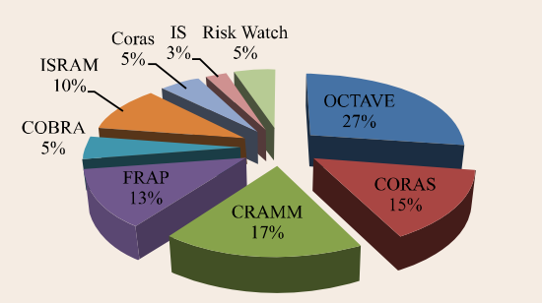
Fig. 4.1. Statistics on the use of IB risk analysis methods in 2015

4.2. Determination of the method of risk analysis in the context of the constructed cyber security landfill

Referring to the third section, which describes and builds a GNS3-based cyber security probe, we can conclude that testing and evaluating a secure network should be considered in the context of testing the performance, the impact of the settings on the security level of the AS as a whole, and in the context of the tools used. protection of information. This is due to the fact that in this case, the focus is on the technical part, with little regard for organizational measures related to the protection of information in the AU. Considering that the emphasis is placed on the hardware and network level of information security, it is not advisable to assess the security of the network with mixed (complex) methods.
Based on the fact that as set out above quantitative methods in carrying out risk analysis at the software-technical level of protection, and if you do not take into account the organizational and technical component, have greater efficiency, then the quantitative methodology should be chosen.
Among the major quantitative methods for analyzing the information risks of RiskWatch, Digital Security, ISRAM and iRisk, the advantages and disadvantages of which are described above, the iRisk method is more appropriate. This can be explained primarily by the fact that this methodology is free of charge, sufficiently informative, includes another CVSS v3 methodology for vulnerability assessment, which is actively supported by the National Institute of Standards and Technologies and contains up-to-date information on critical vulnerabilities of software and hardware, which in turn, it allows for an effective assessment of the security level of the network. IRisk SecureState Equation (4.2)
contains 25 different discrete data points that can be summarized to give a security rating.

4.3. Testing cybersecurity information security system by iRisk method

Based on the wounding iRisk = (Vulnerability x Threat) - Controls generalized iRisk risk assessment is calculated taking into account the following parameters: Vulnerability - vulnerability assessment, Threat - threat assessment, Control - assessment of security measures [29].
We first calculate Vulnerability (vulnerability), for which we use the standard CVSS v3 [29]. The calculation is performed according to the scheme shown in Fig. 4.2. A lot of coefficients are used in the calculations, so for convenience, we use the software of the National Institute of Standards and Technologies and just by setting the parameters correctly we will get the result of calculations in the form of a scale from 1 to 10, where 1 corresponds to the lowest level, ie no vulnerability, and the value 10 corresponds to the critical a vulnerability that needs to be addressed immediately.
The standard includes three sets of metrics needed to calculate, basic, time, and contextual.
Basic metrics describe vulnerability characteristics that do not change over time and are independent of the runtime. These metrics describe the complexity of exploiting vulnerabilities and the potential loss of privacy, integrity, and accessibility.
Time metrics make an overall assessment of the completeness of the vulnerability information.
Contextual metrics security experts can make the resulting assessment of the information environment amendment.
It is customary to publish the metric value as a pair of vectors (specific values ​​of individual indicators) and a numerical value calculated on the basis of all indicators and using the formula defined in the standard. In Fig. 4.2 shows all the necessary parameters for calculating the contextual metric of a cyber security site.
Attack vector is the degree of distance of a potential attacker from the attack object. In the case of a cyber security site, we consider the case when the attack is carried out from the network. Local when the attacker needs a local session or is an authorized user, and Physical when physical access to the subsystem is required.
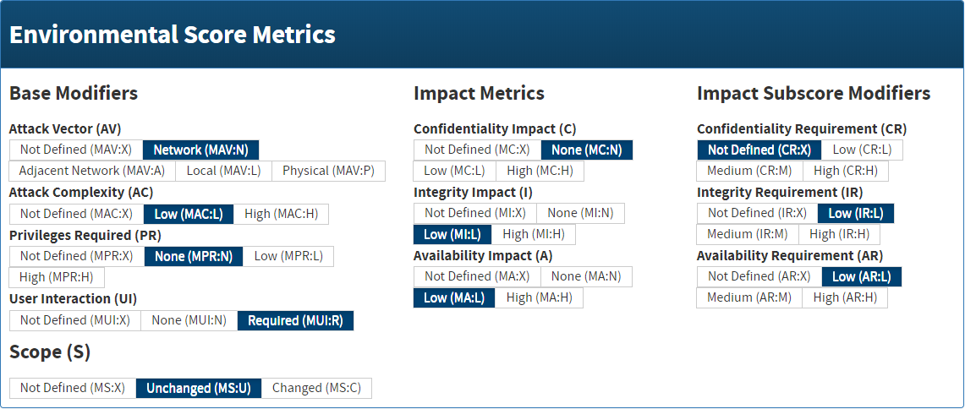
Fig. 4.2. Contextual metric of a cybersecurity site
Access Complexity is a qualitative assessment of the complexity of an attack. It is interpreted from the subjective point of view of the expert. For example, implementing a counterfeit SSL certificate by attacking a Microsoft Outlook application certificate is rated High and Amazon medium for the web application.
Authentication means whether it is needed at all and is based on how many independent authentication processes an attacker needs to take to exploit the vulnerability.
User Interaction (UI) means whether any action to the user is necessary for the attack to succeed.
Scope limits whether the exploitation of a vulnerability violates the privacy, integrity or accessibility of another component of the system.
The interaction metrics Сonfidentiality Impact (C), Integrity Impact (I), Availability Impact (A) evaluate the degree of impact on the confidentiality, integrity and accessibility of the attackable component.
Time metrics mean whether the vulnerability and the means described can be described publicly or whether there is only a theoretical possibility of exploitation.
Contextual metrics allow Confidentiality Requirement (CR), Integrity Requirement (IR), Availability Requirement (AR) to declare which data characteristic of the attacked object has the greatest impact on the functionality of the system.
Threat Assessment
According to this standard, a threat is interpreted as a negative event that can occur as a result of taking advantage of the vulnerability. In order to make the equation as simple and straightforward as possible, the iRisk technique focuses on two main components: impact and probability.
Impact is the amount of damage that this incident will bring to an organization. The iRisk SecureState equation currently uses the following criteria to determine impact. By default, the following values ​​are specified, but can be modified to meet the needs of the object being evaluated.
- Financial (25) - Can threats disrupt an organization's financial flows
- Strategic (15) - Can threats lead to long-term strategic losses
- Operation (25) - whether there will be threats to the continuity of work
- Legal Compliance (25) - Can Threats Affect Standards Ability
- Reputation (10) can affect customer relationships
Another major component of the threat is probability. Two factors are taken into account in assessing the likelihood of iRisk, the annual expected number of threat implementations and the level of knowledge, and the access required by the attacker.

Table 4.3
Correlation table between level of knowledge / access and annual number of threats implemented (ARO)
 | Annual expected number of threat implementations
Level of knowledge / access | Very often  (1.0 - 0.81) | Often  (0.8 - 0.51) | Not often  (0.5 - 0.21) | Rarely  (0.0 - 0.2)
Outside, no technical skills (1.0) | 1.0 - 0.81 | 0.8 - 0.51 | 0.5 - 0.21 | 0.0 - 0.2
Outside, Some Technical Skills (0.9) | 0.9 - 0.729 | 0.72 - 0.459 | 0.45 - 0.189 | 0.0 - 0.18
Insider, Normal User (0.8) | 0.9 - 0.729 | 0.72 - 0.459 | 0.45 - 0.189 | 0.0 - 0.18
Outside, Advanced Technical Skills (1.0) | 0.8 - 0.648 | 0.64 -0.408 | 0.4 - 0.168 | 0.0 - 0.16
Outside, Esperanto (0.7) | 0.7 - 0.567 | 0.56 -0.357 | 0.35 - 0.147 | 0.0 - 0.14
Outside, Hacking Esperanto (0.6) | 0.6 - 0.486 | 0.48 -0.306 | 0.3 - 0.126 | 0.0 - 0.12
State Sponsored (0.5) | 0.5 - 0.405 | 0.4 - 0.255 | 0.25 - 0.105 | 0.0 - 0.1
Insider, Privileged Access (0.5) | 0.5 - 0.405 | 0.4 - 0.255 | 0.25 - 0.105 | 0.0 - 0.1
Insider, Administrator (0.2) | 0.2 - 0.162 | 0.16 -0.102 | 0.1 - 0.042 | 0.0 - .04
Insider hacking expert (0.1) | 0.1 - 0.081 | 0.08 -0.051 | 0.05 - 0.021 | 0.0 - 0.02

The threat is calculated using the formula 4.3, where Likelihood (probability) is the correlation of Table 4.3. If the threat is on a scale of 100 to 50 - the risk level is high, 50 to 10 - the average is 1 to 10 - low.
$Threat = Impact*Likelihood$ (4.3)
The structure of the Control parameter (evaluation of security measures) is presented in Figure 4.4. Based on the ISACA iRisk organization's definition of security, preventive, detection, correction or containment tools can be applied.
According to the standard measures have the following ratings preventive - 5, detection - 4, corrections - 3, deterrence - 3.
The next step is to determine Controls (efficiency), according to the standard, it has a five-point scale, the score is 5 if the information security in the network exceeds the target significantly, 4 - exceeds the target, 3 - the implementation meets the goal, 2 - the implementation does not completely satisfies the purpose, 1 - slightly meets the purpose.
Completing the CMMI metrics we get the following values:
- Optimized (801 - 1000) - The tool cannot be designed or implemented better
- Managed (601 - 800) - Continues to improve
- Defined (401 - 600) - Defenses are clearly defined and reduce risk to moderate
- Initial / Ad-Hoc (1 - 200) - Provides only some security value
The three main components that appear in the iRisk method balance each other. The highest possible threat score is 100, which is multiplied by the maximum vulnerability (10). That is, potentially 1000 points, offset by potentially perfectly implemented protection, will ultimately leave zero risk. In practice, this may not be achievable and in any case remains some of the residual risk. That is, the risk varies from 0 to 1000, in this case the less value we get, the more secure the AU is.
The built-in cybersecurity probe has not many vulnerabilities, due to high-quality equipment, delimitation that divides the network into demilitarized zones, internal and external networks, as well as network settings through which, with limited access to the outside, limited number of half-connections, resulting in reduced DdoS attacks, network scanning capabilities, and more. However, there remain vulnerabilities at the hardware and software level. Next, we will look at some of them, the calculation of the security of the cyber security landfill will be done by the iRisk method.

4.3.1 Cisco IOS Arbitrary Command Execution Vulnerability Vulnerability (CVE-2012-0384).
A vulnerability of Cisco network equipment that can be exploited by an intruder within the network if it is authorized as a user. The vulnerability arises because of an error in the implementation of HTTP / HTTPS AAA authorization (user profile) AAA that allows the authenticated user to execute any arbitrary Cisco IOS software commands configured for the user privilege level [29].
Since iRisk = (Vulnerability x Threat) - Controls, to calculate Vulnerability we calculate the basic metric, for the sake of correctness, we adjust the security of the cyber security landfill and calculate the environment and time metric as described above.
Base Score Metrics {Attack Complexity = Low; Privileges Required = Low; User Interaction = None; Scope = Unchanged; Confidentiality Impact = High; Integrity Impact = High; Availability Impact = High}
Temporal Score Metrics Score Metrics {Exploitability = Functional exploit exist; }
Environmental Score Metrics {Base Modifiers {Attack Vector = Local; Attack Complexity = Low; Privileges Required = Low; User Interaction = None;} {Scope = Unchanged;} {Impact Metrics {Confidentiality Impact = Low; Integrity Impact = Low; Availability Impact = High;}} {Impact Subscore Modifiers {Confidentiality Requirement = Low; Integrity Requirement = Low; Availability Requirement = Low}}}}
The resulting baseline calculation is a 7.8 / 10 difference estimate, which is shown in Fig. 4.6.
Threat = Impact * LikelihoodGiven that the threat should be implemented from the middle and primarily focused on the fact that it is used by the average user without administrative rights, and to estimate the expected number of threats as high, from table 4.3 we choose the correlation value Impact = 0.9. From here, Threat = 0.9 * 100 = 90.
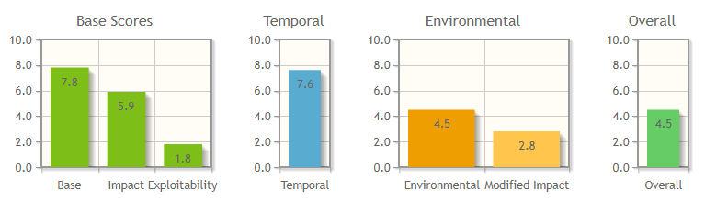
Fig. 4.3. Resulting vulnerability CVE-2012-0384 for cybersecurity site
Judging from the above, the value of Controls is estimated at 650, which means it continues to develop.
That is, the value for Cisco IOS Arbitrary Command Execution Vulnerability (CVE-2012-0384) iRisk = (7.8 * 90) - 650 = 50.

4.3.2. Cisco Access Control Bypass Vulnerability Vulnerability (CVE-2012-1342).
A Cisco router vulnerability that allows remote attacks to bypass the Access Control List (ACL), that is, an access control list that identifies who or what can gain access to the object. The vulnerability allows an unauthenticated remote attacker to bypass the access control list and send the network traffic that should be rejected. Implementation of vulnerability leads to disruption of the integrity of the AS [28].
In the same way as for the CVE-2012-0384 vulnerability, we calculate the iRisk value.
Base Score Metrics {Attack Vector = Network; Attack Complexity = Low; Privileges Required = None; User Interaction = None; Scope = Changed; Confidentiality Impact = None; Integrity Impact = Low; Availability Impact = Impact None}
That when calculating in CVSS v3.0 the calculator gives the value Vulnerability = 5.8.
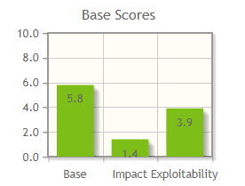
Fig. 4.4. Cisco Access Control Bypass Vulnerability vulnerability benchmark
Value calculation Threat(threats) = 1.4 * 0.72 * 100 = 108, hence iRisk = (5.8 * 108) - 610 = 16.4, which means that the vulnerability will be approximately zero, that is, it can be concluded that the vulnerability can be exploited with a low probability .

4.3.3. EternalBlue vulnerability (CVE-2017-0144).
This vulnerability exploits the Server Message Block v1 (SMB) protocol vulnerability. An attacker, having formed and transmitted to a remote host a specially prepared package, is able to gain remote access to the system and run arbitrary code on it.
Based on this vulnerability, the Wana Decryptor encryption virus was built. The virus affected about 450,000 computers worldwide. Most affected computers were found in Ukraine, Russia and India. Once launched, the malware acts like a classic ransomware: it generates a unique asymmetric RSA-2048 algorithm key for each infected computer. Then WannaCry starts scanning the system for user-defined files of certain types, leaving the critical ones for further operation intact. Each selected file is encrypted with the AES-128-CBC algorithm unique (random) for each key, which in turn is encrypted with the RSA public key of the infected system and stored in the header of the encrypted file. The .wncry extension is appended to each encrypted file. A pair of RSA keys of an infected system is encrypted by an attacker's public key and sent to the control servers located on the Tor network, after which all keys from the infected machine's memory are removed. After completing the encryption process, the program displays a window asking you to transfer a certain amount of Bitcoin (equivalent to $ 300) to the specified wallet within three days. If the redemption does not arrive on time, then its amount will automatically double. On the seventh day, if WannaCry is not removed from the infected system, the encrypted files are destroyed [27]. the program displays a window asking you to transfer a certain amount of Bitcoin (equivalent to $ 300) to the specified wallet within three days. If the redemption does not arrive on time, then its amount will automatically double. On the seventh day, if WannaCry is not removed from the infected system, the encrypted files are destroyed [27]. the program displays a window asking you to transfer a certain amount of Bitcoin (equivalent to $ 300) to the specified wallet within three days. If the redemption does not arrive on time, then its amount will automatically double. On the seventh day, if WannaCry is not removed from the infected system, the encrypted files are destroyed [27].
According to a study by Symantec, the algorithm of tracking the malicious payments of each victim and sending her the key for decryption was implemented in error. This makes the ransom payments meaningless, since the individual keys will not be sent anyway and the files will remain encrypted.
If in the classic scheme, the ransomware was hacked to the computer through the actions of the user via email or web link, then in the case of WannaCry user participation is completely excluded. The minimum length of time between the detection of a vulnerable computer and its full infection is about 3 minutes.
Let's calculate the iRisk value for vulnerability CVE-2017-0144 EternalBlue.
The default EternalBlue vulnerability metric will have the following options. The result is shown in fig. 4.5.
Base Score Metrics {Attack Vector = Network; Attack Complexity = High; Privileges Required = None; User Interaction = None; Scope = Unhanged; Confidentiality Impact = High; Integrity Impact = High; Availability Impact = High}
Since the attack is conducted from the outside and the probability is very high, the attacker must be an expert in hacking, according to the iRisk methodology in this case, Threat = Impact * Likelihood threat value, in this case Impact value = 100, and Likelihood correlation value = 0.7.
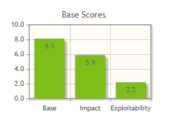
Fig. 4.5. CVE-2017-0144 EternalBlue vulnerability benchmark
From here you can calculate the iRisk value for CVE-2017-0144, without the security patch as of March 14, 2017. iRisk = (8.1 * 70) - 0 = 567

4.3.4 Meltdown Vulnerability (CVE-2017-5754).
The vulnerability exploits the side-effect of out-of-order execution execution out of turn in modern processors. To read kernel data, including personal information and passwords. Running out of turn has a major impact on performance and is included in most modern processors. The attack is independent of the operating system and does not exploit software vulnerabilities. Meltdown essentially breaks down the entire security system based on address space isolation including virtual Meltdown allows you to read some of the memory of other processes and virtual machines.
Instead of waiting for data from external buses with high latency and idle time, the processor starts executing instructions and fills the idle parts of the kernel. These actions greatly speed up the execution time of instructions, but allow the unprivileged process to execute code in turn and load data from the kernel memory into a temporary register. Even more - the processor performs calculations based on the value of this register, for example, it downloads data from an array of data depending on the register value. The processor guarantees the correct execution of the code, however, a side effect is to fill the cache depending on the executable code out of turn. This way the attacker can read all the data using the microarray feature. The KAISER patch eliminates this vulnerability but decreases processor performance [28].
We calculate the iRisk value for the cyber security site, assuming that no KAISER patch is installed.
We calculate the baseline metric for Meltdown vulnerability (CVE-2017-5754), the result of which is reflected in Table. 4.9.
Base Score Metrics {Attack Vector = Local; Attack Complexity = High; Privileges Required = Low; User Interaction = None; Scope = Changed; Confidentiality Impact = High; Integrity Impact = None; Availability Impact = Impact None}
Given that the attacker can act both externally and from the middle and the attack can be carried out often, and the attacker can have just an advanced level of skill, and the attack code is outlined in large numbers of articles, it will give a correlation Impact = 0.9 and Threat (threats ) will be 100 * 0.9 = 90
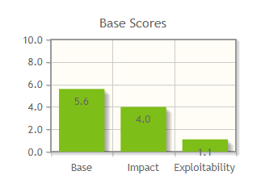
Fig. 4.6. Meltdown Basic Vulnerability Metric (CVE-2017-5754)
The resulting value iRisk for Meltdown (CVE-2017-5754) will be equal to iRisk = 5.6 * 90-0 = 504, as without the KAISER patch, this vulnerability was not detected at all and was embedded in the architecture of most modern processors.

4.3.5. SPECTRE vulnerability (CVE-2017-5753, CVE-2017-5715).
SPECTRE vulnerability, this vulnerability is assigned two IDs CVE-2017-5753, CVE-2017-5715 and in its essence is similar to Meltdown, but with some differences, in particular, that during speculative code execution, the processor can execute instructions that it would not perform subject to strictly sequential (non-speculative) computation, and although subsequently the result of their execution is discarded, its imprint remains in the processor cache and can be used.
The prediction unit works statistically, ie it collects data on similar branching performed at the moment, and on this basis predicts the result of each subsequent branching.
That is, for example, if the code if (a <b), which requires long and tedious loading of a and b, is given a thousand times in a row, it is true, then for the first time it is possible to decide for the first time with great certainty that it will still be true even before of how a and b were loaded from memory and the test actually occurred. Meanwhile, processors make no difference between the processes in which this condition is calculated.
Specter vulnerability does not have direct access to another's memory, in any form, even with speculative execution. Instead, Specter makes sure that the attacking process (this can be both the kernel of the system and another user program) will itself publish information about the contents of its own memory.
A program that exploits a vulnerability creates the most similar construction, and we execute it many times, and each time a fairly calculated condition produces true, the array indexes are absolutely valid. The branch prediction unit thus gathers statistics that say that this construct is always calculated to true, so when you encounter it, you can not wait for the condition to finish calculating, but go to the content immediately.
Then the data is transmitted to the attacker that x suddenly pops up far beyond the array1 array. If there were no speculative execution, the processor would calculate the condition x <array1_size, find it invalid and move on. But the prediction block tells him that x <array1_size will almost certainly be executed, so as long as the value of array1_size is slowly and sadly drawn from memory to really compare another result, the processor starts executing the body of this piece of code [28].
Specter vulnerability is not easy to implement - however, provided an attack on a particular software is known to the attacker and, if possible, available in open source in the same version and on the same system on which the attack is intended, it can be implemented.
Another variant of Specter implementation is "branching" - in the processor there is a similar block of transition prediction, the essence of which is to predict the address at which the next instruction of indirect transition will be made (Meltdown, but here they play a different role).
To simplify the work, this block does not broadcast between virtual and real addresses, and therefore can be trained in the address space of the attacker for certain actions.
That is, if we know that we need instruction in the program being attacked, it is located at 123456, and also in this program is regularly made an indirect transition. The attacker creates a construct that is as similar as possible to the transition in the attacker program, but always makes the transition to 123456. In our address space, of course, absolutely valid and legal transition. What we have at 123456 is irrelevant.
After a while, the conversion prediction unit is absolutely certain that all transitions of this kind lead to the address 123456, so when the attacking program comes to execution during a similar transition, the processor happily starts speculative execution of instructions from the address 123456. Already in the address space of the attacked program [28 ].
After a while, the true transition address will be deducted, the processor detects an error and discards the results of speculative execution, however, as with all other Meltdown and Specter applications, most execution results remain in the cache.
We calculate the iRisk value for the Specter vulnerability. The basic metric is the same in both variants of realization of vulnerabilities, the results of calculation are presented in Fig. 4.7.
Base Score Metrics {Attack Vector = Local; Attack Complexity = High; Privileges Required = Low; User Interaction = None; Scope = Changed; Confidentiality Impact = High; Integrity Impact = None; Availability Impact = Impact None}
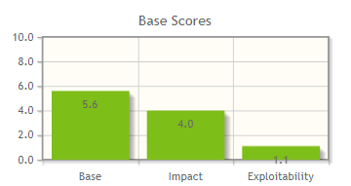
Fig. 4.7. The base vulnerability metric is Specter CVE-2017-5753 and CVE-2017-5715
In both cases, with Specter we are dealing with the fact that the processor learns to execute one process faster on the example of executing another process, thus effectively allowing the second process to control the progress of the first one. There are no Specter universal patches yet, and the CVE-2017-5715 protection is prompted to constantly clear the cache and clean up the kernel code.
We calculate the value of iRisk for CVE-2017-5715, given the complexity of accurate implementation and the impact only on confidentiality of information, so the value Impact = 50, (including financial, reputational and strategic impact), considering that the vulnerability will try to exploit mainly the outside and the attacker should have advanced technical skills, then the correlation value Likelihood = 0.64. These parameters are typical for both CVE-2017-5753 and CVE-2017-5715.
However, the Controls parameters in this case need to be evaluated differently, in particular given that for the CVE-2017-5715 vulnerability patches were released that partially solves this problem only in some cases, the Controls value can be considered Initial / Ad-Hoc = 100 provides only some security value regarding CVE-2017-5753, Controls can be considered 0, as this problem has not been resolved at this time.
Hence for CVE-2017-5715 iRisk = (5.6 * 50 * 0.64) - 100 = 79.2.
For CVE-2017-5753 iRisk = (5.6 * 50 * 0.64) - 0 = 179.2

. Conclusions to the section

This section examines the methods of testing and risk analysis of the AU, identifying the optimal method for testing the information security system based on a cyber security site. First of all, the existing methods of testing and assessing the vulnerabilities of the AU are analyzed to determine their advantages and disadvantages, which consists in quantitative and qualitative assessment of IP protection for the possibility of further comparison of the spent resources and security of the IP. It is concluded that it is not advisable to evaluate the network security with mixed (complex) methods.
The iRisk methodology was chosen for testing, primarily because it is free of charge, sufficiently informative, and includes another CVSS v3 methodology for vulnerability assessment, which is actively supported by the National Institute of Standards and Technology. The calculation is made using the formula iRisk = (Vulnerability x Threat) - Controls.

Tab. 4.4
IRisk table of values ​​for the constructed cyberback box
Vulnerability | The value of iRisk
Cisco IOS Arbitrary Command Execution Vulnerability (CVE-2012-0384) | 50
Cisco Access Control Bypass Vulnerability (CVE-2012-1342) | 16.4
EternalBlue (CVE-2017-0144) | 567
Meltdown (CVE-2017-5754) | 504
Specter (CVE-2017-5715) | 79.2
Specter (CVE-2017-5753) | 179.2

The following OSes have been tested for Cisco IOS Arbitrary Command Execution Vulnerability (CVE-2012-0384), Cisco Access Control Bypass Vulnerability (CVE-2012-1342), EternalBlue (CVE-2017-0144), Meltdown (CVE-2017-5754) , Specter (CVE-2017-5753) (CVE-2017-5715), the conclusions about the robustness of the built network to specific threats by the iRisk method, where values ​​are ranged from 0 to 1000 and zero corresponds to the AU in which this vulnerability can be neglected, then as with the largest value, if it exceeds 100 it is necessary to solve this vulnerability. The higher the iRisk value, the more critical the vulnerability is and the higher the priority for protecting the AU. The results of the calculations are given in (Table 4.4).

CONCLUSIONS

The thesis analyzed the legal framework in the field of information resources protection in information and telecommunication systems. In particular, the following normative documents were analyzed: Law of Ukraine "On Information", Law of Ukraine "On Protection of Information in Information and Telecommunication Systems", ND TZI 1.1-002-99 "General Provisions for Protection of Information in Computer Systems from Unauthorized Access" regulatory documents. According to the normative documents, it can be concluded that the current domestic regulatory framework is more satisfying to the needs of the time, but as in most countries of the world there is a need for its further improvement of state regulation in the field of technical protection of information and ensuring information security in information and telecommunication systems.
In the course of this work, the possibility of constructing a virtual cyber security landfill on different platforms - virtual network emulators was analyzed, conclusions were drawn for each of the emulators based on the advantages and disadvantages of each. GNS3 was selected to build a virtual cyber security landfill based on the virtual network emulator, despite some disadvantages, such as the lack of multi-user support and the limited availability of neglected QEMU network connections. In all other respects, this emulator is ideally suited to implement on its basis a full-fledged virtual network, configure it for any needs and perform full testing, except for the use of wireless networks and devices that are not emulated at any of the platforms.
The topology of the cyber security polygon was developed and implemented on the basis of GNS3 application software. The computer network topology consists of a Cisco ASA 5520 firewall that divides the company network into a demilitarized zone, an internal and an external network. Cisco 3745 router configures routing between employee networks and management and remotely connects to secure SSH protocol version 2. In the demilitarized zone, a Web server is set up that can be accessed from an external network (Cisco ASA automatically transmits packets to it via 80 port to the server) and from the internal network. Also configured is an FTP server that can only be accessed from the internal network. Cisco ASA has set up static NAT to access a local server from the Internet, as well as the lack of access to the internal network from the outside and the graphical interface of Cisco ASDM firewall control. Network settings checked.
To test the built-in cybersecurity site, the network and ports of the network devices were scanned from the outside using the Zenmap utility as a result of ASA and NAT settings, the scan gave nothing but the found IP address of the external ASA interface, and the scan from the inside, which resulted in information being collected internal network.
Hping3 utility implemented a network stress test - Syn-Flood server denial-of-service attack, based on an attempt to initialize a large number of concurrent TCP connections by sending a SYN packet with a non-existent return address. The counteraction to this attack was implemented.
The methods of testing and analysis of the risks of the AU were considered, the optimal method for testing the information security system based on the cyber security polygon was determined. First of all, the existing methods of testing and assessing the vulnerabilities of the AU are analyzed to determine their advantages and disadvantages, which consists in quantitative and qualitative assessment of IP protection for the possibility of further comparison of the spent resources and security of the IP. It is concluded that it is not advisable to evaluate the network security with mixed (complex) methods.
The iRisk methodology was chosen for testing, primarily because it is free of charge, sufficiently informative, and includes another CVSS v3 methodology for vulnerability assessment, which is actively supported by the National Institute of Standards and Technology. The following OSes have been tested for Cisco IOS Arbitrary Command Execution Vulnerability (CVE-2012-0384), Cisco Access Control Bypass Vulnerability (CVE-2012-1342), EternalBlue (CVE-2017-0144), Meltdown (CVE-2017-5754) , Specter (CVE-2017-5753) (CVE-2017-5715), the conclusions about the robustness of the built network to specific threats by the iRisk method, where values ​​are ranged from 0 to 1000 and zero corresponds to the AU in which this vulnerability can be neglected, then as with the largest value, if it exceeds 100 it is necessary to solve this vulnerability. The higher the iRisk value, the more critical the vulnerability is and the higher the priority for protecting the AU. The results of the calculations are given in (Table 4.4). The most critical is the EternalBlue vulnerability, unless a security patch is installed, based on that vulnerability, viruses such as WCry, WCrypt, WannaCrypt, WNCRY, and WanaCrypt0r 2.0 are built.

REFERENCES

- The official GNS3 Documentation [Електронний ресурс] – Режим доступу : https://www.gns3.com/support/docs
- Dynamips / Dynagen Tutorial [Електронний ресурс] – Режим доступу : http://www.iteasypass.com/Dynamips.htm
- Лекція 1: Курс UnetLab. Введение [Електронний ресурс] // Ольков Евгений – Режим доступу : http://blog.netskills.ru/2016/03/1-unetlab.html
- UNetLab. Добавление образов Cisco IOU/IOL [Електронний ресурс] – Режим доступу : http://it-blackbox.blogspot.com/2016/01/unetlab-cisco-iouiol.html
- Корниенко Б.Я. Информационная безопасность и технологии компьютерных сетей: монография / Б.Я. Корниенко // ISBN 978-3-330-02028-3, LAMBERT Academic Publishing, Saarbrucken, Deutschland. − 2016. – 102 с.
- Azure Stream Analytics [Електронний ресурс]: Режим доступу: https://azure.microsoft.com/ru-ru/services/stream-analytics/
- Google Cloud IoT [Електронний ресурс]: Режим доступу: https://cloud.google.com/solutions/iot/
- AWS IoT SDKs [Електронний ресурс]: Режим доступу: https://docs.aws.amazon.com/iot/latest/developerguide/iot-sdks.html
- ThingWorx Industrial IoT Platform [Електронний ресурс]: Режим доступу: https://developer.thingworx.com/platform
- Bosch IoT Gateway [Електронний ресурс]: Режим доступу: https://developer.bosch-iot-suite.com/service/gateway-software/
- Корниенко Б.Я. Кибернетическая безопасность – операционные системы и протоколы / Б.Я. Корниенко // ISBN 978-3-330-08397-4, LAMBERT Academic Publishing, Saarbrucken, Deutschland. − 2017. – 122 с.
- Корнієнко Б.Я. Дослідження моделі взаємодії відкритих систем з погляду інформаційної безпеки /Б.Я. Корнієнко//Наукоємні технології. – 2012, № 3 (15), С. 83 – 89, doi.org/10.18372/2310-5461.15.5120 (ukr).
- Korniyenko B.Y. Open systems interconnection model investigation from the viewpoint of information security /B. Korniyenko, O. Yudin, E. Novizkij//The Advanced Science Journal. – 2013. - issue 8. - P. 53 – 56.
- Bluetooth Broadcasting [Електронний ресурс]: Режим доступу: https://www.c-sharpcorner.com/UploadFile/2cb323/bluetooth-broadcasting/
- Корнієнко Б.Я. Реалізація інформаційної безпеки у моделі взаємодії відкритих систем/Юдін О.К., Корнієнко Б.Я./Збірник тез VI Міжнародної науково-технічної конференції «Комп’ютерні системи та мережні технології» (CSNT-2013), 11-13 червня 2013 р., - С.73.
- ZigBee [Електронний ресурс]: Режим доступу: http://www.rovdo.com/zigbee
- Корнієнко Б.Я. Інформаційні технології оптимального управління виробництвом мінеральних добрив : монографія / Б.Я. Корнієнко. – К.: Вид-во Аграр Медіа Груп, 2014. – 288 с.
- Korniyenko B.Y. Design and research of mathematical model for information security system in computer network / B.Y. Korniyenko, L.P. Galata // Науковий журнал «Наукоємні технології». – 2017, № 2 (34), С. 114 - 118.
- Korniyenko B. Modeling of security and risk assessment in information and communication system /B. Korniyenko, L. Galata, O. Kozuberda/ Sciences of Europe. – 2016. – V. 2. – No 2 (2). – P. 61 -63.
- Korniyenko B. The classification of information technologies and control systems / B. Korniyenko // International scientific journal. – 2016. –№ 2. – P. 78 - 81.
- Korniyenko B. Risk estimation of information system / B. Korniyenko, A. Yudin, L. Galata// Wschodnioeuropejskie Czasopismo Naukowe. – 2016. –№ 5. – P. 35 - 40.
- Корнієнко Б.Я. Безпека аутентифікації у web-ресурсах / Б.Я. Корнієнко, О.К. Юдін, О.С. Снігур / Науково-практичний журнал «Захист інформації». – 2012. - № 1 (54). - С. 20 -25, doi.org/10.18372/2410-7840.14.2056 (ukr).
- PostgreSQL vs. MySQL [Електронний ресурс]: Режим доступу: http://www.postgresqltutorial.com/postgresql-vs-mysql/
- Redis vs. MongoDB [Електронний ресурс]: Режим доступу: https://scalegrid.io/blog/comparing-in-memory-databases-redis-vs-mongodb-percona-memory-engine/
- Корнієнко Б.Я. Прикладні програми управління інформаційними ризиками / Б.Я. Корнієнко, Ю.О. Максімов, Н.М. Марутовська / Науково-практичний журнал «Захист інформації». – 2012. - № 4 (57). - С. 60 – 64, doi.org/10.18372/2410-7840.14.3493 (ukr).
- Korniyenko B. Security Estimation of the Simulation Polygon for the Protection of Critical Information Resources / B. Korniyenko, L. Galata, L. Ladieva //CEUR Workshop Proceedings, Selected Papers of the XVIII International Scientific and Practical Conference "Information Technologies and Security" (ITS 2018) Kyiv, Ukraine, November 27, 2018, Vol-2318, - P. 176-187, urn:nbn:de:0074-2318-4
- Корнієнко Б.Я. Дослідження імітаційного полігону захисту критичних інформаційних ресурсів методом IRISK / Б.Я. Корнієнко, Л.П. Галата // Моделювання та інформаційні технології. – 2018. – Вип. 83. – С. 34-41.
- Корнієнко Б.Я. Побудова та тестування імітаційного полігону захисту критичних інформаційних ресурсів / Б.Я. Корнієнко, Л.П. Галата // Науковий журнал «Наукоємні технології». – 2017, № 4 (36), С. 316 - 322.
- Корнієнко Б.Я. Інформаційні технології оптимального управління виробництвом мінеральних добрив :монографія / Б.Я. Корнієнко. – К.: Вид-во Аграр Медіа Груп, 2014. – 288 с.

