Міністерство освіти і науки України
Національний технічний університет України
«Київський політехнічний інститут
імені ІГОРЯ СІКОРСЬКОГО»

Оlena Mulyk
Lesia Repeta

CALCULUS: part І
DIFFERENTIAL CALCULUS OF FUNCTION OF ONE VARIABLE

Tutorial

Recommended by the Methodical Council of the Igor Sikorsky KPI
as a Tutorial for bachelors
according to the educational program «Medical Engineering»
Branch of knowledge 163 Biomedical Engineering

Electronic online educational publication

Київ
КПІ ім. Ігоря Сікорського
2022
Reviewer Олешко Тетяна Анатоліївна, к ф-м.н, доцент каф. прикладної математики ФККПІ Національного авіаційного університету;
Стогній Валерій Іванович, к.ф-м.н, доцент каф. КМФ та ДР, ФМФ НТУУ «КПІ» ім. Ігоря Сікорського;
Editor-in-Chief Коновалова Наталія Романівна, к ф-м.н, доцент каф. Математичного
аналізу та теорії ймовірностей ФМФ

Гриф надано Методичною радою КПІ ім. Ігоря Сікорського
(протокол № 6 від 24.06.2022 р.)
за поданням Вченої ради факультету/навчально-наукового інституту
(протокол № 3 від 16.06.2022 р.)

The tutorial outlines the main topics of the course of differential calculus of a function of one variable. The main focus is on the methods and theorems needed for further study of the course "Higher Mathematics". Many solved examples are given and tasks for independent solution are offered. The tutorial is designed for bachelors according to the educational program «Medical Engineering». Branch of knowledge 163 Biomedical Engineering.

Реєстр. № НП 21/22‐931. Обсяг авт. арк.
Національний технічний університет України
«Київський політехнічний інститут імені Ігоря Сікорського»
проспект Перемоги, 37, м. Київ, 03056
https://kpi.ua
Свідоцтво про внесення до Державного реєстру видавців, виготовлювачів
і розповсюджувачів видавничої продукції ДК № 5354 від 25.05.2017 р.

© Olena Mulyk, Lesia Repeta.
© КПІ ім. Ігоря Сікорського, 2022
CONTENTS

1. The limit of numerical sequence. | 8
1.1 Definitions of the limit of numerical sequence. | 8
1.2 Limit of the numerical sequence: $\lim_{n→∞}{X_{n}=A}$. | 9
1.3 Important theorems on the sequence limit theorem (existence criterion of limit of numerical sequence). | 14
1.4 Properties of sequences and properties of limits. | 16
1.5 Euler number $e$. | 17
2. The limit of the function. | 21
2.1 The formal definition of the limit. | 21
2.2 Properties of the limit of function. | 22
2.3 Calculation of function limits. | 22
3. Basic theorems of limits of the function. | 27
3.1 Theorems comparisons and substitution. | 27
3.2 The first important limit. | 28
3.3 The second important limit. | 30
3.4 Comparison of infinitesimal functions. | 33
4. Continuous functions. | 36
4.1 Definition of continuous functions at the point. | 36
4.2 Types of discontinuities. | 37
4.3 Properties of continuous functions. | 40
5. The derivative. | 45
5.1 The definition of the derivative. | 45
5.2 The existence of a derivative. | 45
5.3 Geometric meaning of the derivative. | 46
5.4 Finding derivative functions. | 47
5.5 Implicit differentiation. | 54
5.6 Logarithmic differentiation. | 57
5.7 Parametric differentiation. | 61
6. The differential. | 64
6.1 The first order differential. | 64
6.2 Differentials of higer orders. | 67
7. Higher order derivatives. | 70
7.1 Higher order derivatives of explisit functions. | 70
7.2 Leibnitz's formula. | 71
7.3 Higher order parametric differentiation. | 73
8. Basic theorems of the differential calculus. | 78
8.1 Intermediate value theorem and the extreme value theorem. | 78
8.2 Rolle’s theorem. | 78
8.3 Lagrange`s theorem (mean value theorem). | 79
8.4 Cauchy theorem. | 81
8.5 L’hopital’s theorem (L'hôpital's rule). | 81
9. The taylor and the maclaurin formulas. | 87
9.1 The Taylor` s polynomial and remainder term. | 87
9.2 The Taylor` s polynomial and remainder term. | 89
9.3 Table of important maclaurin formula for reference. | 90
10. Investigation of functions using derivatives. | 94
10.1 Increasing and decreasing functions. | 94
10.2 Extrema and the first derivative test. | 96
10.3 Absolute extrema. | 100
11. The second derivative for investigation of functions. | 103
11. 1 The second derivative test for a local maximum or minimum. | 103
11.2 The second-derivative test for concavity. | 104
11.3 Inflection points. | 106
12. Asymptote. | 109
13. Graphing a function. | 113
REFERENCES | 117

PREFACE
In the original work presents educational problems with important definitions and theorems for successful study of the 1st year "Higher Mathematics" for the first semester of study. Content of work corresponds to the curricula of higher mathematics of all technical specialties of NTUU "KPI" full-time and part-time forms of education and contains the following sections of the discipline "Higher Mathematics":
- limit of the function, continuity;
- differential calculus of functions of one variable;
The purpose of the abstract is:
- systematic presentation of theoretical material, which frees the lecturer from "dictation" and allows more explanation;
- effective preparation of the student for the colloquium and exam;
- selection of corner questions of mathematical analysis.
The proposed synopsis accompanies, but does not replace the live lecture, just as the text of a dramatic work does not replace the performance.
Consideration begins with the property of a numerical sequence and its limit, which allows you to easily go to the definition of the limit of the function. Limit is a fundamental concept in calculus. It is used when we consider differentiation (to define derivatives) and integration (to define definite integrals). There are many types of limits. Students should notice that their definitions are similar. To help students understand such similarities and to emphasize the differences, there were a lot of examples given.
The section of continuous functions is rather conceptual. Students should understand the difference between types of discontinuity of functions that help to draw graphs correctly.
The definition of the derivative and the ways of its finding for the function given explicitly, implicitly and parametrically are considered in detail. Geometric content of the first derivative and examples are given.
More specifically were discussed, derivatives of higher orders and application of derivatives for research of functions and construction of their schedules and which being their result.
At the end of each section (except the few), there is an exercise. Students are advised to do as many problems as possible. Most of the exercises are simple drills. Such exercises may not help students understand the concepts; however, without practices, students may find it difficult to continue reading the subsequent sections. It is also convenient to calculate the rating for teachers and students.
1. THE LIMIT OF NUMERICAL SEQUENCE
1.1 Definitions of the limit of numerical sequence
Definition: The numerical sequence ${\left\{X_{n}\right\}}_{n∈N}$ (NS) is considered to be given if the number $n$ corresponding to this number ( $X_{n}$) can be specified for any number $n$, $n∈N$.
${X_{1},X_{2},⋯X}_{n}$ members of sequence, $X_{n}$ - common member of the numerical sequence ${\left\{X_{n}\right\}}_{n∈N}$. If $n⟶∞⇒ {\left\{X_{n}\right\}}^{∞}.$

EXAMPLE 1. ${\left\{n^{2}\right\}}^{∞}⟶X_{1}=1, X_{2}=4, X_{3}=9⋯X_{10}=100⋯$
The numerical sequence:
- constant: $1,1,1⋯1,⋯$
- fluctuate: ${(-1)}^{n}.$
- increasing: if $∀ n_{1}, n_{2} ∈N, n_{1}<n_{2}$, $X_{1}<X_{2}$. For example: ${\left\{\frac{n+1}{4}\right\}}^{∞}$.
- decreasing: if $∀ n_{1}, n_{2} ∈N, n_{1}<n_{2}$, $X_{1}>X_{2}$. For example: ${\left\{\frac{2n+1}{3n^{2}+4}\right\}}^{∞}$.
- bounded: if $∃ M>0, ∀n∈N, \left|X_{n}\right|≤M$. For example: ${\left\{\frac{{\left(-1\right)}^{n}}{n}\right\}}^{∞}→$
$∃ M=2: \left|\frac{{\left(-1\right)}^{n+1}}{n}\right|<2,$ $∃ M=1: \left|\frac{{\left(-1\right)}^{n+1}}{n}\right|≤1.$

Here is a graph of a sequence which converges to 0:

Figure.1 Example of the sequence which converges to $0$.

Next picture (Figure2.) is a graph of a sequence which converges to $4$. Some of the terms equal $4$, some terms are above $4$ and some are below. But from the $8-$ th term onwards, all of the terms are between the dashed lines. The distance between the dashed lines is $2ℇ$, this positive value will be used to define the boundary of the sequence.

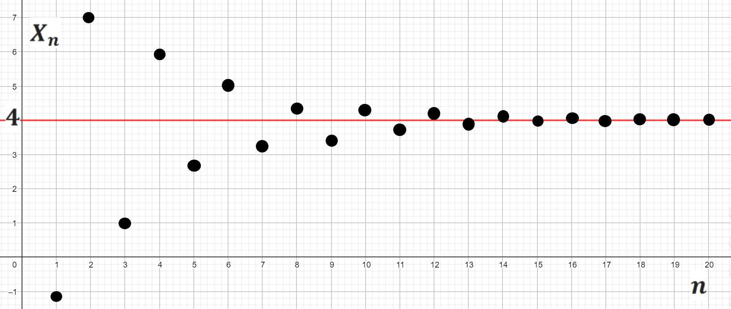
Figure2. Example of the sequence which converges to $4$.

1.2 LIMIT OF THE NUMERICAL SEQUENCE: $\lim_{n→∞}{X_{n}=A}$
The number $A$ is the limit of the numerical sequence ${\left\{X_{n}\right\}}_{n∈N}$ if for all positive $ℇ$ there is a number $N(ℇ)$, dependent on $ℇ$, such that for all $n$, greater than $N(ℇ)$, all members of the sequence ${\left\{X_{n}\right\}}_{n∈N}$ belong to $ℇ-$ around ($ℇ$ -neighborhood) the number $A$:
$$∀ℇ>0 ∃ N=N\left(ℇ\right): ∀n>N\left(ℇ\right): \left|X_{n}-A\right|<ℇ.$$
Definition: A sequence of real numbers,${\left\{X_{n}\right\}}_{n∈N}$, converges to a real number,$A$, if and only if, for each $ℇ>0$, there exists a natural number$N\left(ℇ\right)$, such that, for all
$n>N\left(ℇ\right)$, $\left|X_{n}-A\right|<ℇ$. When ${\left\{X_{n}\right\}}_{n∈N}$ converges to $A$ we write: $\lim_{n→∞}{X_{n}=A}$.
Neighborhood of number $A$: $\left|X_{n}-A\right|<ℇ ⇒-ℇ+A<X_{n}<ℇ+A$ is shown on the Figure 3.

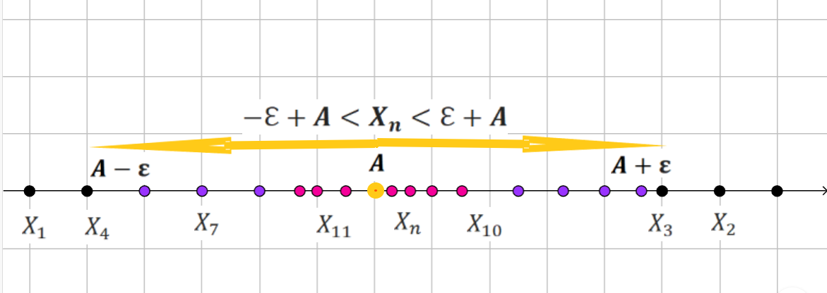
Figure 3. Example of the sequence which converges to the number $A$.
$ℇ-$ around ($ℇ$ -neighborhood of point A) the number $A$.

EXAMPLE 2: Show that $\lim_{n→∞}{\frac{n+1}{4n-3}}=\frac{1}{4}$.
SOLUTION: We have $X_{n}=\frac{n+1}{4n-3}$, $A=\frac{1}{4}$ $\underset{⇒}{def}\left|\frac{n+1}{4n-3}-\frac{1}{4}\right|<ℇ⇒\left|\frac{4n+4-4n+3}{4(4n-3)}\right|<ℇ⇒\left|\frac{7}{4(4n-3)}\right|<ℇ$ $n∈N⇒\frac{7}{4\left(4n-3\right)}<ℇ⇒n>\frac{7}{16ℇ}+\frac{3}{4}$ if take $ℇ=0,1⇒$
$$⇒n>\frac{7}{16∙0,1}+\frac{3}{4};n>5,1, n≥6.$$
If take $ℇ=0,01⇒n>\frac{7}{16∙0,01}+\frac{3}{4};n>44,5, ⇒n≥45$.
The inverse dependence of the number $n$ on the given $ε$.
EXAMPLE 3: Show: $\lim_{n→∞}\left(\sqrt{n+1}-\sqrt{n}\right)=0.$
SOLUTION: We use the identity $A-B=\frac{A^{2}-B^{2}}{A+B}$ which tells us that:
$$\left|\sqrt{n+1}-\sqrt{n}\right|=\frac{1}{\sqrt{n+1}+\sqrt{n}}<\frac{1}{2\sqrt{n}};$$
Given $ℇ>0$, $\frac{1}{2\sqrt{n}}<ℇ$ if ${\frac{1}{4n^{2}}<ℇ}^{2}$ i.e. $n>\frac{1}{4ℇ^{2}}$.

Definition: A numerical sequence that has a limit of zero is called an infinitely small sequence: $\lim_{n→∞}{α_{n}=0}$.
If ${\left\{α_{n}\right\}}_{n∈N}$ is infinitely small sequence, then:
$∀ℇ>0 ∃ N=N\left(ℇ\right): ∀n>N\left(ℇ\right): \left|α_{n}\right|<ℇ.$ ${\left\{α_{n}\right\}}^{∞}→0, n→∞$.
A numerical sequence ${\left\{X_{n}\right\}}_{n∈N}$ that has finite limit called converging sequence.
If the sequence has an infinite limit or the limit does not exist, the sequence is called a divergent.

How to use an infinitesimal sequence of the form ${\left\{\frac{A}{n^{α}}\right\}}_{n∈N}$?
The main rules are: $\left[\begin{matrix}\lim_{n→∞}\frac{A}{n^{α}}=0, \\ \lim_{n→∞}\frac{n^{α}}{A}=∞, \\ \lim_{n→∞}\frac{An^{α}}{Bn^{α}}=\frac{A}{B},\end{matrix}\right.A, α,β∈R$.

EXAMPLE 3: Find a limit: $\lim_{n→∞}\frac{{5n}^{3}+{2n}^{2}-3n+4}{n^{3}+{5n}^{2}+7n}$.
SOLUTION: The ratio of polynomials gives the uncertainty $\left(\frac{∞}{∞}\right)$. First you need to make algebraic transformations, then use the rule $\lim_{n→∞}\frac{An^{α}}{Bn^{α}}=\frac{A}{B}$:
$\lim_{n→∞}\frac{{5n}^{3}+{2n}^{2}-3n+4}{n^{3}+{5n}^{2}+7n}\left(\frac{∞}{∞}\right)=\lim_{n→∞}\frac{n^{3}(5+\frac{{2n}^{2}}{n^{3}}-\frac{3n}{n^{3}}+\frac{4}{n^{3}})}{n^{3}(1+\frac{{5n}^{2}}{n^{3}}+\frac{7n}{n^{3}})}\left(\begin{matrix}\frac{{2n}^{2}}{n^{3}}=\frac{2}{n}→0 \\ \frac{3n}{n^{3}}=\frac{3}{n^{2}}→0 \\ \frac{4}{n^{3}}→0\end{matrix}\right)=5$.
EXAMPLE 4. Find a limit: $\lim_{n→∞}\frac{{3n}^{3}+{2n}^{2}-3n+4}{{4n}^{2}+7n-3}$.
SOLUTION: The ratio of polynomials gives the uncertainty $\left(\frac{∞}{∞}\right)$. First you need to make algebraic transformations, then use the rule $\lim_{n→∞}\frac{n^{α}}{A}=∞$:
$\lim_{n→∞}\frac{{3n}^{3}+{2n}^{2}-3n+4}{{4n}^{2}+7n-3}\left(\frac{∞}{∞}\right)=\lim_{n→∞}\frac{n^{3}(5+\frac{{2n}^{2}}{n^{3}}-\frac{3n}{n^{3}}+\frac{4}{n^{3}})}{n^{2}(4+\frac{7n}{n^{2}}-\frac{3}{n^{2}})}=\left(\begin{matrix}\frac{{2n}^{2}}{n^{3}}=\frac{2}{n}→0 \\ \frac{3n}{n^{3}}=\frac{3}{n^{2}}→0 \\ \frac{4}{n^{3}}→0\end{matrix}\right)=$
$\underset{n→∞}{=lim}\frac{{5n}^{3}}{{4n}^{2}}=\lim_{n→∞}\frac{5n}{4}=+∞$.
EXAMPLE 5: Find a limit: $\lim_{n→∞}\frac{{5n}^{4}+{2n}^{3}-{5n}^{2}-3n+4}{{7n}^{5}+{5n}^{3}+7n-10}$.
SOLUTION: The ratio of polynomials gives the uncertainty $\left(\frac{∞}{∞}\right)$. First you need to make algebraic transformations, and then use the rule $\lim_{n→∞}\frac{A}{n^{α}}=0$:
$\lim_{n→∞}\frac{{5n}^{4}+{2n}^{3}-{5n}^{2}-3n+4}{{7n}^{5}+{5n}^{3}+7n-10}\left(\frac{∞}{∞}\right)=\lim_{n→∞}\frac{n^{4}(5+\frac{{2n}^{3}}{n^{4}}-\frac{{5n}^{2}}{n^{4}}-\frac{3n}{n^{4}}+\frac{4}{n^{4}})}{n^{5}(7+\frac{{5n}^{3}}{n^{5}}+\frac{7n}{n^{5}}-\frac{10}{n^{5}})}\underset{n→∞}{=lim}\frac{{5n}^{4}}{{7n}^{5}}=\lim_{n→∞}\frac{5n}{4}=0$.
EXAMPL 6: Find a limit: $\lim_{n→∞}(\frac{2}{n+3}+\frac{3}{n+4})$;
SOLUTION: Subtraction of polynomials same power gives uncertainty$\left(∞-∞\right)$. First you need to make algebraic transformations, then use the rule $\lim_{n→∞}\frac{A}{n^{α}}=0$: $\lim_{n→∞}\left(\frac{2}{n+3}+\frac{3}{n+4}\right)=\left(∞-∞\right)=\lim_{n→∞}\frac{2\left(n+4\right)+3(n+3)}{(n+3)(n+4)}\underset{n→∞}{=lim}\frac{5n+17}{n^{2}+7n+12}=$
$=\lim_{n→∞}\frac{n(5+\frac{17}{n})}{n^{2}(1+\frac{7}{n}+\frac{12}{n^{2}})}=\lim_{n→∞}\frac{1}{n}=0$.
EXAMPLE 7. Find a limit: $\lim_{n→∞}\frac{\left(2n\right)!-\left(2n+2\right)!}{{\left(2n\right)!(n}^{2}+3n+2)}$.
SOLUTION: The ratio of polynomials gives the uncertainty $\left(\frac{∞}{∞}\right)$. First you need to make algebraic transformations, then use the rule $\lim_{n→∞}\frac{An^{α}}{Bn^{α}}=\frac{A}{B}$:
$\lim_{n→∞}\frac{\left(2n\right)!-\left(2n+2\right)!}{{\left(2n\right)!(n}^{2}+3n+2)}\left(\frac{∞}{∞}\right)=\lim_{n→∞}\frac{\left(2n\right)!(1-(2n+1)\left(2n+2\right))}{\left(2n\right)!}=\lim_{n→∞}\frac{{-4n}^{2}-6n-1}{n^{2}+3n+2}=-4$.

PROBLEM 1. Find a limit:
1. $\lim_{n→∞}\frac{{5n}^{3}-4n-5}{n^{4}-7n}$ | 11. $\lim_{n→∞}\frac{n^{4}-n^{3}-n^{2}-5n+10}{-{2n}^{3}+2n-24}$;
2. $\lim_{n→∞}\frac{{6n}^{2}-4n+9}{{5n}^{2}-15n+6}$; | 12. $\lim_{n→∞}\frac{{2n}^{3}-10n+12}{n^{3}+n^{2}-6n}$;
3. $\lim_{n→∞}\frac{-{2n}^{4}+n-26}{n^{4}+{2n}^{3+}5n-14}$; | 13. $\lim_{x→-∞}\frac{{4n}^{3}-2n^{2}-3n-91}{{3n}^{3}-n^{2}+9n-14}$;
4. $\lim_{n→∞}\frac{n^{2}-n-6}{n^{2}+x-12}$; | 14. $\lim_{n→-∞}\frac{{9n}^{4}+{3n}^{3}-n^{2}+9n-14}{3n^{4}+{2n}^{3}+7n-34}$;
5. $\lim_{n→-∞}\frac{n^{4}+{2n}^{3}+5n-14}{n^{3}-2n-3}$; | 15. $\lim_{n→-∞}\frac{{-n}^{4}+{7n}^{3}-{9n}^{2}+n-4}{{7n}^{5}+n^{3}+3n-8}$;
6. $\underset{x→∞}{nim}\frac{n^{4}+{3n}^{3}-n^{2}+9n-14}{-n^{5}+{2n}^{3}+7n-19}$; | 16. $\lim_{n→∞}\frac{{2n}^{4}+n^{3}-n^{2}+n-2}{{8n}^{4}+{2n}^{3}+3n-19}$;
7. $\lim_{n→∞}\frac{{5n}^{4}+{9n}^{3}-n^{2}+n-1}{{3n}^{4}+{12n}^{3}+8n-3}$; | 17. $\lim_{n→-∞}\frac{n^{4}-20n^{2}+9n-100}{10{2n}^{3}+77n-99}$;
8. $\lim_{n→-∞}\frac{n^{5}+n^{3}-n^{2}+2n-6}{{10n}^{4}+{5n}^{3}+9n-8}$; | 18. $\lim_{n→-∞}\frac{{3n}^{4}+{2n}^{3+}5n-14}{2n^{4}+16n+24}$;
9. $\lim_{n→∞}\frac{{3n}^{3}-n^{2}+17n-11}{{9n}^{3}+{2n}^{3}+4n-9}$; | 19. $\lim_{n→∞}\frac{n^{6}+{12n}^{4}-42n^{2}+16}{n^{5}+{51n}^{3}+99n}$;
10.$\lim_{n→-∞}\frac{n^{5}+{3n}^{3}-n^{2}}{n^{6}+24n-19}$; | 20. $\lim_{n→-∞}\frac{{5n}^{5}+{4n}^{3}-{3n}^{2}+2n-1}{25n^{5}+{16n}^{2}+9n-4}$;

PROBLEM 2: Find a limit:
1. $\lim_{n→∞}(\frac{-4}{n+5}+\frac{3}{n-2})$; | 11. $\lim_{n→∞}(\frac{-4}{n+5}+\frac{3}{n-2})$;
2. $\lim_{n→∞}(\frac{2}{n+3}+\frac{3}{n+4})$; | 12. $\lim_{n→∞}(\frac{-3}{n+8}+\frac{4}{n-2})$;
3. $\lim_{n→∞}(\frac{5}{n+1}-\frac{3}{n-4})$; | 13. $\lim_{n→∞}(\frac{5}{n+5}-\frac{3}{n-1})$;
4. $\lim_{n→∞}(\frac{-3}{n-3}+\frac{3}{n+2})$; | 14. $\lim_{n→∞}(\frac{-3}{n+2}+\frac{2}{n-5})$;
5. $\lim_{n→∞}(\frac{-4}{n+1}+\frac{3}{n+2})$; | 15. $\lim_{n→∞}(\frac{-9}{n+5}+\frac{1}{n-2})$;
6. $\lim_{n→∞}(\frac{-1}{n+2}+\frac{2}{n-3})$; | 16. $\lim_{n→∞}(\frac{6}{n+1}-\frac{2}{n-4})$;
7. $\lim_{n→∞}(\frac{2}{n+3}-\frac{3}{n-2})$; | 17. $\lim_{n→∞}(\frac{-4}{n+4}+\frac{3}{n-7})$;
8. $\lim_{n→∞}(\frac{-7}{n+5}+\frac{4}{n-3})$; | 18. $\lim_{n→∞}(\frac{3}{n+7}-\frac{1}{n-2})$;
9. $\lim_{n→∞}(\frac{4}{n-5}-\frac{3}{n+7})$; | 19. $\lim_{n→∞}(\frac{-5}{n+2}+\frac{3}{n-2})$;
10. $\lim_{n→∞}(\frac{-2}{n+5}+\frac{5}{n-3})$; | 20.$\lim_{n→∞}(\frac{1}{n+3}-\frac{3}{n-2})$.

PROBLEM 3:
1. $\lim_{n→∞}\frac{\left(n+2\right)!}{\left(n+1\right)!+\left(n+3\right)!}$; | 11. $\lim_{n→∞}\frac{\left(2n+2\right)!(5n-2)}{\left(2n+1\right)!+\left(2n+3\right)!}$;
2. $\lim_{n→∞}\frac{3n\left(2n+1\right)!}{\left(2n+2\right)!-\left(2n+1\right)!}$; | 12. $\lim_{n→∞}\frac{\left(3n+2\right)!}{\left(3n\right)!+\left(3n+1\right)!}$;
3. $\lim_{n→∞}\frac{\left(2n\right)!(4n^{2}-1)}{\left(2n+2\right)!-n\left(2n+1\right)!}$; | 13. $\lim_{n→∞}\frac{(3n-1)\left(n+1\right)!}{\left(n+2\right)!+\left(n-1\right)!}$;
4. $\lim_{n→∞}\frac{\left(n\right)!(n^{2}-4)}{\left(n+2\right)!-n\left(n+1\right)!}$; | 14. $\lim_{n→∞}\frac{\left(n+1\right)!(3n+2)}{\left(n+2\right)!-(n-1)∙n!}$;
5. $\lim_{n→∞}\frac{\left(2n\right)!(4n^{2}-7)}{\left(2n+2\right)!-n\left(2n+1\right)!}$; | 15. $\lim_{n→∞}\frac{\left(2n\right)!(4n^{2}+5)}{\left(2n-1\right)!-n\left(2n+1\right)!}$;
6. $\lim_{n→∞}\frac{\left(2n\right)!(n^{2}-6n+8)}{\left(2n+2\right)!-n\left(2n+1\right)!}$; | 16. $\lim_{n→∞}\frac{\left(4n\right)!(n^{2}+1)}{\left(4n+2\right)!-n\left(4n+1\right)!}$;
7. $\lim_{n→∞}\frac{\left(2n\right)!-\left(2n+1\right)!}{\left(2n+2\right)!-\left(2n+1\right)!}$; | 17. $\lim_{n→∞}\frac{\left(2n+2\right)!+\left(2n-1\right)!}{\left(2n\right)!-\left(2n+1\right)!}$;
8. $\lim_{n→∞}\frac{(\left(3n\right)!-\left(3n+1\right)!)(5n+3)}{\left(3n+2\right)!+\left(3n+1\right)!}$; | 18. $\lim_{n→∞}\frac{(9n^{2}-1)(\left(n\right)!-\left(n+1\right)!)}{\left(n+2\right)!-\left(n+1\right)!}$;
9. $\lim_{n→∞}\frac{\left(n-1\right)!(2n+5)}{\left(n+2\right)!-(3n-4)∙n!}$; | 19. $\lim_{n→∞}\frac{\left(n+1\right)!(3n+2)}{\left(n+2\right)!-(n-1)∙n!}$;
10. $\lim_{n→∞}\frac{\left(3n\right)!(n^{2}-n-2)}{\left(3n+2\right)!-(3n)!\left(3n+1\right)}$; | 20. $\lim_{n→∞}\frac{\left(n+2\right)!-\left(n-1\right)!}{\left(n+1\right)!-n!{\left(n+1\right)}^{2}}$;

1.3 IMPORTANT THEOREMS ON THE SEQUENCE LIMIT
THEOREM (Existence criterion of limit of numerical sequence).
In order for a sequence ${\left\{X_{n}\right\}}^{∞}$ to have a limit $A$, it must be represented in the form:
$X_{n}=A+α_{n},$ where ${\left\{α_{n}\right\}}^{∞}→0$.
Proof: $∎$
If $\lim_{n→∞}{X_{n}=A}$ $\underset{⇒}{def}$ $∀ℇ>0 ∃ N=N\left(ℇ\right): ∀n>N\left(ℇ\right): \left|X_{n}-A\right|<ℇ$ and
$X_{n}=A+α_{n},$ then $α_{n}=X_{n}-A,$ $\underset{n→∞}{α_{n}: lim}{α_{n}=0}\underset{⇒}{def}∀ℇ>0 ∃ N_{1}=N_{1}\left(ℇ\right):$ $∀n>N_{1}\left(ℇ\right): \left|α_{n}\right|<ℇ\underset{⇒}{def}\left|X_{n}-A\right|<ℇ⇒\lim_{n→∞}{X_{n}=A}. ∎$

THEOREM (The limit transition theorem in inequalities):
Let sequences ${\left\{X_{n}\right\}}^{∞}$and ${\left\{Y_{n}\right\}}^{∞}$converging: $\lim_{n→∞}{X_{n}=A}$ and $\lim_{n→∞}{Y_{n}=B}$ and the inequality $X_{n}<Y_{n}$ holds then the inequality $\lim_{n→∞}{X_{n}<\lim_{n→∞}{Y_{n}}}$ comes true.
Proof: $∎$ Suppose if $A≥B$.
$\begin{matrix}\lim_{n→∞}{X_{n}=A}\underset{⇒}{def}∀ℇ>0 ∃N_{1} =N_{1}\left(ℇ\right): ∀n>N_{1}\left(ℇ\right): \left|X_{n}-A\right|<ℇ \\ \lim_{n→∞}{Y_{n}=B}\underset{⇒}{def}∀ℇ>0 ∃ N_{2}=N_{2}\left(ℇ\right): ∀n>N_{2}\left(ℇ\right): \left|Y_{n}-B\right|<ℇ\end{matrix}⟹$
If choose $ℇ=\frac{A-B}{2}$, $N_{max}=\left\{N_{1},N_{2}\right\}$ then:
$\left|X_{n}-A\right|<\frac{A-B}{2}⇒-\frac{A-B}{2}<X_{n}-A<\frac{A-B}{2}$ $⇒$
$$⇒-\frac{A-B}{2}+A<X_{n}<\frac{A-B}{2}+A ⇒\frac{A+B}{2}<X_{n}<\frac{3A-B}{2}.$$
Also $\left|Y_{n}-B\right|<\frac{A-B}{2} ⇒-\frac{A-B}{2}<Y_{n}-B<\frac{A-B}{2} ⇒-\frac{A-B}{2}+B<Y_{n}<\frac{A-B}{2}+B$
$⇒\frac{3B-A}{2}<Y_{n}<\frac{A+B}{2}$. The result is a contradiction $\frac{A+B}{2}<X_{n}$ and $Y_{n}<\frac{A+B}{2}$ but $X_{n}<Y_{n}$ by the theorem.$∎$

THEOREM (The Sandwich Theorem): Let ${\left\{X_{n}\right\}}^{∞}, {\left\{Y_{n}\right\}}^{∞}$ and ${\left\{Z_{n}\right\}}^{∞}$ be three sequences of real numbers such that $X_{n}≤Z_{n}≤Y_{n}$ for all $n∈N$. Suppose that sequences ${\left\{X_{n}\right\}}^{∞}$and ${\left\{Y_{n}\right\}}^{∞}$converging: $\lim_{n→∞}{X_{n}=A}$ and $\lim_{n→∞}{Y_{n}=A}$ . Then sequence ${\left\{Z_{n}\right\}}^{∞}$ converges to $A$: $\lim_{n→∞}{Z_{n}=A}$.
Proof: $∎$ $\lim_{n→∞}{X_{n}=A}$ $\underset{⇒}{def}∀ℇ>0 ∃N_{1} =N_{1}\left(ℇ\right): ∀n>N_{1}\left(ℇ\right): \left|X_{n}-A\right|<ℇ⟹$
$-ℇ+A<X_{n}<$ $ℇ+A$
$$\lim_{n→∞}{Y_{n}=A}\underset{⇒}{def}∀ℇ>0 ∃ N_{2}=N_{2}\left(ℇ\right): ∀n>N_{2}\left(ℇ\right): \left|Y_{n}-A\right|<ℇ⟹$$
$-ℇ+A<Y_{n}<$ $ℇ+A$
Let $N_{max}=\left\{N_{1},N_{2}\right\}$ then $∀ℇ>0 ∃N: ∀n>N: -ℇ+A<X_{n}≤Z_{n}≤Y_{n}<$ $ℇ+A$ $⇒\left|Z_{n}-A\right|<ℇ$ $\underset{⇒}{def}\lim_{n→∞}{Z_{n}=A}$.$∎$

Definition: A subsequence of a sequence ${\left\{X_{n}\right\}}_{n∈N}$ is a subset of ${\left\{X_{n}\right\}}_{n∈N}$ which is ordered. More specifically:
Definition: Let ${\left\{X_{n}\right\}}_{n∈N}$ be a sequence and ${\left\{n_{k}\right\}}_{k∈N}$ be any sequence of natural numbers such that $n_{1}<n_{2}<n_{3}⋯<n_{k}<⋯$ The sequence ${\left\{X_{n}\right\}}_{n∈N}$ is called a subsequence of ${\left\{X_{n}\right\}}_{n∈N}$.

THEOREM (Monotone Convergence Theorem): Suppose ${\left\{X_{n}\right\}}_{n∈N}$ is a monotone increasing, bounded sequence of real numbers. That is, $X_{n}<X_{n+1}$ and $\left|X_{n}\right|≤M$ some $M$ and for all $n∈N$. Then ${\left\{X_{n}\right\}}_{n∈N}$ has a limit.

THEOREM (Bolzano-Weierstrass Theorem): Every bounded sequence of real numbers ${\left\{X_{n}\right\}}_{n∈N}$ has a convergent subsequence.
THEOREM (Theorem on the existence of a limit): If a sequence of real numbers ${\left\{X_{n}\right\}}_{n∈N}$ has a limit, then this limit is unique.

1.4 PROPERTIES OF SEQUENCES AND PROPERTIES OF LIMITS
Let`s establish some familiar properties of sequences:
Suppose ${\left\{X_{n}\right\}}^{∞}$and ${\left\{Y_{n}\right\}}^{∞}$are convergent sequences, with limits $A$ and $B$ respectively. Then:
- For all $α∈R: \lim_{n→∞}{α}X_{n}=αA$;
- $\lim_{n→∞}{{(X}_{n}+}Y_{n})=A+B$;
- $\lim_{n→∞}{{(X}_{n}∙}Y_{n})=A∙B$;
- If $Y_{n}≠0$ for all $n∈N$ and $B≠0$, then $\lim_{n→∞}{\frac{X_{n}}{Y_{n}}=\frac{A}{B}.}$
Properties of infinitesimal sequences:
THEOREM: The algebraic sum of two infinitesimal sequences is an infinitesimal sequence.
If $\left\{\begin{matrix}{\left\{α_{n}\right\}}^{∞}→0, n→∞ \\ {\left\{β_{n}\right\}}^{∞}→0, n→∞\end{matrix}\right.⇒{\left\{α_{n}+β_{n}\right\}}^{∞}→0, n→∞$.
Proof: $∎\begin{matrix}\lim_{n→∞}{α_{n}=0} \underset{⇒}{def}∀ℇ>0 ∃N_{1} =N_{1}\left(ℇ\right): ∀n>N_{1}\left(ℇ\right): \left|α_{n}\right|<\frac{ℇ}{2} \\ \lim_{n→∞}{β_{n}=0}\underset{⇒}{def}∀ℇ>0 ∃ N_{2}=N_{2}\left(ℇ\right): ∀n>N_{2}\left(ℇ\right): \left|β_{n}\right|<\frac{ℇ}{2}\end{matrix}$ $⇒\left\{α_{n}+β_{n}\right\}:$
Consider the amount: $∀ℇ>0 ∃ N=N\left(ℇ\right):$ $\left|α_{n}+β_{n}\right|≤\left|α_{n}\right|+\left|β_{n}\right|<\frac{ℇ}{2}+\frac{ℇ}{2}=ℇ\underset{⇒}{def}{\left\{α_{n}+β_{n}\right\}}^{∞}→0, n→∞, \lim_{n→∞}{(α_{n}{+β}_{n})=0}$.$∎$
COROLLARY: The algebraic sum of an infinite number of infinitesimal sequences is an infinitely small sequence: $\lim_{n→∞}{{(α}_{1}{+α}_{2}{+α}_{3}+⋯+α_{k})=0}$ if $\left\{α_{i}\right\}→0,n→∞, i=\overline{1,k}.$

THEOREM: The product of a finite number of infinitely small sequences is an infinitely small sequence: $\lim_{n→∞}{α_{1}α_{2}α_{3}⋯α_{k}=0}$ if $\left\{α_{i}\right\}→0,n→∞, i=\overline{1,k}.$
THEOREM: The product of an infinitesimal sequence in a limited sequence is an infinitesimal sequence.
Proof: $∎$For limited sequence ${\left\{X_{n}\right\}}_{n∈N}\underset{⇒}{def}∃M>0: ∀ n∈N, \left|X_{n}\right|<M$. Let’s show that ${\left\{{α_{n}X}_{n}\right\}}_{n∈N}→0, n→∞.$
If $\lim_{n→∞}{α_{n}=0} \underset{⇒}{def}∀ε>0 ∃N =N\left(ℇ\right): ∀n>N\left(ℇ\right): \left|α_{n}\right|<\frac{ℇ}{M}$ and for $\left\{α_{n}X_{n}\right\}$ come true that:
$\left|α_{n}X_{n}\right|=\left|α_{n}\right|\left|X_{n}\right|<\frac{ℇ}{M}∙M=ℇ, ∀ℇ>0, ∀n>N\left(ℇ\right)\underset{⇒}{def}$
$\underset{⇒}{def}\lim_{n→∞}{α_{n}X_{n}=0}$ $∎$.
COROLLARY: If ${\left\{α_{n}\right\}}^{∞}$ the infinitesimal sequence then:
$\lim_{n→∞}{{Cα}_{n}=0, C=const}$.
COROLLARY: If ${\left\{α_{n}\right\}}^{∞}→0, n→∞$ then:
${\left\{\frac{1}{α_{n}}\right\}}^{∞}→∞, n→∞$will be an infinitely large sequence.

1.5 EULER NUMBER $e$
If $n→∞$ expression ${(1+\frac{1}{n})}^{n}$ gives us the uncertainty ${(1)}^{∞}$ and we are interested in $\lim_{n→∞}{{(1+\frac{1}{n})}^{n}}$. Let`s show that this sequence is limited. For this we recall the formula of the Newton binomial:
${(a+b)}^{n}=a^{n}+na^{n-1}b+\frac{n(n-1)}{2!}a^{n-2}b^{2}+\frac{n(n-1)(n-2)}{3!}a^{n-3}b^{3}+⋯+\frac{n\left(n-1\right)⋯\left(n-k+1\right)}{k!}a^{n-k}b^{k}+⋯+b^{n}$, where binomial cofficients: $C_{n}^{k}=\frac{n!}{\left(n-k\right)!k!}$.
If $a=1,b=\frac{1}{n}$:
Then: ${(1+\frac{1}{n})}^{n}=1+n∙1∙\frac{1}{n}+\frac{n\left(n-1\right)}{2!}\frac{1}{n^{2}}+\frac{n\left(n-1\right)\left(n-2\right)}{3!}\frac{1}{n^{3}}+⋯+\frac{n\left(n-1\right)⋯\left(n-k+1\right)}{k!}\frac{1}{n^{k}}+⋯+\frac{1}{n^{n}}=2+\frac{\left(n-1\right)}{2!}\frac{1}{n}+\frac{\left(n-1\right)\left(n-2\right)}{3!}\frac{1}{n^{2}}+⋯+\frac{n\left(n-1\right)⋯\left(n-k+1\right)}{k!}\frac{1}{n^{k-1}}+⋯+\frac{1}{n^{n}}=$ $2+\frac{1}{2!}\left(1-\frac{1}{n}\right)+\frac{1}{3!}\left(1-\frac{1}{n}\right)\left(1-\frac{2}{n}\right)+⋯+\frac{1}{k!}\left(1-\frac{1}{n}\right)\left(1-\frac{2}{n}\right)⋯\left(1-\frac{k-1}{n}\right)+⋯+\frac{1}{n^{n}}=$
$$=\left|\frac{1}{n^{n}}=\frac{n!}{n!n^{n}}=\frac{1}{n!}\left(1-\frac{1}{n}\right)\left(1-\frac{2}{n}\right)⋯\left(1-\frac{n-1}{n}\right)\right|=$$
$2+\frac{1}{2!}\left(1-\frac{1}{n}\right)$+$\frac{1}{3!}\left(1-\frac{1}{n}\right)\left(1-\frac{2}{n}\right)+⋯++\frac{1}{k!}\left(1-\frac{1}{n}\right)\left(1-\frac{2}{n}\right)⋯\left(1-\frac{k-1}{n}\right)+$
$+⋯+\frac{1}{n!}\left(1-\frac{1}{n}\right)\left(1-\frac{2}{n}\right)⋯\left(1-\frac{n-1}{n}\right)<2+\frac{1}{2!}+\frac{1}{3!}+⋯+\frac{1}{n!}<$
$$<2+\frac{1}{2}+\frac{1}{2^{2}}+\frac{1}{2^{3}}+⋯+\frac{1}{2^{n-1}}=\left|S_{n}=\frac{b_{1}\left(1-q^{n}\right)}{1-q^{n}}\right|=2+\frac{\frac{1}{2}\left(1-\frac{1}{2^{n}}\right)}{1-\frac{1}{2}}=3-\frac{1}{2^{n-1}};$$
${2<(1+\frac{1}{n})}^{n}<3⇒$ Thus it is proved that the sequence is limited.
Let`s show that it is monotone: $X_{n}<X_{n+1}$.
$X_{n}=$2+$\frac{1}{2!}\left(1-\frac{1}{n}\right)$+$\frac{1}{3!}\left(1-\frac{1}{n}\right)\left(1-\frac{2}{n}\right)+⋯+$
$+\frac{1}{k!}\left(1-\frac{1}{n}\right)\left(1-\frac{2}{n}\right)⋯\left(1-\frac{k-1}{n}\right)+⋯+\frac{1}{n!}\left(1-\frac{1}{n}\right)\left(1-\frac{2}{n}\right)⋯\left(1-\frac{n-1}{n}\right)$;
$X_{n+1}=$2+$\frac{1}{2!}\left(1-\frac{1}{n+1}\right)$+$\frac{1}{3!}\left(1-\frac{1}{n+1}\right)\left(1-\frac{2}{n+1}\right)+⋯+$
$$\frac{1}{k!}\left(1-\frac{1}{n+1}\right)\left(1-\frac{2}{n+1}\right)⋯\left(1-\frac{k}{n+1}\right)+⋯+\frac{1}{\left(n+1\right)!}\left(1-\frac{1}{n+1}\right)\left(1-\frac{2}{n+1}\right)⋯\left(1-\frac{n}{n+1}\right);$$
$${X_{n+1}-X}_{n}=\frac{1}{\left(n+1\right)!}\left(1-\frac{1}{n+1}\right)\left(1-\frac{2}{n+1}\right)⋯\left(1-\frac{n}{n+1}\right)>0⇒$$
$$\underset{⇒}{Bolzano-Weierstrass Theorem}\lim_{n→∞}{{\left(1+\frac{1}{n}\right)}^{n}}=e≈2,718281823459045…$$
Use in function $y=lnx, y=e^{x}.$

EXAMPLE 5: Find a limit: $\lim_{n→∞}{\left(\frac{n+2}{n-1}\right)}^{5n+3}$.
SOLUTION: The expression ${\left(\frac{n+2}{n-1}\right)}^{∞}$ gives us the uncertainty ${(1)}^{∞}$. Let’s do algebraic transformations:$\frac{n+2}{n-1}=\frac{n-1+3}{n-1}=1+\frac{3}{n-1}$. Then, use the rule $\lim_{n→∞}{{\left(1+\frac{1}{n}\right)}^{n}}=e$:
$\lim_{n→∞}{\left(\frac{n+2}{n-1}\right)}^{5n+3}=\lim_{n→∞}{\left(1+\frac{3}{n-1}\right)}^{5n+3}={(1)}^{∞}$=$\lim_{n→∞}{\left(\underset{e}{\underbrace{{\left(1+\frac{3}{n-1}\right)}^{\frac{n-1}{3}}}}\right)}^{\frac{3(5n+3)}{n-1}}$=
$$=\lim_{n→∞}e^{\frac{3(5n+3)}{n-1}}=e^{15}.$$

PROBLEM 4. Find a limit:
1. $\lim_{n→∞}{\left(\frac{n-2}{n+1}\right)}^{2n+3};$ | 11. $\lim_{n→∞}{\left(\frac{n+2}{n+7}\right)}^{2(n-3)}$;
2. $\lim_{n→∞}{\left(\frac{n-1}{n+2}\right)}^{3n+1}$; | 12. $\lim_{n→∞}{\left(\frac{n-3}{n+5}\right)}^{4n-3}$;
3. $\lim_{n→∞}{\left(\frac{n+2}{n+1}\right)}^{2(n+1)}$; | 13. $\lim_{n→∞}{\left(\frac{n-2}{n+10}\right)}^{n+1}$;
4. $\lim_{n→∞}{\left(\frac{n-1}{n+3}\right)}^{3n-3}$; | 14. $\lim_{n→∞}{\left(\frac{n+5}{n-1}\right)}^{3n+2}$;
5. $\lim_{n→∞}{\left(\frac{n+4}{n+1}\right)}^{5n+1}$; | 15. $\lim_{n→∞}{\left(\frac{n-1}{n+2}\right)}^{n-3}$;
6. $\lim_{n→∞}{\left(\frac{n-2}{n+4}\right)}^{5n-1}$; | 16. $\lim_{n→∞}{\left(\frac{n-2}{n+3}\right)}^{4n+1}$;
7. $\lim_{n→∞}{\left(\frac{n+3}{n+2}\right)}^{2n+1}$; | 17. $\lim_{n→∞}{\left(\frac{n-2}{n+2}\right)}^{2+n}$;
8. $\lim_{n→∞}{\left(\frac{n-4}{n+5}\right)}^{3n-2}$; | 18. $\lim_{n→∞}{\left(\frac{n-3}{n+1}\right)}^{3n+1}$;
9. $\lim_{n→∞}{\left(\frac{n-1}{n+4}\right)}^{7n+3}$; | 19. $\lim_{n→∞}{\left(\frac{n-1}{n+1}\right)}^{5n+3}$;
10. $\lim_{n→∞}{\left(\frac{n-2}{n+1}\right)}^{2n+3}$; | 20. $\lim_{n→∞}{\left(\frac{n+2}{n+5}\right)}^{3n-1}$.

Questions for self-control:
- What numerical sequences are called convergent? Give examples.
- What numerical sequences are called divergent? Give examples.
- How many limits can have a sequence of real numbers ${\left\{X_{n}\right\}}_{n∈N}$?
- What numerical sequence is called an infinitesimal sequence?
- What number will be equal to the product of ten infinitesimal functions?
- What number will be equal to the sum of twenty infinitesimal functions?
- Prove that, for any sequence ${\left\{X_{n}\right\}}_{n∈N}$ $\lim_{n→∞}{X_{n}=0}⇔\lim_{n→∞}\left|X_{n}\right|=0$.
- Why does the definition of limit say $ℇ>0$, rather than $ℇ≥0$.
- What is the difference between a bounded sequence and a sequence that has the Limit?
- Directly from the definition of limit (i.e., without using theorems about limits you learned in calculus), prove that:
a) $\lim_{n→∞}\frac{n}{n+1}=1$; b) $\lim_{n→∞}\frac{n^{2}+1}{n^{2}-1}=1;$ c) $\lim_{n→∞}\frac{cos⁡(an)}{n+1}=0, a∈R.$
- In which cases we use Euler number $e$: $\lim_{n→∞}{{\left(1+\frac{1}{n}\right)}^{n}}=e$?

2. THE LIMIT OF THE FUNCTION
2.1 THE FORMAL DEFINITION OF THE LIMIT
Definition: Let $f(x)$ be a function defined on an open interval containing a (possibly undefined at $a$ itself). Then, $\lim_{x→a}{f\left(x\right)=}A$ for every $ℇ>0$ there exists a $δ(ℇ)>0$ such that, for all $x$ in the domain $0<\left|x-a\right|<δ$, implies $\left|f(x)-A\right|<ℇ$.

EXAMPLE 1. Testing the Definition. Show: $\lim_{x→1}\left(5x-3\right)=2$.
SOLUTION: We have to find a suitable $δ(ℇ)>0$ so that if $x≠1$ and $x$ is within distance $δ$ , that is if: $0<\left|x-1\right|<δ$. Then is $f\left(x\right)$ within distance $ℇ$ of $2$ that is:
$\left|f(x)-2\right|<ℇ⇒\left|(5x-3)-2\right|<ℇ⇒\left|(5x-5\right|<ℇ⇒$
$5\left|x-1\right|<ℇ⇒\left|x-1\right|<\frac{E}{5}=δ$.
Thus, we can take $δ=\frac{E}{5}$ due to the fact that $\left|x-1\right|<\frac{E}{5}$ therefore:
$0<\left|x-1\right|<δ, δ\left(ℇ\right)=\frac{E}{5}, \left|f(x)-2\right|<ℇ⇒\lim_{x→1}\left(5x-3\right)=2.$
The existence of the EF dependence corresponds to the definition of the function limit.
Definition: Let $f(x)$ be a function defined on an open infinite interval $x_{0}<x<∞.$ Then, $\lim_{x→+∞}{f\left(x\right)=}A$ for every $ℇ>0$ there exists a $Δ>0$ such that, for all $x>∆$, implies $\left|f(x)-A\right|<ℇ$. If $\lim_{x→-∞}{f\left(x\right)=}A$, for every $ℇ>0$ there exists a $Δ>0$ such that, for all $x<-∆$, implies $\left|f(x)-A\right|<ℇ$. Then we say that the limit of $f(x)$ for $x→∞$ is $A$.
Definition: One-sided limits are differentiated as right-hand limits (when the limit approaches from the right) and left-hand limits (when the limit approaches from the left) whereas ordinary limits are sometimes referred to as two-sided limits. Right-hand limits approach the specified point from positive side. Left-hand limits approach this point from negative side.
The right-handed limit: $\lim_{x→a+}{f\left(x\right)=\lim_{x→a+0}{f\left(x\right)=A^{+}}}$,
The left-handed limit: $\lim_{x→a-}{f\left(x\right)=\lim_{x→a-0}{f\left(x\right)=A^{-}}}$.

2.2 PROPERTIES OF THE LIMIT OF FUNCTION.

Suppose $f(x)$ and $g\left(x\right)$ are function with limits $A$ and $B$ respectively, $b, α∈R$, for them:
- The limit of number is a number $\lim_{x→a}b=b.$
- For all $α∈R: \lim_{x→a}{α}f(x)=αA$;
- $\lim_{x→a}{ (f\left(x\right)±g\left(x\right))}=A±B$;
- $\lim_{x→a}{(f\left(x\right)∙g\left(x\right))}=A∙B$;
- If $g\left(x\right)≠0$ for all $n∈N$ and $B≠0$, then $\lim_{x→a}{\frac{f(x)}{g(x)}=\frac{A}{B};}$
- $\lim_{x→a}\sqrt[n]{f(x)}=\sqrt[n]{\lim_{x→a}f(x)}, f\left(x\right)≥0, n∈Q.$

2.3 CALCULATION OF FUNCTION LIMITS
- Limit at the points: Substitution Method. The number $a$ can be infinitely large or infinitely small, then the limit of the functions is $\lim_{x→a}{f(x)=A}$. To calculate the value of the limit of a function at a point, you need to substitute the value of a instead of each variable:

EXAMPLE 2. Find a limit:
SOLUTION:$\lim_{x→2}({x^{2}+3x-5)=}\lim_{x→2}{x^{2}+\lim_{x→2}3∙x-\lim_{x→2}5=2^{2}+6-}5=5$.
If we have a rational function it can be written as:
EXAMPLE 3. Find a limit:
SOLUTION:$\lim_{x→-1}\frac{x^{3}+4x-3}{x^{2}+5}=\frac{\underset{x→-1}{limx^{3}}+\lim_{x→-1}4x-\lim_{x→-1}3}{\lim_{x→-1}x^{2}+\lim_{x→-1}5}=\frac{-1+4-3}{1+5}=\frac{0}{6}=0$.
EXAMPLE 4. Find a limit:
SOLUTION: $\lim_{x→1}\frac{x^{3}+6x-5}{x^{2}-1}=\frac{\underset{x→1}{limx^{3}}+\lim_{x→1}6x-\lim_{x→1}5}{\lim_{x→1}x^{2}-\lim_{x→1}1}=\frac{1+6-5}{1-1}=\frac{2}{0}=∞$;
EXAMPLE 5. Find a limit:
SOLUTION: $\lim_{x→1}\frac{{-x}^{3}-6x-5}{x^{2}-1}=\frac{\underset{x→1}{-limx^{3}}-\lim_{x→1}6x-\lim_{x→1}5}{\lim_{x→1}x^{2}-\lim_{x→1}1}=\frac{-1-6-5}{1-1}=\frac{-12}{0}=-∞$;
If the substitution results in an expression $\frac{±α}{0}, α∈R,$the answer is $±$infinity.
It is used to calculate fraction functions limits at a point Factoring Method. To start this method, the numerator and denominator must be factored its application helps to eliminate uncertainty $\frac{0}{0}$:

EXAMPLE 6. Find limits: $\begin{matrix}1)\lim_{x→-1}\frac{x^{2}-3x-4}{x^{2}-x-2}; \\ 2) \lim_{x→1}\frac{x^{3}-1}{x^{2}-1}.\end{matrix}$
SOLUTION:$1)\lim_{x→-1}\frac{x^{2}-3x-4}{x^{2}-x-2}=\left|\frac{0}{0}\right|=\lim_{x→-1}\frac{(x-4)(x+1)}{(x-2)(x+1)}=\lim_{x→-1}\frac{x-4}{x-2}=\frac{-5}{-3}=\frac{5}{3};$
$2) \lim_{x→1}\frac{x^{3}-1}{x^{2}-1}=\left|\frac{0}{0}\right|=\lim_{x→1}\frac{(x-1)(x^{2}+x+1)}{(x-1)(x+1)}=\lim_{x→1}\frac{x^{2}+x+1}{x+1}=\frac{3}{2}$.

Conjugate Method: If function is a fraction with irrationality then required to multiply both the numerator and denominator by the conjugate of the radical expression:
EXAMPLE 7. Find a limit:
SOLUTION:
$\lim_{x→-2}\frac{x+2}{\sqrt{x+6}-2}=\left|\frac{0}{0}\right|=\lim_{x→-2}\frac{x+2}{(\sqrt{x+6}-2)}∙\frac{\sqrt{x+6}+2}{\left(\sqrt{x+6}+2\right)}=\lim_{x→-2}\frac{\left(x+2\right)\left(\sqrt{x+6}+2\right)}{x+6-4}=4$.

- Limits at inﬁnity. Instead of letting $x$ approach some ﬁnite number, one can let $x$ become “larger and larger” and ask what happens to $f\left(x\right).$

EXAMPLE 8. 1) $\lim_{x→+∞}\left(6x+1\right)=6∙∞+1=∞$,
2)$\lim_{x→+∞}\frac{3}{6x+1}=\frac{3}{6∙∞+1}=\frac{3}{∞}=0$.
If the substitution results in an expression $\frac{±α}{∞}=0, α∈R$the answer alwaysis $0$:
$\lim_{x→±∞}\frac{1}{x^{n}}=0,$and$\lim_{x→±∞}\frac{1}{\sqrt[n]{x}}=0$.

We will use this fact to find the limit of the relation of polynomials:
$\lim_{x→±∞}\frac{P_{n(x)}}{Q_{m(x)}}=\left|\frac{∞}{∞}\right|=\lim_{x→±∞}\frac{p_{n}x^{n}+p_{n-1}x^{n-1}+⋯+p_{1}x+p_{0}}{q_{m}x^{m}+q_{m-1}x^{m-1}+⋯+q_{1}x+q_{0}}=\left[\begin{matrix}\frac{p_{n}}{q_{m}}, m=n, \\ 0, m>n, \\ ∞, m<n.\end{matrix}\right.$
EXAMPLE 9. Find a limit:
SOLUTION:$\lim_{x→+∞}\frac{6x+5}{2x+1}=\lim_{x→+∞}\frac{x(6+\frac{5}{x})}{x(2+\frac{1}{x})}=\lim_{x→+∞}\frac{6+\frac{5}{x}}{2+\frac{1}{x}}=\frac{6}{2}=3$;
EXAMPLE 10. Find a limit:
SOLUTION:
$\lim_{x→+∞}\frac{{-2x}^{3}-6x+5}{x^{3}+3x^{2}-6x+1}=\lim_{x→+∞}\frac{x^{3}(-2-\frac{6}{x^{2}}+\frac{5}{x^{3}})}{x^{3}(1+\frac{3}{x^{3}}-\frac{6}{x^{3}}+\frac{1}{x^{3}})}=\lim_{x→+∞}\frac{-2-\frac{6}{x^{2}}+\frac{5}{x^{3}}}{1+\frac{3}{x^{3}}-\frac{6}{x^{3}}+\frac{1}{x^{3}}}=\frac{-2}{1}=-2$;
EXAMPLE 11. Find a limit:
SOLUTION:
$\lim_{x→+∞}\frac{{-2x}^{4}-7x^{3}-6x+5}{x^{3}+3x^{2}-6x+1}=\lim_{x→+∞}\frac{x^{4}(-2-\frac{7}{x}-\frac{6}{x^{3}}+\frac{5}{x^{4}})}{x^{3}(1+\frac{3}{x}-\frac{6}{x^{3}}+\frac{1}{x^{3}})}=\lim_{x→+∞}\frac{x(-2-\frac{7}{x}-\frac{6}{x^{3}}+\frac{5}{x^{4}})}{1+\frac{3}{x}-\frac{6}{x^{2}}+\frac{1}{x^{3}}}=\frac{∞}{1}=∞$;
EXAMPLE 12. Find a limit:
SOLUTION:
$\lim_{x→+∞}\frac{{-2x}^{3}-7x^{2}-6x+5}{x^{4}+3x^{2}-6x+1}=\lim_{x→+∞}\frac{x^{3}(-2-\frac{7}{x}-\frac{6}{x^{2}}+\frac{5}{x^{3}})}{x^{4}(1+\frac{3}{x^{2}}-\frac{6}{x^{3}}+\frac{1}{x^{4}})}=\lim_{x→+∞}\frac{-2-\frac{7}{x}-\frac{6}{x^{2}}+\frac{5}{x^{3}}}{x(1+\frac{3}{x^{2}}-\frac{6}{x^{3}}+\frac{1}{x^{4}})}=\frac{-2}{∞}=0$;
The Conjugate Method is used if the function is the difference of irrational expressions:
EXAMPLE 12. Find a limit: $\lim_{x→+∞}\left(\sqrt{{3x}^{2}-7x+1}-\sqrt{{3x}^{2}-2x+10}\right).$
SOLUTION:$\lim_{x→+∞}\left(\sqrt{{3x}^{2}-7x+1}-\sqrt{{3x}^{2}-2x+10}\right)=\left|∞-∞\right|=$
$\underset{x→+∞}{=lim}\left(\sqrt{3x^{2}-7x+1}-\sqrt{{3x}^{2}-2x+10}\right)∙\frac{\sqrt{{3x}^{2}-7x+1}+\sqrt{3x^{2}-2x+10}}{\sqrt{3x^{2}-7x+1}+\sqrt{3x^{2}-2x+10}}=\underset{x→+∞}{=lim}\frac{3x^{2}-7x+1-\left(3x^{2}-2x+10\right)}{∙\left(\sqrt{3x^{2}-7x+1}+\sqrt{3x^{2}-2x+10}\right)}=\lim_{x→+∞}\frac{-\left(5x+9\right)}{\sqrt{3x^{2}-7x+1}+\sqrt{3x^{2}-2x+10}}=\lim_{x→+∞}\frac{-x\left(5+\frac{9}{x}\right)}{x\sqrt{3-\frac{7}{x}+\frac{1}{x^{2}}}+x\sqrt{3-\frac{2}{x}+\frac{10}{x^{2}}}}=\underset{x→+∞}{=lim}\frac{-\left(5+\frac{9}{x}\right)}{\sqrt{3-\frac{7}{x}+\frac{1}{x^{2}}}+\sqrt{3-\frac{2}{x}+\frac{10}{x^{2}}}}=\frac{-5}{2\sqrt{3}}$.
PROBLEM 5. Find a limit the function:
1. $\lim_{x→1}\frac{x^{2}-4x-5}{x^{2}-1}$; | 11. $\lim_{x→-∞}\frac{{3x}^{5}+x^{3}-4x+12}{x^{4}+2x^{3}-21x^{2}-2x-10}$;
2. $\lim_{x→2}\frac{{12x}^{3}+x^{2}-4x}{x^{2}-21}$; | 12. $\lim_{x→∞}\frac{{3x}^{3}+x^{2}-4x}{x^{4}+2x^{2}-21}$;
3. $\lim_{x→∞}\frac{{3x}^{5}+x^{2}-4x+13}{{7x}^{4}+2x^{3}-21x^{2}-x-5}$; | 13. $\lim_{x→∞}\frac{{3x}^{3}+x^{2}-4x}{x^{4}+2x^{2}+8x-21}$;
4. $\lim_{x→-∞}\frac{{3x}^{3}+x^{2}-4x-1}{x^{4}+2x^{2}-21}$; | 14. $\lim_{x→-∞}\frac{{2x}^{3}+11x^{2}-15}{{3x}^{2}+5x-12}$;
5. $\lim_{x→∞}\frac{{3x}^{5}-2x^{4}-{4x}^{3}-4x-10}{{7x}^{6}+2x^{3}-21x+7}$; | 15. $\lim_{x→∞}\frac{{4x}^{5}+x^{4}-{4x}^{3}-4x-10}{{7x}^{6}+2x^{3}-21x+7}$;
6. $\lim_{x→-∞}\frac{{3x}^{3}+x^{2}-4x}{x^{4}+2x^{2}-21}$; | 16. $\lim_{x→∞}\frac{{12x}^{3}+x^{2}-4x+14}{{13x}^{3}+2x^{2}-21x-5}$;
7. $\lim_{x→∞}\frac{x^{5}+x^{4}-{4x}^{3}-4x-10}{{3x}^{6}+2x^{3}-21x+7}$; | 17. $\lim_{x→-∞}\frac{{3x}^{5}+x^{3}-4x+12}{x^{4}+2x^{3}-21x^{2}-2x-10}$;
8. $\lim_{x→-∞}\frac{{4x}^{5}+x^{4}-{4x}^{3}-4x-10}{{7x}^{6}+2x^{3}-21x+7}$; | 18. $\lim_{x→∞}\frac{{2x}^{3}-7x^{2}-5x+24}{x^{4}+2x^{2}-2x+5}$;
9. $\lim_{x→∞}\frac{x^{5}+{2x}^{4}-x^{3}-7x-11}{{2x}^{4}+x^{3}-2x+12}$; | 19. $\lim_{x→∞}\frac{{12x}^{3}+5x^{2}-4x+14}{{3x}^{3}+2x^{2}-x-5}$;
10. $\lim_{x→∞}\frac{{4x}^{5}+x^{4}-{4x}^{3}-x-11}{{2x}^{5}+2x^{3}-2x+3}$; | 20. $\lim_{x→-∞}\frac{{3x}^{5}+{2x}^{3}-4x+17}{x^{4}+x^{3}-2x^{2}-x-1}$;

PROBLEM 6. Find a limit the function:
1. $\lim_{x→∞}\frac{{3x}^{3}+x^{2}-4x}{x^{4}+2x^{2}-21}$; | 11. $\lim_{x→-∞}\frac{{3x}^{5}+x^{3}-4x+12}{x^{4}+2x^{3}-21x^{2}-2x-10}$;
2. $\lim_{x→∞}\frac{{12x}^{3}+x^{2}-4x}{{12x}^{3}+2x^{2}-21}$; | 12. $\lim_{x→∞}\frac{{3x}^{3}+x^{2}-4x}{x^{4}+2x^{2}-21}$;
3. $\lim_{x→∞}\frac{{3x}^{5}+x^{2}-4x+13}{{7x}^{4}+2x^{3}-21x^{2}-x-5}$; | 13. $\lim_{x→∞}\frac{{3x}^{3}+x^{2}-4x}{x^{4}+2x^{2}+8x-21}$;
4. $\lim_{x→-∞}\frac{{3x}^{3}+x^{2}-4x-1}{x^{4}+2x^{2}-21}$; | 14. $\lim_{x→-∞}\frac{{2x}^{3}+11x^{2}-15}{{3x}^{2}+5x-12}$;
5. $\lim_{x→∞}\frac{{3x}^{5}-2x^{4}-{4x}^{3}-4x-10}{{7x}^{6}+2x^{3}-21x+7}$; | 15. $\lim_{x→∞}\frac{{4x}^{5}+x^{4}-{4x}^{3}-4x-10}{{7x}^{6}+2x^{3}-21x+7}$;
6. $\lim_{x→-∞}\frac{{3x}^{3}+x^{2}-4x}{x^{4}+2x^{2}-21}$; | 16.: $\lim_{x→∞}\frac{{12x}^{3}+x^{2}-4x+14}{{13x}^{3}+2x^{2}-21x-5}$;
7. $\lim_{x→∞}\frac{x^{5}+x^{4}-{4x}^{3}-4x-10}{{3x}^{6}+2x^{3}-21x+7}$; | 17.$\lim_{x→-∞}\frac{{3x}^{5}+x^{3}-4x+12}{x^{4}+2x^{3}-21x^{2}-2x-10}$;
8. $\lim_{x→-∞}\frac{{4x}^{5}+x^{4}-{4x}^{3}-4x-10}{{7x}^{6}+2x^{3}-21x+7}$; | 18. $\lim_{x→∞}\frac{{2x}^{3}-7x^{2}-5x+24}{x^{4}+2x^{2}-2x+5}$;
9. $\lim_{x→∞}\frac{x^{5}+{2x}^{4}-x^{3}-7x-11}{{2x}^{4}+x^{3}-2x+12}$; | 19. $\lim_{x→∞}\frac{{12x}^{3}+5x^{2}-4x+14}{{3x}^{3}+2x^{2}-x-5}$;
10. $\lim_{x→∞}\frac{{4x}^{5}+x^{4}-{4x}^{3}-x-11}{{2x}^{5}+2x^{3}-2x+3}$; | 20. $\lim_{x→-∞}\frac{{3x}^{5}+{2x}^{3}-4x+17}{x^{4}+x^{3}-2x^{2}-x-1}$.

Questions for self-control:
- Why does the definition of limit say $δ>0$, rather than $δ≥0$.
- Why does the definition of limit say $ℇ>0$, rather than $ℇ≥0$.
- What is the difference between a bounded function and a function that has the Limit?
- Why there are no limits $\lim_{x→∞}sinx$ and $\lim_{x→0}\cos{\frac{π}{x}}$?
- What kind of method is used to eliminate uncertainty $\frac{0}{0}$ if function is a fraction of polynomials?
- What kind of method is used to eliminate uncertainty $\frac{0}{0}$ if function is a fraction with irrationality?
- What kind of method is used to eliminate uncertainty $\frac{∞}{∞}$ if function is a fraction of polynomials?
- What kind of method is used to eliminate uncertainty $∞-∞$ if function is a fraction of polynomials?

3. BASIC THEOREMS OF LIMITS OF THE FUNCTION
3.1 THEOREMS COMPARISONS AND SUBSTITUTION
THEOREM (The Theorem comparison of two functions): Let $f(x)$ and $g(x)$ be functions whose limits for $x→a$ exist, and assume that $0 ≤f(x)≤g(x)$ and holds for all $x$, then: $\lim_{x→a}f\left(x\right)≤\lim_{x→a}g\left(x\right).$
THEOREM (The Sandwich Theorem): Suppose that $f(x)≤h(x)≤g(x)$, (for all $x$) and that $\lim_{x→a}f\left(x\right)=\lim_{x→a}g\left(x\right)$, then: $\lim_{x→a}f\left(x\right)=\lim_{x→a}h\left(x\right)=\lim_{x→a}g\left(x\right)$.
Definition: A function $α\left(x\right)$ is called infinitesimally small if its limit goes to zero:
$\lim_{x→a}α\left(x\right)=0$.
EXAMPLE 1. Find a limit of function: $\lim_{x→0}xcos\frac{1}{x}$ ?
SOLUTION: Based on that $\left|сos\frac{1}{x}\right|≤1$ and $\lim_{x→0}\left|x\right|=\underset{x→0}{lim⁡(-}\left|x\right|)=0$, for proof we will use the Sandwich Theorem:
$f\left(x\right)=-\left|x\right|, h\left(x\right)=xcos\frac{1}{x}, g\left(x\right)=\left|x\right|$, then: $-\left|x\right|≤xcos\frac{1}{x}≤\left|x\right|$.
The corollary: $\lim_{x→0}xcos\frac{1}{x}=0$. Similarly: $\lim_{x→0}xsin\frac{1}{x}=0$. The limit of the product of a finite function and infinitesimally small goes to zero.
Summarizing the result: the limit $\lim_{x→0}cos\frac{1}{x}$ (the same as $\lim_{x→0}sin\frac{1}{x}$) does not exist, but multiplying with $x$changed that. The product of a finite and infinitesimal function will be an infinitesimal function.
Given two functions $f\left(u\right)$ and $g\left(x\right)$ one can consider their composition $f\left(g\left(x\right)\right)$. To compute the limit $\lim_{x→a} f\left(g\left(x\right)\right)$we write$u=g\left(x\right)$, so that we want to know $\lim_{x→a} f\left(u\right)$, where $u=g\left(x\right)$. Suppose that you can ﬁnd the limits: $\lim_{x→a} g\left(x\right)=L$ and $\lim_{u→L} f\left(u\right)=A$. Then it seems reasonable that as $x$ approaches $a$, $u$ will approach$L$, and $f\left(g\left(x\right)\right)$ approaches $A.$
THEOREM: (Theorem of Substitution in Limits):
If $\lim_{x→a} g\left(x\right)=L$ and if the function$f\left(u\right)$ is continuous at $u=L$, then: $\lim_{x→a} f\left(g\left(x\right)\right)=\lim_{u→L} f\left(u\right)=A$ : $\lim_{x→a} f\left(g\left(x\right)\right)=A$.
3.2 THE FIRST IMPORTANT LIMIT
THEOREM: Exist the limit: $\lim_{x→0}\frac{sinx}{x}=1$.
We begin by only considering positive angles, and in fact we will only consider angles $0<α<\frac{π}{2}$. If angles $α→0:sinα≈α, cosα≈1-\frac{1}{2}α^{2}$.
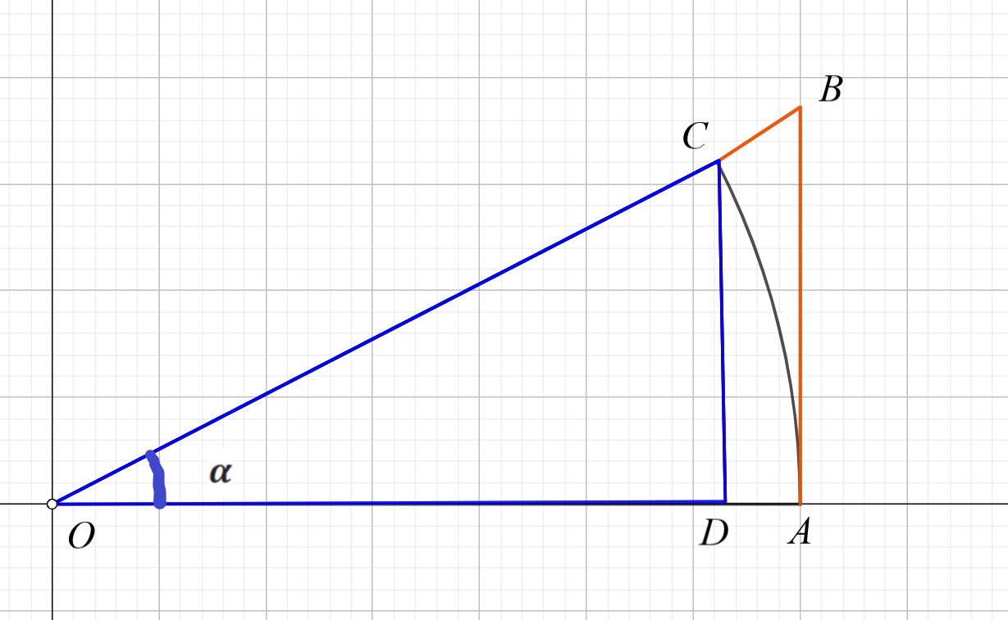
Figure 4. The first important limit. Single circle sector $OAC$.

$\left|OC\right|=\left|OA\right|=1, \hat{COA}=α$, $\left|CD\right|=sinα, \left|BA\right|=tgα$.
The circular wedge $OAC$ contains the triangle $OAC$ and is contained in the right triangle$OAB$. The area of triangle $OAC$ is$\frac{1}{2}sinα$. The area of circular wedge $OAC$ is$\frac{1}{2}α$. The area of right triangle$OAB$ is $\frac{1}{2}tgα$. Hence one has $sinα<α<tgα$ for all angles: $0<α<\frac{π}{2}$.
If angles belong to the segment $0<α<\frac{π}{2}$ the following transformations can be made: $sinα<α<\frac{sinα}{cosα} ⇒1<\frac{α}{sinα} <\frac{1}{cosα}⇒cosα<\frac{sinα}{α}<1$. Since in the neighborhood of zero ($α→0: sinα≈0, cosα≈1$) the cosine of the angle is equal to one, then by the Sandwich Theorem gives:
$\lim_{x→0}\frac{sinx}{x}=1$.
The trigonometric formula $1-cosα={2sin}^{2}α$ and limits properties allows the limit to be written in the form:
$\lim_{x→0}{\left(\frac{sinx}{x}\right)}^{2}=\lim_{x→0}\frac{1-cosx}{{2x}^{2}}=1,⇒cosx≈1-{2x}^{2}, x→0.$
Before beginning observe that the limit has the indeterminate form $\frac{0}{0}$:
COROLLARY 1: $\lim_{x→0}\frac{tgx}{x}=\lim_{x→0}\frac{1}{x}\frac{sinx}{cosx}=\lim_{x→0}\frac{sinx}{x}=1.$
COROLLARY 2: $\lim_{x→0}\frac{arcsinx}{x}→\left|\frac{0}{0}\right|=\left|\begin{matrix}arcsinx=t \\ x=sint \\ x→0, t→0\end{matrix}\right|=\lim_{t→0}\frac{t}{sint}=1.$

When applying the property of limits (note that all limits are entered for $x→0$):
$\lim_{x→0}\frac{sinαx}{βx}=\frac{α}{β}$; | $\lim_{x→0}\frac{\sin^{n}x}{x^{n}}=1$; | $\lim_{x→0}\frac{tgx}{x}=1$; | $\lim_{x→0}\frac{tgαx}{βx}=\frac{α}{β}$;
$\lim_{x→0}\frac{{tg}^{n}x}{x^{n}}=1$; | $\lim_{x→0}\frac{arcsinx}{x}=1$; | $\lim_{x→0}\frac{\arcsin^{n}x}{x^{n}}=1$; | $\lim_{x→0}\frac{1-cosx}{x^{2}}=\frac{1}{2}$.
EXAMPLE 2. Find the limit: $\lim_{x→0}\frac{sin2x}{{3x}^{2}-x}$
SOLUTION: $\lim_{x→0}\frac{sin2x}{{3x}^{2}-x}=\lim_{x→0}\frac{sin2x}{2x}∙\frac{2}{\left(3x-1\right)}=\lim_{x→0}\frac{sin2x}{2x}∙\left(-2\right)=-2.$

PROBLEM 7: Find the limit:
1. $\lim_{x→0}\frac{sin3x}{{2x-5x}^{2}}$; | 11. $\lim_{x→0}\frac{\sin^{2}4x}{{\left({x-3x}^{2}\right)}^{2}}$;
2. $\lim_{x→0}\frac{x^{2}+3x}{3arcsin2x}$; | 12. $\lim_{x→0}\frac{{2x}^{2}-x}{4tgx}$;
3. $\lim_{x→0}\frac{tg5x}{{x-2x}^{2}}$; | 13. $\lim_{x→0}\frac{sin6x}{{3x-8x}^{2}}$;
4. $\lim_{x→0}\frac{3x^{2}+x}{2tg3x}$; | 14. $\lim_{x→0}\frac{x^{4}+3x^{2}}{-2\arcsin^{2}3x}$;
5. $\lim_{x→0}\frac{\sin^{2}3x}{{\left({2x+5x}^{2}\right)}^{2}}$; | 15. $\lim_{x→0}\frac{{tg}^{3}2x}{{2x^{3}-5x}^{5}}$;
6. $\lim_{x→0}\frac{5x-x^{2}}{3tgx}$; | 16. $\lim_{x→0}\frac{{-x}^{2}+7x}{7arcsin2x}$;
7. $\lim_{x→0}\frac{{tg}^{3}x}{{\left({x-2x}^{2}\right)}^{3}}$; | 17. $\lim_{x→0}\frac{tg2x}{{2x+x}^{2}}$;
8. $\lim_{x→0}\frac{x^{2}+x}{arcsin7x}$; | 18. $\lim_{x→0}\frac{x^{3}+3x^{2}}{\sin^{2}2x}$;
9. $\lim_{x→0}\frac{1-cos3x}{x^{2}}$; | 19. $\lim_{x→0}\frac{sin5x}{{5x}^{2}-7x}$;
10. $\lim_{x→0}\frac{x^{2}-3x}{sin5x}$; | 20. $\lim_{x→0}\frac{\arcsin^{2}3x}{{3x^{3}-x}^{2}}$.

3.3 THE SECOND IMPORTANT LIMIT
THEOREM: Exist the limit: $\lim_{x→∞}{\left(1+\frac{1}{x}\right)}^{x}=e, e=2,718281823459045…$
Proof:
$∎$ If we denote an integer part of a number $\left[ x\right]=n$ then $,n<x<n+1$ and
$\frac{1}{n+1}<\frac{1}{x}<\frac{1}{n}$. Then:
$1+\frac{1}{n+1}<1+\frac{1}{x}<1+\frac{1}{n}, ⇒{\left(1+\frac{1}{n+1}\right)}^{n}<{\left(1+\frac{1}{x}\right)}^{x}<{\left(1+\frac{1}{n}\right)}^{n+1}$and $\lim_{n→∞}{\left(1+\frac{1}{n+1}\right)}^{n}=\lim_{n→∞}\frac{{\left(1+\frac{1}{n+1}\right)}^{n+1}}{\left(1+\frac{1}{n+1}\right)}=e.$
$$\lim_{n→∞}{\left(1+\frac{1}{n}\right)}^{n+1}=\lim_{n→∞}{\left(1+\frac{1}{n}\right)}^{n}\left(1+\frac{1}{n}\right)=e .$$
By the Sandwich Theorem gives: $\lim_{x→∞}{\left(1+\frac{1}{x}\right)}^{x}=e.$ The limit has the indeterminate form ${\left(1\right)}^{∞}$, the addition $\frac{1}{x}→0, x→∞$ is infinitesimally small.
If $x→-∞$ posible make substitution $x=-\left(t+1\right), t→∞,$then:
$\lim_{x→-∞}{\left(1+\frac{1}{x}\right)}^{x}=\lim_{t→∞}{\left(1-\frac{1}{t+1}\right)}^{-(t+1)}=\lim_{t→∞}{\left(\frac{t}{t+1}\right)}^{-(t+1)}=\lim_{t→∞}{\left(1+\frac{1}{t+1}\right)}^{t}=e.$ $∎$
COROLLARY 3: $\lim_{x→0}{\left(1+x\right)}^{\frac{1}{x}}={\left(1\right)}^{∞}=e$;

EXAMPLE 3. Find the limit:
SOLUTION: $\lim_{x→0}\frac{\ln\left(1+x\right)}{x}=\left|\frac{0}{0}\right|\underset{x→0}{=lim\ln{{\left(1+x\right)}^{\frac{1}{x}}}=lne=1}$;
EXAMPLE 4. Find the limit: $\lim_{x→0}\frac{e^{x}-1}{x}.$
SOLUTION: $\lim_{x→0}\frac{e^{x}-1}{x}=\left|\frac{0}{0}\right|\left|\begin{matrix}t=e^{x}-1, x→0,t→0 \\ \ln\left(t+1\right)={lne}^{x} \\ \ln\left(t+1\right)=x\end{matrix}\right|=\lim_{t→0}\frac{t}{\ln\left(t+1\right)}=1$;
EXAMPLE 5. Find the limit: $\lim_{x→0}\frac{{\left(1+x\right)}^{α}-1}{αx}.$
SOLUTION: $\lim_{x→0}\frac{{\left(1+x\right)}^{α}-1}{αx}=\left|\frac{0}{0}\right|=\lim_{x→0}\frac{1+αx+\frac{α\left(1-α\right)}{2!}x^{2}+⋯+\frac{α\left(1-α\right)⋯\left(n-α+1\right)}{n!}x^{n}+⋯-1}{αx}=$
$=\lim_{x→0}\frac{αx(1+\frac{1-α}{2!}x+⋯+\frac{\left(1-α\right)⋯\left(n-α+1\right)}{n!}x^{n-1}+⋯)}{αx}=1$.
When applying the property of limits (note that all limits are entered for $x→0$):
$\lim_{x→∞}{\left(1+\frac{1}{αx}\right)}^{βx}=e^{\frac{β}{α}}$; | $\lim_{x→0}{\left(1+αx^{n}\right)}^{\frac{β}{x^{n}}}=e^{\frac{β}{α}}$; | $\lim_{x→0}\frac{e^{αx}-1}{βx}=\frac{α}{β}$; | $\lim_{x→0}\frac{e^{x^{n}}-1}{x^{n}}=1$;
$\lim_{x→∞}{\left(1+\frac{1}{αx^{n}}\right)}^{βx^{n}}=e^{\frac{β}{α}}$; | $\lim_{x→0}\frac{\ln\left(1+x^{n}\right)}{x^{n}}=1$; | $\lim_{x→0}\frac{\ln\left(1+αx\right)}{βx}=\frac{α}{β}$; | $\lim_{x→0}\frac{{(1+x^{n})}^{α}-1}{αx^{n}}=1$.
EXAMPLE 6. Find a limit:$\lim_{x→0}\frac{ln⁡(1+2x)}{sin3x}$.
SOLUTION: $\lim_{x→0}\frac{ln⁡(1+2x)}{sin3x}=\left|\frac{0}{0}\right|=\lim_{x→0}2∙\left(\frac{∙ln⁡(1+2x)}{2x}\right)∙\frac{1}{3}\left(\frac{3x}{sin3x}\right)=\frac{2}{3}$.
EXAMPLE 7. Find a limit: $\lim_{x→\frac{π}{2}}\frac{1-sinx}{x-\frac{π}{2}}$.
SOLUTION: Note that the variable does not go to zero: $x→\frac{π}{2}$. In this case, a substitution is required to solve the limit $x-\frac{π}{2}=t$.
$\lim_{x→\frac{π}{2}}\frac{1-sinx}{x-\frac{π}{2}}=\left|\frac{0}{0}\right|\left|\begin{matrix}x-\frac{π}{2}=t \\ x=t+\frac{π}{2} \\ x→\frac{π}{2}⇒t→0\end{matrix}\right|$=$\lim_{t→0}\frac{1-sin⁡(t+\frac{π}{2})}{\left(t+\frac{π}{2}\right)-\frac{π}{2}}=\lim_{t→0}\frac{1-cost}{t}=\left|\frac{0}{0}\right|=\lim_{t→0}\frac{\sin^{2}t}{t}$=
$\underset{t→0}{=lim}\frac{sint}{t}∙sint=0$.
In the general case: $\lim_{x→a}\frac{f(x)}{g(x)}=\left|\begin{matrix}x-a=t \\ x=t+a \\ x→a⇒t→0\end{matrix}\right|=\lim_{t→0}\frac{f(t+a)}{g(t+a)}$.

PROBLEM 8: Find a limit:
1. $\lim_{x→0}{\frac{{ln(1+x}^{2})}{e^{2x^{2}}-1}}$; | 11. $\lim_{x→0}{\frac{{ln(1+2x}^{2})}{{2-2e}^{x^{2}}}}$;
2. $\lim_{x→0}{\frac{{\left(1+x^{2}\right)}^{2}-1}{e^{2x^{2}}-1}}$; | 12. $\lim_{x→0}{\frac{e^{2x}-1}{\sqrt{x}+x^{2}}}$;
3. $\lim_{x→0}{\frac{1-e^{5x}}{\sqrt{x}-x^{2}}};$ | 13. $\lim_{x→0}{\frac{{ln(1+2x}^{2})}{3\sqrt{x}-x^{2}}}$;
4. $\lim_{x→0}{\frac{{ln(1+x}^{2})}{e^{2x^{2}}-1}}$; | 14. $\lim_{x→0}{\frac{{3e}^{2x}-3}{x^{3}+3x}}$;
5. $\lim_{x→0}{\frac{x^{2}\sqrt{x}-x^{2}}{e^{2x^{2}}-1}}$; | 15. $\lim_{x→0}{\frac{e^{9x^{2}}-1}{\ln\left(1+3x^{2}\right)}}$;
6. $\lim_{x→0}{\frac{1-e^{3x}}{2\sqrt{x}-x}};$ | 16.$\lim_{x→0}{\frac{3-{3e}^{2x}}{2\sqrt{x}+x^{2}}};$
7. $\lim_{x→0}{\frac{{ln(1+3x}^{2})}{e^{2x}-1}}$; | 17. $\lim_{x→0}{\frac{{ln(1-3x}^{2})}{e^{5x^{2}}-1}}$;
8. $\lim_{x→0}{\frac{{ln(1+x}^{2})}{e^{2x^{2}}-1}}$; | 18. $\lim_{x→0}{\frac{{\left(1+2x\right)}^{3}-1}{e^{6x}-1}}$;
9. $\lim_{x→0}{\frac{e^{4x}-1}{3x-x^{2}}};$ | 19. $\lim_{x→0}{\frac{3-{3e}^{5x}}{2x-x^{2}}};$
10. $\lim_{x→0}{\frac{{{(1+x}^{2})}^{3}-1}{e^{5x^{2}}-1}}$; | 20. $\lim_{x→0}{\frac{3x^{4}-x^{2}}{e^{2x^{2}}-1}}$.

3.4 COMPARISON OF INFINITESIMAL FUNCTIONS
In order to compare two infinitesimal functions $α\left(x\right)$ and $β\left(x\right)$, one must find the limit of their relation $\lim_{x→0}\frac{α\left(x\right)}{β\left(x\right)}=C$, where the next cases are possible:
- $\lim_{x→0}\frac{α\left(x\right)}{β\left(x\right)}=Constant, C∈R$. $α\left(x\right)$and $β\left(x\right)$infinitesimal functions of one order of smallness;
- $\lim_{x→0}\frac{α\left(x\right)}{β\left(x\right)}=1$, $α\left(x\right)$and $β\left(x\right)$ infinitesimal functions of one order of smallness
- $\lim_{x→0}\frac{α\left(x\right)}{β\left(x\right)}=0$, $α\left(x\right)$ infinitesimal function of higher order of smallness compared to $β\left(x\right)$.
- $\lim_{x→0}\frac{α\left(x\right)}{β\left(x\right)}=∞$, $β\left(x\right)$ infinitesimal function of higher order of smallness compared to $α\left(x\right)$.
Based on the properties shown, it is possible to write a list of infinitesimal equivalent functions:
if $x→0$: $sinx\sim tgx\sim arcsinx\sim arctgx\sim \ln\left(1+x\right)\sim e^{x}-1\sim x$.

EXAMPLE 8. To compare infinitesimal function: $α\left(x\right)=x(1-cosx)$ and
$β\left(x\right)={tg}^{3}x, x→0$.
SOLUTION: Let's create the limit $\lim_{x→0}\frac{α\left(x\right)}{β\left(x\right)}$:
$\lim_{x→0}\frac{α\left(x\right)}{β\left(x\right)}=\lim_{x→0}\frac{x\left(1-cosx\right)}{2{tg}^{3}x}=\left|\frac{0}{0}\right|=\lim_{x→0}\frac{x\sin^{2}x}{\sin^{3}x}∙\cos^{3}x=\underset{x→0}{=lim}\frac{x}{sinx}∙\cos^{3}x=1$.
Since the limit of the relation $α\left(x\right)$ and $β\left(x\right)$ are equal one, they are called equivalent infinitesimal functions.
EXAMPLE 9. To compare infinitesimal function $α\left(x\right)=\ln{(1-3x)}$and
$β\left(x\right)=e^{3x^{2}-2x}-1, x→0$.
SOLUTION: Let's create the limit $\lim_{x→0}\frac{α\left(x\right)}{β\left(x\right)}$:
$\lim_{x→0}\frac{α\left(x\right)}{β\left(x\right)}=\left|\frac{0}{0}\right|=\lim_{x→0}\frac{\ln{(1-3x^{2})}}{e^{3x^{2}-2x}-1}=\lim_{x→0}\frac{\ln{(1-3x^{2})}}{-3x^{2}}∙\frac{-3x^{2}}{x(3x-2)}∙\frac{x(3x-2)}{e^{x(3x-2)}-1}=\underset{x→0}{=lim}\frac{-3x^{2}}{x(3x-2)}=\lim_{x→0}\frac{-3x}{3x-2}=0$.
Since the limit of the relation $α\left(x\right)$ and $β\left(x\right)$ are equal zero $α\left(x\right)$ infinitesimal function of higher order of smallness compared to $β\left(x\right)$.
EXAMPLE 10. To compare infinitesimal function $α\left(x\right)=1-cos3x$ and
$β\left(x\right)=\arcsin{(2{x)}^{3}}, x→0$.
SOLUTION: Let's create the limit $\lim_{x→0}\frac{α\left(x\right)}{β\left(x\right)}$:
$\lim_{x→0}\frac{α\left(x\right)}{β\left(x\right)}=\lim_{x→0}\frac{1-cos6x}{\arcsin{(2{x)}^{3}}}=\left|\frac{0}{0}\right|=\lim_{x→0}\frac{2\sin^{2}3x}{{(2x)}^{3}}∙\frac{{\left(3x\right)}^{2}}{(2{x)}^{3}}\frac{(2{x)}^{3}}{\arcsin{(2{x)}^{3}}}=\lim_{x→0}\frac{2∙9}{8∙x}=∞$.
Since the limit of the relation $α\left(x\right)$ and $β\left(x\right)$ are infinity $α\left(x\right)$is infinitesimal function of higher order of smallness compared to $β\left(x\right)$.

PROBLEM 9: To compare infinitesimal function $α\left(x\right)$ and $β\left(x\right)$:
1. $α\left(x\right)=$5$\sin^{2}3x$,  $β\left(x\right)=e^{3x^{2}-2x}-1,$if $x→0$; | 11. $α\left(x\right)=3{tg}^{2}3x$,  $β\left(x\right)=e^{4x^{2}-2x}-1,$if $x→0$;
2. $α\left(x\right)=$5${tg}^{2}3x$,  $β\left(x\right)=e^{3x^{2}-2x}-1,$if $x→0$; | 12. $α\left(x\right)=$5${tg}^{2}3x$,  $β\left(x\right)={\left(1+x^{2}\right)}^{5}-1,$if $x→0$;
3. $α\left(x\right)=$5$\sin^{2}3x$,  $β\left(x\right)=arctg\left(3x^{2}-2x\right),$if $x→0$; | 13. $α\left(x\right)=2{arcsin3x}^{2}$,  $β\left(x\right)=tg\left(5x^{2}-2x\right),$if $x→0$;
4. $α\left(x\right)=2\sin^{3}2x$,  $β\left(x\right)=\ln\left(3x^{2}-1\right),$if $x→0$; | 14. $α\left(x\right)=4\sin^{3}3x$,  $β\left(x\right)=\ln\left(5x^{2}+1\right),$if $x→0$;
5.$α\left(x\right)=e^{2x}-1$,  $β\left(x\right)=\ln\left(3x^{2}-1\right),$if $x→0$; | 15.$α\left(x\right)=e^{2x}-1$,  $β\left(x\right)=arctg\left(x^{2}+x\right),$if $x→0$;
6.$α\left(x\right)=5\arcsin^{2}2x$,  $β\left(x\right)=\ln\left(2x^{2}+1\right),$if $x→0$; | 16.$α\left(x\right)=3{arctg}^{2}2x$,  $β\left(x\right)=\ln\left(2x^{2}+1\right),$if $x→0$;
7. $α\left(x\right)=3{tg}^{2}x$, $β\left(x\right)=e^{3x^{2}}-1,$if $x→0$; | 17. $α\left(x\right)=3\sin^{2}x$,  $β\left(x\right)=e^{7x^{2}}-1,$if $x→0$;
8. $α\left(x\right)=3\sin^{2}5x$,  $β\left(x\right)=\arcsin{2x^{3}},$if $x→0$; | 18. $α\left(x\right)=2\sin^{2}5x$,  $β\left(x\right)=\operatorname{arctg}{4x^{2}},$if $x→0$;
9. $α\left(x\right)=2e^{x^{2}\sqrt{x}}-2$,  $β\left(x\right)=\ln\left(3x^{2}+1\right),$if $x→0$; | 19. $α\left(x\right)=2e^{\sqrt{x}}-2$,  $β\left(x\right)=\ln\left(1+\sqrt{x}\right),$if $x→0$;
10. $α\left(x\right)=2\ln\left(2x^{2}+1\right)$,  $β\left(x\right)=\operatorname{arctg}{2x^{3}},$if $x→0$; | 20. $α\left(x\right)=2\ln\left(2x^{2}+1\right)$,  $β\left(x\right)=\operatorname{arctg}\left(2x^{2}+x^{3}\right),$if $x→0$.

Questions for self-control:
- What function is called an infinitesimal function?
- When the First Important Limit can be used?
- When the Second Important Limit can be used?
- How possible to use the First Important Limit for finding limit:
$\lim_{x→π}\frac{sin3x}{x-π}$ ?
- How possible to use the Second Important Limit for finding limit:
$\lim_{x→b}\frac{a^{x}-a^{b}}{x-b}$ ?
- What does it mean to compare two infinitesimal functions?
- What function be infinitesimal equivalent function of ${(e}^{3x^{2}-2x}-1)$, when $x→0$?
- What function be infinitesimal equivalent function of $\arcsin{(2{x)}^{3}}$, when $x→0$?

4. CONTINUOUS FUNCTIONS
4.1 DEFINITION OF CONTINUOUS FUNCTIONS AT THE POINT
We say the function $f(x)$ is continuous at the point $x=a$ if exist the limit $\lim_{x→a}{f\left(x\right)=f(a)}$ (i.e. we can make the value of $f\left(x\right)$ as close as we like to $f\left(a\right)$by taking $x$ sufficiently close to $x=a$ ). We will all time talk about the interval around the point $x=a$ (including $x=a$) where $x∈(a-;a+)$ and defined as the neighborhood of this point.
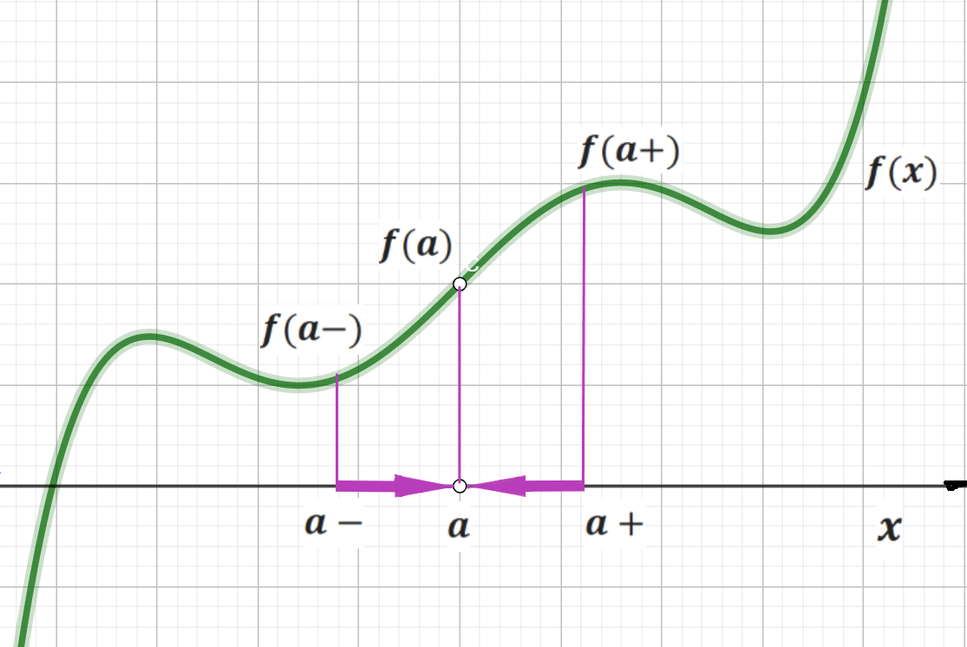
Figure 5. The neighborhood of point $x=a$.

Definition: Continuity, at a point $x=a$, is defined when the limit of the function from the left equals the limit from the right and this value is also equal to the value of the function $f\left(a\right)$. Using notation, for all points $x=a$, where:
$\lim_{x→a-}{f\left(x\right)=\lim_{x→a+}{f\left(x\right)=\lim_{x→a}{f\left(x\right)=}f(a)}}$,
the function is said to be continuous.
(Note that this implies that $\lim_{x→a-}{f\left(x\right)}$ and $\lim_{x→a+}{f\left(x\right)}$ both exist and are equal and $\lim_{x→a}{f\left(x\right)}$ exist and is equal $f(a)$).
Note that this definition implies that the function $f\left(x\right)$ has the following three properties if $f\left(x\right)$ is continuous at $x=a$:
1. $f(a)$ is defined (a is in the domain of $f\left(x\right)$);
2. $\lim_{x→a}{f\left(x\right)}$ exist and is equal $f(a)$;
3. $\lim_{x→a}{f\left(x\right)=}f(a)$ (it is meant that $\lim_{x→a-}{f\left(x\right)}$ and $\lim_{x→a+}{f\left(x\right)}$ both exist and are equal is equal $f(a)$).

4.2 TYPES OF DISCONTINUITIES
We say $f\left(x\right)$ has a removable discontinuity at $x=a$ if we can remove the discontinuity at $x=a$, by changing the value of the function at $x=a$ (making $\lim_{x→a}{f\left(x\right)}=f(a)$) Provided that that $\lim_{x→a-}{f\left(x\right)}$ and $\lim_{x→a+}{f\left(x\right)}$ both exist and are equal and $\lim_{x→a}{f\left(x\right)}$ exist and is equal $f(a)$). This type of discontinuities are called discontinuities of first kind (when left and right limits both exist).
1) The removable discontinuity. The left and right limits of $f\left(x\right)$exists and equal.

EXAMPLE 1. Let us investigate the function for continuity: $f\left(x\right)=\frac{x^{2}-1}{x-1}$ at point $x=1$.
SOLUTION: The point $x=1$ not belong to the domain of $f\left(x\right)$ and the function at this point has discontinuity, but exist the left and right limits:
$\lim_{x→1}{\frac{x^{2}-1}{x-1}=\lim_{x→1}{\frac{(x+1)(x-1)}{x-1}==\lim_{x→1}\left(x+1\right)=2}}$.
$\lim_{x→1-}{f\left(x\right)=}\lim_{x→1-}{\frac{x^{2}-1}{x-1}=\lim_{x→1-}{\frac{(x+1)(x-1)}{x-1}=\lim_{x→1-}\left(x+1\right)=\left(1-\right)+1=2}}$;
$\lim_{x→1+}{f\left(x\right)=\lim_{x→1+}{\frac{x^{2}-1}{x-1}}}=\lim_{x→1+}{\frac{(x+1)(x-1)}{x-1}}=\lim_{x→1+}\left(x+1\right)=\left(1+\right)+1=2$.
This function can be extended as continuous function by defining the value of $f(x)$ to be the limit value at $x=1$: $f\left(x\right)=\left\{\begin{matrix}\frac{x^{2}-1}{x-1}, x≠1, \\ 2, x=1.\end{matrix}\right.$
That was an example of removable discontinuity of the function.

EXAMPLE 2. Let us investigate the function for continuity: $f\left(x\right)=\frac{sinx}{x}$.
SOLUTION: The point $x=0$ not belong to the domain of $f\left(x\right)$ and the function at this point has discontinuity at $x=0$, but exist the left and right limits and limit $x→0$:
$\lim_{x→0}{f\left(x\right)=}\lim_{x→0}{\frac{sinx}{x}=1}$; $\lim_{x→0-}{f\left(x\right)=}\lim_{x→0-}{\frac{sinx}{x}=\frac{sin⁡(0-)}{(0-)}=1}$;
$\lim_{x→0+}{f\left(x\right)=\lim_{x→0+}\frac{sinx}{x}{=\frac{sin⁡(0+)}{(0+)}}}=1$.
Therefore, if you define the function at a point $x=0$ the function $f\left(x\right)=\frac{sinx}{x}$ becomes continuous: $f\left(x\right)=\left\{\begin{matrix}\frac{sinx}{x}, x≠0, \\ 1, x=0.\end{matrix}\right.$ This example also shows how you can eliminate the breakpoint of a function and therefore this point is a point of removable discontinuity of the function.

2) The jump discontinuity: The left and right limits of $f\left(x\right)$exists but not equal.

EXAMPLE 3: Let us investigate the function for continuity: $f\left(x\right)=\frac{\left|x-1\right|}{x-1}$.
SOLUTION: The point $x=1$ not belong to the domain of $f\left(x\right)$ and the function at this point has discontinuity. Left and right limits exist but not equal and general limit does not exist if the left-and right-hand limits aren’t equal - resulting in a discontinuity in the function:
$\lim_{x→1-}{f\left(x\right)=\lim_{x→1-}{\frac{\left|x-1\right|}{x-1}=\frac{-(1-)+1}{\left(1-\right)-1}}}=-1$;
$\lim_{x→1+}{f\left(x\right)=\lim_{x→1+}{\frac{\left|x-1\right|}{x-1}=\frac{\left(1+\right)-1}{\left(1+\right)-1}}}=1$;
The values of limits on the left and right exist, but they are different – because at this point function has jump discontinuity. This type of discontinuities is also called discontinuities of first kind.
3) The infinite discontinuity: Left or right limit of $f\left(x\right)$ is $+∞$ or $-∞$. This type of discontinuities is called discontinuities of second kind (when at least one of the limits does not exist or is infinite).
EXAMPLE 4. Let us investigate the function for continuity: $f\left(x\right)=\frac{2}{x-3}$.
SOLUTION: The point $x=3$ not belong to the domain of $f\left(x\right)$ and the function at this point has discontinuity. Find the left and right limit:
$\lim_{x→3-}{f\left(x\right)=\lim_{x→3-}{\frac{2}{x-3}=\frac{2}{\left(3-\right)-3}=\frac{2}{0-}=-∞}}$;
$\lim_{x→3+}{f\left(x\right)=\lim_{x→3+}{\frac{2}{x-3}=\frac{2}{\left(3+\right)-3}=\frac{2}{0+}=+∞}}$;
Both left and right limit of $f\left(x\right)$ are infinity because of the function has second kind discontinuity at point $x=3$.
EXAMPLE 5. Let us investigate the function for continuity$f\left(x\right)=\frac{2x+1}{x^{2}-1}$.
SOLUTION: Points $x=±1$ not belong to the domain of $f\left(x\right)$ and the function at those points has discontinuity. A general limit does not exist wherever a function increases or decreases infinitely (“without bound”) as it approaches a given
$x=±1$ –value: $\begin{matrix}\lim_{x→1±}\frac{2x+1}{x^{2}-1}=\frac{3}{0±}=±∞ \\ \lim_{x→-1±}\frac{2x+1}{x^{2}-1}=\frac{-1}{0∓}=∓∞\end{matrix}$.

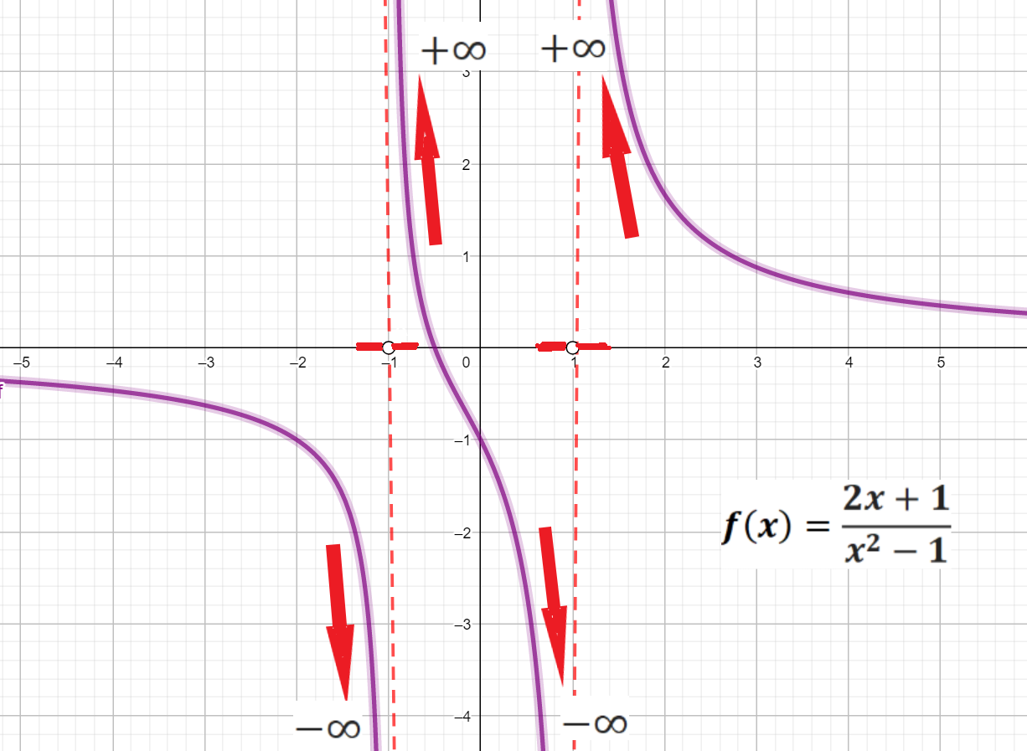
Figure 6. The function $f\left(x\right)=\frac{2x+1}{x^{2}-1}$ increases and
decreases infinitely (“without bound”) at points $x=±1.$

Both left and right limit of $f\left(x\right)$ at points $x=±1$ are infinity. Therefore, the function has a second kind discontinuity at those points.
4) If both left and right limits of the function $f\left(x\right)$ do not exist or one of them, that means the function has second kind discontinuity.
EXAMPLE 6. Let us investigate the function for continuity: $f\left(x\right)=sin\frac{π}{x}$.
SOLUTION: The point $x=0$ not belong to the domain of $f\left(x\right)$ and the function at this point has discontinuity. Find the left and right limit:
$$\left.\begin{matrix}\lim_{x→0-}{f\left(x\right)=\lim_{x→0-}{sin\frac{π}{x}=sin\frac{π}{\left(0-\right)}=sin(-∞)}} \\ \lim_{x→0+}{f\left(x\right)=\lim_{x→0+}{sin\frac{π}{x}=sin\frac{π}{\left(0+\right)}=sin(+∞)}}\end{matrix}\right\}∄$$
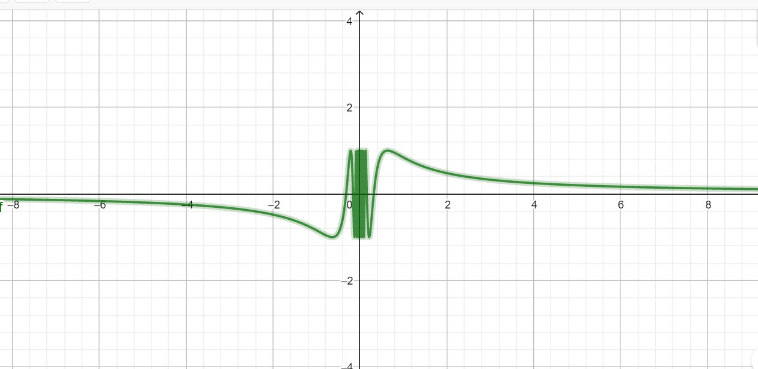
Figure 7. The graph of the function $f\left(x\right)=sin\frac{π}{x}$.

Both left and right limit of $f\left(x\right)$ are not exist. Therefore, the function has second kind discontinuity at point $x=0$.

4.2 PROPERTIES OF CONTINUOUS FUNCTIONS
The functions $sinx$ and $cosx$, a polynomial function are continuous everywhere i.e., in particular, for any real number $x∈R$.
A rational function $f\left(x\right)=\frac{P_{n}(x)}{Q_{m}(x)}$ where $P_{n}(x)$ and $Q_{m}(x)$ are polynomials is continuous on its domain, i.e. $\lim_{x→a}{f\left(x\right)=\frac{P_{n}(x)}{Q_{m}(x)}}$ for all values of $a$, where $Q_{m}(a)≠0$. For Root function:
$f\left(x\right)=\sqrt[n]{x}⟹\left\{\begin{matrix}n=2m, m∈N: then f\left(x\right) is continuous on ∀x∈\left[0;+∞\right); \\ n=2m-1, m∈N: then f\left(x\right) is continuous on ∀x∈\left(-∞;+∞\right).\end{matrix}\right.$
Functions which are algebraic combinations of the functions using addition, subtraction, multiplication and division listed above are also continuous on their domains.
The exponential function $f\left(x\right)=a^{x}, (a>0, a≠1)$ is defined $∀x∈(-∞;+∞)$ and has an inverse logarithmic function $f\left(x\right)=\log_{a}{x, (a>0, a≠1) }$defined $∀x∈(0;+∞)$.

THEOREM: If $f\left(x\right)$ and $g\left(x\right)$are continuous at $x=x_{0}$ and $c_{1},c_{2}$ is constant, then the following functions are also continuous at $x=x_{0}$:
1) $c_{1}f\left(x\right)$ $±c_{2}g\left(x\right)$;
2) $c_{1}f\left(x\right)∙c_{2}g\left(x\right)$;
3) $\frac{f(x)}{g(x)},$ if $g(x_{0})≠0.$
4) if $y=g\left(x\right)$ is continuous at point $x=x_{0}$ and function $f\left(y\right)$ continuous at point $y_{0}=g(x_{0})$, then: $\lim_{x→x_{0}}f\left(g\left(x_{0}\right)\right)=\lim_{y→y_{0}}f\left(y_{0}\right), y=g\left(x\right).$

Definition (functions continuous on the interval):
If the function $f\left(x\right)$ is continuous at each point of the interval $(a;b)$ that function is called continuous in the interval $(a;b)$.
Definition (functions continuous on the closed interval):
If the function $f\left(x\right)$ is continuous at each point of the interval $(a;b)$ and at point $a$ is continuous on the right side, and at point $b$ is continuous left, that function is called continuous in the closed interval $[a;b]$.
THEOREM: Continuous functions on closed, bounded interval is bounded.
THEOREM: Let $f\left(x\right)$ be a continuous function on closed, bounded interval $[a;b]$. Then supremum ($supf\left(x\right)$) and infimum ($inff\left(x\right)$) of functions are achieved in $[a;b]$.
THEOREM: Let $f\left(x\right)$ be a continuous function on $[a;b]$ and let $f\left(c\right)>0$ for some $c∈(a;b)$, Then there exists $δ>0$ such that $f\left(x\right)>0$ in $(c-δ;c+δ)$.
This theorem proves that the function retains its sign near the point of the domain.
THEOREM: Let $f\left(x\right)$ be a continuous function on $∀x∈R$, let $f\left(a\right)∙f\left(b\right)<0$ for some $a,b∈R$. Then there exits $C∈(a;b)$ such that $f\left(c\right)=0$.
THEOREM (intermediate value theorem): Let $f\left(x\right)$ be a continuous function on $[a;b]$ and let $f\left(a\right)<y<f\left(b\right)$. Then there exists $c∈(a;b)$ such that $f\left(c\right)=y$. REMARK: A continuous function assumes all values between its maximum and minimum.
THEOREM (continuity of the inverse function): If the function $f\left(x\right)$ is strictly monotonic and continuous on the close interval $[a;b]$ then the inverse function $f^{-1}\left(x\right)$ is continuous on $[A;B]$, where $\left[A;B\right]-$ the set of values of the function $f\left(x\right)$

PROBLEM 10. Investigate the function for continuity and discontinuity:
- a) $f\left(x\right)=\frac{x^{2}-x-6}{x^{2}+x-2}$;  b)$2arctg\frac{1}{x-3};$  c)$f\left(x\right)=\frac{e^{x-1}-1}{x^{3}-x^{2}+x-1}.$ | 11. a) $f\left(x\right)=\frac{x^{2}+x-2}{x^{2}-x-6}$;  b) $f\left(x\right)=3arctg\frac{1}{x-2};$  c)$f\left(x\right)=\frac{arctg(1-x)}{x^{3}-x^{2}+x-1}$.
- a)$f\left(x\right)=\frac{x^{2}+x-6}{x^{2}-5x+6}$;  b)$f\left(x\right)=\frac{x^{2}-4}{|x-2|};$  c)$f\left(x\right)=\frac{e^{x+1}-1}{x^{3}+x^{2}+x+1}$. | 12. a)$f\left(x\right)=\frac{x^{2}-5x+6}{x^{2}+x-6}$;  b)$f\left(x\right)=\frac{x^{2}-4}{|x+2|};$  c)$f\left(x\right)=\frac{arcsin(x-1)}{x^{3}-x^{2}+x-1}.$
3. a)$f\left(x\right)=\frac{x^{2}-x-6}{x^{2}-4x+3}$;  b)$f\left(x\right)=\frac{2^{1/x}-1}{2^{1/x}+1}$;  c)$f\left(x\right)=\frac{arcsin(x+1)}{x^{3}+x^{2}+x+1}$. | 13. a)$f\left(x\right)=\frac{x^{2}-4x+3}{x^{2}-x-6}$;  b)$f\left(x\right)=\frac{3^{1/x}-1}{3^{1/x}+1};$  c)$f\left(x\right)=\frac{tg(x-1)}{x^{3}-x^{2}+x-1}$.
4. a)$f\left(x\right)=\frac{x^{2}-x-6}{x^{2}-2x-3}$;  b)$f\left(x\right)=\frac{3}{3^{1/x}+1};$  c)$f\left(x\right)=\frac{tg(x+1)}{x^{3}+x^{2}+x+1}$. | 14. a)$f\left(x\right)=\frac{x^{2}-2x-3}{x^{2}-x-6}$;  b)$f\left(x\right)=\frac{3}{2^{1/x}+1};$  c)$f\left(x\right)=\frac{arcsin(2-x)}{x^{3}-2x^{2}+2x-4}$.
5. a)$f\left(x\right)=\frac{x^{2}+x-6}{x^{2}+4x+3}$;  b) $f\left(x\right)=\frac{3}{2^{tgx}+1};$  c)$f\left(x\right)=\frac{e^{x-2}-1}{x^{3}-2x^{2}+2x-4}$. | 15. a)$f\left(x\right)=\frac{x^{2}+4x+3}{x^{2}+x-6}$;  b)$f\left(x\right)=\frac{2}{3^{tgx}+1};$  c)$f\left(x\right)=\frac{sin(x+3)}{x^{3}+3x^{2}+x+3}$.
6. a)$f\left(x\right)=\frac{x^{2}+2x-3}{x^{2}+x-6}$;  b)$f\left(x\right)=arctg\frac{2}{x-4};$  c)$f\left(x\right)=\frac{sin(x+1)}{x^{3}+x^{2}+x+1}$ | 16. a)$f\left(x\right)=\frac{x^{2}+x-6}{x^{2}+2x-3}$;  b)$f\left(x\right)=arctg\frac{3}{x+4};$  c)$f\left(x\right)=\frac{e^{x-3}-1}{x^{3}-3x^{2}+x-3}$
7. a)$f\left(x\right)=\frac{x^{2}+2x-3}{x^{2}+4x+3}$;  b)$f\left(x\right)=\frac{x^{2}-9}{|x-3|};$  c)$f\left(x\right)=\frac{tg(x-1)}{x^{3}-x^{2}+3x-3}$. | 17. a)$f\left(x\right)=\frac{x^{2}-4x+3}{x^{2}+2x-3}$;  b)$f\left(x\right)=\frac{x^{2}-9}{|x+3|};$  c)$f\left(x\right)=\frac{tg(x+1)}{x^{3}+x^{2}+3x+3}$.
8. a)$f\left(x\right)=\frac{x^{2}+x-2}{x^{2}-4x+3}$;  b)$f\left(x\right)=\frac{2^{1/x}-3}{2^{1/x}+1};$  c)$f\left(x\right)=\frac{tg(x-3)}{x^{3}-3x^{2}+x-3}$. | 18. a)$f\left(x\right)=\frac{x^{2}-4x+3}{x^{2}+x-2}$;  b)$f\left(x\right)=\frac{3^{1/x}-2}{3^{1/x}+2};$  c)$f\left(x\right)=\frac{sin(x-3)}{x^{3}-3x^{2}+x-3}$.
9. a)$f\left(x\right)=\frac{x^{2}+2x-3}{x^{2}+x-2}$;  b)$f\left(x\right)=\frac{2}{2^{1/x}+3};$  c)$f\left(x\right)=\frac{sin(x+2)}{x^{3}+2x^{2}+3x+6}$. | 19. a)$f\left(x\right)=\frac{x^{2}+x-2}{x^{2}+2x-3}$;  b)$f\left(x\right)=\frac{1}{3^{1/x}+2}$;  c)$f\left(x\right)=\frac{arctg(x+2)}{x^{3}+2x^{2}+3x+6}$.
10. a)$f\left(x\right)=\frac{x^{2}+2x-3}{x^{2}-4x+3}$;  b)$f\left(x\right)=\frac{3}{3^{tgx}+2};$  c)$f\left(x\right)=\frac{e^{x-3}-1}{x^{3}-3x^{2}+x-3}.$ | 20. a)$f\left(x\right)=\frac{x^{2}-4x+3}{x^{2}+2x-3}$;  b) $f\left(x\right)=\frac{2}{2^{tgx}+3};$  c)$f\left(x\right)=\frac{e^{x+3}-1}{x^{3}+3x^{2}+x+3}$.

- Questions for self-control:
- What are the three main features of continuous functions at a point?
- How to find the left - side limit function at a point?
- What is the breakpoint, which is called a point of removable discontinuity?
- What is the breakpoint, which is called a point of jump discontinuity?
- What is the infinite discontinuity?
- What points are called breakpoints of the second kind?
- What is the difference between functions continuous on the interval and functions continuous on the closed interval?
- How do you understand the concept supremum ($supf\left(x\right)$) and infimum ($inff\left(x\right)$) of given function?

5. THE DERIVATIVE
5.1 THE DEFINITION OF THE DERIVATIVE
Let the function $f(x)$ be defined at a point $x=x_{0}$ and in some of neighborhood $x∈(x-δ;x+δ)$. We give the fixed value of the argument $x_{0}$ an increment $∆x$ such that $x=x_{0}+∆x$ belongs to the neighborhood. Accordingly, the increment of the function $∆f\left(x\right)=f\left(x+∆x\right)-f(x)$.
Definition (derived function at a point):
Let $f(x)$ be a function with domain $D$. Then the derivative of $f(x)$ is:
$$\lim_{∆x→0}{\frac{f\left(x+∆x\right)-f(x)}{∆x}=\lim_{∆x→0}\frac{∆f(x)}{∆x}=f^{/}(x)},$$
whenever this limit exists.
We say that $f\left(x\right)$ is differentiable at $x=x_{0}$ when $f^{/}\left(x_{0}\right)$ exists for $x_{0}∈D$, and that $f\left(x\right)$ is differentiable when $f^{/}\left(x\right)$ exists for all $x∈D$. The ratio $\frac{f\left(x+∆x\right)-f\left(x\right)}{∆x}$ is called the difference quotient of the derivative.
Exist many different notations are used for the derivative of a function $y=f\left(x\right)$, including $f^{/}\left(x\right)=\frac{df\left(x\right)}{dx}=\frac{dy}{dx}=y^{/}=\dot{y}$. For the derivative at the point use the notation: $f^{/}\left(x_{0}\right)=\frac{df\left(x_{0}\right)}{dx}={\left.\frac{dy}{dx}\right|}_{x=x_{0}}=y^{/}(x_{0})$.

5.2 THE EXISTENCE OF A DERIVATIVE
Derivatives at the point are considered left and right: (unilateral derivatives). Left derivative (right derivative) the functions $f(x)$ at the point $x_{0}$ are called: $\begin{matrix}\lim_{∆x→-0}{\frac{f\left(x+∆x\right)-f(x)}{∆x}=f_{-}^{/}(x)} \\ \lim_{∆x→+0}{\frac{f\left(x+∆x\right)-f(x)}{∆x}=f_{+}^{/}(x)}\end{matrix}$.
THEOREM (criterion for the existence of a finite derivative):
At the point $x_{0}$ there is a finite derivative $f^{/}\left(x_{0}\right)$ if and only if there are finite right and left derivatives and these derivatives are equal to each other:
$f^{/}\left(x_{0}-0\right)=f^{/}\left(x_{0}+0\right)=f^{/}\left(x_{0}\right)$.

5.3 GEOMETRIC MEANING OF THE DERIVATIVE
The derivative enables the determination of the equation of a line tangent to a given curve at a given point. For the function $y=f\left(x\right)$ the slope of a secant line joining two points $B(x_{B};f\left(x_{B}\right))$, and $A(x_{A};f\left(x_{A}\right))$ is: $\frac{f\left(x_{B}+∆x\right)-f(x_{B})}{∆x}=\frac{∆f(x)}{∆x}$. Then the point $A(x_{A};f\left(x_{A}\right))$ begins to move along the curve $y=f\left(x\right)$ in the direction of the point $B(x_{B};f\left(x_{B}\right))$ and, accordingly, the limit is considered, at $∆x→0$.

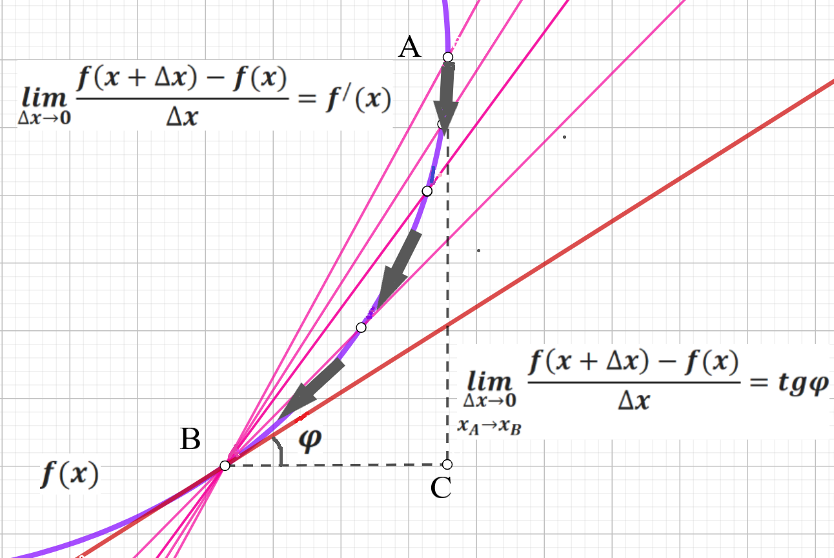
Figure 8. A tangent line at point $B$ as a limit of secant lines.

To find the slope of the line tangent to a function $f\left(x\right)$ at the point $B(x_{B};f\left(x_{B}\right))$, we take a limit of the slopes of secant lines, letting $∆x$ approach $0$. Figure 8. illustrates why this limit process makes intuitive sense; you can see that the slopes of the secant lines get closer and closer to the slope of the tangent line as the point $A(x_{A};f\left(x_{A}\right))$, where $x_{A}=x_{B}+∆x$ gets closer and closer to $B(x_{B};f\left(x_{B}\right))$. The definition of the derivative reflects these ideas. The following definition expresses the real number $x_{B}$ as a variable quantity $∆x$ to identify a general formula for the derivative, enabling us to determine the slope of the line tangent to $f(x)$ whenever this slope is defined.
If there is a limit $\lim_{∆x→0}{\frac{f\left(x+∆x\right)-f(x)}{∆x}=f^{/}(x_{0})}$ and its value is a number, not infinity, then we can write the equation of tangent and normal to the curve. The equation of the tangent line to the function $y=f\left(x\right)$ at a given point ${(x}_{0};y_{0})$ is written as: $y-f(x_{0})=f^{/}(x_{0})(x-x_{0})$, where $f^{/}\left(x_{0}\right)-$ the value of the derivative of the function $y=f\left(x\right)$ at the point ${(x}_{0};y_{0})$.
Using the value of the derivative at given point $f^{/}(x_{0})$ the coordinates of this point ${(x}_{0};y_{0})$, possible to write the equation of a normal line of the function
$y=f\left(x\right)$ at this point $y-y_{0}=-\frac{1}{f^{/}(x_{0})}(x-x_{0})$.
The slope of the normal line is the opposite reciprocal of the tangent line’s slope, because the normal line is perpendicular to the tangent line. This can also be described as the normal line is orthogonal to the curve.
If the limit $\lim_{∆x→0}{\frac{f\left(x+∆x\right)-f(x)}{∆x}=f^{/}(x_{0})}=±∞$ exists and is equal to infinity - the tangent will be parallel to the axis $OY$ and has the form $x=x_{0}$. Examples of vertical tangents in Figure 9.
If there is no finite or infinite derivative at point $x=x_{0}$, then a tangent cannot be drawn at such a point. Examples of that point in Figure 10.

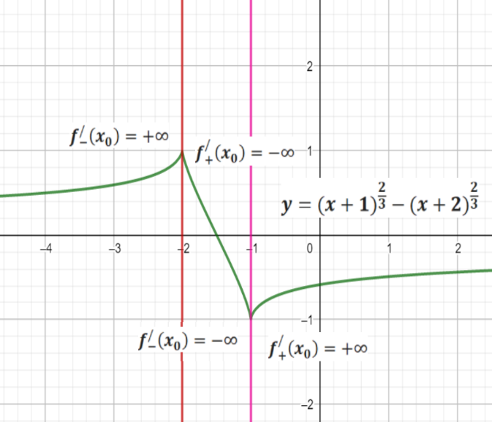
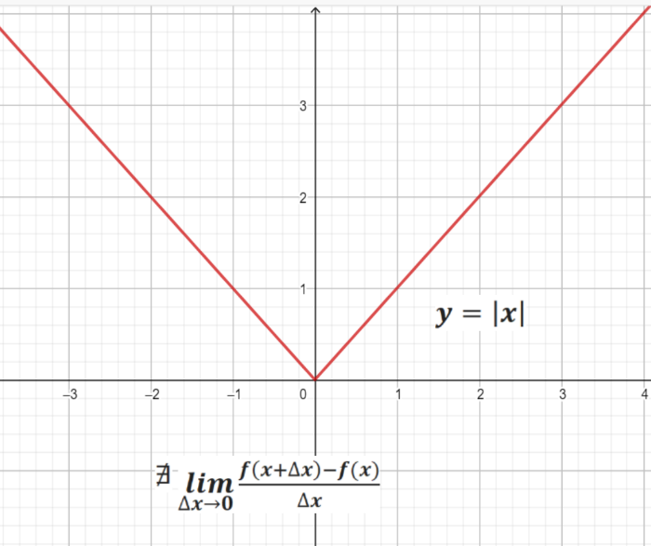
Figure 10. Example of tangent not exist.

Figure 9. Example of vertical tangents.

5.4 FINDING DERIVATIVE FUNCTIONS
EXAMPLE 1. Applying the definition to find derivative $f\left(x\right)=x^{2}$.
SOLUTION: Let give the fixed value of the argument $x_{0}$ an increment $∆x$ such that $x=x+∆x$ belongs to the neighborhood. Accordingly, the increment of the function: $∆f\left(x\right)=f\left(x+∆x\right)-f\left(x\right)={\left(x+∆x\right)}^{2}-x^{2}$.
Then: $f^{/}\left(x\right)=\lim_{∆x→0}{\frac{{\left(x+∆x\right)}^{2}-x^{2}}{∆x}=\lim_{∆x→0}{\frac{x^{2}+2x∆x+{(∆x)}^{2}-x^{2}}{∆x}=}}2x$.
EXAMPLE 2. Applying the definition to find derivative $f\left(x\right)=sin2x$.
SOLUTION: Let give the fixed value of the argument $x_{0}$ an increment $∆x$ such that $2x=(2x+2∆x)$ belongs to the neighborhood. Accordingly, the increment of the function: $∆f\left(x\right)=f\left(x+∆x\right)-f\left(x\right)=sin\left(2x+2∆x\right)-sin2x$. Then:
$f^{/}\left(x\right)=\lim_{∆x→0}{\frac{sin\left(2x+2∆x\right)-sin2x}{∆x}=\lim_{∆x→0}{\frac{2sin∆xcos(2x+∆x)}{∆x}=\left|\begin{matrix}sin∆x\sim ∆x \\ ∆x→0\end{matrix}\right|}}=$
$\underset{∆x→0}{=lim}{\frac{2cos(2x+∆x)}{∆x}=2\cos{2x}}$.
While we can use the formal definition of the derivative to compute derivatives of a given function, theoretical applications of the definition are more important. Using the definition, we can prove general theorems that hold for all derivatives, making it easy to differentiate many familiar functions without explicitly applying the definition one function at time. Many functions are so complicated in structure that directly using the difference quotient becomes unwieldy or impossible. The next theorem states analytic properties of derivatives to facilitate such computations.

THEOREM: If $c∈R$ and both $f\left(x\right)$ and $g\left(x\right)$ are differentiable functions, then the following rules:
- The constant rule: $\frac{d}{dx}\left[c\right]={(c)}^{/}=0$;
- The scalar multiple rule: $\frac{d}{dx}\left[cf\left(x\right)\right]={(cf(x))}^{/}=cf^{/}(x)$;
- The sum rule: $\frac{d}{dx}\left[f\left(x\right)+g(x)\right]={(f\left(x\right)+g(x))}^{/}=f^{/}\left(x\right)+g^{/}(x)$;
- The difference rule: $\frac{d}{dx}\left[f\left(x\right)-g(x)\right]={(f\left(x\right)-g(x))}^{/}=f^{/}\left(x\right)-g^{/}(x)$;
- The power rule: $\frac{d}{dx}\left[x^{n}\right]={(x^{n})}^{/}=nx^{n-1}, n∈R$;
- The product rule: $\frac{d}{dx}\left[f\left(x\right)∙g(x)\right]={(f\left(x\right)∙g(x))}^{/}=f^{/}\left(x\right)g\left(x\right)-g^{/}(x)f\left(x\right)$;
- The quotient rule: $\frac{d}{dx}\left[\frac{f\left(x\right)}{g\left(x\right)}\right]={\left(\frac{f\left(x\right)}{g\left(x\right)}\right)}^{/}=\frac{f^{/}\left(x\right)g\left(x\right)-f(x)g^{/}(x)}{g^{2}(x)}$, provided that $g\left(x\right)≠0$;
- The compound function rule (The chain rule):
$\frac{d}{dx}\left[f(g\left(x\right))\right]={\left(f(g\left(x\right))\right)}^{/}=f^{/}\left(g(x)\right){∙g}^{/}(x)$;
- Derivative of inverse function: If $f\left(x\right)$ is a function with inverse function $f^{-1}(x)$ , then $\frac{d}{dx}\left[f^{-1}(x)\right]={{(f}^{-1})}^{/}=\frac{1}{f^{/}(f^{-1}\left(x\right))}$.
EXAMPLE 3: Proof rules for differentiable functions:
Let use the definition of the derivative to prove the scalar multiple rule. For any constant $c∈R$ and differentiable function $f\left(x\right)$: $\frac{d}{dx}\left[cf\left(x\right)\right]=cf^{/}(x)$.
$\frac{d}{dx}\left[cf\left(x\right)\right]=\lim_{∆x→0}{\frac{cf\left(x+∆x\right)-cf(x)}{∆x}=c\lim_{∆x→0}{\frac{f\left(x+∆x\right)-f(x)}{∆x}={cf}^{/}(x)}}$.
Let prove the power rule: If $n∈N$, then: $\frac{d}{dx}\left[x^{n}\right]=nx^{n-1}.$
PROOF: Let prove the power rule in the case of the positive integers n ∈ N by using the binomial theorem to expand the term $f\left(x+∆x\right)={(x+∆x)}^{n}$ in the difference quotient as follows:
${(x+∆x)}^{n}=x^{n}+n∙x^{n-1}∙∆x+\frac{n\left(n-1\right)}{2!}{x^{n-1}∆x}^{2}+\frac{n\left(n-1\right)\left(n-2\right)}{3!}{x^{n-3}∆x}^{3}+⋯+\frac{n\left(n-1\right)⋯\left(n-k+1\right)}{k!}{x^{n-k}∆x}^{k}+⋯+n{x∆x}^{n-1}+x^{n}$.
Applying the definition of the derivative:
$$\frac{d}{dx}\left[x^{n}\right]=\lim_{∆x→0}{\frac{{(x+∆x)}^{n}-x^{n}}{∆x}=}$$
$$=\lim_{∆x→0}{\frac{\left(x^{n}+n∙x^{n-1}∙∆x+\frac{n\left(n-1\right)}{2!}{x^{n-1}∆x}^{2}+…+n{x∆x}^{n-1}+{∆x}^{n}\right)-x^{n}}{∆x}}$$
$$=\lim_{∆x→0}{\frac{n∙x^{n-1}∙∆x+\frac{n\left(n-1\right)}{2!}{x^{n-1}∆x}^{2}+…+n{x∆x}^{n-1}+{∆x}^{n}}{∆x}=}$$
$${=nx}^{n-1}+\left[Terms involving ∆x and higher powers of ∆x, but ∆x→0\right].$$

A complete proof of the power rule must consider arbitrary real numbers $n∈R$, not just positive integers $n∈N$. The power rule extends to the negative integers, to rational powers and to all real numbers.
EXAMPLE 4. Using the Theorem of differentiable functions:
1) The inverse of the function $f\left(x\right)=x^{2}$ with domain reduced to$[0;+∞)$ is $f^{-1}\left(x\right)=\sqrt{x}$ . Use the formula ${{(f}^{-1}(x))}^{/}=\frac{1}{f^{/}(f^{-1}\left(x\right))}$ to find the derivative of $f^{-1}\left(x\right)$.
SOLUTION: We have $f^{/}\left(x\right)=2x$, and $f^{-1}\left(x\right)=\sqrt{x}$ so that:
$f^{/}\left(f^{-1}\left(x\right)\right)=2\sqrt{x}$. Using the formula above, we have: ${{(f}^{-1}(x))}^{/}=\frac{1}{2\sqrt{x}}$.
2) Let find derivatives of inverse sine functions: ${(arcsinx)}^{/}=\frac{1}{\sqrt{1-x^{2}}}$.
SOLUTION: The function $f\left(x\right)=sinx$ with domain reduced to $[-\frac{π}{2};\frac{π}{2}]$ has inverse function$f^{-1}\left(x\right)=arcsinx$. We have $f^{/}\left(x\right)=cosx$, so that $f^{/}\left(f^{-1}\left(x\right)\right)=cos⁡(arcsinx)$. The formula for the derivative of an inverse function now gives:
$\frac{d}{dx}\left[arcsinx\right]={(arcsinx)}^{/}=\frac{1}{cos(arcsinx)}=\frac{1}{\sqrt{1-\sin^{2}(arcsinx)}}=\frac{1}{\sqrt{1-x^{2}}}$.

BASIC FORMULAS OF DIFFERENTIATION
If functions $u\left(x\right)$ - differentiated function and C is constant.
Function | Derivative | Function | Derivative
C | 0 | $$arcsinu$$ | $$\frac{u^{/}}{\sqrt{1-u^{2}}}$$
$$u^{n}$$ | $$nu^{n-1}∙u^{/}, n∈R$$ | $$arccosu$$ | $$-\frac{u^{/}}{\sqrt{1-u^{2}}}$$
$$a^{u}, a>0, a∈R$$ | $$a^{u}∙u^{/}lna$$ | $$arctgu$$ | $$\frac{u^{/}}{1+u^{2}}$$
$$e^{u}$$ | $$e^{u}∙u^{/}$$ | $$arcctgu$$ | $$-\frac{u^{/}}{1+u^{2}}$$
$$\log_{a}{u}, 0<a≠1$$ | $$\frac{u^{/}}{ulna}$$ | $$shu$$ | $$chu∙u^{/}$$
$$lnu$$ | $$\frac{u^{/}}{u}$$ | $$chu$$ | $$shu∙u^{/}$$
$$sinu$$ | $$cosu∙u^{/}$$ | $$thu$$ | $$\frac{u^{/}}{{ch}^{2}u}$$
$$cosu$$ | $$-sinu∙u^{/}$$ | $$cthu$$ | $$-\frac{u^{/}}{{sh}^{2}u}$$
$$tgu$$ | $$\frac{u^{/}}{\cos^{2}u}$$
$$ctgu$$ | $$-\frac{u^{/}}{\sin^{2}u}$$

EXAMPLE 5. What is the derivative of $f\left(x\right)=\cos^{3}\left(x^{2}+5x-7\right)?$
SOLUTION: Combining two (or more) functions like this is called composing the functions, and the resulting function is called a compound function. We use the chain rule (the chain rule is a formula that expresses the derivative of the composition of differentiable functions):
$$f^{/}\left(x\right)={\left(\cos^{3}\left(x^{2}+5x-7\right)\right)}^{/}{\left(cos⁡\left(x^{2}+5x-7\right)\right)}^{/}{\left(x^{2}+5x-7\right)}^{/}=$$
$=3\cos^{2}(x^{2}+5x-7)(-sin⁡(x^{2}+5x-7))(2x+5)$.
EXAMPLE 6. What is the derivative of $f\left(x\right)=\ln\left(arcsinx^{3}\right)?$
SOLUTION: $f^{/}\left(x\right)={\left(\ln\left(arcsinx^{3}\right)\right)}^{/}∙{\left(arcsinx^{3}\right)}^{/}∙{\left(x^{3}\right)}^{/}=\frac{1}{arcsinx^{3}}\frac{3x^{2}}{\sqrt{1-{{(x}^{3})}^{2}}}.$
EXAMPLE 7. What is the derivative of $f\left(x\right)=arctg\sqrt{x}∙\sqrt[3]{x^{2}-3x+8} ?$
SOLUTION: $f^{/}\left(x\right)={\left(arctg\sqrt{x}\right)}^{/}\sqrt[3]{x^{2}-3x+8}+arctg\sqrt{x}{\left(\sqrt[3]{x^{2}-3x+8}\right)}^{/}$=
=$\frac{1}{1+{(\sqrt{x})}^{2}}\frac{1}{\sqrt{x}}∙\sqrt[3]{x^{2}-3x+8}+arctg\sqrt{x}∙\frac{2x-3}{3\sqrt[3]{{{(x}^{2}-3x+8)}^{2}}}=\frac{x^{2}-3x+8+(2x-3)\sqrt{x}arctg\sqrt{x}}{3\sqrt{x}(1+x)\sqrt[3]{{{(x}^{2}-3x+8)}^{2}}}.$
EXAMPLE 8. What is the derivative of $f\left(x\right)=\frac{e^{2x-5}}{{ch}^{2}3x}?$
SOLUTION: $f^{/}\left(x\right)=\frac{{\left(e^{2x-5}\right)}^{/}{ch}^{2}3x-e^{2x-5}{\left({ch}^{2}3x\right)}^{/}}{{\left({ch}^{2}3x\right)}^{2}}=\frac{2e^{2x-5}{ch}^{2}3x-e^{2x-5}2ch3xsh3x}{{ch}^{4}3x}=$
$=2e^{2x-5}\frac{ch3x(ch3x-sh3x)}{{ch}^{4}3x}=2e^{2x-5}\frac{ch3x-sh3x}{{ch}^{3}3x}=2e^{2x-5}\frac{e^{x}+e^{-x}-e^{x}+e^{-x}}{2{ch}^{3}3x}=\frac{2e^{-x-5}}{{ch}^{3}3x}.$

PROBLEM 11. What is the derivative of $f\left(x\right)$:
$a) f\left(x\right)=sin\left(3x^{2}+2\right)∙ln\left(\sqrt{x+1}\right)$;
$$b) f\left(x\right)=\frac{x^{2}-3x+2}{tg5x}.$$
$$a) f\left(x\right)=\sin^{2}\left(3x+2\right)∙ln\left(\sqrt{x+1}\right);$$
$$b) f\left(x\right)=\frac{tg5x}{x^{2}-3x+2}.$$
$$a) f\left(x\right)=cos\left(3x^{3}-2\right)ln\left(\sqrt{x+1}\right);$$
$$b) f\left(x\right)=\frac{x^{2}+3x+2}{arctg\sqrt{x}}$$
$$a) f\left(x\right)=\cos^{3}\left(3x-2\right)ln\left(\sqrt{x+1}\right)$$
$$b) f\left(x\right)=\frac{arctg\sqrt{x}}{x^{3}+2x-2}.$$
$a) f\left(x\right)=cos\left(3x^{3}-2\right)ln\left(1+\sqrt{x}\right)$;
$$b) f\left(x\right)=\frac{arcsin\sqrt{x}}{e^{x^{3}+2x-2}}.$$
$a) f\left(x\right)=arcsin\sqrt{x+1}∙ln\left(3x^{5}-2\right)$;
$$b) f\left(x\right)=\frac{\sqrt{x^{2}-3x+2}}{e^{5x}}.$$
$a) f\left(x\right)=arctg\sqrt{x+1}∙ln\left(3x^{5}-2\right)$;
$$b) f\left(x\right)=\frac{sin\sqrt{x}}{e^{x^{3}+2x-2}}.$$
$a) f\left(x\right)=e^{\sqrt{x+1}}∙ln\left(3x^{5}+2x\right)$;
$$b) f\left(x\right)=\frac{arctg{(x}^{2})}{{{(x}^{3}+2x-2)}^{2}}.$$
$$a) f\left(x\right)=cos\left(\sqrt{x+1}\right)∙ln\left(3x+x^{3}\right);$$
$$b) f\left(x\right)=\frac{e^{x^{2}}}{{tg(x}^{3}+2x-2)}.$$
$a) f\left(x\right)=\sqrt{x^{2}+1}∙tg\left(3x^{5}+2x\right)$;
$$b) f\left(x\right)=\frac{arcsinx^{2}}{e^{x^{3}+2x-2}}$$
$a) f\left(x\right)=\sqrt{x^{2}+1}∙cos\left(3x^{5}+2x\right)$;
$$b) f\left(x\right)=\frac{arcsinx^{2}}{ch3x}.$$
$a) f\left(x\right)=\sqrt{4-x^{2}}∙tg\left(3x^{5}+2x\right)$;
$$b) f\left(x\right)=\frac{shx^{2}}{e^{x^{2}+x-2}}.$$
$a) f\left(x\right)=arctg\sqrt{4-x^{2}}∙e^{\left(3x^{5}+2x\right)}$;
$$b) f\left(x\right)=\frac{cos\left(\sqrt{x^{2}+1}\right)}{ln\left(3-x\right)}∙$$
$a) f\left(x\right)=arctg\left(4-x^{2}\right)∙e^{\left(3x^{5}+2x\right)}$;
$$b) f\left(x\right)=\frac{ln\left(3x+x^{3}\right)}{\sqrt{x+1}}.$$
$a) f\left(x\right)=arctg\left(4-x\right)∙e^{\left(3x^{5}+2\sqrt{x}\right)}$;
$$b) f\left(x\right)=\frac{sin\left(\sqrt{x^{2}+1}\right)}{ln\left(3-x\right)}∙$$
$a) f\left(x\right)=cos\left(\sqrt{x+1}\right)∙\ln^{2}\left(3x+1\right)$;
$$b) f\left(x\right)=\frac{tg\left(3x+x^{3}\right)}{sh\sqrt{x+1}}.$$
$a) f\left(x\right)=arcsin\sqrt{2-x^{2}}∙e^{\left(5x^{2}-2x\right)}$;
$$b) f\left(x\right)=\frac{ln\left(3x-x^{3}\right)}{\sqrt{x^{2}+4}}.$$
$a) f\left(x\right)={ctg}^{3}\left(3x-2\right)\left(\sqrt{x^{2}+3x-1}\right)$;
$$b) f\left(x\right)=\frac{sh\sqrt{x}}{e^{x^{2}+x-2}}.$$
$a) f\left(x\right)=ctg{\left(3x-2\right)}^{2}\left(\sqrt{3x^{2}+2x-1}\right)$;
$$b) f\left(x\right)=\frac{arccos\left(\sqrt{x+1}\right)}{ln\left(3x+1\right)}∙$$
$a) f\left(x\right)={tg}^{3}\left(x-2\right)\left(\sqrt{x^{2}+3x-1}\right)$;
$$b) f\left(x\right)=\frac{{sh}^{2}x}{ln(\sqrt{x}+3)}.$$

5.5 IMPLICIT DIFFERENTIATION
Sometimes functions are given not in the form$y=f\left(x\right)$ but in a more complicated form in which it is difficult or impossible to express $y$ explicitly in terms of $x$, and given in the way $F\left(x;y\right)=0$. Such functions are called implicit functions. In this unit we explain how these can be differentiated using implicit differentiation.
Consider an expression such as: $x^{2}-4x+y^{2}+6y+1=0$, this function given in way $F\left(x;y\right)=0$ is said to be defined implicitly. It will be necessary to use a rule known as the chain rule or the rule for differentiating a function of a function: $\frac{d}{dx}\left[f(g\left(x\right))\right]={\left(f(g\left(x\right))\right)}^{/}=f^{/}\left(g(x)\right){∙g}^{/}(x)$, but make changes to the notation: $\frac{d}{dx}\left[f(y\left(x\right))\right]=\frac{d}{dx}\left[f(y\left(x\right))\right]\frac{dy}{dx}=\frac{d}{dx}\left[f(y\left(x\right))\right]y^{/}$. We can generalize this as follows: to differentiate a function of $y$ with respect to $x$, we differentiate with respect to $y$ and then multiply by $\frac{dy}{dx}=y^{/}$:
$${\frac{d}{dx}(x}^{2})-\frac{d}{dx}(4x)+\frac{d}{dx}(y^{2})+\frac{d}{dx}(6y)+\frac{d}{dx}(1)=0⟹$$
when we want to differentiate a function of y with respect to$x$x, we differentiate with respect to $y$ and then multiply by $\frac{dy}{dx}$ and taking into account $\frac{dx}{dx}=1$:
$$⟹2x-4+\frac{d}{dy}\left(y^{2}\right)\frac{dy}{dx}+\frac{d}{dx}\left(6y\right)\frac{dy}{dx}=0⟹2x-4+2yy^{/}+6=0⟹$$
$⟹y^{/}=-\frac{x+1}{y}$.
EXAMPLE 9. Make to differentiate, with respect to $x$, the implicit function: ${4x}^{3}-3y^{4}+\sqrt{y}=6xy$.
SOLUTION: We differentiate each term with respect to $x$: $${\frac{d}{dx}(4x}^{3})-\frac{d}{dx}\left(3y^{4}\right)+\frac{d}{dx}\left(\sqrt{y}\right)=\frac{d}{dx}\left(6xy\right)⟹$$
$$⟹12x^{2}-\frac{d}{dy}\left(3y^{4}\right)\frac{dy}{dx}+\frac{d}{dy}\left(\sqrt{y}\right)\frac{dy}{dx}=6\left(\frac{d}{dx}x∙y+x\frac{d}{dx}y\right)⟹$$
$$⟹12x^{2}-12y^{3}\frac{dy}{dx}+\frac{1}{2\sqrt{y}}\frac{dy}{dx}=6\left(\frac{dx}{dx}∙y+x\frac{dy}{dx}\right)⟹$$
$$⟹12x^{2}-12y^{3}y^{/}+\frac{y^{/}}{2\sqrt{y}}=6\left(y+xy^{/}\right)⟹$$
$$⟹y^{/}\left(-6x+\frac{1}{2\sqrt{y}}-12y^{3}\right)=6y-12x^{2}⟹y^{/}=\frac{6y-12x^{2}}{\frac{1}{2\sqrt{y}}-12y^{3}-6x}.$$
EXAMPLE 10. Make to differentiate, with respect to $x$, the implicit function: ${cosx}^{3}-\sin{(3x+2y^{2})}=\frac{e^{y}}{x}$.
SOLUTION: We differentiate each term with respect to $x$:
$${\frac{d}{dx}(cosx}^{3})-\frac{d}{dx}\left(\sin{(3x+2y^{2})}\right)=\frac{d}{dx}\left(\frac{e^{y}}{x}\right)⟹$$
$${-3x^{2}sinx}^{3}-\frac{d}{dy}\left(\sin{(3x+2y^{2})}\right)\frac{dy}{dx}=\frac{d}{dy}\left(\frac{e^{y}}{x}\right)\frac{dy}{dx}⟹$$
$$⟹{-3x^{2}sinx}^{3}-cos\left(3x+2y^{2}\right)\left(3+4yy^{/}\right)=\frac{e^{y}y^{/}-e^{y}}{x^{2}}⟹$$
$$⟹{-y}^{/}\left(4ycos\left(3x+2y^{2}\right)+\frac{e^{y}}{x^{2}}\right)={3{(x}^{2}sinx}^{3}+cos\left(3x+2y^{2}\right)-\frac{e^{y}}{x^{2}})⟹$$
$$⟹y^{/}=-\frac{{3{(x}^{4}sinx}^{3}+x^{2}cos\left(3x+2y^{2}\right)-e^{y})}{4x^{2}ycos\left(3x+2y^{2}\right)+e^{y}}.$$
Now it was included plenty of detail in this calculation. With practice, you will be able to omit many of the intermediate stages.

EXAMPLE 10. Find an equation of the tangent and normal line to the curve:
$x^{3}+y^{2}+2x-6=0$ when the ordinate of point $y_{0}=3$.
SOLUTION: Find the values of $x_{0}$ which correspond to $y_{0}=3$, this is point $M(-1;3)$: if $y_{0}=3⟹x^{3}+3^{2}+2x-6=0$ and the equation $x^{3}+2x+3=0$ has only one real root $x_{0}=-1$.
Further the function is differentiated each term with respect to $x$:
${3x}^{2}+2yy^{/}+2=0⟹y^{/}=-\frac{{3x}^{2}+2}{2y}$, and substitute the coordinates of the point:
${\left.y^{/}\right|}_{M\left(-1;3\right)}=-{\left.\frac{{3x}^{2}+2}{2y}\right|}_{M\left(-1;3\right)}=-\frac{5}{6}$. The equation of the tangent is given by:
$y-3=-\frac{5}{6}\left(x+1\right)⟹y=-\frac{5}{6}x+\frac{13}{6}$.

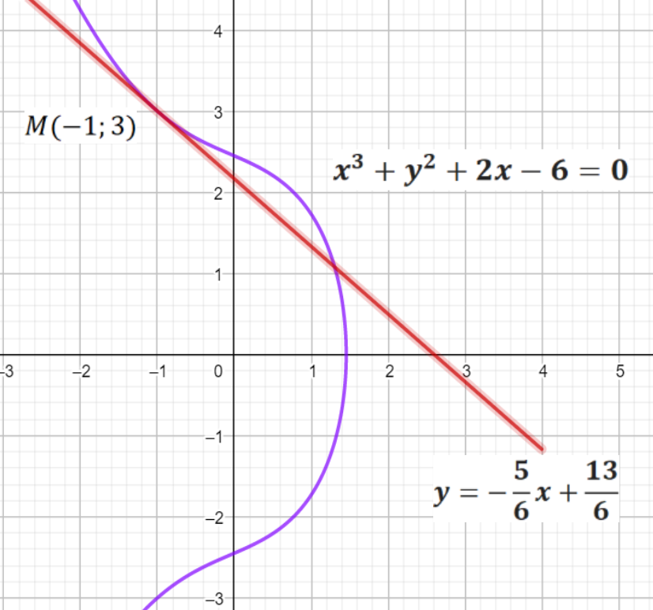
Figure 11. The equation for the explicit function is given
by: $x^{3}+y^{2}+2x-6=0$.

PROBLEM 12. What is the derivative of $f\left(x\right)$:
1. | ${y^{2}x}^{2}-3y+e^{y+x}=4$; | 11. | $x^{2}y^{2}+e^{3y-x}=2y$;
2. | $3{yx}^{3}-cos⁡(xy)=2x$; | 12. | ${5y^{2}x}^{3}+3\ln\left(4x+5y\right)=x$;
3. | $\ln\left(x+y\right)+3x^{3}{-y}^{2}=2$; | 13. | $y^{3}{+2yx}^{2}=cos(y+4)$;
4. | $cos⁡(2x-y){+xy}^{2}=1$; | 14. | $y^{2}x^{3}+\frac{y}{x}-3x=4$;
5. | $x^{3}y^{2}+e^{y-x}=2y$; | 15. | $x^{3}y^{3}-3y+e^{y-3x}=2$;
6. | $yx^{2}-\cos{(x-y)}=\frac{2}{3^{y}}$; | 16. | ${2x}^{2}-y^{3}=sin(xy)$;
7. | $y^{2}{+5yx}^{3}=ln⁡(1+x)$; | 17. | ${y^{6}x}^{3}-2\ln\left(x+y\right)=2y-2$;
8. | $\cos^{2}y-4x^{3}y^{2}=3x$; | 18. | $y^{3}x^{3}+\frac{cosx}{y}+2x=5$;
9. | $y^{3}x^{3}+\frac{x}{y}+2x=1$; | 19. | $y^{2}-3\frac{x}{y}+e^{y-x}=2$;
10. | ${6y^{2}x}^{3}-2\ln\left(x+y\right)=x$; | 20. | $siny+x^{2}=\frac{2x}{3^{y}}$;

5.6 LOGARITHMIC DIFFERENTIATION
Because of computers, logarithms are no longer used to simplify computations with numbers (except within the computer). However, they are still used to simplify expression manipulations as in the method of “logarithmic differentiation” (and they are used in a host of other applications as well). The usefulness of the method hinges on the laws of logarithms (for positive real numbers $x$ and $y$ and any real number $r$):
- $\ln\left(xy\right)=lnx+lny$;
- $ln\frac{x}{y}=lnx-lny$;
- $lnx^{r}=rlnx, r∈R$.
Logarithmic differentiation. Given an equation $y=f\left(x\right)$ expressing $y$ explicitly as a function of $x$, the derivative $y^{/}$ is found using logarithmic differentiation as follows:
- Apply the natural logarithm $ln$ to both sides of the equation and use laws of logarithms to simplify the right-hand side;
- Find $y^{/}$ using implicit differentiation;
- Replace $y$ with $y=f\left(x\right)$.
Simplifying expressions: The initial step in the method of logarithmic differentiation simplifies the expression by changing powers to products and products to sums.
EXAMPLE 11. Given $y=\frac{e^{x^{2}}{(\sqrt{x}+1)}^{3}}{\sqrt{cos2x}},$ use the method of logarithmic differentiation to find $y^{/}$.
SOLUTION: Apply $ln$ to both sides and use laws of logarithms:
$$lny=ln\frac{e^{x^{2}}{(\sqrt{x}+1)}^{3}}{\sqrt{cos2x}}=lne^{x^{2}}+ln{(\sqrt{x}+1)}^{3}-ln\sqrt{cos2x}=$$
$${=x}^{2}+3\ln\left(\sqrt{x}+1\right)-\frac{1}{2}ln⁡(cos2x).$$
Find $y^{/}$ using implicit differentiation of both sides:
$\frac{d}{dx}\left(lny\right)=\frac{d}{dx}\left(x^{2}+3\ln\left(\sqrt{x}+1\right)-\frac{1}{2}ln⁡(cos2x)\right)⟹$
${ ⟹\frac{1}{y}y}^{/}=2x+\frac{3}{\sqrt{x}+1}\frac{1}{2\sqrt{x}}-\frac{1}{2}\frac{-2sin2x}{cos2x}⟹$ Replace $y$ with $y(x)$:
$y^{/}=y\left(2x+\frac{3}{\sqrt{x}+1}\frac{1}{2\sqrt{x}}-\frac{1}{2}\frac{-2sin2x}{cos2x}\right)⟹y^{/}=\left(2x+\frac{3}{\sqrt{x}+1}\frac{1}{2\sqrt{x}}+tg2x\right)\frac{e^{x^{2}}{\left(\sqrt{x}+1\right)}^{3}}{\sqrt{cos2x}}.$

The method is somewhat restrictive in that all quantities appearing as the argument of a logarithm must be positive. In the preceding example the domain of the function not at the center of our consideration, but this domain is $x∈[0;+∞)$ due to the factor $\sqrt{x}$ and $\sqrt{cos2x}$, so all logarithm arguments are positive for every $x≥0$. Therefore, the formula obtained for the derivative is valid for all positive $x$.

Powers with variable base and variable exponent: Logarithmic differentiation provides a means for finding the derivative of powers in which neither exponent nor base is constant.
EXAMPLE 12. Find the derivative of $y=x^{\sqrt{x}}, x>0$.
SOLUTION: Apply ln to both sides and use laws of logarithms:
$lny={ln(x}^{\sqrt{x}})=\sqrt{x}lnx$
After that use logarithmic differentiation: $\frac{d}{dx}\left(lny\right)=\frac{d}{dx}\left(\sqrt{x}lnx\right)⟹$
$${ ⟹\frac{1}{y}y}^{/}=\frac{1}{2\sqrt{x}}lnx+\frac{\sqrt{x}}{x}=\frac{1}{\sqrt{x}}\left(ln\sqrt{x}+1\right)=\frac{lne\sqrt{x}}{\sqrt{x}}⟹y^{/}=y\frac{lne\sqrt{x}}{\sqrt{x}}⟹$$
$$y^{/}={\frac{lne\sqrt{x}}{\sqrt{x}}∙x}^{\sqrt{x}}.$$
EXAMPLE 13. Find the derivative of $y={(lnx)}^{sinx}, 1<x<π$.
SOLUTION: Apply $ln$ to both sides and use laws of logarithms:
$lny={ln(lnx)}^{sinx}=sinx∙\ln\left(lnx\right)$;
After that use logarithmic differentiation:
$\frac{d}{dx}\left(lny\right)=\frac{d}{dx}\left(sinx∙lnn\left(lnx\right)\right)=cosx∙ln\left(lnx\right)+sinx\frac{1}{lnx}∙\frac{1}{x}⟹$
$${ ⟹\frac{1}{y}y}^{/}=\left(cosx∙ln\left(lnx\right)+\frac{sinx}{xlnx}\right)⟹y^{/}=y\left(cosx∙ln\left(lnx\right)+\frac{sinx}{xlnx}\right)⟹$$
$$y^{/}=\left(cosx∙ln\left(lnx\right)+\frac{sinx}{xlnx}\right){(lnx)}^{sinx}.$$

PROBLEM 13. What is the derivative of $f\left(x\right)$:
$a) f\left(x\right)={(cosx)}^{x} b) f\left(x\right)=\frac{x^{2}-3x+2}{tg5x∙\left(\sqrt{x+1}\right)}$.
$a) f\left(x\right)={(sinx)}^{2x}; b) f\left(x\right)=\frac{tg5x∙\left(\sqrt{x+1}\right)}{x^{2}-3x+2}$.
$a) f\left(x\right)={(cosx)}^{3x}; b) f\left(x\right)=\frac{x^{2}+3x+2}{(2x-1)\sqrt{x}}$.
$a) f\left(x\right)={(x^{2}-5x)}^{x}; b) f\left(x\right)=\frac{(3x+7)\sqrt{x}}{x^{2}+x-2}$.
$a) f\left(x\right)={(x-1)}^{sinx}$; $b) f\left(x\right)=\frac{\sqrt{x-3}}{{\left(x+1\right)}^{2}cosx}$.
$a) f\left(x\right)={(x-1)}^{\sqrt{x}}$; $b) f\left(x\right)=\frac{\sqrt{x^{2}-3x+2}}{cosx∙{\left(x+1\right)}^{2}}.$
$a) f\left(x\right)={(2x-1)}^{sinx}$; $b) f\left(x\right)=\frac{sinx∙\sqrt{x+8}}{x^{2}+x-12}.$
$a) f\left(x\right)={(x+5)}^{sinx}$; $b) f\left(x\right)=\frac{{(x}^{2}+1)∙sinx}{{{(x}^{2}+2x+2)}^{2}}.$
$a) f\left(x\right)={(x-1)}^{sinx}; b) f\left(x\right)=\frac{{(x+5)}^{3}cosx}{{(x}^{2}+2x+1)}$.
$a) f\left(x\right)={(x-1)}^{x^{2}}$; $b) f\left(x\right)=\frac{arcsinx^{2}}{e^{x^{3}+2x-2}}$
$a) f\left(x\right)=\sqrt{x^{2}+1}∙cos\left(3x^{5}+2x\right)$; $b) f\left(x\right)=\frac{arcsinx^{2}}{ch3x}$.
$a) f\left(x\right)={(sinx)}^{x^{2}}$; $b) f\left(x\right)=\frac{shx^{2}}{e^{x^{2}+x-2}}.$
$a) f\left(x\right)=x^{\left(3x^{5}+2x\right)}$; $b) f\left(x\right)=\frac{cos2x∙\sqrt{x^{2}+1}}{{\left(3+x\right)}^{3}}∙$
$a) f\left(x\right)=x^{\left(3x^{4}-x\right)}$; $b) f\left(x\right)=\frac{\left(3x+x^{3}\right)}{sinx∙\sqrt{x+1}}.$
$a) f\left(x\right)={(sinx)}^{\left(2\sqrt{x}\right)}$; $b) f\left(x\right)=\frac{sin\left(2x+3\right)∙\sqrt{x^{2}+1}}{\left(3-x\right)}∙$
$a) f\left(x\right)=cos\left(\sqrt{x+1}\right)∙\ln^{2}\left(3x+1\right)$; $b) f\left(x\right)=\frac{\left(3x+x^{3}\right)}{\sqrt{x+1}}.$
$a) f\left(x\right)=arcsin\sqrt{2-x^{2}}∙e^{\left(5x^{2}-2x\right)}$; $b) f\left(x\right)=\frac{ln\left(3x-x^{3}\right)}{\sqrt{x^{2}+4}}.$
$a) f\left(x\right)={\left(x-2\right)}^{3x}$; $b) f\left(x\right)=\frac{sin\left(2x+3\right)}{{\left(3x-2\right)}^{3}\left(\sqrt{x^{2}+3x-1}\right)}$.
$a) f\left(x\right)={\left(x-2\right)}^{sin2x}$; $b) f\left(x\right)=\frac{\sqrt{x^{2}+3x-1}}{\left(3x+1\right)∙\sqrt{x}}∙$
$a) f\left(x\right)={\left(\sqrt{x}\right)}^{sin2x}$; $b) f\left(x\right)=\frac{\left(\sqrt{x^{2}+2x-8}\right)}{sin⁡(5x-2)∙\sqrt{x}}.$

5.7 PARAMETRIC DIFFERENTIATION
Sometimes the equation of a curve is not be given in Cartesian form $y=f\left(x\right)$ but in parametric form:$\left\{\begin{matrix}x=ϕ(t) \\ y=ψ(t)\end{matrix}, t∈[α;β]\right.$.
Parametric functions arise often in particle dynamics in which the parameter $t$ represents the time and $F\left(x\left(t\right);y\left(t\right)\right)=0$ then represents the position of a particle as it varies with time.
Let $Ω$ be a parametric curve described by the parametric equations $\left\{\begin{matrix}x=ϕ\left(t\right), \\ y=ψ\left(t\right);\end{matrix}\right.$. If the function $ϕ\left(t\right)$ and $ψ\left(t\right)$ are differentiable and $y$ is also a differentiable function of $x$, the three derivatives $\frac{dy}{dx}$, $\frac{dy}{dt}$ and $\frac{dx}{dt}$ are related by the Chain rule: $\frac{dy}{dt}=\frac{dy}{dx}\frac{dx}{dt}$ using this we can obtain the formula to compute:
$\frac{dy}{dx}=\frac{\frac{dy}{dt}}{\frac{dx}{dt}}$, if $\frac{dx}{dt}≠0$.
Notation which is also used for derivative parametric equations:
$\begin{matrix}\frac{dy}{dt}=y_{t}^{/} \\ \frac{dx}{dt}=x_{t}^{/}\end{matrix}⟹y_{x}^{/}=\frac{y_{t}^{/}}{x_{t}^{/}}$.
The value of $\frac{dy}{dx}$ gives the slope of a tangent to the curve at any given point. This sometimes helps us to draw the graph of the curve.The curve has a horizontal tangent when $\frac{dy}{dx}=0$, and has a vertical tangent when $\frac{dy}{dx}=∞$.
EXAMPLE 14. Find an equation of the tangent to the curve:
$\left\{\begin{matrix}x=t^{2}-2t, \\ y=t^{3}-3t,\end{matrix} \right.$ when $t=-2$ and plot the function.
SOLUTION: When $t=-2$, the corresponding point on the curve is $M(8;-2)$, the derivative $\left\{\begin{matrix}{\left.x_{t}^{/}\right|}_{t=-2}={\left.2t-2\right|}_{t=-2}=-6, \\ {\left.y_{t}^{/}\right|}_{t=-2}={\left.3t^{2}-3\right|}_{t=-2}=9,\end{matrix}⟹y_{x}^{/}=\frac{y_{t}^{/}}{x_{t}^{/}}=-\frac{3}{2}\right.$.
The equation of the tangent line at the point $M(8;-2)$:
$y-y_{0}={\left.y_{x}^{/}\right|}_{t=-2}\left(x-x_{0}\right)⟹y=-\frac{3}{2}x+10$ (The red line on Figure 13.)
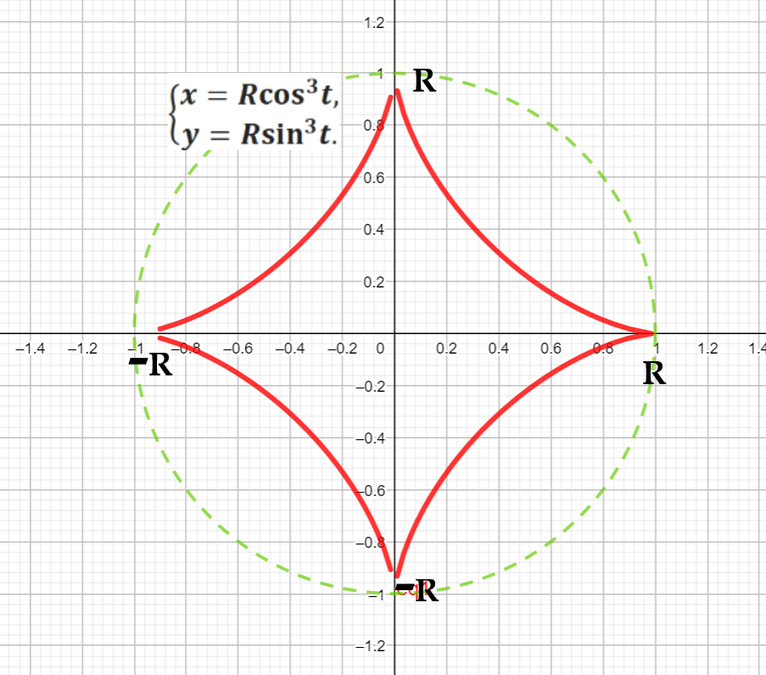
Figure 12. The hypocycloid construction of the astroid. If the radius of the fixed circle is $R=1$ then the equation is given by $\left\{\begin{matrix}x=R\cos^{3}t, \\ y=R\sin^{3}t.\end{matrix}\right.$

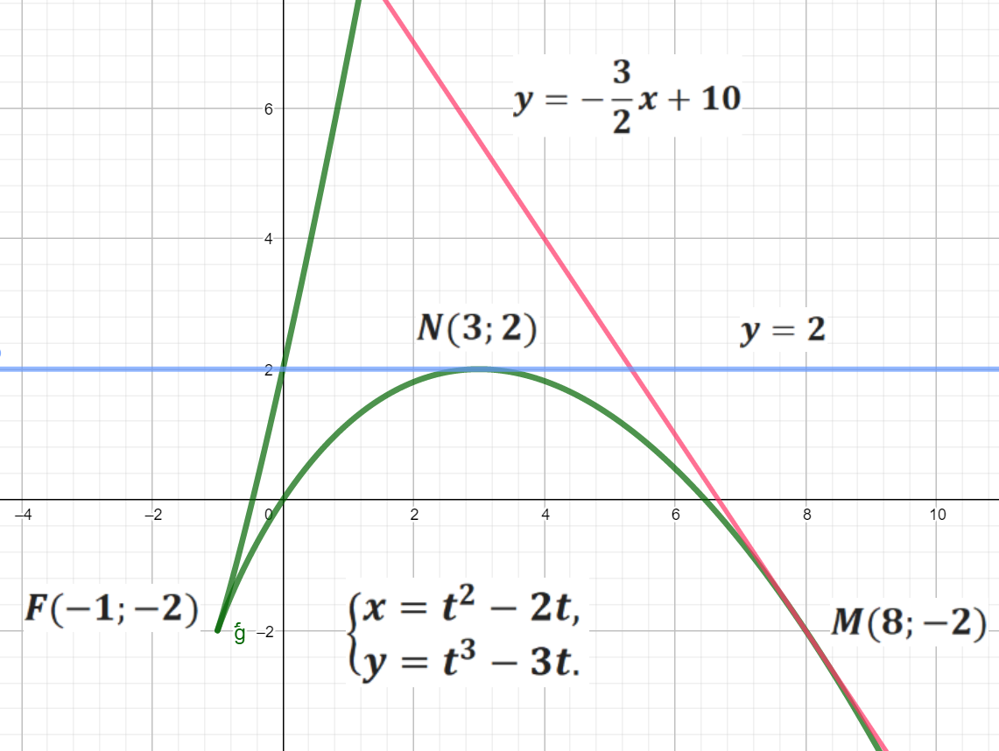
Figure 13. The function $\left\{\begin{matrix}x=t^{2}-2t, \\ y=t^{3}-3t,\end{matrix} \right.$ has next equation in the explicit form: $\left\{\begin{matrix}y={(x+1)}^{\frac{3}{2}}+3x+1, \\ y=\left(1-\sqrt{x+1}\right)\left(x-1-2\sqrt{x+1}\right),\end{matrix}x≥-1.\right.$

EXAMPLE 15. Find the point on the parametric curve where the tangent is horizontal: $\left\{\begin{matrix}x=t^{2}-2t, \\ y=t^{3}-3t.\end{matrix} \right.$
SOLUTION: From above, we have that:
$\left\{\begin{matrix}x_{t}^{/}=2t-2, \\ y_{t}^{/}=3t^{2}-3,\end{matrix}⟹y_{x}^{/}=\frac{y_{t}^{/}}{x_{t}^{/}}=\frac{3\left(t^{2}-1\right)}{2\left(t-1\right)}=\frac{3(t+1)}{2}\right., t≠1⟹t^{2}-1=0,$ if $t=±1$. When $t=-1$, $x_{t}^{/}≠0$ and therefore the graph has a horizontal tangent $y=2$ (The blue line on Figure 13.). The corresponding point on the curve is $N(3;2)$.
When $t=1$, we have $x_{t}^{/}=2t-2=0$ and there is not a well defined tangent. If the curve describes the motion of a particle, this is a point where the particle has stooped. In this case, we see that the corresponding point on the curve is $F(-1;-2)$ and the curve has a cusp (sharp point).
EXAMPLE 16. Consider the curve $L$ defined by the parametric equations: $\left\{\begin{matrix}x=tcost, \\ y=tsint,\end{matrix}t∈\left(-π;π\right).\right.$Find the equations of both tangents to $L$ at point $M(0;\frac{π}{2})$.
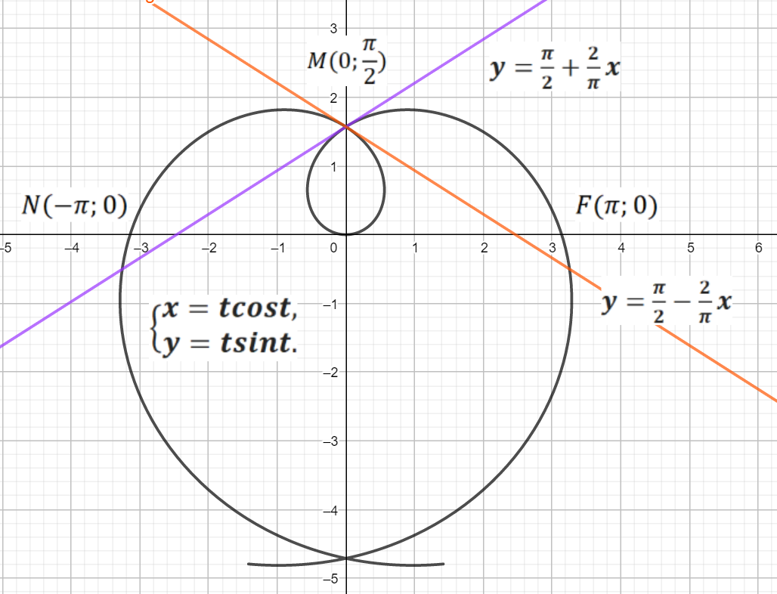
SOLUTION: If $t∈\left(-π;π\right)$ the curve $L$ is plotted between points $F(π;0)$ and
$N\left(-π;0\right)$. Find the values of $t$ which correspond to this point $M(0;\frac{π}{2})$.
Figure 14. The equation for the explicit function is given by $\left\{\begin{matrix}x=tcost, \\ y=tsint,\end{matrix}t∈\left(-5;5\right).\right.$

At this point, $x=tcost=0$, therefore, either $t=0$ or $cost=0$ and $t=±\frac{π}{2}$. When$t=0$, the corresponding point on the curve is $O(0;0)$. When $t=±\frac{π}{2}$,
$y=\frac{π}{2}sin\frac{π}{2}=-\frac{π}{2}\sin\left(-\frac{π}{2}\right)=\frac{π}{2}$, the corresponding point is $M(0;\frac{π}{2})$.
Next step to find: $\left\{\begin{matrix}x_{t}^{/}=cost-tsint, \\ y_{t}^{/}=sint+tcost,\end{matrix}⟹y_{x}^{/}=\frac{y_{t}^{/}}{x_{t}^{/}} =\frac{sint+tcost}{cost-tsint}\right.⟹$
if $t=\frac{π}{2}⟹y_{x}^{/}=\frac{y_{t}^{/}}{x_{t}^{/}}={\left.\frac{sint+tcost}{cost-tsint}\right|}_{t=\frac{π}{2}}=-\frac{2}{π},$ the equation of the tangent is given by: $y=\frac{π}{2}-\frac{2}{π}x.$ If $t=-\frac{π}{2}⟹y_{x}^{/}=\frac{y_{t}^{/}}{x_{t}^{/}}={\left.\frac{sint+tcost}{cost-tsint}\right|}_{t=-\frac{π}{2}}=\frac{2}{π},$ the equation of the tangent is given by: $y=\frac{π}{2}+\frac{2}{π}x.$

PROBLEM 13. What is the derivative of $f\left(x\right)$:
1. | $\left\{\begin{matrix}x=t+cost, \\ y=t-sint,\end{matrix}t∈\left(-π;π\right)\right.$; | 11. | $\left\{\begin{matrix}x=5cost, \\ y=3sint,\end{matrix}t∈\left(-π;π\right)\right.$;
2. | $\left\{\begin{matrix}x=\cos^{3}t, \\ y=\sin^{3}t,\end{matrix}t∈\left(-π;π\right)\right.$; | 12. | $\left\{\begin{matrix}x=\frac{3}{\sqrt{t}}, \\ y=\sqrt[5]{t^{3}},\end{matrix}t∈\left(0;+∞\right)\right.$;
3. | $\left\{\begin{matrix}x=3\cos^{2}t, \\ y={2sin}^{2}t,\end{matrix}t∈\left(-π;π\right)\right.$; | 13. | $\left\{\begin{matrix}x=\sqrt{t-1}, \\ y=\frac{1}{\sqrt{t-1}},\end{matrix}\right.t∈\left(1;+∞\right)$;
4. | $\left\{\begin{matrix}x=\sqrt{t-3}, \\ y=\frac{1}{\sqrt{t-3}},\end{matrix}\right.t∈\left(3;+∞\right)$; | 14. | $\left\{\begin{matrix}x={sh}^{2}2t, \\ y=\frac{4}{{ch}^{2}2t},\end{matrix}t∈\left(-π;π\right)\right.$;;
5. | $\left\{\begin{matrix}x=2t-cost, \\ y=2t+sint,\end{matrix}t∈\left(-π;π\right)\right.$; | 15. | $\left\{\begin{matrix}x={4cos}^{3}t, \\ y=6\sin^{3}t,\end{matrix}t∈\left(-π;π\right)\right.$;
6. | $\left\{\begin{matrix}x={sh}^{2}t, \\ y=\frac{1}{{ch}^{2}t},\end{matrix}t∈\right.\left(0;+∞\right)$; | 16. | $\left\{\begin{matrix}x=t+sint, \\ y=2-cost,\end{matrix}t∈\left(-π;π\right)\right.$;
7. | $\left\{\begin{matrix}x=e^{-5t}, \\ y=e^{7t},\end{matrix}t∈\left(-∞;+∞\right)\right.$; | 17. | $\left\{\begin{matrix}x={2cos}^{2}t, \\ y=3\sin^{2}t,\end{matrix}t∈\left(-π;π\right)\right.$;
8. | $\left\{\begin{matrix}x=5cost, \\ y=3sint,\end{matrix}t∈\left(-π;π\right)\right.$; | 18. | $\left\{\begin{matrix}x=e^{3t}, \\ y=e^{-4t},\end{matrix}t∈\left(-∞;+∞\right)\right.$;
9. | $\left\{\begin{matrix}x=\sqrt{t}, \\ y=\sqrt[5]{t},\end{matrix}t∈\left(0;+∞\right)\right.$;; | 19. | $\left\{\begin{matrix}x=\frac{t+1}{t^{2}}, \\ y=\sqrt[7]{t^{3}},\end{matrix}t∈\left(0;+∞\right)\right.$;
10. | $\left\{\begin{matrix}x={3cos}^{3}t, \\ y={6sin}^{3}t,\end{matrix}t∈\left(-π;π\right)\right.$; | 20. | $\left\{\begin{matrix}x=t+cost, \\ y=t-sint,\end{matrix}t∈\left(-π;π\right)\right.$;

Questions for self-control:

- What is the criterion for the existence of a finite derivative?
- What is the main geometric meaning of the derivative?
- What is the tangent line to the curve? Write the equation of the tangent line.
- What is the secant line of the curve? Write the equation of the secant lines.
- What is the normal to the curve? Write the equation of the normal to the curve.
- What the chain rule is? Where is it used?
- How to differentiate an implicit function?
- When it is effective to use the logarithmic differentiation?
- Consider the curve $L$ defined by the parametric equations:
$\left\{\begin{matrix}x=2cost, \\ y=3sint,\end{matrix}t∈\left(-π;π\right).\right.$Find the equations of tangent and normal lines to the curve $L$ at point $M(2;0)$.
- Consider the curve $L$ defined by the parametric equations:
$\left\{\begin{matrix}x=2cost, \\ y=2sint,\end{matrix}\right.t∈\left(-π;π\right).$ Find the equations of tangent and normal lines to the curve $L$ at the points $\left(±2;0\right)$ and at the points $\left(0;±2\right)$.

6. THE DIFFERENTIAL.
6.1 THE FIRST ORDER DIFFERENTIAL
Let a function $y=f(x)$ be defined in some neighbourhood of a point $x_{0}$ and let there exist a number $A$ such that the increment $∆f$ may be represented as $∆f(x_{0};∆x)=A∆x+o(∆x)$ with $\frac{o(∆x) }{∆x}→0$ as $∆x→0$. The term $A∆x$ in this sum is denoted by the symbol $dy$ or $df(x)$ and is named the differential of the function $f(x)$ (with respect to the variable $x$) at $x$. The differential is the principal linear part of increment of the function (its geometrical experession is the segment $AB$ in Figure. 15, where $MB$ is the tangent to $y=f(x)$ at the point $M(x_{0};y_{0})$ under consideration).
The function $y=f(x)$ has a differential at $x_{0}$ if and only if it has a finite derivative:
$$f^{/}\left(x_{0}\right)=\lim_{∆x→0}{\frac{∆f(x_{0})}{∆x}}=A,$$
at this point $x_{0}$ and $∆f\left(x_{0}\right)=∆f\left(x_{0}+∆x\right)-f(x_{0})$.
A function for which a differential exists is called differentiable at the point in question. Thus, the differentiability of a function implies the existence of both the differential and the finite derivative, and $df\left(x\right)=f^{/}\left(x\right)dx$ also $df\left(x\right)=dy=f^{/}\left(x\right)∆x$. For the independent variable $x$ one puts $dx=∆xdx=∆x$, and one may accordingly write $dy=f^{/}\left(x\right)∆x$, i.e. the derivative is equal to the ratio of the differentials:
$f^{/}\left(x\right)=\frac{dy}{dx}$.

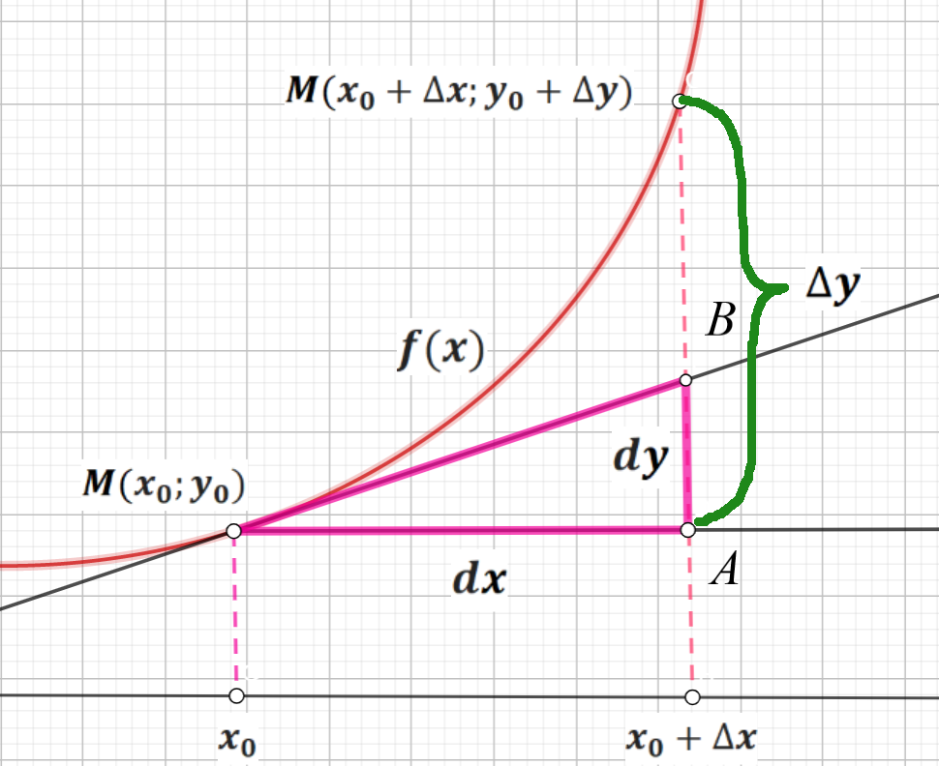
Figure 15. Geometric content of the differential of function $y=f(x)$.

The differential $dy$ is also known as the first differential, or differential of the first order.

EXAMPLE 1. Given $y=3x^{4}$, find $dy$: $dy=d\left(3x^{4}\right)=12x^{3}dx$.

EXAMPLE 2. Given $y=\frac{3}{5}\cos^{2}(5x-4)$, we use the chain rule and find $dy$: $dy=\frac{3}{5}∙2∙\cos\left(5x-4\right)\left(-\sin\left(5x-4\right)∙5\right)dx=-3sin2(5x-4)dx$.

The formula for the differential has the form $df\left(x_{0}\right)=f^{/}\left(x_{0}\right)dx$ where it is indicated that $dx=∆x$, i.e. if $f^{/}\left(x_{0}\right)≠0$, then for $∆x→0$ the increment of the function and its differential at the point $x_{0}$are equivalent to infinitesimal, then:
$$dy≈∆y, ∆x→0.$$
This formula is used in approximate calculations in the form:
$$f\left(x_{0}+∆x\right)≈f\left(x_{0}\right)+f^{/}\left(x_{0}\right)∆x.$$

EXAMPLE 3. Calculate approximately $arctg1,04$.
SOLUTION: If $x_{0}+∆x=1,04$ $x_{0}=1$ and $∆x=0,04$ then the approximate formula is used for the calculation where:
$f\left(x\right)=arctgx⟹f^{/}\left(x_{0}\right)={\left.\frac{1}{1+x^{2}}\right|}_{x_{0}=1}=\frac{1}{2}$.
Approximate value of the arctangent: $arctg1,04≈arctg1+\frac{1}{2}∙0,04≈0,805.$
EXAMPLE 4. Find the approximate value of the volume of the sphere if the radius $R=1,02m$.
SOLUTION: The formula for the volume of a sphere:
$V=\frac{4}{3}πR^{3}$. If $x_{0}+∆x=1,02$, $x_{0}=1$ and $∆x=0,02$ then the approximate formula is used for the calculation where:
$V\left(x\right)=\frac{4}{3}πx^{3}⟹V\left(1\right)=\frac{4}{3}π$, $V^{/}\left(x_{0}\right)={\left.4πx^{2}\right|}_{x_{0}=1}=4π$.
Approximate value of the volume of a sphere: $V≈\frac{4}{3}π+4π∙0,02≈4,43m^{3}$.

6.2 DIFFERENTIALS OF HIGER ORDERS

Let $y=f(x)$ have a differential $dy=f^{/}\left(x\right)dx$ at each point of some interval. Here $dx=∆x$ is some number independent of $x$ and one may say, therefore, that $dx=const, d\left(dx\right)=0$. The differential $dy$ is a function of $x$ alone, and may in turn have a differential, known as the second differential, or the differential of the second order:
$d^{2}f\left(x\right)=d\left(df\left(x\right)\right)=d\left(f^{/}\left(x\right)dx\right)=$
$${\left(f^{/}\left(x\right)dx\right)}^{/}dx+\underset{dx=const, d\left(dx\right)=0}{\underbrace{f^{/}\left(x\right)d\left(dx\right)}}=f^{//}\left(x\right)dx∙dx⟹$$
$$d^{2}f\left(x\right){=f}^{//}\left(x\right){dx}^{2}$$

Here $dx∙dx={\left(dx\right)}^{2}={dx}^{2}$. The same $d^{3}f\left(x\right)=d\left(d^{2}f\left(x\right)\right){=f}^{///}\left(x\right){dx}^{3}$
In general, the $n-$th differential, or the differential of order $n$, is defined by induction by the equality $d^{n}f(x)=d(d^{n-1}f(x))$, on the assumption that the differential $d^{n-1}f(x)$ is defined on some interval and that the value of$dx$ is identical at all steps, from there:
$f^{/}\left(x\right)=\frac{dy}{dx}; f^{//}\left(x\right)=\frac{d^{2}y}{{dx}^{2}}; f^{///}\left(x\right)=\frac{d^{3}y}{{dx}^{3}}…$

EXAMPLE 5. $y=\frac{2}{3}e^{6x}$, find $d^{3}y$.
SOLUTION: The variable $x$ is the independent variable, firstly we need to find:
$y^{/}=4e^{6x},$ $y^{//}=24e^{6x},$ $y^{//}=144e^{6x}$ then:
${dy=4e^{6x}⟹ d}^{2}y=24e^{6x}{dx}^{2}⟹d^{3}y=144e^{6x}{dx}^{3}$.

The invariance condition for $d^{2}f\left(x\right),d^{3}f(x)⋯$ is generally not satisfied (with the exception $f(t)$ where $t$ is a linear function).
If a given function $f\left(x\right)$ is compounded $x=x(t)$, then second- and higher-order differentials do not have invariance properties. In such cases $d\left(dx\right)≠0$, and have to be used the formula of product differentiation:
$$d^{2}y=d\left(f^{/}\left(x\right)∙dx\right)=d\left(f^{/}\left(x\right)\right)dx+{f^{/}\left(x\right)d(dx)=f}^{//}\left(x\right){dx}^{2}+f^{/}\left(x\right)d^{2}x.$$

But sometimes, a compound function can be written relative to an independent variable.

EXAMPLE 6. Given $y=x^{2}$, and $x=t^{3}-1$, find $d^{2}y$.
SOLUTION: 1) $y^{/}=2x, y^{//}=2, dx=3t^{2}dt, d^{2}x=6tdt^{2}$, and now apply the formula for $d^{2}y$:
$d^{2}y=2{dx}^{2}+2xd^{2}x=2{(3t^{2}dt)}^{2}+2\left(t^{3}-1\right)6tdt^{2}=$
$$=2\left(9t^{4}+6t^{4}-6t\right)dt^{2}=6\left(5t^{4}-2t\right)dt^{2}.$$
2) If $x=t^{3}-1$, then $y={(t^{3}-1)}^{2}$and possible to use the formula for independent variable: $d^{2}f\left(t\right){=f}^{//}\left(t\right){dt}^{2}$. Then:
$y^{/}=2\left(t^{3}-1\right)3t^{2}dt=6\left(t^{5}-t^{2}\right)dt,$
$y^{//}={(6\left(t^{5}-t^{2}\right))}^{/}=6(5t^{4}-2t)$ and $d^{2}y=6(5t^{4}-2t)dt^{2}$.

Questions for self-control:
- What is the geometric content of the differential of the function?
- How to find the differential of the composition of function?
- How is the differential used for approximate calculations?
- How we can find the differential of the second-order? the third-order?
- For which function is possible to find the differential of the nth order?
- $y=\frac{2}{3}2^{6x}$, find $d^{3}y$, $y=\frac{5}{3}\cos^{3}2x$, find $d^{2}y$.
- What is the invariance property of the first differential?

7. HIGHER ORDER DERIVATIVES
7.1 HIGHER ORDER DERIVATIVES OF EXPLISIT FUNCTIONS
If $f(x)$ is differentiable, then its derivative $f^{/}(x)$ may also be differentiable. The derivative of $f^{//}(x)$ is called the second derivative of $f(x)$ and is denoted $f^{//}(x)$ or second order derivative. The next the third derivative $f^{//}(x)$, the fourth derivative is denoted $f^{IV}(x)$ and others $f^{V}\left(x\right), f^{VI}(x)⋯$
Derivatives of higher orders also denote: $f^{\left(2\right)}\left(x\right), f^{\left(3\right)}\left(x\right),⋯f^{(6)}(x)⋯$ .
EXAMPLE 1. If ${f\left(x\right)=x}^{5}-{3x}^{3}+x+1$ polynomial function defined for all $x$.
SOLUTION: We will find all possible derivatives for this function: $f^{/}\left(x\right)={5x}^{4}-{9x}^{2}+1$, $f^{//}\left(x\right)={20x}^{3}-18x$,${ f}^{///}\left(x\right)=60x^{2}-18, f^{IV}\left(x\right)=120x, f^{IV}\left(x\right)=120$, $f^{V}\left(x\right)=f^{\left(5\right)}(x)=0$. For any $n≥5:$ $f^{\left(n\right)}(x)=0.$
EXAMPLE 2. Find $f^{\left(n\right)}\left(x\right),$ if $f\left(x\right)={(ax+b)}^{m}$.
SOLUTION: 1) If $m$ be a positive integer, we have:
$f^{/}\left(x\right)=am{(ax+b)}^{m-1}, f^{//}\left(x\right)=a^{2}m(m-1){(ax+b)}^{m-2}⋯⟹$
$$⟹f^{\left(n\right)}\left(x\right)=a^{n}m\left(m-1\right)⋯\left(m-n+1\right){(ax+b)}^{m-n}⟹$$
$$f^{\left(n\right)}\left(x\right)=a^{n}\frac{m!}{\left(m-n\right)!}{(ax+b)}^{m-n}.$$
If $m=n$: $f^{\left(m\right)}\left(x\right)=a^{m}m!$ The number of derivatives is limited by the order of the polynomial $m$, $f^{\left(m+1\right)}\left(x\right)=0$.
2) If $m$ be a negative integer, we have: $f\left(x\right)={(ax+b)}^{-m}$
$$f^{/}\left(x\right)=a(-m){\left(ax+b\right)}^{-m-1}⟹f^{//}\left(x\right)=a^{2}(-m)(m-1){(ax+b)}^{-m-2}⟹$$
$$⋯⟹f^{\left(n\right)}\left(x\right)=a^{n}\left(-m\right)\left(-m-1\right)⋯\left(-m-\left(n-1\right)\right){\left(ax+b\right)}^{-m-n}=$$
$$=a^{n}{(-1)}^{n}m\left(m+1\right)⋯\left(m+n-1\right){\left(ax+b\right)}^{-m-n}⟹$$
$$f^{\left(n\right)}\left(x\right)=a^{n}\frac{\left(m+n-1\right)!}{\left(m-1\right)!}{\left(ax+b\right)}^{-m-n}, x≠-\frac{b}{a}.$$
The number of derivatives can be infinite.
Functions are differentiated $n$ -times:
EXAMPLE 3. If 1) $f\left(x\right)=\frac{x+3}{x-1}$; 2) $f\left(x\right)=lnx$; 3) $f\left(x\right)=cos2x$; 4) $f\left(x\right)=sinx$.
SOLUTION:1) Find the first derivative of $f\left(x\right)=\frac{x+3}{x-1}=1+\frac{4}{x-1}⟹$
$f^{/}\left(x\right)=4\frac{\left(-1\right)}{{\left(x-1\right)}^{2}};$ then the second derivative of $f\left(x\right)$; $f^{//}\left(x\right)=4\frac{(-1)(-2)}{{\left(x-1\right)}^{3}}$; …so on $⟹⋯⟹f^{\left(n\right)}\left(x\right)=4\frac{{\left(-1\right)}^{n}n!}{{\left(x-1\right)}^{n+1}}, n∈N.$
2)$f\left(x\right)=lnx⟹f^{/}\left(x\right)=\frac{1}{x}⟹f^{//}\left(x\right)=\frac{-1}{x^{2}}⟹f^{///}\left(x\right)=\frac{(-1)(-2)}{x^{3}}⟹⋯$
$$⟹f^{\left(n\right)}\left(x\right)=\frac{{\left(-1\right)}^{n-1}\left(n-1\right)!}{{\left(x-1\right)}^{n}}, n∈N.$$
3) The derivatives repeat in a 4-cycle, so we can write:
$f\left(x\right)=cos2x⟹f^{/}\left(x\right)=-2sin2x⟹f^{//}\left(x\right)=-2^{2}cos2x⟹$
$f^{///}\left(x\right)=2^{3}sin2x⟹f^{\left(4\right)}\left(x\right)=2^{4}cos2x⟹⋯ f^{\left(n\right)}\left(x\right)=2^{n}cos\left(2x+\frac{πn}{2}\right)$.
4) The derivatives repeat in a 4-cycle, so we can write:
$f\left(x\right)=sinx⟹f^{/}\left(x\right)=cosx⟹f^{//}\left(x\right)=-sinx⟹f^{///}\left(x\right)=-cosx⟹$
$$⟹⋯⟹f^{\left(n\right)}\left(x\right)=sin\left(x+\frac{πn}{2}\right).$$
EXAMPLE 4. If $f\left(x\right)=\frac{5}{x^{2}-3x-4}$ find $f^{\left(10\right)}\left(x\right)$.
SOLUTION: $f\left(x\right)=\frac{5}{(x-4)(x+1)}=\frac{1}{x-4}-\frac{1}{x+1}⟹f^{/}\left(x\right)=\frac{-1}{{\left(x-4\right)}^{2}}-\frac{-1}{{\left(x+2\right)}^{2}}⟹$
$$f^{//}\left(x\right)=\frac{(-1)(-2)}{{\left(x-4\right)}^{3}}-\frac{\left(-1\right)\left(-2\right)}{{\left(x+1\right)}^{3}}⟹f^{//}\left(x\right)=\frac{-1∙2∙3}{{\left(x-4\right)}^{4}}-\frac{-1∙2∙3}{{\left(x+1\right)}^{4}}⟹⋯$$
$⟹f^{\left(10\right)}\left(x\right)={\left(-1\right)}^{10}10!\left(\frac{1}{{\left(x-4\right)}^{11}}-\frac{1}{{\left(x-4\right)}^{11}}\right)=3628800\left(\frac{1}{{\left(x-4\right)}^{11}}-\frac{1}{{\left(x-4\right)}^{11}}\right)$.

7.2 LEIBNITZ'S FORMULA
THEOREM: (on derivatives of higher orders of sum and product of functions). If the functions $U(x)$ and $V(x)$ have derivatives of $n-$ th order at a point $x$, then the functions $U(x)±V(x)$ and $U(x)∙V(x)$ also have derivatives of $n-$ th order at this point, moreover:
${(U(x)V(x))}^{(n)}=C_{n}^{0}U^{(n)}V+C_{n}^{1}U^{(n-1)}V^{/}+C_{n}^{2}U^{(n-2)}V^{//}+⋯+$
$${+C}_{n}^{n-1}U^{/}V^{\left(n-1\right)}+C_{n}^{n}UV^{\left(n\right)}=\sum_{k=1}^{n}{C_{n}^{k}U^{(n-k)}V^{\left(n\right)}},$$
where $C_{n}^{k}=\frac{n!}{\left(n-k\right)!k!}, C_{n}^{0}=1, C_{n}^{n}=1$ are Binomial coefficients. We can also write in a simpler form:
$${(U(x)V(x))}^{(n)}=U^{(n)}V+\frac{n}{1!}U^{(n-1)}V^{/}+\frac{n(n-1)}{2!}U^{(n-2)}V^{//}+$$
$$+\frac{n(n-1)(n-2)}{3!}U^{(n-2)}V^{//}+⋯+nU^{/}V^{\left(n-1\right)}+UV^{\left(n\right)}.$$
The formula for ${(U(x)V(x))}^{(n)}$ is called Leibniz`s formula. It resembles a formula Newtonian binomial, only instead of degrees are orders of derivatives.
COROLLARY: If the function $f\left(x\right)$ is $n-$ th times differentiable at the point $x$, a
$C=const$, then: ${(Cf(x))}^{(n)}=Cf^{\left(n\right)}\left(x\right), C=const n∈N.$
Let us recall the binomial coefficients $C_{n}^{k}$:
$$\begin{matrix}\begin{matrix}1 \\ 1 1\end{matrix} & \begin{matrix}{(a+b)}^{0} \\ {(a+b)}^{1}\end{matrix} \\ \begin{matrix}1 2 1 \\ 1 3 3 1 \\ 1 4 6 4 1\end{matrix} & \begin{matrix}{(a+b)}^{2} \\ {(a+b)}^{3} \\ {(a+b)}^{4}\end{matrix} \\ \begin{matrix}1 5 10 5 1 \\ ⋮\end{matrix} & \begin{matrix}{(a+b)}^{5} \\ ⋮\end{matrix}\end{matrix}$$
These coefficients are used in binomial expansions and possible to use in Leibniz`s formula.
Leibniz formula for the third-order derivative:
$${(U(x)V(x))}^{(3)}=U^{(3)}V+3U^{(3-1)}V^{(1)}+3U^{(3-2)}V^{(2)}+UV^{(3)}.$$

EXAMPLE 5. Find the $11-$th derivatives of function ${f\left(x\right)=(x}^{2}-3x+6)e^{2x}$.
SOLUTION: Denote the functions: $\left\{\begin{matrix}U\left(x\right)=x^{2}-3x+6; \\ V\left(x\right)=e^{2x}, \end{matrix}\right.$ and find their derivatives:
1) The function $U\left(x\right)$ is the polynomial and has only two derivatives:
$$\begin{matrix}U^{/}\left(x\right)=2x-3, \\ U^{//}\left(x\right)=2, \\ U^{///}\left(x\right)=0.\end{matrix}$$
2) The function $V\left(x\right)$ is an exponential function and differentiable $n$ times:
$$\begin{matrix}V^{/}\left(x\right)=2e^{2x}, \\ V^{//}\left(x\right)={2^{2}e}^{2x}, \\ V^{///}\left(x\right)={2^{3}e}^{2x},\end{matrix}⋯⟹V^{\left(n\right)}\left(x\right)={2^{n}e}^{2x}⟹V^{\left(11\right)}\left(x\right)={2^{11}e}^{2x}.$$
3) We use Leibniz formula for the eleven-order derivative:
$${(U(x)V(x))}^{(11)}=U^{(11)}V+\frac{11}{1!}U^{(11-1)}V^{(1)}+\frac{11∙10}{2!}U^{(11-2)}V^{(2)}+⋯$$
Since all derivatives $U\left(x\right)$ of the order $n≥3$ are equal to zero, the formula will have only three terms, and
${(U(x)V(x))}^{(11)}={2^{11}e}^{2x}\left(x^{2}-3x+6\right)+\frac{11}{1!}{2^{10}e}^{2x}\left(2x-3\right)+\frac{110}{2!}{2^{9}e}^{2x}∙2=$
$$={2^{9}e}^{2x}\left(2x^{2}-6x+12+44x-66+110\right)={2^{9}e}^{2x}\left(2x^{2}+38x+56\right).$$
EXAMPLE 6. Find the $4-$th derivative of function $f\left(x\right)=\frac{cos2x}{x}$.
SOLUTION: Denote the functions: $\left\{\begin{matrix}U\left(x\right)=cos2x; \\ V\left(x\right)=\frac{1}{x}, \end{matrix}\right.$ and find their derivatives:
1) The function $U\left(x\right)$ is differentiable $n$ times: $f^{\left(n\right)}\left(x\right)=2^{n}cos\left(2x+\frac{πn}{2}\right),n∈Z.$
$$\begin{matrix}U^{(1)}\left(x\right)=-2sin2x, \\ U^{(2)}\left(x\right)=-2^{2}cos2x, \\ \begin{matrix}U^{(3)}\left(x\right)=2^{3}sin2x, \\ U^{(4)}\left(x\right)=2^{4}cos2x.\end{matrix}\end{matrix}$$
2) The function $V\left(x\right)$ also is differentiable $n$ times:
$f^{\left(n\right)}\left(x\right)=\frac{{\left(-1\right)}^{n}n!}{x^{n+1}}, n∈N.$ And derivatives:
$\begin{matrix}V^{(1)}\left(x\right)=-\frac{1}{x^{2}}, \\ V^{(2)}\left(x\right)=\frac{2}{x^{3}}, \\ \begin{matrix}V^{(3)}\left(x\right)=-\frac{6}{x^{4}}, \\ V^{(4)}\left(x\right)=\frac{24}{x^{5}}.\end{matrix}\end{matrix}$.
3) We use Leibniz formula for the $4-$th order derivative:
$${(U(x)V(x))}^{(4)}=U^{(4)}V+\frac{4}{1!}U^{(3)}V^{(1)}+\frac{12}{2!}U^{(2)}V^{(2)}+\frac{24}{3!}U^{(1)}V^{(3)}+\frac{24}{4!}UV^{(4)}=$$
$${=2}^{4}cos2x\frac{1}{x}+4∙2^{3}sin2x\frac{1}{x^{2}}-{6∙2}^{2}cos2x\frac{2}{x^{3}}+4∙2sin2x\frac{6}{x^{4}}+cos2x\frac{24}{x^{5}}=$$
$$=cos2x\left(\frac{16}{x}-\frac{24}{x^{3}}+\frac{24}{x^{5}}\right)+sin2x\left(\frac{32}{x^{2}}+\frac{16}{x^{4}}\right).$$

PROBLEM 14. What is the derivative of $f\left(x\right)$?:
1. | $f\left(x\right)=\left(4x^{3}{+2x}^{2}+x\right)e^{2x}$; | 11. | $f\left(x\right)=\left(3x^{3}{-x}^{2}+7x\right)sin4x$;
2. | $f\left(x\right)=\left(4x^{3}{+2x}^{2}+x\right)sin2x$; | 12. | $f\left(x\right)=\left(2x^{3}{-x}^{2}+3x\right)cos5x$;
3. | $f\left(x\right)=\left(4x^{3}{+2x}^{2}+x\right)cos2x$; | 13. | $f\left(x\right)=\left(x^{3}{-5x}^{2}-2x\right)ch3x$;
4. | $f\left(x\right)=\left(x^{3}{-x}^{2}+5x\right)e^{-3x}$; | 14. | $f\left(x\right)=\left({2x}^{3}{-x}^{2}-2x\right)sh3x$;
5. | $f\left(x\right)=\left(x^{3}{-2x}^{2}+3x\right)sin3x$; | 15. | $f\left(x\right)=\left(3x^{3}{-3x}^{2}+7x\right)e^{-2x}$;
6. | $f\left(x\right)=\left(2x^{3}{+2x}^{2}-x\right)cos3x$; | 16. | $f\left(x\right)=\left(2x^{3}{-x}^{2}+7x\right)sin2x$;
7. | $f\left(x\right)=\left(2x^{3}{+5x}^{2}-2x\right)ch2x$; | 17. | $f\left(x\right)=\left(2x^{3}{-5x}^{2}+6x\right)cos3x$;
8. | $f\left(x\right)=\left(x^{3}{-3x}^{2}-2x\right)sh2x$; | 18. | $f\left(x\right)=\left({4x}^{3}{-3x}^{2}-5x\right)sh2x$;
9. | $f\left(x\right)=\left(x^{3}{-3x}^{2}+4x\right)e^{-2x}$; | 19. | $f\left(x\right)=\left(5x^{3}{+x}^{2}-3x\right)ch3x$;
10. | $f\left(x\right)=\left(2x^{3}{-2x}^{2}+5x\right)sin5x$; | 20. | $f\left(x\right)=\left({4x}^{3}{-x}^{2}+5x\right)e^{-x}$.

7.3 HIGHER ORDER PARAMETRIC DIFFERENTIATION
The second derivative $\frac{d^{2}y}{dx^{2}}$ can also be obtained from $\frac{dy}{dx}$ and $\frac{dx}{dt}$. Indeed:
$$y_{xx}^{//}=\frac{d^{2}y}{dx^{2}}=\frac{d}{dx}\left(\frac{dy}{dx}\right)=\frac{\frac{d}{dt}\left(\frac{dy}{dx}\right)}{\frac{dx}{dt}}, \frac{dx}{dt}≠0 ⟹\left\{\begin{matrix}x=x(t) \\ y_{x}^{/}=\frac{y_{t}^{/}}{x_{t}^{/}}\end{matrix}\right.⟹y_{xx}^{//}=\frac{({y_{x}^{/})}_{t}^{/}}{x_{t}^{/}}$$
The $n$-oder derivative $\frac{d^{n}y}{dx^{n}}$ can also be obtained from:
$\left\{\begin{matrix}x=x\left(t\right), \\ y_{x^{n-1}}^{(n-1)}=\frac{{\left(y_{x^{n-2}}^{(n-2)}\right)}_{t}^{/}}{x_{t}^{/}};\end{matrix}\right.⟹y_{x^{n}}^{(n)}=\frac{{\left(y_{x^{n-1}}^{(n-1)}\right)}_{t}^{/}}{x_{t}^{/}}$.

EXAMPLE 7. Find the first and the second derivative of function:
$\left\{\begin{matrix}x=t^{2}-2t, \\ y=t^{3}-3t,\end{matrix} t∈R.\right.$
SOLUTION: The first derivative:
$\left\{\begin{matrix}x_{t}^{/}=2t-2, \\ y_{t}^{/}=3t^{2}-3,\end{matrix}⟹y_{x}^{/}=\frac{y_{t}^{/}}{x_{t}^{/}}=\frac{3\left(t^{2}-1\right)}{2\left(t-1\right)}=\frac{3(t+1)}{2}\right., t≠1.$
The second derivative: $\left\{\begin{matrix}x=t^{2}-2t, \\ y_{x}^{/}=\frac{3(t+1)}{2},\end{matrix}⟹y_{xx}^{//}=\frac{{\left(y_{x}^{/}\right)}_{t}^{/}}{x_{t}^{/}}=\frac{3(t+1)}{4\left(t-1\right)}=\frac{3}{4(t-1)}\right., t≠1.$
If $t=1$ derivatives not exist.

EXAMPLE 8. Find the first and the second derivative of the function: $\left\{\begin{matrix}x=a\cos^{3}t, \\ y=b\sin^{3}t,\end{matrix} t∈[0;2π].\right.$
SOLUTION: The first derivative:
$\left\{\begin{matrix}x_{t}^{/}=3a\cos^{2}t(-sint), \\ y_{t}^{/}=3{bsin}^{2}tcost,\end{matrix}⟹y_{x}^{/}=\frac{y_{t}^{/}}{x_{t}^{/}}=-\frac{3{bsin}^{2}tcost}{3a\cos^{2}tsint}\right.=-\frac{b}{a}tgt, t≠\frac{πn}{2}, nϵN.$
The second derivative: $\left\{\begin{matrix}x=a\cos^{3}t, \\ y_{x}^{/}=-\frac{b}{a}tgt,\end{matrix}⟹y_{xx}^{//}=\frac{{\left(y_{x}^{/}\right)}_{t}^{/}}{x_{t}^{/}}=-\frac{b}{a}\frac{\frac{1}{\cos^{2}t}}{3a\cos^{2}t(-sint)}=\right.$
$$=\frac{b}{3a^{2}\cos^{4}tsint}, t≠\frac{πn}{2}, nϵN.$$

PROBLEM 15. What is the second derivative of $f\left(x\right)$:
1. | $\left\{\begin{matrix}x=t+cost, \\ y=t-sint,\end{matrix}t∈\left(-π;π\right)\right.$; | 11. | $\left\{\begin{matrix}x=5cost, \\ y=3sint,\end{matrix}t∈\left(-π;π\right)\right.$;
2. | $\left\{\begin{matrix}x=\cos^{3}t, \\ y=\sin^{3}t,\end{matrix}t∈\left(-π;π\right)\right.$; | 12. | $\left\{\begin{matrix}x=\frac{3}{\sqrt{t}}, \\ y=\sqrt[5]{t^{3}},\end{matrix}t∈\left(0;+∞\right)\right.$;
3. | $\left\{\begin{matrix}x=3\cos^{2}t, \\ y={2sin}^{2}t,\end{matrix}t∈\left(-π;π\right)\right.$; | 13. | $\left\{\begin{matrix}x=\sqrt{t-1}, \\ y=\frac{1}{\sqrt{t-1}},\end{matrix}\right.t∈\left(1;+∞\right)$;
4. | $\left\{\begin{matrix}x=\sqrt{t-3}, \\ y=\frac{1}{\sqrt{t-3}},\end{matrix}\right.t∈\left(3;+∞\right)$; | 14. | $\left\{\begin{matrix}x={sh}^{2}2t, \\ y=\frac{4}{{ch}^{2}2t},\end{matrix}t∈\left(-π;π\right)\right.$;;
5. | $\left\{\begin{matrix}x=2t-cost, \\ y=2t+sint,\end{matrix}t∈\left(-π;π\right)\right.$; | 15. | $\left\{\begin{matrix}x={4cos}^{3}t, \\ y=6\sin^{3}t,\end{matrix}t∈\left(-π;π\right)\right.$;
6. | $\left\{\begin{matrix}x={sh}^{2}t, \\ y=\frac{1}{{ch}^{2}t},\end{matrix}t∈\right.\left(0;+∞\right)$; | 16. | $\left\{\begin{matrix}x=t+sint, \\ y=2-cost,\end{matrix}t∈\left(-π;π\right)\right.$;
7. | $\left\{\begin{matrix}x=e^{-5t}, \\ y=e^{7t},\end{matrix}t∈\left(-∞;+∞\right)\right.$; | 17. | $\left\{\begin{matrix}x={2cos}^{2}t, \\ y=3\sin^{2}t,\end{matrix}t∈\left(-π;π\right)\right.$;
8. | $\left\{\begin{matrix}x=5cost, \\ y=3sint,\end{matrix}t∈\left(-π;π\right)\right.$; | 18. | $\left\{\begin{matrix}x=e^{3t}, \\ y=e^{-4t},\end{matrix}t∈\left(-∞;+∞\right)\right.$;
9. | $\left\{\begin{matrix}x=\sqrt{t}, \\ y=\sqrt[5]{t},\end{matrix}t∈\left(0;+∞\right)\right.$;; | 19. | $\left\{\begin{matrix}x=\frac{t+1}{t^{2}}, \\ y=\sqrt[7]{t^{3}},\end{matrix}t∈\left(0;+∞\right)\right.$;
10. | $\left\{\begin{matrix}x={3cos}^{3}t, \\ y={6sin}^{3}t,\end{matrix}t∈\left(-π;π\right)\right.$; | 20. | $\left\{\begin{matrix}x=t+cost, \\ y=t-sint,\end{matrix}t∈\left(-π;π\right)\right.$;

Questions for self-control:
- For which functions can we find second-order derivatives? third order?
- For which functions can we find derivatives of the nth order?
- If function $S\left(x\right)=4x^{3}{+2x}^{2}+x$ has the meaning of the trajectory of the body, what will be the meaning of the first and second derivatives of the $S\left(x\right)$?
- How many times possible to differentiate the function $arctgx$?
- How many times possible to differentiate the function $arcsinx$?
- Find the $10$-oder derivative $\frac{d^{10}y(x)}{dx^{10}}$, if $y\left(x\right)=e^{x}cosx$.
- Find the first and the second derivative of the function:
$\left\{\begin{matrix}x=4\cos^{3}t, \\ y=4\sin^{3}t,\end{matrix} t∈[0;2π]\right.$at the point $M(\sqrt{2};\sqrt{2})$.

8. BASIC THEOREMS OF THE DIFFERENTIAL CALCULUS
8.1 INTERMEDIATE VALUE THEOREM AND THE EXTREME VALUE THEOREM
Recall importants theorems for solving equations and studying functions:
INTERMEDIATE VALUE THEOREM (Bolzano`s Theorem):
Let $f(x)$ be a continuous function on the closed interval $[a;b]$. Assume that $m$ is a number ($y=f(x)$ -value) between $f(a)$ and $f(b)$. Then there is at least one number $c$ ($x$ -value) in the close interval $[a;b]$ which satisfies $f\left(c\right)=m$.
The Intermediate Value Theorem applies to continuous functions and is used to prove that equations, both algebraic and transcendental, are solvable. Note that this theorem will be used to prove the existence of solutions, but will not actually solve the equations.
THE EXTREME VALUE THEOREM (Weierstrass Theorem):
If a real-valued function $f(x)$ is continuous on the closed interval $[a;b]$, then $f(x)$ must attain maximum $M$ and minimum $m$ each at least once. That is, there exist numbers $x=c$ and $x=d$ in closed interval $[a;b]$, such that:
$f\left(c\right)≤f\left(x\right)≤f\left(d\right), ∀x∈$, where $f\left(c\right)=m$, $f\left(d\right)=M$.

Based on these two theorems, the following three theorems were proved, the proof of which will not be given.

8.2 ROLLE’S THEOREM
Suppose $f(x)$ is continuous on the closed interval $[a;b]$ and differentiable on the open interval $(a;b)$ and $f\left(a\right)=f(b)$, then there is at least one point $x=c$ on interval $(a;b)$ with $f^{/}\left(c\right)=0$.
This version of Rolle's theorem is used to prove the Mean value theorem of which Rolle's theorem is indeed a special case. It is also the basis for the proof of Taylor theorem.
That is, function $f(x)$ has a horizontal tangent in a point $x=c$ somewhere between point $x=a$ and $x=b$. For a simple illustration of Roll's Theorem, see the figures below.
Figure 16., Figure 17., Figure 18. will help to understand the meaning of the theorem on an intuitively. The next we give an application of Rolle’s Theorem and the Intermediate Value Theorem.
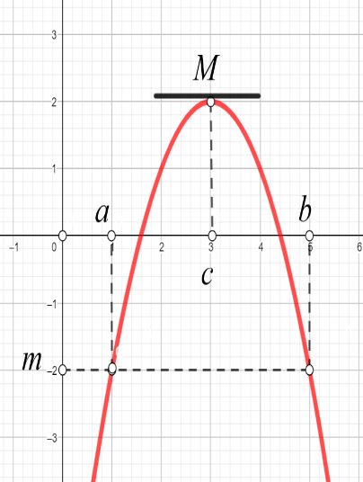
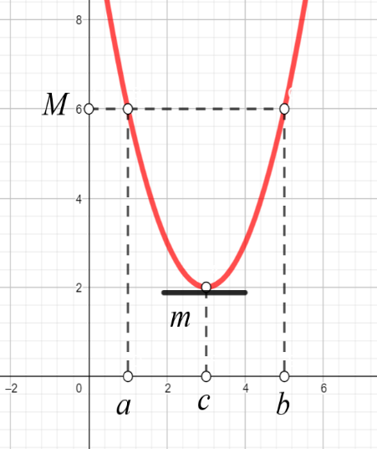
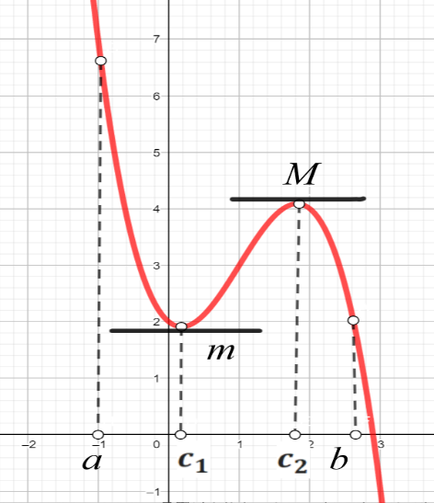
Figure 17.
Figure 16.
Figure 18.
Figure 17.

EXAMPLE 1. We show that $x^{5}+4x=1$ has exactly one solution.
SOLUTION: Let $f\left(x\right)=x^{5}+4x-1$. Since $f\left(x\right)$ is a polynomial, $f\left(x\right)$ is continuous everywhere. $f^{/}\left(x\right)={5x}^{4}+4>0,$ $f^{/}\left(x\right)≠0$ for all $x$. By The Rolle’s Theorem, no equation of the form $f^{/}\left(c\right)=0$ is possible and therefore the given equation has at most one solution.
Since $f\left(x\right)=x^{5}+4x-1$ is continuous everywhere, by the Intermediate Value Theorem, and $f\left(0\right)=-1, f\left(1\right)=4$ which means a change of sign of function on the close interval $[0;1]$, equation $x^{5}+4x=1$ has a solution in the interval [0, 1]. Together these reults say equation $x^{5}+4x=1$ has exactly one solution, and it lies in the close interval $[0;1]$.
COROLLARY: Between any two roots of a differentiable function there is at least one root of its derivative.
The traditional name of the next theorem is the Mean Value Theorem. A more descriptive name would be Average Slope Theorem.

8.3 LAGRANGE`S THEOREM (mean value theorem)
Suppose $f(x)$ is continuous on the closed interval $[a;b]$ and differentiable on the open interval $(a;b)$, then there is at least one point $x=c$ on this interval, such that: $f\left(b\right)-f\left(a\right){=f}^{/}\left(c\right)\left(b-a\right)⟺f^{/}\left(c\right)=\frac{f\left(b\right)-f\left(a\right)}{\left(b-a\right)}.$
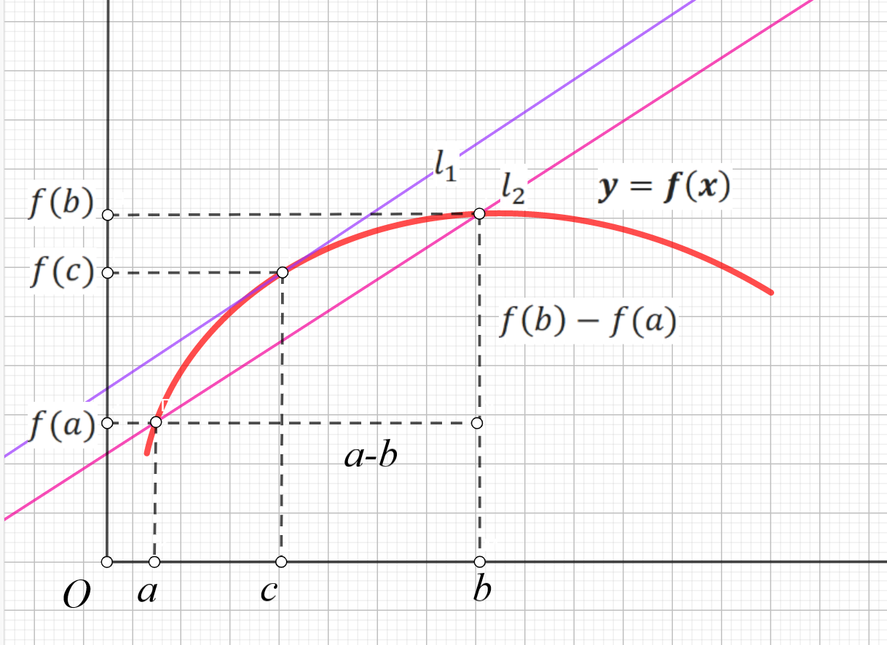
Figure 19. On a smooth curve $y=f\left(x\right)$:
$∃c∈\left[a;b\right]:l_{1}∥l_{2}⇒f\left(b\right)-f\left(a\right){=f}^{/}\left(c\right)\left(b-a\right)$.

Geometric meaning of Lagrange's theorem (Figure 19.):
on a smooth curve $L:y=f\left(x\right)$ there is a point $x=c$ in which the tangent $l_{1}$ to this curve will be parallel to the intersecting line $l_{2}$ (chord) connecting the points $A(a;f\left(a\right))$ and $B(b;f\left(b\right))$.
COROLLARY: If $f^{/}\left(x\right)=0$ on a nonempty open interval $℧$, then $f(x)$ is a constant $∀x∈℧$.
COROLLARY: If $f(x)$ and $g(x)$ have equal derivatives on an interval $℧$, then there is a constant $C$ such that $f\left(x\right)=g\left(x\right)+C, ∀x∈℧$.
The Mean Value Theorem can be used to estimate how much a function may vary from an initial value over an interval you can write for this:
$$f\left(b\right)=f\left(a\right){+f}^{/}\left(c\right)\left(b-a\right).$$
Suppose $f(x)$ is differentiable on $[a;b]$ and we know that $\left|f^{/}(x)\right|≤M,∀x∈[a;b]$. Then:
$f\left(b\right)-f\left(a\right){=f}^{/}\left(c\right)\left(b-a\right)⟹\left|f\left(b\right)-f\left(a\right)\right|=\left|f^{/}\left(c\right)\right|\left|b-a\right|≤M\left|b-a\right|$. Therefore: $-M\left|b-a\right|≤f\left(b\right)-f\left(a\right)≤M\left|b-a\right|$, and:
$-M\left|b-a\right|+f\left(a\right)≤f\left(b\right)≤M\left|b-a\right|+f\left(a\right)$.
EXAMPLE 2. Suppose a particle’s position at time $t$ is $S\left(t\right)$, and we know that $\left|S^{/}(t)\right|≤0,2$. If $S\left(1\right)=1$, in what interval will $S\left(2\right)$ lie in?
SOLUTION: We have: $f\left(a\right)=S\left(1\right)=1,b=2,M=0,2$. Therefore:
$-0,2\left|2-1\right|+1≤S\left(2\right)≤0,2\left|2-1\right|+1⟹0,8≤S\left(2\right)≤1,2$:
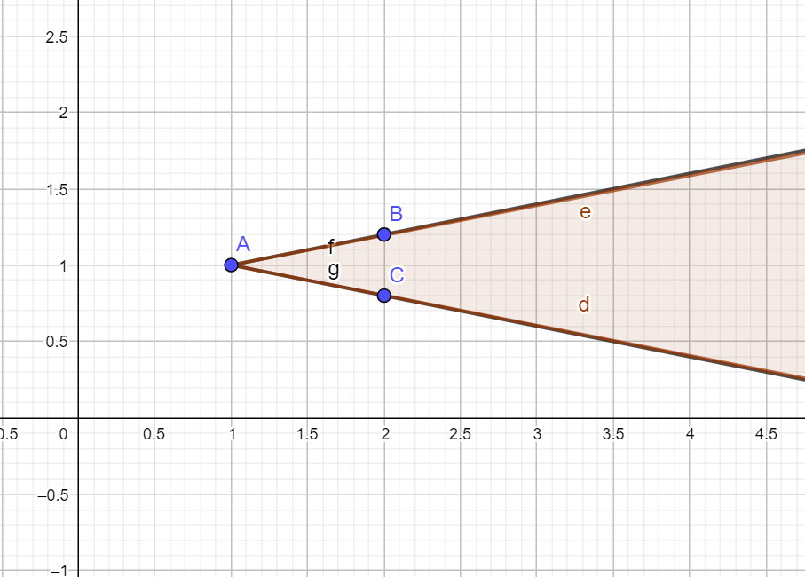
Figure 20. Particle’s position at time $t=2$ is $0,8≤S\left(2\right)≤1,2.$
8.4 CAUCHY THEOREM
Suppose $f(x)$ and $g(x)$ are continuous on the closed interval $[a;b]$ and differentiable on the open interval $(a;b)$, and $g\left(x\right)≠0, ∀x∈[a;b]$ then there is at least one point $x=c$ on this interval, such that: $\frac{f\left(b\right)-f\left(a\right)}{g\left(b)-g(a\right)}=\frac{f^{/}\left(c\right)}{g^{/}\left(c\right)}$.
The Rolle’s theorem, Lagrange`s mean value theorem and Cauchy theorem are used to prove L`Hopital's theorem, which is important for practice.

8.5 L’HOPITAL’S THEOREM (L'Hôpital's rule)
There are two versions of L’Hopital’s theorem, which provide an opportunity to solve problems of indeterminate forms $\frac{0}{0};\frac{∞}{∞};∞-∞;∞∙0; 1^{∞};0^{0};∞^{0}$.
L’HOPITAL’S THEOREM 1: $\left(\frac{0}{0}\right)$ Suppose $f(x)$ and $g(x)$ be continuous and differentiable functions on an interval containing $x=a$, with$f\left(a\right)=g\left(a\right)=0$, and assume that $f^{/}(x)$ and $g^{/}(x)$ are continuous at $x=a$ and $g^{/}(a)≠0$. If exist $\lim_{x→a}{\frac{f^{/}(x)}{g^{/}(x)}=K}$ then:
$\lim_{x→a}{\frac{f(x)}{g(x)}}=\lim_{x→a}{\frac{f^{/}(x)}{g^{/}(x)}=K}$, also $\lim_{x→a+}{\frac{f(x)}{g(x)}}=\lim_{x→a+}{\frac{f^{/}(x)}{g^{/}(x)}}$ and $\lim_{x→a-}{\frac{f(x)}{g(x)}}=\lim_{x→a-}{\frac{f^{/}(x)}{g^{/}(x)}}$.

EXAMPLE 3. Compute the limits: 1)$\lim_{x→-1}{\frac{x^{2}+6x+5}{x+1}}$; 2) $\lim_{x→0}\frac{2\sin^{2}3x}{tgx}$.
SOLUTION: 1) We apply of L’Hopital’s rule if $f\left(x\right)=x^{2}+6x+5$ and
$g\left(x\right)=x+1$: $\lim_{x→-1}{\frac{x^{2}+6x+5}{x+1}=\left(\frac{0}{0}\right)=}\lim_{x→-1}\frac{2x+6}{1}=4$;
2) We apply of L’Hopital’s rule if $f\left(x\right)=2\sin^{2}3x$ and $g\left(x\right)=tgx$:
$\lim_{x→0}\frac{2\sin^{2}3x}{tgx}=\left(\frac{0}{0}\right)=2\lim_{x→0}\frac{6sin3xcos3x}{1/{\cos^{2}x}}=6\lim_{x→0}\frac{sin6x}{1/{\cos^{2}x}}=0$.

L’hopital’s Theorem 1. can be applied if $x→±∞$ using a substitution:
$x→\frac{1}{x},$ then:
$\lim_{x→∞}{\frac{f(x)}{g(x)}}=\lim_{x→0}\frac{f\left(\frac{1}{x}\right)}{g\left(\frac{1}{x}\right)}=\lim_{x→0}{\frac{{\left(f\left(\frac{1}{x}\right)\right)}^{/}}{{\left(g\left(\frac{1}{x}\right)\right)}^{/}}}=\lim_{x→0}\frac{f^{/}\left(\frac{1}{x}\right)\left(-\frac{1}{x^{2}}\right)}{g^{/}\left(\frac{1}{x}\right)\left(-\frac{1}{x^{2}}\right)}=\lim_{x→∞}{\frac{f^{/}(x)}{g^{/}(x)}}$and $\frac{∞}{∞}=\frac{\frac{1}{0}}{\frac{1}{0}}=\frac{0}{0}.$

EXAMPLE 4. Compute the limits: $\lim_{x→∞}{\frac{x^{2}+6x+5}{x^{3}-{3x}^{2}+x+1}}$.
SOLUTION: Functions ${f\left(x\right)=x}^{2}+6x+5$, $g\left(x\right)=x^{3}-{3x}^{2}+x+1$ satisfy conditions of the L’hopital’s theorems and their derivatives also execute that conditions, then the L’hopital’s theorem is used twice:
$\lim_{x→∞}{\frac{x^{2}+6x+5}{x^{3}-{3x}^{2}+x+1}=}\left(\frac{∞}{∞}\right)⟹$
$\lim_{x→∞}{\frac{{(x^{2}+6x+5)}^{/}}{{(x^{3}-{3x}^{2}+x+1)}^{/}}=}\lim_{x→∞}{\frac{2x+6}{{3x}^{2}-6x+1}=\left(\frac{∞}{∞}\right)=\lim_{x→∞}\frac{{(2x+6)}^{/}}{{({3x}^{2}-6x+1)}^{/}}\lim_{x→∞}\frac{2}{6x-6}=0}$.
L’HOPITAL’S THEOREM 2: $\left(\frac{∞}{∞}\right)$ Suppose$f(x)$ and $g(x)$ be continuous and differentiable functions on an interval containing $x=a$ (except perhaps the point itself $x=a$) with$f\left(x\right)=g\left(x\right)=±∞$ on it and assume that $g^{/}(a)≠0$. If exist $\lim_{x→a}{\frac{f^{/}(x)}{g^{/}(x)}}=K$ then: $\lim_{x→a}{\frac{f(x)}{g(x)}}\underset{x→a}{=lim}{\frac{f^{/}(x)}{g^{/}(x)}}=K$.

Remark:
- Point $x=a$ can be finite or infinite;
- The number $K$ can be finite or infinite;
- The L’Hopital’s Theorem can be used in the case of one-sided limits
- If derivatives of functions $f(x)$ and $g(x)$ satisfy the conditions of the L’Hopital’s Theorem, the both of L’Hopital’s Theorem can be used again.

EXAMPLE 5. Compute the limits: $\lim_{x→±∞}{\frac{e^{x}}{x^{2}}}$.
SOLUTION:$\left[\begin{matrix}\lim_{x→+∞}{\frac{e^{x}}{x^{2}}}=\left(\frac{∞}{∞}\right)⟹\lim_{x→+∞}{\frac{{(e^{x})}^{/}}{{(x^{2})}^{/}}}=\lim_{x→+∞}{\frac{e^{x}}{2x}=\left(\frac{∞}{∞}\right)}=\lim_{x→+∞}{\frac{e^{x}}{2}=+∞, } \\ \lim_{x→-∞}{\frac{e^{x}}{x^{2}}}=\left(\frac{0}{∞}\right)⟹\lim_{x→+∞}\frac{e^{-x}}{x^{2}}=\lim_{x→+∞}\frac{1}{{e^{x}x}^{2}}=0.\end{matrix}\right.$,
Similarly, we can prove that: $\lim_{x→+∞}{\frac{x^{k}}{e^{x}}=0}$ for $k∈R$.
This result means that as $x→+∞$, the exponential function $e^{x}$ is going too faster than any polynomial of $x$.

Other indeterminate forms: $∞∙0;∞-∞; 1^{∞};0^{0};∞^{0}$.
1) Note that these forms above are just formal expressions which does not have very precise mathematical meanings as $∞$ is not a real number (also$±∞$). Some of the indeterminate forms can actually be rewritten into the standard form $\left(\frac{0}{0}\right)$. Symbolically we have $\frac{1}{0}=∞$, and $0∙∞=0∙\frac{1}{0}=\frac{1}{∞}∙∞$. Therefore:
$$\left[\begin{matrix}\lim_{x→a}{f\left(x\right)∙g\left(x\right)=}\left(0∙∞\right)=\lim_{x→a}\frac{f\left(x\right)}{1/{g\left(x\right)}}=\left(\frac{0}{0}\right), \\ \lim_{x→a}{f\left(x\right)∙g\left(x\right)=}\left(∞∙0\right)=\lim_{x→a}\frac{g\left(x\right)}{1/{f\left(x\right)}}=\left(\frac{∞}{∞}\right).\end{matrix}\right.$$

EXAMPLE 6. Compute the limits: $\lim_{x→2}\left(x-2\right){tg\frac{πx}{4}}$.
SOLUTION: $\lim_{x→2}\left(2-x\right){tg\frac{πx}{4}=\left(0∙∞\right)=\lim_{x→2}\frac{(2-x)}{ctg\frac{πx}{4}}}=\left(\frac{0}{0}\right)⟹$
$⟹\lim_{x→2}\frac{{\left(2-x\right)}^{/}}{{\left(ctg\frac{πx}{4}\right)}^{/}}=-\underset{x→2}{\frac{4}{π}lim}\frac{-1}{1/{\sin^{2}\frac{πx}{4}}}=\frac{4}{π}\lim_{x→2}{\sin^{2}\frac{πx}{4}=}\frac{4}{π}$.
EXAMPLE 7. Consider the one-side limit: $\lim_{x→0+}xlnx$.
SOLUTION: $\lim_{x→0+}xlnx=\left(0∙(-∞\right))=\lim_{x→0+}\frac{lnx}{1/x}=\left(\frac{∞}{∞}\right)⟹$
$⟹\lim_{x→0+}\frac{{\left(lnx\right)}^{/}}{\left(1/x\right)}=-\lim_{x→0+}{\frac{1/x}{1/{x^{2}}}}=-\lim_{x→0+}{x}=0$.
This result means that as $x→0+$, the linear function $x$ is going too faster than the logarithm function $lnx$ going to $-∞$.
2) There is in fact no general way to evaluate the indeterminate form $∞-∞$, but for this particular example, we can transform it as:
$$\lim_{x→0}\left(\frac{1}{sinx}-\frac{1}{x}\right)=\left(∞-∞\right)=\lim_{x→0}\frac{x-sinx}{xsinx}=\left(\frac{0}{0}\right)=\lim_{x→0}\frac{1-cosx}{sinx+xcosx}=\left(\frac{0}{0}\right)=$$
$$=\lim_{x→0}\frac{sinx}{2cosx-xsinx}=0.$$

3) $1^{∞};0^{0};∞^{0}$. Recall that if $a>0$, and $b∈R$ , we define:
$a^{b}=e^{lna^{b}}=exp(b∙lna)$. Therefore:
$\lim_{x→a}{\left(f(x)\right)}^{g(x)}=e^{\underset{x→a}{limln{\left(f(x)\right)}^{g(x)}}}\underset{x→a}{=lim}exp\left(g\left(x\right)∙ln⁡(f(x))\right)=$
$$=exp\lim_{x→a}(g\left(x\right)∙ln⁡(f(x)).$$

EXAMPLE 8. Compute the limits:$\lim_{x→∞}x^{\frac{1}{x}}$.
SOLUTION: $\lim_{x→∞}x^{\frac{1}{x}}=\left(∞^{0}\right)=exp\left(\lim_{x→∞}\frac{1}{x}lnx\right)=exp\left(\lim_{x→∞}\frac{lnx}{x}\right)=\left(\frac{∞}{∞}\right)=$
$$=exp\lim_{x→∞}\frac{1}{x}=e^{0}=1.$$
EXAMPLE 9. Compute the limits:$\lim_{x→0}{(cos2x)}^{\frac{1}{x^{2}}}$.
SOLUTION:$\lim_{x→0}{(cos2x)}^{\frac{1}{x^{2}}}={(1}^{∞})=exp\left(\lim_{x→0}\frac{1}{x^{2}}ln(cos2x)\right)=$
$=exp\left(\lim_{x→0}\frac{ln(cos2x)}{x^{2}}\right)=\left(\frac{0}{0}\right)=exp\left(\lim_{x→0}\frac{\frac{2(-sin2x)}{cos2x}}{2x}\right)$=$-2exp\left(\lim_{x→0}{\frac{tg2x}{2x}}\right){=e}^{-2}$
EXAMPLE 10. Compute the limits:$\lim_{x→0}{\left(x^{2}\right)}^{tgx}$.
SOLUTION:$\lim_{x→0}{\left(x^{2}\right)}^{tgx}={(0}^{0})=exp\left(\lim_{x→0}\left(tgx∙lnx^{2}\right)\right)=\left(0∙∞\right)=$
$exp\left(\lim_{x→0}\frac{lnx^{2}}{ctgx}\right)=\left(\frac{∞}{∞}\right)$=$exp\left(\lim_{x→0}\frac{\frac{1}{x^{2}}2x}{\frac{1}{\cos^{2}x}}\right)=exp\left(\lim_{x→0}\frac{2\cos^{2}x}{x}\right)=e^{∞}=∞.$

PROBLEM 16. Find the limits:
1.$\lim_{x→0}{\frac{6sinx-6x+x^{3}}{x^{2}}}$; | 11. $\lim_{x→0}{\frac{x^{2}}{6sinx-6x+x^{3}}}$;
2. $\lim_{x→1}{\frac{e^{x-1}-x-1}{x^{3}{+2x}^{2}-7x+4}}$; | 12. $\lim_{x→-1}{\frac{e^{x+1}+x-1}{x^{3}{+6x}^{2}+9x+4}}$;
3. $\lim_{x→2}{\frac{2ln(x-1)+x^{2}-6x+8}{2x^{3}{-6x}^{2}+8}};$ | 13. $\lim_{x→-2}{\frac{2ln(x+3)+x^{2}+2x}{x^{3}{+5x}^{2}+8x+4}}$;
4. $\lim_{x→2}{\frac{2e^{x-2}-x^{2}+2x-2}{x^{3}{-3x}^{2}+4}}$; | 14. $\lim_{x→-1}{\frac{x^{3}{-x}^{2}-5x-3}{2ln(2-x)+x^{2}-1}}$;
5. $\lim_{x→-2}{\frac{2x^{3}{+10x}^{2}+16x+8}{2e^{x+2}-x^{2}-6x-10}}$; | 15. $\lim_{x→1}{\frac{2lnx+x^{2}+4x+3}{4x^{3}{-20x}^{2}+28x-12}}$;
6. $\lim_{x→1}{\frac{3e^{x-1}-3x-3}{x^{3}{-5x}^{2}+7x-3}}$; | 16. $\lim_{x→3}{\frac{x^{3}{-3x}^{2}-9x+27}{e^{x-3}-x+2}}$;
7. $\lim_{x→0}{\frac{2\sqrt{x+1}-x-2}{x^{3}{-3x}^{2}+x}}$; | 17. $\lim_{x→2}{\frac{x^{3}{-6x}^{2}+12x-8}{2ln(x-1)+x^{2}-6x+8}}$;
8. $\lim_{x→3}{\frac{2ln(x-2)-x^{2}+4x-3}{x^{3}{-3x}^{2}-9x+27}}$; | 18. $\lim_{x→0}{\frac{{2x}^{3}-3x^{2}}{3-x-3\sqrt[3]{x+1}}}$;
9. $\lim_{x→2}{\frac{2e^{x-2}-x^{2}+2x-2}{x^{3}{-7x}^{2}+12x-12}}$; | 19. $\lim_{x→-3}{\frac{2\sqrt{x+4}+x+1}{x^{3}{+7x}^{2}+15x+9}}$;
10. $\lim_{x→-1}{\frac{2ln(x+2)-x^{2}-4x-3}{x^{3}{-x}^{2}-5x-3}}$; | 20. $\lim_{x→2}{\frac{x^{3}{-2x}^{2}-4x+8}{2ln(3-x)+x^{2}-2x}}$.

Questions for self-control:
- Check whether the Roll theorem performed for a function $y=\sqrt[3]{x^{2}}$ on the close interval $[-1;1]$.
- Show that the function $f\left(x\right)=x^{2}+5x+4$ satisfies the conditions of Roll's theorem on the interval $[-4;-1]$.
- Check whether the Roll theorem performed for a function $y=\left|x-4\right|$ on the close interval $[2;6]$.
- How many solutions does the equation $f^{/}\left(x\right)=0$ has if
- $f\left(x\right)=x(x-1)(x-2)$?
- Proof that $\ln\left(x+1\right)<x, ∀x>0$. Use Lagrange's theorem on the segment $[0;x]$ for proof.
- Write the Cauchy formula $\frac{f\left(b\right)-f\left(a\right)}{g\left(b)-g(a\right)}=\frac{f^{/}\left(c\right)}{g^{/}\left(c\right)}$ for functions:
$f\left(x\right)={2x}^{2}+5x+1$ and $g\left(x\right)=x^{2}+4$ on the segment $[0;2]$ and find the value $x=c, c∈\left[0;2\right].$
- For which indeterminate forms can be used of L’Hopital’s theorem?
- How can be used of L’Hopital’s theorem for indeterminate forms $1^{∞};0^{0};∞^{0}$?
- Problem: The bank is robbed in Davidson at 1:00 P.M. The RCMP know that the robbers will head for either Saskatoon or Regina at no more than 200 kmh. Where should they locate their roadblocks at 1:12 P.M.?

9. THE TAYLOR AND THE MACLAURIN FORMULAS
9.1 THE TAYLOR` S POLYNOMIAL AND REMAINDER TERM
In mathematics, the Taylor formula of a function is an infinite sum of terms that are expressed in terms of the function's derivatives at a single point. This result which allows us to compute the values of elementary functions like $sinx, lnx, e^{x}, \frac{c}{ax+b}$ and their combinations. This formula can be used to approximate these functions by polynomials (which are easy to compute) and provides an estimate of the error involved in the approximation.
Definition: The Taylor`s polynomial of $n-$th order of the function $f\left(x\right)$ by powers of $\left(x-x_{0}\right)$ is called a polynomial:
$T_{n}(x)=f\left(x_{0}\right)+\frac{f^{/}\left(x_{0}\right)}{1!}\left(x-x_{0}\right)+\frac{f^{//}\left(x_{0}\right)}{2!}{\left(x-x_{0}\right)}^{2}+⋯+\frac{f^{\left(n\right)}\left(x_{0}\right)}{n!}{\left(x-x_{0}\right)}^{n}$.
The values of the derivatives of the function and its Taylor polynomial up to the nth order are the same:
$$T_{n}\left(x\right)=f\left(x_{0}\right),T_{n}^{/}\left(x_{0}\right)=f^{/}\left(x_{0}\right), T_{n}^{//}\left(x_{0}\right)=f^{/}\left(x_{0}\right), ⋯T_{n}^{\left(n\right)}\left(x_{0}\right)=f^{\left(n\right)}\left(x_{0}\right).$$
Definition: The Taylor`s formula of $n-$th order of the function $f\left(x\right)$ in around the point $x_{0}$ is called the formula:
$$f\left(x\right)=T_{n}\left(x\right)+R_{n}\left(x\right),$$
where $T_{n}\left(x\right)$ the Taylor`s polynomial, $R_{n}\left(x\right)=f\left(x\right)-T_{n}\left(x\right)$ remainder term.
Also, the function $T_{n}\left(x\right)$ is called the Taylor polynomial of degree $n$ of the function $f\left(x\right)$ at point $x_{0}$. This can be thought of as a polynomial which approximates the function $f\left(x\right)$ in some interval containing $x_{0}$. The error in the approximation is given by the remainder term $R_{n}\left(x\right)$. If we can show $R_{n}\left(x\right)→0$ as $n→∞$ then we get a sequence of better and better approximations to $f\left(x\right)$ leading to a power series expansion:
$$f(x)=\sum_{n=1}^{∞}{\frac{f^{\left(n\right)}\left(x_{0}\right)}{n!}{\left(x-x_{0}\right)}^{n},}$$
which is known as the Taylor series for $f(x)$.
TAYLOR’S THEOREM: Let function $f\left(x\right)$ be an $n+1$ times differentiable function on an open interval containing the points $x_{0}$ and $x$. Then:
$f\left(x\right)=f\left(x_{0}\right)+\frac{f^{/}\left(x_{0}\right)}{1!}\left(x-x_{0}\right)+\frac{f^{//}\left(x_{0}\right)}{2!}{\left(x-x_{0}\right)}^{2}+\frac{f^{///}\left(x_{0}\right)}{3!}{\left(x-x_{0}\right)}^{3}+⋯++\frac{f^{\left(n\right)}\left(x_{0}\right)}{n!}{\left(x-x_{0}\right)}^{n}+R_{n}(x)$,
where $R_{n}\left(x\right)$ is remainder term which is determined by the necessary accuracy of the calculation and can be represented in Lagrange form, Peano form or others.
Remark. The theorem makes it possible to write a function by a polynomial of the form:
$$Q_{n}\left(x\right)=a_{0}+a_{1}\left(x-x_{0}\right)+a_{2}{\left(x-x_{0}\right)}^{2}+a_{3}{\left(x-x_{0}\right)}^{3}+⋯+a_{n}{\left(x-x_{0}\right)}^{n},$$
where $a_{k}=\frac{f^{\left(k\right)}\left(x_{0}\right)}{k!}, k=\overline{1,n}.$
Remark. If the function $f\left(x\right)$ is polynomial of $n-$th order $R_{n}\left(x\right)=0$.
Remark. Taylor's formula near the point $x_{0}=0$ is called the Maclaurin formulas:
$f\left(x\right)=f\left(0\right)+\frac{f^{/}\left(0\right)}{1!}x+\frac{f^{//}\left(0\right)}{2!}x^{2}+\frac{f^{///}\left(x_{0}\right)}{3!}x^{3}+⋯+\frac{f^{\left(n\right)}\left(0\right)}{n!}x^{n}+⋯=\sum_{n=1}^{∞}{\frac{f^{\left(n\right)}\left(0\right)}{n!}x^{n}}$.
Definition (Peano form of the remainder):
Let $n≥1$ be an integer, and let $x_{0}∈R$ be a point. If $f\left(x\right)$ is a function that is $n$ times differentiable at the point $x_{0}$, then there exists a function $θ_{n}(x)$ such that:
$f\left(x\right)=T_{n}\left(x\right)+θ_{n}\left(x\right){\left(x-x_{0}\right)}^{n},$ where $\lim_{x→x_{0}}{θ_{n}\left(x\right)=0}.$
The term $R_{n}\left(x\right)=f\left(x\right)-T_{n}\left(x\right)=θ_{n}\left(x\right){\left(x-x_{0}\right)}^{n}$ is called the Peano form of the remainder.
Definition (Lagrange form of the Remainder): Let $n≥1$ be an integer, and let $x_{0}∈R$ be a point. If $f\left(x\right)$ is a function that is $n+1$ times differentiable on an open interval $℧$containing $x_{0}$, then for all $x∈℧$, there exists a number $c$ strictly between $x_{0}$ and $x$ such that: $R_{n}\left(x\right)=\frac{f^{\left(n+1\right)}\left(c\right)}{\left(n+1\right)!}{\left(x-x_{0}\right)}^{n+1}$, also
$R_{n}\left(x\right)=\frac{f^{\left(n+1\right)}\left(x_{0}+θ(x-x_{0})\right)}{\left(n+1\right)!}{\left(x-x_{0}\right)}^{n+1},0<θ<1$.
Taylor's formula can be written in differential form if: $x-x_{0}=∆x$, $x=x_{0}+∆x$
$f\left(x\right)=f\left(x_{0}\right)+\frac{f^{/}\left(x_{0}\right)}{1!}∆x+\frac{f^{//}\left(x_{0}\right)}{2!}{∆x}^{2}+⋯++\frac{f^{\left(n\right)}\left(x_{0}\right)}{n!}{∆x}^{n}+R_{n}(x)$, because
$$∆f\left(x_{0}\right)={f(x}_{0}+∆x)-f\left(x_{0}\right), f^{\left(n\right)}\left(x_{0}\right){∆x}^{n}=d^{n}f\left(x_{0}\right).$$
Then the Taylor formula of the $n-$ th order of the function $f(x)$ can be written in differential form:
$∆f\left(x_{0}\right)=df\left(x_{0}\right)+\frac{d^{2}f\left(x_{0}\right)}{2!}{∆x}^{2}+\frac{d^{3}f\left(x_{0}\right)}{3!}{∆x}^{3}+⋯+\frac{d^{n}f\left(x_{0}\right)}{n!}{∆x}^{n}+R_{n}\left(x\right)$.

9.2 TAYLOR'S - MACLAURIN FORMULA FOR
ELEMENTARY FUNCTIONS
$f\left(x\right)=f\left(0\right)+\frac{f^{/}\left(0\right)}{1!}x+\frac{f^{//}\left(0\right)}{2!}x^{2}+\frac{f^{///}\left(x_{0}\right)}{3!}x^{3}+⋯+\frac{f^{\left(n\right)}\left(0\right)}{n!}x^{n}+R_{n}(x)$.
EXAMPLE 1. Find the Taylor`s formula for $y=e^{x}$ for $x_{0}=0, x_{0}=1$.
SOLUTION: 1) If $x_{0}=0$ all derivatives of $f\left(x\right)$ are $e^{x}$, so $f^{\left(n\right)}\left(0\right)=1$ for all $n≥0$:
$$\left.\begin{matrix}f^{/}\left(x\right)=e^{x}, \\ f^{//}\left(x\right)=e^{x}, \\ \begin{matrix}\begin{matrix}f^{///}\left(x\right)=e^{x}, \\ ⋮\end{matrix} \\ f^{(n)}\left(x\right)=e^{x}, \\ f^{(n+1)}\left(x\right)=e^{x},\end{matrix}\end{matrix}\right\}⟹\left\{\begin{matrix}f^{/}\left(0\right)=1, \\ f^{//}\left(0\right)=1, \\ \begin{matrix}\begin{matrix}f^{///}\left(0\right)=1, \\ ⋮\end{matrix} \\ f^{(n)}\left(0\right)=1, \\ f^{(n+1)}\left(c\right)=e^{c}, c∈\left(0;x\right).\end{matrix}\end{matrix}\right.$$
$$\begin{matrix}e^{x}=1+x+\frac{x^{2}}{2!}+\frac{x^{3}}{3!}+\frac{x^{4}}{4!}+⋯+\frac{x^{n}}{n!}+θ_{n}\left(x^{n}\right), \\ e^{x}=1+x+\frac{x^{2}}{2!}+\frac{x^{3}}{3!}+\frac{x^{4}}{4!}+⋯+\frac{x^{n}}{n!}+\frac{x^{n+1}}{\left(n+1\right)!}e^{c}, c∈\left(0;x\right).\end{matrix}$$
2) If $x_{0}=1$ all derivatives of $f\left(x\right)$ are $e^{x}$, so $f^{\left(n\right)}\left(1\right)=e$ for all $n≥0$:
$e^{x}=1+e\left(x-1\right)+\frac{e}{2!}{\left(x-1\right)}^{2}+\frac{e}{2!}{\left(x-1\right)}^{2}+⋯+\frac{e}{n!}{\left(x-1\right)}^{n}+R_{n}(x)$.
EXAMPLE 2. Calculate the Euler number $e$ accurately $ℇ=0.001$.
SOLUTION: We use the Maclaurin formula:
$e=1+1+\frac{1}{2!}+\frac{1}{3!}+\frac{1}{4!}+⋯+\frac{1}{n!}+\frac{e^{c}}{\left(n+1\right)!}, c∈\left(0;1\right)$,
The smallest value of $n$ that satisfies the condition $\frac{e^{c}}{\left(n+1\right)!}≈\frac{2}{7!}<0,001$, where $c∈\left(0;1\right)$ equal $n_{0}=6$. Because: $e≈1+1+\frac{1}{2!}+\frac{1}{3!}+\frac{1}{4!}+\frac{1}{5!}+\frac{1}{6!}=2,718.$
9.3 TABLE OF IMPORTANT MACLAURIN FORMULA
function | maclaurin formula
$$e^{x}$$ | $1+x+\frac{x^{2}}{2!}+\frac{x^{3}}{3!}+\frac{x^{4}}{4!}⋯+\frac{x^{n}}{n!}+R_{n}(x)$,  $R_{n}\left(x\right)=\left[\begin{matrix}θ_{n}\left(x^{n}\right), \\ \frac{x^{n+1}}{\left(n+1\right)!}e^{c}, c∈\left(0;x\right).\end{matrix}\right.$ | $$x∈R$$
$$sinx$$ | $x-\frac{x^{3}}{3!}+\frac{x^{5}}{5!}-\frac{x^{7}}{7!}+⋯+\frac{{{\left(-1\right)}^{n}x}^{2n+1}}{\left(2n+1\right)!}+R_{n}(x)$,  $R_{n}\left(x\right)=\left[\begin{matrix}θ_{n}\left(x^{2n}\right), \\ {(-1)}^{n+1}cosc\frac{x^{n+1}}{\left(2n+1\right)!}e^{c}, c∈\left(0;x\right),\end{matrix}\right.$. | $$x∈R$$
$$cosx$$ | $1-\frac{x^{2}}{2!}+\frac{x^{4}}{4!}-\frac{x^{6}}{6!}+⋯+{\left(-1\right)}^{n}\frac{x^{2n}}{\left(2n\right)!}+R_{n}(x)$,  $$R_{n}\left(x\right)=\left[\begin{matrix}θ_{n}\left(x^{2n+1}\right), \\ {(-1)}^{n+1}sinc\frac{x^{n+1}}{\left(2n+2\right)!}e^{c}, c∈\left(0;x\right),\end{matrix}\right.$$ | $$x∈R$$
$$\frac{1}{1±x}$$ | $$1±x+x^{2}±x^{3}+⋯+{\left(-1\right)}^{n}x^{n}+R_{n}\left(x\right).$$ | $$\left|x\right|<1$$
$$\ln\left(1+x\right)$$ | $$x-\frac{x^{2}}{2}+\frac{x^{3}}{3}-\frac{x^{4}}{4!}+⋯+\frac{{\left(-1\right)}^{n-1}}{n}x^{n}+R_{n}\left(x\right).$$  $$R_{n}\left(x\right)=\left[\begin{matrix}θ_{n}\left(x^{n}\right), \\ \frac{{(-1)}^{n}}{{(1+c)}^{n+1}}\frac{x^{n+1}}{n+1}, c∈\left(0;x\right),\end{matrix}\right.$$ | $$\left|x\right|<1$$
$$tgx$$ | $$x-\frac{x^{3}}{3}+\frac{x^{5}}{5}-\frac{x^{7}}{7}+⋯+\frac{{{\left(-1\right)}^{n}x}^{2n+1}}{2n+1}+R_{n}\left(x\right).$$  $$R_{n}\left(x\right)=\left[\begin{matrix}θ_{n}\left(x^{2n}\right), \\ {(-1)}^{n+1}tgc\frac{x^{n+1}}{2n+3}, c∈\left(0;x\right),\end{matrix}\right.$$ | $$\left|x\right|<1$$
$$({x+1)}^{α}$$ | $$1+αx+\frac{α(α-1)}{2!}x^{2}+⋯+\frac{α\left(α-1\right)⋯\left(α-n+1\right)}{n!}x^{k}+R_{n}\left(x\right).$$  $R_{n}\left(x\right)=\left[\begin{matrix}θ_{n}\left(x^{n}\right), \\ \frac{α\left(α-1\right)⋯\left(α-n\right){(1+c)}^{α-n-1}}{\left(n+1\right)!}x^{n+1}, c∈\left(0;x\right),\end{matrix}\right.$. | $$\left|x\right|≤1$$

Remark: The Taylor formula / Maclaurin formula of the infinitely differentiable function does not necessarily equal to the original function. A proof is required to show that they are equal (or not equal) for a function under consideration, see Figure 21.
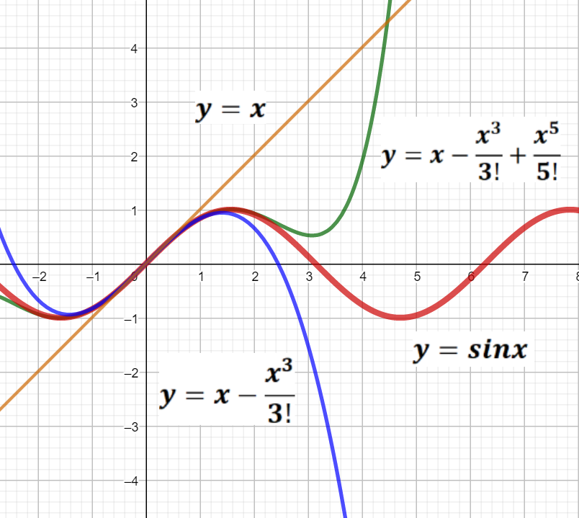
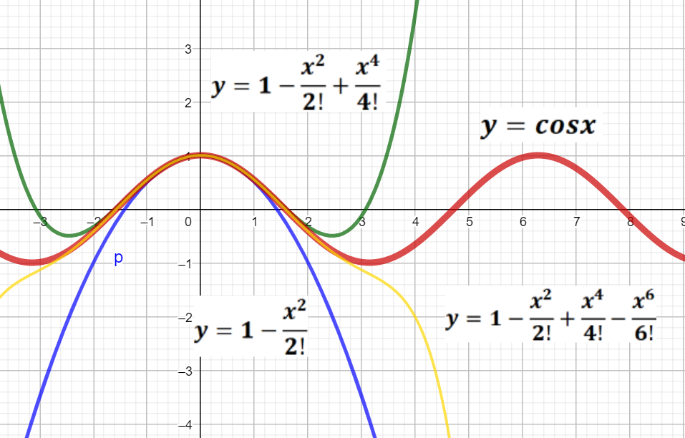
Figure 21. Approximation of the function $y=sinx$ and
$y=cosx$ of Taylor polynomials.

EXAMPLE 3: Find the limit: $\lim_{x→0}{\frac{sinx}{x}}$.
SOLUTION: We use the Maclaurin formula for $sinx$:
$$\lim_{x→0}{\frac{sinx}{x}=}\lim_{x→0}{\frac{x-\frac{x^{3}}{3!}+\frac{x^{5}}{5!}-\frac{x^{7}}{7!}+⋯}{x}=\lim_{x→0}}\left(1-\frac{x^{2}}{3!}+\frac{x^{4}}{5!}-\frac{x^{6}}{7!}+⋯\right)=1.$$
The result agrees with the answer we get from L‘Hopital’s Rule and The first Important limint.
EXAMPLE 4: Find the Taylor`s polynomial for function
$f(x)=x^{3}+{5x}^{2}-4x+7$ at $x_{0}=1.$
SOLUTION: We need to find the derivatives of $f(x)$ and $f\left(x_{0}\right)=f\left(1\right)=9$:
$$\left.\begin{matrix}f^{/}\left(x\right)=3x^{2}+10x-4, \\ f^{//}\left(x\right)=6x+10, \\ f^{///}\left(x\right)=6,\end{matrix}\right\}⟹\left\{\begin{matrix}f^{/}\left(x_{0}\right)=f^{/}\left(1\right)=9, \\ f^{//}\left(x_{0}\right)=f^{//}\left(1\right)=16, \\ f^{///}\left(x_{0}\right)=f^{///}\left(1\right)=6.\end{matrix}\right.$$
The Taylor`s polynomial of the given function $f(x)=x^{3}+{5x}^{2}-4x+7$:
$f\left(x\right)=f\left(x_{0}\right)+\frac{f^{/}\left(x_{0}\right)}{1!}\left(x-x_{0}\right)+\frac{f^{//}\left(x_{0}\right)}{2!}{\left(x-x_{0}\right)}^{2}+\frac{f^{///}\left(x_{0}\right)}{3!}{\left(x-x_{0}\right)}^{3}⟹$
$$⟹f\left(x\right)=9+\frac{9}{1!}\left(x-1\right)+\frac{16}{2!}{\left(x-1\right)}^{2}+\frac{6}{3!}{\left(x-1\right)}^{3}.$$

PROBLEM 17. Find the Taylor polynomial for function $f(x)$ at the given point $x_{0}$:
1. | $$x^{4}-5x^{3}{+x}^{2}-3x+4, x_{0}=2$$ | 11. | $$x^{4}-x^{3}{+5x}^{2}-3x-2, x_{0}=1$$
2. | $$x^{4}+3x^{3}{-x}^{2}+2x+1, x_{0}=1$$ | 12. | $$x^{4}{-5x}^{2}-2x+2, x_{0}=-2$$
3. | $$x^{4}+3x^{3}{-x}^{2}+2x, x_{0}=-1$$ | 13. | $$x^{4}+4x^{3}{-3x}^{2}+x, x_{0}=-2$$
4. | $$x^{4}-2x^{3}{+x}^{2}-x+4, x_{0}=-1$$ | 14. | $$x^{4}-3x^{3}{+x}^{2}-2x+3, x_{0}=1$$
5. | $$x^{4}{+5x}^{2}-3x+2, x_{0}=-2$$ | 15. | $$x^{4}-x^{3}{+3x}^{2}-x+5, x_{0}=-1$$
6. | $$x^{4}-x^{3}{+2x}^{2}-3x+4, x_{0}=2$$ | 16. | $$x^{4}+3x^{3}-5x+2, x_{0}=-1$$
7. | $$x^{4}{+5x}^{3}-3x+2, x_{0}=-2$$ | 17. | $$x^{4}-x^{3}{+3x}^{2}-x+3, x_{0}=-1$$
8. | $$x^{4}-4x^{3}{+3x}^{2}-x+1, x_{0}=2$$ | 18. | $$x^{4}-4x^{3}{+x}^{2}-2x+1, x_{0}=2$$
9. | $$x^{4}+4x^{3}{-x}^{2}+3x+2, x_{0}=1$$ | 19. | $$x^{4}+4x^{3}{-3x}^{2}+x+1, x_{0}=1$$
10. | $$x^{4}{+6x}^{3}-2x+2, x_{0}=-2$$ | 20. | $$x^{4}+x^{3}{-3x}^{2}+5x, x_{0}=-1$$

Questions for self-control:
- What is number $θ$ in Lagrange form of the Remainder?
- What is the meaning of the function $θ_{n}(x)$ in Peano form of the Remainder?
- How many terms can the Taylor polynomial has?
- What kind of approximation is given by the remainder term$R_{n}\left(x\right)$?
- Find the Taylor polynomial of the second order for function $f\left(x\right)=x^{4}+4x^{2}-x+3$ at the given point $x_{0}=1$ with the Remainder $R_{n}(x)$ of Lagrange form.
- Find the Taylor polynomial of the third order for function
$f\left(x\right)=\frac{1}{\sqrt{x}}$ at the point $x_{0}=1$.
- Find the Taylor polynomial of the third order for function
$f\left(x\right)=arcsinx$.

10. THE INVESTIGATION OF FUNCTIONS USING DERIVATIVES
Derivatives are used to describe the shapes of graphs of functions.
10.1 INCREASING AND DECREASING FUNCTIONS
DEFINITION: A continuous function $f\left(x\right)$ is called increasing on an interval $(a;b)$ if for any $x_{1},x_{2}∈(a;b)$ , we have that $x_{1}<x_{2}⟹{f(x}_{1})<{f(x}_{2})$.
A continuous function $f\left(x\right)$ is called decreasing on an interval $(a;b)$ if for any $x_{1},x_{2}∈(a;b)$ we have that $x_{1}<x_{2}⟹{f(x}_{1})>{f(x}_{2})$.
Note that some books call these strictly increasing and strictly decreasing respectively.
Derivatives can be used to determine whether a continuous function is increasing, decreasing or constant on an interval. Let $f\left(x\right)$ be differentiable on the interval $\left(a;b\right):$
$f\left(x\right)$ is increasing if derivative $f^{/}\left(x\right)>0$,
$f\left(x\right)$ is decreasing if derivative $f^{/}\left(x\right)<0,$
$f\left(x\right)$ is constant if derivative $f^{/}\left(x\right)=0.$

$f\left(x\right)$ is increasing if${f(x}_{1})<{f(x}_{2})$ if $x_{1}<x_{2}$,
$f\left(x\right)$ is decreasing if ${f(x}_{1})>{f(x}_{2})$ if $x_{1}<x_{2}.$
$f^{/}\left(x\right)$is constant if ${f(x}_{1})={f(x}_{2})$ if ${∀x}_{1},x_{2}∈(a;b)$

If function $f\left(x\right)$ is a continuous function, then function $f^{/}\left(x\right)$can only change signs at values of $x=x_{0}$ where $f^{/}\left(x_{0}\right)=0$ or $f^{/}\left(x_{0}\right)$ doesn’t exist. This number is called a critical value or a critical point of the function $f\left(x\right)$ if it is ${(x}_{0};f(x_{0}))$. The value $x_{0}$ have to be in the domain $D(x)$ of the function $f\left(x\right)$.
EXAMPLE 1: Let $f\left(x\right)=\frac{x^{3}}{3}-4x.$ Find the intervals on which $f\left(x\right)$ is increasing or decreasing.
SOLUTION: This is a continuous function $∀x∈R$. The derivative is:
$f^{/}\left(x\right)=x^{2}-4=(x-2)(x+2)$.
Because of the above, we split our real line up where $f^{/}\left(x\right)=0⟹x=±2$ and
use the snake rule to determine the signs of the derivative at the axis $OX:$Figure 22. There are critical points of the given function: $C(-2;\frac{16}{3})$ and $D(2; -\frac{16}{3})$.
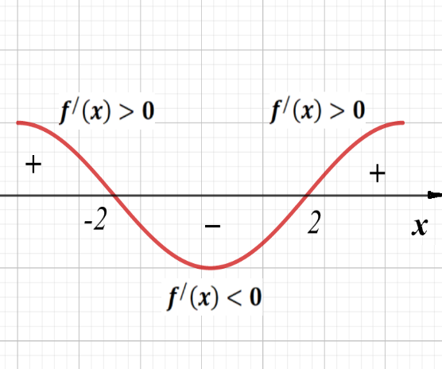
On interval $(-∞;-2)∪(2;+∞)$ function is increasing. On interval $(-2;2)$ function is decreasing.

Figure 22. Intervals of monotonic behavior of function $f\left(x\right)=\frac{x^{3}}{3}-4x$.

EXAMPLE 2: Let $f\left(x\right)=\frac{x^{2}}{2}+\frac{1}{x}.$ Find the intervals on which $f\left(x\right)$ is increasing or decreasing.
SOLUTION: The domain of given function is: $x≠0$ and this is a continuous function $∀x∈R\backslash 0$. The derivative is:
$f^{/}\left(x\right)=x-\frac{1}{x^{2}}=\frac{x^{3}-1}{x^{2}},$ $f^{/}\left(x\right)=0⟹ x=1$.
The derivative is also not defined when $x=0$, so these are the places we divide our real line.
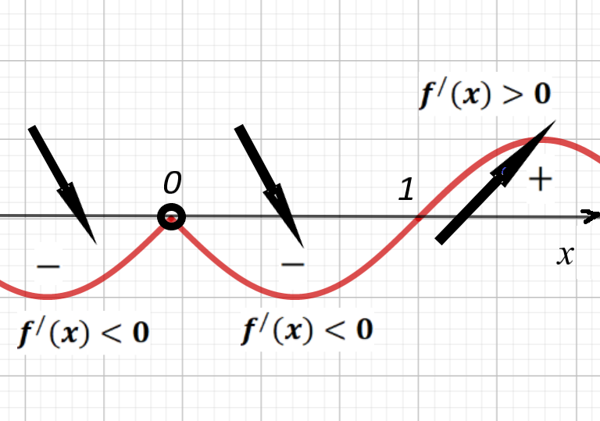
Figure 23. Intervals of monotonic behavior of function $f\left(x\right)=\frac{x^{2}}{2}+\frac{1}{x}.$

To find out what sign the derivative is on $(-∞;1)$, we can substitute in a test point in that interval and see if the result is positive or negative. The point $x=-1$ is a convenient one to use: $f^{/}\left(x\right)=x-\frac{1}{x^{2}}⟹f^{/}\left(-1\right)=-2$.
Because of our fact, $f^{/}\left(x\right)$ will be negative everywhere in $(-∞;0)$, and thus $f\left(x\right)$ is decreasing on interval $(-∞;0)$. Similarly, the point $x=\frac{1}{2}$ is a convenient one to use: $f^{/}\left(x\right)=x-\frac{1}{x^{2}}⟹f^{/}\left(\frac{1}{2}\right)=-3<0$ and thus $f\left(x\right)$ is decreasing on interval $(0;1)$. Lastly, the point $x=2$ give the result: $f^{/}\left(2\right)=\frac{3}{4}$ , so $f^{/}\left(x\right)$ will be positive everywhere in $(1;+∞)$ and thus $f\left(x\right)$ is increasing on $(1;+∞)$. On interval $(-∞;0)∪(0;1)$ function is decreasing. On interval $(1;+∞)$ function is increasing. There is critical poinst of the given function: $A(1;\frac{3}{2})$ and critical number $x=0$.

10.2 EXTREMA AND THE FIRST DERIVATIVE TEST
Definition: Let f be a function $f\left(x\right)$ defined at a point $x=x_{0}$. Then:
1. We say that continuous function $f\left(x\right)$ has a relative minimum (or local minimum) at the point $x=x_{0}$ if there is an interval$(a;b)$ containing $x_{0}$ such that ${f(x}_{0})<f(x)$ for all $x$ in $(a;b)$.
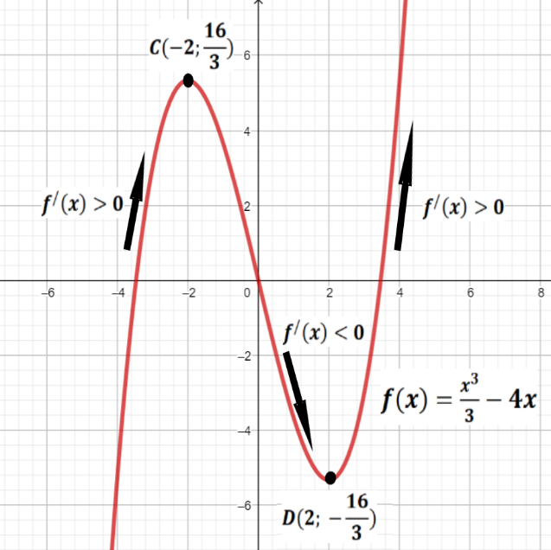
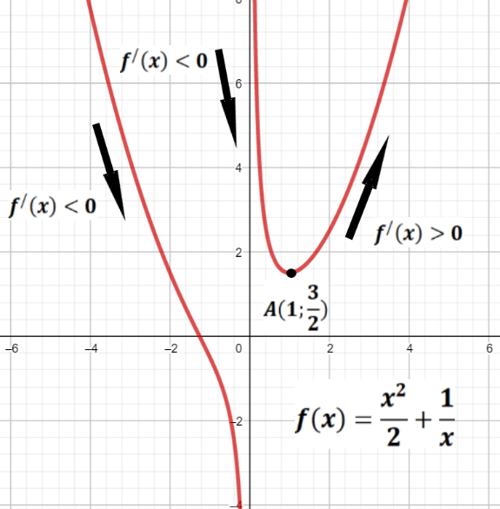
Figure 24. Graphs of functions $f\left(x\right)=\frac{x^{2}}{2}+\frac{1}{x}$ and $f\left(x\right)=\frac{x^{3}}{3}-4x.$

2. We say that continuous function $f\left(x\right)$ has a relative maximum (or local maximum) at the point $x=x_{0}$ if there is an interval $(a;b)$ containing $x_{0}$ such that ${f(x}_{0})>f(x)$ for all $x$ in $(a;b)$.
The word “relative” is significant here. We are not saying that a relative max is largest value of the function $f(x)$ ever takes. We will get to such points on some interval. Together, relative maxes and mins are called relative extrema.
THEOREM: If the continuous function $f(x)$ has a relative max or min at $x=x_{0}$, then either the derivative is zero ( $f^{/}\left(x_{0}\right)=0$) or the derivative doesn’t exist ($∄f^{/}\left(x_{0}\right)$).
We notice that in the examples above (Figure 24.) that we have local minimums with intervals of negative slope to the left and positive slope to the right. Under some conditions, this is what happens in general:
THEOREM (The First Derivative Test):
Let the function $f\left(x\right)$ be continuous on the interval $(a;b)$ and suppose that $x_{0}$ is the only critical point of $(a;b)$. Suppose $f\left(x\right)$ is differentiable on $(a;b)$ except possibly at $x_{0}$. Then:
1. If $f^{/}\left(x\right)$ is negative to the left of $x_{0}$ and positive to the right of $x_{0}$, then the function $f\left(x\right)$ has a local min at $x_{0}$.
2. If $f^{/}\left(x\right)$is positive to the left of $x_{0}$ and negative to the right of $x_{0}$, then the function $f\left(x\right)$ has a local max at $x_{0}$.
3. If $f^{/}\left(x\right)$ is the same sign to the right and left of $x_{0}$ then $x_{0}$ is neither a max nor a min. This case is called the point $x_{0}$ a saddle point if $f^{/}\left(x_{0}\right)=0$.

EXAMPLE 3. Find the critical points and identify their type for the following functions: $f\left(x\right)=4x^{3}-21x^{2}+18x+7$.
SOLUTION: We first have to find the critical points:
$f^{/}\left(x\right)12x^{2}-42x+18=12\left(x-3\right)\left(x-\frac{1}{2}\right),f^{/}\left(x\right)=0⟹ x_{1}=3,x_{2}=\frac{1}{2}.$
So the critical points are $x_{1}=3,x_{2}=\frac{1}{2}$.
To fill in our real line we plug in some test points from intervals $\left(-∞;\frac{1}{2}\right), \left(\frac{1}{2};3\right), \left(3;+∞\right)$ or use the snake rule. Thus we have the following:

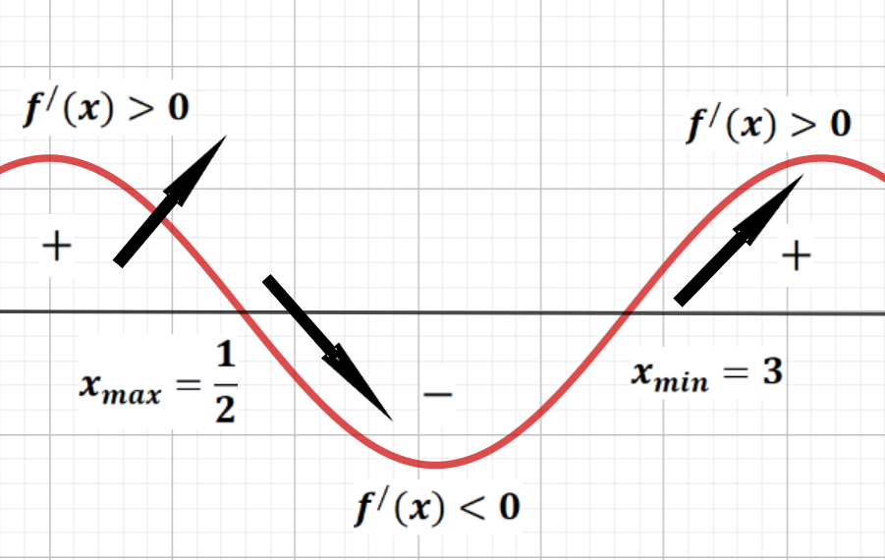
Figure 25. The local max and the local min of the function $f\left(x\right)=4x^{3}-21x^{2}+18x+7.$

By the first derivative test we can conclude that $f\left(x\right)$ has a local max at $x=\frac{1}{2}$ and a local min at $x=3$.

EXAMPLE 4. Find the critical points and identify their type for the following functions: $f\left(x\right)=e^{x}x^{4}$.
SOLUTION: We first have to find the critical points:
$f^{/}\left(x\right)=e^{x}x^{4}+4e^{x}x^{3}=e^{x}x^{3}\left(x+4\right),{ f}^{/}\left(x\right)=0⟹ x_{1}=0,x_{2}=-4.$
The critical points are $x_{1}=0,x_{2}=-4$ and $e^{x}>0,∀x∈R.$
To fill in our real line we plug in some test points from intervals $\left(-∞;-4\right), \left(-4;0\right), \left(3;+∞\right)$ or use the snake rule. At intervals $\left(-∞;-4\right)$ and $\left(3;+∞\right)$ the function increases, and at interval $\left(-4;0\right)$ it decreases. So by the first derivative test we can conclude that $f\left(x\right)$ has a local max at $x=-4$ and a local min at $x=0$. Thus we have the following on the Figure 26.

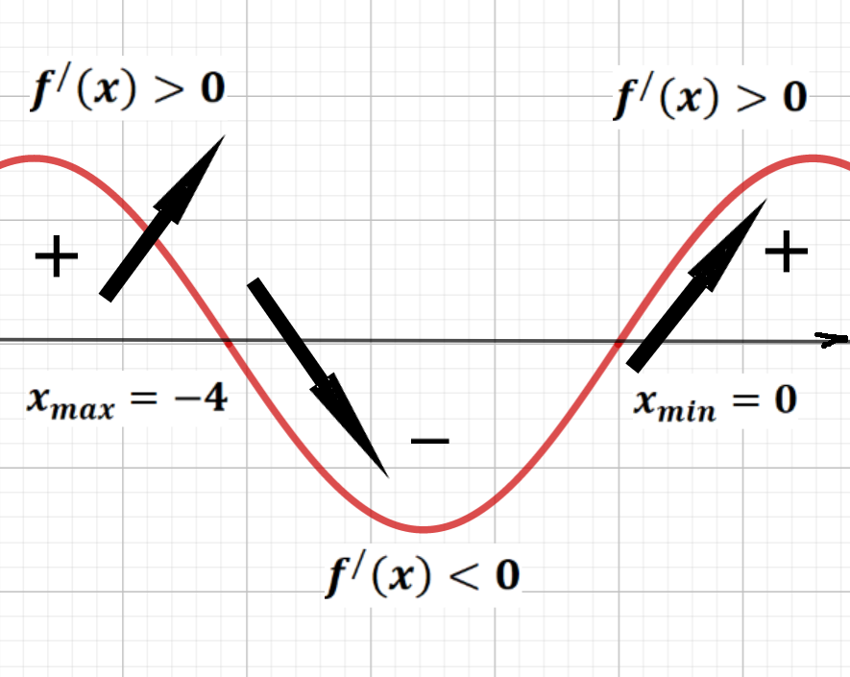
Figure 26. The local max and the local min of the function $f\left(x\right)=e^{x}x^{4}.$

EXAMPLE 5. Find the critical points and identify their type for the following functions: $f\left(x\right)=\sqrt[3]{x}e^{\frac{x}{6}}$.
SOLUTION: We first have to find the critical points:
$f^{/}\left(x\right)={\frac{1}{6}e}^{\frac{x}{6}}\sqrt[3]{x}+\frac{1}{3}e^{\frac{x}{6}}x^{-\frac{2}{3}}=e^{\frac{x}{6}}\left(\frac{\sqrt[3]{x}}{6}+\frac{1}{3\sqrt[3]{x^{2}}}\right)=\frac{e^{\frac{x}{6}}(x+2)}{6\sqrt[3]{x^{2}}}$;
$$f^{/}\left(x\right)=0⟹ x_{1}=-2.$$
And if $x_{2}=0$ the derivative of the given function is no exist, so the critical points are $x_{1}=-2,x_{2}=0$.
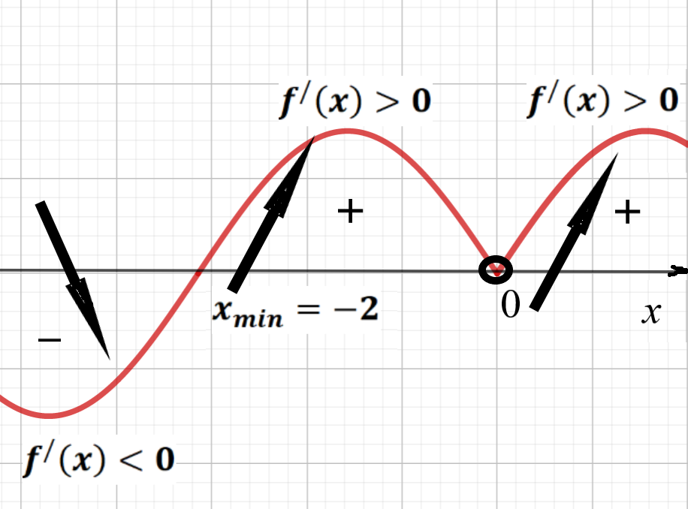
Figure 27. The local min of the function$f\left(x\right)=\sqrt[3]{x}e^{\frac{x}{6}}.$

The denominator of the derivative is positive $∀x∈R$ that why $x_{2}=0$ is not extremal point. To fill in our real line we plug in some test points from intervals $\left(-∞;-2\right), \left(-2;0\right), \left(0;+∞\right)$ or use the snake rule. So by the first derivative test we can conclude that $f\left(x\right)$ has a local min at $x=-2$. So there is a local min at $x=-2$ and at $x=0$ there is neither a max nor a min (notice that there is not a saddle point there because the derivative doesn’t exist there). It is important to note that $x=0$ is still a critical point.

EXAMPLE 6. Find the critical points and identify their type for the following functions: $f\left(x\right)=\frac{1}{x}$.
SOLUTION: We first have to find the critical points: $f^{/}\left(x\right)=-\frac{1}{x^{2}}$. Then $f^{/}\left(x\right)$
is undefined at $x=0$, but there is no critical point there since $f\left(x\right)=\frac{1}{x}$ is also undefined at $x=0$. The function decreases on the entire numerical axis.

Remark: if $x=x_{0}$ is not in the domain, you cannot have a critical point at $x=x_{0}.$

10.3 ABSOLUTE EXTREMA
In applications, we are generally uninterested in local maxes and mins. Instead of we want to know when our function is maximal or minimal on its entire domain.
Definition: Let $f\left(x\right)$ be defined on an interval $℧$ (possibly all of $R$) containing $x_{0}$. Then $f\left(x\right)$ is said to have an absolute maximum or global maximum on $℧$ if ${f(x}_{0})≥f(x)$ for every $x$ in $℧$.
There is an analogous statement for absolute/global minimums.
The next theorem is both deep and extremely important.
Remark:(Extreme Value Theorem): If $f(x)$ is continuous on a closed interval $[a;b]$, then $f(x)$ has both an absolute max and an absolute min on$[a;b]$.
To find extrema on a closed interval $[a;b]$ proceed as follows:
1. Evaluate $f(x)$ at each critical point in $[a;b]$.
2. Evaluate $f(x)$ at the endpoints $a$ and $b$.
3. The least of these values is the absolute min and the greatest is the absolute max.
EXAMPLE 7. Find the absolute max and min of the following function:
$f\left(x\right)=x^{4}-8x^{2}+5$ on the interval $[-1;3]$.
SOLUTION: We first have to find the critical points:
$f^{/}\left(x\right)=4x^{3}-16x=4x\left(x-2\right)\left(x+2\right)=0$.
The critical points are $x_{1}=0,x_{2}=-2, x_{3}=2$. We can throw away $x_{2}=-2$ because it isn’t in$[-1;3]$. Now we calculate $f\left(x\right)$ at all relevant points:$$\begin{matrix}f\left(-1\right)=1-8+5=-2, A\left(-1;-2\right); \\ \begin{matrix}f\left(0\right)=0+0+5=5, C(0;5) \\ f\left(2\right)=16-32+5=-11, \end{matrix} \\ f\left(3\right)=81-72+5=14.\end{matrix}$$
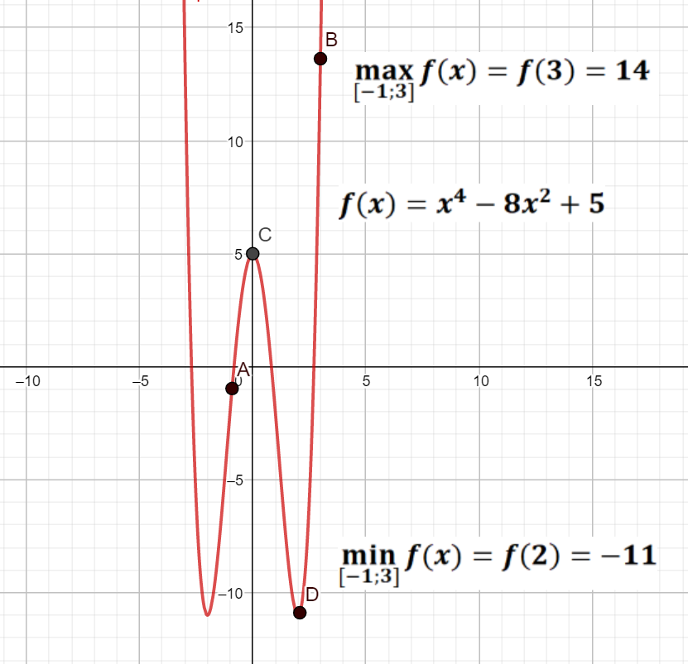
Figure 28. The graph of the functions: $f\left(x\right)=x^{4}-8x^{2}+5$
and its absolute max and min on the interval $[-1;3]$.

That is why the absolute max occurs at the endpoint $x=3$ and the absolute min is at $x=-2$. Note that the absolute maxes and mins can occur at endpoints. See (Figure 28.).
PROBLEM 18: Find the absolute max and min of the following function:
$1. y=x^{2}+\frac{16}{x}-16, x∈\left[1; 4\right]$; | $11. y=4-x-\frac{4}{x^{2}}, x∈\left[1; 4\right]$;
$2. y=2\sqrt{x}-x, x∈\left[0; 4\right]$; | $12. y=x-4\sqrt{x+2}-8, x∈\left[2; 7\right]$;
$3. y=-\frac{x^{2}}{2}+\frac{8}{x}+8, x∈\left[-4;-1\right]$; | $13. y=2\sqrt{x-1}-x+2, x∈\left[1;5\right]$;
$4. y=2x^{2}+\frac{108}{x}-59, x∈\left[2; 4\right]$; | $14. y=-\frac{4x^{2}+6x}{x^{2}+4x+5}, x∈\left[-2;1\right]$;
$$5. y=3-x-\frac{4}{({x+2)}^{2}}, x∈\left[-1;2\right];$$ | $15. y=\frac{x^{2}}{2}+\frac{8}{x+2}+2x, x∈\left[0;6\right]$;
$6. y=\frac{10x+10}{x^{2}+2x+2}; x∈\left[-1;2\right]$; | $16. y=\frac{{-2x}^{2}+14x-14}{x^{2}-2x+2}, x∈\left[1;4\right]$;
$7. y=\frac{4}{x^{2}}-8x-15, x∈\left[-2; 1\right]$; | $17. y=x-4\sqrt{x} +5, x∈\left[1; 9\right];$
$$8. y=\frac{4x}{x^{2}+4}, x∈\left[-4;2\right];$$ | $18. y=5+x+\frac{4}{({x+2)}^{2}}, x∈\left[0;2\right]$;
$9. y=\frac{4}{x^{2}}+8x-15, x∈\left[1; 2\right]$; | $19. y=\frac{-4x}{x^{2}+4}, x∈\left[-4;2\right]$;
$10. y=\frac{10x}{x^{2}+1}, x∈\left[0;3\right]$; | $20. y=-\frac{x^{2}+6x}{x^{2}+2x+5}, x∈\left[-5;1\right]$.

Questions for self-control:
- What functions are called monotonically increasing in the interval?
- What functions are called monotonically descending on an interval?
- Give an example of a non-increasing and non-decreasing explicitly given function.
- What points are called critical points of a function?
- What kind of point is called relative minimum?
- What kind of point is called relative maximum?
- When the continuous function $f\left(x\right)$ has extrema points?
- What is the difference between the critical and extrema point of the function?
- What is the difference between the local maximum point of the function and the absolute or global maximum point?
- How to find global maximum and minimum of function on a given segment?

11. THE SECOND DERIVATIVE OF FUNCTIONS
11. 1 THE SECOND DERIVATIVE TEST FOR
A LOCAL MAXIMUM OR MINIMUM
The Second-Derivative Test at a local maximum or minimum is sufficient condition of local extremum. We usually show that a function $y=f\left(x\right)$ has a local maximum or minimum at a critical point $x_{0}$ by determining whether the derivative is positive or negative in open intervals to the left and to the right of $x_{0}$. In some cases, however, it is more convenient to calculate the second derivative at $x_{0}$ and use the following result.
THEOREM (The Second-Derivative Test for a local maximum or minimum):
Let $x_{0}$ be a citical point and the function $f\left(x\right)$ be continuous in some neighborhood of point $x_{0}$. Then:
- If $f^{/}\left(x_{0}\right)=0$ and $f^{//}\left(x_{0}\right)>0$, then the function $f\left(x\right)$ has a local minimum at point $x_{0}$;
- If $f^{/}\left(x_{0}\right)=0$ and $f^{//}\left(x_{0}\right)<0$, then the function $f\left(x\right)$ has a local maximum at point $x_{0}$;
- If the derivative $f^{/}\left(x_{0}\right)$ does not change the sign when passing through $x_{0}$,
then at point $x_{0}$ there is no extremum.

EXAMPLE 1. Find the critical points and identify their type for the following functions: $f\left(x\right)=4x^{3}-21x^{2}+18x+7$.
SOLUTION: We first have to find the critical points:
$f^{/}\left(x\right)=12x^{2}-42x+18=12\left(x-3\right)\left(x-\frac{1}{2}\right),f^{/}\left(x\right)=0⟹ x_{1}=3,x_{2}=\frac{1}{2}.$
So the critical points are $x_{1}=3,x_{2}=\frac{1}{2}$. Find the second derivative $f^{//}\left(x\right)$:
$$f^{//}\left(x\right)=24x-42⟹\begin{matrix}f^{//}\left(3\right)=72-42=30>0, \\ f^{//}\left(\frac{1}{2}\right)=12-42=-30<0.\end{matrix}$$
So by the second-derivative test we can conclude that $f\left(x\right)$ has a local max at $x=\frac{1}{2}$ and a local min at $x=3$. A similar result was obtained in the previous section.

11.2 THE SECOND-DERIVATIVE TEST FOR CONCAVITY
The graph in Figure 29. is said to be concave up and the graph in Figure 30. is said to be concave down, according to the following definition.
Definition (Concavity): 1) If the slope $f^{/}\left(x\right)$ of the tangent line at $x$ to the graph of continuously differentiable function $y=f\left(x\right)$ in interval $(a;b)$ increases as $x$ increases across an open interval $(a;b)$, then graph of the function $f\left(x\right)$ is concave upward (concave up, denote $f∪$) on the interval $∀ x∈(a;b)$.
A continuously differentiable function $f\left(x\right)$ in interval $(a;b)$, is convex downward (convex down, denote $f∪$) if and only if all points $\left(x;f\left(x\right)\right), x∈(a;b)$, of the graph of the function lie not lower than the tangent drawn to it at any point $\left(x_{с};f\left(x_{с}\right)\right), x_{с}∈(a;b)$.
2) If the slope $f^{/}\left(x\right)$ of the tangent line at $x$ to the graph of $y=f\left(x\right)$ decreases as $x$ increases across an open interval $x∈(a;b)$, the the graph of the function is concave downward (concave down, denote $f∩$) on the interval $∀ x∈(a;b)$.
A continuously differentiable function $f\left(x\right)$ in interval $(a;b)$, is convex upwards (convex up, denote $f∩$) if and only if all points $\left(x;f\left(x\right)\right), x∈(a;b)$, of the graph of the function lie not higher than the tangent drawn to it at any point $\left(x_{с};f\left(x_{с}\right)\right), x_{с}∈(a;b)$.

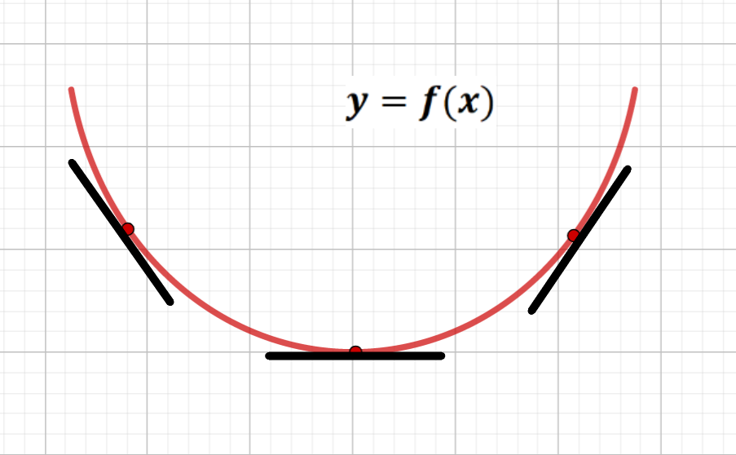
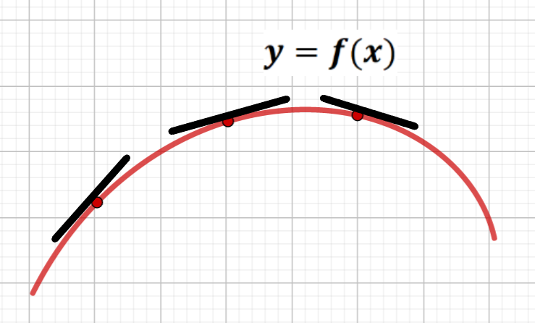
Figure 30. Slope decreasing,
Graph is concave downward or concave function (denote $f∩$).
Figure 29. Slope increasing,
Graph is concave upward or convex function (denote $f∪$).

THEOREM (The Second-Derivative Test for concavity):
Let the function $y=f\left(x\right)$ in the interval $(a;b)$ be twice continuously differentiated, then:
1) If $f^{//}\left(x\right)$ exists and is positive on an open interval $(a;b)$, then the graph of the function $y=f\left(x\right)$ is concave upward on the interval $∀x∈(a;b)$.
2) If $f^{//}\left(x\right)$ exists and is negative on an open interval $(a;b)$, then the graph of the function $y=f\left(x\right)$ is concave downward on the interval $∀x∈(a;b)$.

EXAMPLE 2. Find the open intervals on which the graph of the function
$f\left(x\right)=x^{3}-6x^{2}+3x+5$ is concave upward and on which it is concave downward.
SOLUTION: The first and second derivatives of $f\left(x\right)=x^{3}-6x^{2}+3x+5$:
$f^{/}\left(x\right)=3x^{2}-12x+3$, $f^{//}\left(x\right)=6x-12$.
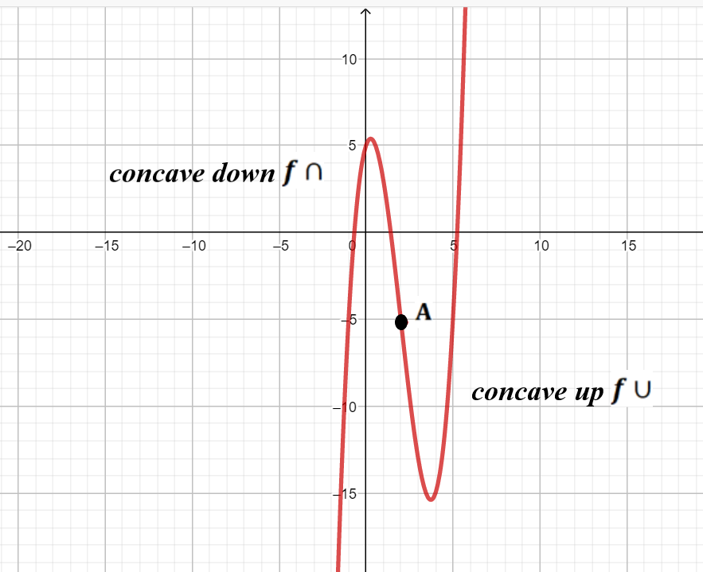
The second derivative is zero at $x_{0}=2$ negative for $x<2$, and positive for $x>2$ (Figure 31.). By Theorem above, the graph of $y=f\left(x\right)$ is concave downward on $(-∞;2)$ and concave upward on$(2;+∞)$. This can be seen from its graph in
Figure 31.
where the curve switches from concave up to concave down is called an inflection point of the graph $y=f\left(x\right)$.

The point $A\left(2;-5\right)$ on the graph of $f\left(x\right)=x^{3}-6x^{2}+3x+5$
where the curve switches from concave up to concave down is called an inflection point of the graph $y=f\left(x\right)$.

11.3 INFLECTION POINTS
Definition: The inflection points of the function $y=f\left(x\right)$ is called the point $x_{0}$, in which the direction of convexity changes to the opposite.
The convexity intervals of the function can be separated from each other either by points where the second derivative is zero, or by points where the second derivative is equal to infinity, or by points where the second derivative does not exist.
Definition (critical point of the $2-$nd order): Let the function $f\left(x\right)$ is denoted around the point $x_{0}$. The point $x_{0}$ is called the critical point $2-$nd order, if one of the conditions is met:
1) $f^{//}\left(x_{0}\right)=0$;
2) $f^{//}\left(x_{0}\right)=∞$;
3) $∄f^{//}\left(x_{0}\right)$.
THEOREM (sufficient condition for the existence of the inflection point):
If point $x_{0}$ for the function $f\left(x\right)$ is a critical point of the $2-$nd order, and, passing through this point, the second derivative $f^{//}\left(x\right)$ changes sign, then the point $x_{0}$ is the inflection point of the function $f\left(x\right)$.

EXAMPLE 3. Find the inflection point of the function $f(x)=ln⁡(1+x^{2})$ and intervals where the given function is concave up and on which it is concave down.
SOLUTION: The first and second derivatives of $f(x)=ln⁡(1+x^{2})$:
$$f^{/}\left(x\right)=\frac{2x}{1+x^{2}},$$
$$f^{//}\left(x\right)=\frac{2\left(1+x^{2}\right)-4x^{2}}{{(1+x^{2})}^{2}}=\frac{2(1-x^{2})}{{(1+x^{2})}^{2}}.$$
The second derivative is zero at $x_{0}=±1$ negative for $x∈\left(-∞;-1\right)∪(1;+∞)$ and the graph is concave down on this interval, and positive for $(-1;1)$ and the graph is concave up on it (Figure 32). The graph has inflection points at $x_{0}=±1$, on the graph there are points $A(-1;ln2)$ and $B(1;ln2)$. This can be seen from its graph in Figure 32.
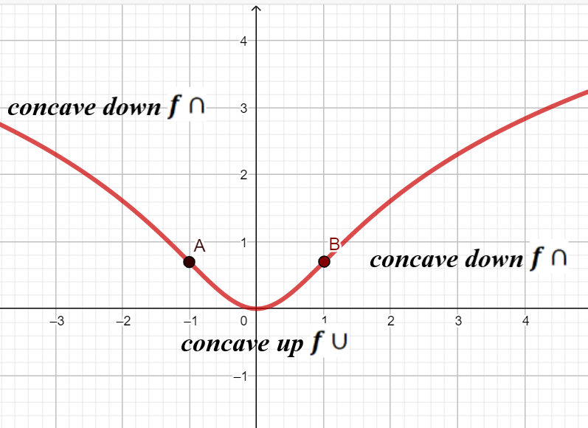
Figure 32. There are inflection points $A\left(-1;ln2\right)$ and $B\left(1;ln2\right)$ on the graph of the function $f(x)=ln⁡(1+x^{2})$.

PROBLEM 19: Find the inflection points and intervals where the given function is concave up and on which it is concave down of the given function:
$1. y=x^{2}+\frac{16}{x}-16$; | $11. y=4-x-\frac{4}{x^{2}}$;
$2. y=2\sqrt{x}-x$; | $12. y=x-4\sqrt{x+2}-8$;
$3. y=-\frac{x^{2}}{2}+\frac{8}{x}+8$; | $13. y=2\sqrt{x-1}-x+2$;
$4. y=2x^{2}+\frac{108}{x}-59$; | $14. y=-\frac{4x^{2}+6x}{x^{2}+4x+5}$;
$5. y=3-x-\frac{4}{({x+2)}^{2}}$; | $15. y=\frac{x^{2}}{2}+\frac{8}{x+2}+2x$;
$6. y=\frac{10x+10}{x^{2}+2x+2}$; | $$16. y=\frac{{-2x}^{2}+14x-14}{x^{2}-2x+2};$$
$7. y=\frac{4}{x^{2}}-8x-15$; | $17. y=x-4\sqrt{x} +5;$
$8. y=\frac{4x}{x^{2}+4}$; | $18. y=5+x+\frac{4}{({x+2)}^{2}}$;
$9. y=\frac{4}{x^{2}}+8x-15$; | $19. y=\frac{-4x}{x^{2}+4}$;
$10. y=\frac{10x}{x^{2}+1}$; | $20. y=-\frac{x^{2}+6x}{x^{2}+2x+5}$.

Questions for self-control:
- How possible to use the second derivative for finding a local maximum or minimum?
- Give an example of the graph of the function $f\left(x\right)$ is concave upward on the interval $(a;b)$?
- Give an example of the graph of the function $f\left(x\right)$ is concave downward on the interval $(a;b)$?
- How does changing slope a tangent line to the graph $y=f\left(x\right)$ if the function is concave down along the interval $(a;b)$?
- How does changing slope a tangent line to the graph $y=f\left(x\right)$ if the function is concave up along the interval $(a;b)$?
- How is the behaves of the tangent line to the graph of $y=f\left(x\right)$ if the function is concave up on the interval $(a;b)$?
- How is the behaves of the tangent line to the graph of $y=f\left(x\right)$ if the function is concave down on the interval $(a;b)$?
- What kind of point is called the inflection point?
- What is the difference between the critical point of the second-order and the inflection point?

12. ASYMPTOTE.
The asymptote of a curve $y=f(x)$ with an infinite branch is a line such that the distance $\left|MN\right|$ from the point $M$ of the curve to this line goes to zero when the point $M$ moves away along the infinite branch from the origin $O$.
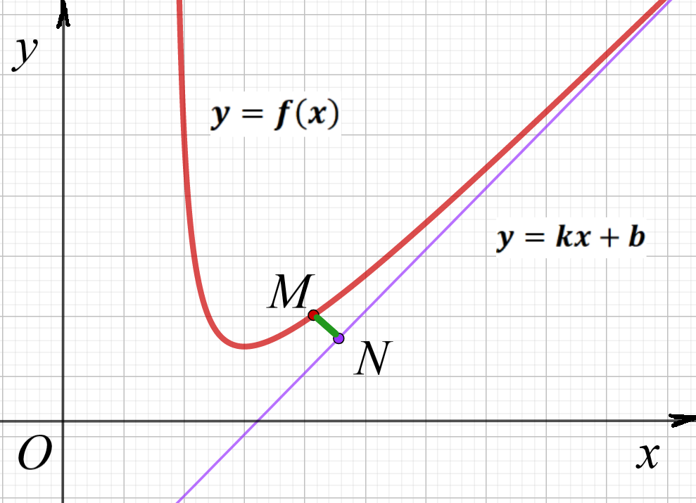
Figure 33. The distance $\left|MN\right|$ from the point $M$ of the curve and the point $N$ of the asymptote approaches
to zero: $\left|MN\right|={\lim_{x→∞}{(f\left(x\right)-kx-b)}=0}$.

Definition: The vertical line ${x=x}_{0}$ is called a vertical asymptote of the graph of $y=f\left(x\right)$ if $\lim_{x→x_{0}-0}{f\left(x\right)=±∞}$ and$\lim_{x→x_{0}+0}{f\left(x\right)=±∞}$.

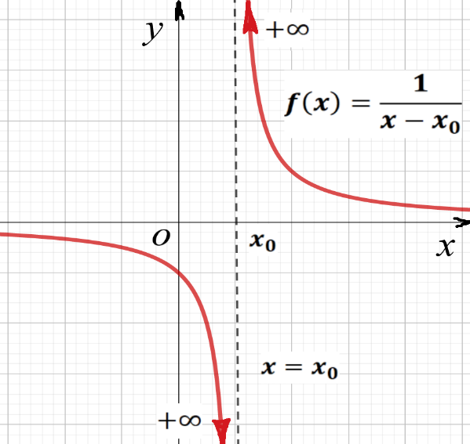
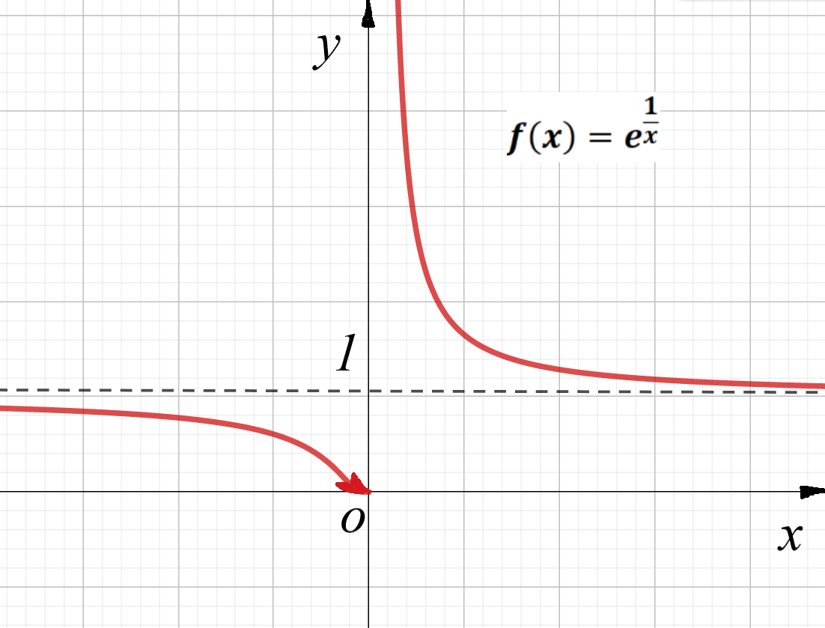

Figure 35. The vertical asymptote $x=0$.
The horizontal asymptote $y=1$ appears when $x→±∞$.

$${x=x}_{0}$$
Figure 34. The vertical asymptote.

The graph of $y=f\left(x\right)$ will have vertical asymptotes at those values of $x$ for which the denominator is equal to zero, a logarithmic function will have a vertical asymptote precisely where its argument is equal to zero so on.

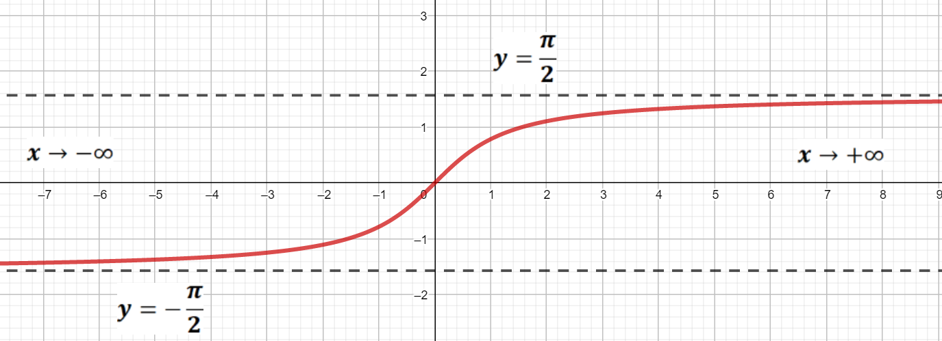
Definition: The horizontal line ${y=y}_{0}$ is called a horizontal asymptote of the graph of $y=f\left(x\right)$ if $b=\lim_{x→±∞}f\left(x\right)$. There are lines that the graph of the function approaches as $x→±∞$. For example, the arctangent function satisfies: $\begin{matrix}\lim_{x→+∞}{arctgx=\frac{π}{2};} \\ \lim_{x→-∞}{arctgx=-\frac{π}{2}.}\end{matrix}$
Figure 36. The arctangent function $y=arctgx$ is bounded of horizontal asymptotes $y=\frac{π}{2}$ and $y=-\frac{π}{2}$.

A graph can have an infinite number of vertical asymptotes, but it can only have at most two horizontal asymptotes. Horizontal asymptotes describe the left and right-hand behavior of the graph. A graph will (almost) never touch a vertical asymptote; however, a graph may cross a horizontal asymptote.
Definition: The line $y=kx+b$ is a slant asymptote to the graph of the function $f\left(x\right)$ at $x→±∞$ if:
$\lim_{x→±∞}({f\left(x\right)-kx-b)=0}$ where $k=\lim_{x→±∞}\frac{f(x)}{x}$ and $b=\lim_{x→±∞}(f\left(x\right)-kx)$.
If one of the limits does not exist, it has no asymptotes.
EXAMPLE 1. Find all asymptotes of the function: $f\left(x\right)=\frac{x^{3}}{x^{2}-4}$.
SOLUTION: Firstly we determine the domain of the given function $f\left(x\right)$:
$D\left(x\right)=\left\{x∈R | x≠±2\right\}$, values of $x$ for which the denominator is equal to zero will give vertical asymptotes at $x=±2$:
$$\begin{matrix}\lim_{x→-2-0}\frac{x^{3}}{x^{2}-4}=\frac{{(-2-0)}^{3}}{{(-2-0)}^{2}-4}=+∞; \\ \lim_{x→-2+0}\frac{x^{3}}{x^{2}-4}=\frac{{(-2+0)}^{3}}{{(-2+0)}^{2}-4}=-∞.\end{matrix}$$
$$\begin{matrix}\lim_{x→2-0}\frac{x^{3}}{x^{2}-4}=\frac{{(-2-0)}^{3}}{{(-2-0)}^{2}-4}=+∞; \\ \lim_{x→2+0}\frac{x^{3}}{x^{2}-4}=\frac{{(-2+0)}^{3}}{{(-2+0)}^{2}-4}=-∞.\end{matrix}$$
The given function is odd and has symmetry with respect to the origin, so you can make a symmetrical reflection and investigate the asymptote only for $x≥0$.
Find the slant asymptote $y=kx+b$:
$$k=\lim_{x→+∞}\frac{f(x)}{x}=\lim_{x→+∞}{\frac{x^{3}}{{x(x}^{2}-4)}}=1;$$
$$b=\lim_{x→±∞}\left(f\left(x\right)-kx\right)=\lim_{x→+∞}\left(\frac{x^{3}}{x^{2}-4}-x\right)=\lim_{x→+∞}\frac{x^{3}-x^{3}+4}{x^{2}-4}=0;$$
The slant asymptote of the given function is $y=x$.
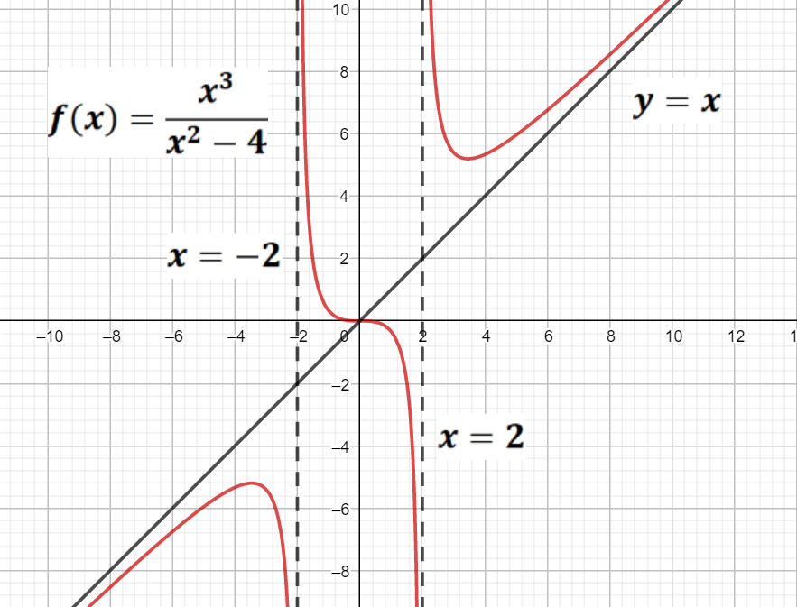
Figure 37. The function has three asymptotes $x=-2$, $x=2$ and $y=x$.

Questions for self-control:
- Give an example of a function that has one vertical asymptote.
- Give an example of a function that has two vertical asymptotes.
- Give an example of a function that has many vertical asymptotes.
- Give an example of a function that has an even number of vertical asymptotes.
- What kind of functions have horizontal asymptotes?
- How many horizontal asymptotes can a continuous function have?
- How is it possible to find the sloping asymptotes of function?

13. GRAPHING A FUNCTION
The study of the twice differentiable function $y=f\left(x\right)$ on $D\left(f\right)$ (except, perhaps, for a finite set of points) and the construction of its graph should be carried out according to the scheme:
- Domain: Determine the domain of the given function $f\left(x\right)$: $D\left(x\right), E(y)$.
- Intercepts: Find at which points the graph of the function intercepts the $x$ and $y-$axis.
- Symmetries: Set up the possible symmetries of the graph of the function: $\begin{matrix}f\left(-x\right)=f\left(x\right), \\ f\left(-x\right)=-f\left(x\right), \\ f\left(-x\right)≠f\left(x\right), f\left(-x\right)≠-f\left(x\right), \end{matrix}$.
- Breakpoints: Determine the possible breakpoints of the function and the vertical asymptotes of its graph.
- Max/Min, Increasing/Decreasing: Determine whether the first derivative of the function is zero: $f^{/}\left(x\right)=0$ and find critical points of $1-$st order. Find the intervals of increase $(f^{/}\left(x\right)>0)$ and decrease ${(f}^{/}\left(x\right)<0)$ of the given function and the local maximum and minimum values of it (if they exist).
- Concavity: Determine whether the second derivative of the function is zero: $f^{//}\left(x\right)=0$ and find critical points of $2-$nd order. Find the intervals on which the given function is concave $(f^{//}\left(x\right)>0)$ and convex ${(f}^{//}\left(x\right)<0)$ and mark points of inflection, if they exist.
- Tails and Asymptotes: Find the slant and horizonta asymptotes of the graphs of the given functions.
- Plot the graph of the function $f\left(x\right)$ according to the established information.

EXAMPLE 1. Let's build a graph of the function: $f\left(x\right)=\frac{e^{x}}{x+2}$.
SOLUTION: 1) Firstly determine the domain of the given function $f\left(x\right)$:
$D\left(f\right)=(-∞;-2)∪(-2;+∞)$.
2) The function $f\left(x\right)$ is not symmetrical: $f\left(-x\right)=\frac{e^{-x}}{-x+2}⟹\begin{matrix}f\left(-x\right)≠f\left(x\right), \\ f\left(-x\right)≠-f\left(x\right).\end{matrix}$
3) The point $x=2$ is breakpoint of the function $f\left(x\right)=\frac{e^{x}}{x+2}$ and there is vertical asymptote of its graph $x=2$ (Figure 40.): $\begin{matrix}\lim_{x→-2-0}\frac{e^{x}}{x+2}=\frac{e^{-2-0}}{-2-0+2}=\frac{e^{-2}}{-0}=-∞, \\ \lim_{x→-2+0}\frac{e^{x}}{x+2}=\frac{e^{-2+0}}{-2+0+2}=\frac{e^{-2}}{+0}=+∞.\end{matrix}$
4) Points of intersection of the graph of the function with the coordinate axes:
if $x=0⟹y=\frac{1}{2}$, we received the point $M\left(0;\frac{1}{2}\right)$ and $y≠0$, because of $\frac{e^{x}}{x+2}≠0$.
5) The investigation of the first derivation of the given function $f\left(x\right)=\frac{e^{x}}{x+2}$:
$f^{/}\left(x\right)=\frac{e^{x}\left(x+2\right)-e^{x}}{{(x+2)}^{2}}=\frac{e^{x}(x+1)}{{(x+2)}^{2}}$;
if $f^{/}\left(x\right)=0$ we have the critical point $1-$nd order: $x_{1}=-1$; if $f^{/}\left(x\right)=∞$, we have the critical point $1-$nd order: $x_{2}=-2$, but $x_{2}=-2 ∉D(f)$. The first derivative of the function changes the sign at point $x_{1}=-1$ from negative to positive - so this is the point $A\left(-1;\frac{1}{e}\right)$ of the local minimum.
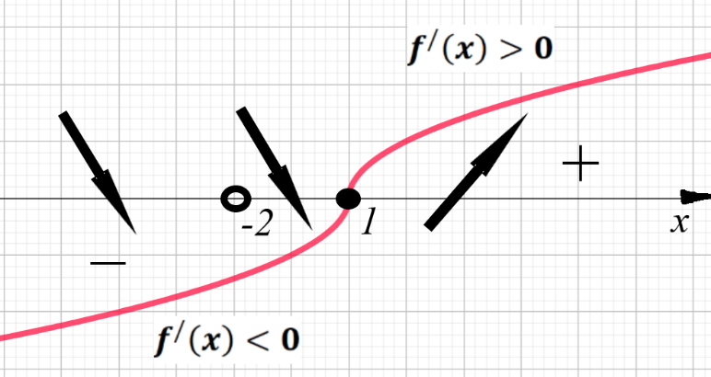
Figure 38. The function $f\left(x\right)=\frac{e^{x}}{x+2}$ decreases at intervals $(-∞;-2)∪(-2;-1)$ and increases on the interval $\left(-1;+∞\right).$

6) The investigation of the first derivation of the given function $f\left(x\right)=\frac{e^{x}}{x+2}$:
$f^{//}\left(x\right)={\left(\frac{e^{x}(x+1)}{{(x+2)}^{2}}\right)}^{/}=\frac{\left(e^{x}\left(x+1\right)+e^{x}\right){\left(x+2\right)}^{2}-e^{x}(x+1)2(x+2)}{{(x+2)}^{4}}=\frac{e^{x}(x^{2}+2x+2)}{{(x+2)}^{3}};$
$f^{//}\left(x\right)≠0, ∀x∈R$ and we have the critical point $2-$nd order at $x_{1}=-2$ when $f^{//}\left(x\right)=∞$, $x_{1}=-2 ∉D(f)$. The second derivative of the function changes the sign at point $x_{1}=-2$ from negative to positive - so this is the inflection point.

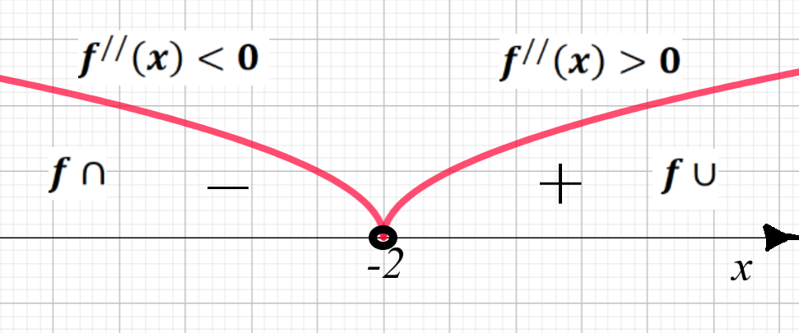
Figure 39. The function $f\left(x\right)=\frac{e^{x}}{x+2}$ is concave down at intervals $(-∞;-2)$ and is concave up on intervals $(-2;-1)∪\left(-1;+∞\right).$

7) Find the slant asymptote $y=kx+b$:
$$k=\lim_{x→±∞}\frac{f(x)}{x}⟹\begin{matrix}\lim_{x→+∞}{\frac{e^{x}}{x(x+2)}}=+∞, \\ \lim_{x→-∞}{\frac{e^{x}}{x(x+2)}}=0.\end{matrix}$$
$$b=\lim_{x→±∞}\left(f\left(x\right)-kx\right)⟹\lim_{x→-∞}\left(\frac{e^{x}}{x+2}-0x\right)=0;$$
The slant asymptote of the given function is $y=0$ if $x→-∞$.
8) Now is plotting the graph of the function $f\left(x\right)=\frac{e^{x}}{x+2}$:
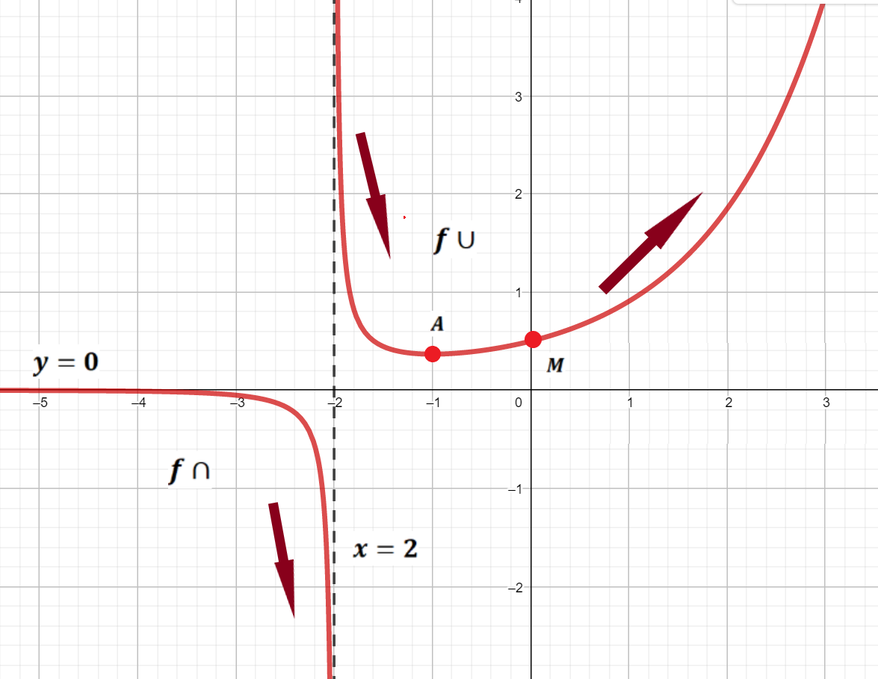
Figure 40. The graph of the function $f\left(x\right)=\frac{e^{x}}{x+2}$.

PROBLEM 20. Graphing the given function $y=f(x)$.
$1. y=\frac{2}{x^{2}+2x}$; | $11. y=\frac{12x}{x^{2}+9}$;
$2. y=\frac{4-x^{3}}{x^{2}}$; | $12. y=\frac{2x}{{(x-4)}^{2}}$;
$3. y=\frac{2x^{3}+1}{x^{2}}$; | $13. y=\frac{3x^{4}+1}{x^{3}}$;
$4. y=\frac{-8x}{x^{2}+4}$; | $14. y=\frac{8x-8}{{(x+1)}^{2}}$;
$5. y=\frac{4}{x^{2}+2x-3}$; | $15. y=\frac{32-x^{3}}{x^{2}}$;
$6. y=\frac{4-x^{2}}{x^{2}}$; | $16. y=\frac{3x-2}{x^{3}}$;
$7. y=\frac{-x^{2}}{{(x+2)}^{2}}$; | $17. y=\frac{4}{3+2x-x^{2}}$;
$8. y=\frac{12-{3x}^{2}}{x^{2}+12}$; | $18. y=\frac{{(x-1)}^{2}}{{(x+1)}^{2}}$;
$9. y=\frac{x^{2}-x+1}{x-1}$; | $19. y=\frac{{4(x+1)}^{2}}{x^{2}+2x+4}$;
$10. y=\frac{4x^{2}}{3+x^{2}}$; | $20. y=\frac{x^{2}+2x-7}{x^{2}+2x-3}$.

REFERENCES

- Understanding Basic Calculus/ S.K. Chung /Department of Mathematics, University of Hong Kong/ http://math.schung.info/calculus/basic_calculus.html.
- Differential and Integral calculus with examples and applications/George A. Osborne, S.B. – walker professor of mathematics in the Massachusetts instinute of technology. – Boston, USA D.C. Heath & Co Publishers, 1906.
- Диференціальне та інтегральне числення функцій однієї змінної. Практикум. (І курс І семестр) / Уклад.: І. В. Алєксєєва, В. О. Гайдей, О. О. Диховичний, Л. Б. Федорова. — К: НТУУ «КПІ», 2013. — 252 с.
- Диференціальне та інтегральне числення функцій однієї змінної. Конспект лекцій. (І курс І семестр) / В. О. Гайдей, Л. Б. Федорова, І. В. Алєксєєва, О. О. Диховичний. — К: НТУУ «КПІ», 2013. — 104 с.
- Берман Г. Н. Сборник задач по курсу математического анализа / Г. Н. Берман. — С.Пб.: Лань, Специальная литература, 2002. — 448 с. — ISBN 5- 8114-0107-8.
- Письменный Д. Конспект лекций по высшей математике. Полный курс / Д. Письменный. — М.: Айрис-Пресс, 2008. — 608 с. ISBN 978-5-8112-3118-8, 978-5-8112-3480-6.
- Limits and continuity – A guide for teachers (Years 11–12) Principal author: Peter Brown, University of NSW/ Australian Mathematical Sciences Institute Building 161 The University of Melbourne VIC 3010 Email: enquiries@amsi.org.au Website: www.amsi.org.au
- Math 221 first semester calculus\2010\The Free Lecture Notes Page (wisc.edu)
- The Derivative\2010\The Free Lecture Notes Page (wisc.edu)
- Вища математика: збірник задач: Навч. посібник /В. П. Дубовик, І. І. Юрик, І.П. Вовкодав та ін.; За ред. В. П. Дубовика, І. І. Юрика. – К.: А. С. K., 2005. – 480 с.
- Математика для економістів : Посібник для студентів фінансово економічного профілю Уклад.: З.П. Ординська, Л.А. Репета- К:. НТУУ «КПІ», 2014 -226 с.

