Національний технічний університет України
«Київський політехнічний інститут
імені ІГОРЯ СІКОРСЬКОГО»
ФАКУЛЬТЕТ БІОМЕДИЧНОЇ ІНЖЕНЕРІЇ
КАФЕДРА БІОМЕДИЧНОЇ ІНЖЕНЕРІЇ

До захисту допущено:
Завідуючий кафедри БМІ
________ Владислав ШЛИКОВ
^{(підпис)}
“ ______ ” _____________2024

Дипломна робота
на здобуття ступеня бакалавра
за освітньо-професійною програмою «Медична інженерія»
спеціальності 163 Біомедична інженерія
на тему: «Блок регулювання температури у контурі штучного кровообігу»

Виконав:
студент IV курсу, групи БМ-03і
Алі Салех Ахмат Махамат __________

Керівник:
завідувач кафедри БМІ, д.т.н.
Шликов Владислав Валентинович __________

Консультант з розділу охорони праці:
доц. каф. ОПЦБ, к.т.н.
Калінчик Віктор Васильович __________

Рецензент:
завідувач кафедри ББЗЛ,
д.мед.н., проф. Худецький І.Ю. __________

Засвідчую, що у цій дипломній роботі немає запозичень з праць інших авторів без відповідних посилань.

Студент ____________

Київ – 2024

National Technical University of Ukraine
“Igor Sikorsky Kyiv Polytechnic Institute”
FACULTY OF BIOMEDICAL ENGINEERING
Department of BIOMEDICAL ENGINEERING

«Admission to the defense»
Head of the Department of BMI ________ Vladyslav SHLYKOV
^{(signature)}
“ ______ ” _____________2024

Graduate work
to obtain a bachelor's degree
under the educational and professional program "Medical Engineering"
specialty 163 "Biomedical engineering"
on the topic: «The temperature control unit in the circuit of cardiopulmonary bypass»

Completed:
4th year student, group BM-03i,
Ali Saleh Ahmat Mahamat
^{(Full Name)} |  | ^{(signature)}
Head:
Assoc. Prof., Doctor of Engineering,
Vladyslav Shlykov
^{(Full Name)} |  | ^{(signature)}
Consultant for section Safety and Labor Protection:
Assoc. Prof. of the department of power supply, PhD,
Vasyl Kalinchyk
^{(Full Name)} |  | ^{(signature)}
Reviewer:
Head of the Department of Biosafety and Human Health,
Khudetskyy Igor Yulianovych
^{(Full Name)} |  | ^{(signature)}

I certify that in this master's dissertation there are no borrowings from the works of other authors without appropriate references.

Student __________________
^{(signature)}
KYIV - 2024
National Technical University of Ukraine
“Igor Sikorsky Kyiv Polytechnic Institute”
FACULTY OF BIOMEDICAL ENGINEERING
Department of BIOMEDICAL ENGINEERING

Level of education |  | Diploma
Specialty | 163 «Biomedical engineering»
^{(code and name)}

I APPROVE
Head of the Department of BMI ________ Vladyslav SHLYKOV
^{(signature)}
“ ______ ” _____________2024

TASK
for a student's diploma thesis
Ali Saleh Ahmat Mahamat
^{(Full Name)}
1. The topic of the work |  | The temperature control unit in the circuit of cardiopulmonary bypass
scientific supervisor of the dissertation |  |  | Vladyslav SHLYKOV, Doctor of Engineering, Associate Professor
 |  |  | (last name, first name, patronymic, academic degree, academic title)
approved by the order of the university № 56/24-сi from 27/05/2024
2. The deadline for students to submit a dissertation 08.06.2024
3. Initial data for work: scientific and technical literature, hardware and software platform Arduino Uno; heat exchangers; circuit of cardiopulmonary bypass.
4. The content of the work: developing an algorithm for operation system of the temperature control; writing code to implement this algorithm and creation of a working layout of the system.
5. A list of illustrative material (with an indication of posters, presentations, etc.): software implementation for process of the temperature control in the circuit of cardiopulmonary bypass.
6. Approximate list of graphic material 17 tables, 24 figures, software that can process of the temperature control in the circuit of cardiopulmonary bypass.
7. Adviser of work sections Safety and Labor Protection
Department | Surname, initials and position  adviser | Signature, date
Department | Surname, initials and position  adviser | task  published | task  accepted
Labor protection | Kalinchyk V.V  dep. Safety of labor, industrial and of civil security"
8. Date of issue of the task 12.04.2024
Calendar plan
№ з/п | Name of stages of execution  diploma thesis | Deadline for stages  diploma thesis | Note
1 | Analysis of scientific literature and patent databases on a given topic | 19.04.2024
2 | Development of the content and structure of bachelor thesis | 29.04.2024
3 | Development of technical requirements for the creation system | 08.05.2024
4 | Development of the temperature control system algorithm | 15.05.2024
 | Creation of a functional scheme of the device | 22.05.2024
5 | Writing the software code to implement the algorithm | 29.05.2024
6 | Creating a working layout of the system of the temperature control | 27.05.2024
7 | Getting a review and feedback | 03.06.2024
8 | Passing norm control | 08.06.2024
9 | The bachelor thesis protection | 17.06.2024

Student |  |  |  | Ali Saleh Ahmat
 |  | ^{(signature)} |  | ^{(initials, surname)}
Supervisor of the dissertation |  |  |  | Vladyslav Shlykov
 |  | ^{(signature)} |  | ^{(initials, surname)}

ABSTRACT

The subject of Graduate work: "The temperature control unit in the circuit of cardiopulmonary bypass".
The work is 53 pages long, contains 24 illustrations, 17 tables. In total, 25 sources have been processed.
Actuality: With the help of the proposed method of temperature control, it is possible to more precisely control (with respect to existing analogues) the temperature of cooling and heating of blood in the system of the artificial blood circulation apparatus and in other systems. This model of temperature control provides continuous monitoring of the parameters of heating or cooling of the liquid at the exit of the system, which leads to the avoidance of direct intervention by medical staff in the regulation process.
The purpose: to develop a system for managing heat exchange processes in the system of artificial blood circulation on the basis of hardware-computing platform Arduino IDE.
Objective: To analyze the literature on the subject of existing analogues, to develop a functional scheme and algorithm of the system, to create a working model.
Key words: artificial blood circulation, cardiopulmonary bypass, Arduino, Peltier element, temperature control.

TABLE OF CONTENTS
Introduction…………………………………………………………………………8
Вим

Лист
№ докум.

Підпис
Дата

Лист
6

БМ03.03.2705.1806.ПЗ

Розробив
Суворов Р.О.
Перевірив
Данілова В.А.
Реценз.
Маріц Н.О.
Н. Контр.
Юр’єва К.О.
Затвердив
Лебедєв О.В.
Лебе
The temperature control unit in the circuit of cardiopulmonary bypass
Літ.

Листів
54
Igor Sikorsky Kyiv Polytechnic Institute
SECTION 1…………………………………………………………………………9
CIRCUIT OF CARDIOPULMONARY BYPASS……………………………..……9
Conclusion to Section 1 21
SECTION 2 22
DEVELOPMENT OF A TEMPERATURE CONTROL SYSTEM 22
2.1 Technical requirements for the system to be developed 22
2.2 Overview and selection of system elements 23
2.2.1 Overview of the heating elements 23
2.2.2 Overview of the Arduino computing platform 25
2.3 Description of the functional diagram of the circuit temperature control system 27
2.4 Description of the temperature control algorithm 31
Conclusion to Section 2 34
SECTION 3 35
DEVELOPMENT OF A WORKING MODEL OF THE SYSTEM 35
3.1 Experimental verification of the Peltier element. Processing of the obtained data. 35
Conclusion to the section 3 39
SECTION 4 40
LABOR PROTECTION 40
4.1 General description of the facility to be developed 40
4.2 Analysis of potential hazards posed by the design of the projected facility and measures to eliminate them 41
4.2.1 Surface temperature 42
4.2.2 Sharp edges and irregularities 43
4.2.3 Electrical safety 43
4.2.4 Fire safety 44

4.3 Operating instructions 46
4.3.1 General requirements 46
Изм.
Лист
№ докум.
Підпис
Дата
Лист

БМ03.03.2705.1806.ПЗ

General requirements: 46
4.3.2 Safety requirements before starting work 46
Safety requirements: 46
4.3.3 Safety requirements when working with the unit 46
Conclusions to Section 4 48
CONCLUSION 49
LIST OF REFERENCES 50

INTRODUCTION
Изм.
Лист
№ докум.
Підпис
Дата
Лист

БМ03.03.2705.1806.ПЗ

Constancy of body temperature is a necessary condition for the normal functioning of all cells and functions of the body. The heat balance is directly dependent on the balance between heat generation and heat transfer. Therefore, such a concept as heat exchange is a very important engineering and design characteristic of medical equipment. After all, this very concept characterizes the physical process of transferring energy in the form of a certain amount of heat from one body to another. During the transfer of heat, a certain amount of it is released into the environment. Having correctly selected the heat exchanger in medical equipment or entire systems of equipment, it is possible to correctly diagnose the patient, avoid the occurrence of unforeseen errors and damages. The temperature in the circuit can be monitored using various sensors. It was the interest in temperature regulation in system circuits that determined the purpose of this work.
The purpose of the work: development of a control system for heat exchange processes in the system of the artificial blood circulation device based on the Arduino hardware and computing platform.
To achieve the goal of practice, I defined the following tasks:
• Analysis of the literature on the subject of existing analogues;
• Analysis of heat exchangers and their types;
• Development of an algorithm and functional scheme;
• Development of software code;
• Creating a working layout of the system
The relevance is that with the help of this method of regulation, it is possible to control the temperature of cooling and heating of blood in the ACC system and in other systems more precisely (compared to already existing analogues).

CHAPTER 1
Изм.
Лист
№ докум.
Підпис
Дата
Лист

БМ03.03.2705.1806.ПЗ

CIRCUIT OF CARDIOPULMONARY BYPASS
  - Description of the research object

A fairly large proportion of people in the world suffer from heart failure or have heart defects. Even at the beginning of the 20th century, it was not possible to perform an operation on the valves of the heart and other parts of it, and almost all attempts at surgical intervention ended fatally for the patient.
Only in 1925 was created the first artificial blood circulation device for a warm-blooded organism (autojector), which was designed by S.S. Bryuhonenko. And already in 1930, with the help of an autojector, N.N. Terebynsky experimentally proved the possibility of a successful operation on heart valves. In 1951, Italian surgeons A. Dogliotti and A. Costantina, using an artificial blood circulation device, performed an operation to remove a mediastinal tumor.
By itself, the object (ASK) is a device that ensures the optimal level of blood circulation and exchange processes in the patient's body or in an isolated organ; intended for temporary performance of the functions of the heart and lungs (Figure 1.1). [1]
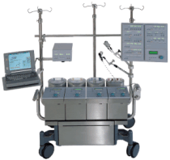
Figure 1.1 – Device of artificial blood circulation
This object consists of two main components - a device for injecting arterial blood into the patient's body and a device for arterializing blood (removing carbon dioxide from the blood and saturating it with oxygen) - an oxygenator. Modern artificial blood circulation devices are equipped with a number of auxiliary and recording devices.
Изм.
Лист
№ докум.
Підпис
Дата
Лист

БМ03.03.2705.1806.ПЗ

The apparatus of artificial blood circulation includes a complex of interconnected systems and blocks. First of all, this is an "artificial heart" - a pump that pumps blood with the volume flow rate necessary for life support. A gas exchange device ("artificial lung" or oxygenator) saturates the blood with oxygen, removes carbon dioxide and maintains the acid-alkaline balance within physiological limits.
The apparatus of artificial blood circulation is activated by means of hydraulic, pneumatic or electromechanical drives. In emergency mode, a manual drive is used.
In the world, many artificial blood circulation devices have been created for different purposes:
• for isolated chemotherapy of malignant neoplasms, inflammatory processes and destructive lesions;
• for auxiliary artificial blood circulation in case of cardiac and respiratory function disorders;
• for resuscitation of patients who are in a state of clinical death;
• to support the vital activity of isolated organs intended for further transplantation.
All devices have a common structural scheme and differ from each other in performance, control system features or additional special functional units.[2]
Artificial blood circulation begins with simultaneously turning on the arterial pump and removing the clamps from the venous line of the device, preventing the complete outflow of blood from the body. Synchronously increasing the performance of the pump and the amount of venous inflow, bring the volumetric rate of perfusion to estimated (2.2-2.4 l/min per 1 m² of body surface). In the future, the criteria of perfusion adequacy will be used.
The duration of artificial blood circulation depends on the nature of the pathology and varies from a few minutes (suture of the atrial septal defect, elimination of isolated valvular stenosis of the pulmonary trunk) to many hours (simultaneous prosthetics of several heart valves)
Изм.
Лист
№ докум.
Підпис
Дата
Лист

БМ03.03.2705.1806.ПЗ

The transition to natural blood circulation begins with a gradual or simultaneous cessation of blood flow to the apparatus with a simultaneous decrease in the productivity of the arterial pump. Blood pumping in the artery is completely stopped after reaching the optimal volume of circulating blood in the vascular bed of the patient, which is judged by the value of the central venous pressure, which should be 150-180 mm of water column at this moment.
In the case of prolonged artificial blood circulation (over 1 hour), it is advisable to combine it with artificial hypothermia, which is accompanied by a decrease in the body's need for oxygen, which allows to reduce the volumetric rate of perfusion, and thus the injury of the formed blood elements. In most cases, moderate hypothermia is sufficient (the temperature in the esophagus is not lower than 28 °). Deep hypothermia up to 15-10 ° is used extremely rarely, if a temporary complete stop of blood circulation is necessary.
When conducting artificial blood circulation, the method of controlled hemodilution is widely used, that is, the dilution of circulating blood is replaced by liquids (for example, low-molecular solutions of electrolytes, sugars or proteins). [3]
The following basic requirements are put forward to the modern ASK:
• the device must reliably maintain the specified minute volume of blood circulation in the body (about 4-5 l for an adult patient) and the specified temperature of the circulating blood during the entire perfusion;
• the oxygenator must ensure adequate arterialization of blood: its oxygen saturation is not lower than 95% and maintenance of pCO2 at the level of 35-45 mm Hg. Art.;
• the volume of filling of the ASC should be small (no more than 3 l during perfusion of adult patients);
• the device must be equipped with a device for returning to the circulatory circuit the blood that flows from the opened cavities of the heart and damaged tissues;
Изм.
Лист
№ докум.
Підпис
Дата
Лист

БМ03.03.2705.1806.ПЗ

• blood injury in the device should be minimal (no more than 40 mg of free plasma hemoglobin in the first hour of perfusion);
• the physiological block of ASK should be made of non-toxic material, chemically inert in relation to blood; its design should ensure the possibility of cleaning and sterilization in clinic conditions.
Any ASK consists of two blocks: physiological and mechanical. The physiological block includes all details that are in contact with blood. The main nodes of the physiological unit are the oxygenator, or "artificial lungs", and the arterial pump, or "artificial heart". This also includes various types of containers and hoses, with the help of which the nodes of the physiological block are connected to each other, forming an extracorporeal system - the so-called circulatory circuit of the device along which blood moves during artificial blood circulation. [4]

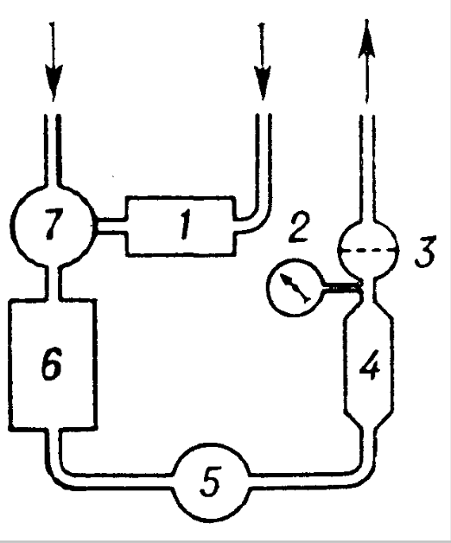
Figure 1.2 – Scheme of the artificial blood circulation apparatus

The Figure 1.2 shows the diagram of the artificial blood circulation device, where the typical nodes of the object are marked with numbers:
1. Coronary suction;
Изм.
Лист
№ докум.
Підпис
Дата
Лист

БМ03.03.2705.1806.ПЗ

2. Manometer;
3. Filter trap;
4. Heat exchanger;
5. Arterial pump;
6. Oxygenator;
7. Receiving vessel
Venous blood from the patient's vessels is automatically transferred to the oxygenator, which is located below the level of the operating table, where it is saturated with oxygen, freed from excess carbon dioxide, and then pumped into the patient's bloodstream by an arterial pump.
Before entering the patient's bloodstream, the blood passes through a heat exchanger (a device for maintaining the necessary blood temperature) and a filter trap that protects against emboli (thrombotic masses, pieces of calcium from valves and gas bubbles) entering the patient's bloodstream. Blood from the open cavities of the heart and damaged tissues is evacuated to the AHC with the help of a special device - the so-called coronary suction.
Oxygenators are divided into two main classes: oxygenators, in which gas exchange is carried out in direct contact of oxygen with blood, and oxygenators, where blood and oxygen are separated by a gas-permeable membrane.
The first class includes two types: bubble and film. The second class was called membrane oxygenators.
The design and manufacture of devices performing the pumping function of the heart are less difficult than solving the problem of artificial arterialization of blood. Pumps with a capacity approximately equal to the minute volume of the heart at rest are being created, that is, about 5 l/min, but their design takes into account the specific requirements for the "artificial heart".

  - Classification of heat exchangers
Изм.
Лист
№ докум.
Підпис
Дата
Лист

БМ03.03.2705.1806.ПЗ

Heat exchange devices are devices in which heat exchange is carried out between two or more heat carriers or between heat carriers and solid bodies (wall, nozzle). They are used in many industries. According to another definition, a heat exchanger is a device for transferring heat from one working medium to another [5].
The classification of heat exchangers depends on many factors and therefore they are divided as follows:
a) According to the purpose of heat exchangers:
• heaters;
• refrigerators/condensers
b) According to the nature of the movement of the coolant:
• direct current (Figure 1.3);
• countercurrent (Figure 1.4);
• with cross movement of heat carriers
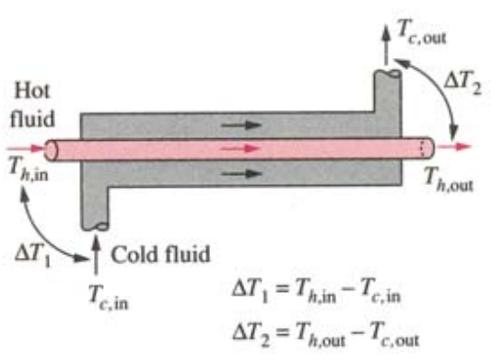
Figure 1.3 – Configuration of a direct flow heat exchanger
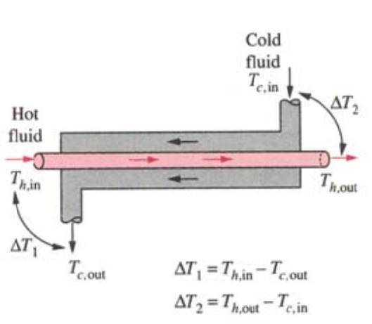
Figure 1.4 – Configuration of a countercurrent heat exchanger
Изм.
Лист
№ докум.
Підпис
Дата
Лист

БМ03.03.2705.1806.ПЗ

c) According to the method of heat transfer:
• surface (in devices of this type, heat exchangers are limited by solid walls, which partially or fully participate in the process of heat exchange between them; the heating surface is the part of the surface of these walls through which heat is transferred);
• mixing (in devices of this type, heat and mass exchange occurs during direct contact and mixing of heat carriers; mixing heat exchangers are sometimes called contact)[17,18]
d) According to the scheme of work in the technological cycle:
• periodic action (in such heat exchangers, the supply and removal of the heat carrier are periodically changed);
• continuous action (heat is transferred continuously through the wall from the heat carrier to the second heat carrier)
e) By design (heat exchangers-heaters):
• steam shirts;
• shell-and-tube (it is a device made of bundles of pipes, which are fastened with the help of pipe grids (boards) and limited by casings made of bundles of pipes);
• coil heat exchangers (straight horizontal pipes, which are located one above the other and connected in series by welding or on flanges);
• "pipe in a pipe" (simple sectional heat exchanger: a smaller diameter pipe is inserted into the outer pipe)
Изм.
Лист
№ докум.
Підпис
Дата
Лист

БМ03.03.2705.1806.ПЗ

All of the above heat exchangers are surface heaters.
Condenser heat exchangers can be surface and mixing
f) According to the form of contact with the heat exchange medium:
• superficial;
• mixing [5, 6].
Modern trends in the study of heat processes consist in the further clarification and generalization of data on the intensity of heat transfer for various technological processes, in the use of computer technology in heat exchange calculations and the selection of economically optimal heat exchangers.
In addition, the technique of heat exchange is being improved by creating new highly efficient and reliable heat exchange equipment, which allows more complete use of energy resources and reduces heat pollution of the environment. [7]

  - Use of a heat exchanger in an artificial blood circulation device

Heat exchangers are widely used in medical devices, for example, in artificial blood circulation machines (AHC). ASC consists of five main components (Figure 1.5):
• venous reservoir;
• oxygen generator;
• main pump;
• heat exchanger;
• arterial filter
Blood from the oxygenator enters the heat exchanger. There it is cooled or heated, depending on the temperature of the water circulating in the exchanger (4-42 °C); heat transfer occurs as a result of conduction. The solubility of gases decreases with an increase in blood temperature, so a filter is installed in the device to catch any bubbles that may form when the blood is warmed [8].
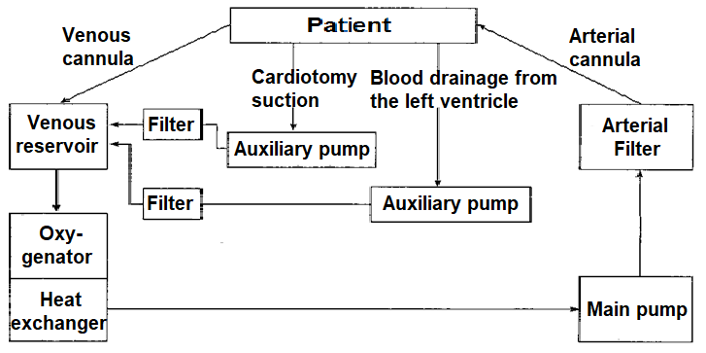
Figure 1.5 – Scheme of the artificial blood circulation apparatus [6]
Изм.
Лист
№ докум.
Підпис
Дата
Лист

БМ03.03.2705.1806.ПЗ

  - Efficiency of the heat exchanger for the artificial blood circulation device

If the heat exchanger of the artificial blood circulation apparatus (Figure 1.6) is well insulated so that the heat loss to the environment is insignificant, then the heat transfer from the warm fluid is equal to the heat transfer to the blood being warmed.
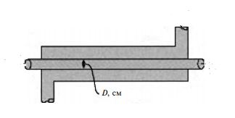
Figure 1.6 – Fragment of the heat exchanger of the artificial blood circulation apparatus [12]

At the same time, changes in kinetic and potential energy for blood flow are insignificant. Taking into account the fact that the temperature gradient between the perfusate (blood in circuit A) and the patient's body should not exceed 7°С, the amount of heat of the blood, which is transferred per unit of time in the heat exchanger, can be calculated from the expression (1.1).
Изм.
Лист
№ докум.
Підпис
Дата
Лист

БМ03.03.2705.1806.ПЗ

Q_{heart} = $m_{liq} · c_{liq} T_{liq}$ = 1, 06 kW (1.1)

where m liq = 0.04 kg/s is the mass of blood that passes through the heat exchanger when heated, c liq 3.64-3.77 $\frac{kJ}{kg · °С}$ – specific heat capacity of blood, ΔTliq = 7.0°С – temperature gradient for blood at the inlet and outlet of the heat exchanger.
Taking into account that all this heat is transferred from water heated to 40 °C, the temperature of the water at the outlet of the heat exchanger of the artificial blood circulation device is determined by formula (1.2).

T_{water,out} = $T_{water,in }- {Q_{water}}/{m_{water}·c_{water}}$ = 39,7 °C, (1.2)
where $m_{water}$ = 1,20 kg/c – mass of water that passes through the heat exchanger; $c_{water}$ = 4,18 $\frac{kJ}{kg · °С}$ – is the specific heat capacity of heated water; T_{water,in} = 40 °C is the temperature of water at the inlet to the heat exchanger when the blood is heated.
Knowing the inlet and outlet temperatures of both fluids, we can determine the heat transfer efficiency ɛ between water and blood (1.3).

ɛ = $\frac{m_{liq }c_{liq} {∆T}_{liq}}{{(mc)}_{min} ({∆T}_{water-liq})}$ = 0.304, or 30.4%. (1.3)

In the formula (1.3) is ${∆T}_{water-liq}$ = T_{water,in} - T_{liq,out} = 23.0 °C; T_{liq,out} = 17.0 °C $-$the initial blood temperature at the outlet of the heat exchanger; ${(mc)}_{min}-$the smallest value of the product (m c_{liq}) and (m c _{water}).
The power factor for a given heat exchanger will vary depending on the geometry and flow configuration (parallel flow, counter flow, cross flow, etc.) in the heat exchanger. Provided that the flow of the fluids is constant, the value of the coefficient is fairly constant (1.4).
Изм.
Лист
№ докум.
Підпис
Дата
Лист

БМ03.03.2705.1806.ПЗ

FROM_{r} = $\frac{m_{liq }c_{liq}}{m_{water} · c_{water}}$ = 0,029 (1.4)

The value of efficiency ɛ is always less than or close to ≤ 1. For any value of C_{r}, it is always possible to determine the maximum permissible value of Q_{heart} , at which the maximum temperature gradient between the perfusate (blood) and the temperature on the surface of the heart will not exceed 7°C. If the blood temperature in the heat exchanger circuit changes, the temperature on the heart surface will change accordingly.
This principle is the basis for the method of controlling the temperature of the heated fluid T_{water,in} at the inlet of the heat exchanger, in which the blood temperature at the outlet of the cardiopulmonary bypass circuit T_{liq,out} is measured using a thermal imager, and the temperature gradient ∆T_{liq} is determined from a 2D model of heat exchange between the myocardium and coronary vessels [12].

  - Existing technical solutions (analogs)

An analysis of the literature showed that the closest analogues are the following:
- Patent number 279896
Figure 1.7 shows a diagram of the operation of a heart-lung machine according to this patent.
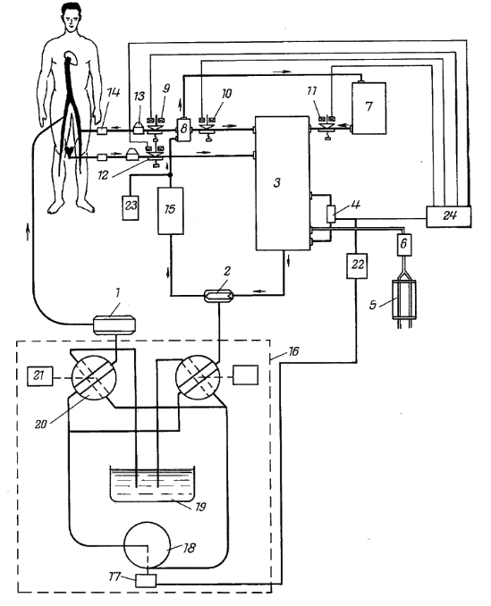
Figure 1.7 - Schematic diagram of the heart-lung machine of patent 279896

Numbers indicate the main elements of the circuit: 1 - arterio-arterial pump and 2 - veno-arterial pump; 3 - oxygenator; 4 - blood level sensor; 5 - gas meter; 6 - humidifier; 7 - donor blood tank; 8 - filter-trap for gas bubbles; 9, 10, 11, and 12 - electromagnetic clamps; 13 - temperature sensor; 14 - blood oxygen saturation sensor; 15 - heat exchanger, 16 - electrohydraulic drive; 17 - centrifugal actuator; 18 - pump; 19 - working fluid reservoir; 20, 21 - distribution valve and its drive; 22 - threshold device.
Изм.
Лист
№ докум.
Підпис
Дата
Лист

БМ03.03.2705.1806.ПЗ

- Patent number RF 2261118
Figure 1.8 shows a diagram of another patent.
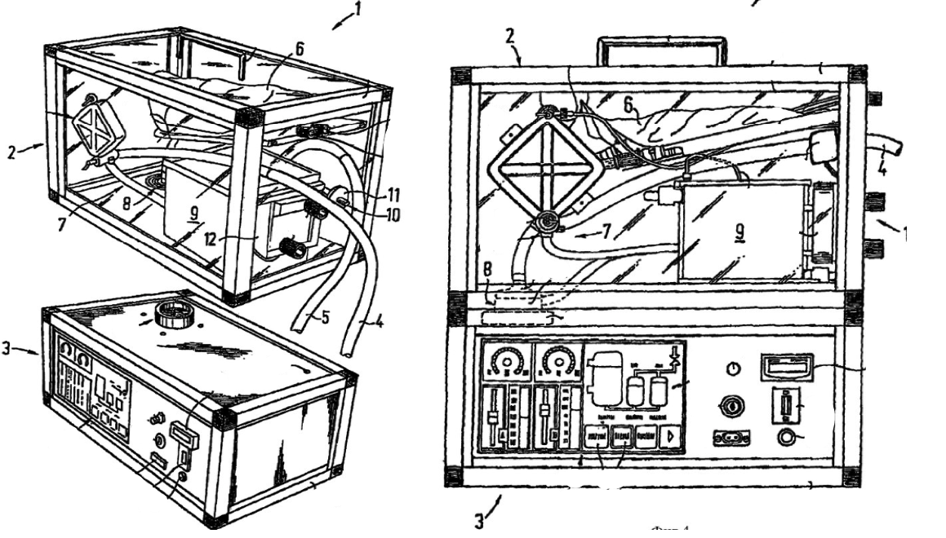
Figure 1.8 - Scheme of operation of the heart-lung machine of patent 2261118

Numbers indicate the main elements of the scheme: 1 - mobile element (the object itself); 2 and 3 - separate modules (2 - single-use module, in which all elements that provide blood circulation, reception of physiological and biological signals are attached; 3 - reusable module, in which all drive and control elements are attached); 4 - arterial tube; 5 - venous tube; 6 - venous blood reservoir; 7 - blood supply system; 8 - blood pump; 9 - oxygenator; 10 - oxygen gas combination; 11 - filter; 12 - temperature control device; 13 - circuit opening.
Изм.
Лист
№ докум.
Підпис
Дата
Лист

БМ03.03.2705.1806.ПЗ

As can be seen from the above technical solutions in the form of patents, each of them has the necessary components of a heart-lung machine and their structure is taken into account in the creation of a future model for temperature control in the circuit of the heart-lung machine.
In each of the above patents, the heat exchanger assumes the obligations of a regulating element responsible for controlling the blood temperature in the ASCB circuit. Therefore, its computing power must be accurate and temperature regulation must be continuous. Quite often, the heat exchanger and temperature controller are integrated. This has certain advantages and disadvantages. Among the advantages is the reduction in the volume of the module and its portability. Among the disadvantages, the unit requires a higher supply voltage and the speed of computing processes is slower, since temperature control and calculations are performed asynchronously. By optimizing the algorithm, it is possible to achieve synchronization of actions in the system, thereby optimizing the system as a whole.
Изм.
Лист
№ докум.
Підпис
Дата
Лист

БМ03.03.2705.1806.ПЗ

Conclusion to Section 1

Heat exchangers in ASHPs are an important elemental part of the entire system, which can be designed in different ways, depending on the type or type of heat exchanger and the system itself. It should be borne in mind that, like any heat carrier, heat exchangers must be ergonomic to avoid energy waste and heat radiation into the environment.
After analyzing a number of patents, I familiarized myself with the principle of using a heat exchanger in an ASK and am ready to develop a system using this element.

SECTION 2
Изм.
Лист
№ докум.
Підпис
Дата
Лист

БМ03.03.2705.1806.ПЗ

DEVELOPMENT OF A TEMPERATURE CONTROL SYSTEM

2.1 Technical requirements for the system to be developed

The developed temperature control system should have the characteristics given in Table 2.1.
Table 2.1 - Technological characteristics of the developed system
Parameter. | Characteristics
Contact surface area of the heating/cooling element | Not less than 30x30 mm
Supply voltage | 5-15 V
Operating temperature | from -10 °C to +70 °C
The power used | ~ 60 W
Temperature change steps | Not less than 30s
Presentation of results | Digital
PC connection interface | USB

For this system, an important parameter is the surface area of the heating or cooling element, because it is one of those parameters that characterize the useful effect of this system. If this area is too small, the blood (or other fluid) will not have time to heat up/cool down from the heating element; if the area is too large, the heating element will require a higher supply voltage, which is not advisable.
Another important parameter of the system is the operating temperature of the heating/cooling element, since it determines the possibility of sudden heating/cooling of the blood in the circuit, when the temperature of the liquid drops. In this case, the element must be able to heat up or cool down to a gradient high/low temperature (when a higher voltage is applied) in order to balance the blood temperature in the circuit at a critical moment.
The convenient presentation of the results allows the operator to track the closed loop of the algorithm by the module. The digital display of indicators is the most appropriate in this case, since it is not always convenient to see some small range of module parameters (temperature or voltage) on the graph.
The temperature change step depends on the supply voltage supplied to the heating/cooling element and the operating temperature of the same element. In this system, the step should be at least 30 seconds to ensure fast temperature control in the circuit. The algorithm reads data from the circuit every 5 seconds, so six such cycles are enough to change the voltage to match the vector of blood temperature changes in the circuit.
Изм.
Лист
№ докум.
Підпис
Дата
Лист

БМ03.03.2705.1806.ПЗ

2.2 Overview and selection of system elements

2.2.1 Overview of the heating elements

Taking into account the above technical characteristics, the heating elements of the system were selected.
PTC Heater Heating Element Constant Temperature is a heating element designed to heat air or solids (Table 2.2, Figure 2.1).

Table 2.2 - Technological characteristics of PTC Heater Heating Element Constant Temperature
Parameter. | Characteristics
Contact surface area of the heating/cooling element | 25x20 mm
Supply voltage | 5-24 В
Operating temperature | from +200 °C to +270 °C
The power used | more than 120 W

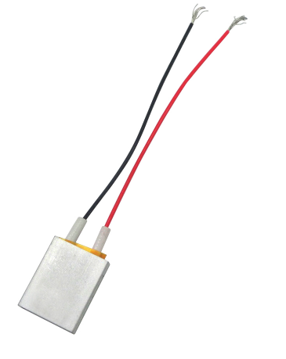
Figure 2.1 - PTC Heater Heating Element Constant Temperature

This element does not fit the technical description because it has a smaller heating/cooling contact surface area, too high an operating temperature, which can lead to blood clotting in the circuit and makes it impossible to cool the liquid, and too high a power consumption.
Изм.
Лист
№ докум.
Підпис
Дата
Лист

БМ03.03.2705.1806.ПЗ

HU-2 Optex - the HU-2 heating element set is designed to expand the operating temperature range of operation and heating of objects (Table 2.3, Figure 2.2).
Table 2.3 - Technological characteristics of HU-2 Optex
Parameter | Characteristics
Contact surface area of the heating/cooling element | 78x43 mm
Supply voltage | 24 V
Operating temperature | from -60 °C to +50 °C
The power used | 60 W

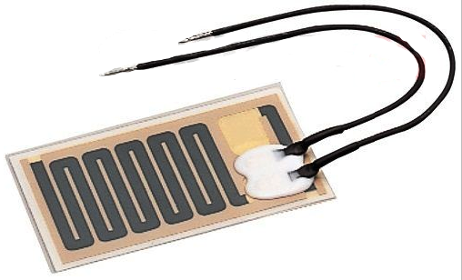
Figure 2.2 - HU-2 Optex heating element

This element fits the technical description of the circuit, but, given the price (~4000 UAH), it is too expensive to purchase and operate. Also, it requires a higher supply voltage than provided.
The Peltier element was chosen for the system, which is described in detail in Section 2.3.

2.2.2 Overview of the Arduino computing platform
Изм.
Лист
№ докум.
Підпис
Дата
Лист

БМ03.03.2705.1806.ПЗ

The Arduino Nano V3.0 is a small, self-contained board based on the ATmega328 microcontroller. It is almost the same in functionality as the Arduino Duemilanove/Uno, but has a different form factor (Figure 2.3).
Characteristics:
- Microcontroller: ATmega328P
- Operating voltage: 5V
- Input voltage (recommended): 7-12V
- Digital inputs / outputs: 14 (of which 6 can be used as PWM)
- Analog inputs: 6
- Current strength at inputs/outputs: 40 mA
- Current strength for 3.3V output: 50 mA
- Memory: 32kB of which 2kB is used by the bootloader
- Frequency: 16 MHz
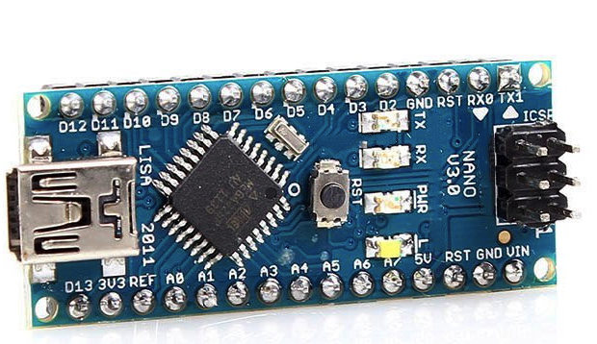
Figure 2.3 - Arduino Nano V3.0

This platform is not suitable for the scheme, as a Mini-B USB cable is used to connect to a PC and the functionality of the board itself is cut off, which makes it impossible to connect a display and shield to it.
Arduino Mega 2560 Rev3 is the latest version of the microcontroller board from Arduino. It is based on the powerful ATmega2560 chip, which operates at 16 MHz (Figure 2.4).
Изм.
Лист
№ докум.
Підпис
Дата
Лист

БМ03.03.2705.1806.ПЗ

Characteristics:
- Microcontroller: ATmega2560
- Operating frequency: 16MHz
- Operating voltage: 5V
- Power supply voltage: 7-12V
- Supply voltage: 6-20V
- Digital inputs/outputs: 54, of which 15 can operate in PWM mode
- Analog inputs: 16
- Current strength at inputs/outputs: 40mA
- Current consumption for 3.3V outputs: 50mA
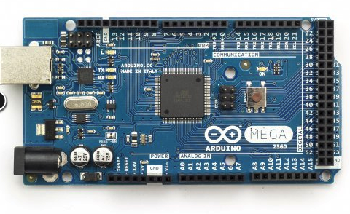
Figure 2.4 - Arduino Mega 2560 Rev3

This platform is not suitable for the scheme due to its pricing policy, and has a lot of unnecessary functionality that takes up an array of the platform's computing power.
For the system, we chose Arduino Uno Rev3, which is described in detail in Section 2.3.

2.3 Description of the functional diagram of the circuit temperature control system
Изм.
Лист
№ докум.
Підпис
Дата
Лист

БМ03.03.2705.1806.ПЗ

The functional diagram of the temperature control system based on the Arduino hardware and computing platform is shown in Figure 2.5
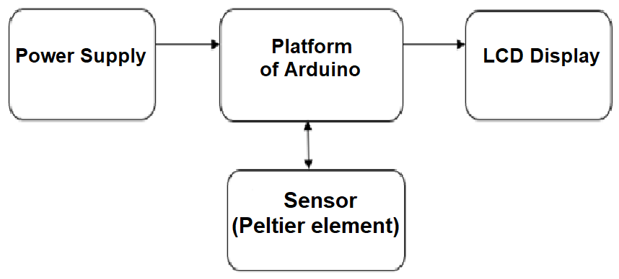
Figure 2.5 - Functional diagram of the temperature control system based on the Arduino hardware and computing platform

Four elements were used to implement this system:
- Arduino Uno.
- Power shield.
- LCD display.
- Thermoelectronic cooler with Peltier element.

1. Arduino Uno Rev3. Arduino (Figure 2.6) is an open platform that allows you to assemble any electronic device. It is based on the ATmega328P processor. This allows you to increase the speed of data transfer; no drivers are required for Linux and Mac and allows you to use the controller as a keyboard, mouse, or joystick when flashing. A simplified version of C++ is used for programming, and development can be carried out both using the free Arduino IDE platform and with the help of any C/C++ Toolkit.
The platform includes 14 digital inputs/outputs, 6 analog outputs, a 16 MHz quartz resonator, a USB connector, a power connector, and a reset button.
Изм.
Лист
№ докум.
Підпис
Дата
Лист

БМ03.03.2705.1806.ПЗ

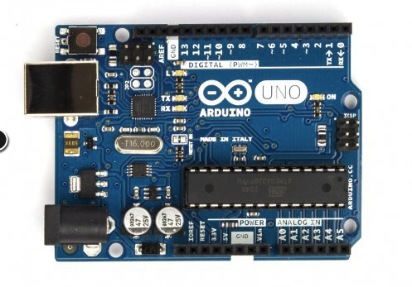
Figure 2.6 - Arduino Uno Rev3

2. Power shield from DFRobot (Figure 2.7). To realize the purpose of this work, more than two supply voltages are required (Arduino provides voltages of 3.3V and 5V). This shield can be supplied with a voltage in the range of 4.5 - 35V, the output is from 1.25 to 12V with a maximum current of 3A. The efficiency of this shield is set at 90%. Also on board this power shield is a built-in voltage meter that can transmit the output voltage to analog input 0 (if the appropriate jumper is installed). The output voltage can be controlled (enabled/disabled) using the digital pin 13 (again, if the corresponding jumper is installed).
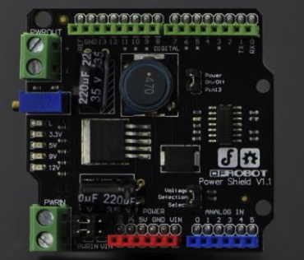
Figure 2.7 - Power shield from DFRobot
Изм.
Лист
№ докум.
Підпис
Дата
Лист

БМ03.03.2705.1806.ПЗ

3. LCD display 20x4 I2C bus (Figure 2.8). LCD screen with 20 characters and 4 lines. It is built on the basis of a chip that can be compared with the HD44780, which allows you to work with it through the standard LiquidCrustal library. The connection is standard as for the entire line of similar displays on this controller. You can use it in both 8-bit and 4-bit mode. Thanks to it, you can explicitly monitor the necessary parameters and obtain data for further calculations.
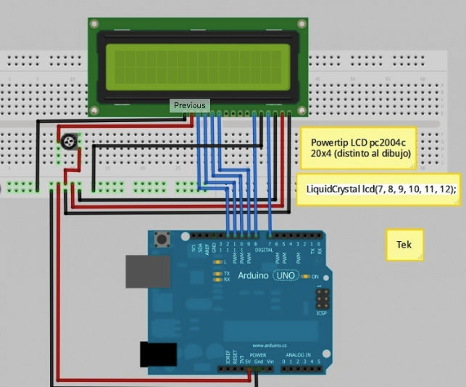
Figure 2.8 - Diagram of the display connection to the platform

Characteristics:
Изм.
Лист
№ докум.
Підпис
Дата
Лист

БМ03.03.2705.1806.ПЗ

- Dimensions: 80x36 mm
- Operating temperature: 0 - 50°C
- Backlight: blue
- Symbol color: white
- Character size: 4.35x2.95 mm
- Format: 16х2
- Dimensions of the point: 0.5x0.5 mm
- Interface: HD44780
- Visible area: 64.5x13.8 mm
- Power supply: 5V

4. Thermoelectronic cooler Peltier element - heat pump (Figure 2.9). The principle of operation of the Peltier element is that when a current flows through two semiconductors in contact with each other, the plate is heated on one side and cooled on the other, and the temperature difference on both sides of the plates is the same. For this property, the Peltier element is called a thermal pump. By itself, it cannot cool the processor or, in our case, the blood. It simply pumps the heat generated from one cover to the other, from the processor to the cooler. A thermoelectric pump has a cold side where heat is absorbed and a hot side where it is released. The power of the Peltier element should be one and a half to two times the power of the cooling surface. [13, 14].
Characteristics of the Peltier element:
- Size: 40mm × 40mm × 4mm;
- supply voltage: from 0 to 15.2V;
- Current consumption: from 0 to 6A;
- Operating temperature: -30 to 70;
- maximum power consumption: 60W;
- weight: 22g

Figure 2.9 - Peltier element [14].

An oscilloscope was used as a power supply, which was used to regulate the voltage supply to the Peltier element.
Изм.
Лист
№ докум.
Підпис
Дата
Лист

БМ03.03.2705.1806.ПЗ

2.4 Description of the temperature control algorithm

The algorithm itself can be represented as three pseudo-independent blocks:
- The first block
T₀, T_{min}, T_{max}
Setting the initial parameters
Turn on the power to the TEC

Feed U_{i}

Changing the polarity of TEC power supply

U_{i}
T_{i}

Figure 2.10 - First part of the block diagram (power supply polarity)

The first block displays the algorithm for reversing the polarity of the power supply on the Peltier cell and begins with setting the minimum and maximum temperature that can be controlled. After the initial parameters are set, the module is switched on and supplied with a certain amount of power (variable in time). Depending on the voltage, the circuit must change its polarity, transmitting the temperature of the i-th value to the following components.
T_{i}
Setting the heating/cooling mode

TEC temperature reduction in accordance with U_{вх} (T )_{tec}

Increase in TEC temperature in accordance with U_{вх} (T )_{tec}

Cooling
Heating
- The second block
Изм.
Лист
№ докум.
Підпис
Дата
Лист

БМ03.03.2705.1806.ПЗ

Figure 2.11 - First part of the block diagram (setting the heating/cooling mode)

The second part of the general scheme is an algorithm for setting the heating or cooling mode on the Peltier element.
The system reads the input discrete temperature value and the polarity value of the heating element. And, according to the received data, the AO heats the element or cools it according to the dependence of the input voltage on the temperature on the TPP element.
- The third block
Disconnecting the TEC power supply

Turning on the power to the TEC

Switching the polarity of the TEC power supply

T_{e}(T0 _{min} ; T _{0 max})
T_{і} > T_{0 max}
T_{і} < T_{0 min}

U_{i}
Temperature control T_{і} < > T₀

Figure 2.12 - First part of the block diagram (temperature control)
The third part of the circuit is responsible for controlling the temperature in the system circuit to prevent overheating or hypothermia in the ASCB circuit. This is done in such a way that, having a certain ith temperature, we read its value and compare it with the limit values that were set at the beginning of the algorithm.
Изм.
Лист
№ докум.
Підпис
Дата
Лист

БМ03.03.2705.1806.ПЗ

If temperature T is within the critical temperature limits, the process goes to the beginning of the flowchart, with further polarity operation.
If temperature T exceeds the critical temperature limits, the power supply polarity of the TPP is switched and the plant switches to pseudo-unit No. 2.
To control the temperature, a scenario algorithm was created that implies a cyclical process (continuous operation), since the failure or stopping of the heating/cooling processes and the analysis of parameters within the circuit is unacceptable in a heart-lung machine.
The full algorithm is cyclic and is presented in eight blocks:
1. The first step is to set the initial temperature parameters (limit temperatures): T_{0 min} for cooling, T_{0 max} for heating.
2. Turn on the power to the Peltier cell (TEC1-12706).
3. Next is the process of switching the polarity on the Peltier element.
4. Setting the voltage U_{i} (externally) on the controlled power supply (since the polarity will change, you need to check and reinitialize the voltage variable all the time).
5. Conditional operator - depending on the specified condition (heating/cooling mode), it switches to one of the specified units. In this case, the power supply polarity at the TPP is checked.
6. In the case of the heating mode, the temperature increases on the heating element according to U_{вх} (T_{тес} ). Otherwise, the temperature decreases or heats up with a certain gradient in the temperature value in the same accordance with signal U_{вх}(T _{тес}).
7. Temperature Control Operator: checking the discrete temperature value (T_{і} ) at the same time and checking with the set initial parameters (T_{0 min} – for cooling, and T_{0 max} – for heating).
Изм.
Лист
№ докум.
Підпис
Дата
Лист

БМ03.03.2705.1806.ПЗ

8. In case of TPP power outage and if T_{і} is greater than T_{0 max} or less than T_{0 min}, the transition to step 3 is performed – reversal of TPP power supply polarity. If T_{0 min} is within the initial (limit temperatures), the transition is to step 2 – switching on TPP power supply.
The process is continuous, since the power supply polarity is reversed when overheating or cooling, and otherwise the temperature data is checked for limit values (whether T_{і} is within the range (T_{0 min} ; T_{0 max}).

Conclusion to Section 2

After analyzing some of the possible components, it was found that all the selected elements allow the scheme to be reproduced without spending money on its creation in economic terms, since individual modules are quite cheap in terms of pricing.
All the selected elements have a functionality that fits the algorithm for controlling the temperature in the system described in section 2.4.
This algorithm is designed to be cyclical to continuously display the temperature and monitor the voltage on the heating element during operation in the ASK circuit.

SECTION 3
Изм.
Лист
№ докум.
Підпис
Дата
Лист

БМ03.03.2705.1806.ПЗ

DEVELOPMENT OF A WORKING MODEL OF THE SYSTEM

3.1 Experimental verification of the Peltier element. Processing of the obtained data.

Using this algorithm and the model, an experiment was conducted: by changing the input voltage (applied to the Peltier element) using an oscilloscope, the following data were read:
- temperature on one of the surfaces of the Peltier element (heating temperature);
- temperature on the other side of the Peltier element (cooling temperature);
- input voltage Vin and output voltage Vout.
All the data found are recorded in a separate table (Table 3.1).
Table 3.1 - Experimental temperature and voltage data
№ | Uin, V | Uout, V | Tcooling, К | Theating, К | T1, К
1 | 0 | 0 | 295,3 | 295,3 | 295,9606
2 | 3,3 | 2,4 | 293 | 307 | 303,1143
3 | 4,5 | 3,1 | 295 | 313 | 306,7829
4 | 5 | 3,6 | 297 | 318 | 309,84
5 | 6 | 4,3 | 298 | 325 | 314,12
6 | 7 | 5,2 | 302 | 330 | 317,1771
7 | 8 | 6,2 | 303 | 337 | 321,4571
8 | 9 | 6,9 | 308 | 346 | 326,96
9 | 10 | 7,6 | 311 | 356 | 333,0743
10 | 11 | 8,5 | 318 | 366 | 339,1886
11 | 12 | 9 | 323 | 376 | 345,3029
12 | 13 | 9,1 | 332 | 384 | 350,1943
13 | 14 | 9,2 | 336 | 390 | 353,8629
14 | 15 | 9,3 | 342 | 395 | 356,92

Experimental temperature and voltage data in this table:
Uin - input voltage on the Peltier element;
Uout - output voltage on the Peltier element;
Tcooling - temperature of the "cooling" side of the Peltier element;
Theating - temperature of the "heating" side of the Peltier element;
Изм.
Лист
№ докум.
Підпис
Дата
Лист

БМ03.03.2705.1806.ПЗ

T1 is the temperature on the surface of the tube through which blood flows (for CABG).
T1 is calculated by formula (3.1)

$λ\frac{Т_{heating} - Т_{1}}{D}= α(Т_{heating}-T_{w})$ (3.1)

where T_{w} is the temperature at the inlet of the system, λ is the thermal conductivity of stainless steel, α is the heat transfer coefficient of water, D is the cross-sectional diameter of the ASHK system [19, 21].
These data are constant and are recorded in Table 3.2 for further calculations to find T1.
Table 3.2 - Table values of some constants [17, 18].
λ | 17.5 W/(m*K)
α | 340 W/(m² -K).
D | 0,02 m
T _{w} | 297 K

The value of T_{w} is chosen as 24°C for empirical calculations, since the heat exchanger fluid cannot be the same as the ambient temperature, since the circulation inside the heat exchanger heats it to a higher temperature.
The system itself is shown in Figure 3.1.
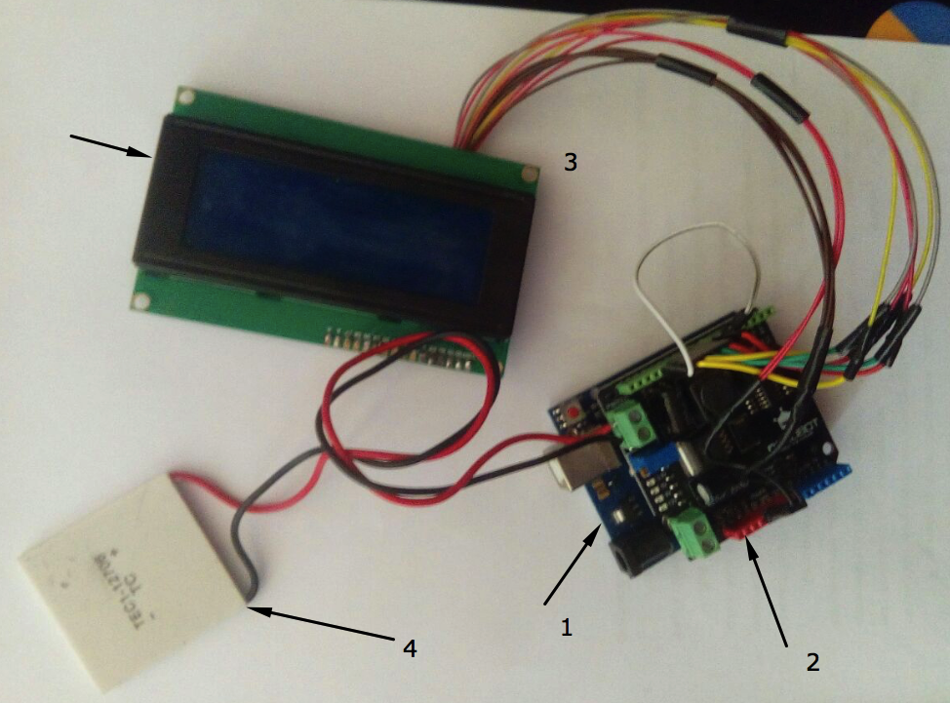
Figure 3.1 - Working layout of the scheme
Components of the layout:
Изм.
Лист
№ докум.
Підпис
Дата
Лист

БМ03.03.2705.1806.ПЗ

- Arduino Uno Rev3.
- Power shield
- LCD display.
- Thermoelectronic cooler with Peltier element.
From formula (3.1), let us express T1:

$T_{1}=- \frac{αD\left(T_{heating}- T_{w}\right)}{λ}+ T_{heating}$ (3.2)

Substituting the data from Table 1 into formula (3.2), we found the value of T1 for each measurement.
Based on the data in Table 3.1, we constructed graphs of the dependence of the cooling temperature (T_{cooling} ) and heating temperature (T_{heating} ) on the input voltage (Figure 3.2) and a graph of the temperature on the tube surface (T₁ ) on the input voltage (Figure 3.3).

Figure 3.2 - Dependence of the cooling temperature (T_{cooling} ) and heating temperature (T_{heating} ) on the input voltage
Figure 3.1 shows that the gradient of the difference between T_{cooling} and T_{heating} increases with increasing U_{in}. At a voltage of 3.3V, a decrease in the temperature of the "cooling" side of the Peltier element is observed. Starting from 4.5V, this surface begins to heat up, which is due to the insufficient power of this element. This drawback can be eliminated by using another Peltier element with higher operating temperature limits (in this case, the heating temperature T_{heating} went beyond these temperature limits).
Изм.
Лист
№ докум.
Підпис
Дата
Лист

БМ03.03.2705.1806.ПЗ

There was no point in applying a higher voltage to the Peltier element, since with an increase in U_{in}, the value of U_{out} grew with a smaller and smaller increase.
The maximum supply voltage of the Peltier cell is 15.2V.

Figure 3.3 - Dependence of the temperature on the surface of the tube (T₁ ) on the input voltage

The graph shows that as the input voltage increases, the temperature on the surface of the tube increases. That is, the temperature T_{heating} is sufficient to heat the shell through which the blood will flow. The temperature T₁ grows smoothly, without jumps in values, which is necessary because the liquid must absorb this heat evenly so as not to damage the structure and lead to unpredictable problems in the cardiopulmonary bypass.
Изм.
Лист
№ докум.
Підпис
Дата
Лист

БМ03.03.2705.1806.ПЗ

Conclusion to the section 3

In the course of the third part, the Peltier element was experimentally tested, the relationship between the input voltage and the heating and cooling temperatures was established; the relationship between the input voltage and the temperature on the surface of the tube through which the blood flows was determined.
The graphs show how the input voltage affects the temperatures indicated above and, using this data, it is possible to predict further temperature rise or fall depending on the supply voltage applied to the cell. This allows the operator to monitor the module without interfering with its operation.

SECTION 4
Изм.
Лист
№ докум.
Підпис
Дата
Лист

БМ03.03.2705.1806.ПЗ

LABOR PROTECTION

4.1 General description of the facility to be developed
5
1
2
3
4

6

4

Figure 4.1 - Block diagram of the device

All the parts used to make the model of the unit are non-standard, which is due to the specifics of the tasks performed (Table 4.1).
Table 4.1 - Component parts of the facility (standard, non-standard), schemes of their interconnection
No. of part. | Name of the component part | Connection diagram | Geometric dimensions, mm
1 | Arduino Uno Rev3 board | Basic component | 68x53x15
2 | Power shield from DFRobot | Mounted in the Arduino base board | 68x50x20
3 | LCD display 20x4 I2C bus | It is connected with the help of papa-papa wires, soldering one of the ends. | 98x60x20
4 | Thermoelectronic cooler Peltier element TEC1 | Screws into the connection socket using standard wires | 40x40x4
5 | Cover (housing) | Freely removable | 150x120x40
6 | Power supply wires | Connects via USB port | length 1000 mm

The projected plant is electrically dependent, so it consumes electrical energy. The plant is fully automatic. The model is designed for commercial use and assembly in an assembly shop. Due to the fact that the machine is powered by electricity, additional fire and electrical safety measures must be taken.
Изм.
Лист
№ докум.
Підпис
Дата
Лист

БМ03.03.2705.1806.ПЗ

In terms of energy consumption for maintenance and adjustment procedures, the work is classified as "light - 1a". The duration of work with the installation (including adjustment) is from 2 to 5 minutes. It is not necessary to arrange a permanent workplace for the operator.
The unit is activated automatically after connecting to the on-board computer of the AFC via a USB cable and placing the Peltier element on the circuit where the liquid temperature is to be regulated. To automatically control the temperature, it is enough to connect the unit to an on-board computer or a PC that receives readings of the temperature of the liquid in the middle of the AFC circuit.
The unit has a power on indicator, 4 power supply voltage indicators. The display also monitors the temperature of the heating (or cooling) elements and the voltage of the elements used.
Type of climatic design of the instrument - for use in a laboratory with a moderate macroclimate - U 4.2 according to GOST 15150.

  - Analysis of potential hazards posed by the design of the projected facility and measures to eliminate them

Table 4.2 shows the analysis of hazardous and harmful factors that arise during the operation of the developed plant.
Table 4.2 - Hazardous and harmful factors
Type of factors | Characteristics
Physical factors | Surface temperature
Physical factors | Electrical safety
Physical factors | Sharp edges and bumps
Physical factors | Fire safety
Biological factors | Block surface
Chemical factors | Absent
Psychophysiological | Absent
Since this installation is automatic, there are no psychophysiological factors, as the operator does not have to control the heating/cooling process manually.
Изм.
Лист
№ докум.
Підпис
Дата
Лист

БМ03.03.2705.1806.ПЗ

This unit is applied to the surface of the ASC, which is used in laboratory and medical facilities, so the surface of this device must be sterile and disinfected.
During operation, the module does not emit harmful chemicals, does not react with the surface of the fastener, and is isolated from the environment by a cover.

    - Surface temperature

In the process of operation of this unit, some of the elements (Peltier element and the platform itself) are heated (useful and passive) or cooled (useful).
The beneficial effect of heating and cooling is due to the use of this device to cool or heat the tube to remove (cool) or give (heat) heat to the liquid circulating in the ASC.
The heating of the platform itself occurs due to the passage of a current of a specific voltage through the microcontroller, which causes the former to heat up. The heating does not reach critical temperatures and is not capable of causing significant damage to the equipment or the operator. In addition, the platform itself is insulated with a heat-resistant cover.
Table 4.3 shows the sources and consequences of the impact of the temperature of the surface of elements on human health

Table 4.3 - Sources and effects of surface temperature
Source. | Consequences
Cooling side of the Peltier element | Skin damage in places of direct contact. The damage is minor, as the element is cooled to -30 °C.
Heating side of the Peltier element | Skin damage in places of direct contact. Damage can be severe as the cell heats up to +120 °C (at high voltage, the maximum temperature may rise by 5-7% of the nominal temperature specified in the cell documentation).
Heating the lid | The damage is minor. Maximum heating of the lid +70 °C
Table 4.4 shows the safety measures that must be taken to eliminate the risk of harm to health due to careless handling of heated (cooled) surfaces of the installation.
Изм.
Лист
№ докум.
Підпис
Дата
Лист

БМ03.03.2705.1806.ПЗ

Table 4.4 - Security measures
Type of event | Means of overcoming the danger
Technical measures | Attaching the protective cover to the Peltier element;  Isolating the Arduino platform itself with a protective case
Organizational measures | Conducting briefings with laboratory/medical staff on the safe handling of the device to prevent thermal exposure of employees
Organizational measures | Familiarize employees with the device operating instructions
Personal protective equipment | Hand protection equipment  Dermatological protective products  Comprehensive means of protection

4.2.2 Sharp edges and irregularities

Table 4.5 shows the sharp edges and unevenness of the installation
Table 4.5 - Sources and consequences of exposure to sharp edges and bumps
Source. | Consequences
Cover (housing) of the device | Risk of injury to hands and soft tissue injuries when installing and carrying this module

Table 4.6 shows the precautions for sharp edges and uneven installation.
Table 4.6 - Security measures
Type of protection | Means of overcoming the danger
Technical | Rounding of edges and corners of the case
Organizational | Familiarize employees with the device's operating instructions

4.2.3 Electrical safety

This device consumes electricity. Consequently, this device may cause electrical shock.
Table 4.7 shows a list of possible electrical injuries and their characteristics
Table 4.7 - Sources of danger
Изм.
Лист
№ докум.
Підпис
Дата
Лист

БМ03.03.2705.1806.ПЗ

Type of electric shock | Characteristics
Electrical burns | Damage to the surface of the body under the influence of an electric arc or high currents passing through the human body
Electric signs | They are gray or pale yellow spots in the form of a callus on the surface of the skin at the point of contact with live parts.

Table 4.8 shows a list of causes of electrical injuries and means of preventing them.
Table 4.8 - list of causes of electrical injuries and means of their prevention
Reason. | Means of overcoming the danger
Reason. | Technical | Organizational
Damage to the insulation of the appliance wiring | Insulation of the wires connecting the Peltier element to the platform, inaccessibility of current-carrying parts of the microprocessor | Training of personnel in electrical safety, briefings, and monitoring of electric current parameters.
Disconnecting live parts of the device from the supporting parts | Inaccessibility of current-carrying parts of the microprocessor | Training of personnel on electrical safety, briefings, regular technical inspections of equipment by technical personnel of the laboratory/medical facility

4.2.4 Fire safety

In order to prevent fires in the laboratory space where the facility under development will be operated, it is necessary to analyze the fire hazards. Table 4.9 shows the main sources of fire hazards.
Table 4.9 - Sources of danger
Source of danger | Consequence.
Material of the device | Poisoning by toxic combustion products of the plant
Increased temperature of some elements of the device | Fire of elements of other equipment in contact with the device  Spreading fire to other installations/devices
Damage to the insulation of the device wiring | Fire on a surface in contact with a damaged section of electrical wiring due to a spark or heating of the surface
Table 4.10 shows the parameters of fire hazard and its characteristics. It has been established that in the event of a fire, the unit under development belongs to class E - burning of electrical installations under voltage.
Изм.
Лист
№ докум.
Підпис
Дата
Лист

БМ03.03.2705.1806.ПЗ

Table 4.10 - Fire hazard parameters
Fire hazard parameter | View | Characteristics
Fire class | E | Burning of electrical installations under voltage
Indicators of fire and explosion hazard of substances and materials. | Highly combustible materials | Substances and materials that are incapable of burning or charring in the air under the influence of fire or high temperature

Table 4.11 shows the toxic combustion products that will be produced if the installation catches fire.
Table 4.11 - toxic combustion products
Toxin | Characteristics | Consequence.
carbon monoxide | Not very dangerous | Headaches, shortness of breath, arrhythmia
hydrogen chloride | Moderately dangerous | Causes cough, inflammation of the nasal and oral cavity
Acrolein | Extremely dangerous | Burning in the eyes, lacrimation, conjunctivitis, eyelid swelling, sore throat, cough

Table 4.12 shows the fire protection and extinguishing measures that must be provided in the room where the unit is to be operated. In the event of a fire, it is sufficient to prevent the combustion products of the installation from entering the respiratory tract. However, if this is not possible, the use of a respirator is recommended.
Table 4.12 - Protection and means of overcoming fire hazards
Type of event | Events.
Technical measures | Isolation of the Peltier element and microprocessors by protective enclosures, covers
Organizational measures | Fire safety training and periodic monitoring of knowledge of fire safety rules. Fire evacuation plan.
Personal protective equipment | Respirator RPG-67A

4.3 Operating instructions

4.3.1 General requirements

General requirements:
Изм.
Лист
№ докум.
Підпис
Дата
Лист

БМ03.03.2705.1806.ПЗ

1.1 Only persons who have undergone an introductory briefing, on-the-job training, and an occupational safety and health examination are allowed to work with this device.
  - Employees are obliged:
1. Know the procedure for checking and using the mechanical and electrical parts of the device, protective equipment;
2. Perform only the work specified in the equipment operating instructions or job descriptions approved by the company's administration and provided that safe methods of performance are well known;
3. Know and be able to provide first aid to victims of electric shock and other accidents;
4. Follow fire safety instructions.

4.3.2 Safety requirements before starting work

Safety requirements:
1. Check the serviceability of the unit and personal protective equipment.
2. Report all defects and malfunctions found in the device to the technical service of the institution.

4.3.3 Safety requirements when working with the unit

1. Make sure that the module itself is disconnected from the power supply before attaching the device to the AED circuit.
2. Place the module on a stable surface, preferably at a level of 1000-1200 mm from the ground.
Изм.
Лист
№ докум.
Підпис
Дата
Лист

БМ03.03.2705.1806.ПЗ

3. Install this device by attaching the Peltier element to the tube through which the liquid circulates.
4. Connect the USB cable to the on-board computer of the System or to a PC located directly near the operator. Thus, the device will be connected to the power source.
5. Set the initial voltage and temperature on the Peltier cell using the on-board computer program or PC.
6. Make sure that all the indicators are in working order.
7. Start the temperature control cycle on the on-board computer or on a PC.

4.3.4 Safety requirements after completion of work

When you are finished using the device, end the program cycle, disconnect the power cable (USB cable) from the on-board computer (PC). Do not touch the Peltier element for the first 5 minutes, as it may have a high temperature rating and may cause harm to the operator.
Protect the unit from water vapor, liquid water, and flammable materials. Do not remove the module cover unless absolutely necessary. Do not upgrade the unit, as this may cause malfunction of the unit. During operation, do not touch the Peltier element without wearing personal protective equipment.

Conclusions to Section 4
Изм.
Лист
№ докум.
Підпис
Дата
Лист

БМ03.03.2705.1806.ПЗ

In this section of the thesis, potential hazards created during the operation of the installation for temperature control in the circuit of the heart-lung machine (HLM) were identified and analyzed. In particular, fire, electrical, mechanical and temperature hazards were analyzed. For each type of hazard, measures were developed to improve (normalize) working conditions during the operation of the plant under development. After identifying the hazards, design changes were made to the plant to make it safer to operate. An operating manual has been prepared for the unit under development, which describes the recommendations and rules for operation. The plant under development is safe and complies with all labor protection standards.

CONCLUSION
Изм.
Лист
№ докум.
Підпис
Дата
Лист

БМ03.03.2705.1806.ПЗ

In the course of this thesis, literature sources in the field of medical equipment, namely, cardiopulmonary bypass, were analyzed. An algorithm for temperature control in the circuit cardiopulmonary bypass was created; a block diagram of the regulator module was depicted and described.
An algorithm (system) for controlling the temperature at the outlet of the heart-lung machine in the extracorporeal circulation circuit based on the Arduino hardware and computer platform has been developed.
This system helps to solve a number of problems in modern medicine:
- the ability to more precisely adjust the temperature in heat exchangers;
- better control of thermal processes in system of the cardiopulmonary bypass;
- the ability to adjust the temperature according to the specified parameters without direct intervention.
In the course of the practical part, a functional diagram of the system was drawn up using the Arduino platform, which indicates the availability of reproducing the study in economic terms. An algorithm was created, which is divided into logical blocks and described according to each of them. The possibility of integrating Arduino into the medical field has been experimentally confirmed. The data were read and processed with their subsequent display in graphical form.
This regulator can be used in medical laboratories and surgical rooms for cardiopulmonary bypass.

LIST OF REFERENCES
Изм.
Лист
№ докум.
Підпис
Дата
Лист

БМ03.03.2705.1806.ПЗ

- Galletti P.M. Fundamentals and techniques of extracorporeal circulation / P.M. Galletti, G.A. Bricer. 1966. 340 p.
- Artificial circulation apparatus [Electronic resource]. - 2017: https://mylearningid.com/artificial-blood-circulation-apparatus.
- Artificial circulation [Electronic resource]. - 2010: http://www.ordodeus.ru/Ordo_Deus9Iskussnvennoe_krovoobrazhshenie.html.
- Artificial Blood Circulation Apparatus (ABA) [Electronic resource]. 2014 - Access to the resource: https://studopedia.su/12_72639_oksigenator.html.
- Heat exchange apparatus [Electronic resource]. - 2017. - Access mode to the resource: http://ukrndnc.org.ua/index.php?option=com_terminus&Itemid=191&task=view&id=9008.
- Types of heat exchangers [Electronic resource]. - 2015: http://www.teploprofi.com/vidi-teploobmennikov/.
- Prospects for the study of heat exchange processes [Electronic resource]. - 2017: http://ni.biz.ua/9-7/50948.html.
- General principles of organization of industrial production of medicinal products - Kyiv, 2017. 127 p.
- Heat exchangers [Electronic resource]. - 2016: http://heat.sarzem.ru/interes_img/heatexchange.pdf.
- Heart-lung machine [Electronic resource]. - 2018: https://ru.wikipedia.org/wiki/%D0%90%D0%BF%D0%BF%D0%B0%D1%80%D0%B0%D1%82.
- J. Edward M. Clinical Anesthesiology / M.J. Edward, M. Magid S. - Moscow: BINOM, 2000. 351 p.
- Danilova V.A., Shlykov V.V. Method of non-contact temperature control // Bulletin of NTUU "KPI". Ser. Instrumentation. - 2015. - No. 49. - P. 88-94.
Изм.
Лист
№ докум.
Підпис
Дата
Лист

БМ03.03.2705.1806.ПЗ

- Cooling by Peltier element [Electronic resource]. - 2002: https://www.hwp.ru/Coolers/Peltier/index.html.
- Thermoelectronic cooler element Peltier TEC1 12706 12V 6A [Electronic resource]. - 2018: https://arduino.ua/prod1357-termoelektronnii-kyler-element-pelte-tec1-12706-12v-6a.
- ARDUINO UNO REV3 [Electronic resource]. - 2017: https://store.arduino.cc/arduino-uno-rev3.
- Bakulev A. N. Modern issues of artificial circulation in experiment and clinic. - Moscow, 1966. - P 5.
- Heat exchangers and equipment [Electronic resource]. - 2012: http://www.gas-burners.ru/heat_exchangers.php.
- Plate heat exchangers. Operation and principle of operation. Technical characteristics and application [Electronic resource]. - 2013. - Mode of access to the resource: http://www.intech-gmbh.ru/plate_heat_exchangers.php.
- Sivukhin DV. General course of physics: thermodynamics and molecular physics. - Moscow: Fizmatlit, 2016. - P. 345.
- Utkin V.V. Plant at the Two Rivers. 1973-1992 (part 1) - Kirovo-Chepetsk: Kirovo-Chepetsk Chemical Plant named after B.P. Konstantinov, 2013. 144 p.
- Thermodynamics and Molecular Physics [Electronic resource]. 2014: https://mipt.lectoriy.ru/course/Physics-Thermodynamics-09L.
- Density of water, thermal conductivity and physical properties of H2O [Electronic resource]. - 2016: http://thermalinfo.ru/svojstva-zhidkostej/voda-i-rastvory/teploprovodnost-i-plotnost-vody-teplofizicheskie-svojstva-vody-h2o.
- Heat transfer [Electronic resource]. 2013. - Access mode to the resource: https://isuct.ru/dept/chemkiber/piaht/metodwork/newmet/3.htm.
- Thermal conductivity [Electronic resource]. - 2018. - Access mode to the resource: https://www.calc.ru/125.html.
Изм.
Лист
№ докум.
Підпис
Дата
Лист

БМ03.03.2705.1806.ПЗ

- Maksymenko V.B., Danilova V.A., Shlykov V.V. The discrete model for the system of the myocardium and coronary vessels // Scientific Visti NTUU "KPI". - 2017. - No. 1. - P. 54-60.

