NATIONAL TECHNICAL UNIVERSITY OF UKRAINE
“IGOR SIKORSKY KYIV POLYTECHNIC INSTITUTE”
Faculty of biomedical engineering
Department of biomedical engineering

The following are admitted to the defense:
Head of Department
________ Vladyslav SHLYKOV
"___"_____________20__ year

Graduate work
to obtain a bachelor's degree
under the educational and professional program "Medical engineering"
Specialization 163 "Biomedical engineering"
on the topic: “Study of the spatial distribution of magneto-sensitive nanoparticles under the influence of a constant magnetic field of neodymium magnets”

Performed by:
IV year student, group БМ - 93
Ahmed Aref Ahmed Ba Nafea __________
Supervisor:
Assistant at the Department of Biomedical Engineering,
M.D. Valerii Orel __________
Consultant for Occupational safety section:
Assistant Professor at the Department of Labor Protection,
Industrial and Civil Safety,
Ph.D. Demchuk Hlib __________
Reviewer:
Senior Lector of the Department of Biosafety and Human Health,
Ph.D. Halyna Kosiakova __________

I certify that this thesis contains no borrowings from the works of other authors without appropriate references.
Student _____________

Kyiv - 2023
NATIONAL TECHNICAL UNIVERSITY OF UKRAINE
“IGOR SIKORSKY KYIV POLYTECHNIC INSTITUTE”
Faculty of Biomedical Engineering
Department of Biomedical Engineering
Level of higher education - first (bachelor's)
Specialization - 163 "Biomedical Engineering"
Educational and professional program "Medical engineering"

APPROVED by
Head of Department
_______ Vladyslav SHLYKOV
"___"_____________20__ year

TASK
for the student's diploma thesis
Ahmed Aref Ahmed Ba Nafea
1. The topic of the work " Study of the spatial distribution of magneto-sensitive nanoparticles under the influence of a constant magnetic field of neodymium magnets ", supervisor of work Orel Valerii, approved by the order of the university dated "___"_________ 20__ year No._____
2. The deadline for student submission of work is 06/09/2023
3. Initial data for work: magnetically sensitive nanoparticles, neodymium magnets, Hall sensor.
4. Content of the work: study of the features of the distribution of magnetosensitive nanoparticles under the influence of a constant magnetic field of neodymium magnets.
5. List of illustrative material (with an indication of posters, presentations, etc.): tables and images obtained as a result of the analytical and practical parts of the work, presentation in MS PowerPoint .
6. Consultants of work sections
Section | Surname, initials and position  of the consultant | Signature, date
Section | Surname, initials and position  of the consultant | issued the task | accepted the task
Occupational Safety | Assistant Professor at the Department of Labor Protection, Industrial and Civil Safety, PhD Demchuk Hlib
7 . Assignment date: 05.05.2023.
Calendar plan
No. z/p | The name of the stages of completion  of the thesis | The term of performance  of work stages | Note
1. | Analysis of modern scientific literature and patent database. | April 2023
2. | Development of a stand and conducting experiments with their help in a petri dish in air and in a simulator of human vessels in blood plasma. | April / May 2023
3. | Measurement of magnetic induction for magnets with different coupling strength using a Hall sensor. | May 2023
4. | Construction of three-dimensional graphs of the distribution of magnetic induction of neodymium magnets with different coupling strength. | May 2023
5. | Calculation of the heterogeneity of the permanent magnetic field of neodymium magnets. | May 2023
6. | Study of the spatial distribution of nanoparticle conglomerates in a vessel simulator. | May 2023
7. | Occupational safety | May 2023
8. | Presentation of the final version of the thesis. | June 2023
9. | Defense of the thesis. | June 2023

Student Ahmed Aref Ahmed Ba Nafea

Supervisor Valerii OREL

ANNOTATION
The subject of diploma: “Study of the spatial distribution of magneto-sensitive nanoparticles under the influence of a constant magnetic field of neodymium magnets”
Diploma work consists of 51 pages, 4 sections, 27 illustrations, 15 tables and 19
references.
Relevance: One of the approaches to improve cancer treatment is by the application of magnetic nanotechnology. It is possible to control the spatial distribution of magnetically sensitive nanoparticles using a constant magnetic field. Based on this, it is appropriate to investigate the spatial distribution of magnetically sensitive nanoparticles using modifiers of the spatial distribution of a permanent magnetic field.
Purpose: Study the distribution of magneto-sensitive nanoparticles under the influence of a constant magnetic field of neodymium magnets.
Tasks: Develop stands and conduct experiments with their help in a Petri dish in air and in a simulator of human vessels in blood plasma; measure the magnetic induction for magnets with different coupling strengths using a Hall sensor; construct three-dimensional graphs of the distribution of the magnetic induction of neodymium magnets with different coupling strengths; calculate the heterogeneity of the permanent magnetic field of neodymium magnets; investigate the spatial distribution of conglomerates of nanoparticles in a vessel simulator.

Key words: Magneto-sensitive nanoparticles, neodymium magnet, constant magnetic field, field distribution, magnetic targeting.

CONTENTS
Вим

Лист
№ докум.

Підпис
Дата

Лист

БМ42.08.2903.1040.ПЗ

Розробив

Перевірив

Реценз.

Н. Контр.

Затвердив

Літ.

Листів

КПІ ім. Ігоря Сікорського

ФБМІ БМ-93
INTRODUCTION 8
SECTION 1 Theoretical part 10
1.1 Magneto sensitive nanoparticles and their synthesis 10
1.2 Magneto sensitive nanoparticles in biomedicine 14
1.3 The influence of spatial heterogeneity on the dynamics of tumor growth 16
SECTION 2 Materials and methods 18
2.1 Moran's coefficient of spatial autocorrelation 18
2.2 The method of calculating the planes of nanoparticles in tubes 19
2.3 Nanoparticles and their substitutes 20
2.4 Neodymium magnets 20
2.5 Modifiers of spatial distribution of CMF 21
2.5.1 Modifier of the “cone” type 21
2.5.2 Modifier of the “brush 0.2” type 21
2.5.3 Modifier of the “brush 2” type 22
2.6 Hall effect sensor 22
2.7 Stands for experiments 25
SECTION 3 RESULTS 29
3.1 Measurement of magnetic field strength using a Hall effect sensor 29
3.2 Construction of three-dimensional graphs of the magnetic field strength distribution in the MATLAB environment. 32

3.3 Heterogeneity 36
3.4 Study of the spatial distribution of MSN in a simulator of human vessels 38
SECTION 4 OCCUPATIONAL SAFETY 48
4.1 Characteristics of the premises 48
4.2 Assessment of dangerous and harmful factors when performing distribution of MSN by CMF of neodymium magnets. 50
CONCLUSIONS 51
References 53

Вим

Лист
№ докум.

Підпис
Дата

Лист

БМ42.08.2903.1040.ПЗ

Розробив

Перевірив

Реценз.

Н. Контр.

Затвердив

Літ.

Листів

КПІ ім. Ігоря Сікорського

ФБМІ БМ-93

LIST OF ABBREVIATIONS
Изм.
Лист
№ докум.
Підпис
Дата
Лист
8

БМ93.04.2605.5223

Magneto-sensitive nanoparticle – MSN;
Constant magnetic field – CMF;
Electromagnetic field – EMF;

INTRODUCTION
Изм.
Лист
№ докум.
Підпис
Дата
Лист

БМ93.04.2605.5223

The field of healthcare is being advanced by the progress in nanoscience and nanotechnology, enabling personalized approaches to the diagnosis and treatment of diseases. Magneto-sensitive nanoparticles are widely employed in nanomedicine owing to their favorable surface-to-volume ratio. Researchers have proposed diverse methodologies for surface modification of these nanoparticles for biomedical applications. The unique surface characteristics of these nanoparticles make them capable of exhibiting desirable properties during interactions with the biological media. Iron oxide nanoparticles can be engineered to possess sizes within the range of 5 to 100 nm. The potential of magneto-sensitive nanoparticles in the development of nanopharmaceuticals is highly promising.
These nanoparticles can be targeted and accumulated at the precise location of a tumor by means of constant magnetic fields. This ability has paved the way for more practical strategies in the realm of remote-controlled drug delivery and release. By modifying the surface properties of nanoparticles, researchers aim to minimize undesirable interactions with normal tissues. Several approaches have been devised to enhance cancer diagnostics and treatment by harnessing the interactions between magnetically targeted nanoparticles and malignant tumors.
To further optimize the delivery and therapeutic efficacy of these nanoparticles against malignant tumors, it is critical to evaluate their distribution under constant magnetic fields generated by permanent neodymium magnets.
Изм.
Лист
№ докум.
Підпис
Дата
Лист
9

БМ93.04.2605.5223
The purpose of the work is to study the distribution of magneto-sensitive nanoparticles under the influence of a constant magnetic field of neodymium magnets.
In order to reach this aim, the following tasks were formulated:
- develop stands and conduct experiments with their help in a Petri dish in air and in a simulator of human vessels in blood plasma;
- measure the magnetic induction for magnets with different coupling strengths using a Hall sensor;
- construct three-dimensional graphs of the distribution of the magnetic induction of neodymium magnets with different coupling strengths;
- calculate the heterogeneity of the permanent magnetic field of neodymium magnets;
- investigate the spatial distribution of conglomerates of nanoparticles in a vessel simulator.

Изм.
Лист
№ докум.
Підпис
Дата
Лист
10

БМ93.04.2605.5223

SECTION 1 Theoretical part
Изм.
Лист
№ докум.
Підпис
Дата
Лист
11

БМ93.04.2605.5223

1.1 Magneto sensitive nanoparticles and their synthesis

The use of magnetic materials is the direction of modern nanoscience that is developing most actively, in recent years it has been attracting more and more attention of researchers from various fields of chemistry, physics, biology and medicine. Magnetic materials and the phenomenon of magnetism have been known to mankind for a long time, and it is well known what role magnetic phenomena play in the life of modern man. With the intensive development of science in recent decades, the term nano rapidly bursting into the scientific vocabulary. Historically, magneto-sensitive nanoparticles (MSN) began to be looked more closely in the first half of the 1990s. Researchers from various fields of inorganic and organometallic chemistry encountered what is now known as nanoparticles or nanomaterials, and at that time - everyone called them as they were closer to the type of solids – magnetic fluids, clusters or active metal powders. Due to the still insufficient development of physic-chemical methods for studying the structure of matter, it was considered difficult to give an exact description of the obtained objects and explain their unusual properties, but the general opinion and hypotheses converged on the fact that these objects have enormous potential and carry, if not technological revolution, then many important fundamental discoveries and promising technological applications. In the past little more than a quarter of a century, a colossal leap has been made in the understanding of the nano phenomenon, it has become possible to manufacture monodisperse nanoparticles with controlled size, shape, and sometimes structure for a wide range of compositions, from nanocomponent ones, for example, spherical iron or magnetite tetrapod’s – to complex multicomponent ones with a complex structure – FeCo alloy [1].
The increased interest of researchers in nano-objects is caused by the discovery of unusual physical and chemical properties in them, which is connected with the manifestation of the so-called quantum dimensional effects. These effects are caused by the fact that with a decrease in size and the transition from a macroscopic body to the scale of several hundred or several thousand atoms, the density of states in the valence band and in the conduction, band changes dramatically, which is reflected in the properties determined by the behavior of electrons, primarily magnetic and electric. At the macroscale, the “continuous” density of states is replaced by discrete levels, with the distances between them depending on the particle size. At such scales, the material ceases to demonstrate the physical properties inherent in microstates of matter or manifests them in a modified form. Due to this size-dependent behavior of physical properties and the atypicality of these properties in comparison with the properties of atoms on the one hand, and macroscopic bodies on the other, nanoparticles are separated into a separate, intermediate regions [2].
Изм.
Лист
№ докум.
Підпис
Дата
Лист

БМ93.04.2605.5223
Another factor that affects the physical and chemical properties of small particles as their size decreases is the increase in their relative share of surface atoms that are in other conditions (coordination number, symmetry of the local environment, etc.) than atoms of the bulk phase. Due to this, there is a serious change in the properties of surface atoms, as a result of which the nature of the interaction between atoms on the surface and atoms inside the particle also changes, which can lead to a drastic change in physical properties. For example, it has been shown theoretically and experimentally that in magnetic clusters of Ni₃₈Pt₆ composition, the magnetism of surface atoms completely disappears when they are covered with carbonyl ligands, while the magnetic behavior of atoms inside the cluster remains unchanged. The presence of such inhomogeneities does not allow us to consider MSN literally homogeneous, because the properties of the surface and internal regions differ. From an energetic point of view, the reduction of particle size leads to an increase in the share of surface energy in its chemical potential, which makes it able to effectively interact with any chemical compounds. The depth of interaction with the environment is determined by two main factors: the surface energy and the nature of the chemical substance of the nanoparticle. Thus, cobalt MSN have a very strong ability to be oxidized by air oxygen, and on their surface there is usually a layer of antiferromagnetic cobalt oxide, which, interacting with the metal ferromagnetic core, makes a significant contribution to the magnetic properties, influencing the coercivity, increasing/decreasing it depending on of its thickness (such effects are called exchange anisotropy and allow controlling the coercivity of MSN and nanomaterials based on them) [3].
Изм.
Лист
№ докум.
Підпис
Дата
Лист
12

БМ93.04.2605.5223
Currently, the unique physical properties of MSN are intensively studied. A special place among them is occupied by magnetic properties, in which the differences between massive (bulky) material and nanomaterial are most clearly manifested. In particular, it is shown that the magnetization (per atom) and magnetic anisotropy of MSN can be significantly greater than that of a massive sample, and differences in the Curie (T_{C}) or Neel (T_{N}) temperatures, i.e., in the temperatures of arbitrary establishment of parallel or antiparallel orientation of spins, nanoparticles and corresponding macroscopic phases reach hundreds of degrees. In addition, magnetic nanomaterials have a number of unusual properties – high exchange interaction values, abnormally large magnetocaloric effect, etc. [4].
The magnetic properties of MSN are determined by many factors, among which the chemical composition, the type of crystal lattice and the degree of its defects, the size and shape of the particles, the morphology (for particles with a complex structure), the interaction of the particles with the surrounding matrix and neighboring particles should be highlighted. By changing the size, shape, composition and structure of MSN, it is possible to control the magnetic characteristics of materials based on them within certain limits. However, control all these factors in the synthesis of MSN of approximately the same size and chemical composition, it is not always possible to succeed, therefore, the properties of the same type of nanomaterials can differ greatly.
MSN are widespread in nature and are found in many biological objects. Magnetic nanomaterials are used in information recording and storage systems, in new permanent magnets, in magnetic cooling systems, as magnetic sensors, etc. All this explains the great interest of specialists of various profiles in such systems.
Изм.
Лист
№ докум.
Підпис
Дата
Лист
13

БМ93.04.2605.5223
Ferromagnets should be noted among the magnetic materials that have found wide technological application. In addition to ferromagnets, in which the magnetic moments of atoms are ordered, magnetic spin glasses are also technologically used - systems in which the competition of random magnetic interactions between magnetic moments leads to a magnetically disordered state [5].
Modern methods of obtaining nanoparticles of magnetic materials can be divided into two groups: based on obtaining nanoparticles from compact materials or (top-down), on the contrary, based on the assembly of nanoparticles from atoms, ions, and molecules (bottom-up). Compared to the methods of obtaining magnetic nanoparticles based on the principle of grinding (evaporation-condensation, laser ablation, crushing of compact materials in ball mills), the concept of assembly bottom-up has a large number of possibilities for controlling the size, shape, composition, structure, self-organization processes and physical properties of MSN. A convenient tool for the implementation of such an approach are the methods of chemical synthesis of nanoparticles, which represent and combine the approaches of inorganic, organometallic and organic synthesis with the processes of heterogeneous phase formation in colloidal or similar systems [6].
MSN in the form of a ferrofluid have been known to researchers since the mid-1960s. First of all, such a surge of interest in water dispersions of magnetite was caused by the prospect of its wide application in biology, diagnostics and medicine, due to its low toxicity and high saturation magnetization. Colloidal magnetite can be obtained by hydrolysis of a mixture of iron (II) and (III) chlorides in a ratio of at least 1 to 2, using an ammonium hydroxide solution, after which stable ashes were prepared in an alkaline medium - using tetramethylammonium hydroxide, and in an acidic - after exposure to a dilute perchloric acid solution. Schematically, the reaction of magnetite formation can be written as follows:
Изм.
Лист
№ докум.
Підпис
Дата
Лист

БМ93.04.2605.5223
Изм.
Лист
№ докум.
Підпис
Дата
Лист
14

БМ93.04.2605.5223
FeCl₂ + 2FeCl₃ + 8NH₃ • H₂O → Fe₃O₄ + 8NH₄Cl + 4H₂O (1.1.1)

The experimental technique of preparing, as it turned out later, Fe₃O₄ MSN is so simple that now the experiment is a demonstration and is included in some laboratory workshops on inorganic chemistry. Conducting the synthesis with various modifications, magnetite MSN are obtained even now. Focusing on the more delicate details of the experiment, researchers try to select the conditions in such a way as to obtain MSN of the desired size, shape and properties [7].

1.2 Magneto sensitive nanoparticles in biomedicine

The magneto-mechanical approach is a powerful technique used in many different applications in biomedicine, including remote control enzyme activity, cell receptors, cancer-selective treatments, mechanically-activated drug releases, etc. This approach is based on the use of a combination of MSN and external magnetic fields that have led to the movement of such nanoparticles with torques and forces (enough to change the conformation of biomolecules or even break weak chemical bonds) [8].
There is no doubt that malignant tumors remain one of the most complex medical and biological problems. A positive outcome of therapy for cancer patients depends on early diagnosis and timely medical or surgical intervention. However, in most cases, not only the transformation of a normal cell into a malignant one, but also the formation of a tumor focus remains undefined until the clinical manifestation of the disease. Therefore, the search for new methods of early diagnosis of tumors and the creation of drugs that have a selective effect on malignant cells is an urgent problem all over the world. High hopes for achieving this goal are placed on the rapid development of nanotechnology.
Изм.
Лист
№ докум.
Підпис
Дата
Лист
15

БМ93.04.2605.5223
The rapid development of nanotechnologies, which is enriched thanks to the further expansion of fundamental research, opens the prospect of a qualitatively new level of therapy for cancer patients. It can be argued that drug therapy has recently been at the stage of its new birth. The problem of creating new anticancer drugs is one of the most urgent in modern oncology. The lack of selectivity of the action of known drugs, as well as high general toxicity conditions both the further search for new compounds and the improvement of dosage forms of existing drugs in order to increase their selectivity and safety. Modern nanotechnologies will allow to solve not only this task, but also to achieve multi-vectoring in the mechanism of antitumor action of nanocomposites. Researchers involved in drug development have long understood that targeted delivery of active agents is a fundamental part of drug development. A wide range of drug delivery systems should ideally improve its stability and therapeutic concentration in the target tissue, as well as controlled absorption and impact on the molecular target [9].
MSN are of great interest for medicine, which is due to the possibility of remote control of them and structures based on them when an external magnetic field is applied. Currently, a wide range of MSN has been synthesized: based on metals Co, Fe, Ni, iron oxides, ferrites MgFe₂O₄, СoFe₂O₄, MnFe₂O₄, LiFe₅O₈, as well as СoPt, FePt, MnAl, SmCo₅, Fe₁₄Nd₂B. Oxide particles have weaker magnetic properties than metal-based nanoparticles, but they are more resistant to oxidation. Currently, nanosized iron oxide particles are most widely used in biomedicine due to their low toxicity and stable magnetic characteristics. For the biomedical application of MSN, a number of requirements must be met: to form a stable colloidal system in aqueous solutions and other biocompatible solvents, to be able to vary the parameters of the solution (concentration of salts, pH and temperature) in intervals determined by the purpose of the study in each specific case. However, due to high reactivity, there is practically no inert environment for MSN. One of the features of the behavior of MSN in solution is their tendency to aggregation, therefore the practical use of nanoparticle solutions is related to their stabilization (coating the surface of the magnetic core, adding stabilizers, selecting solvents, etc.) [10].
Изм.
Лист
№ докум.
Підпис
Дата
Лист

БМ93.04.2605.5223
Изм.
Лист
№ докум.
Підпис
Дата
Лист

БМ93.04.2605.5223
Изм.
Лист
№ докум.
Підпис
Дата
Лист
16

БМ93.04.2605.5223
The most relevant field of research into the biomedical properties of MSN the principal parameters of nanoparticles are their shape, size, surface characteristics and inner structure. It was shown that some types of tumor cells are more sensitive to high temperatures than non-degenerate cells, in connection with which a method of increasing the effectiveness of tumor therapy, local controlled hyperthermia, was proposed. The energy of the magnetic field in which MSN are located is transformed into the internal energy of the nanoparticles, which is accompanied by their heating. The property of inductive heating of MSN made it possible to develop the idea of using them for hyperthermic destruction of tumor cells. Hyperthermia is successfully used together with chemotherapy or radiotherapy to increase their effectiveness. Approaches to tumor hyperthermia based on MSN of iron oxide and cobalt ferrite are being developed [11].
Изм.
Лист
№ докум.
Підпис
Дата
Лист
17

БМ93.04.2605.5223

1.3 The influence of spatial heterogeneity on the dynamics of tumor growth

It is generally accepted that the maximum effect of anticancer drugs in a malignant tumor occurs at a uniformly distributed temperature of more than 41ºC. At such temperatures, the synthesis of heat shock proteins can be initiated and the probability of the formation of thermotolerance and chemoresistance at the cellular level significantly increases, which significantly reduces the antitumor effectiveness of drugs [12].
An inhomogeneous electromagnetic field (EMF) causes stimulation of biological tissues, initiating gene expression, protein synthesis, cell proliferation and differentiation based on the correction of nonlinear wave phenomena in the body. Nonlinear wave phenomena are called spatial alternation of maxima and minima of any process that change over time, for example, waves of a chemical reaction, waves of reagent density, EMF intensity, temperature. Mathematically, nonlinear waves are described in most cases by nonlinear partial differential equations [13].
Analysis of magnetic resonance imaging of the stomach shows that a malignant tumor can be a more heterogeneous environment for EMF than normal tissue. In recent years, there has been concern about the potential risks of the occurrence of oncological diseases as a result of deterministic and stochastic effects of radiofrequency EMF irradiation of the human body. The propagation of heterogeneous radio waves in the heterogeneous structure of the tumor is accompanied by nonlinear effects with more significant changes in the direction of the initial vectors and field gradients than in normal tissues. In the case of a local impact on a malignant tumor, irradiation occurs in the near zone of the formed wave (induction field or standing wave). In the near zone, the distribution of maxima and minima of electric and magnetic field is different from that in the far zone of the waves (radiation field or traveling wave).
It is known that EMFs can affect chemical reactions by adjusting their activation energy above thermal noise thresholds. Non-thermal (a thermic) effects can be alternative to classic synergistic hyperthermic methods of combined anticancer therapy. Therefore, it was proposed to use non-homogeneous EMFs that initiate chaotic eddy currents orthogonal to magnetic field lines in regional regional inductive hyperthermia (radiofrequency hyperthermia) of malignant tumors. Indeed, it can be assumed that an increase in EMF heterogeneity will activate non-equilibrium thermodynamic processes in the tumor and increase the activity of anticancer drugs [14-16].
Conclusion to the Section 1. This section provided the analysis of physicochemical properties of magneto-sensitive nanoparticles, ways of their synthesis and key applications to the medicine. Magnetic targeted delivery under constant magnetic fields (CMF) produced by permanent magnets remains a critical step to distribute the nanoparticles to the tumor.

Изм.
Лист
№ докум.
Підпис
Дата
Лист
18

БМ93.04.2605.5223

SECTION 2 Materials and methods

2.1 Moran's coefficient of spatial autocorrelation

Изм.
Лист
№ докум.
Підпис
Дата
Лист
19

БМ93.04.2605.5223
An important indicator of the magnetic field in matters of magnetic hyperthermia is heterogeneity (heterogeneity):

G + 1 = r (2.1.1),

where G is heterogeneity and r is Moran's coefficient of spatial autocorrelation.
In the case of a complex structure, when the relations between neighboring areas and points have a non-linear character, an indicator of spatial autocorrelation is used, for example, Moran's coefficient.
Spatial autocorrelation is inherently similar to the autocorrelation coefficient. Only in the case of spatial autocorrelation, the degree of correlation between different values of the same characteristic, which are spatially shifted from each other by a predetermined value, is evaluated. [17]
Moran's coefficient of spatial autocorrelation is calculated according to the following formula:

(2.1.2),

where n is the number of the image’s points; is the intensity value of the points; is average value of the intensity; is a weighting factor equal to the inverted distance between points.

2.2 The method of calculating the planes of nanoparticles in tubes

When studying the spatial distribution of MSN in a simulator of human vessels, 2 quantities were calculated for the numerical description of the obtained results: the area occupied by the particles in the tube, relative to the selected section of the tube, and the total surface area of ​​the particles in the tube.
Изм.
Лист
№ докум.
Підпис
Дата
Лист
20

БМ93.04.2605.5223
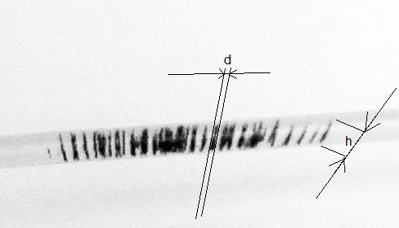
Figure 2.2.1 – The scheme for obtaining the physical dimensions of particles

Figure 2.2.1 schematically shows how the geometric parameters of the cylinders were obtained, to which the shapes in which the particles were taken were approximated. At the same time, the possibility of obtaining a result in millimeters was realized with the help of a ruler that was used in the stand and thereby set the scale of objects on the digital image.
When calculating the percentage of the area occupied by particles, the same particle sizes were used, but their volume was not taken into account, that is, the sum of the planes of all rectangles with width d and length h was taken.

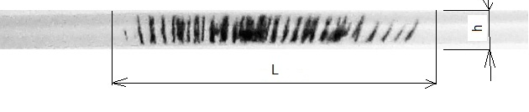
Изм.
Лист
№ докум.
Підпис
Дата
Лист

БМ93.04.2605.5223
Figure 2.2.2 – Obtaining the physical dimensions of the total area

The total area of the tube was obtained as the product of the width of the tube (h = 4mm) and the length of the tube, chosen based on the calculation of the impact of all particles under the influence of the magnet with any nozzle. That is, L=40mm was chosen as the maximum length occupied by the particles during the entire experiment.
Изм.
Лист
№ докум.
Підпис
Дата
Лист
21

БМ93.04.2605.5223

2.3 Nanoparticles and their substitutes

The experiments used MSN ordered from the company Sigma Aldridge Fe₃O₄ (Sigma) with a size of less than 50 nm. In pilot studies, where it was necessary to immerse the particles in water or human blood serum, magnetic stainless-steel particles with a size of 500-600 nm were taken as a replacement for the purpose of economy.
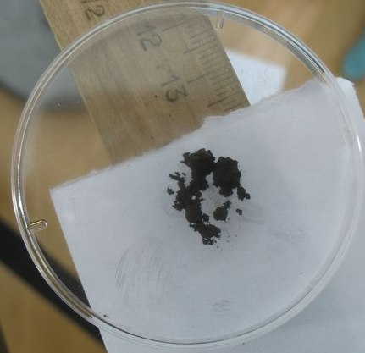
Figure 2.3.1 – Sigma Aldridge Fe₃O₄ MSN

2.4 Neodymium magnets
During the work, two neodymium magnets were used. Characteristics of the first: adhesion force (approximately) - 40 kg; outer diameter - 45 mm; height - 15 mm; weight - 0.18 kg; the volume is 24 cm³; coating – nickel; working temperature - 80ºС. Characteristics of the second: adhesion force (approximately) - 100 kg; outer diameter - 55 mm; height - 25 mm; weight - 0.44 kg; the volume is 59 cm³; coating – nickel; working temperature - up to 80ºС.
Изм.
Лист
№ докум.
Підпис
Дата
Лист

БМ93.04.2605.5223
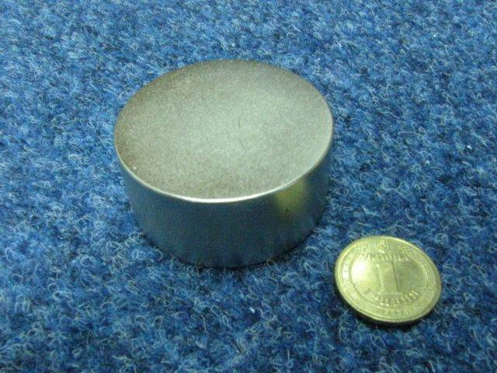
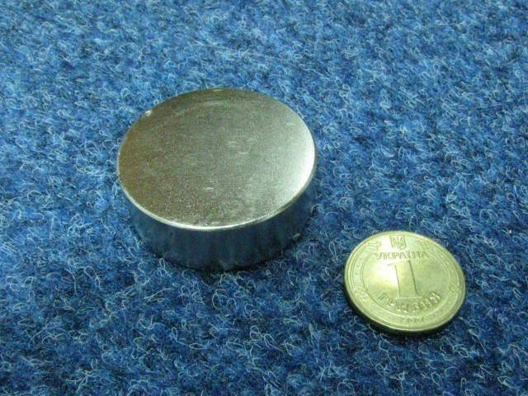
Figure 3.4.1 – Neodymium magnet 40 kg (left) and 100 kg (right).
Изм.
Лист
№ докум.
Підпис
Дата
Лист
22

БМ93.04.2605.5223

2.5 Modifiers of spatial distribution of CMF
During the work, metal modifiers were used, which were held on magnets by magnetic force. The purpose of their use was to change the shape of the field lines for better retention of MSN in the tumor zone.

2.5.1 Modifier of the “cone” type
It is a metal cone with a height of 21 mm and a diameter of 54 mm.
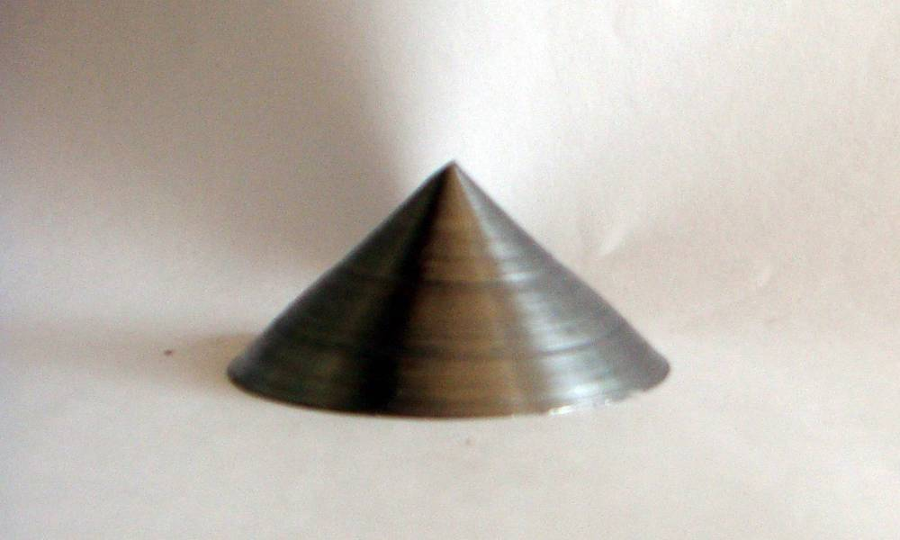
Figure 2.5.1.1 – Modifier “cone”

2.5.2 Modifier of the “brush 0.2” type
The “brush 0.2” type (formalized further in the work under the abbreviation Sh0.2). It is the working part of the brush for processing metal surfaces. The area completely covers the magnets. The height of the brush needles is 6.5 mm, the diameter of each needle is 0.2 mm, the distance between the needles is 0.5 mm, the area of the entire modifier is 66x56 mm.
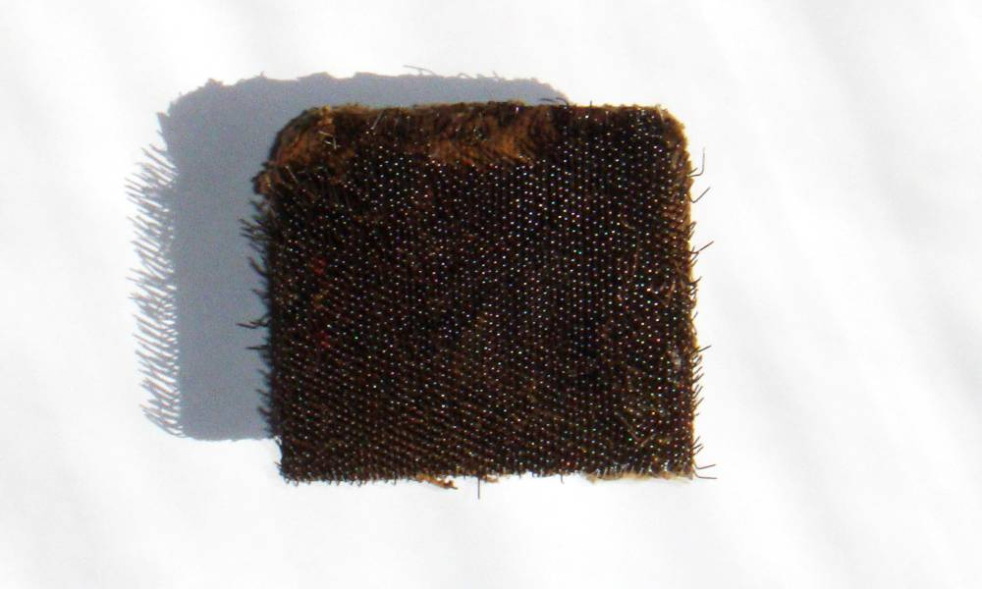
Figure 2.5.2.1 – Brush modifier “Sh0,2”

2.5.3 Modifier of the “brush 2” type
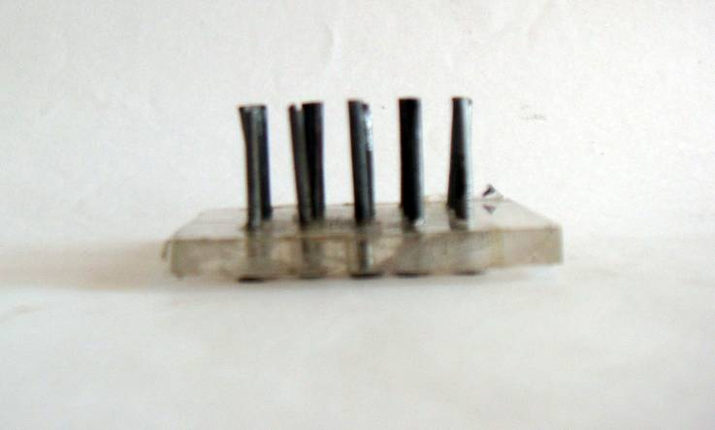
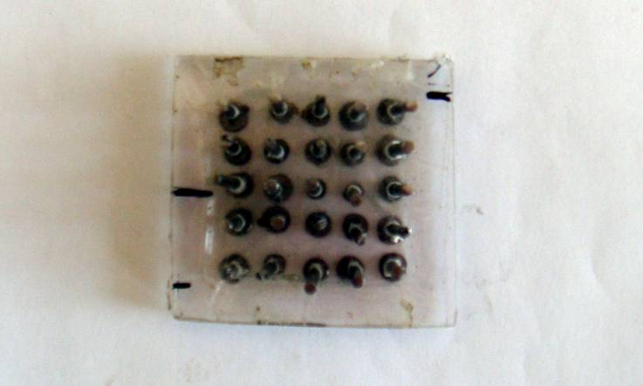
The “brush 2” type (hereinafter formalized under the abbreviation Sh2) consists of 25 blunt metal pins evenly spaced from each other fixed on plexiglass. The average height of the pins is 20 mm, the average distance between the pins is 7 mm, the thickness of the pins is 2 mm, the area occupied by the pins on the plexiglass is 38x38mm.
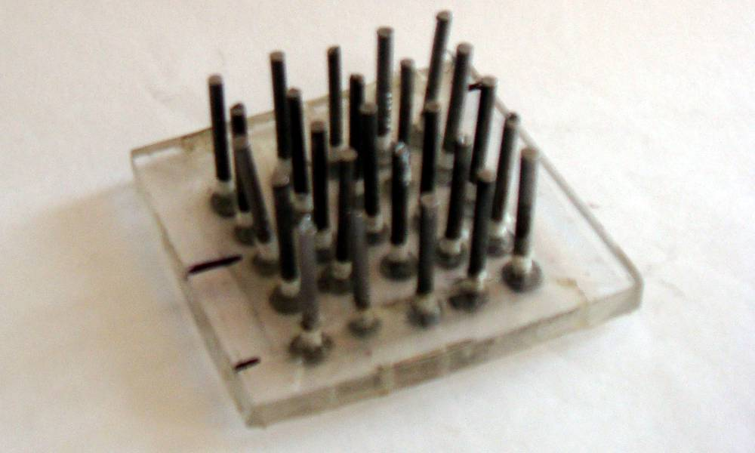
Figure 2.5.3.1 – Brush modifier “Sh2” from different angles

Изм.
Лист
№ докум.
Підпис
Дата
Лист

БМ93.04.2605.5223

2.6 Hall effect sensor
The strength of the magnetic field was measured using a Hall sensor. The Hall effect is a phenomenon in which a transverse potential difference occurs, when a direct current conductor is placed in a magnetic field.
Изм.
Лист
№ докум.
Підпис
Дата
Лист
23

БМ93.04.2605.5223
In the simplest consideration, the Hall effect looks like this. Let an electric current flow through a metal bar in a weak magnetic field under the action of tension. The magnetic field will deflect charge carriers (electrons to be precise) from their movement along or against the electric field to one of the faces of the beam. Thus, the Lorentz force will lead to the accumulation of a negative charge near one face of the bar and a positive charge near the opposite face. Accumulation of charge will continue until the electric field of charges, which arose under the action of the magnetic field, balances the magnetic component of the Lorentz force.
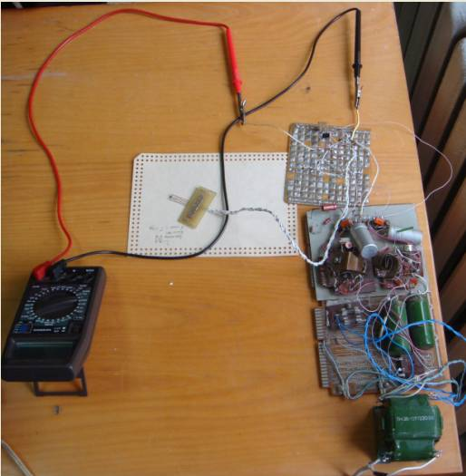

Figure 2.6.1 – Working bench for measuring the voltage between the contacts of the Hall sensor

Figure 2.6.2 shows the schematic diagram of the device with a Hall effect sensor. With the help of this device, all measurements of the voltage generated by the sensor due to the magnetic fields of the studied magnets were carried out. The device includes a sensor (marked as D1 in the diagram), resistors (R1, R2,...Rbal), an operational amplifier (OP) and a voltmeter (M3900). The Hall sensor has 4 output contacts (legs): 2 signal (Hall legs), and 2 power legs
Изм.
Лист
№ докум.
Підпис
Дата
Лист
24

БМ93.04.2605.5223
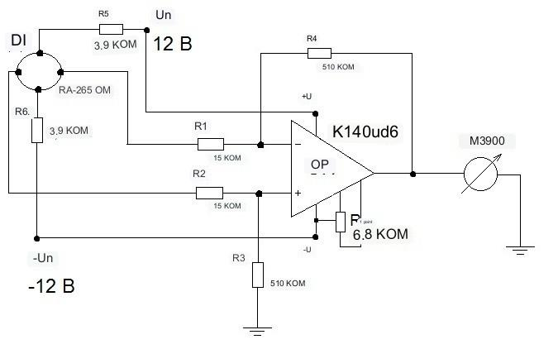
Figure 2.6.2 – Schematic diagram of a device with a Hall effect sensor

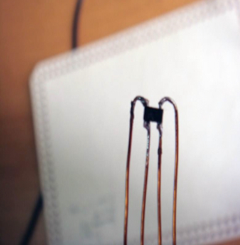
The main property of the sensor is to accumulate charges between the Hall legs under the influence of an external magnetic field and the power current flowing through the sensor itself. The value of the supply current is set using resistors R5, R6. The value of I_{source} = 2.98 mA was chosen. This value is due to the fact that with a larger current, the sensor becomes more sensitive to measurements, but begins to heat up, which makes long-term measurement impossible due to the inconsistency of measurements [18].
Figure 2.6.3 – Hall effect sensor

The signal legs of the sensor are connected to the operational amplifier. The K140UD6 model amplifier with the following characteristics was used in the work: maximum supply voltage 15 V 10%; the output voltage is at least 11 V; input current not more than 100 nA; the voltage amplification factor is not less than 30,000 V; input resistance 1 mΩ.
Изм.
Лист
№ докум.
Підпис
Дата
Лист
25

БМ93.04.2605.5223
Measurements were taken from a voltmeter that worked in the 0-20 V range. Magnetic induction data were recorded at 25 points (for the “cone” and “Sh0.2” type modifiers) and at 81 points (for the “Sh2” type modifier) and entered into the table. Since the received data were in Volts, they were converted from Tesla using the following curve:
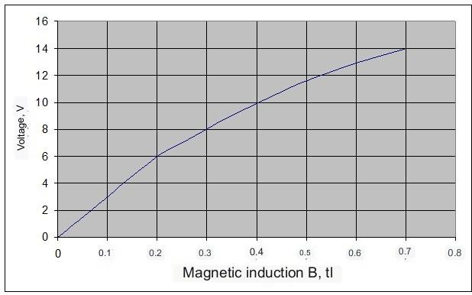
Magnetic induction B, T

Figure 2.6.4 – Calibration curve

2.7 Stands for experiments
Изм.
Лист
№ докум.
Підпис
Дата
Лист
26

БМ93.04.2605.5223
The following stand was used to fix the distribution of MSN in space under the action of CMF:
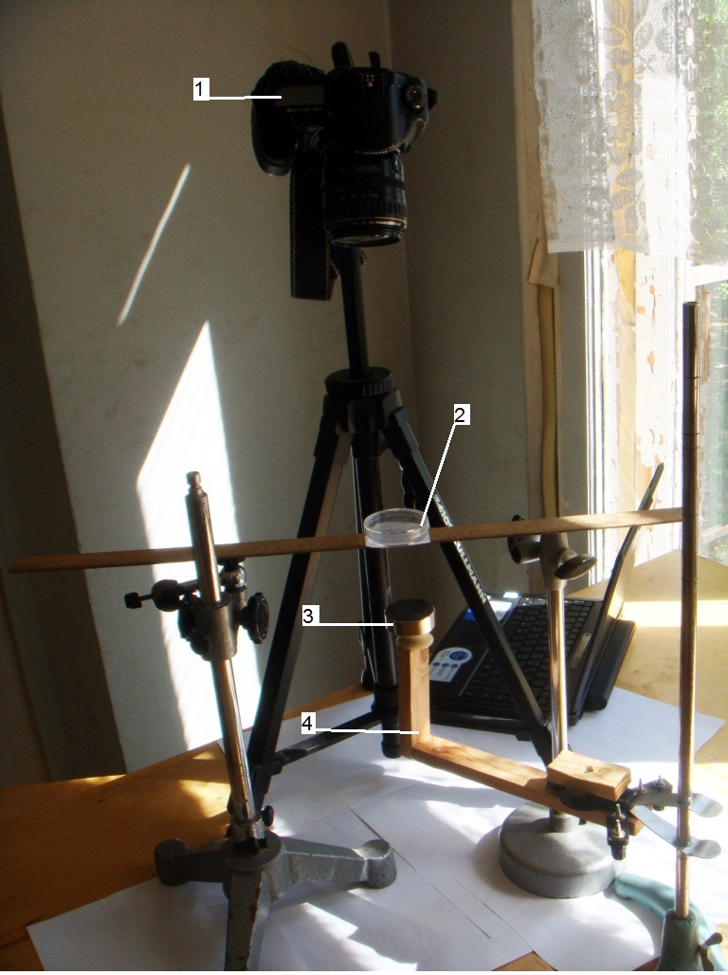
Изм.
Лист
№ докум.
Підпис
Дата
Лист
27

БМ93.04.2605.5223
Figure 2.7.1 – Developed stand for experiments: 1- Canon 10D digital camera mounted on a tripod; 2 – Petri dish containing the studied MSN, which is placed on tripods; 3 – permanent neodymium magnet (in this case, it is a 40 kg magnet); 4 – a tripod on which the magnet is held and moved.
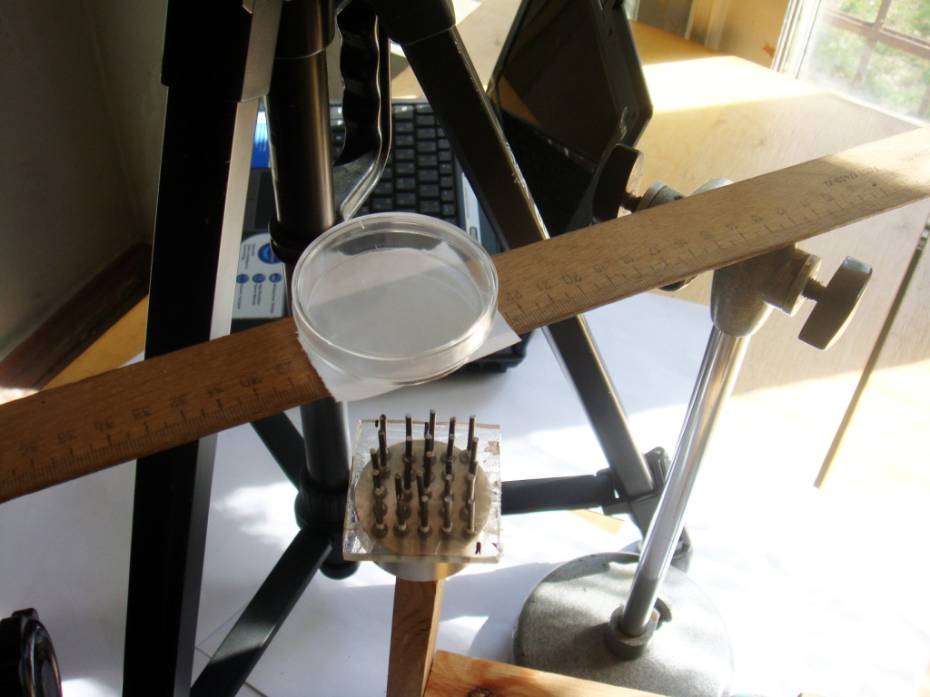
Изм.
Лист
№ докум.
Підпис
Дата
Лист
28

БМ93.04.2605.5223
Figure 2.7.2 – Fixing the modifier on the magnet and location of the magnet

In Figure 2.7.2 the magnet for modifier Sh2 is fixed under the Petri dish. The following stand was used to record the distribution of MSN in the tubes - imitators of human vessels in the blood serum (Fetal bovine serum, Sigma) under the action of a permanent magnetic field.

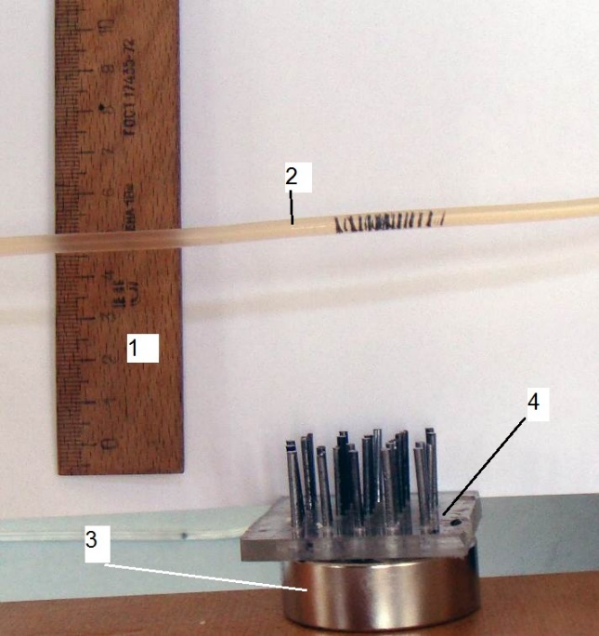
Figure 2.7.3 – Stand for fixing the position of MSN in a tube with blood serum: 1 – ruler; 2 – tube with serum; 3 – magnet; 4- modifier Sh2.

Conclusion to the Section 2. This section explained the selection of magnetite nanoparticles, permanent magnets with different adhesion force and rational for different modifiers of the field produced by the magnets. Methods and equipment for measuring the distribution of CMFs were described. Developed two stands: one for recording the spatial distribution of nanoparticles in a petri dish in air and in a simulator of human vessels in blood plasma using digital images at different distances from magnets with and without modifiers of the spatial distribution of the magnetic field; and the second for measuring and visualizing the strength of the magnetic field of permanent magnets, and the magnetic field of permanent magnets with modifiers of the spatial distribution of the magnetic field.
Изм.
Лист
№ докум.
Підпис
Дата
Лист
29

БМ93.04.2605.5223

SECTION 3 RESULTS
Изм.
Лист
№ докум.
Підпис
Дата
Лист
30

БМ93.04.2605.5223

3.1 Measurement of magnetic field strength using a Hall effect sensor

The Hall effect sensor described above makes it possible to measure the magnetic field induction at a point. The value of the magnetic induction was taken at 25 points for each magnet. These points were located in a 5x5 square. Measurements were made at different distances from the modifiers to the measurement point. This distance was called L. L: 0 mm, 3 mm, 3.9 mm, 6.9 mm, 12 mm, 50 mm, 80 mm. Data U, V were entered in the table.
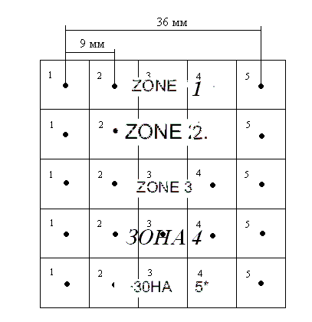
Figure 3.1.1 – Magnetic field induction measurement areas

Figure 3.1.1 shows that in each zone measurements were made at five points. At the same time, the distance between the centers of the squares (measurement was carried out at these points) is 9 mm. Measurements were made at different distances from the modifiers, namely: 0 mm, 3 mm, 3.9 mm, 6.9 mm, 12 mm, 50 mm, 80 mm. Data U, V were entered in the table.

Table 3.1.1 – Measurements for magnet 40 kg
Изм.
Лист
№ докум.
Підпис
Дата
Лист
31

БМ93.04.2605.5223

 |  | U, V, zones in Figure. 3.1.1
Zones | L, mm | 1 2 3 4 5
zone 1 | 0 | 7.72 8.48 8.77 8.48 6.94
zone 1 | 3 | 5.71 6.92 7.55 7.19 4.91
zone 1 | 3.9 | 5.38 6.57 7.26 6.93 5.01
zone 1 | 6.9 | 5.14 5.95 6.34 5.76 4.45
zone 1 | 12 | 4.61 5.18 5.44 5.29 4.37
zone 1 | 50 | 0.86 0.91 0.94 0.91 0.83
zone 1 | 80 | 0.36 0.37 0.38 0.36 0.33
zone 2 | 0 | 8.59 8.83 8.73 8.75 8.53
zone 2 | 3 | 6.93 7.99 8.30 8.2 6.88
zone 2 | 3.9 | 6.86 7.81 8.11 8.01 6.64
zone 2 | 6.9 | 6.09 7.09 7.36 7.26 5.65
zone 2 | 12 | 5.22 6.25 6.59 6.55 5.52
zone 2 | 50 | 0.91 1.00 1.06 1.04 0.91
zone 2 | 80 | 0.36 0.38 0.41 0.41 0.38
zone 3 | 0 | 8.76 8.76 8.66 8.73 8.41
zone 3 | 3 | 7.33 8.14 8.16 8.08 6.92
zone 3 | 3.9 | 7.19 8.05 8.07 7.95 6.65
zone 3 | 6.9 | 6.32 7.34 7.44 7.27 5.68
zone 3 | 12 | 5.58 6.57 6.71 6.61 5.60
zone 3 | 50 | 0.96 1.08 1.13 1.10 0.97
zone 3 | 80 | 0.38 0.40 0.41 0.41 0.38
zone 4 | 0 | 8.45 8.85 8.77 8.72 8.21
zone 4 | 3 | 6.95 8.10 8.09 7.95 6.35
zone 4 | 3.9 | 6.48 7.82 7.98 7.79 6.48
zone 4 | 6.9 | 5.89 7.16 7.17 6.97 5.44
zone 4 | 12 | 4.98 6.41 6.62 6.53 5.63
zone 4 | 50 | 0.95 1.07 1.10 1.08 0.97
zone 4 | 80 | 0.37 0.40 0.41 0.41 0.38
zone 5 | 0 | 6.33 8.73 8.72 8.61 5.23
zone 5 | 3 | 4.28 7.43 7.48 7.16 4.75
zone 5 | 3.9 | 6.86 7.13 7.09 5.93 4.38
zone 5 | 6.9 | 4.45 6.30 6.28 6.06 3.87
zone 5 | 12 | 4.82 6.04 6.13 6.03 4.80
zone 5 | 50 | 0.89 1.01 1.03 1.02 0.90
zone 5 | 80 | 0.37 0.40 0.40 0.40 0.36

Table 3.1.2 – Measurements for magnet 100 kg
Изм.
Лист
№ докум.
Підпис
Дата
Лист
32

БМ93.04.2605.5223
 |  | U, V, zones in Figure. 3.1.1
Zones | L, mm | 1 2 3 4 5
ZONE 1 | 0 | 9.48 9.64 9.57 9.68 9.58
ZONE 1 | 3 | 7.80 8.61 8.71 8.55 8.27
ZONE 1 | 3.9 | 7.74 8.32 8.36 8.21 7.63
ZONE 1 | 6.9 | 6.84 7.51 7.71 7.54 6.88
ZONE 1 | 12 | 5.83 6.29 6.57 6.41 5.73
ZONE 1 | 50 | 1.67 1.72 1.80 1.78 1.62
ZONE 1 | 80 | 0.73 0.74 0.74 0.73 0.69
ZONE 2 | 0 | 9.30 9.37 9.12 9.26 9.48
ZONE 2 | 3 | 8.44 8.65 8.72 8.71 8.55
ZONE 2 | 3.9 | 8.20 8.41 8.45 8.40 8.10
ZONE 2 | 6.9 | 7.53 7.98 7.97 7.90 7.55
ZONE 2 | 12 | 6.17 6.84 7.25 7.28 6.82
ZONE 2 | 50 | 1.82 1.92 2.00 2.03 1.77
ZONE 2 | 80 | 0.76 0.78 0.82 0.81 0.73
ZONE 3 | 0 | 9.27 9.40 9.42 9.45 9.49
ZONE 3 | 3 | 8.07 8.55 8.60 8.61 8.43
ZONE 3 | 3.9 | 8.16 8.42 8.49 8.43 8.07
ZONE 3 | 6.9 | 7.29 7.93 7.98 7.88 7.40
ZONE 3 | 12 | 6.15 7.07 7.36 7.34 7.04
ZONE 3 | 50 | 1.87 2.06 2.09 2.04 1.82
ZONE 3 | 80 | 0.78 0.83 0.84 0.83 0.77
ZONE 4 | 0 | 9.31 9.51 9.41 9.49 9.48
ZONE 4 | 3 | 7.70 8.31 8.53 8.50 8.28
ZONE 4 | 3.9 | 7.87 8.26 8.43 8.35 7.83
ZONE 4 | 6.9 | 6.98 7.54 7.78 7.66 7.19
ZONE 4 | 12 | 6.40 7.18 7.36 7.34 6.85
ZONE 4 | 50 | 1.87 2.04 2.09 2.02 1.88
ZONE 4 | 80 | 0.79 0.82 0.83 0.81 0.75
ZONE 5 | 0 | 8.90 9.16 9.27 9.30 8.97
ZONE 5 | 3 | 7.14 7.87 8.22 8.06 7.48
ZONE 5 | 3.9 | 7.41 7.75 7.88 7.51 6.55
ZONE 5 | 6.9 | 6.34 6.83 7.03 6.93 5.82
ZONE 5 | 12 | 5.97 6.86 7.02 6.99 6.35
ZONE 5 | 50 | 1.79 1.97 1.98 1.92 1.73
ZONE 5 | 80 | 0.78 0.82 0.82 0.80 0.73

It can be seen that the values in Volts of the table 3.1.2 are greater than the corresponding values in the table. 3.1.1, which is explained by the fact that the adhesion force of a 100 kg magnet is much greater than that of a 40 kg magnet.

3.2 Construction of three-dimensional graphs of the magnetic field strength distribution in the MATLAB environment.
Изм.
Лист
№ докум.
Підпис
Дата
Лист
33

БМ93.04.2605.5223

The data taken by the Hall sensor (U, V) were converted into a magnetic induction indicator (B, T) using a calibration curve. Using the Matlab R2008a environment, three-dimensional models of the magnetic induction field distribution were constructed. Graphs were built in pairs - the upper plane corresponds to the induction of a 100 kg magnet field, as it is always larger in value, the lower plane corresponds to a 40 kg magnet. In this way, you can see the power of each of the magnets and visually compare them.
The coefficient k appears in the figures below. It means that each value of the magnet's intensity per 100 kg was increased by k times. This was done so that it was possible to visually see the shape of the lower graph, if it merges or overlaps with the upper one [24].
The percentage by which the average value of the magnetic induction of a 100 kg magnet is greater than the average value of the magnetic induction of a 40 kg magnet at different values of L was also calculated. This value was denoted as in Figure 3.1.2 where, B = 40 and B = 100 are the average values of the magnetic induction of magnets 40 and 100, respectively. The value of B = 100 was taken as 100%.
The percentage by which the average value of the magnetic induction of a 100 kg magnet is greater than the average value of the magnetic induction of a 40 kg magnet at different values of L was also calculated. This value was denoted as P.
(3.2.1)
where, B₄₀ and B₁₀₀ are the average values of the magnetic induction of magnets 40 and 100, respectively. The value of B100 was taken as 100%.
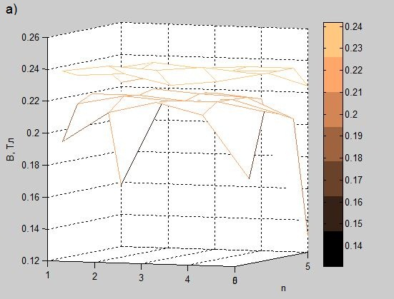
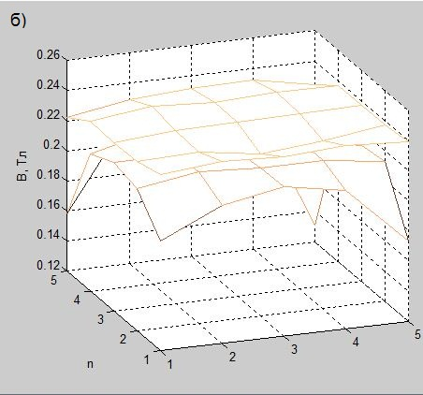
The x-axis shows the serial number of the points from which the indicators were taken. The distance between the points is 9 mm.
Изм.
Лист
№ докум.
Підпис
Дата
Лист
34

БМ93.04.2605.5223
Figure 3.1.2 – Magnetic field induction of 40 and 100 kg magnets, L=0 mm

It can be seen from the graphs that they are similar in shape and value at a given height (0 mm). It is also interesting to note that the magnitude of the inductances does not decrease uniformly to the edge of the magnet, but has a small peak close to the edge, only after which it rapidly drops to zero. The inductance of the magnetic field of a 100 kg magnet is greater than the inductance of a 40 kg magnet by only P = 9.173%.

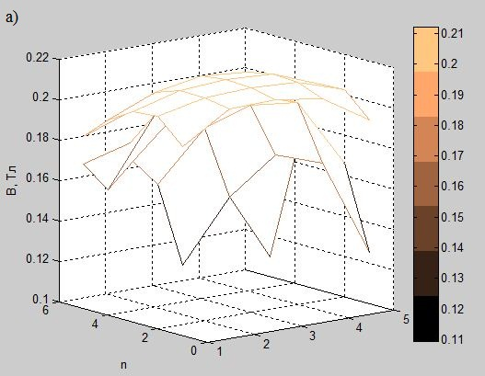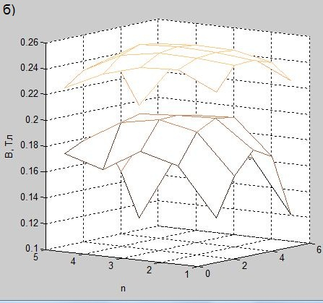
Figure 3.1.3 – Magnetic field inductance of 40 and 100 kg magnets L = 3.9 mm
Figure 3.2.3 shows: a – original values of inductances; b - inductances with a coefficient of k = 1.2 for clarity of the graph. In this case, the difference is still small and amounted to Р = 8.638%.
Изм.
Лист
№ докум.
Підпис
Дата
Лист
35

БМ93.04.2605.5223
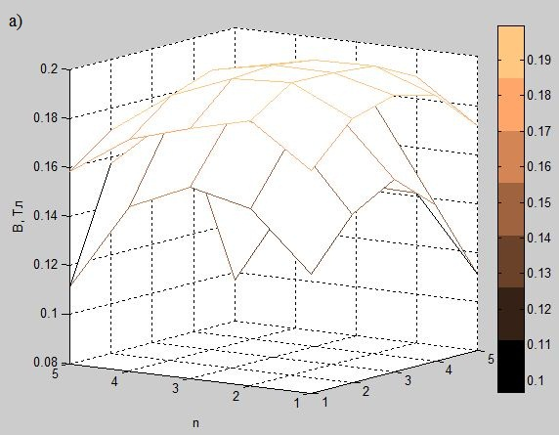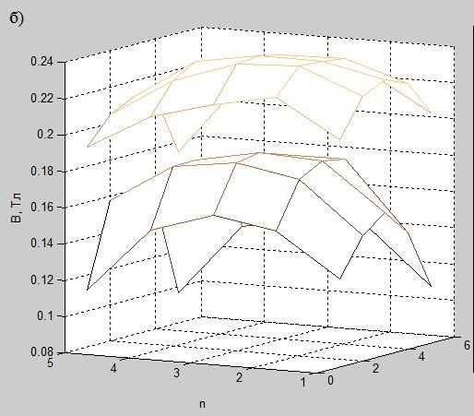
Figure 3.2.4 – Magnetic field inductance of 40 and 100kg magnets L=6.9 mm

Figure 3.2.4 shows: a – original values of inductances; b - inductances with a coefficient for clarity of graph forms. In this case, the difference is practically imperceptible: Р = 8.410%, the form remains similar.

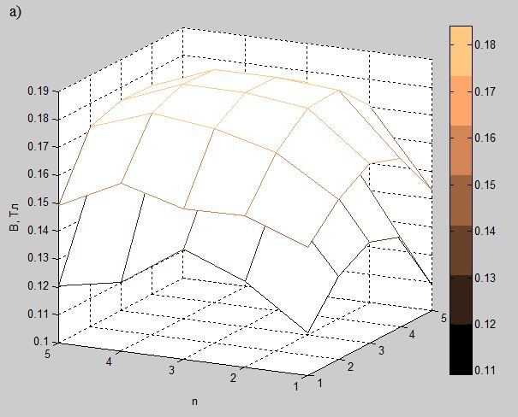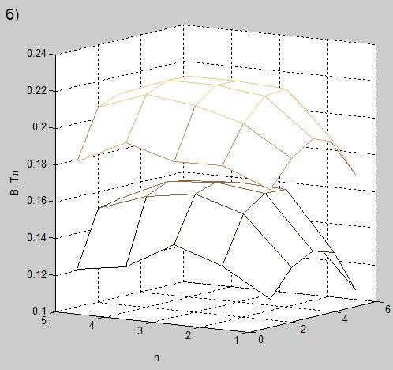
Figure 3.2.5 – Magnetic field inductance of 40 and 100kg magnets L = 12 mm

Figure 3.2.5 shows: a – original values of inductances; b - inductances with a coefficient for clarity of graph forms. In this case, the difference remains almost unchanged: Р = 8.668%, the graphs are also similar in shape.

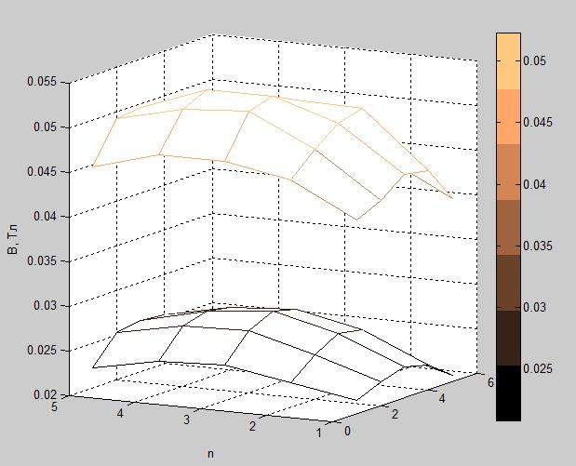
Изм.
Лист
№ докум.
Підпис
Дата
Лист
36

БМ93.04.2605.5223
Figure 3.2.6 – Magnetic field inductance of 40 and 100 kg magnets L = 50 mm

At such a distance as shown in Figure 3.2.6, the difference in the inductance of the magnetic fields of the 40 and 100 kg magnets is already clearly visible. In percentage terms, the field of a magnet of 100 kg is on average greater than the field of a magnet of 40 kg by P = 52.0719%. This is quite a noticeable result, also because at approximately this distance in a real experiment there may be MSN that need to be held by a magnet.

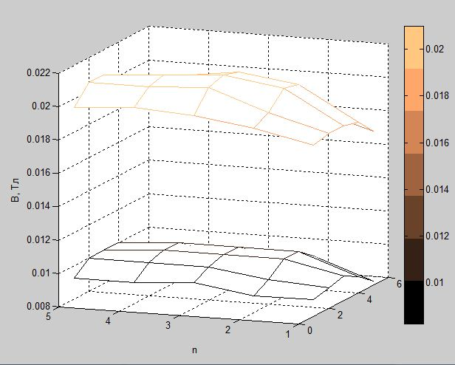
Figure 3.2.7 – Magnetic field inductance of 40 and 100 kg magnets L = 80 mm
From Fig. 3.2.7. it can be seen that the inductances of both magnets at a distance of 80 mm from the magnets rapidly weaken in relation to a distance of 50 mm. At the same time, the form of both graphs remains similar. Also, the difference P is 49.2576%, which is quite similar to the previous result and indicates the preservation of the regularity of the inductance change with increasing distance to the magnet.
Изм.
Лист
№ докум.
Підпис
Дата
Лист

БМ93.04.2605.5223

Table 3.2.1 – The difference between the average values of the magnetic induction of two magnets in percent, according to formula 3.2.1
L, mm | P, %
0 | 9,173
3 | 8,572
3,9 | 8,638
6,9 | 8,410
12 | 8,668
50 | 52.0719
80 | 49.2576

The following should be noted from the above results. The lines of magnetic induction of both studied magnets begin to smooth out with increasing distance and head towards the shape of a more even plane, parallel to the plane of the magnet. It is worth noting that at a distance of L=0 mm from the magnet (40 and 100 kg), the lines of magnetic induction take on a somewhat complex shape with the maximum peaks not in the center, but at a distance of 1-2 mm from the edge of the magnet. At the same time, a sharp decline of the lines is observed when approaching the edge directly. This is generally typical of permanent neodymium magnets.
In general, at most working distances, the lines of magnetic induction behave according to a typical well-known pattern: as the distance increases, the “dome” formed by the lines becomes more and more smoothed until it turns into a plane.

3.3 Heterogeneity
Изм.
Лист
№ докум.
Підпис
Дата
Лист

БМ93.04.2605.5223

On the basis of the obtained voltage data, the index of heterogeneity (heterogeneity) of the magnetic field at different distances from the modifiers was calculated, which is equal to:
Изм.
Лист
№ докум.
Підпис
Дата
Лист
37

БМ93.04.2605.5223
G = 1 – r, where r is the modified Moran spatial autocorrelation coefficient.
The values measured by the Hall sensor in Volts were taken as input data in the program (Nonuniformity v.1.1, NCI). The calculated data are entered in the table.
Изм.
Лист
№ докум.
Підпис
Дата
Лист
38

БМ93.04.2605.5223

Table 3.3.1 – Dependence of the heterogeneity of the inductance of the magnetic field depending on the distance to the magnets
 | G
h, mm | 40 kg | 100 kg
0,0000 | 1,0207 | 0,9840
3,0000 | 0,9894 | 0,9090
3,9000 | 0,9638 | 0,9416
6,9000 | 0,9609 | 0,9323
12,0000 | 0,9502 | 0,9244
50,0000 | 0,9213 | 0,9231
80,0000 | 0,9435 | 0,9040

In order to visually compare the ability of modifiers to level the field, graphs of the dependence of G on h were constructed:

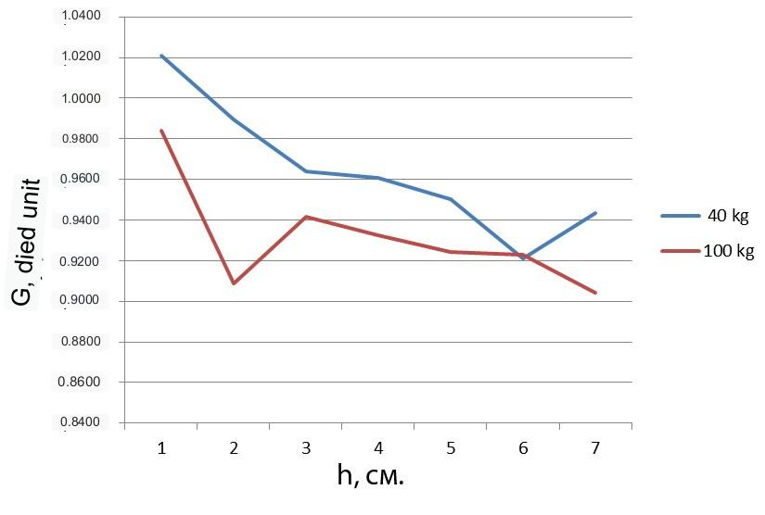
G ,field unit

Figure 3.3.2 – Graph of the dependence of the dependence of G on h

From Figure 3.3.2. it can be seen that the heterogeneity of both magnets decreases with increasing distance to the magnets, while the heterogeneity of the 100 kg magnet more rapidly approaches its minimum value.

3.4 Study of the spatial distribution of MSN in a simulator of human vessels

In the course of the work, digital images of the distribution of MSN were made in a simulator of a human vessel - a dropper with the blood plasma inside.
Fixing was carried out at a distance of 12 mm from the extreme point of the modifier to the beginning of the dropper tube. This distance was chosen because it is operational when conducting experiments. That is, the malignant tumor is approximately at this distance from the edge of the modifier [19].
The obtained images were processed on a computer in order to calculate the area occupied by the particles inside the dropper. The parameters for the calculation were the total surface area of the particles with the approximation of each “group” of particles to the shape of a cone or cylinder, and the ratio of the total surface covered by the particles on the plane of the side view to a certain segment of the dropper, which is the same for all modifiers.
The results of the work were tables with calculations and diagrams.
The following values are indicated in the tables:
r - radius of the base of each group of MSN;
h - the height occupied by a group of MSN in the tube;
S surface - surface area when the groups of MSN are approximated to the shape of a cylinder;
Изм.
Лист
№ докум.
Підпис
Дата
Лист
39

БМ93.04.2605.5223

Table 3.4.1 – Calculation of the planes occupied by MSN under the action of CMF of a 100 kg magnet without a modifier
Изм.
Лист
№ докум.
Підпис
Дата
Лист
40

БМ93.04.2605.5223

r, mm | h, mm | S high, mm ² | size, mm ²
0,2 | 4 | 2,512 | 0,8
0,3 | 4 | 3,768 | 1,2
0,2 | 4 | 2,512 | 0,8
0,4 | 4 | 5,024 | 1,6
1 | 4,5 | 14,13 | 4,5
0,5 | 4,5 | 7,065 | 2,25
0,5 | 4,5 | 7,065 | 2,25
1 | 4,5 | 14,13 | 4,5
1,5 | 4,5 | 21,195 | 6,75
1,2 | 4,5 | 16,956 | 5,4
0,3 | 4 | 3,768 | 1,2
0,2 | 4,5 | 2,826 | 0,9
1 | 4,5 | 14,13 | 4,5
0,2 | 3 | 1,884 | 0,6
0,1 | 4 | 1,256 | 0,4
0,3 | 3 | 2,826 | 0,9
0,2 | 4 | 2,512 | 0,8
Total |  | 142,40 | 45,35
Total size, mm ² |  | Between points, %
160 |  | 28,34

Table 3.4.2 – Calculation of the planes occupied by MSN under the action of CMF of a 100 kg magnet with the modifier “Sh0.2”

r, mm | h, mm | S high, mm ² | size, mm ²
0,5 | 3 | 4,71 | 1,5
0,1 | 2 | 0,628 | 0,2
1 | 4,5 | 14,13 | 4,5
0,1 | 1 | 0,314 | 0,1
0,1 | 1 | 0,314 | 0,1
0,2 | 2 | 1,256 | 0,4
0,7 | 4,5 | 9,891 | 3,15
0,3 | 4,5 | 4,239 | 1,35
0,5 | 4,5 | 7,065 | 2,25
0,1 | 4,5 | 1,413 | 0,45
1 | 3 | 9,42 | 3
0,5 | 4,5 | 7,065 | 2,25
0,5 | 4,5 | 7,065 | 2,25
0,2 | 5 | 3,14 | 1
0,2 | 4,5 | 2,826 | 0,9
1 | 4,5 | 14,13 | 4,5
0,2 | 3 | 1,884 | 0,6
1 | 4,5 | 14,13 | 4,5
1 | 4,8 | 15,072 | 4,8
1,1 | 4,8 | 16,5792 | 5,28
0,2 | 4,5 | 2,826 | 0,9
0,1 | 4 | 1,256 | 0,4
0,7 | 4,7 | 10,3306 | 3,29
0,1 | 3 | 0,942 | 0,3
0,5 | 5 | 7,85 | 2,5
0,1 | 1 | 0,314 | 0,1
Total |  | 158,79 | 50,57
Total size , mm ² |  | Between points , %
160 |  | 31,61

Table 3.4.3 – Calculation of the planes occupied by MSN under the action of CMF of a 100 kg magnet with the modifier “Sh2”
Изм.
Лист
№ докум.
Підпис
Дата
Лист
41

БМ93.04.2605.5223

r, mm | h, mm | S high, mm ² | size, mm ²
0,1 | 1 | 0,314 | 0,1
0,1 | 4,5 | 1,413 | 0,45
0,5 | 4,5 | 7,065 | 2,25
0,1 | 4,5 | 1,413 | 0,45
0,1 | 4,5 | 1,413 | 0,45
1 | 4 | 12,56 | 4
0,1 | 4,5 | 1,413 | 0,45
0,8 | 4,5 | 11,304 | 3,6
0,1 | 4 | 1,256 | 0,4
0,8 | 4 | 10,048 | 3,2
1 | 4,2 | 13,188 | 4,2
0,2 | 3 | 1,884 | 0,6
0,5 | 4,5 | 7,065 | 2,25
1 | 4,5 | 14,13 | 4,5
1,5 | 5 | 23,55 | 7,5
0,5 | 4,5 | 7,065 | 2,25
0,3 | 4,5 | 4,239 | 1,35
0,3 | 4,5 | 4,239 | 1,35
0,7 | 4,5 | 9,891 | 3,15
0,7 | 4,5 | 9,891 | 3,15
0,5 | 4,5 | 7,065 | 2,25
1 | 4,5 | 14,13 | 4,5
0,2 | 4 | 2,512 | 0,8
0,1 | 3 | 0,942 | 0,3
0,1 | 3 | 0,942 | 0,3
0,1 | 3 | 0,942 | 0,3
Sum |  | 169,87 | 54,1
Total size, mm ² |  | Between points , %
160 |  | 33,81
Изм.
Лист
№ докум.
Підпис
Дата
Лист
42

БМ93.04.2605.5223

Table 3.4.4 – Calculation of the planes occupied by MSN under the action of CMF of a 100 kg magnet with the “Cone” modifier
r, mm | h, mm | S high , mm ² | size, mm ²
0,1 | 4,5 | 1,413 | 0,45
0,1 | 3 | 0,942 | 0,3
0,4 | 4 | 5,024 | 1,6
0,5 | 4 | 6,28 | 2
0,2 | 4,5 | 2,826 | 0,9
0,8 | 3 | 7,536 | 2,4
0,1 | 3 | 0,942 | 0,3
1 | 4 | 12,56 | 4
0,5 | 4 | 6,28 | 2
1 | 3 | 9,42 | 3
1,3 | 4 | 16,328 | 5,2
0,5 | 4 | 6,28 | 2
0,1 | 3 | 0,942 | 0,3
0,1 | 5 | 1,57 | 0,5
0,8 | 4,5 | 11,304 | 3,6
0,2 | 2 | 1,256 | 0,4
1 | 4,5 | 14,13 | 4,5
0,2 | 4 | 2,512 | 0,8
1 | 4 | 12,56 | 4
0,9 | 4,5 | 12,717 | 4,05
0,1 | 4,5 | 1,413 | 0,45
1,2 | 4,7 | 17,7096 | 5,64
0,2 | 4,5 | 2,826 | 0,9
0,3 | 4 | 3,768 | 1,2
0,3 | 4 | 3,768 | 1,2
0,2 | 4,5 | 2,826 | 0,9
Sum |  | 165,13 | 52,59
Total size , mm ² |  | Between points, %
160 |  | 32,87

Изм.
Лист
№ докум.
Підпис
Дата
Лист
43

БМ93.04.2605.5223
Table 3.4.5 – Calculation of the planes occupied by MSN under the action of CMF of a 40 kg magnet with the “Cone” modifier

r, mm | h, mm | S high, mm ² | size, mm ²
0,1 | 4,5 | 1,413 | 0,45
1,2 | 4,5 | 16,956 | 5,4
2,1 | 3,7 | 24,3978 | 7,77
1 | 1 | 3,14 | 1
1,3 | 4,5 | 18,369 | 5,85
1,3 | 4,5 | 18,369 | 5,85
1 | 1 | 3,14 | 1
1,5 | 4,3 | 20,253 | 6,45
1,5 | 2 | 9,42 | 3
Sum |  | 115,46 | 36,77
Total size, mm ² |  | Between points, %
160 |  | 22,98

Table 3.4.6 – Calculation of the planes occupied by MSN under the action of CMF of a 40 kg magnet with the modifier “Sh0.2”

r, mm | h, mm | S high , mm ² | size, mm ²
0,5 | 4,5 | 7,065 | 2,25
0,1 | 4,2 | 1,3188 | 0,42
1,2 | 4,5 | 16,956 | 5,4
1 | 4,2 | 13,188 | 4,2
3 | 4,5 | 42,39 | 13,5
1 | 4,5 | 14,13 | 4,5
0,8 | 4,5 | 11,304 | 3,6
1,2 | 4,5 | 16,956 | 5,4
0,5 | 4,5 | 7,065 | 2,25
0,8 | 4,5 | 11,304 | 3,6
0,2 | 4,5 | 2,826 | 0,9
1 | 4,5 | 14,13 | 4,5
0,1 | 2,7 | 0,8478 | 0,27
Sum |  | 159,48 | 50,79
Total size , mm ² |  | Between points, %
160 |  | 31,74

Table 3.4.7 – Calculation of the planes occupied by MSN under the action of CMF of a 40 kg magnet with the modifier “Sh2”
Изм.
Лист
№ докум.
Підпис
Дата
Лист
44

БМ93.04.2605.5223
r, mm | h, mm | S high , мм² | Size , мм²
1 | 4,5 | 14,13 | 4,5
0,2 | 4,5 | 2,826 | 0,9
1,3 | 4,5 | 18,369 | 5,85
1 | 4,5 | 14,13 | 4,5
2 | 4,5 | 28,26 | 9
2,5 | 4,5 | 35,325 | 11,25
2,5 | 4,5 | 35,325 | 11,25
0,5 | 4,5 | 7,065 | 2,25
1 | 4,5 | 14,13 | 4,5
0,4 | 4,5 | 5,652 | 1,8
0,7 | 4,5 | 9,891 | 3,15
0,5 | 4,5 | 7,065 | 2,25
1 | 4,5 | 14,13 | 4,5
0,1 | 4 | 1,256 | 0,4
Sum |  | 207,55 | 66,1
Total size, mm² |  | between points, %
160 |  | 41,31

Table 3.4.8 – Calculation of the planes occupied by MSN under the action of CMF of a 40 kg magnet without a modifier.

r, mm | h, mm | S high , mm ² | size, mm ²
0,1 | 1 | 0,314 | 0,1
0,8 | 3 | 7,536 | 2,4
0,5 | 3,5 | 5,495 | 1,75
0,1 | 2 | 0,628 | 0,2
0,1 | 1 | 0,314 | 0,1
1 | 3,8 | 11,932 | 3,8
0,1 | 3,8 | 1,1932 | 0,38
0,2 | 3 | 1,884 | 0,6
1 | 4 | 12,56 | 4
1,1 | 4 | 13,816 | 4,4
0,1 | 3,7 | 1,1618 | 0,37
1 | 4,2 | 13,188 | 4,2
0,2 | 3,2 | 2,0096 | 0,64
2 | 3,8 | 23,864 | 7,6
1 | 3,8 | 11,932 | 3,8
1 | 3,8 | 11,932 | 3,8
2 | 4 | 25,12 | 8
3 | 3,5 | 32,97 | 10,5
0,2 | 2,5 | 1,57 | 0,5
Sum |  | 179,42 | 57,14
Total size, mm ² |  | Between points, %
160 |  | 35,71
Изм.
Лист
№ докум.
Підпис
Дата
Лист
45

БМ93.04.2605.5223
On the basis of all the tables, diagrams were built, data were grouped according to the principle of the magnitude of the magnet's adhesion force, i.e. for a 40 kg magnet, and for a 100 kg magnet.

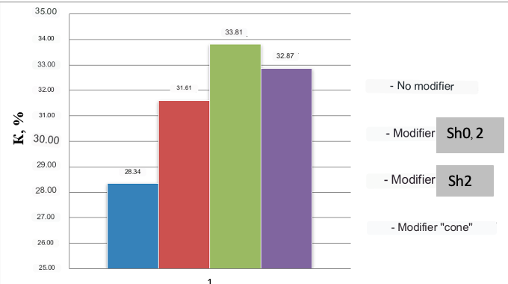
Figure 3.4.1 – Ratio of the area occupied by particles under the action of a 100 kg magnet to the total area, %

Figure 3.4.1 shows that the maximum area of the particle is occupied with the Sh2 modifier, but the difference with the indicators of the occupied area with other modifiers is not great. Particles occupy a much smaller area in the absence of modifiers.

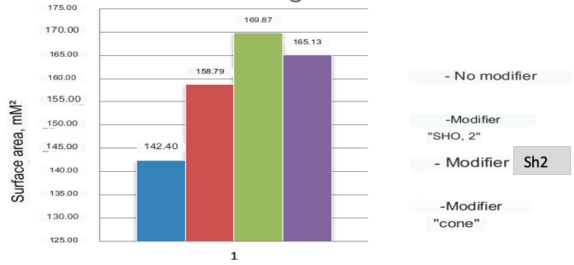
mm²
Figure 3.4.2 – Surface areas occupied by particles under the influence of a 100 kg magnet
Изм.
Лист
№ докум.
Підпис
Дата
Лист
46

БМ93.04.2605.5223
From Figure 3.4.2, it can be seen that the surface area of the particles is maximum if the magnet has the modifier Sh2 (169.87 mm²). The cone modifier showed a result smaller than the maximum by 4.74 mm², that is, close to the Sh2 modifier. As in the previous case, the particles have the smallest surface area in the case when the magnet was without a modifier.

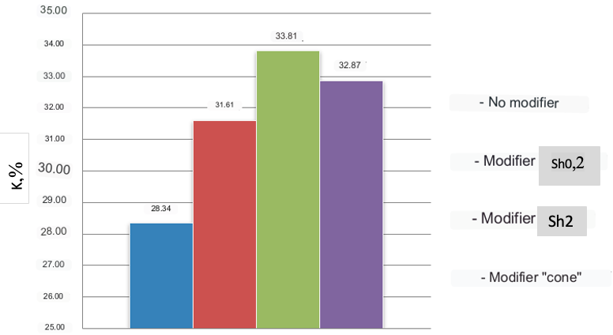
Fig. 3.4.3 – Ratio of the area occupied by particles under the action of a 40 kg magnet to the total area, %

From Figure 3.4.3 it can be seen that the 40 kg magnet showed results that differ slightly from the results of the 100 kg magnet. The coefficient was the maximum when using the Sh2 modifier (33.81%). The cone modifier showed a result close to the maximum (32.87%).
Изм.
Лист
№ докум.
Підпис
Дата
Лист
47

БМ93.04.2605.5223

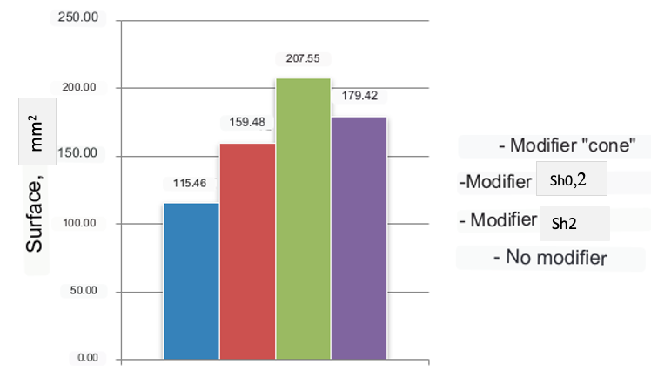
Figure 3.4.4 – Surface areas occupied by particles under the action of a 40 kg magnet

From Figure. 3.4.4 it can be stated that the particles have the largest surface area when using the Sh2 modifier (207.55 mm²). When using the “cone” modifier, the particles are collected so that they have the smallest area (115.46 mm²).
Analyzing the received data, the following can be noted. For a 100 kg magnet at a distance of 12 mm, the conglomerate of MSN occupies the largest area and has the largest surface area when the magnet is used with the W² modifier. This pattern is also valid for a 40 kg magnet. However, it should be noted that when using the “cone” modifier with a 40 kg magnet, there is a high clustering of particles in a small area. This can be used to analyze the results of a real experiment. It can also be assumed that with the maximum surface area, the particles will be able to interact with the external environment (malignant tumor) as much as possible, that is, to carry out the maximum exchange of thermal energy, which can improve the antitumor effect.
The obtained results are necessary for modeling the behavior of MSN in tumor blood vessels under the influence of CMF and EMF.
Conclusion to the Section 3. Measurements of the magnetic induction of permanent neodymium magnets demonstrated that with increasing distance from the magnets, the lines of magnetic induction smooth out evenly and decrease numerically (from 0.24 to 0.01 T at working distances).
Изм.
Лист
№ докум.
Підпис
Дата
Лист

БМ93.04.2605.5223
3D models of magnetic induction lines indicated that the difference between 40 and 100 kg magnets becomes larger as the distance from the magnets increases. However, at the working distances of the magnets, this difference is almost insignificant.
By calculating the spatial correlation, it was shown that the greatest heterogeneity was observed at the minimum distances from the magnets. This may indicate the effectiveness of the effect on a malignant tumor in its early stages of development, that is, when the size of the tumor is minimal.
Studying the distribution of particles in a simulator of a human vessel, the maximum area in the vessel is occupied by the particles when using the Sh2 modifier. At the same time, the surface area of the particles inside the vessel is the largest. The highest degree of clustering of particles in the vessel is observed when using the “cone” modifier.
Изм.
Лист
№ докум.
Підпис
Дата
Лист
48

БМ93.04.2605.5223

SECTION 4 OCCUPATIONAL SAFETY
Изм.
Лист
№ докум.
Підпис
Дата
Лист
49

БМ93.04.2605.5223

In this section, potentially dangerous and harmful factors arising from the use of a permanent magnetic field of neodymium magnets will be identified and evaluated.

4.1 Characteristics of the premises

The cabinet for magnetic nanotherapy is a dry, bright room with a floor covered with a special polymer coating. The walls of the room are covered with light-colored oil paint. The list of equipment is given in Table 4.1.

Table 4.1.1 – Characteristics of the magnetic nanotherapy cabinet. Parameters premises and equipment
No | Name | Main characteristics |  |  | Number
1 | Parameters  office | 5000x4000x3000 mm |  |  | –
2 | Number working people | The doctor is a radiologist, medical and technologist |  |  | 2
3 | Natural lighting | Window metal plastic Rexay 1200x1400 mm |  |  | 1
4 | artificial lighting | Lamp KANLUX 26577 |  |  | 4
5 | This medical service tray VM 5.100 | 800x500x850 mm Material : stainless steel |  |  | 1
6 | Chair medical St-12 |  | Dimensions : 56 0x4 3 0x 43 0 mm Material : upholstery - artificial leather , frame - metal | 1
7 | Table laboratory island  SO- P |  | 1200 x 1500 x 760 mm Material : plastic, metal | 1
8 | Table office L-27 |  | 1 2 00 x 600 x 750 mm  Material : L chipboard , metal | 2
9 | Office chair , computer chair Henry CH TILT |  | Dimensions : 95 0x4 5 0x 65 0 mm Material : upholstery - artificial leather , frame - metal | 2
10 | Office chair ISO black Halmar |  | Dimensions : 820x470x550 mm Material : fabric upholstery , metal frame | 1
11 | C tel-sink medical MM4.100 |  | 500x400x300 mm Material :  Stainless Steel | 1
12 | Wardrobe bivalve medical ShD-P-3 |  | Dimensions : 90 0x4 5 0x 2000 mm Material : chipboard | 1
13 | Mitsubishi split system air conditioner Heavy SKM 25 ZSP |  | Dimensions : external block 262x769x210 mm , internal block 540x780x290 mm Voltage : 220V | 1
14 | Fire protection system DIP-1 |  | 110 x 110 x 60 mm Electronic | 1
15 | Extinguisher carbon dioxide VVK- 2 |  | Dimensions : 599x108 mm | 1

Table 4.1.2 compares the main characteristics regulatory values cabinet of magnetic nanotherapy with expected values .
Table 4.1.2 – Comparison regulatory parameters
No | Cabinet parameter | Real value | Normative value
1 | Area for 1 employee | 10$m^{2}$ | 4.5$m^{2}$
2 | Volume per 1 worker | $$30{ m}^{3}$$ | 15${ m}^{3}$
3 | Minimum width of passage | 1.6 m | 1.5 m
4 | The width of the doorway | 1.09 m | At least 1 m

According to the results of tables 3.2 is possible do conclusion that this cabinet coresponds to the necessary norms. Carrying out measures normalization is not required because real value the area and volume of the room , the minimum width of the passage and the width of the double passage correspond to the normative value.
Изм.
Лист
№ докум.
Підпис
Дата
Лист
50

БМ93.04.2605.5223

4.2 Assessment of dangerous and harmful factors when performing distribution of MSN by CMF of neodymium magnets.
Изм.
Лист
№ докум.
Підпис
Дата
Лист
51

БМ93.04.2605.5223

According to ДСТУ 12.0.003-74, all dangerous and harmful factors are divided into 4 groups. The results detection availability or absence data factors in the office are listed in the Table 4.2.1.
Table 4.2.1 – Dangerous and harmful production factors
Group dangerous factors | List basic factors
Physical | electrical safety , fire department security , increased level the effect of a permanent magnetic field
Chemical | missing
Biological | missing
There are no psychophysiological ones | missing

According to the results of the study of factors that pose a threat to the health of personnel, given in Table 4.2.1, it can be seen that there are only physical dangerous factors.
Conclusions to the Section 4. In this section, the main potential hazards that may arise when using a constant field of neodymium magnets for the distribution of magnetosensitive nanoparticles were considered. Accordingly, technical, organizational, regime and operational measures were developed to increase the security of the office.

CONCLUSIONS

During the study of the spatial distribution of magneto-sensitive nanoparticles in the constant magnetic field of neodymium magnets, the following stands were developed:
Изм.
Лист
№ докум.
Підпис
Дата
Лист
52

БМ93.04.2605.5223
1. a stand for recording the spatial distribution of nanoparticles in a petri dish in air and in a simulator of human vessels in blood plasma using digital images at different distances from magnets with and without modifiers of the spatial distribution of the magnetic field;
2. a stand for measuring and visualizing the strength of the magnetic field of permanent magnets, and the magnetic field of permanent magnets with modifiers of the spatial distribution of the magnetic field.
Based on the measurements of the magnetic induction of permanent neodymium magnets, it has been proven that with increasing distance from the magnets, the lines of magnetic induction smooth out evenly and decrease numerically (from 0.24 to 0.01 T at working distances). What is more, the stronger the magnetic coupling force, the slower the induction weakening.
From the developed graphs of 3D models of magnetic induction lines, it can be stated that the difference between 40 and 100 kg magnets becomes larger as the distance from the magnets increases. However, at the working distances of the magnets, this difference is almost insignificant.
Based on the calculation of the spatial correlation, it is shown that the greatest heterogeneity is observed at the minimum distances from the magnets. This may indicate the effectiveness of the effect on a malignant tumor in its early stages of development, that is, when the size of the tumor is minimal. Also, this indicator indicates that there is no big difference between magnets with quite different adhesion forces.
According to the results of studying the distribution of particles in a simulator of a human vessel, the maximum area in the vessel is occupied by the particles when using the Sh2 modifier. At the same time, the surface area of the particles inside the vessel is the largest. The greatest clustering of particles in the vessel is observed when using the “cone” modifier.
Изм.
Лист
№ докум.
Підпис
Дата
Лист
53

БМ93.04.2605.5223
The main potential hazards that may arise when using a constant field of neodymium magnets for the distribution of magneto-sensitive nanoparticles were considered. Accordingly, technical, organizational, regime and operational measures were developed to increase the security of the office.

References
- Bayda S, Adeel M, Tuccinardi T, et al. History of Nanoscience and Nanotechnology: From Chemical-Physical Applications to Nanomedicine// Molecules. – 2019. – № 25. – С.1–15.
Изм.
Лист
№ докум.
Підпис
Дата
Лист

БМ93.04.2605.5223
- Szefler B. Nanotechnology, from quantum mechanical calculations up to drug delivery// Int J Nanomedicine. – 2018. – № 13. – С.6143–6176.
- Issa B, Obaidat IM, Albiss BA, Haik Y. Magnetic nanoparticles: surface effects and properties related to biomedicine applications// Int J Mol Sci. – 2013. – № 11. – С.21266– 21305.
- Arosio P. Applications and Properties of Magnetic Nanoparticles// Nanomaterials (Basel). – 2021.– № 5. – С.1297.
- Katz E. Magnetic Nanoparticles// Magnetochemistry. – 2020. –№6–С.6.
- Ali A, Shah T, Ullah R, Zhou P, Guo M, Ovais M, Tan Z, Rui Y. Review on Recent Progress in Magnetic Nanoparticles: Synthesis, Characterization, and Diverse Applications// Front Chem. –2021. – №9.–С. 629054.
- Qu, S., Yang, H., Ren, D., Kan, S., Zou, G., Li, D., & Li, M. (1999). Magnetite Nanoparticles Prepared by Precipitation from Partially Reduced Ferric Chloride Aqueous Solutions// Journal of colloid and interface science. –1999. –№1– С.190–192.
- Orel, V. B., Papazoglou, Α. S., Tsagkaris, C., Moysidis, D. V., Papadakos, S., Galkin, O. Y., Orel, V. E., & Syvak, L. A. (2023). Nanotherapy based on magneto-mechanochemical modulation of tumor redox state// Wiley interdisciplinary reviews. Nanomedicine and nanobiotechnology. –2023. –№3– С.e1868.
- Maniam G, Mai CW, Zulkefeli M, Dufès C, Tan DM, Fu JY. Challenges and Opportunities of Nanotechnology as Delivery Platform for Tocotrienols in Cancer Therapy// Front Pharmacol. –2018.– № 9– С.1358.
Изм.
Лист
№ докум.
Підпис
Дата
Лист

БМ93.04.2605.5223
- Alromi DA, Madani SY, Seifalian A. Emerging Application of Magnetic Nanoparticles for Diagnosis and Treatment of Cancer// Polymers (Basel). –2021. – №23–С.4146.
- Liu X, Zhang Y, Wang Y, Zhu W, Li G, Ma X, Zhang Y, Chen S, Tiwari S, Shi K, Zhang S, Fan HM, Zhao YX, Liang XJ. Comprehensive understanding of magnetic hyperthermia for improving antitumor therapeutic efficacy// Theranostics. –2020. – №8–С.3793–3815.
- Ruell, P. A., Hoffman, K. M., Chow, C. M., & Thompson, M. W. Effect of temperature and duration of hyperthermia on HSP72 induction in rat tissues// Molecular and cellular biochemistry. –2004. – №1-2. –С.187–194.
- Goodman, E. M., Greenebaum, B., & Marron, M. T. Effects of electromagnetic fields on molecules and cells// International review of cytology. –1995. –№ 158–С. 279–338.
- Julius Adams Stratton, Stratton Julius Adams. Electromagnetic Theory// McGraw-Hill, 2007 – Science– С.644.
- Naarala J, Kolehmainen M, Juutilainen J. Electromagnetic Fields, Genomic Instability and Cancer: A Systems Biological View// Genes (Basel). –2019–№6–С. 479.
- Stapf, M., Pömpner, N., Teichgräber, U., & Hilger, I. Heterogeneous response of different tumor cell lines to methotrexate-coupled nanoparticles in presence of hyperthermia// International journal of nanomedicine. –2016–№11–С.485–500.
- Chen Y. An analytical process of spatial autocorrelation functions based on Moran's index// PLoS One–2021. –№4–С.e0249589.
- Gooth, J.; Borg, M.; Schmid, H.; Bologna, N.; Rossell, M.D.; Wirths, S.; Moselund, K.; Nielsch, K.; Riel, H. Transition to the quantum hall regime in Ina's nanowire cross-junctions// Semicond. Sci. Technol. – 2019–№34–С.035028.
- Lee J., Moon S., Lim J., Gwak M.-J., Kim J.G., Chung E., Lee J.-H. Imaging of the finger vein and blood flow for anti-spoofing authentication using a laser and a mems scanner// Sensors. –2017–№17–С.925.
Изм.
Лист
№ докум.
Підпис
Дата
Лист

БМ93.04.2605.5223

