UDC 681.301

Pavlo Katin, assoc. prof., PhD; Xu Bingjie, student

National Technical University of Ukraine
“Igor Sikorsky Kyiv Polytechnic Institute”

A UNIFIED MODEL OF A WEB APPLICATION FOR CUSTOMER-EXECUTOR INTERACTION

Abstract

Pavlo Katin, assoc. prof., PhD; Xu Bingjie, student

A unified model of a web application based on the Django framework for customer-executor interaction

This report presents a comprehensive exploration and development of a Django-based fresh e-commerce system in the context of the rapidly evolving Internet landscape and the growing demand for green consumption. The traditional consumption models are being disrupted by the ubiquity of online consumption, with a particular focus on fresh produce. The report details the theoretical foundations and development process of the Django-based system, highlighting its practical applications through the enhancement of algorithms.

Introduction

The rapid development of e-commerce is powerfully driving the growth of fresh e-commerce, with online consumption becoming ubiquitous. The rapid development of fresh e-commerce is built upon this foundation. Positioned within the backdrop of the new era of consumption, fresh e-commerce represents both an opportunity and a challenge. In recent years, with Python gaining popularity, there has been a growing number of Internet software developed using Django, the mainstream web framework for Python, both domestically and internationally. However, there is a notable absence of Django sites specifically developed for the context of fresh e-commerce. It is evident that exploring a mature and viable development model for fresh e-commerce is crucial. While the development model in China is still immature, the development of fresh e-commerce abroad, though relatively mature, still has room for improvement. The consumption of fresh products is gradually diversifying, and the continuous emergence of innovative models is making the user's choice of fresh consumption more diverse and the experience better. The development of fresh e-commerce requires proactive exploration, keeping an eye on the future. This paper focuses on the rapid and efficient development of a fresh e-commerce system based on Django. For practitioners in the field of fresh e-commerce and developers in the Django community, it undoubtedly holds reference value and practical significance.

Research Objective
The main purpose is to focus on the rapid and efficient development of a fresh e-commerce system based on Django. This system utilizes Django as the web framework, Python as the backend development language, MySQL as the system database, Nginx as the web server, and uWSGI as the serving method. The author, through detailed research on the Django development framework, standardizes the system development process, thereby improving development efficiency. By enhancing the collaborative filtering algorithm and applying it practically in this system, the quality of personalized recommendations for users is elevated.

Description of the program
The Django Fresh E-commerce System consists of three parts:
(1) Fresh E-commerce business system: This part is divided into frontend functional modules and backend management modules. Frontend functionalities mainly include user login and registration, product display, user shopping cart, order management, user center, user reviews, and the search engine. The backend management module mainly includes the management of users, products, orders, and system permissions. The foundation to achieve these module functionalities is the system's powerful data storage capability, so the database module is also a significant part of this system.
(2) User behavior data collection system based on user browsing behavior. This system is built based on the fresh e-commerce business system. The objects being collected are the users of the fresh e-commerce system, and the collected content includes various data generated by user behaviors such as visits, clicks, purchases, etc.
(3) Product recommendation system: The service object of this system is all visitors to the e-commerce system. Different types of visitors use different recommendation strategies. This system is built based on an improved collaborative filtering algorithm, providing personalized product recommendation services to users.
The class diagram for the fresh e-commerce platform system can be found in Figure 1-1.
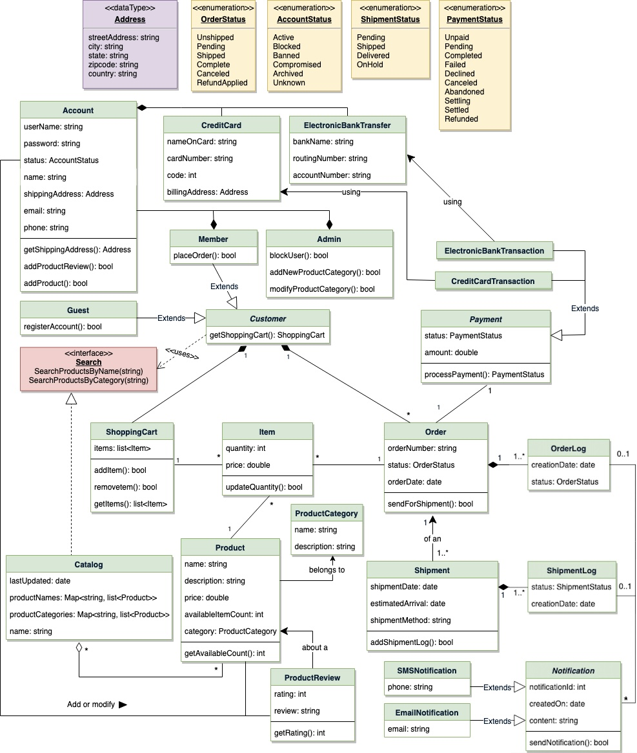
Figure 1-1: Class Diagram of the Fresh E-commerce System

Sequence diagram for searching from the catalog, as depicted in Figure 1-2.
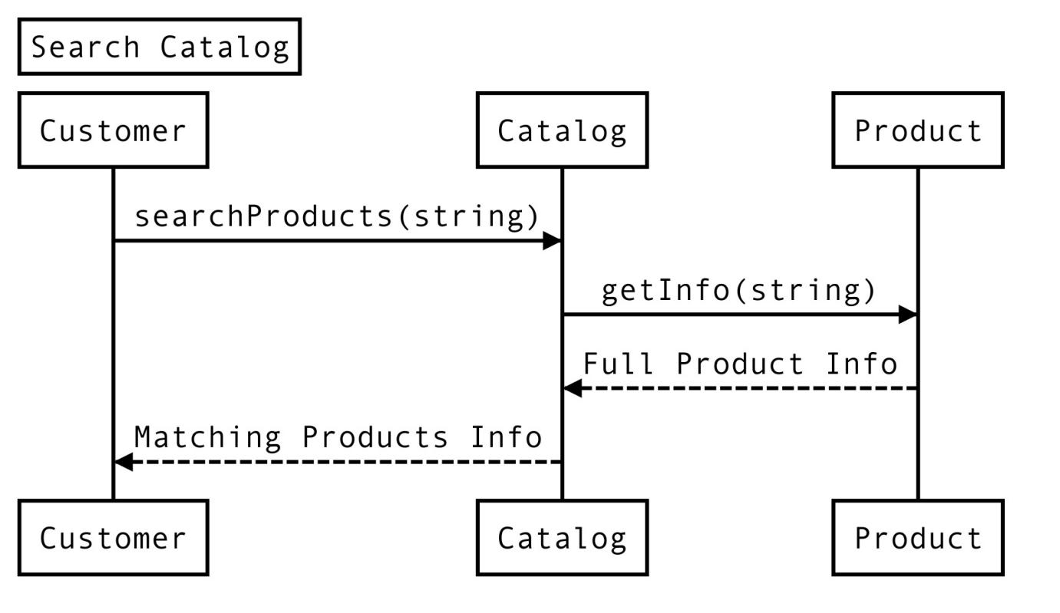
Figure 1-2: Fresh E-commerce system sequence diagram

Sequence diagram for adding items to the shopping cart, as illustrated in Figure 1-3.
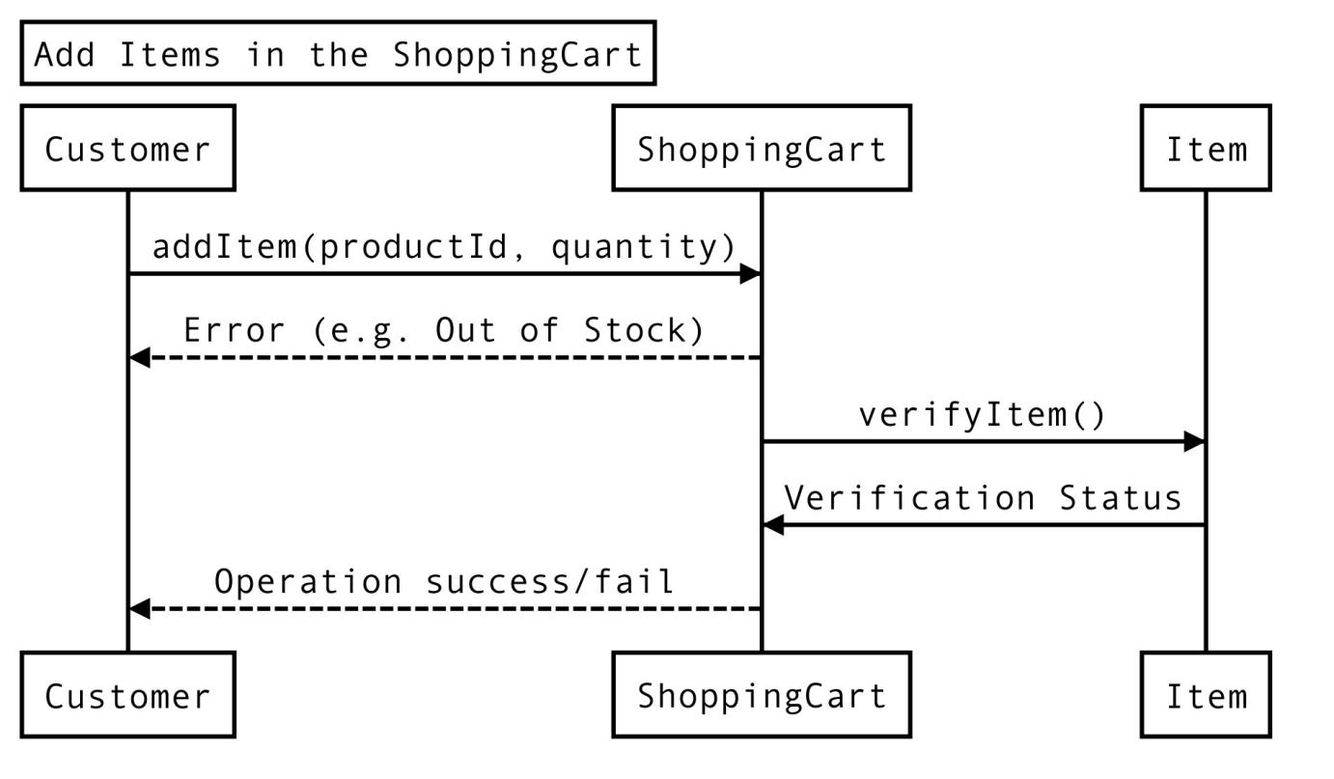
Figure 1-3: Fresh E-commerce system sequence diagram

Sequence diagram for checking out and placing an order, as shown in Figure 1-4.
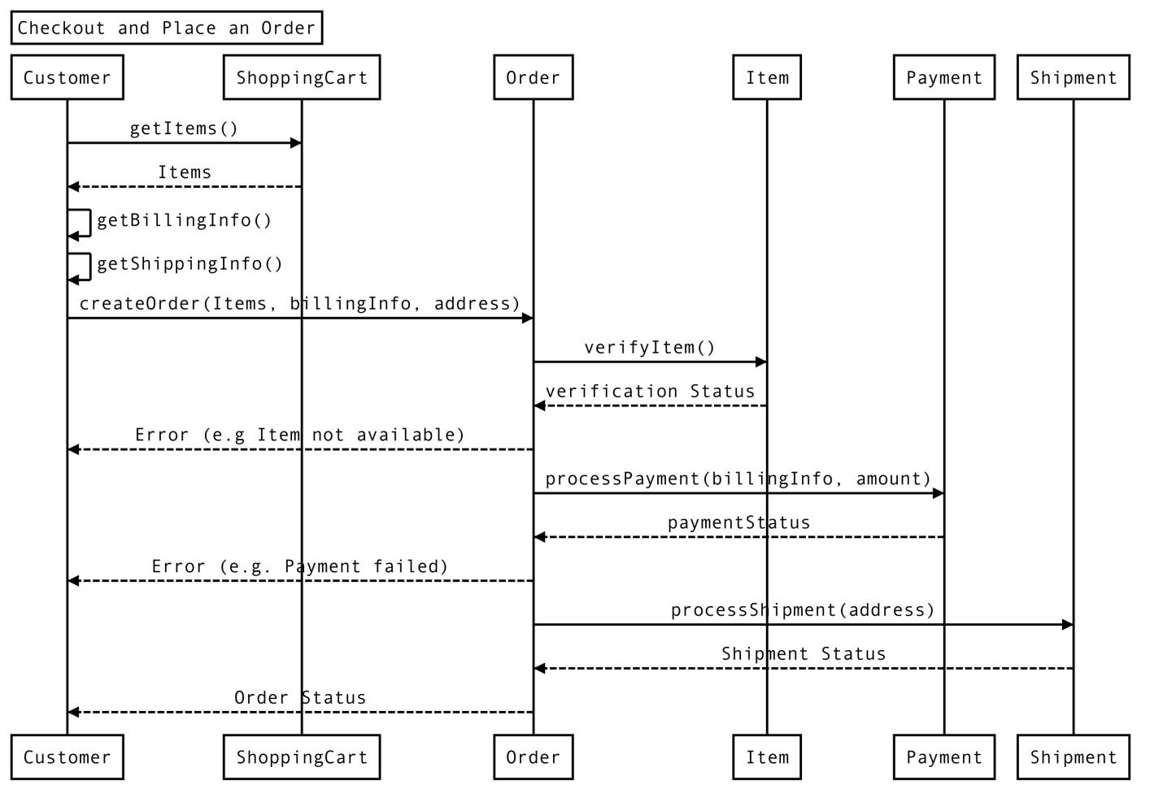
Figure 1-4: System sequence diagram for Fresh E-commerce system

The E-R model is a database modeling tool that is conducive to effective communication between users and designers. It is easy to understand and convenient to express. Drawing an ER diagram can effectively describe the characteristics of the data and the constraints between them. MySQL Workbench, as an excellent and free database management software, can conveniently help users build an ER model. In this software, it is called an Enhanced Entity-Relationship model (EER model). By abstracting business operations into data models, business demand information can be directly reflected.

Conclusion

The article summarizes the research on the following aspects: introduction of the relevant technical theories of the Django fresh e-commerce system, completion of the design and implementation of the fresh e-commerce system, construction of the search engine, research and implementation of the user behavior data collection system, data visualization analysis, research on collaborative filtering algorithms, and construction of the product recommendation system. The project is a Django application developed independently based on PyCharm, ultimately building a complete and effective fresh e-commerce system. The system is feature-rich, easy to operate, and runs stably, demonstrating good practical application value. The following can be taken up as future works:
(1) The system does not currently support the functionality for merchants to open online stores. This module can be added in the future to enhance the platform's functionality and completeness.
(2) All payment modules in the system use simulated methods, including simulated payment interfaces for SMS, logistics, and payment. The system has not integrated these third-party payment modules that require actual payment or enterprise qualification verification.
(3) The product recommendation system can be further optimized in the later stages, considering that real-world applications of recommendation systems require sufficient user data for optimization. Additionally, user behavior data analysis can be improved and refined in the future.
(4) The performance of the system can be further optimized, including front-end performance optimization and MySQL database optimization.
Considering the areas for improvement mentioned above, continuous refinement of the system will be undertaken in the future to achieve better results.

References

- Wu Tao. Design and Research of E-commerce System for Agricultural Inputs [D]. University of Science and Technology of China, 2014.
- Li Bo. Research on the Development of Fresh E-commerce Industry [D]. Graduate School of the Chinese Academy of Social Sciences, 2014.
- Chu Meng, Zhang Baoming. The Development Status and Trends of Fresh E-commerce in China [J]. E-commerce, 2015, 12: 13-14.
- Wu Chuanshu. Analysis of the Development Models of Fresh E-commerce Abroad [J]. World Agriculture, 2015, 05: 136-138+50.
- Luo Shengyuan. Analysis and Recommendations of China's Fresh E-commerce Industry Based on the SCP Paradigm [D]. Capital University of Economics and Business, 2017.
- Yao Bin. Research on the O2O Operation Mode of Fresh Agricultural Products [D]. Zhejiang University of Technology, 2015.

