National Technical University of Ukraine
“Igor Sikorsky Kyiv Polytechnic Institute”
FACULTY OF BIOMEDICAL ENGINEERING
DEPARTMENT OF BIOMEDICAL ENGINEERING

“As a manuscript”  UDC 618.146-073.006 | «Approved for defense»  Head of the Department of BMI ___________ Vladyslav SHLYKOV  (signature) (initials, surname)  “ ____ ” ______________2024
Master's Thesis
to obtain the master's level
under the educational and professional program "Medical Engineering"
specialty 163 "Biomedical engineering"
on the topic: “Cervical protection under vaginal endoscopy, new strategies for the prevention, treatment of HPV and cervical cancer”
Completed:
II-year student, group ZM-32mp
DongMei Wang ______________

Supervisor:
Assoc. prof. dep. ТMВE, Ph.D., Assoc. prof.
Olena BESPALOVA _____________

Reviewer:
Assoc. prof. dep. BSHH, Ph.D., Assoc. prof.
Galyna KOSIAKOVA

I certify that in this master's dissertation there are no borrowings from the works of other authors without appropriate references.
Student ____________________
^{(signature)}
Kyiv –2024
НАЦІОНАЛЬНИЙ ТЕХНІЧНИЙ УНІВЕРСИТЕТ УКРАЇНИ
«КИЇВСЬКИЙ ПОЛІТЕХНІЧНИЙ ІНСТИТУТ
імені ІГОРЯ СІКОРСЬКОГО»
Факультет біомедичної інженерії
Кафедра біомедичної інженерії

«На правах рукопису»  УДК 618.146-073.006 | До захисту допущено:  Завідувач кафедри БМІ  ________ Владислав ШЛИКОВ  «___»_____________2024р.

Магістерська дисертація
на здобуття ступеня магістра
за освітньо-професійною програмою «Медична інженерія»
зі спеціальності 163 «Біомедична інженерія»
на тему: «Захист шийки матки під час вагінальної ендоскопії, нові стратегії профілактики, лікування ВПЛ та раку шийки матки»

Виконав:
студент ІI курсу, групи ЗМ-32мп
Ван Донмеї ___________

Керівник:
Доцент. каф. ТМБІ, к.б.н., доцент,
Беспалова Олена Ярославівна ___________

Рецензент:
Доцент. каф. ББЗЛ, к.б.н., доцент,
Косякова Галина Василівна ___________

Засвідчую, що у цій магістерській дисертації немає запозичень з праць інших авторів без відповідних посилань.
Студент _____________

Київ – 2024 року
National Technical University of Ukraine
“Igor Sikorsky Kyiv Polytechnic Institute”
FACULTY OF BIOMEDICAL ENGINEERING
DEPARTMENT OF BIOMEDICAL ENGINEERING

The level of higher education is the second (master's) degree for the educational and scientific program of the master's degree "Medical Engineering"
Specialty (specialization) 163 "Biomedical Engineering"

«Approved for defense»
Head of the Department of BMI
___________ Vladyslav SHLYKOV
(signature) (initials, surname)
“ ____ ” ______________2024

THE TASK
of the master's thesis
DongMei Wang

1. The topic of thesis: “Cervical protection under vaginal endoscopy, new strategies for the prevention, treatment of HPV and cervical cancer”,
Scientific supervisor of thesis:: Assoc. prof. of the Department of TMBЕ,
Candidate of Biological Sciences, Assoc. prof. Olena BESPALOVA,
(First name, name, academic degree, academic rank)
approved by dictate of university from « 11 » 11 2024, № 137/24-сі
2. The term of the student's dissertation submission: December 11, 2024.
3. Object of study: cervical protection under vaginal endoscopy.
4. Subject of study: оptimization of colposcopy method and cervical protection strategy.
5. List of tasks to be developed:
- еvaluate the efficacy of colposcopy:
- to clarify the accuracy and effectiveness of colposcopy in the screening of HPV infection, cervical intraepithelial neoplasia (CIN) and cervical cancer through comparative analysis.
6. Previous list of illustrative material: the thesis including 12 illustrations, and 21 tables.
7. Previous list of publications
8. Date of issue of the task: 01.09.2024.

Calendar schedule

11 | The name of the stages of execution master's dissertation | The term of implementation of the stages of the master's dissertation | Note
12 | Review of literary sources on the topic of work | September 2024 | Done
13 | Analysis of the obtained results | October - November 2024 | Done
14 | Designing a master's thesis | November - December 2024 | Done
15 | Submission of master's thesis for norm control | December 2024 | Done
16 | Submission of a master's thesis for review. Receiving a review | December 2024 | Done
17 | Submission of a package of documents for protection | December 11, 2024 | Done
18 | Master's thesis defense | December 18, 2024 | Done

Student ____________ DongMei Wang
(signature) (First name, name)

Scientific supervisor of dissertation ___________ Olena BESPALOVA
(signature) (First name, name)

ABSTRACT

As the close association between human papilloma virus (HPV) infection and cervical cancer is widely recognized, colposcopy, as an important tool for cervical cancer screening, plays an increasingly prominent role in early detection, diagnosis and treatment of cervical cancer. This study aims to explore the use of colposcopy in cervical protection and how to reveal new strategies to prevent and treat HPV and cervical cancer through this technique. Using a retrospective analysis and prospective controlled design, we collected clinical data on patients undergoing colposcopy during 2024, evaluated the effectiveness of colposcopy in the early detection of cervical precancerous lesions, and analyzed the impact of different treatment approaches on patient outcomes. This study found that colposcopy significantly improved the diagnostic accuracy of premalignant cervical cancer lesions, especially in patients with high-risk HPV infection. In addition, combined with colposcopy-guided targeted therapy, such as laser ablation and cryotherapy, can effectively reduce the progression of cervical precancerous and reduce the incidence of cervical cancer. The results of this study indicate that colposcopy not only plays an important role in the early diagnosis of cervical cancer, but also provides an important basis for the development of individualized prevention and treatment strategies. By optimizing the colposcopy process and combining modern treatment techniques, it is expected to further improve the treatment effect of cervical cancer and reduce the disease burden. The innovation of this study is to propose a comprehensive management scheme combining colposcopy and targeted therapy, providing a new perspective for the prevention and treatment of cervical cancer.

Key words: colposcopy; cervical protection; human papilloma virus; cervical cancer; prevention strategy; treatment strategy

CONTENT

INTRODUCTION …………………………………………………………………7
SECTION 1. Literature review. Principle and application of colposcopy………………………………………………………………………...111.1 Basic principles and equipment of colposcopy………………………………11
1.2 The Application Value of Colposcopy in the Diagnosis of Cervical Lesions………………………………………………………………………….…16
1.3 Specific Applications of Colposcopy in the Diagnosis of Cervical Lesions…………………………………………………………………………....17
SECTION 2 Relationship between HPV infection and cervical cancer. ………..20
2.1 Biological characteristics and infection mechanism of HPV………………..20
2.2 HPV infection and the development of CIN and cervical cancer……………23
2.3 HPV infection and the prevention and treatment of cervical cancer ………..27
2.4 Screening method for cervical lesions: the traditional and modern comparison and the advantages of combined screening………………………………………29
SECTION 3 Practical Methods and Materials…………………………………...36
3.1.Selection of jects and sample selection ……………………………………...36
3.2 Sample size determination and grouping …………………………………….37
3.3 Practice methods………………………………………………………………38
SECTION 4 Practical Results ………………………………………………….42
4. 1. Data collection and processing ……………………………………………..42
4.2 Analysis of screening results ……………………………………………….45
4.3. Pathological and histological examination results …………………………..46
SECTION 5 STARTUP PROJECT DEVELOPMENT…………………………. 51
CONCLUSION …………………………………………………………………..82
REFERENCES …………………………………………………………………..84

INTRODUCTION

Background information
HPV (human papilloma virus) is a virus that exists widely in nature, and is closely related to human health, especially to cervical cancer in women. As one of the common gynecological malignancies, cervical cancer has a high incidence and mortality rate worldwide, which poses a serious threat to women's life and health. Therefore, a thorough understanding of the relationship between HPV and cervical cancer, as well as the prevalence status and harm of cervical lesions, is important for the development of effective prevention and treatment strategies HPV is a double-stranded DNA virus that mainly infects the stratified squamous epithelium of the human skin and mucosa, such as the vulva, vagina, and cervix [1]. According to the virus type, HPV can be divided into high risk type and low risk type. High-risk HPV, such as HPV16,18, is closely related to the occurrence of cervical cancer, while low-risk HPV mainly causes benign lesions such as genital warts. HPV infection is universal, especially in women with a sexual history, rates as high as 80% – 85% [2]. However, most HPV infected people can clear the virus naturally within 1-2 years, and only a few infected people will develop persistent HPV infection, which develops into cervical intraepithelial neoplasia (CIN) and even cervical cancer.
The epidemic status and hazards of cervical disease and cervical cancer
Cervical cancer is one of the most common malignancies in women worldwide, with its morbidity and mortality being particularly prominent in developing countries. According to the World Health Organization, more than 500,000 new cervical cancer cases and more than 300,000 deaths are reported worldwide each year. The onset age of cervical cancer shows a younger trend, which brings a great threat to women's life and health.

Cervical lesions are the precursor lesions of cervical cancer, including CIN and carcinoma in situ. CIN can be divided into CIN I, CIN II, CIN III, among which CIN III includes severe allotype and carcinoma in situ. The epidemic situation of cervical lesions shows the following characteristics: first, the incidence is high, especially in women with sexual history; second, the younger trend is obvious, the incidence of cervical lesions in young women is increasing year by year; third, the regional differences are significant, and the incidence of cervical lesions and cervical cancer in developing countries and economically underdeveloped areas is higher than that in developed countries [2]. The harm of cervical lesions and cervical cancer cannot be ignored. First, cervical cancer is a malignant tumor, highly invasive and metastatic, leading to patient death if not treated promptly. Secondly, the treatment process of cervical lesions and cervical cancer is complex and expensive, placing a huge financial burden on patients and families. In addition, cervical lesions and cervical cancer may also cause psychological problems, such as anxiety, depression, etc., which may further affect the quality of life of patients.
The importance of colposcopy in cervical protection

Colposcopy is an important means of gynecological examination, important for the early detection, diagnosis and treatment of cervical lesions and cervical cancer. Colposcope is an optical instrument that allows the doctor to clearly observe the cervical epilesions by amplifying the subtle structures of the cervix and vagina. Colposcopy combined with acetate white test, iodine test and other auxiliary means, can further improve the detection rate of cervical lesions.
The importance of colposcopy examination in cervical protection is mainly reflected in the following aspects: First, the early detection of cervical lesions. Colposcopy can detect small lesions that are difficult to detect to the naked eye, such as CINI, which provides the possibility of early treatment. Second, to guide biopsy and surgical treatment. Colposcopy can accurately locate the lesion site, provide doctors with accurate biopsy and surgical treatment guidance, and ensure the accuracy and effectiveness of treatment. The third is the follow-up and monitoring. Colposcopy can also be used for follow-up and monitoring after the curative treatment of cervical lesions, to detect recurrence or new lesions in time, so as to take corresponding treatment measures [3]. Colposcopy also has the advantages of simple operation, high safety, and small pain for patients. During the examination, the doctor will use the vourur to expose the vagina and cervix, and then observe the lesions of the cervical epithelium through a colposcopy lens. The entire examination procedure usually takes only a few minutes, and the patient feels little pain or discomfort. At the same time, colposcopy is a non-invasive examination means, will not cause any harm to the patient's body.
HPV and cervical cancer are closely related, and the prevalence status and harm of cervical lesions and cervical cancer cannot be ignored. As an important gynecological examination method, colposcopy plays an important role in cervical protection. By strengthening the prevention and screening of HPV infection and improving the early detection and treatment rates of cervical lesions and cervical cancer, we can effectively reduce the incidence and mortality of cervical cancer and protect the life and health of women.

The main objectives of this study can be summarized

Evaluate the efficacy of colposcopy: to clarify the accuracy and effectiveness of colposcopy in the screening of HPV infection, CIN and cervical cancer through comparative analysis, so as to provide a scientific basis for clinical decision-making.Explore the effectiveness of new strategies

Research objectives

The aim of this study is to explore the value of colposcopy in cervical protection and to reveal new strategies for the prevention and treatment of hpv and cervical cancer.

This study mainly focuses on the following core questions
  - How accurate and effective is colposcopy in screening for hpv and cervical cancer?
  - Can new strategies based on colposcopy improve the detection and treatment of cervical lesions?
  - What are the challenges and limitations of the practical application of colposcopy in cervical protection?
  - How can the colposcopy process and follow-up management be optimized to promote long-term protection of cervical health?
  - What is the future direction of colposcopy technology and cervical protection strategies?
  - By examining these questions in depth, this study aims to provide a scientific basis for the application of colposcopy in cervical protection and to promote the continuous optimization and advancement of strategies for the prevention and treatment of HPV and cervical cancer.

SECTION 1
Literature review

Principle and application of colposcopy

1.1 Basic principles and equipment of colposcopy
Colposcopy is an important gynecological clinical diagnostic technique, through the principle of optical or electronic magnification, the vagina and cervix are carefully observed in order to find cancer-related lesions, and point biopsy of suspicious sites. This examination technology not only improves the diagnostic accuracy of the disease, but also provides patients with the opportunity for early treatment, thus greatly improving the cure rate of the disease. The following will discuss the basic principle of colposcopy, equipment structure and clinical application in detail (Figure 1) [4].
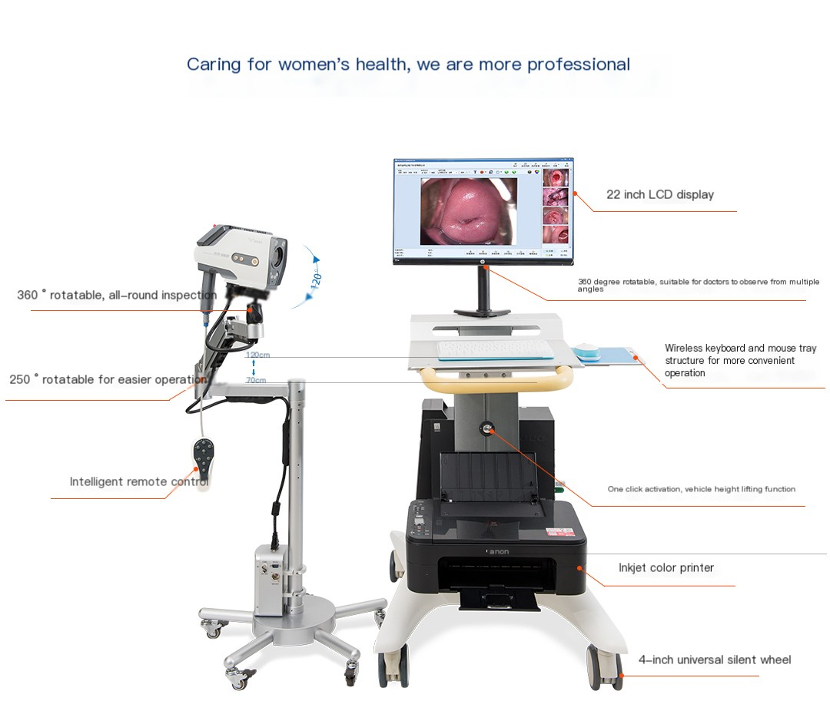

Figure 1. Colposcope [5]
Basic principles of colposcopy
The basic principle of colposcopy is to enlarge the vagina and cervix by optical or electronic means in order to directly observe their vascular morphology and epithelial structure. This amplification can often be 10 to 40 times larger, allowing doctors to clearly see small changes in these areas [6].
During a colposcopy, the doctor applies an acetic acid solution to the surface of the cervix. The principle of action of acetic acid solution is to cause a temporary reversible shrinkage of cervical cells, so that the light transmission of the epithelium is changed. This change, under the magnification of the microscope, can reveal some subtle changes in the blood vessels and epithelium on the surface of the cervix. By looking at these changes, the doctor can tell if there is an abnormality and determine where it is.
In addition, colposcopy is often combined with iodine tests. The principle of the iodine test is that iodine reacts with glycogen in the cervical epithelium to produce color changes [7]. Normal cervical epithelium is rich in glycogen and reacts with iodine to appear brown. Abnormal epithelium, such as cancerous tissue, does not discolor or is lighter due to lack of glycogen. With the iodine test, the doctor can further identify the abnormal area [8].
Colposcopy has significant advantages in the diagnosis of cervical diseases. It can quickly identify cervical lesions invisible to the naked eye, and timely detect cervical inflammatory lesions and cervical precancerous lesions or cancerous changes. In addition, colposcopy can also selectively locate the biopsy under direct vision, which changes the habit of subjective biopsy in the past, and greatly improves the positive rate of biopsy [9].

Colposcopy equipment introduction
Colposcopy equipment is mainly composed of magnifying glass, support, light source and other parts. With the development of technology, modern colposcope is also equipped with advanced equipment such as camera system, head, elevator, etc., making inspection more accurate and convenient [10].
Magnifying glass: The magnifying glass is the core component of the colposcope and is responsible for magnifying the vagina and cervix to the appropriate multiple. The magnification of the magnifying glass is usually 10×, 16×, 24× and other options to meet different inspection needs. The distance of the eyepiece of the binocular colposcope can be adjusted between 50-80mm, which is convenient for the doctor to observe and operate [11].
Stand: The stand is used to support the magnifying glass and light source, and allows the doctor to adjust the height and Angle of the lens as needed. The bracket base is usually fitted with four universal wheels that allow the doctor to push back and forth during the examination. On the vertical axis of the support, there is a transverse arm that can move up and down by using the lever principle. One end of the transverse arm is the lens, and the other end is a weight to maintain balance, which can easily raise or drop the lens [12].
Light source: Light source is an integral part of colposcopy. Optical colposcope usually uses a cold light source, the light source is located far away from the support of the lens, and the light is transmitted to the magnifying glass through the optical fiber, so that the part being observed does not heat [13]. The light source of modern colposcopes usually uses 250W Xenon cold light source optical fiber illumination, which can provide stable, bright light and ensure clear images during inspection.
Camera system: Modern colposcopes are also equipped with a camera system for recording and storing images during the examination. The camera system is controlled by microcomputer, with automatic white balance, color saturation adjustment and other functions to ensure image quality. With the camera system, doctors can easily review and analyze test results, improving diagnostic accuracy [14].
Head and elevator: Head and elevator are auxiliary parts of colposcopy equipment. The head is used to adjust the direction and Angle of the lens, allowing the doctor to position the viewing area more accurately. The elevator is used to adjust the height of the lens to adapt to the examination needs of different patients. Through the combination of the head and the elevator, the doctor can flexibly adjust the position of the lens to ensure a clear and stable view during the examination [15].
In addition, the electronic colposcope is equipped with advanced image processing and analysis software to automatically identify and label abnormal areas, further improving diagnostic efficiency and accuracy.

Application of colposcopy
Colposcopy has wide application value in gynecological clinic. It can not only screen cervical lesions, cervical cancer and other malignant tumors, but also can be used for cervical inflammation, vulvar cancer and other lesions diagnosis and treatment.
Screening for cervical lesions: Cervical lesions are one of the common gynecological diseases, including cervicitis, cervical polyps, cervical cysts and so on. Colposcopy can clearly show the blood vessels and epithelial structures on the surface of the cervix, helping the doctor to accurately determine whether there are abnormalities. For suspicious sites, doctors can perform a spot biopsy to improve the accuracy of diagnosis [16].
Diagnosis of cervical cancer: Cervical cancer is one of the common malignant tumors in women, which seriously threatens the life and health of women. Colposcopy can quickly identify cancerous tissue in the cervix and perform a localized biopsy [17]. From the results of the biopsy, doctors can diagnose cervical cancer and develop a personalized treatment plan.
Diagnosis and treatment of cervical inflammation: Cervical inflammation is a common gynecological disease, usually caused by bacterial infection [18]. Colposcopy can clearly show the inflammation of the cervix and help the doctor determine the type and extent of inflammation. For mild inflammation, doctors can give medication; For severe inflammation or inflammation accompanied by polyps, cysts and other lesions, surgery is required.
Vulvar cancer diagnosis: vulvar cancer is a malignant tumor of the female reproductive system, although the incidence is low, but once it occurs, it poses a serious threat to the life and health of patients [19]. Colposcopy can look at the blood vessels and epithelial structures of the vulva and help doctors determine if cancerous tissue is present. For suspicious areas, the doctor can perform a biopsy to confirm the diagnosis.
Postoperative follow-up and monitoring: Colposcopy is an important tool for postoperative follow-up and monitoring in patients who have already been treated for cervical lesions or cervical cancer. Through regular examinations, doctors can detect recurrence or metastasis in time and take appropriate treatment measures.
The clinical application of colposcopy in gynecology not only improves the diagnostic accuracy of diseases, but also provides patients with the opportunity for early treatment. Through the timely detection and treatment of cervical lesions and cervical cancer and other malignant tumors, colposcopy has effectively reduced the morbidity and mortality of these diseases, and improved the quality of life of the majority of women [20].
Colposcopy, as a non-invasive and repeatable examination technique, has significant advantages. It can not only provide clear images to help doctors accurately determine the location and nature of the lesion, but also reduce the pain and discomfort of the patient. In addition, with the continuous development of technology, modern colposcopes are also equipped with advanced image processing and analysis software, further improving diagnostic efficiency and accuracy [21].
Colposcopy also has certain limitations. For example, exposure to a limited field of vision may result in inadequate treatment. In addition, patients need to be fully prepared before colposcopy, such as avoiding sex, vaginal irrigation, etc., so as not to affect the results of the examination. Therefore, when performing colposcopy, the doctor needs to fully understand the patient's history and symptoms, and develop a personalized examination plan according to the actual situation.
Colposcopy is an important gynecological clinical diagnostic technique, which has a wide range of application value and significant advantages [22]. Through continuous technological innovation and improvement, colposcopy will provide more patients with the opportunity for early detection and treatment, and make greater contributions to the development of gynecology clinical.

1.2 The Application Value of Colposcopy in the Diagnosis of Cervical Lesions
Colposcopy plays a pivotal role in the diagnosis of cervical lesions, with its application value manifested in several critical aspects:
Enhancing Diagnostic Accuracy
Colposcopy, through the magnification of subtle cervical and vaginal structures, allows physicians to observe lesions with greater clarity. The use of acetic acid and iodine tests enables the identification of suspicious areas for precise biopsy sampling. high-precision examination significantly improves the diagnostic accuracy of cervical lesions [23].
Early Detection of Lesions
Colposcopy is adept at detecting early-stage lesions such as cervical intraepithelial neoplasia (CIN), which might be imperceptible to the naked eye. The magnification effect of colposcopy reveals minute abnormalities, enabling timely diagnosis and treatment, thus effectively preventing the progression of lesions and reducing the incidence of cervical cancer [24].
Guiding Biopsy Sampling
During colposcopy, physicians can precisely sample the observed lesion, enhancing the accuracy of pathological examinations and avoiding misdiagnoses. Colposcopy also directs the selection of the optimal biopsy site, minimizing patient discomfort and complications.
Evaluating Treatment Effectiveness
For patients who have undergone treatment for cervical lesions, colposcopy serves as a tool to assess therapeutic outcomes. By observing tissue repair and the presence of residual lesions, physicians can gauge patient recovery and determine the need for further treatment or follow-up.
Reducing Medical Costs
As an efficient diagnostic method, colposcopy reduces medical costs by facilitating early detection and accurate diagnosis, thereby avoiding unnecessary overtreatment and surgical complications, conserving medical resources, and offering personalized treatment plans that improve therapeutic outcomes and patient satisfaction.

1.3 Specific Applications of Colposcopy in the Diagnosis of Cervical Lesions
Diagnosis of Cervicitis
Cervicitis, an inflammatory pathology；pathological changes；lesion of the cervical mucosa, is characterized by cervical congestion, edema, and erosion. [25]. Colposcopy observes subtle changes in the cervical mucosa, such as vascular congestion and edema, aiding in the diagnosis of cervicitis and ruling out other cervical lesions like CIN and cervical cancer.
Diagnosis of Cervical Polyps
Cervical polyps, which are pedunculated growths on the cervical mucosa, often present as single or multiple red nodules at the cervical os [26]. Colposcopy clearly visualizes the morphology, size, and position of cervical polyps, aiding in their diagnosis. Suspicious polyps can be biopsied under direct colposcopic view to determine their nature.
Diagnosis of Cervical Intraepithelial Neoplasia (CIN)
CIN a precancerous condition of the cervix, ranges from CIN I to CIN III. Colposcopy observes subtle changes in cervical epithelium, such as cellular atypia and mitotic figures, aiding in the diagnosis of CIN. The use of acetic acid and iodine tests helps identify suspicious areas for precise biopsy sampling, which is crucial for the early detection and diagnosis of CIN [27].
Diagnosis of Cervical Cancer
Cervical cancer, a malignant tumor of the cervical epithelium, often presents as cauliflower-like, papillary, or ulcerative masses at the cervical os [28]. Colposcopy observes the morphology, size, and position of cervical cancer and assesses the depth and extent of tumor infiltration. Colposcopy also guides biopsy sampling to determine the pathological type and staging of the cancer. For suspicious cases of cervical cancer, colposcopy can facilitate cytological or histological examinations for further confirmation.

1.4 Precautions and Limitations of Colposcopy
While colposcopy is invaluable in diagnosing cervical lesions, certain precautions and limitations should be considered:
Precautions
Patients should empty their bladders before the examination and avoid strenuous activity during the procedure. Physicians must thoroughly disinfect the external genitalia and use a speculum to expose the cervix, ensuring the accuracy and safety of the examination [29]. Physicians should observe subtle changes in the cervix and vagina during the examination and perform acetic acid and iodine tests as needed. If suspicious lesions are found, physicians should biopsy under direct colposcopic view, taking care not to damage surrounding healthy tissues.
Limitations
Although colposcopy can observe subtle structures of the cervix and vagina, it has certain limitations in diagnosing deep-seated lesions. The results of colposcopy are influenced by the physician's experience and skill level, introducing subjectivity and potential errors. For some patients with cervical conditions such as cervical stenosis or atrophy, colposcopy may be challenging to perform or yield suboptimal results.
Conclusion and Outlook
Colposcopy, as an advanced gynecological examination method, holds significant value in the diagnosis of cervical lesions [30]. It offers numerous benefits, including enhanced diagnostic accuracy, early lesion detection, guided biopsy sampling, treatment effectiveness evaluation, and reduced medical costs. However, it is essential to be mindful of certain precautions and limitations to ensure the accuracy and safety of the examination [31].
In the future, with ongoing advancements and innovations in medical technology, colposcopy is expected to play an even more substantial role in the diagnosis of cervical lesions. For instance, by integrating colposcopy with other advanced diagnostic methods such as ultrasound, CT, and MRI, the diagnostic accuracy of cervical lesions can be further improved [32]. The development of smarter and more automated examination equipment could reduce the workload for physicians and increase examination efficiency. Additionally, strengthening patient education and awareness can enhance the recognition and importance of cervical lesions, promoting early detection and diagnosis [33].

SECTION 2
Relationship between HPV infection and cervical cancer

2.1 Biological characteristics and infection mechanism of HPV
HPV (Human Papilloma virus) is a dna virus that is widely found in nature and belongs to the genus Papilloma virus A of the lactopolyviridae family [34]. HPV infection is closely associated with a number of human diseases, especially cervical cancer, making it an important subject in the field of public health. In this paper, the biological characteristics and infection mechanism of HPV will be described in detail, and relevant literature will be cited to explain.

Biological characteristics of HPV
HPV is a virus with a double-linked, loop-like DNA structure and a genome size of about 8kb that is highly conserved and variable [35]. HPV virus particles are spherical, about 50-60nm in diameter, without envelope, with 72 shell particles on the surface, which are icosahedral symmetry [36]. The HPV genome encodes a variety of viral proteins, including early proteins (E1, E2, E4, E5, E6, and E7), late proteins (L1 and L2), and non-structural proteins (such as NS1). These proteins play important roles in viral replication, transcriptional regulation, cell transformation and immune escape.
There are many subtypes of HPV, and more than 200 types of HPV subtypes have been found, which can be divided into low-risk and high-risk types according to their pathogenicity or carcinogenic risk to host cells. Low-risk HPV mainly causes various types of skin warts, such as common warts, plantar warts, plantar warts, etc., and usually does not pose a serious health threat to the human body. However, high-risk HPV may lead to a variety of malignant tumors, such as cervical cancer, anal cancer, penile cancer, etc., seriously threatening human life and health. Among them, HPV16, 18, 45, 58 and other types are recognized as the main carcinogenic types of cervical cancer (Figure 2 ) [37].
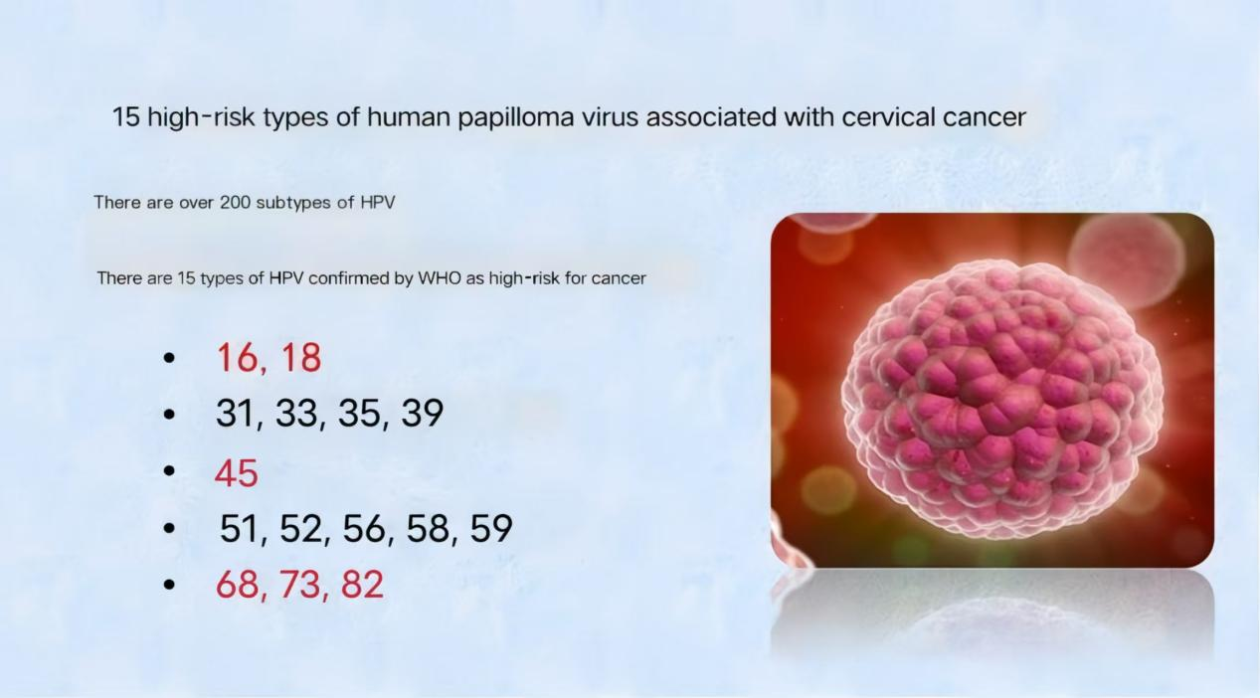
Figure 2. HPV high-risk type [6].

HPV infection mechanism
HPV is mainly transmitted through direct contact, including sexual contact, indirect contact and mother-to-child transmission. Sexual contact is the main way of HPV transmission, when the genitals of an infected person and the genitals of a healthy person are in direct contact, the virus is likely to enter the body through mucous membranes or skin lesions. In addition, indirect contact transmission mainly refers to transmission through contaminated items, such as towels, bath towels, underwear, etc. When the secretions or body fluids of infected people contaminate related items, healthy people may be infected with HPV when they come into contact with these items. Mother-to-child transmission is relatively rare and usually occurs during childbirth, when a mother passes the virus to her newborn [38].
Symptoms after HPV infection vary depending on the type of virus and the site of infection. For the skin area, HPV infection may lead to the appearance of various skin warts, such as common warts, flat warts, etc. These skin warts are usually self-healing, but in some cases, they may also cause discomfort such as pain and itching. In the mucosal area, HPV infection may lead to genital warts (condyloma acuminatum), laryngeal papilloma and other lesions. These lesions are not only contagious, but may also cause psychological stress and social distress in patients.
More importantly, high-risk HPV infection may lead to cervical dysplasia and cervical cancer and other malignant tumors. After HPV infects cervical epithelial cells, viral DNA will integrate into the host genome, resulting in host genome instability, tumor suppressor gene inactivation, immune escape and epigenetic regulation disorder, thus promoting carcinogenesis. In this process, HPV's E6 and E7 proteins play a key role. The E6 protein is able to bind to the intracellular p53 tumor suppressor protein, causing its degradation and inactivation, thereby losing its inhibitory effect on cell growth. E7 protein can bind to retinoblastoma protein (Rb) in the cell, resulting in its loss of function, and then promote cell proliferation and carcinogenesis [39].
A review published in Trends Mol Med provides a systematic introduction to the biological mechanisms of HPV integration.⁴¹ The article pointed out that HPV integration is a key link in the occurrence of cervical cancer, but the integrated virus loses the ability to replicate and spread, which leads to the inability of HPV to continue its "life" by infecting a new host. HPV integration leads to host genome instability, tumor suppressor gene inactivation, immune escape and epigenetic regulation disorder, thus promoting carcinogenesis. In addition, we explore in depth the mechanisms of HPV integration, including the role of early HPV genes E1 and E2 in viral genome replication in the integration process, and the mechanism by which short nucleotide (MHs) sequences between the virus and host genomes may promote HPV integration.
When HPV infects cervical epithelial cells, it may trigger a series of cellular changes, from mild dysplasia to high dysplasia, which may eventually lead to cancer. In this process, the interaction between virus and host, the variation of virus genome and environmental factors may affect the progression of the disease. Therefore, regular cervical cancer screening and taking appropriate preventive measures are essential to reduce the risk of cervical cancer [40].

Epidemiology of HPV infection and cervical cancer
Cervical cancer is the fourth most common cancer in women worldwide, with nearly half a million new cases each year. About 90 percent of cervical cancers are caused by HPV infection. This data fully illustrates the close relationship between HPV infection and cervical cancer [41].
The epidemiological characteristics of HPV infection vary by region, age, sexual habits, and other factors. In high-income countries, the incidence of HPV infection and cervical cancer is on the decline due to widespread access to cervical cancer screening and HPV vaccination. However, in low-income countries, rates of HPV infection and cervical cancer remain higher due to lower screening and vaccination coverage.
In addition, HPV infection varies among different age groups. Young women are the main population of HPV infection, especially the early age of first sex, the number of sexual partners, smoking, the use of immunosuppressants and other factors can increase the risk of HPV infection. HPV infection rates gradually decrease with age, but the risk of cervical cancer caused by high-risk HPV infections gradually increases.
There is a direct relationship between HPV infection and cervical cancer, especially high-risk HPV persistent infection is the main risk factor for cervical cancer. Understanding the biological characteristics and infection mechanism of HPV is of great significance for prevention and control of cervical cancer. By getting regular cervical cancer screening, getting the HPV vaccine, and taking appropriate preventive measures, you can effectively reduce your risk of cervical cancer. In the future, with the in-depth study of the mechanism of HPV infection and the continuous emergence of new technologies, we have reason to believe that the prevention and treatment of cervical cancer will make more significant progress.

2.2 HPV infection and the development of CIN and cervical cancer
Cervical cancer is a common malignant tumor in women, its morbidity and mortality are in the forefront of female malignant tumors. In recent years, with the intensive study of the pathogenesis of cervical cancer, it is gradually recognized that HPV infection is the main cause of cervical cancer development. When HPV infects cervical epithelial cells, viral DNA integrates into the host cell genome, resulting in uncontrolled cell proliferation and the formation of CIN. As the lesion progresses, some patients with CIN will develop invasive cervical cancer (Figure 3. ) [42].
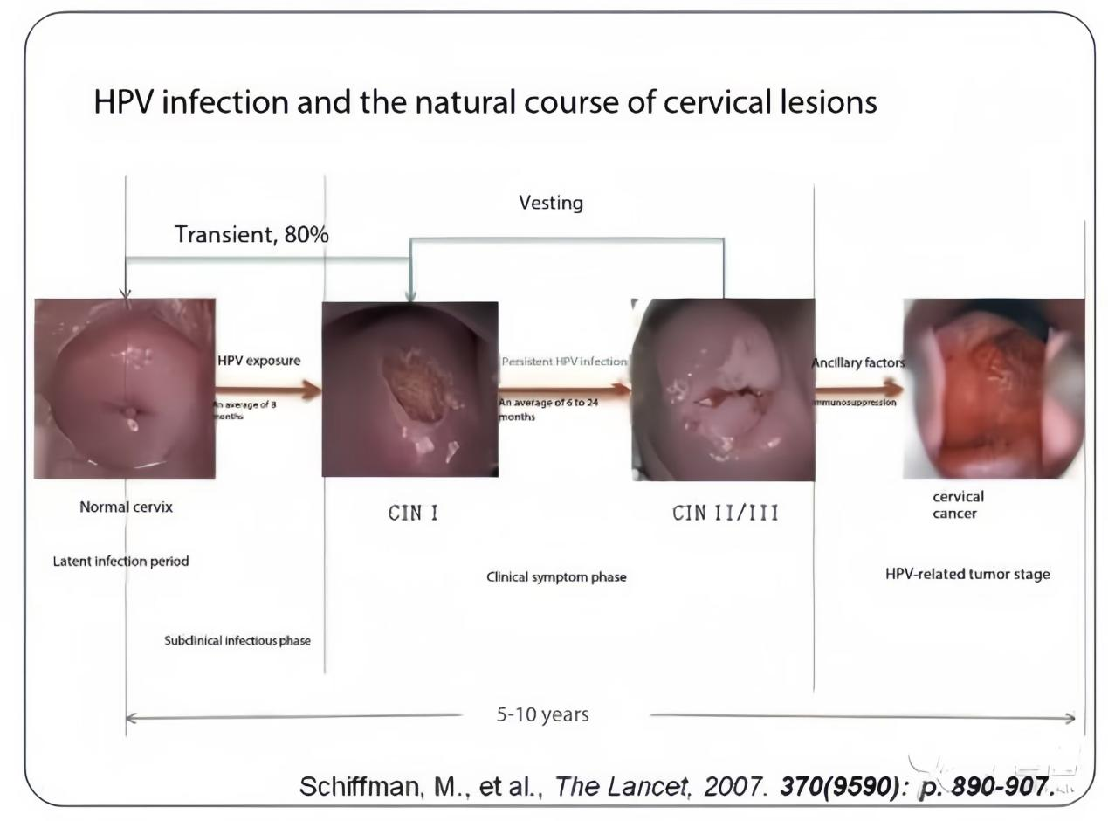
Figure 3. HPV infection and the natural course of cervical lesions [42].

HPV infection and the occurrence of CIN
CIN is a precursor lesion of cervical cancer, including three grades: CINI, CIN II and CIN III. Among them, CINI was mild dysplasia, CIN II was moderate dysplasia, and CIN III included severe atypia and carcinoma in situ. After HPV infection of cervical epithelial cells, the viral DNA is integrated into the host cell genome, causing uncontrolled cell proliferation and subsequent formation of CIN. Studies have shown that high-risk HPV infection is the main cause of CIN development. In patients with CIN, the detection rate of HPV is more than 90%, and the detection rate of high-risk HPV such as HPV16 and 18 is more than 70%.
After HPV infection of cervical epithelial cells, the viral DNA is first integrated into the host cell genome to form an integrative HPV DNA. The expression products of integrative HPV DNA, such as E6 and E7, bind to the tumor suppressor protein p53 and retinoblastoma protein (Rb) in host cells to inhibit their normal function, leading to uncontrolled cell proliferation and blocked apoptosis. Moreover, HPV infection may also trigger immune escape mechanisms in host cells to further promote the development and development of CIN (Figure 4) [43].
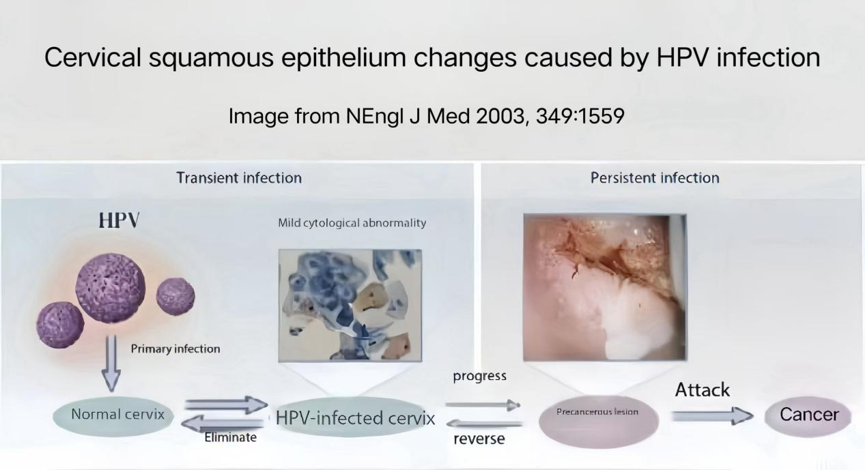
Figure 4. Cervical squamous epithelial changes caused by HPV infection [43].

The evolution of CIN to cervical cancer
The evolution of CIN to cervical cancer is a complex and lengthy process involving the dysregulation of multiple genes and signaling pathways. With the progression of CIN lesions, some cells will develop increased genomic instability, chromosomal abnormalities, and telomere shortening, and then develop into invasive cervical cancer.
Continuous infection with high-risk HPV plays a crucial role in the evolution of CIN to cervical cancer. Oncoproteins such as E6 and E7 of high-risk HPV will continuously inhibit the normal function of host cells, leading to uncontrolled cell proliferation and blocked apoptosis. At the same time, high-risk HPV may also trigger the immune escape mechanisms of host cells to further promote the occurrence and development of tumors. In addition, environmental factors, genetic factors, and lifestyle habits may also have an impact on the evolution of CIN to cervical cancer (Figure 5.) [16].
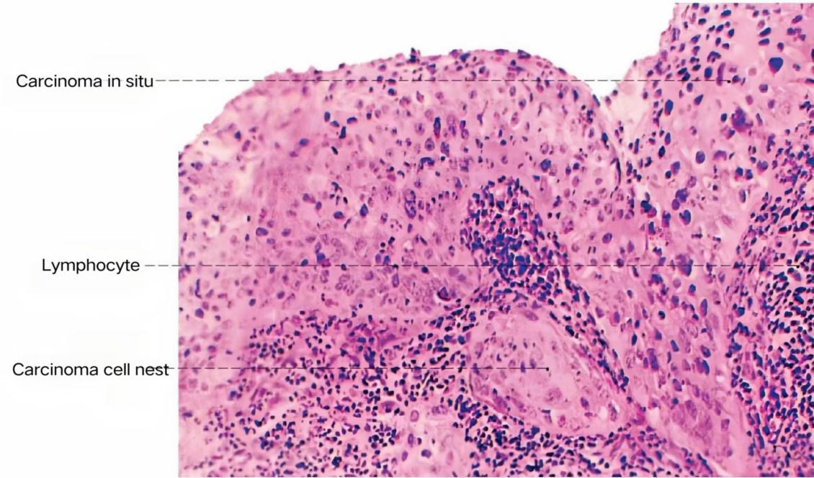
Figure 5. Invasive cervical cancer [16].

Pathogenesis of cervical cancer
The pathogenesis of cervical cancer involves the dysregulation of multiple genes and signaling pathways. Oncoproteins such as E6 and E7 of high-risk HPV are key molecules in cervical carcinogenesis. These oncoproteins inhibit their normal function by binding to the tumor suppressor proteins p53 and Rb within their host cells, thus leading to uncontrolled cell proliferation and arrested apoptosis. At the same time, high-risk HPV may also trigger the immune escape mechanisms of host cells to further promote the occurrence and development of tumors. In addition to the persistent infection with high-risk HPV, the incidence of cervical cancer may also be related to genetic factors, environmental factors, living habits, etc. For example, reproductive factors such as early marriage, early pregnancy and excessive childbirth, as well as bad living habits such as smoking and drinking alcohol, may increase the risk of cervical cancer. In addition, the incidence of cervical cancer is also closely related to the immune function of the body. Both immunocompromised or the presence of immune escape mechanisms may promote the development and development of cervical cancer [9].
2.3 HPV infection and the prevention and treatment of cervical cancer
Given that HPV infection is the leading cause of cervical cancer development, the prevention and treatment of HPV infection is important for reducing the morbidity and mortality of cervical cancer.
Preventive measure
The main measures to prevent HPV infection include strengthening sexual health education, promoting safe sex, conducting regular cervical cancer screening, and receiving HPV vaccination. Strengthening sexual health education can increase public awareness and emphasis of HPV infection and thus take active preventive measures. Promoting safe sex can reduce the transmission route of HPV and reduce the risk of infection. Regular cervical cancer screening can allow for early detection of CIN and cervical precancerous lesions, leading to prompt treatment measures. Vaccination against HPV can prevent high-risk HPV infection, thus reducing the incidence of cervical cancer (Figure 6.).
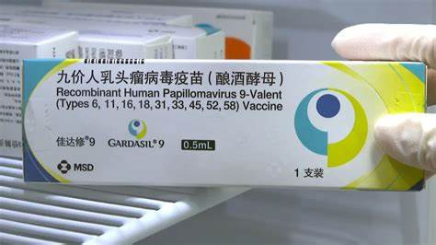Figure 6. HPV 9-Valent vaccine [9].

The HPV vaccine is an effective means to prevent HPV infection. At present, there are a variety of HPV vaccines available on the market, including bivalent, quadrivalent and nine-valent vaccines. These vaccines all have good safety and efficacy, and can significantly reduce the incidence of HPV infection and cervical cancer. However, it should be noted that HPV vaccines do not cure already infected HPV or treat diseases such as CIN and cervical cancer. Therefore, regular cervical cancer screening and gynecological examination are still required after HPV vaccination.
Therapeutic measure
For patients who have developed CIN or cervical cancer, the treatment measures mainly include surgical treatment, radiotherapy and chemotherapy. Surgical treatment is the main treatment of CIN and early cervical cancer, including cervical conization, total hysterectomy, etc. Radiotherapy and chemotherapy are mainly used for the treatment of advanced cervical cancer. However, it should be noted that these therapeutic measures do not completely cure cervical cancer or prevent its recurrence. Therefore, we need to pay close attention to the treatment and take active preventive measures to reduce the risk of recurrence.
In addition to traditional treatments such as surgery, radiotherapy and chemotherapy, some new treatments have emerged in recent years, such as immunotherapy and gene therapy. These new methods have potential therapeutic efficacy and safety advantages, but need further clinical studies and validation.
HPV infection is closely related to cervical cancer, and persistent infection with high-risk HPV is the main cause of cervical cancer. Prevention and treatment of HPV infection is important for reducing the morbidity and mortality of cervical cancer. HPV infection can be effectively prevented by strengthening sexual health education, promoting safe sex, conducting regular cervical cancer screening and HPV vaccination. For patients who already have developed CIN or cervical cancer, aggressive treatment is needed to control disease progression and reduce the risk of recurrence [44].
In the future, with the continuous study of the pathogenesis of HPV infection and cervical cancer and the emergence of new treatments, we have reason to believe that the prevention and treatment of cervical cancer will make more significant progress. At the same time, it is also necessary to strengthen the public's awareness and importance of HPV infection and cervical cancer, improve people's health awareness and self-health care ability, and jointly promote the in-depth development of cervical cancer prevention and control work.

2.4 Screening method for cervical lesions: the traditional and modern comparison and the advantages of combined screening
Cervical disease is one of the common health problems in women, and its early screening is of great significance to prevent the occurrence of cervical cancer. With the progress of medical technology, the screening methods of cervical lesions are also developing and improving. This paper will compare the traditional screening method (Pap smear) with the modern screening method (TCT, HPV test), and explore the advantages of combined TCT and HPV screening [37].
Traditional screening method: Pap smear
Pap smear method, also known as cervical smear cytology, is a traditional screening method for cervical lesions. The operation process is relatively simple, the doctor uses a cork scraper to gently scrape at the cervix to collect the cervix detached cells, and then observe under a microscope. The method has the advantage of being cheap and easy to survey, so it was widely used for a time (Figure 7.) [45].

Figure 7. Pap smear [45].
The Pap smear method also has some obvious drawbacks. First, the diagnostic accuracy is relatively low because the cells piled together. Secondly, the classification standard of Pap smear method is relatively vague, which may easily lead to misdiagnosis and missed diagnosis. Therefore, with the continuous progress of medical technology, the traditional screening methods are gradually replaced by the modern screening methods.
Modern screening methods: TCT check up, HPV check
TCT check up
TCT examination, namely thin-layer fluid-based cytology, is one of the important means of modern screening for cervical lesions. The operation process is to open the vaginal mouth through the vaginal speculum, expose the cervix, with a special cervical brush into the cervical tube, rotate 5-7 laps and take out, the specimen attached to the cervical brush is evenly placed in the preservation fluid, and then sent to the pathology department for testing [46]. The advantage of TCT examination is its high production quality, uniform distribution of cells and easy observation, thus improving the accuracy of diagnosis. In addition, TCT examination is also able to screen out cervical inflammatory cells or malignant cells, providing strong support for early intervention and treatment (Figure 8.) [47].

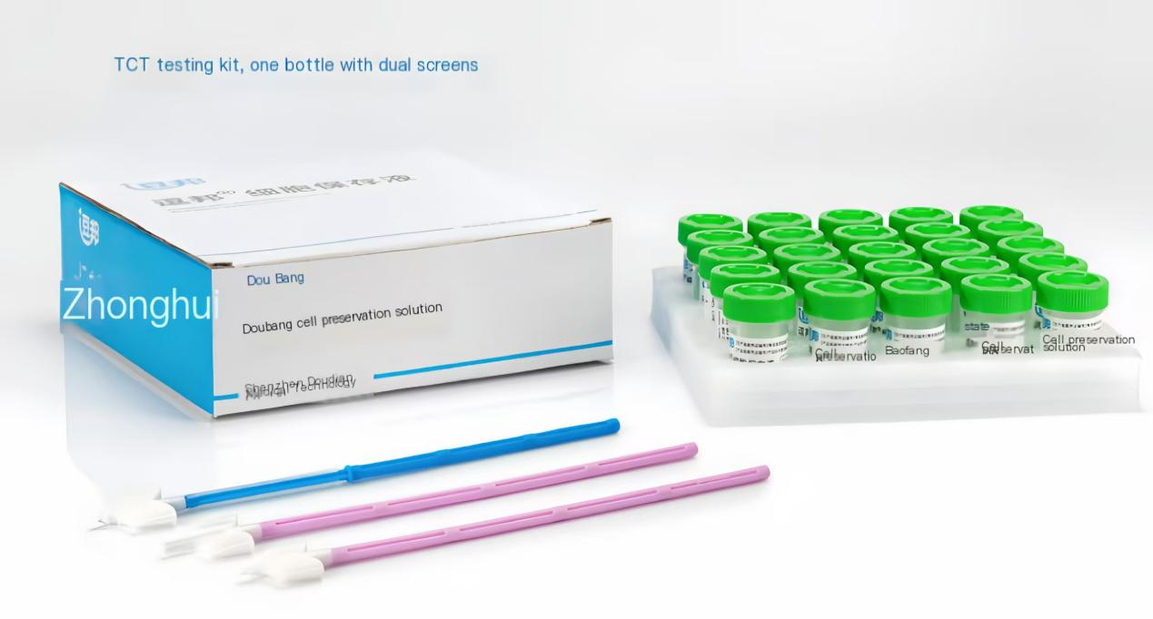
Figure 8. TCT Sampling tools [47].

HPV check
HPV testing is a method to assessing the health status of the cervix by detecting HPV virus in cervical cells. HPV virus is one of the main causes of cervical cancer, so HPV detection is of great significance to prevent the occurrence of cervical cancer. The process of HPV testing is usually done through a cervical sample brush and then testing the cervical cells for the presence of HPV virus. Based on the results, doctors can determine whether a woman is infected with HPV and whether the type of virus is high-risk. High-risk HPV infection is closely related to the occurrence of cervical cancer, so HPV testing is important for identifying high-risk groups and taking corresponding preventive measures (Figure 9.) [48].

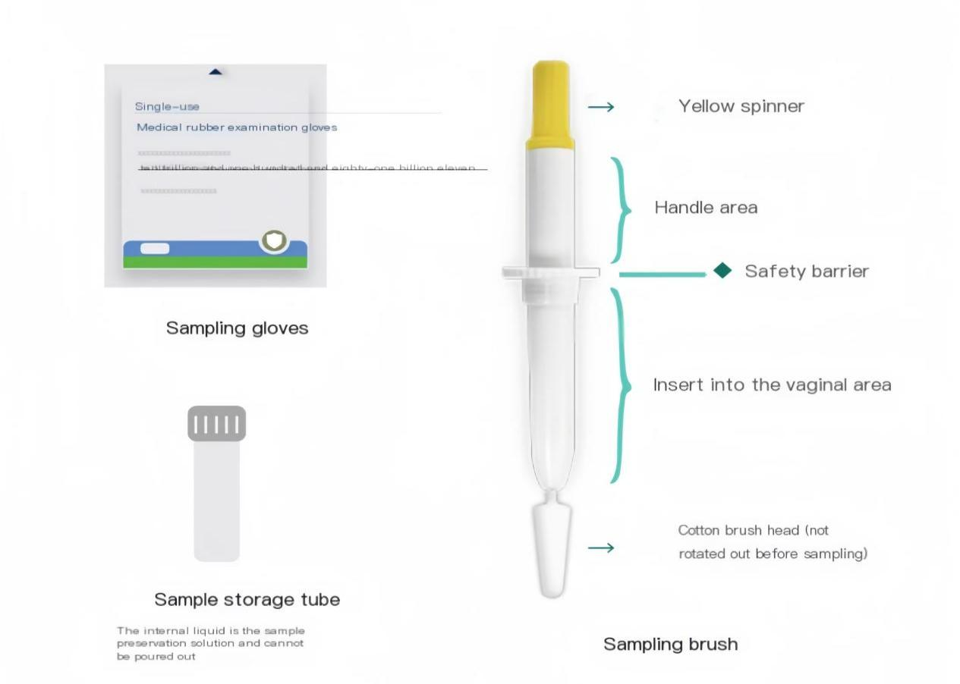
Figure 9. HPV Sampling tools [48].
Advantages of combined TCT with HPV screening.
Combined screening of TCT and HPV is one of the important means of modern cervical lesion screening. Its advantage lies in its complementary advantages, improve the accuracy of diagnosis, and reduce the possibility of missed diagnosis.
Complementary advantage
The TCT examination can visually observe the abnormal changes in the cervical cells, so as to determine the presence of cervical lesions. However, the TCT examination is relatively weak enough to detect HPV infection. HPV testing is able to identify high-risk HPV infection, thus assessing the risk of cervical lesions. Therefore, combined screening with HPV can complement the advantages and improve diagnostic accuracy.
Improve the diagnostic accuracy
Combined TCT with HPV screening could significantly improve the screening accuracy of cervical cancer. By simultaneously detecting abnormal changes in cervical cells and HPV infection, doctors can more accurately judge the cervical health status, so as to take timely intervention and treatment measures. In addition, combined screening can also reduce the possibility of missed diagnosis and improve the detection rate of cervical lesions.
Early detection of lesions
The HPV infection often precedes the cervical cytopathies. Therefore, the potential risks can be detected early through HPV testing, and combined with the results of TCT examination, doctors can take interventions before the cell malignant change to achieve early diagnosis and early treatment. This is important for the prevention of cervical cancer development.
Guide treatment decisions
Based on the results of the combined screening of TCT and HPV, doctors can develop more targeted treatment options for patients. For example, follow-up may be observed only in patients with HPV infection alone, and further examination and treatment may be required. This personalized treatment plan can help to improve the treatment effectiveness and reduce the patient's pain and medical costs.
Monitor disease progression
In patients with pre-existing cervical lesions, simultaneous examination of TCT and HPV helps in monitoring treatment effects and condition changes. Through regular follow-up and review, doctors can timely understand the progress of the patient's condition and provide a basis for subsequent treatment. This helps to adjust the treatment plan timely and improve the treatment effect.
Prevent cervical cancer occurrence
Combined screening of TCT and HPV can help to identify high-risk groups and take corresponding preventive measures. For example, for patients with high-risk HPV infection, HPV vaccine can be administered and follow-up can be strengthened, thus reducing the risk of cervical cancer. This preventive intervention helps to protect women's reproductive health and improve their quality of life.
Matters needing attention
Before screening TCT with HPV, women should check the following:
Avoid menstruation, so as not to affect the examination results. Avoid sex, vaginal irrigation and medication 2-3 days before examination to affect the results.
Stay relaxed, and actively cooperate with the doctor's examination.
Cervical lesion screening is one of the important means to ensure female reproductive health. Traditional screening methods (Pap smear) and modern screening methods (TCT, HPV test) each have their own advantages and disadvantages. However, combined TCT and HPV screening can complement the advantages, improve the accuracy of diagnosis, and reduce the possibility of missed diagnosis. Therefore, it is recommended that women regularly screen for cervical lesions and choose appropriate screening methods according to the doctor's advice. Through early detection, early diagnosis and early treatment, we can together protect women's reproductive health [49].
New strategies for the prevention and treatment of HPV and cervical cancer
Colposcopy plays an important role in the prevention and treatment of HPV and cervical cancer. Here are some of the new strategies based on colposcopy：
● Early screening and diagnosis: regular colposcopy can timely detect cervical lesions, so as to take early treatment measures. This early screening and diagnostic strategy helps to reduce the incidence and mortality of cervical cancer [50].
● Personalized treatment plan: Through colposcopy, doctors can develop a personalized treatment plan according to the site, extent and severity of the lesion. This personalized treatment regimen can help to improve the treatment effect and reduce unnecessary injuries and complications.
● Follow-up and monitoring: For patients with cervical lesions who have been treated, regular colposcopy can timely detect recurrent or progressive lesions. This follow-up and monitoring strategy facilitates timely adjustment of treatment regimen and improve survival and quality of life of patients [51].
● HPV vaccination: HPV vaccination is an effective means to prevent cervical cancer. The incidence of cervical cancer can be reduced by the HPV vaccination. However, even with HPV vaccination, routine colposcopy is required to monitor cervical health.
● Health education and publicity: strengthen health education and publicity, improve the public awareness and attention to cervical cancer. The incidence and mortality of cervical cancer can be reduced by popularizing knowledge of cervical cancer prevention and early screening strategies [52].
Summary
As an important gynecological diagnostic technology, colposcopy plays a vital role in the diagnosis of cervical lesions. Through clear images, precise positioning, combined with acetic acid test and iodine test, and image acquisition and preservation, colposcopy improves the accuracy of biopsy, providing new strategies for the prevention and treatment of HPV and cervical cancer. In the future, with the continuous progress of science and technology and the continuous accumulation of clinical experience, colposcopy will play a more important role in the diagnosis and treatment of cervical lesions.
Cervical protection under colposcopy is not only conducive to the early detection and treatment of cervical lesions, but also provides new ideas and methods for improving the prevention and treatment effect of cervical cancer. We should make full use of this technology, strengthen health education and publicity, raise the public awareness and attention to cervical cancer, and jointly promote the development of cervical cancer prevention and control cause.

SECTION 3
Practical Methods and Materials

3.1.Selection of jects and sample selection

Inclusion and exclusion criteria for the study subjects
Inclusion criteria: Gender: female
Age range: women between the ages of 21 and 65 years were selected for the study because this age group is a major risk group for HPV infection and cervical cancer development.
History of HPV infection: including women with known HPV-positive patients and those at risk of HPV infection (e. g., multiple sexual partners, early sex, low immunity, etc.).
Abnormal cervical cytology: women with abnormal cell morphology by preliminary cervical cytology (e. g. Pap smear).
Voluntary participation: All participants signed informed consent to participate in the study and agreed to undergo colposcopy and related treatment.
Exclusion criteria
Pregnancy or lactation: Due to the special physiological state of pregnant and lactating women, these women are excluded in order to avoid potential effects on the fetus or infant.
History of cervical surgery: women who have had cervical surgery recently (such as in the past 6 months), who may affect the physiological structure and function of the cervix and thus the study results.
Severe gynecological diseases: Women with severe gynecological diseases (such as severe cervical erosion, cervical polyps, cervical cancer, etc.) because their treatment regimen may not be consistent with the purpose of this study.
Allergy history: Women allergic to medications or materials required for colposcopy.
Failure to complete follow-up: women who failed to complete regular follow-up as required by the study.

3.2 Sample size determination and grouping
Determination of the sample size
The sample size was determined based on statistical principles, taking into account the reliability and accuracy of the study and the feasibility of practical operation. The specific sample size is determined by the following factors:
Expected effect size: Expected effect size for HPV infection and cervical cancer according to previous studies or literature reports.
Significance level: Set the significance level (e. g., α =0.05) to control for the probability of a type I error (ie, incorrectly rejecting the true null hypothesis).
Test efficacy: Set the test efficacy (e. g. 1- β =0.80) to ensure the probability that the null hypothesis will be correctly rejected when a real effect is present.
Number and proportion of groups: Considering that the study may involve multiple groups (e. g., treatment group, control group, etc.), the sample size proportion of each group needs to be reasonably determined.
Considering the above factors, the appropriate sample size calculation formula (such as Cochran's Q sample size calculation formula) is used to determine the total sample size.
Sample formula and calculation
The formula is: n1=n2=(δ/σz1−α/2+z1−β)2
Use the formula Determine the significance level α and test the efficacy of 1 β:α=0.05 1−β=0.80
Z 1 α / 2 and z1 β:
Z 1 α / 2 =1.96 (for α =0.05)
z1−β​
Determine the expected effect size of the following δ:
This is usually based on previous studies or as reported in the literature. For example, if previous studies showed that the difference between the mean in the treatment and control groups was 5 units, then δ =5.
Determine the overall standard deviation of the σ:
This can similarly be estimated from previous studies or in the literature. For example, if the standard deviation is 10 units, then σ =10.
To ate the sample size:n1=n2=(5/101.96+0.84)2
n1=n2=(0.52.8)2
n1=n2=5.62
N1=n231.36 (since the sample size must be an integer, usually rounded up to the nearest integer, namely at least 32 people per group).
Group: According to the study purpose and the design scheme, the included women were randomly divided into the following groups:
Treatment group: To receive cervical protection treatment under colposcopy, including medication, physical therapy, etc.
Control group: only receive routine cervical health examination, no special treatment.
Subgroup analysis: According to the type of HPV infection and the results of cervical cytology, the subgroups were further subdivided to further analyze the effects of different factors on the treatment effect.
With reasonable grouping and sample size determination, this study aims to reveal new strategies for cervical protection under colposcopy in the prevention and treatment of HPV and cervical cancer, and to provide a scientific basis for clinical practice.

3.3 Practice methods
At present, the screening and diagnosis of precancerous lesions of the cervix adopts a "three-step" diagnosis and treatment procedure, which includes cervical cytology examination and/or high-risk HPV DNA testing, vaginal colposcopy examination, and cervical tissue biopsy. The diagnosis is based on histological diagnosis (Figure 10).
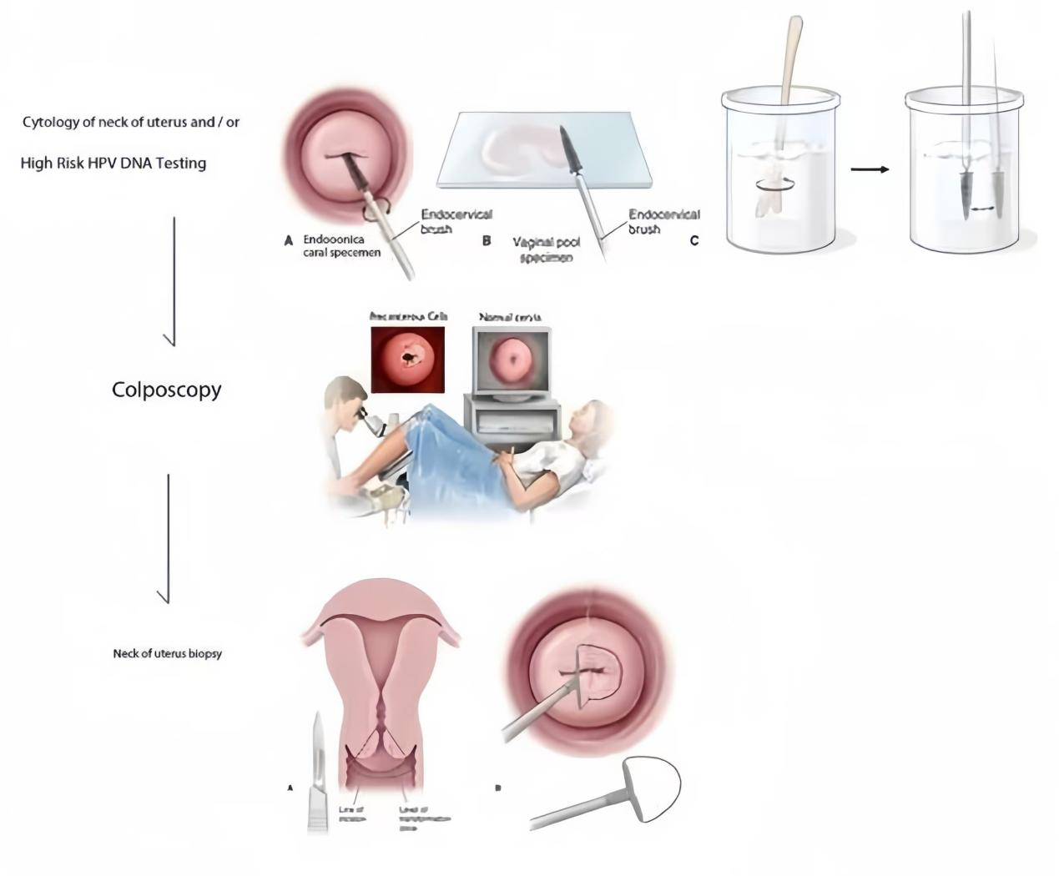Figure 10. Inspection process [5].

Joint screening process of TCT and HPV
Combined TCT and HPV combined screening is an important means of cervical cancer screening, and the combination of both can significantly improve the detection rate of cervical precancerous lesions. The specific screening procedure is as follows:
Pre-screening preparation
Choose the appropriate screening time: the best screening time is 3-7 days after clean menstruation, when the cervical mucus is less, easy sampling.
Avoid sex, vaginal irrigation and medication within 24 hours before screening to affect the test results.
If there is vaginitis or cervicitis and other diseases, need should be treated first, and then screened after inflammation control.
Screening process:
This woman was examined lying on her back on a gynecological examination bed and the doctor exposed the cervix with a voyeur.
Wipe clean the cervical mucus with a cotton swab to ensure accurate sampling.
Samples for TCT and HPV testing were collected using a dedicated cervical brush rotating clockwise around the cervix and inside the cervical canal for 5-6 weeks.
The collected samples were placed into vials containing cell and virus storage solutions and sent to the laboratory for testing.
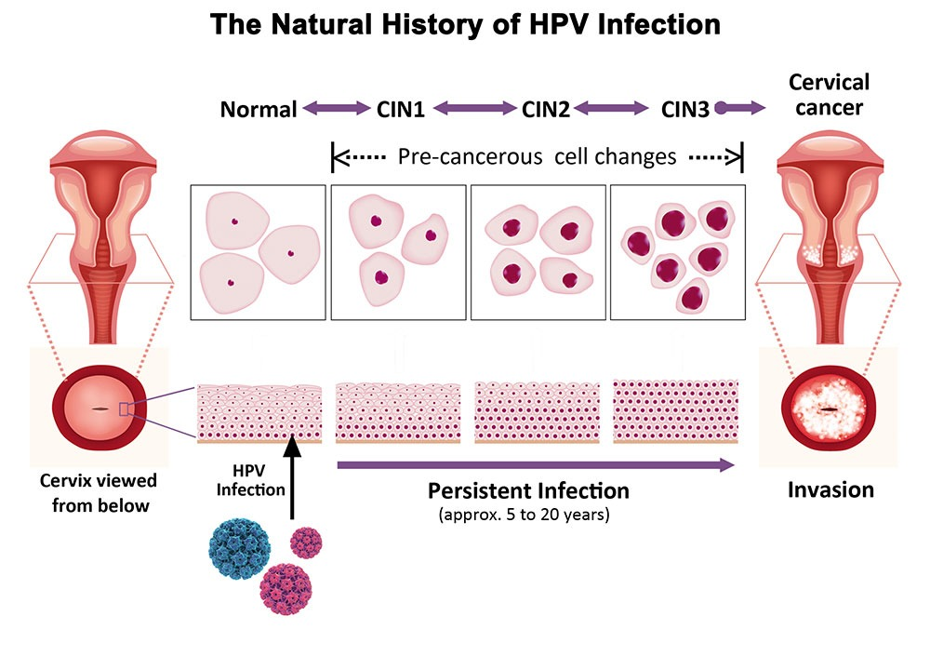Figure 11. Example of inspection results [5].
Results interpretation
The results of the TCT examination mainly focus on the morphological changes of cervical cells, such as squamous epithelial cells, glandular epithelial cells, and atypical squamous cells (Figure 11.).
The HPV test results focus on the presence of HPV infection, especially the high-risk HPV type (e. g., HPV16,18, etc.) infection.
The results of both should be combined with clinical information, and further colposcopy or biopsy should be performed if necessary.

SECTION 4
Practical Results

4. 1. Data collection and processing
Data Collection
There are currently 4500 women, data were collected by combined screening with TCT and HPV, colposcopy, and biopsy materials.
The age(21-65), HPV infection, cervical cytology findings, colposcopy findings, and biopsy pathology results were recorded for each woman.
Data Processing and Statistics
Use Excel to enter and organize data.
The data were analyzed by descriptive statistics, including mean, standard deviation, frequency distribution, etc.
Draw a table to visually show the data distribution and trends.
According to the statistical results, draw the research conclusion, and put forward the corresponding suggestions or further research directions (Table 4.1).
Table 4.1
TCT screening related data for cervical cancer
Age | TCT check up | cervical cytology examination results |  |  |  |  |  |  |  | Proportion of TCT positivity in different age groups (Exclude inflammation)
 |  | Inflammation | Abnormal glandular cells | ASC-US | ASC-H | LSIL | HSIL | Cancer | Total number of positive cases  (Exclude inflammation)
21-25 | 900 | 3 | 0 | 8 | 4 | 6 | 0 | 0 | 18 | 2%
26-29 | 900 | 9 | 2 | 13 | 6 | 8 | 3 | 1 | 33 | 3.667%
30-39 | 900 | 13 | 5 | 37 | 8 | 11 | 6 | 7 | 74 | 8.222%
40-49 | 900 | 8 | 5 | 23 | 7 | 9 | 10 | 9 | 63 | 7%
50-65 | 900 | 5 | 3 | 10 | 4 | 3 | 5 | 8 | 33 | 3.667%

- If the TCT result is ASC-US, HPV testing is preferred. If it is negative, cytology will be rechecked 6-12 months or combined screening will be repeated every 3 years; If it is positive, a vaginal colposcopy examination is required.
- TCT results for ASC-H, LSIL, and HSIL require vaginal colposcopy and biopsy of suspected lesions.
- The TCT results indicate that AGC should undergo HPV testing, colposcopy, cervical endometrial scraping, and endometrial examination.
- Proportion of TCT positivity in different age groups (%) = Total number of TCT Positive cases in different age groups / Total TCT screening by age group
Table 4.2
HPV high-risk screening related data
Age | Total number of HPV screenings | HPV screening result (positive) |  |  |  |  |  |  |  |  |  |  |  |  |  |  |  | The proportion of HPV positive (16/18 type) in different age groups
 |  | Type 16 | Type 18 | Type 31 | Type 33 | Type 35 | Type 39 | Type 45 | Type 51 | Type 52 | Type 56 | Type 58 | Type 59 | Type 68 | Type 73 | Type 82
21-25 | 18 | 0 | 0 | 0 | 1 | 0 | 0 | 0 | 0 | 1 | 0 | 0 | 0 | 0 | 0 | 0 | 0
26-29 | 33 | 1 | 0 | 1 | 0 | 0 | 1 | 0 | 2 | 2 | 0 | 0 | 0 | 1 | 0 | 0 | 3.030%
30-39 | 900 | 15 | 6 | 23 | 25 | 10 | 7 | 12 | 24 | 32 | 6 | 7 | 5 | 29 | 3 | 9 | 2.333%
40-49 | 900 | 9 | 6 | 15 | 14 | 10 | 4 | 8 | 18 | 25 | 5 | 6 | 0 | 33 | 0 | 4 | 1.667%
50-65 | 900 | 5 | 3 | 6 | 5 | 10 | 3 | 10 | 6 | 15 | 4 | 2 | 0 | 12 | 1 | 2 | 0.889%
- The proportion of HPV positive (16/18 type) in different age groups（%） = Total number of HPV positive cases in different age groups/ Total HPV screening by age group (Table 4.2).
- If HPV16/18 is positive, regardless of the TCT result, vaginal colposcopy can be performed first.
Table 4.3
Data from TCT and HPV combined screening, colposcopy, and biopsy sampling of 4500 women.
Age | Number of inspectors | TCT check up | *TCT test (positive) | HPV check up | *HPV test (16/18) positive | Number of vaginal colposcopy examinations and cervical biopsies | pathological results of biopsy (positive) | supplement | Biopsy rate | Detection rate
21-25 | 900 | 900 | 18 | 18 | 0 | 12 | 6 | CIN I→ 6 | 0.667% | 50%
26-29 | 900 | 900 | 33 | 33 | 1 | 26 | 12 | CIN I→ 8  CIN II→3  CANCER→1 | 0.889%  0.333%  0.111% | 46.15%
30-39 | 900 | 900 | 74 | 900 | 21 | 53 | 24 | CIN I→ 11  CIN II→5  CIN III→ 1  CANCER→7 | 1.222%  0.556%  0.111%  0.778% | 45.28%
40-49 | 900 | 900 | 63 | 900 | 15 | 50 | 28 | CIN I→ 9  CIN II→7  CIN III→ 3  CANCER→9 | 1%  0.778%  0.333%  1% | 56%
50-65 | 900 | 900 | 33 | 900 | 8 | 28 | 16 | CIN I→ 3  CIN II→3  CIN III→ 2  CANCER→8 | 0.333%  0.333%  0.222%  0.889% | 57.14%

- The Chinese Cancer Screening Guidelines (1) (2023) recommend that women aged 25 be the starting age for HPV screening (Table 4.3).
- HPV screening alone or HPV combined with cytology screening is not recommended for women aged 21-29. If there are abnormalities in TCT screening, perform HPV testing again.（ASCCP 2012).
- This study is based on ASCCP 2012.

4.2 Analysis of screening results

Comparison of positive rates between TCT and HPV screening alone and in combination
In this practice, we compared the positive rates of TCT with HPV alone and in combination with screening. The specific results are as follows:
Positive rate of TCT screening alone: out of 4500 women, 221 women had abnormal TCT test results, with a positive rate of 4.911%.
Positive rate for HPV screening alone (high-risk): 464 of the same 2751 women were positive for HPV, with a positive rate of 16.87%. Among them, 45 people were positive for HPV 16/18, accounting for 1.636%.
Positive rate of combined TCT and HPV screening: The positive rate is about 21.78%
By comparison, we found that the positive rate for combined TCT and HPV screening was higher than that for either method alone, indicating that combined screening is able to improve the detection rate of cervical lesions.

Analysis of the detection rate of cervical lesions under colposcopy examination
During the colposcopy session, we further examined women who had screened positive. The specific results are as follows:
Among women screened positive for TCT and HPV, 169 underwent vaginal colposcopy examination.
We identified 86 cervical lesions by colposcopy, of which 37 were LSIL, 24 were HSIL, and 25 were cancers.
The detection rate of cervical lesions by colposcopy is 50.89% (i.e. the number of lesions detected divided by the number of women who undergo colposcopy).
Summary: colposcopy as a further diagnostic method after TCT and HPV screening, can effectively detect cervical lesions. At the same time, TCT combined with HPV screening can improve the positive rate of screening, thus contributing to the early detection and treatment of cervical lesions and reducing the risk of cervical cancer.

4.3. Pathological and histological examination results

4.3.1 Detection of various types of cervical lesions (including CINI, CIN II, CIN III, and cervical cancer)
In this pathological histological examination, a biopsy was conducted on the suspicious lesion location after combined TCT and HPV screening and colposcopy, and the specific cervical lesion detection situation was obtained. The specific results are as follows:
CINI : a total of 37 cases were detected, accounting for 43.02% of all cervical lesions. CINI is usually considered as a mild dysplasia with a greater probability of natural regression, but close follow-up or appropriate therapeutic measures are still required.
CIN II : a total of 18 cases were detected, accounting for 20.93% of all cervical lesions. The risk of progression of CIN II is higher than CINI, so more aggressive intervention and treatment are needed to prevent its further progression to more severe lesions.
CIN III : a total of 6 cases were detected, accounting for 6.977 % of all cervical lesions. CIN III Is regarded as a precancerous lesion with a high risk of carcinogenesis, so once diagnosed, immediate treatment is usually needed to remove or destroy the diseased tissue.
Cervical cancer: a total of 25 cases were detected, accounting for 29.07% of all cervical lesions. Cervical cancer is the most serious condition in cervical lesions. After diagnosis, personalized treatment plans should be formulated according to the stage and pathological type of tumor.
The above data show that the combined TCT and HPV screening and postoperative positioning biopsy can detect different levels of cervical lesions more accurately, which provides an important basis for the early diagnosis and treatment of patients.

4.3.2 Accurate assessment of colposcopy for localized biopsy of suspicious lesion site
Accuracy assessment
Colposcopy plays an important role in the diagnosis of cervical lesions, which significantly improves the accuracy of biopsy by direct observation and localization of suspicious lesions. In this practice, the accuracy of localization biopsy under colposcopy was assessed as follows:
Positioning accuracy: colposcopy successfully located all suspicious lesions identified by combined screening with TCT and HPV, and performed a biopsy at these sites, with a positioning accuracy of 100%. This result indicates that colposcopy has a high reliability in the localization of cervical lesions.
Diagnosis coincidence rate: compare the pathological results of the positioning biopsy under colposcopy with the final diagnostic results, and find that the diagnostic coincidence rate between the two reached 100%. This data indicates that the diagnostic accuracy of localization biopsy under colposcopy is high, which can provide strong support for the diagnosis and treatment of patients.

Evaluation significance
Colposcopy is important to assessing the accuracy of localized biopsy of suspicious lesion sites. First, it verifies the validity and reliability of colposcopy in the diagnosis of cervical lesions; second, it provides clinicians with a more accurate and reliable diagnostic basis for diagnosis and helps to develop a more reasonable and personalized treatment plan; finally, it helps to improve the early diagnosis rate and treatment success rate of cervical lesions and reduce the risk of cervical cancer.
Suggestions
In the field of cervical lesion prevention, combined with current technology and practices, we make the following recommendations aimed at further improving the effect of cervical protection and reducing the morbidity and mortality of cervical cancer

Promote the combined screening strategy for HPV and TCT
Strengthen public education: popularize the importance of joint HPV and TCT screening through the media and community activities, and improve women's awareness and attention to cervical diseases.
Optimize the screening process: Establish a standardized screening process to ensure that every woman is fully and accurately evaluated when she is screened. At the same time, simplify the screening process to improve the efficiency of screening and reduce the waiting time and inconvenience of women. Strengthening medical resource integration: encourage medical institutions to strengthen cooperation, share screening resources, and improve the accessibility and coverage of screening services (Figure 12).
Strengthen colposcopy technical training and popularization

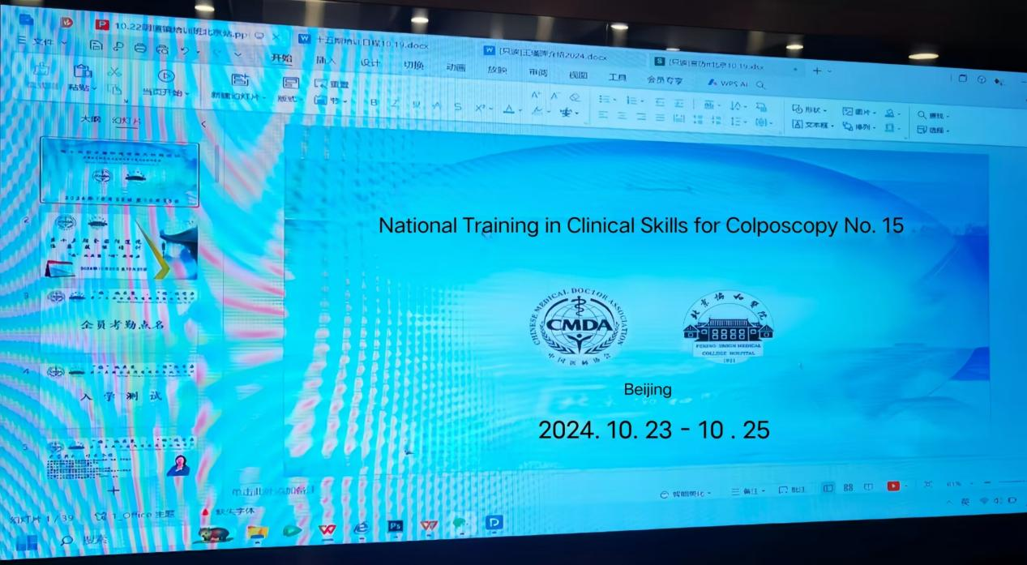

Figure 12. Vaginal mirror skills training
Establish a training system: establish a training system for colposcopy technology, including theoretical training, practical operation and case analysis, to ensure that doctors can fully master the colposcopy technology.
Promotion of advanced technology: encourage medical institutions to introduce and apply advanced colposcopy equipment and technology to improve the accuracy and reliability of the examination. At the same time, to strengthen the exchange and cooperation with the international advanced technology, to promote the continuous innovation and development of colposcopy technology.
Strengthen quality control: establish a quality control system for colposcopy examination, standardize the management of the examination process, and ensure the accuracy and reliability of the examination results. At the same time, doctors' skills are assessed and evaluated regularly to improve their professional level and service quality.
Improve the prevention and treatment system of cervical lesions
Establish cervical lesion database: establish cervical lesion database, collect and analyze the epidemiology, clinical characteristics and treatment effect of cervical lesion data, to provide a scientific basis for the formulation of more accurate prevention and treatment strategies. Strengthen investment in scientific research: encourage scientific research institutions and enterprises to increase investment in scientific research in the field of prevention and treatment of cervical lesions, and promote the research and development and application of new technologies and new methods. At the same time, strengthen international cooperation and exchanges to jointly promote the development of the prevention and treatment of cervical lesions. Improve public health literacy: through health education, health consultation and other ways, improve the public awareness and attention to cervical lesions, advocate a healthy lifestyle, and reduce the risk of cervical lesions.
Promoting the joint screening strategy of HPV and TCT, strengthening the training and popularization of colposcopy technology, and improving the prevention and treatment system of cervical lesions are important ways to improve the effect of cervical protection and reduce the incidence and mortality of cervical cancer. We call on all sectors of society to work together to protect women's health.

SECTION 5

STARTUP PROJECT DEVELOPMENT

5.1 Concept description of the entrepreneurial project
In today's society, women's health issues are receiving increasing attention, among which cervical cancer, as one of the common malignant tumors among women, has a high morbidity and mortality rate, posing a serious threat to women's lives and health. The development of cervical cancer is related to a variety of factors, but HPV infection is considered to be the most important cause. HPV is a widespread virus, which can be transmitted through sexual contact, and after infection, it can cause abnormal proliferation of cervical epithelial cells, which can then develop into CIN, and ultimately may evolve into cervical cancer. Given the seriousness of cervical cancer, prevention and treatment are particularly important. However, traditional screening methods such as Pap smear have high rates of leakage and misdiagnosis, which are difficult to meet clinical needs. With the continuous progress of medical technology, colposcopy as an advanced diagnostic technique, has gradually occupied an important position in the screening and diagnosis of cervical lesions. Colposcopy can magnify the surface of the cervix and clearly show the microstructure of the cervical epithelium, so as to more accurately detect suspicious lesions and provide a strong basis for early treatment. Сolposcopy is able to magnify small lesions in the cervix and vagina, enabling doctors to more accurately identify abnormal changes, thus improving the diagnostic accuracy of cervical lesions. Especially for early cervical cancer and precancerous lesions, colposcopy has irreplaceable advantages. colposcopy has irreplaceable advantages in the diagnosis of cervical lesions, and provides strong support for the prevention and treatment of cervical diseases by improving diagnostic accuracy, precise localization and qualitative diagnosis, increasing the positive biopsy rate, and monitoring the effectiveness of treatment . The description of the startup project idea is defined in Table 5.1.1.

Table 5.1.1
Description of the startup project idea
Content of the idea | application area | User benefit
Develop a high-definition intelligent colposcope system | Gynecological examination, disease diagnosis | - Improve diagnostic accuracy and early detection of cervical and vaginal lesions  - Reduce patient examination pain and improve examination comfort  3. Optimize doctors' workflow and improve examination efficiency
Provide remote colposcopy consultation services | Telemedicine and health management | 1. Patients can be diagnosed by professional doctors without going to the hospital  2. Expert resources are being made more widely used to improve the level of diagnosis  3. Convenient and fast, saving patients' time and energy
Develop personalized inspection programs | Customized medical services | 1.Make examination plans according to the specific situation of patients to be more targeted.  2. Reduce unnecessary examination items and reduce the economic burden of patients. 3. Improve patients' satisfaction and trust in medical services
Promote colposcopy health education | Public health publicity and health education | To improve the public awareness and acceptance of colposcopy examination  Enhance women's health awareness and promote the popularization of gynecological examination  3. Reduce the incidence and mortality of cervical and vaginal diseases
Establish a colposcopy technology training platform | Medical education, skills training | Cultivate more professional colposcopy doctors 2. Improve doctors' operation skills to ensure the quality of examination 3. Promote the sustainable development and popularization of colposcopy technology

Currently, colposcopy is not used in gynecology to diagnose cervical cancer. Therefore, Table 5.1.2 will list the strengths and weaknesses of the startup project, assuming that competitors do not have such technologies.
Table 5.1.2

Determining the strong, weak and neutral characteristics of a project idea
№ | Technical and economic characteristics of ideas | Competitors' products |  | W  ( weak side) | N  ( neutral side) | S  (strong side)
№ | Technical and economic characteristics of ideas | My project | Competitors | W  ( weak side) | N  ( neutral side) | S  (strong side)
1. | Improve diagnostic accuracy-High-definition intelligent colposcope system can provide clearer and more accurate images, helping doctors to make a more accurate diagnosis | + | ̶ | The disadvantages include factors such as low market awareness, high cost input, time needed for technology popularization, policy and regulatory risks, and fast technology update and iteration. | The advantages mainly emphasize the technical innovation, improvement of diagnostic accuracy, patient experience optimization, expert resource optimization and market expansion potential of the project. | 1. Leading in technological innovation  2. Expert resource optimization-Remote colposcopy consultation service can make full use of expert resources to improve the level of diagnosis and reduce the rate of misdiagnosis
2. | Technology popularization takes time-the popularization of new technologies takes some time, including doctor training, improved patient acceptance improvement, etc., which may affect the rapid promotion of the project | + | ̶ |  | The neutral characteristics section mentions two factors: market competition and patient acceptance that may affect the development of the project. These factors are neither advantages nor disadvantages, but require the attention and response of the project team. | 1. Improve patient experience-Remote consultation services and personalized test programs can reduce patient waiting time, improve test comfort, and thus improve patient satisfaction  2. Great market expansion potential-With the improvement of women's health awareness and the progress of medical technology, the market demand for colposcope continues to grow, and the project has great potential for market expansion

An analysis of the strengths and weaknesses of the startup project was carried out, the basic idea and areas of application for diagnosing neck cancer were determined. Great market expansion potential-With the improvement of women's health awareness and the progress of medical technology, the market demand for colposcope continues to grow, and the project has great potential for market expansion.

5.2 Technical audit of the project conception
To understand the implementation of the idea, it is necessary to conduct a technological audit of the project (Table 5.2.1) according to standard indicators. The main idea is to use the colposcopy method for diagnosing cervical cancer.

Table 5.2.1
Technical Feasibility of the project conception
№ | Project idea | Technologies for its implementation | Availability of technologies | Technology accessibility
1 | High-definition intelligent colposcopy system research and development | Optical imaging technology, AI image processing technology | high | Yes
2 | Remote colposcopy consultation services are provided | Cloud computing technology, video communication technology | high | Yes
3 | Personalized inspection scheme development | Big data analysis technology, personalized recommendation algorithm | Middle | Yes
4 | Colposcopy health education promotion | Multimedia production technology, social media communication technology | high | Yes
4 | Construction of colposcopy technology training platform | Online education technology, virtual simulation technology | Middle-high | Yes
Summary
It is used to audit the technical feasibility of the project conception and to ensure the technical feasibility and practicability by evaluating the maturity, availability and matching degree of the project requirements. This helps the project team to clarify the technical direction in the early planning stage and avoid the project delay or failure caused by technical problems in the later stage. At the same time, the table also provides important reference information for the project investors and partners about the technical feasibility of the project.

5.3 Analysis of market opportunities for starting entrepreneurial projects
To analyze the market opportunities and threats of the project under development that will arise at the implementation stage, it is necessary to determine the main group of consumers-users. This will allow planning the directions of project development, taking into account the market situation and the needs of potential customers and proposals of competitors' projects. The characteristics of potential customers are presented in Table 5.3.1.

Table 5.3.1
Potential customer characteristics of entrepreneurial projects
№ | Forming the market demand | Target audience (target market segmen) | Differences in the behavior of the different potential target customer groups | Consumer requirements for the product
1 | Focus on women's health and seek high-quality medical services | Private and public medical institutions | Such clients often have high health awareness and are willing to pay extra for high-quality care. They are more inclined to choose reputable, technically advanced medical institutions, and pay attention to personal privacy protection. | - reliability  -high quality  – ease of use
2 | Convenient and efficient medical services are needed | Busy professionals | Due to their busy work and precious time, such customers are more inclined to choose institutions that can provide convenient and efficient medical services. They may be more inclined to use telemedicine services to reduce medical time and costs. | - reliability  -high quality  –ease of use
3 | Open up to new technologies and new products | Young female groups | Such customers are usually open to new technologies and new products, and are willing to try and accept new ways of medical service. They may be more focused on innovative and personalized services and willing to pay a premium for them. | - reliability  -high quality  –ease of use
4 | Focus on the price, the pursuit of cost performance | LMICs | Such customers pay more attention to the price factor when buying medical services, and pursue the pursuit of cost performance. They may be more inclined to choose medical institutions with moderate price and reliable service quality, and focus on the transparency and impartiality of medical services. | - reliability  -high quality  –ease of use
5 | Professional and authoritative medical services are needed | Middle-aged and elderly women | Such customers usually pay more attention to the professionalism and authority of medical services, and are more inclined to choose medical institutions with rich experience and professional qualifications. They may be more concerned with the qualifications and experience of doctors, as well as the comprehensiveness and safety of medical services. | - reliability  -high quality  –ease of use

By understanding the behavior differences of different potential target customer groups, the project team can more accurately locate the target audience, and develop targeted marketing strategies and service plans. For example, for urban white-collar women, the privacy protection and high quality of medical service can be emphasized; for busy professionals, the convenience and efficiency of telemedicine service can be highlighted; for young women, technological innovation and personalized service can be emphasized; for middle and low income women, cost performance and service transparency can be emphasized; for middle-aged and old women, the professionalism and security of medical service can be emphasized. These strategies help to improve customer satisfaction and loyalty, leading to the successful implementation and sustainable development of the project.
Consumer requirements for the product
After identifying potential customer groups, it is necessary to analyze the market environment: prepare threat (Table 5.3.2) and opportunity (Table 5.3.3) tables.

Table 5.3.2
Threat Factors

№ | Factor | Company reaction
1 | The fierce competition from the competitors | Pay close attention to market dynamics, strengthen technological innovation and product research and development, enhance product competitiveness, optimize marketing strategy, enhance brand awareness and reputation to attract more consumers.
2 | Changes in the regulations and policies | To timely understand and adapt to the changes of relevant regulations and policies to ensure the compliance of the company's operations and products and services, and actively communicate and cooperate with government departments to strive for a policy environment conducive to the development of the company.
3 | Technology update is fast | Increase R & D investment, track the technology development trend of the industry, timely update and upgrade the product technology, and at the same time, strengthen the cooperation with scientific research institutions and universities to enhance the technological innovation capability of the company.
4 | Consumer demand changes | Conduct regular market research to understand the changing trend of consumer demand, timely adjust the product strategy and service mode to meet the diversified needs of consumers; Meanwhile, strengthen the interaction and communication with consumers to establish a good customer relationship.
5 | Economic and environmental fluctuations | Pay close attention to the changes in the macroeconomic environment, formulate reasonable financial budget and risk management strategies to deal with possible economic risks; meanwhile, expand diversified markets, reduce the dependence on the single market, and improve the company's ability to resist risks.

Table 5.3.3
Оpportunity factor
№ | factor | Opportunity content | Possible company reaction
1 | Competition | Market demand is growing | Seize the opportunity of market demand growth, increase market promotion, and expand market share; meanwhile, strengthen product research and development, improve product quality and service level, to meet the market demand.
2 | Innovations (expansion of diagnostic arsenal) | New products or services brought about by technological innovation | Use technological innovation to develop new products or services to meet the diversified needs of consumers; Meanwhile, strengthen intellectual property protection to ensure the technological advantage.
3 | Marketing | Policy support and incentives | Actively seek government policy support and incentives, such as tax incentives and financial subsidies, to reduce operating costs and improve profitability, and strengthen cooperation with government departments to jointly promote the development of the industry.
4 | The expansion of cooperative partnerships | The expansion of cooperative partnerships | Establish close partnership with upstream and downstream enterprises to realize resource sharing and complementary advantages; meanwhile, actively seek cooperation opportunities with well-known enterprises at home and abroad to enhance the company's brand influence and market competitiveness.
5 | The development of the international market | The development of the international market | Seize the opportunity of international market, expand overseas market and improve the international visibility of the company; at the same time, understand and adapt to the cultural differences and market needs of different countries and regions, and develop targeted marketing strategies and service models.

After identifying the threat factors of the opportunity, it is necessary to analyze the competitors in the market. For this, the standard model of M. Porter, which allows in-depth analysis of industry competition. Results of the analysis are shown in Table 5.3.4

Table 5.3.4
Analysis of industry Competition by M. Porter
Components of the analysis | Direct competitors | Potential competitors
definition | Enterprises that provide the same or similar products or services in the same market and in the same industry. | At present has not yet entered the market, but have the ability and willingness to enter the market enterprises.
characteristic | - Competition for market share is fierce | - It may not be due to technology, capital, market access and other restrictions
characteristic | - Customer resources grab frequently | -Once conditions are ripe, they may quickly become direct competitors
characteristic | -Brand influence competition is important | - It may enter the market through technological innovation, capital injection and other ways
influence | -Direct affect the market share, profit and brand image of the enterprise | - May pose a threat to the future development of the enterprise
influence | - It needs to be closely followed and developed corresponding competitive strategies developed | - You need to anticipate ahead of time and prepare for your coping strategies
coping strategy | - We will strengthen product innovation and service upgrading | - Pay close attention to the industry trends and technology development trends
coping strategy | - Improve customer satisfaction and loyalty | - Strengthen the cooperation with the upstream and downstream enterprises of the industrial chain
coping strategy | -Strengthen brand publicity and enhance brand influence | - Enhance the core competitiveness and innovation ability of enterprises

Conclusion: Currently, there are no barriers, but there is a possibility that some competitors do not need the supplier to improve the product according to the consumer requirements and no analogues
Considering the data obtained in Tables 5.3.3 and 5.3.4, it can be concluded that currently entering the market with this product is relevant and will be in demand
According to Table.5.3.4. A list of competitive factors was identified and confirmed, considering the characteristics of the project idea and the requirements of potential consumers (given in Table 5.3.1) and the marketing environment. Analysis is provided in Table 5.3.5.
Table 5.3.5
Justification of competitiveness factors
№ | Competitiveness factors | Rationale (citing factors that compare the competing items) on colposcopy
1 | product innovation | The characteristics of the project ideas (Table 5.3.1) show that our colposcopy products are innovative in design and technology, and can meet the needs of potential consumers for new technologies and new experiences. This has a significant competitive advantage compared to other products on the market
2 | Product quality | The product quality concern is highlighted in the potential consumer requirements (Table 5.3.1). Our colposcopy products focus on quality control during the production process to ensure that the products meet the relevant standards and regulations, so as to win the trust and loyalty of consumers
3 | Price competitiveness | Based on the data in Table 5.3.4, we analyzed the price levels of competing products in the market. With reasonable pricing strategies, our colposcopy products can remain competitive in price and attract more price-sensitive consumers.
4 | brand influence | The marketing environment factors (Table 5.3.4) mention the impact of brand awareness on consumers' purchasing decisions. Through brand building and marketing, our colposcopy products enhance the brand awareness and influence, and help to attract more potential consumers.
5 | after-sale service | Expectations for aftermarket service are also included in the potential consumer requirements (Table 5.3.1). We have established a perfect after-sales service system to provide consumers with timely and professional technical support and maintenance services, and enhance consumers' purchase confidence and satisfaction.
6 | product innovation | The characteristics of the project ideas (Table 5.3.1) show that our colposcopy products are innovative in design and technology, and can meet the needs of potential consumers for new technologies and new experiences. This has a significant competitive advantage compared to other products on the market.

The strengths and disadvantages of the project were reanalyzed according to the competitiveness factors given in Table 5.3.5. This analysis is given in Table Table 5.3.6

Table 5.3.6
Comparative Analysis of the advantages and disadvantages of "Project Name"
№ | Competitiveness factor | Points number (1-20） | Advantage / disadvantage superiority
1 | product innovation | 15 | Colposcopy products are innovative in design and technology to meet the market demand.
2 | product quality | 18 | Product quality is reliable, in line with the relevant standards and regulations, to win the trust of consumers.
3 | Price competitiveness | 12 | The price is relatively reasonable, but may be affected by the market competition, need to continue to pay attention to.
4 | brand influence ; brand impact ; brand perception | 10 | Brand awareness is gradually improving, but there is still room for improvement, and marketing promotion needs to be strengthened.
5 | after-sale service | 16 | After-sales service system is perfect, to provide timely and professional technical support and maintenance services

The final stage of the market analysis of the possibility of implementing a startup project is to develop a matrix of strengths and weaknesses, threats and opportunities, namely SWOT based on the factors identified in Table 5.3.6 (Table 5.3.7)

Table 5.3.7
SWOT-Entrepreneurial Project Analysis
Strengths (S): | Weaknesses (W):
-Excellent product quality, stable and reliable performance;  - Reasonable price positioning, high cost-effective;  - Good brand image, word of mouth spread widely;  - Innovation ability is outstanding, continue to lead the market trend;  - Abundant channel resources, online and offline close combination;  - Professional customer service team, strong problem-solving ability | - Some of the details are not fine enough, so we need to improve the perfection of the product;  - Lack of adequate brand recognition in the high-end market;  - Channel expansion is not comprehensive enough, and some market coverage is insufficient;  - The customer service system needs to be improved, and the response speed needs to be improved;  - Supply chain management has bottlenecks that affect production and delivery efficiency
Opportunities (O) | Threats (T):
- Abundant channel resources, online and offline close combination;  - Professional customer service team, strong problem-solving ability | - The marketing strategy lacks innovation and the publicity effect is limited;  - The team lacks expertise in certain key areas;  - Changes in regulation and policy may adversely affect the business

Based on the SWOT analysis, alternatives for market behavior are developed, a list of measures for better bringing the startup project to the market, and an approximate time for their market implementation, taking into account potential competitor projects that may be brought to the market. The identified alternatives are analyzed in terms of timing and probability of obtaining resources.

5.4. Formulation of the project market strategy
To develop a marketing strategy for this project, one first needs to analyze the target group of potential consumers, which is given in Table 5.4.1
Table 5.4.1
Selection of potential consumer target groups
sector | Consumer function | action | consumer demand | irrigation ditch | market | other aspects | relation
Gynecological medical institutions | high resolution imaging | Seek professional diagnosis | Accurate and rapid diagnostic results | Professional medical equipment supplier | Direct selling, bidding | After-sales service and technical support | Long-term cooperative relationship
MEC；medical examination center | Comfortable inspection experience | Focus on health checks | A safe, painless examination procedure | Physical examination equipment supplier | Distribution, cooperation | Brand reputation, user reputation | Partnership
Individual consumer (high-end marke) | Home convenience | Self-health management | High quality, easy to operate | E-commerce platform, exclusive stores | Retail, membership | Brand image and user education | Loyalty to customer relationships

To work in the selected market segments, a basic development strategy must be developed (Table 5.4.2).
Table 5.4.2
Definition of the Basic Development Strategy
number | Selected project development alternatives | Market coverage strategy | Based on the selected alternatives | Basic development strategy | Key competitive position
1 | Develop high-end medical grade high-definition colposscope | Comprehensive coverage for large medical institutions | High-end market positioning | Emphasize the leading technology, excellent quality, to provide professional after-sales service | Market leader
2 | Launch of home convenient HD colposscope | Select the market coverage for home users | Home market positioning | Simplify the operation process, pay attention to the cost performance, and provide convenient purchase channels | Market challenger
3 | Develop mobile HD colposcope equipment | Covering primary medical institutions and remote areas | Popularize the market positioning | Reduce costs, improve equipment efficiency, and provide flexible leasing or purchase options | Market followers and gaps

After determining the basic strategy for the development of the project in the market, it is necessary to determine the basic strategy for competitive behavior (Table 5.4.3). That is, how and how the project will stand out in the context of a competing project.
Table 5.4.3
Definition of basic strategies for competitive behavior
№n | Basic strategies of competitive behavior | Positioning strategy | Market Position (Association) | Consumer cognition
11 | Differentiation strategy | Emphasize the unique selling points, such as technological innovation, quality excellence | Innovation leader | Consumers see the project as unique and of high value
22 | Cost-ahead strategy | Provide cost-effective products, reduce costs | Price advantage | Consumers believe that the project price is reasonable and cost-effective
33 | focusing strategy | Provide customized solutions for specific market segments | Market segment experts | Consumers see the project as professional and targeted in specific areas
44 | Brand building strategy | Strengthen the brand image, enhance the brand awareness and reputation | Brand leader | Consumers believe that the brand of such a project is reliable and trustworthy
55 | Service optimization strategy | Provide excellent customer service and enhance the user experience | Service excellence | Consumers think the project has good service and good user experience

Based on consumer requirements for suppliers and products, and the basic development strategy and competitive behavior strategy chosen, develop positioning strategies, including market position formation (a group of associations), through which consumers must identify the project under development. This choice of strategy and association is shown in Table 5.4.4 .

Table 5.4.4
Definition of the localization strategy
number | Positioning strategy | Market position (a group of associations) | Consumer demand satisfaction point | Basic development strategy relevance | Strategic relevance of competitive behavior
1 | Innovation leading positioning | A leader in technological innovation | Consumers pursue the latest technology and unique features | Basic development strategy of leading technology | Differentiated competitive strategy
2 | Quality excellence positioning | High-quality product provider | Consumers pay attention to product quality and durability | The basic development strategy of high quality and high service | Differentiated competitive strategy
3 | Cost-effective positioning | The best cost-effective choice | Consumers pay attention to the price and cost performance | Cost-leading basic development strategy | Cost leads the competitive strategy
4 | Market segment expert positioning | Area-specific professional solutions | Consumers need customized services for specific needs | A basic development strategy for focusing on specific market segments | Focus on competitive strategies
5 | Brand trust positioning | Well-known brand, reliable guarantee | Consumers value brand reputation and trust | The basic development strategy of brand building | Brand-building competitive strategy
6 | Service first positioning | Excellent customer service experience | Consumers value the service experience and the after-sales support | Highlight the basic development strategy of service optimization | Service optimization and competitive strategy

5.5 Develop a marketing plan for entrepreneurial projects

First of all, we should form the product marketing concept that consumers should accept. Therefore, it is necessary to summarize and summarize the previous analysis results of product competitiveness. Results are shown in Table 5.5.1 .
Table 5.5.1
Identify the key strengths of the potential product concepts

1 | HD imaging quality | A clearer image can help doctors make a more accurate diagnosis
2 | Advanced image processing technology | Such as automatic focus, color correction, etc., to improve the diagnostic efficiency and accuracy
3 | User-friendly operation interface | Simplify the operation process, reduce the learning costs, and improve the user experience
4 | Portable design | Easy to carry and move, suitable for a variety of scenarios and locations
5 | Powerful data storage and management functions | Ability to store large amounts of image data for doctors to review and analysis
6 | Comprehensive after-sales service support | Provide professional after-sales service and technical support to solve the problems encountered in the process of use

After identifying the key strengths, it is necessary to develop a tertiary model of the product (Table 5.5.2)
Table 5.5.2
Description of the three levels of product model
order of goods | Essence and ingredients
Core layer (basic function) | High-definition imaging technology to ensure image clarity and detail presentation  Image processing software, supporting image amplification, reduction, annotation and other basic functions  3. Simple and intuitive operation interface, to meet the basic needs of doctors
Tangible layer (additional features) | 1.Portable design, light and easy to carry, easy to use in different occasions  2.Multiple image storage formats support to facilitate data management and sharing  3.Upgradable software system to support future expansion of new features  4. Adopt high-quality and durable materials to ensure the long-term use and stable performance of the products
Additional layer (value-added services) | 1. Provide comprehensive after-sales service, including technical support, repair and maintenance 2. Customer training plan, help doctors quickly master product skills 3. Regular product update and maintenance, to ensure that the product is always in the best working condition 4., compatibility with other medical equipment, to provide users with a more comprehensive medical solutions
Next, it is necessary to decide on the sales system of the project (Table 5.5.3).
Table 5.5.3
The Formation of the Sales System
The purchase behavior of the opposite-sex target customers | The sales function must be performed by the goods supplier | The depth of the sales channels | Optimal sales system
Seek professional advice and rely on doctor recommendations | Provide product training, technical support and after-sales service | Deep distribution, to establish an extensive sales network | Direct selling + distribution model, through the doctor recommendation and professional sales team for in-depth expansion
Focus on product performance and price comparison | Provide detailed product information and price comparison tools | Moderate distribution, to ensure the coverage of sales channels | Online sales platform + offline experience store, convenient for customers to compare and experience
Pursue convenient purchase, tend to be online shopping | Optimize the online shopping process and provide fast delivery service | Shallow distribution, focusing on online sales channels | The flagship store of the e-commerce platform + social media marketing, to create a convenient online shopping experience
Sensitive to new products and willing to try new technologies | Hold a new product launch conference to provide trial opportunities | Deep distribution, rapid promotion of new products | Direct selling team + industry exhibition + social media promotion, quickly reach the target customers
Depend on brand reputation, trust well-known brands | Strengthen the brand publicity, enhance the brand image and public praise | Extensive distribution, to enhance the brand awareness | Brand stores + large chain drugstores + online flagship stores, a full coverage of the market

The last component of the marketing plan development is the formation of the concept of marketing communication. Data on the formed marketing communications are presented in Table 5.5.4 .
Table 5.5.4
Concept of marketing communication
Details of the customer's behavior | Customer communication channels | Key location | The task of advertising messages | The concept of an advertising appeal
Focus on health and seek high-quality medical services | Social media, professional medical websites, and offline medical shows | Social media platforms, medical professional forums and exhibition sites that are often visited by target customer groups | Communicate the advantages of product high-definition imaging and advanced technology, and enhance the brand awareness | Encourage experience products and provide free trial or consultation opportunities
There is a purchase demand for medical equipment, and we should pay attention to the cost performance | Email marketing, professional medical magazines, industry partner recommendations | Email, medical magazine advertising pages, partner store displays | Emphasize the stable product performance, perfect after-sales service, to provide cost-effective solutions | Guide customers to understand the product details, and offer purchase discounts or installment payment plan
Interested in new products and are willing to try new technology | Online medical community, product launch, industry seminar | Online medical community hot topic discussion area, product conference site, seminar exhibition area | Display the latest technology and innovative functions of products to stimulate customer curiosity | Invite customers to participate in product launches or seminars to experience the changes brought about by new technologies
Depend on doctors' recommendations and trust in professional advice | Doctor training, professional medical conferences, medical trade associations | Doctor training site, medical conference speech, industry association presentation | Enhance product awareness through doctor training, and build trust through professional advice | Encourage doctors to recommend products to patients, and provide doctors' exclusive promotion support

The result is a marketing program that includes product concepts, sales, promotion, and a preliminary analysis of pricing opportunities, based on the values ​​and needs of potential customers, the competitive advantages of the idea, the state and dynamics of the market environment within which the project is implemented, and the corresponding selected alternative market behavior.
Conclusion.
This section analyzes the use of the colposcopy method for diagnosing cervical cancer as a startup project. There is no competition on the market, so entering the market will be easy. To implement the market implementation of the project, you should choose a strategy of strengthening strengths at the expense of market opportunities, as it is the safest and has the shortest implementation time. Further development of the project is possible and necessary, since in the absence of competitors, the product can find its target audience and gain a foothold in the market.

CONCLUSION
● Further efficacy of colposcopy-assisted surgical treatment of cervical cancer
With the continuous progress of medical technology, the application of colposcopy in the surgical treatment of cervical cancer is becoming increasingly extensive. In the future, we can further explore the efficacy of colposcopy-assisted cervical cancer surgery in order to optimize the surgical plan and improve the treatment effect. Specifically, the advantages and limitations of colposcopy-assisted surgery can be evaluated by comparing the survival rate, recurrence rate and quality of life of patients under different surgical methods. In addition, other advanced medical technologies, such as robotic surgery and immunotherapy, can also be combined to explore more efficient and safe treatment strategies for cervical cancer.
● To promote the popularization and optimization of cervical cancer screening technology
Despite the remarkable results of combined screening for HPV and TCT, a proportion of women still fail to receive timely screening for various reasons. Therefore, we need to continue to promote the popularization and optimization of cervical cancer screening technology in the future. On the one hand, more women can be encouraged to participate in screening by strengthening health education and increasing public awareness and emphasis of cervical cancer; on the other hand, more convenient and efficient screening methods, such as self-service sampling and telemedicine, can be explored to lower the screening threshold and increase screening coverage.
● To strengthen interdisciplinary cooperation in cervical cancer prevention and control
The prevention and treatment of cervical cancer requires multidisciplinary cooperation and efforts. In the future, we can strengthen the exchanges and cooperation between the gynecology department, oncology department, pathology department and other disciplines, and jointly promote the research and development and application of cervical cancer prevention and treatment technology. Through interdisciplinary cooperation, we can have a more comprehensive understanding of the pathogenesis and treatment means of cervical cancer, and provide patients with more personalized and accurate treatment plans.
Colposcopy plays an important role in cervical protection, and combined screening for HPV and TCT has also achieved remarkable results as a new strategy to prevent cervical cancer. In the future, we need to continue to study the efficacy of colposcopy-assisted cervical cancer surgery, promote the popularization and optimization of cervical cancer screening technology, and strengthen the interdisciplinary cooperation in cervical cancer prevention and control, so as to better protect women's health.

REFERENCES

- LI Yan, Wang Nan, Zhang Qing, Zhang Hui, Dou Na. Screening method and application of high-risk HPV infection in patients with cervical lesions [J]. https://wap.cnki.net/touch/web/Journal/Article/ZGQX202413033.html Chinese Journal of Nosocomial Infectiology, 2019,33(22):3461-3465. (in Chinese)
- LI Qian, Bian Meilu, Ma Li, Chen Xi, Yuan Jifang, Chen Qingyun, HE Guifang, Liu Honggang. Discussion on the combined application of detection methods in cervical lesion screening [J]. Journal of China-Japan Friendship Hospital,2022,36(01):7-10. (in Chinese)\
- Chen H. Application value of liquid based cytology, human papilloma virus detection and colposcopy in screening of cervical precancerous lesions and cervical cancer [J]. China medical equipment information, 2024, 30 (13) : 116-118. The DOI: 10.15971 / j.carol carroll nki cmdi. 2024.13.022.
- Gu Chenjie, Ma Xinyu, Shi Hui, Xing Yan. Difficulties and strategies of colposcopy in postmenopausal women [J]. Geriatrics and Health Care, 2019,30(03):889-892. (in Chinese)
- Li Y. Cervical cancer and colposcopy [J]. Open book is beneficial -- Seeking medical Advice,2024(06):42. (in Chinese)
- Ni YP. The diagnostic value of colposcopy combined with HPV examination for early screening of cervical lesions [J]. Electronic Journal of Applied Gynecology Endocrinology, 2019,11(13):85-87.
- Colposcopy should not be ignored [J]. The benefit of open book - Seeking medical Advice,2024(04):60.
- Qian D Y. Rational use of colposcopy to improve the accuracy of evaluation of precancerous lesions of cervical cancer [J]. Chinese journal of practical gynecology and obstetrics, 2024, 40 (01) : 26-28, DOI: 10.19538 / j.f k2024010107.
- Colposcopy and Cervical Pathology Group of Obstetrics and Gynecology Branch of Chinese Medical Association, Colposcope and Cervical Disease Professional Committee of Obstetricians and Gynecologists Branch of Chinese Medical Doctor Association. Expert consensus: Colposcopy should be used in China [J]. Chinese Clinical Journal of Obstetrics and Gynecology, 2018,19 (5): 476-480.
- Cheng Yifan, Wang Xinyu, Lu Weiguo, et al. Analysis of the factors associated with missing CIN 2 + in patients diagnosed with CIN 1 by cervical biopsy under colposcopy [J]. Chinese Journal of Medicine, 2010,90 (27): 1882-1885.
- Li Fei, Li Shu, Hu Huiying, et al. 2017 American Society of Colposcopy and Cervical Pathology [J]. Chinese Journal of Practical Gynecology and Obstetrics, 2018,34 (4): 413-418.
- Chen Fei, Li Shu, Hu Huiying, et al. 2017 American Society of Colposcopy and Cervical Pathology [J]. Chinese Journal of Practical Gynecology and Obstetrics, 2018,34 (4): 413-418.
- Lang Jinghe. Diagnosis and treatment of cervical intraepithelial neoplasia [J]. Chinese Journal of Obstetrics and Gynecology, 2001 (36): 5-6.
- Qian Deying, You Zhixue, Yao Fangxue, Jingjing, Peng Jing, Xing Yan, Zhou Binbing. High-risk human papillomavirus DNA testing combined with cytology for precancerous lesions screening of cervical cancer [J]. Chinese Journal of Obstetrics and Gynecology, 2006,41 (1): 34-37.
- Lu Weiguo, Shen Yuanming, Ye Zeng, Xie Xing, etc. Evaluation of the accuracy of biopsy for detecting cervical intraepithelial neoplasia under direct colposcopy [J]. Chinese Journal of Practical Gynecology and Obstetrics, 2006,22 (6): 630-633.
- Huang Zhihong, Wang Ding, Hong Cengshu, et al. Association between human papillomavirus load and cervical cancer and precancerous lesions [J]. Maternal and Child Health in China, 2006,21 (11): 557-559.
- Wei Hong, Shu Yanhong, Hong Yanhua, et al. Clinical value of colposcopy for cervical intraepithelial neoplasia-like lesions [J]. Clinical Medicine in China, 2007,14 (1): 75-76.
- Wei Zhenling. Application of high-frequency electrical waves in the treatment of cervical lesions [J]. Journal of Medicine Forum, 2007,28 (6): 64-65.
- Falls RK.Spontaneous resolution rate of grade 1 cervical intraepithelial neoplasia in a private practice population.Am J Obstet Gynecol,1999:181:278-282.
- Yu Zhizhen & Luo Yunxia. (2024). The clinical value of colposcopy cervical biopsy used to guide the diagnosis of cervical lesions. Grassroots Medical Forum (26), 50-53. DOI:10.19435/j.1672-1721.2024.26.014.
- Cui Ping. (2024). The accuracy of colposcopy biopsy to diagnose cervical intraepithelial neoplasia and the factors affecting missed cervical cancer. Grand physician (17), 15-17.
- Bai Jun & Su Yajie. (2024). High-risk human papillomavirus and liquid-based cytology combined with electronic colposcopy? Comparison of the value of lower cervical biopsy for screening for cervical lesions. Grand physician (15), 7-9.
- Zhang Ling & Chen Limei. (2024). Progress in improving the accuracy of colposcopy in the diagnosis and treatment of intraepithelial lesions in the lower genital tract. Family Planning and Obstetrics and Gynecology in China (07), 23 – 26.
- Li Jinhua, Liang Xiaoyan & Liu Yinfeng. (2024). Value of colposcopy-negative quadrant biopsy combined with high-risk HPV mRNA in the diagnosis of cervical cancer. Family Planning and Obstetrics and Gynecology in China (04), 37-40 + 46 + 113.
- Zhang Liying. (2024). Exploring the effect of colposcopy combined with LEEP on quality of life in cervical precancerous. Chinese and Foreign Medical Treatment (05), 55-58. DOI:10.16662/j.cnki.1674-0742.2024.05.055.
- Hung Ruibao & Zhao Shanmei. (2024). The diagnostic value of colposcopy cervical canal scratching in HPV 16 / 18 infected women. Chinese Health Standard Management (02), 5-8.
- Peng poem Han, Hou Fengping & Li Xiong male. (2024). Clinical research progress of human papillomavirus therapeutic vaccine. Progress in microbiology and immunology (06), 1-8.
- Yu Yinghong, Hu Jie, Liu Yulan, Chen Shigao, Tan Zhiwei & Cheng Shuanghua. (2024). The application effect of TCT examination combined with high-risk HPV test in cervical cancer screening. Chinese Journal of Family Planning (09), 2161-2164.
- Xie Xing & Shen Yuanming. (2019). Controversy and its countermeasures in the prevention and treatment of cervical cancer. Chinese Journal of Practical Gynecology and Obstetrics (10), 1081-1084. DOI:10.19538/j.fk2019100103. [30] Leng Xuejiao, Wu Qinhang & Wang Zhuo. (2021). Progress in cervical cancer prevention and treatment. Modern medicine and health care (24), 4241-4245.
- Shi Liping. (2017). Correlation analysis of the relationship between high-risk HPV infection and cervical cancer and cervical precancerous (master's thesis, Guangzhou Medical University).
- Wang Wei & Chen Xu. (2016). The relationship between HPV16 / 18 virus infection and cervical cancer. The Chinese and Foreign Women's Health Study (05), 29 + 28.
- Su Yanyan. (2016). Clinical analysis of cervical cancer and its precancerous lesions associated with HPV infection. The Chinese and Foreign Women's Health Study (02), 236-237.
- Lu Huixiang. (2010). Prevention and treatment of cervical cancer. Journal of Heze Medical College (04), 86-87.
- Wang Lishun. (1999). High-risk HPV-related cervical cancer development and its preventive and therapeutic vaccines. Chinese Journal of Biological Treatment of Oncology (01), 68-70 + 74.
- Chen Jiexiang (2024-05-15). Cervical cancer secret: prevention and treatment trends you don't know. Medical Health Report, 013.
- Chai Feng. (2023). Doctors remind: cervical cancer prevention is greater than treatment. Anti-cancer Window (02), 28 – 30.
- Liu Qin. (2024). Application of HPV typing test combined with TCT examination in early cervical cancer screening. Marriage, childbearing, and health (14), 22 – 24.
- Wang Jiao, Chai Xurui & Wang Weifang. (2024). Clinical effect of high-risk HPV test and TCT test in cervical cancer screening and diagnosis. Journal of Aerospace Medicine (07), 795-797.
- Han Lu & Tan Fuyong. (2024). Analysis of the role of cervical fluid-based thin-layer cytology (TCT) in health examination. (eds.) Proceedings of the fifth National Medical Research Forum (II) (pp.575-577).
- Song Qian, Zhao Shuzhen & MAO Yaming. (2024). The application value of TCT combined with HR-HPV detection in the early screening of cervical cancer and precancerous lesions. Xinjiang Medicine (04), 420-422 + 426.
- Xiong Xiaoyan. (2024). Clinical value study of HPV-DNA typing test combined with TCT test in cervical cancer screening. Modern Diagnosis and Therapy (07), 1048-1049 + 1052.
- Su Yanyan & Yang Hu. (2023). Clinical utility of colposcopy in the diagnosis of cervical lesions. Practical gynecologic endocrinology electronic journal (32), 116-118.
- Huang Qiuju. (2023). Analysis of the value of TCT combined with HPV detection and colposcopy in early screening for cervical lesions. Heilongjiang Medicine (05), 1186-1188. DOI:10.14035/j.cnki.hljyy.2023.05.069.
- Sun Guangmei. (2023). Analysis of the diagnostic value of high-risk HPV combined with TCT and colposcopy in cervical lesions. UE (11), 94-96.
- Yang Fen, Feng Yanhong & Liu Xiaohong. (2022). Clinical value of electronic colposcopy in the diagnosis of cervical diseases. Shenzhen Journal of Integrated Traditional Chinese and Western Medicine (04), 66-68. DOI:10.16458/j.cnki.1007-0893.2022.04.020.
- Zhao Junqiu. (2021). The diagnostic value of colposcopy in cervical intraepithelial neoplasia. National Health Medicine (17), 90-91.
- Ami Guri matimine. Clinical analysis of cervical squamous intraepithelial lesions in postmenopausal women with high-risk HPV infection [D]. Xinjiang Medical University: 2023.DOI:10.27433/d.cnki.gxyku. 2023.000372.
- Wang Yale. Clinical utility of ultrasound-guided cervical needle biopsy [D]. China Medical University: 2023.DOI:10.27652/d.cnki.gzyku. 2023.000269.
- Wang Fan. Prospective observation of cervical random biopsy in risk-based colposcopy [D]. Tianjin Medical University: 2019.DOI:10.27366/d.cnki.gtyku. 2019.000943.
- An Chunfang. Evaluation of methods for early diagnosis of cervical cancer [D]. Zhengzhou University: 2008.
- Guo Zhiliang, Yi Danni, He Yaojuan & Ji Bing. (2021). Effect of HPV combined with colposcopy on diagnostic efficacy of early diagnosis of cervical cancer. Contemporary medicine (15), 144 – 145.
- Xi Ling & Xu Mindan. (2020). The effect of colposcopy in the diagnosis of diseases in gynecological outpatient department. Practical Gynecologic Endocrinology Electronics-Journal (23), 136-137. DOI:10.16484/j.cnki.issn2095-8803.2020.23.088.

