UDC 004.934

Ph.D, Associate Professor Onai Mykola,
Master's student Hui Wang

National Technical University of Ukraine
"Ihor Sikorsky Kyiv Polytechnic Institute"

MODIFIED METHOD OF PERCEPTUAL HASHING

Анотація

К.т.н., доцент Микола Онай, магістрант Ван Хуї
Модифікований метод перцептивного хешування
У цій статті розглядається задача перцептивного хешування для захисту авторських прав на зображення. Проаналізовано класичні підходи до перцептивного гешування. Запропоновано модифікований метод перцептивного гешування, який підвищує точність виявлення подібності за рахунок врахування предметно-специфічних характеристик зображень. Проведено порівняльний аналіз ефективності та точності модифікованого та класичного методів.

Introduction

The task of perceptual hash [1] method is to generate the unique hash value by extracting the visual features of image, so as to realize the judgment of image similarity and copyright protection. When the traditional perception hash [2] function is created, only the low-frequency part of the image is selected in the feature extraction part, resulting in the loss of image details during feature capture, which reduces the accuracy of similarity value used to measure the accuracy of digital image [3] infringement detection, and makes the result of infringement detection unsatisfactory.
In the specific field of image copyright protection, the accuracy of image similarity judgment is particularly critical to copyright infringement detection, so it is necessary to improve the traditional method. In this paper, an improved perceptual hash method is proposed, which further optimizes the process of image feature extraction and hash generation by combining domain-specific image characteristics. The application of this method can not only significantly improve the ability to distinguish high similarity images, but also enhance the anti-interference performance, so as to provide a more effective technical means for image copyright protection.
Therefore, this study has important practical significance and research value. Through the comparative analysis of the performance of the traditional method and the improved method, the feasibility and superiority of the new method are verified, which opens up a new path for the copyright protection of digital images.

Problem Statement
The existing perceptual hash method is improved to better adapt to the specific needs of image copyright protection when judging image similarity, and improve the ability to distinguish images with high similarity.

Terminology
Perceptual Hashing Method – An method that converts image content into a hash value to detect similar images.

The Proposed Method
Improved perception of the method by increasing the frequency domain sampling range and optimizing the value area, capturing more image details, generating 256 bits, thereby improving the accuracy of image similarity detection.
the traditional perceptual hashing method is improved, and the specific processing steps are as follows:
- Scale the image to get a 32×32×3 3D array.
- Grayscale the image.
- Perform Discrete Cosine Transform (DCT) on the image to convert to frequency domain.
- Select the portion of the frequency domain [4:20,4:20] to calculate the average.
- According to the average binarization (greater than or equal to the average value of 1, less than the average value of 0), to generate a two-dimensional array, the two-dimensional array will be expanded into a one-dimensional array to generate a 256-bit image hash.
The improved perceptual hash method obtains the contour details of the image by moving the value of the frequency domain. At the same time, the sampling matrix of the frequency domain is doubled, so that the length of the generated corresponding hash value is expanded by 4 times. The sampling efficiency is high in the approximate sampling time, and the accuracy of the hash value for infringement detection is greatly improved. Table 1 shows the time required for generating hash values of 1.jpg and 2.jpg images and calculating similarity before and after improving the perceptual hash method.

Table 1
Timeline of image hash generation and similarity measurement before and after the improved perceptual hash method
 |  | Traditional perceptual hashing methods | Improved perceptual hashing method
  1.jpg | Hash Value (bit) | 100000101010101100010  0000001000010100001  1001000010000000000  0010000 | 11101100001101010110010101100100  00000110010010100000011010010111  10010101000010111011100111011001  01100011100011011011001111000011  01110001111011110001010010011100  01101010001100101110010101110001  10011011101000010100001100011010  11000111000111001110101010010100
 | Generation Time (s) | 0.000979 | 0.000997
  2.jpg | Hash Value (bit) | 1010000010001000010  0100000010001010000  0000100000000000100  0000001 | 00001111101001001100111001100111  10101011001100111001001111110000  11001100111100101101110100110011  10011101100011001010011001101101  00110001100010010010110110000110  10111101001100101011110011100110  10100111011111101010110110111000  00110110011000100011001010000011
 | Generation Time (s) | 0.000978 | 0.000997
Resemblance | Similarity (%) | 70.31250 | 47.65625
Measurement | Judgment Time (s) | 0.000996 | 0.001001

As can be seen from Table 1, the improved perceptual hashing method has nearly doubled the accuracy of judging the similarity of different images, and the verification time has only increased by 0.000005 seconds (basically negligible).

Performance Analysis
From 20G of data (including 16 categories of images), select any image for various conversion operations, such as cropping, adding noise, blurring (using the mean blur, adjusting the blur radius to 2px, 4px, 6px, 8px, 10px), sharpening (sharpening from 1 to 6), rotating (rotating counterclockwise), resizing, etc. In the experiment, "Image 2.jpg" in the data set was selected for these transformations, and 37 corresponding transformed images were generated for each original image, as shown in Figure 1.1.
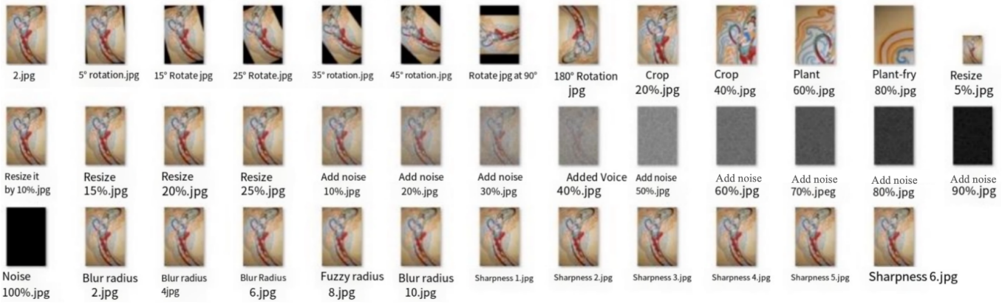
Fig. 1.1. Transformed image after various
Two similar but different original images 1.jpg and 2.jpg were selected to calculate their similarity under different hashing methods. The lower the similarity of different images, the better the perceptual hashing method achieves.
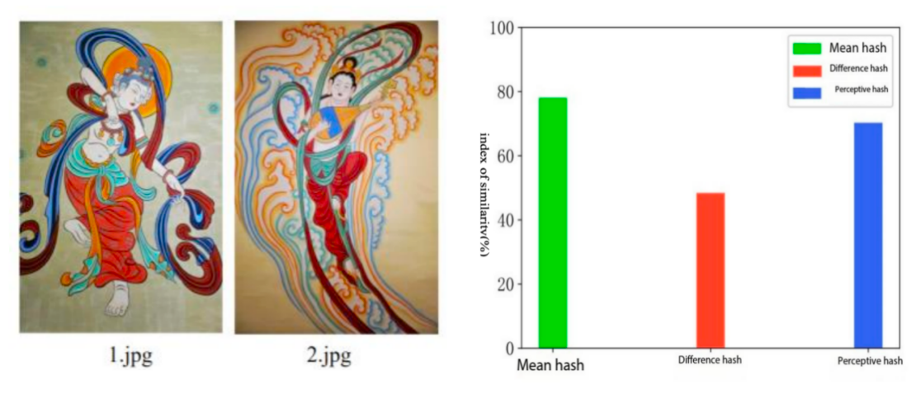
- Image 1.jpg and 2.jpg (b) Similarity of two images under different hashing methods
Fig. 1.2. Similarity of original image with different hashing methods

Fig. 1.2 shows the similarity of the original images with different hashing methods, Fig. 3.3(a) shows the two similar but different original images 1.jpg and 2.jpg, and Fig. 3.3(b) shows the similarity of the two images with different hashing methods. From Fig.3.3(b) It can be seen that the mean hash method, difference hash method, and perceptual hash method have computed similarity measures of 78.12500%, 48.43750%, and 70.31250% for similar but different images, respectively, and the difference hash is relatively effective.
In order to further assess the effectiveness of the three hash methods for infringement detection, the original image 2.jpg for a series of image processing operations, and then calculate the similarity of image 1.jpg and 2.jpg processed images in different hash methods. As shown in Fig. 1.3., respectively, the original image 2.jpg after cropping, noise, blurring, sharpening, rotating, resizing and other operations with the original image 1.jpg to do the similarity measure, in addition to noise processing, other image processing under the three hash methods performance is: difference hash > perceptual hash > mean hash.

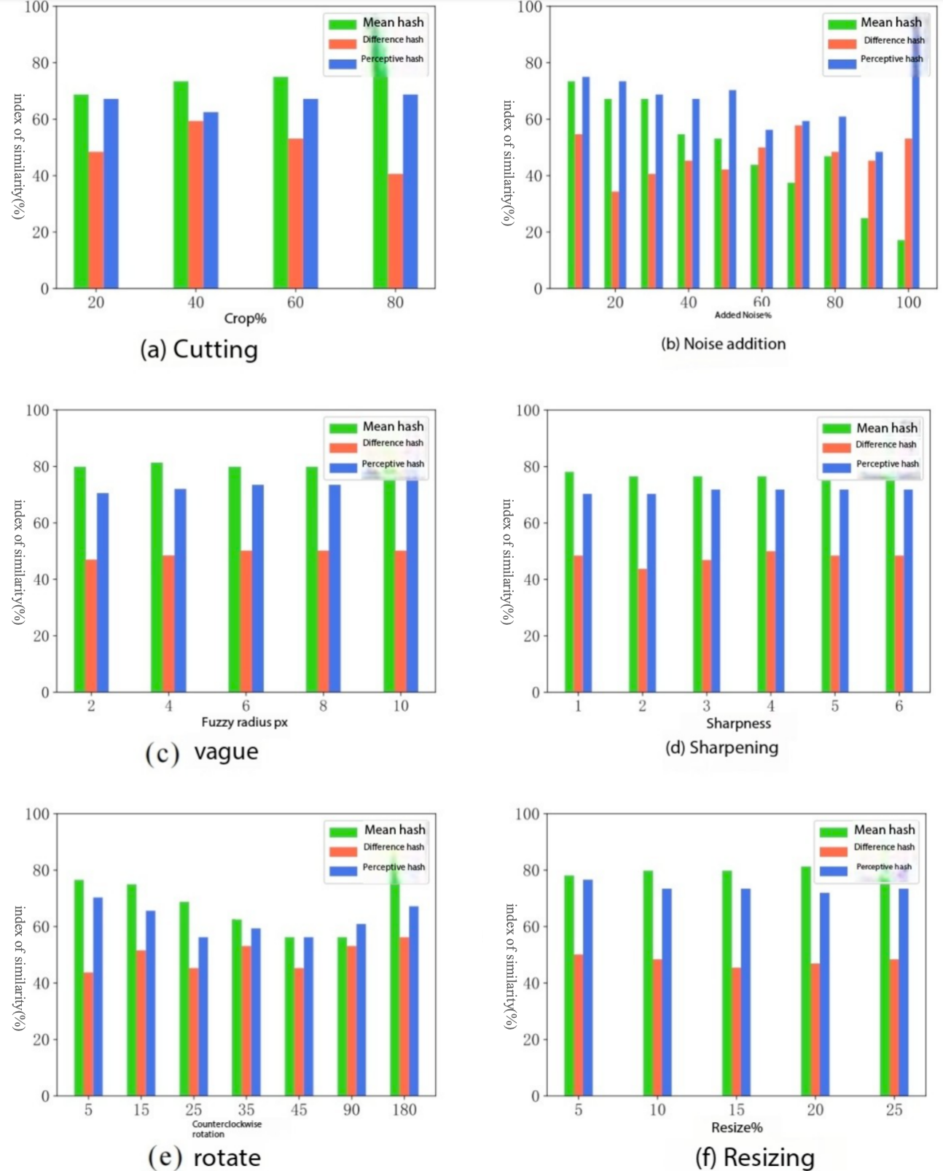
Fig. 1.3. Similarity metric of image 1.jpg before improvement of perceptual hash method and 2.jpg after processing for infringement detection

Compared with the copied images and published versions in the market, the mural images acquired by shooting have higher noise, and the image effect tends to be the image after noise processing, so it is more necessary to consider the selection of hash method in the case of noise processing. It can be seen from Fig. 3.4(b) that the similarity of mean hash and difference hash for different degrees of noise processing is quite different. Relatively speaking, perceptual hash is relatively stable in image noise processing. Therefore, perceptual hash is used to measure image similarity. Although the similarity value of perceptual hashing is relatively stable under image noise processing, the accuracy of similarity judgment is low. Therefore, the method in this chapter solves the problem of low precision effectively by improving the perceptual hashing method. Fig. 1.4 shows the similarity measurement results of image 1.jpg and similar image 2.jpg by using the improved perceptual hash method, mean hash and difference hash.
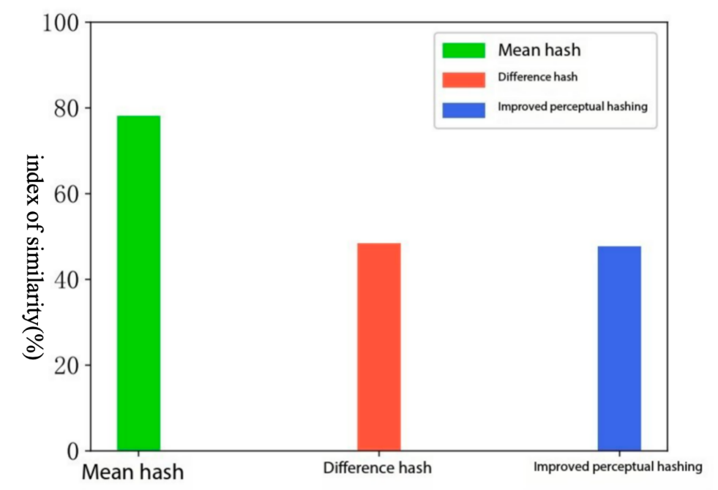
Fig. 1.4. Similarity measures of image 1.jpg and similar image 2.jpg under 3 hashing methods

As can be seen from Fig. 1.4, for similar but different images, the similarity of the improved perceptual hash method is 47.65625%, compared to the 70.31250% of the unimproved perceptual hash method and the 48.43750% of the difference hash, which is a great improvement in the accuracy of similarity metrics.
Using the improved perceptual hash method, the similarity between image 1.jpg and 2.jpg is calculated under different hash methods after doing various image processing, and the metric results are shown in Fig. 1.5.
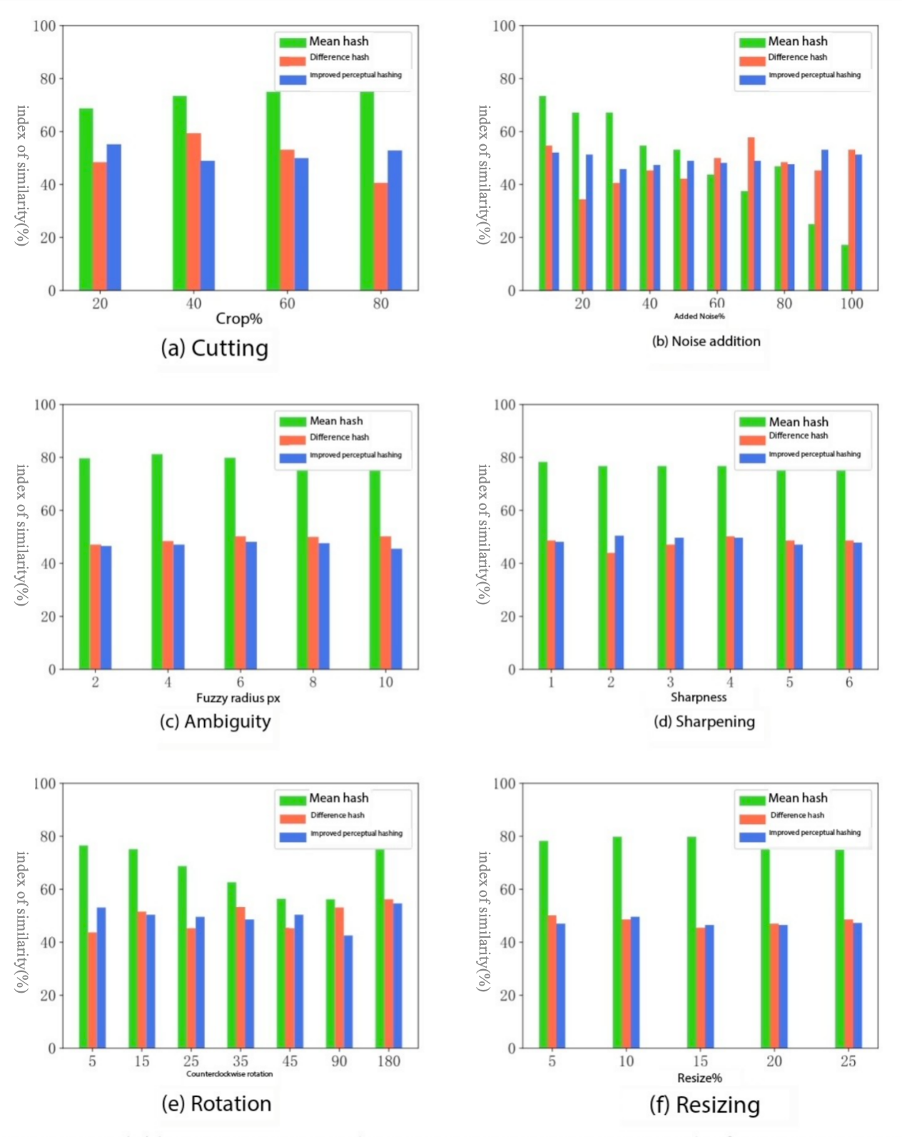
Fig. 1.5. Similarity metric between image 1.jpg after improved perceptual hash method and processed 2.jpg for infringement detection

From Fig. 1.5, it can be seen that the accuracy of similarity determination using the improved perceptual hash method has been greatly improved Lift. The performance of the improved perceptual hash method is relatively stable in different degrees of noise addition processing. In addition to noise processing, other image processing methods using the improved perceptual hash method for image similarity measure performance are better than the mean hash and difference hash.

Conclusions

By moving the value range of frequency domain and expanding the value matrix, the traditional perceptual hash method is improved, and the perceptual hash value is used to detect copyright infringement of uploaded images, which improves the accuracy of image infringement detection when copyright information is registered, and provides more powerful technical support for digital image infringement analysis.

References

- [1] Kumar R, Tripathi R, Marchang N, et al. A secured distributed detection system based on IPFS and blockchain for industrial image and video data security[J]. Journal of Parallel and Distributed Computing, 2021, 152: 128-143.
- [2] Meng Z, Morizumi T, Miyata S, et al. An Improved Design Scheme for Perceptual Hashing Based on CNN for Digital Watermarking[C]// 2020 IEEE 44th Annual Computers, Software
- [3] Shen Y X, Tang W, Xu M, et al. A DWT-SVD based adaptive color multiwatermarking scheme for copyright protection using AMEF and PSO-GWO[J]. Expert Systems with Applications, 2021, 168, 114414.

