UDC 621.391.3

LoRaWAN AS IoT TECHNOLOGY FOR CREATING SMART LEARNING

Rybak O.O., Nazarenko O.I.
National Technical University of Ukraine
“ Igor Sikorsky Kyiv Polytechnic Institute ”
E-mail: alex96.rybak@gmail.com, nazarenkoits@gmail.com

LoRaWAN як технологія інтернету речей для створення smart навчання

У роботі представлено модель використання технології LoRaWAN в Інтернеті Речей, щоб створити smart середовище для навчання студентів в інституті телекомунікаційних систем. Описана мережева архітектура LoRaWAN, її специфікації та властивості створювати комфортні умови та підвищувати продуктивність навчання студентів.

This study is focused on the use of LoRaWAN technology in the Internet of Things to create smart learning environment to teach students in the Institute of Telecommunication Systems. The LoRaWAN network architecture, its specifications and properties are described to enhance students’ learning capabilities.

The real challenge for educators is finding the effective ways to prepare specialists for such a high-tech industry as Telecoms: how to integrate modern technologies into learning sciences and professional training?; how to create immersive and meaningful experiences taking into account interests and needs of today’s students who are considered to be Net Generation or Digital-age learners?
Future Telecoms professionals use the Internet, different tools and devices to collect information for scientific researches, collaborate or communicate. It is crucial for them to be able to gather and analyze data utilizing inquiry and visualization tools, to simulate or design specialism-related processes using graphical or modeling applications, etc. For educators it is very important to create active learning and student-centered environment where learners could be deeply engaged in their specialist fields in face-to-face mode of study as well as remotely, feel comfortable, flexible and motivated to acquire necessary knowledge and gain skills.
The new trend in education, the Internet of Things (IoT) technology, enables creating smartly designed environment to enhance students’ learning possibilities. IoT provides any wireless technology (WiFi, BT, RF, NFC, Zigbee, Cellular, LPWAN etc.) to exchange data between people and things demonstrating their status, allowing them to control remotely actions of things, analyze data by means of machine learning, big data, artificial intelligence, virtual reality in order to optimize any process in different areas of activity.
Since beginning of 2019 the IoT wireless technology based on LoRaWAN is becoming more and more popular, and over 100 large operators have deployed it for different purposes (Telecompaper, 2019).
LoRaWAN is a low-power network protocol (LPWA) designed for the Internet of Things which can connect various LoRa things on batteries to regional, national or global networks (LoRa Alliance, 2018). This is a new technology that does not require SIM cards in things, thanks to the principle of operation of this technology the battery life of sensors increases up to 10 years, and in a short time it has gained great popularity in the world. The coverage of the LoRaWAN network allows creating in hard-to-reach places and working frequency of the technology of 868 MHz. Since it is not a licensed range it makes possible to deploy a private network without any problems. This technology does not always occupy a radio channel, but the longest transmission time is a few seconds for data transmission, the number of seconds or mili seconds depends on the amount of transmitted data on maximum size packet (256 kilobyte), data speed rate of 50 kilobyte/s.
To create smart learning environment pico gateway is going to be installed in the classrooms, that will create a private LoRaWaN network. For testing, The Things Network (free network server) is to be used in the future to create our own network server and an Application Server.
Smart solutions for the learning needs include: 1) sensors: Temperature, Humidity, Light Sensor, Desktop Sensors (identify Student’s Activity and Presence), Environmental Sensors (Pollution, Solar Radiation Levels (Research how polluted air affects material perception)), smoke detectors, sensors for windows and doors (security); 2) smart watches for measuring the pulse, transferring information to the teacher about the state of students’ health (within the audience) and using other technologies to improve the learning process; 3) a database where all information about students and their achievements will be stored (based on these data, an individual approach to each student will be created for more efficient learning).
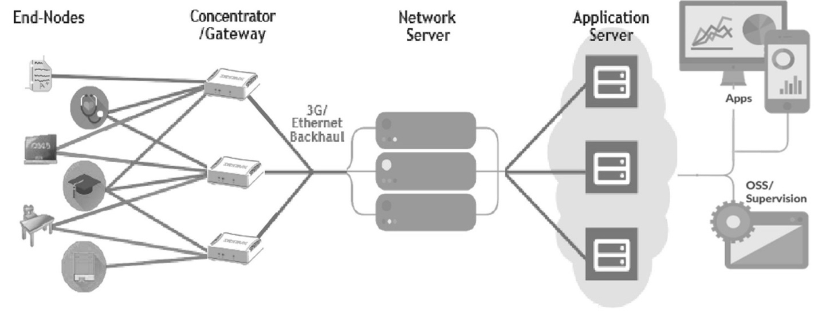
Figure 1 demonstrates the LoRaWAN Network architecture.
Figure 1: LoRaWAN «Star» Network Topology
The LoRaWAN network is always implemented in the star topology (LoRa Alliance, 2018). Unlike the grid topology, the star topology is ideal for end nodes (sensors) with limited power consumption (battery-powered), because only their own messages are transmitted, and there is no need to waste battery time on retransmitting messages from end nodes. A LoRaWAN network consists of one or more LoRaWAN gateways that are connected to one central network, a so-called network server (NS). Each LoRa gateway receives messages from all LoRaWAN end nodes in the radio link. Gateways are connected to a network server via Wi-Fi, Ethernet, or even cellular. Macro gateway provides coverage of the entire city (Pico gateways can be ideal where there is no need to have a large coverage, can be used for underground premises). LoRa can transmit with lower distribution coefficients that requires shorter broadcast times.
Network Server manages the LoRaWAN network (Ram, 2018). It monitors messages (LoRaWAN frames) from all sensors.
The main management functions implemented in NS are (LoRa Alliance, 2018):
• NS controls and monitors all requests from sensors for connection requests, NS informs each sensor on which channel to operate and what spreading factor (SF) to use and what power level is needed for transmission.
• The network server determines the most optimal base station for connecting the sensor and transmitting messages.
• The network server has general administrative functions, the establishment of base station reporting and sensors operation.
LoRaWAN defines three different end-node types or classes:
Class A: Battery Powered Sensors
- Most energy efficient
- Must be supported by all devices
- Downlink available only after sensor TX
- Report status a few times per day
- No planned actuation required
- Extremely low energy.
Class B: Battery Powered Actuators
- Adding scheduled receive windows for downlink messages
- Turn valves on or off with a few minute latency
Class C: Mains Powered Actuators
- Devices which can afford to listen continuously
- No latency for downlink communication
- Constantly listens to network ping for low-latency actuation.
Conclusion. The foregoing IoT model is able to provide the basis for creating environment for smart learning in the Institute of Telecommunication Systems. For further implementation a set of tasks has to be solved: to provide open study programs, design web applications and set up a data exchange system for smart classes and install Web-based applications on devices.
The use of modern technology brings a lot of benefits creating comfortable environment and providing different possibilities to enhance students’ learning capabilities, increase their interests and motivation. Students get the opportunity to acquire necessary knowledge and gain important skills while studying at the university.
In our future articles it will be shown how the data are collected and analyzed from sensors and interactions between students and lecturers in the smart learning
environment, and how the Blockchain technology is used to ensure data security.

References

1. LoRa Alliance passes 100 operator milestone with coverage in 100 countries. (2019). Telecompaper. Retrieved from https://www.telecompaper.com/news/lora-alliance-passes-100-operator-milestone-with-coverage-in-100-countries--1277154.
2. Migrating an Internet of Things (IoT) Sensor Design to LoRaWAN. (2018). LoRa Alliance. Semtech Corporation, Camarillo, CA.

3. Ram, P., (2018). LPWAN, LoRa, LoRaWAN and the Internet of Things:PART I – Understanding the LPWAN, LoRa and LoRaWAN technology. Retrieved from https://medium.com/coinmonks/lpwan-lora-lorawan-and-the-internet-of-things-aed7d5975d5d.

