Ovsiichuk I.M., student,
Krivda O.V., associate professor of the Department of Economics and entrepreneurship, Candidate of Economic Sciences

HR POLICY AS A TOOL FOR STRATEGIC PERSONNEL MANAGEMENT OF AN ENTERPRISE

Keywords: management, HR policy, corruption, human selfishness.

National Technical University of Ukraine "Igor Sikorsky Kyiv Polytechnic Institute"
At the present stage of development, personnel policy is very important in entrepreneurship. Attracting as many human resources as possible to the industry is one of the most important conditions for a successful HR policy.
The purpose of this work is to expose the need for rational and strategic personnel management of the enterprise, which is the main task of personnel policy.
For the successful functioning of any enterprise, a maximum of qualified labor must be attracted. Of course, now the conditions for conducting an effective personnel policy are quite difficult, but this is an integral aspect in the formation of the modern economy. According to the theory, to create an object of labor, you need the means of labor, but all this is useless without human labor.
The main problem of the labor shortage is insufficient remuneration. Corruption operations in our time can be traced in elementary actions at all stages of production. Human selfishness, without realizing it, can destroy the world. To a large extent, the limited financial resources are related to Soviet stereotypes, for example, that education should be free. Following these outdated views, Ukraine still cannot cross this long-passed stage, and therefore the possible labor force is looking for high-quality profits in European countries. Confirming her opinion, Doronina O. A. also considers financial limitations to be the main problem of successful implementation of personnel policy. In the diagram below, you can see how employees ' wages changed in 2018-2019. as you can see, there are no changes, but in this case we can hardly say that stability is the key to success.
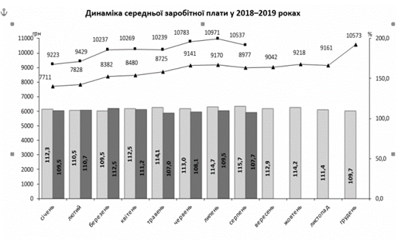
So, the implementation of a successful personnel policy at the present stage of entrepreneurship development is an extremely important task for the state. However, this cannot be done if there are a number of the above problems. That is, the first task is to conduct an internal policy, and then with the personnel policy.

References:
1. Borsch V.I., Belyakova V.V. Formation and implementation of personnel policy at Ukrainian enterprises. Market economy: modern theory and practice of management. Kyiv: 2017. Volume 16. №3 (37). P.175-187.
2. Doronina O.A., Ryazanov M.R. Economics and organization of management. Personnel policy as a tool for strategic development of higher education institutions. Kyiv: 2019. № 1 (33). P.15-20.
3. Strekhova S.V. Personnel policy: levers of influence on efficiency, mechanisms and tools of realization. Economic Journal XXI. Kyiv: 2012. № 3-4. P. 66-70.

