UDC 004.02, 004.9

PhD, Associate professor Tkachenko O.A., Master student Rong Shijie

National Technical University of Ukraine
“Igor Sikorsky Kyiv Polytechnic Institute”

SYSTEM FOOD QUALITY ASSESSMENT: METHODS AND SOFTWARE

Анотація

К.ф.-м.н., доцент Ткаченко О. А., магістрант Ронг Шідже
Система оцінки якості їжі: методи та програмне забезпечення
У роботі розглянуто використання методів машинного навчання для оцінки якості їжі за допомогою комп'ютерного зору з застосуванням згорткових нейронних мереж, статистичного навчання, нечіткої логіки, генетичних алгоритмів і дерев рішень. Реалізовані програмні засоби запропонованого методу розпізнавання продуктів харчування. У роботі також показано результати апробації застосованого методу на прикладі успішного розпізнавання 101 продукту харчування.

Introduction

In Japan, as in many countries around the world, food safety and quality are paramount concerns for consumers, regulatory bodies, and manufacturers alike. The intricate relationship between food consumption and health outcomes, such as allergic reactions, diabetes management, cardiovascular health, and gastrointestinal conditions, necessitates a detailed understanding and monitoring of food products [1, 2].

This is particularly crucial for individuals with specific dietary needs and restrictions. The evolution of technology has opened new avenues for addressing these needs, offering potential solutions that can provide consumers with detailed, accurate, and personalized food product information.

Terminology
CNNs – Convolutional Neural Networks – are a class of deep neural networks, highly effective for analyzing visual imagery. They are specifically designed to process pixel data and are used in image recognition, image classification, object detection, and many other areas in computer vision.
ReLU – Rectified Linear Unit.

Problem statement

Despite advancements in food safety standards and information technology, there remains a significant gap in the availability of detailed food product information tailored to the needs of consumers with health sensitivities in Japan.

There are several traditional methods of describing a food product and its subsequent computer reading and processing: by text, by code, by its appearance.

A description of a product in text form can be found: 1) on the product packaging, 2) on the manufacturer's website, 3) in the standard document according to which it is manufactured (using data from a ministry or other organization). You can scan special codes on the product packaging. If the product is not packaged, then you can recognize it by its appearance, for example, by comparing it with a sample (photo).

Traditional systems and methods for food recognition often do not provide sufficient details. Artificial neural networks are the most universal, modern and complex machine learning tool for recognizing food products by appearance. This method is in the early stages of research and development.

The proposed method
At the earliest reference point of our test technique, it is important to do a few preprocessing to prepare the pictures for work appropriately [3]. It shows the total technique of our proposed framework. Our model is actualized as a convolutional neural organization that comprises of three convolutional layers, continued by ReLU actuation and max pooling and, asolitary completely associated layer and a softmax layer.
We utilized group standardization after every activation function, as it improved the accuracy of our model by around 2%. As an optimizer, we utilized Adam with default learning pace of 0.001, as it beat other improvement calculations (Adagrad, SGD). Cross entropy was utilized as a loss function.
This is done to obtain more filtered images that can be utilized in the subsequent fully connected layers. Two fully connected layers are used next, with 128 and 90 neurons respectively. Dropout layers with a rate of 0.01 are added between the dense layers to prevent overfitting. Dropout randomly sets the weights of some neurons to zero during training, preventing them from dominating the learning process and leading to overfitting on specific neurons.
All the Convolutional 2D layers and fully connected layers in the CNN architecture utilize ReLU activation function, which introduces non-linearity into the network and helps in capturing complex patterns in the data [4, 5].
The CNN architecture consists of the following layers:
- Input Layer: The input images are of size 100x100x3, where 100x100 represents the rescaled size of the images, and 3 denotes the color channels (RGB).
- Convolutional Layer 1: The first convolutional layer consists of 32 kernels with a size of 3x3, which convolve with the input images to extract local patterns or features.
- Max Pooling Layer 1: The output of the first convolutional layer is then passed through a max pooling layer with a pool size of 2x2, which reduces the spatial dimensions and extracts the most relevant features from the convolved images.
- Convolutional Layer 2: The output from the first max pooling layer is then passed through a second convolutional layer with 64 kernels of size 3x3, to obtain more filtered images for improved feature extraction.
- Max Pooling Layer 2: The output of the second convolutional layer is then passed through another max pooling layer with a pool size of 2x2, further reducing the spatial dimensions.
- Fully Connected Layer 1: The output from the second max pooling layer is flattened and passed through a fully connected layer with 128 neurons.
- Fully Connected Layer 2: The output from the first fully connected layer is then passed through another fully connected layer with 90 neurons.
- Dropout Layers: Dropout layers with a rate of 0.01 are added between the dense layers to prevent overfitting.
- ReLU Activation Function: All the convolutional and fully connected layers utilize ReLU activation function, which introduces nonlinearity into the network and helps capture complex patterns in the data.
- Output Layer: The last layer in the architecture is the output layer, consisting of 15 neurons, which is equivalent to the number of categories in the dataset. Each neuron in the output layer produces an output in the form of a probability corresponding to a particular category. The category with the highest probability is predicted as the final class for the input image.
This CNN architecture is designed for image classification tasks, such as food recognition (fig. 1), and aims to capture relevant features from the input images through convolutional and pooling layers, followed by classification using fully connected layers and ReLU activation function, with dropout layers to prevent overfitting.
The application can use its knowledge base on food products and their manufacturers. It is desirable to create such a knowledge base based on an ontological model. The system can identify food image and output information about protein, calcium, fat and carbohydrates in food. In this we have implemented convolution neural network to identifying food images and nutrition information. We have presented dataset from food-101 for classifying images.
We can classify different images among 101 classes of image which were trained then identify nutrition information for each image for each training and testing we got about 80% of accuracy. For the future work have to recognize nutrition according to the quantity of each food item.

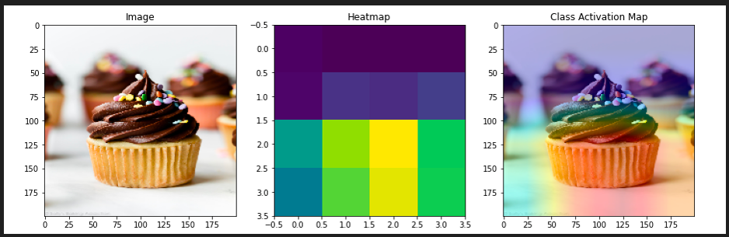
Fig. 1. Use of CNN for food recognition

Table 1 shows fragment of information from the system's (for food recognition) knowledge base, some of which were recognized using the created and used CNN.
For experimental purposes, the data were split into training (80%) and validation (20%).
This is well-established method in classification tasks, offering balanced approach to model development and assessment. To further ensure the robustness of experiments, within this study, a testing subset is employed within the training data. This subset, comprising 20% of the training set, serves as an intermediary checkpoint for model evaluation during the training process. It helps prevent overfitting, which is a common pitfall where a model becomes too tailored to the training data and struggles to generalise to new instances.

Conclusions

In this research, an exploration is made surrounding the various CNN for the complex task of multi-class classification tailored toward the study’s aim to perform fine-grained food image recognition involving food item classes.
The presented results are the basis for further work in the considered subject area, which involves the selection and generation of a more optimal architecture CNN, as well as network training parameters. Moreover, the use of alternative classifiers in combination with CNN functions can further improve their performance.

Table 1.
Fragment of the system's (for food recognition) knowledge base
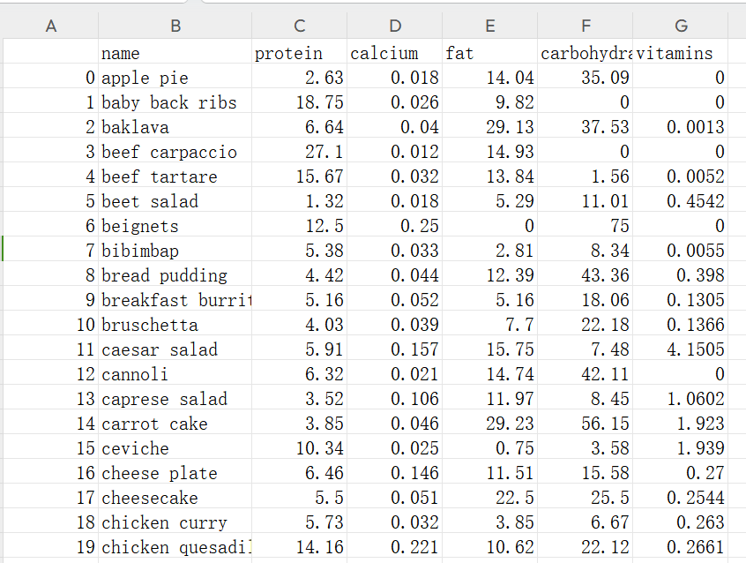

References

- Lasod, A.; Soni, D. Food Recognition System: A Survey International Conference on Advances in Mathematical Sciences and Applications in Engineering and Technology. 2017.
- Sharma, P.; Jadon, S.; Sharma, A. Hybrid Approach for Food Recognition Using Various Filters. International Journal of Advanced Computer Technology, 2022, 11(1), 1-5.
- Gupta, P.; Kaur, B.P. Accuracy enhancement of artificial neural network using genetic algorithm. International Journal of Computer Applications, 2014, 103(13).
- UCI Machine Learning Repository (2024). [Online]. Available at: https://www.geeksforgeeks.org/uci-machine-learning-repository/
- Lu, Yu. Food image recognition by convolutional neural networks (CNNs). (2016). DOI: 10.48550/arXiv.1612.00983. [Online]. Available at: https://www.researchgate.net/publication/311370165_Food_Image_Recognition_by_Using_Convolutional_Neural_Networks_CNNs

