НАЦІОНАЛЬНИЙ ТЕХНІЧНИЙ УНІВЕРСИТЕТ УКРАЇНИ
«КИЇВСЬКИЙ ПОЛІТЕХНІЧНИЙ ІНСТИТУТ
імені ІГОРЯ СІКОРСЬКОГО»
ФАКУЛЬТЕТ БІОМЕДИЧНОЇ ІНЖЕНЕРІЇ
КАФЕДРА БІОМЕДИЧНОЇ ІНЖЕНЕРІЇ
До захисту допущено:
Завідувач кафедри
________ Владислав ШЛИКОВ
«___»_____________20__ р.

Дипломна робота
на здобуття ступеня бакалавра
за освітньо-професійною програмою «Медична інженерія»
спеціальності 163 «Біомедична інженерія»
на тему: «Прилад для дослідження механічних властивостей біоматеріалів»
Виконав:
студент IV курсу, групи БМ-93i
Алі Іслам Талаат Аттіа __________

Керівник:
доцент каф. ББЗЛ, к.т.н., доцент
Антонова-Рафі Юлія Валеріївна ___________

Консультант з охорони праці:
старший викладач кафедри ОПЦБ,
к.т.н. Калінчик Віктор Васильович __________

Рецензент:
асистент каф. ББЗЛ
Данько Дарина Ігорівна __________

Засвідчую, що у цій дипломній роботі немає запозичень з праць інших авторів без відповідних посилань.
Студент _____________

Київ – 2023
NATIONAL TECHNICAL UNIVERSITY OF UKRAINE
«Igor SIKORSKI KYIV POLYTECNIC INSTITUTE»
FACULTY OF BIOMEDICAL ENGINEERING
DEPARTMENT OF BIOMEDICAL ENGINEERING

«Approved for defense»
Head of the Department of BMI ___________ Vladyslav SHLYKOV
(signature) (initials, surname)
“ ____ ” ______________2023
Graduate work
to obtain a bachelor's degree
under the educational and professional program "Medical Engineering"
specialty 163 "Biomedical engineering"
on the topic: Device for investigation of mechanical properties of biomaterials

Completed:
IV year student, group BM-93i
Ali Islam Talaat Atia ______________

Supervisor:
Assoc. prof. dep. BMI, Ph.D., Assoc. prof
Antonova-Rafi Y.V. ______________

Adviser for the labor protection:
Senior Lecturer Ph.D.at the OPСB,
Kalinchyk V.V. _______________

Reviewer:
Senior Lecturer at the BBZL, PhD,
Daryna Igoryvna Danko _______________

I certify that in this master's dissertation there are no borrowings from the works of other authors without appropriate references.
Student _____________
Kyiv –2023
National Technical University of Ukraine
“IGOR SIKORSKY Kyiv Polytechnic Institute”
Faculty of biomedical engineering
Department of biomedical engineering

Level of higher education - bachelor
Specialty 163 "Biomedical engineering"

Approved for defense
Head of the Department
___________ Vladyslav SHLYKOV

“ ____ ” ______________2023

TASK
for a bachelor's thesis of a student
Ali Islam Talaat Atia
^{(Full Name)}
1. Topic: Device for investigation of mechanical properties of biomaterials_______________
supervisor Assoc. prof. department of BSHH, PhD Y.V. Antonova-Rafi
(surname, name, patronymic, academic degree, academic title)
approved by the order of the university № 52/23-si from 05/26/20232.
2. The deadline for students to submit a bachelor thesis 09.06.2023.
3. The object of study is a device for studying the mechanical properties of biomaterials, device software.
4. The subject of the study are models of device for studying the mechanical properties of biomaterials, device software.
5. List of tasks to be developed:
- Review and analysis of literature data on the study of mechanical properties of biomaterials and their features,
- Search for already existing devices,
- Development of a structural and functional diagram of the device,
- Development and calculation of the electrical diagram of the device, layout,
- Analysis of computer modeling technology.
- Development of appropriate software, testing.
6. Approximate list of graphic (illustrative) material - 20 figures and 16 tables.
7. Adviser of work sections Safety and Labor Protection
Department | Surname, initials and position  adviser | Signature, date
Department | Surname, initials and position  adviser | task  published | task  accepted
Labor protection | Kalinchyk V.V  dep. Safety of labor, industrial and  of civil security"
8. Date of issue of the task 05.04.2023
Calendar plan
№ s / n | Name of stages of execution  diploma thesis | Deadline for stages  diploma thesis | Note
1 | Defining the topic of bachelor thesis. Analysis of literature sources. | 05.04.2023
2 | Development of the content and structure of bachelor thesis | 08.04.2023
3 | Analysis of the development of longitudinal flatfoot | 10.04.2023
4 | Introduction to methods of making orthopedic insoles | 12.04.2023
5 | Analysis and description of the prototype of the supinator model | 14.04.2023
6 | Acquaintance with the ANSYS modeling environment | 21.04.2023
7 | Construction of a supinator model in the ANSYS Workbench | 05.05.2023
8 | Parametrization of the supinator model | 19.05.2023
9 | Safety and precautions | 26.05.2023
10 | Registration of bachelor thesis | 04.06.2023
11 | Getting a review and feedback | 05.06.2023
12 | Passing norm control | 07.06.2023
13 | The bachelor thesis protection | 09.06.2023

Student __________________ I. Talaat Attia
(signature) (initials, surname)
Supervisor ___________________ Y.V. Antonova-Rafi
(signature) (initials, surname)

ABSTRACT

The volume of the work is 63 pages, contains 20 illustrations, 16 tables. A total of 24 sources were processed.
Relevance: the development of this device will allow obtaining empirical data on the mechanical properties of biological tissues for further comparison with existing norms and the construction of a mathematical model for a specific research subject. It will also make it possible to judge the viability of biological tissues in the specific studied conditions.
Purpose: creation of a working model of the device for studying the mechanical properties of biomaterials.
Task: review and analysis of literature data on the study of mechanical properties of biomaterials and their features; search for already existing devices performing a similar function and analysis of engineering solutions that were used in their creation; development of the functional scheme of the device; layout; development of appropriate software for debugging the operation of the device itself and for analyzing and displaying the data obtained from it on the interface; conducting tests.
The main results: a review of the literature was carried out, a patent search for analogues was carried out, a functional scheme was created, the selection and inspection of the installation components was carried out, simulation of its operation was carried out, a mock-up of the device was made, and its testing was carried out.
Key words: Poisson's ratio, Young's modulus, strain diagram.

АНОТАЦІЯ

Обсяг дипломної роботи становить 63 сторінки, міститься 20 ілюстрацій, 16 таблиць, 3 додатка. Загалом опрацьовано 24 джерел.
Актуальність: розробка даного приладу дозволить отримувати емпіричні дані про механічні властивості біологічних тканин для подальшого порівняння з існуючими нормами та побудови математичної моделі для конкретного суб’єкта дослідження. Також це дасть змогу судити про життєздатність біологічних тканин в конкретних досліджуваних умовах..
Мета: створення робочого макету приладу для дослідження механічних властивостей біоматеріалів.
Завдання: огляд та аналіз літературних даних щодо дослідження механічних властивостей біоматеріалів і їх особливостей; пошук вже існуючих приладів, що виконують аналогічну функцію і аналіз інженерних рішень, які були використані при їх створенні; розробка функціональної схеми приладу; макетування; розробка відповідного програмного забезпечення для налагодження роботи самого приладу і для аналізу і виведення на інтерфейс отриманих з нього даних; проведення тестувань.
Основні результати: зроблено огляд літератури, проведено патентний пошук аналогів, створено функціональну схему, виконано підбір та огляд компонентів установки, проведено моделювання її роботи, виготовлено макет приладу, проведено його випробування.
Ключові слова: коефіцієнт Пуассона, модуль Юнга, діаграма деформації.
CONTENTS
Introduction 10
SECTION 1. LITERATURE REVIEW 11
1. The importance of bases of elastic strain measurement 12
1.2 Review of existing analogues of devices 14
Elastic Fibers in One Dimension 16
Elastin and Elastin-Like-Peptides 22
Decellularized Tissues 22
SECTION 2. PRACTICAL PART 23
2.1 Block diagram of the installation for determining the mechanical properties of biological tissues 24
2.1.1 Development of the block diagram 24
2.1.2 Elements of the block diagram 24
Elastic Fibres in Three Dimensions 27
2.2 Simulation of Biomaterial Compression Test 31
Biocompatibility testing 32
2.3 Installation base 33
2.4 Designing a working layout 36
2.5 Software for the developed installation 40
The Standard Linear Model 43
Critical energy release rate 45
SECTION 3 OCCUPATIONAL SAFETY 47
3.1 Characteristics of the object and its components 47
3.1.1 Characteristics of the object 47
3.1.2 System components 48
3.1.3 The nature of interaction in the system "man-object" 48
3.2 Assessment of potential hazards created by the system design and measures to eliminate them 49
3.2.1 Mechanical hazard 52
BLISTING APPLICATION OF LOAD CELL READING PROGRAM 56
APPLICATION INSOFTWARE PRODUCT, WHICH IMPLEMENTS USER INTERFACE AND DATA PROCESSING 59
CONCLUSION 60
References 61

INTRODUCTION

In this report we are going to talk about Device for investigation of mechanical properties of biomaterials, Materials science is progressing toward more sophisticated composite materials. It is vital to understand the structure and mechanical characteristics of biological materials from the standpoint of materials science.
Biological tissues are composite materials that incorporate solids and liquids as components, according to materials science. Elasticity and toughness are the essential mechanical qualities that influence their functioning. The mechanical properties of biomaterials refer to their physical behavior under mechanical loads or stresses. These properties include strength, stiffness, toughness, fatigue resistance, and other related parameters that describe how a material responds to mechanical forces.
The importance of mechanical properties of biomaterials lies in their ability to influence the performance of medical devices, implants, and tissue-engineered constructs. A biomaterial with inadequate mechanical properties can result in implant failure, poor tissue integration, or suboptimal clinical outcomes.
Reasons why mechanical properties of biomaterials are important:
Biomechanical Compatibility: A biomaterial must be biomechanically compatible with the tissue it is replacing or augmenting. This means that it must have similar mechanical properties to the surrounding tissues in order to avoid any stress concentrations or load transfer issues that can cause tissue damage.

The purpose of the study was:
assess and understand how these materials behave under different mechanical forces and conditions. It allows researchers, scientists, and engineers to gather quantitative data and empirical evidence about the mechanical characteristics and performance of biomaterials.
The tensile strength, yield strength, elastic modulus, corrosion, creep, and hardness are some of the most important properties of biomaterials that should be carefully studied and evaluated before implantation. For hard tissue applications, the mechanical properties are of top priority.
The objectives of the study were:
1. Review and analysis of published data on biomaterial mechanical properties and features.
2. Look for existing devices that perform a similar function and examine the engineering solutions used in their creation.
3. Design a block diagram and a functioning schematic for the device with the calculations.

SECTION 1. LITERATURE REVIEW

1. The importance of bases of elastic strain measurement
The intended equipment will compress the sample and measure the force-deformation ratio. A deformation diagram will be produced using this data, and the Young's modulus and Poisson coefficient will be determined. So, first and foremost, evaluate the appropriate theory.
Plastic deformation is a distortion that continues in the body after external pressures have been removed.
The deformation of elastic material is a type of deformation in which the body returns to its original size and shape once external forces are removed [1].
Obtaining a deformation diagram helps you to discover many of the most essential characteristic points and their associated values: limit of proportionality - the highest voltage at which Hooke's law remains valid (1.1); elastic limit - the greatest stress at which no residual deformations exist; yield strength - the greatest stress at which deformation increases without a perceptible rise in stress; The tensile strength of a sample is the highest voltage that it can tolerate [2].
Hooke's law (applicable to linear deformation):
F= - k, ∆l (1.1)
where F is the elastic force, l is the difference between the beginning and end length of the sample, and k is the stiffness coefficient.
The coefficient of harshness is calculated as follows:
k= E*S/l , (1.2)
where:
S is the area of the sample under investigation,
l is the length of the test sample,
E is Jung's module.
Because the cross section of biological tissue samples is not always constant, the voltage is distributed differentially throughout the length of the sample. Furthermore, as a sample is compressed, the cross-sectional area changes.
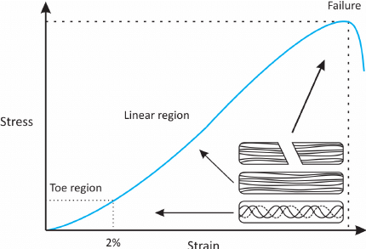
Figure 1.1 There are three distinct regions
Compression stiffness increases considerably for materials such as elastin, muscle, and vessel wall (Fig. 1.1). This feature is observed till the sample is destroyed. On such diagrams, the yield zone is weak.
Formation diagrams produced by a variety of physiological length changes are typically nonlinear. In this situation, Young's modulus E, as an elastic property characteristic, can only be employed in the range of extremely tiny deformations for which Hooke's law is true. In the physiological range of length changes, the decreased Young's modulus is typically utilized, which is an average feature of the sample's elastic characteristics [3, 4]. E_пp
$E_{пр}=\frac{\sum_{i}{E_{i}}}{n}$, (1.3)
where is $E_{i}$ the effective or tangential Young's modulus (1.4).
$E_{i}=\frac{∆σ_{i}}{∆ε_{i}}=\frac{σ_{i+1}-σ_{i}}{ε_{i+1}-ε_{i}}$, (1.4)
The elastic strength E (1.5) of biological tissue is an empirical value that represents the change in relative deformation () of this tissue in response to mechanical stress and displays how much percent this deformation will vary if the load is changed by 1% () [1]: xF
$E=∆x/∆F$ (1.5)
The Poisson index (1.6) is one of the physical properties of an elastic body, equal to the ratio of the absolute values of a body element's relative transverse deformation () to its relative longitudinal deformation () [6, 7]. A stable, isotropic, linear elastic material's Poisson coefficient should be between -1.0 and +0.5. Most materials have values between 0.0 and 0.5. . $\frac{∆d}{d}\frac{∆l}{l}$
$μ=\frac{∆d}{d}\frac{l}{∆l}$ , (1.6)
There are two sorts of mechanical testing for the sample that are functionally connected. Yes, it is feasible to set the deformation of the sample and record the growing stress by exerting an effort that far exceeds the stiffness of the material. This is the most common sort of test in biomechanics. Setting a constant stress in the sample, for example, by loading it with a constant load, allows you to record what sort of deformation occurs in it.

1.2 Review of existing analogues of devices
Usually, the details of such developments are not disclosed. The exception is the research facility shown in Fig.1.2.
The main elements of the installation:
- stepper motor;
- inductive displacement sensor;
- load cell;
- indentor.
The indenter used in the studies was flat and 3 mm in diameter. It was connected to a 1H strain gauge (LSB200, Futek Advanced Sensor Technology Inc., Irvine, CA, USA) and driven by a linear stepper motor with an accuracy of 0.03 mm (UBL23, Saia-Burgess Inc., OH, USA), which was connected to an inductive displacement sensor (DC15, Salartron Metrology Ltd., Leicester, UK) using a specially manufactured device.
The entire system was controlled by the computer through the user interface of software developed with LabWindows/CVI 8.5 (National Instruments Co., TX, USA) [8].
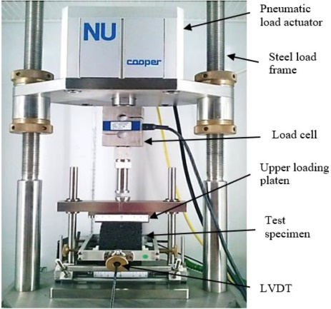
Fig.1.2 Installation for investigation of mechanical properties of biological tissues
During this investigation, samples of the material were put on a horizontal platform that had been wet with a small layer of saline, which provided lubrication and prevented the sample from being dehydrated. Each sample's thickness was measured using digital technology, with little compression maintained throughout the measurement. The platform was adjusted vertically such that the indenter started somewhat higher than the sample. The deformation test included five loading cycles and one unloading cycle. It was performed using an indenter pitch of approximately 0.5 mm. The maximum depth of distortion was specified to be around 20% of the cut's original thickness. The number of test points for this slice was determined by the cross-sectional size.

Elastic Fibers in One Dimension
For the time being, assume that the fiber is represented by a simple spring, as shown in Fig. 4.3. The spring is linked to the wall on the left end, while the right end is loaded with a force F. When no force is applied to the spring (fiber), the length of the spring equals zero, which is referred to as the reference or starting length. After loading the spring, the length changes to, which is referred to as the current length. It is assumed that a linear connection exists between the change in length of the fiber 0 and the applied force:
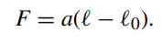
The constant a reflects the stiffness properties of the spring and can be identified by, for instance, attaching a known weight, i.e. a known force, to the spring in a vertical position and measuring the extension of the spring. However, formulating.
the force–extension relation as in Eq. (4.1) is, although formally correct, not very convenient. If another spring was considered with the same intrinsic properties, but a different initial length, the coefficient a would change as well. Therefore, the relation represented by Eq. (4.1) is scaled by the initial, unloaded, length:
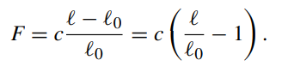
The quantity λ − 1 is usually referred to as strain, and it measures the amount of deformation of the spring. Without any elongation of the spring the stretch satisfies λ = 1, while the strain equals zero. The above force–strain relation represents linear elastic behavior, as depicted in Fig. 4.4(a). If after stretching the fibre returns to its original length, the force equals zero and no energy has been dissipated. Since the stretch λ is a dimensionless quantity and the unit of force is [N] (Newton), the constant c also has unit [N]. For relatively small stretches λ, the actual behavior of many biological fibres may indeed be approximated by a linear relation between force and stretch. However, if the stretch exceeds a certain value, the force–extension behavior usually becomes non-linear. In fact, in many cases fibres have a finite extensibility. If the stretch λ approaches a critical value, say λc, the force in the fibre increases sharply. A typical example of such a behavior is modelled using the following expression for the force–stretch relation:
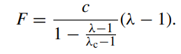
For small extensions (λ ≈ 1) the denominator in this expression satisfies
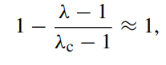

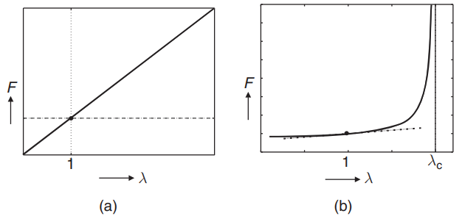
Fig. The differnce between the two equations
Such that the behavior is identical to that of a linear spring. When approaching the critical stretch c, the force increases fast with increasing stretch. This is seen in Fig. (b). The solid line depicts the non-linear, finite extensibility curve, whereas the dotted line depicts the linear behavior.[19]
Collagen is one of the most prevalent proteins in the human body, and it is frequently organized into fibers. Understanding how live tissues respond to mechanical stresses requires knowledge of collagen's mechanical characteristics and the ability to model this feature using mechanical models. Assume that the mechanical behavior of collagen fibers can be represented using the non-linear force-stretch relation stated above, and that the critical strain of collagen fibers is 10%. The apparent stiffness of a material at its current stretch is represented by the local slope of a force-stretch curve. The apparent stiffness at 90% of the critical strain may be calculated by taking the derivative of the force-stretch curve at that point:
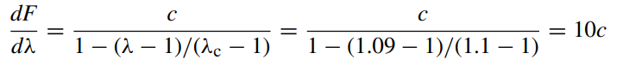
This shows that the stiffness of a non-linear fibrous material can vary tremendously, depending on the stretch that is applied to it.
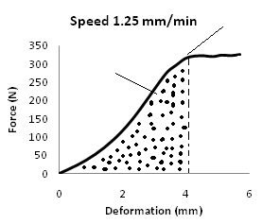
Fig.1.3 Diagram of deformation
The obtained data were used to construct a deformation diagram (Fig. 1.3) for five cycles of studies of the same sample.
To calculate the Young's modulus during this study, the model proposed by Hayes (1.7) was used.
$E=\frac{1-ν^{2}}{2*a*k(ν,a/h)}*\frac{P}{w}$ (1.7)

where :
Е – Young's modulus of fabric
а – radius of the indenter,
ν – Poisson tissue coefficient,
h – initial thickness of the test sample,
κ – correction factor related to υ,
а – aspect ratio a / h [9],
Р / w – the ratio between the force and depth of indentation.
During the literary data analysis, it was decided what data is eventually anticipated to be gathered utilizing the designed device:
- Young's module;
- Poisson coefficient (with a known initial area of the sample, it will be necessary to manually measure the final one);
- boundaries of proportionality, elasticity, fluidity, strength;
-deformation diagram.
Based on these findings, the researcher will be able to assess the survivability of certain tissues under specific situations under investigation, such as after welding.
Definitions of key concepts and basic formulas were provided, on the basis of which further calculations will be made (1.3 and 1.6). The structure of the analogue of the installation was considered and its main elements were highlighted.
Biomaterial research has been ongoing for some years, and several corporations are spending extensively in new product development. However, it is a disputed scientific field. Biomaterial science is a branch of materials research that merges with medicine. The repair or replacement of damaged tissues or organs improves the patient's quality of life. The acceptance of a biomaterial by the body is the decisive factor. A biomaterial used for an implant must have particular properties in order to last a long period. To be long-lasting, a biomaterial utilized for an implant must have specified qualities. Biomedical applications employ a wide range of materials. They are commonly utilized nowadays and can be used alone or in combination. This review will help researchers choose and evaluate biomaterials. The mechanical and physical qualities of a biomaterial should be evaluated before employing it. Recent biomaterials have a structure that is similar to tissue. Advanced antifouling, bactericidal, and antibiofilm technologies are being used to create anti-infective biomaterials and surfaces.
This review attempts to cover critical biomaterial features required for tissue engineering, such as bioactivity, self-assembly, structural hierarchy, applications, heart valves, skin repair, bio-design, essential ideas in biomaterials, bioactive biomaterials, bioresorbable biomaterials, biomaterials in medical practice, and biomaterials in medical practice. biomedical function for design, biomaterial properties such as biocompatibility, heat response, non-toxicity, mechanical properties, physical properties, wear, and corrosion, as well as biomaterial properties such surfaces that are antibacterial, nanostructured materials, and biofilm disrupting compounds, are all being investigated. It is technically possible to stop the spread of implant infection.
Because the surrounding biological environment can recognize and metabolically digest implanted chemicals via known routes, naturally occurring materials provide various benefits. However, natural materials have historically been afflicted by a number of drawbacks, such as immunogenicity, lot-to-lot variability, and toxicity.
structural complexity, and poor biomechanical properties. Recent advancements in the area have resulted in a decrease in these negative qualities, as well as a significant number of successful biomaterials and biomaterial applications based on the unique features of naturally occurring polymers and their chemically modified counterparts.
A distinct feature of organically generated materials is that the host may efficiently remove and metabolize the implanted substance via enzymatic or hydrolytic degradation. While this may not be desirable in permanent and long-term implants such as hip replacements, it is tremendously beneficial when scheduled biological resorption is sought, such as in drug or therapeutic cell delivery vehicles. Natural materials can be chemically changed and cross-linked to tailor the rate of deterioration to a specific biological use.
Chemical alteration and cross-linking are typical ways for modifying natural materials' mechanical qualities such as elasticity and tensile strength, which are frequently inappropriate for dynamic physiologic situations (e.g., the beating heart). The intricate structures of natural materials, on the other hand, might complicate technological alterations that are straightforward to make in synthetic polymers. Nonetheless, multiple research investigations have shown that natural-based materials may be successfully modified and purified. Another prevalent difficulty with natural materials is the lot-to-lot variation in molecular structure caused by animal sources. Variability occurs not just as a result of species-to-species variance, but also as a result of tissue-to-tissue variation. This can make material processing and quantification more difficult. Recently, bacterial recombinant methods have been used to create a variety of natural materials such as hyaluronic acid (HA) and collagen.

Elastin and Elastin-Like-Peptides

Elastin is an extracellular matrix protein that gives tissues and organs elasticity. It is prevalent in blood vessels, ligaments, lung tissue, and skin; it is present in all organs. That are often stretched and relaxed.
Tropoelastin, the soluble protein precursor to elastin, can align and form intermolecular cross-links resulting in extremely stable insoluble elastin. As a biomaterial, elastin can have various forms. Insoluble elastin can be used in autografts or allografts, it can be hydrolyzed to be used in soluble elastin preparations, or tropoelastin can provide components of biomaterials. Elastin-like peptides (ELPs) have been synthetically produced. These polypeptides are composed of the highly repetitive amino acid sequences found in elastin. Physical properties of the ELPs can be manipulated based on amino acid sequence and resulting hydrophobicity. The polypeptides can coacervate and then be cross-linked by gamma irradiation. Researchers have produced non-woven fabrics and fibers by electrospinning EL.

Decellularized Tissues

Tissues are made up of different densities of cellular material and extracellular matrix proteins. Decellularized tissues are natural materials, often from an animal or human source, that have been processed to eliminate all cellular components and detritus while retaining the ECM's three-dimensional structure and functional proteins. For these materials, the tissue location, species of origin, decellularization process methods, and end point sterilizing treatments can all differ substantially. It is vital to eliminate the cellular components and antigens because they are identified as foreign by host tissue and cause an irreversible inflammatory response or immune-mediated rejection of the decellularized tissue.[18]

SECTION 2. PRACTICAL PART

2.1 Block diagram of the installation for determining the mechanical properties of biological tissues

2.1.1 Development of the block diagram

The work process is separated into three major elements to answer the problem: structural, functional-logical, and technological.
At the structural stage of device design, the principles of making such devices are researched, their structure is separated into interconnected blocks, and each component is analyzed independently.
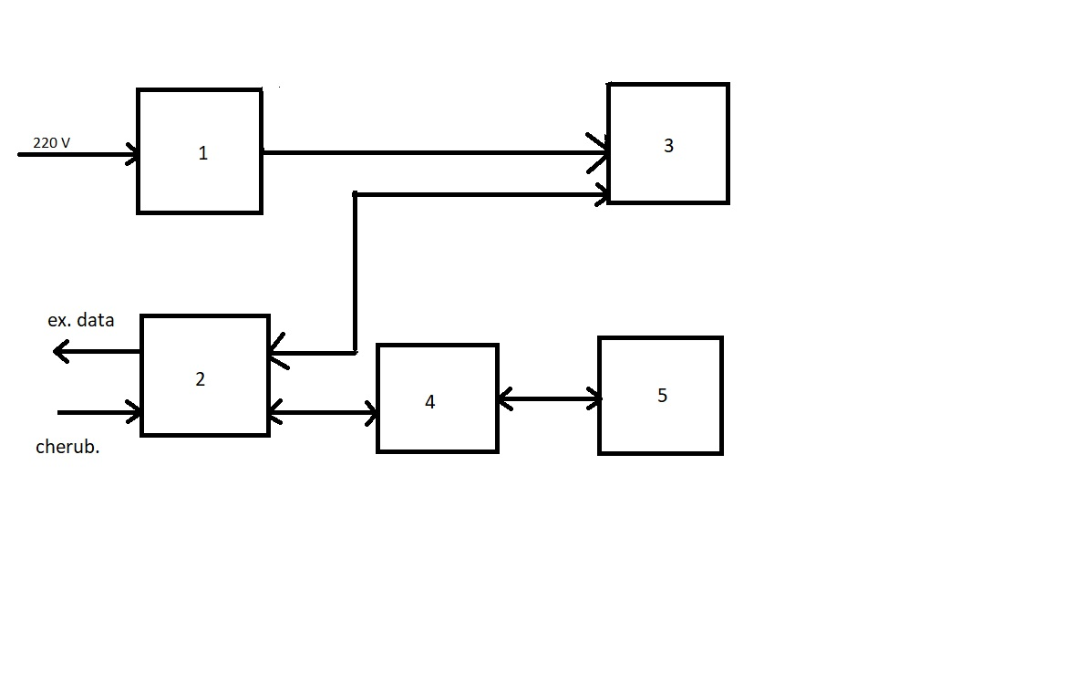
Fig.2.1 – Block diagram of the device for the study of mechanical properties of biomaterials: 1 – power supply, 2 – microcontroller (MK), 3 – servo drive, 5 – ADC, 4 – load cell.

The structural and technical solutions employed in the sources under examination were studied while generating a block schematic of the installation (Fig.2.1) [8,10].

2.1.2 Elements of the block diagram

Deformations can be measured in a variety of methods depending on the conversion principles used: strain resistive, optical-polarization, piezoresistive, fiber-optic, or simple readings from a mechanical load cell line [11]. Strain gauges are the least expensive.
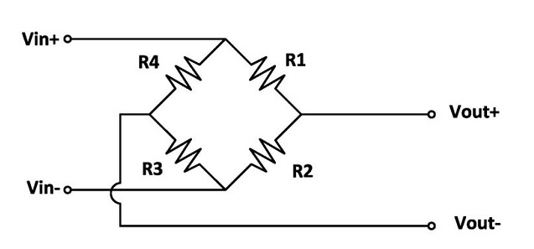
Fig.2.2 – Load cell (electrical circuit)
These instruments (strain gauges) are an elastic component to which a strain gauge is attached; when force (weight of cargo) is applied, the elastic element deforms along with the strain gauge.
The sensor is made up of a metal (typically aluminum or steel) beam and a strain gauge bonded to it (Fig. 2.2), the resistance of which fluctuates in proportion to the beam's deformation (2.3) [12]. Load cell scales also require an ADC to transform the signal. The simplicity and inexpensive cost of these sensors are advantages [13].
By varying the resistance of the strain gauge, the degree of deformation may be calculated, which is proportional to the force applied to the structure [12].
The force measuring concept based on strain gauges is based on the correction of weighted cargo mass and elastic mechanical force of load cells. This force is then translated into an electrical signal (Fig. 2.2). Resistance to conductors:
$R=ρ*l/S$ , (2.1)

where is the density of the conductor;$ρ$
l – conductor length;
S – cross-sectional area.
T
DSP
ADC
FNP
PS

Fig.2.3 – Block diagram of the force measurement unit [14,15](Т – load cell, PS – signal amplifier, LFF – low-pass filter, ADC – analog-to-digital converter, DSP – digital signal processing).
It is important to track the deformation of the sample as well as put pressure on it of several MPa in order to execute the planned device. With these parameters in mind, it is worthwhile to seek for an engine with feedback and the requisite moment of force. It is advisable to use a servo drive.
A servo is an electric motor-powered device that enables for precise control of the model's movements via negative feedback. And, while the force with which the servo drive may apply pressure to the test sample will not be excessive, pressure inadequacy can be avoided by limiting the size of the sample.[19]
Any servo drive contains a sensor and a control unit in its construction (Fig.2.4) that supports particular sensor values based on an external parameter.

Elastic Fibres in Three Dimensions
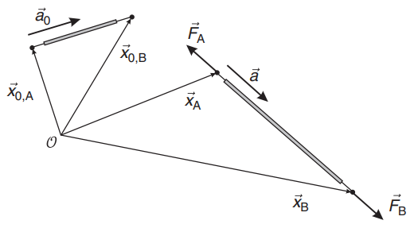
3d dimensions
The material behavior was always assumed to be elastic, implying that a unique relationship existed between extensional force and fibre deformation. This means the force versus stretch curves for the loading and unloading paths are the same. There is no history dependence, and all energy stored in the fiber during deformation is recovered during the unloading period. This also means that the loading or unloading rate has no effect on the force-stretch curves. Most biological materials, however, do not act elastically.
A loading history and a typical reaction of a biological material are presented as examples of deformation histories that may be utilized in an experiment to mechanically describe some material specimen. The specimen is rapidly stretched to a particular value, then the distortion is stabilized and returned to zero after a specified period. After a brief pause, the stretch is applied again, but with a greater stretch value. This cycle of deformation is repeated multiple times. The length change is prescribed in this example, and the associated force is measured.
The force diminishes with time while the length of the fiber remains constant. This is referred to as relaxation. Conversely, if a constant load is applied, the length of the fibre will increase. This is called creep.[19]
When cyclic loading is applied to a material, the force versus stretch relation in the loading phase is generally different from that in the unloading process. This is known as hysteresis, and it is seen in Fig. 5.2. The difference in response routes between loading and unloading suggests that energy is wasted during the operation, generally in the form of heat. Most biological materials exhibit the above-mentioned visco-elastic behavior to some extent.
The current chapter addresses how to mathematically define this behavior. First, pure viscous behavior as attributed to an ideal fluid is investigated. The description will be expanded to include linear viscoelasticity.
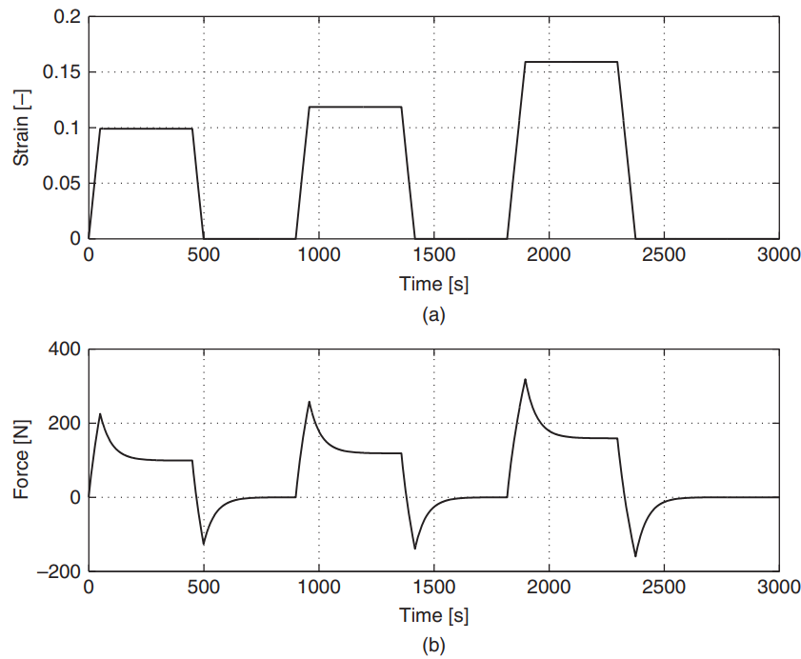
Fig. graph for the dependent behavior
Axons' mechanical behavior (long, slender sections of nerve cells that transport electrical messages to various areas of the human body) is frequently assessed by applying a continuous force or deformation to an axon. The displacement of specific regions within the axon may be recorded using a kymograph, which tracks the change in position of specific spots on the axon over time. The visco-elastic behavior of axons is readily obvious in the experimentally determined kymograph , which was generated in response to a constant force application. The maximal force is applied very immediately after the experiment begins, and the deformation continues to rise over time. If one wants to model the mechanical behavior of axons , then this visco-elastic behavior should be accounted for, as this material response cannot be captured with purely elastic constitutive laws.[19]
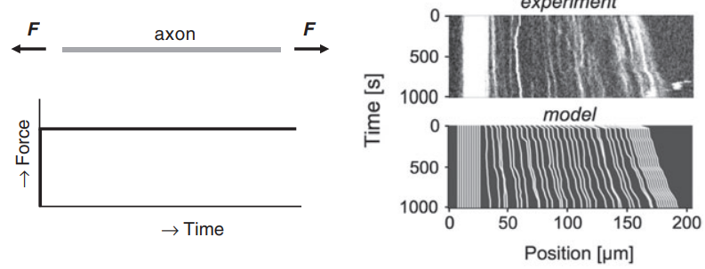
Fig. Example of a force-driven mechanical test on an axon

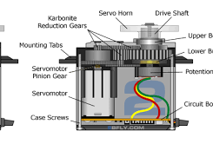
Fig.2.4 – The structure of the servo drive
The principle of operation of the servo:
- The servo receives a pulse signal (Fig.2.5) — a control value that determines the angle of rotation of the servo rolling pin;
- The control unit starts comparing the received parameter with the value on its sensor (potentiometer);
- Depending on the result of the comparison, the control unit returns a signal that determines whether to turn, accelerate or slow down to make the compared indicators the same.
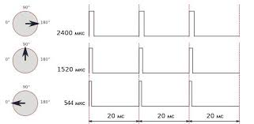
Fig.2.5 – Servo control signal.

Mspawn controller (MK) is a microelectron specialized programmable device.
Features compared to conventional processors:
- built-in program memory and data memory;
- bit processor;
- timers, counters;
- ports, interfaces;
The main purpose of MK is to use it as a control unit in devices, data processing systems and process control systems. Another great advantage of MK is its availability and self-sufficiency: the controller chip contains all the elements for building a control system. C control system based on a microcontroller can consist only of a power supply, a controller chip and passive elements (resistors, capacitors and quartz resonator).

2.2 Simulation of Biomaterial Compression Test

Thecompression of the biomaterial was modified using the COMSOL 5.2 software, using the real parameters of materials (Young's modulus and Poisson coefficient of muscle tcanine).
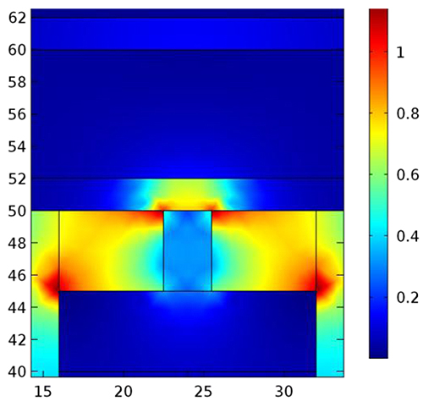
Fig.2.6 – Simulation of biomaterial compression
We were able to calculate the following installation settings based on results:
the servo drive's moment of force (the sample is clearly distorted with a force of 150 N acting on it, thus the servo must exert this force or more);
maximum force for which the load cell should be constructed (according to the servo snout specifications, but not less than 150 N);
The servo drive's discreteness (the greatest normal deformation to the cut was around 1 mm, therefore the lowest reference size of 0.05 mm was chosen).

Biocompatibility testing
The materials chosen for orthopedic applications should be able to function in vivo without causing any undesired local or systemic consequences such as immunological, allergic, inflammatory, or carcinogenic reactions. Biocompatibility encompasses not just bio inertia, but also biofunction and biostability. It is a critical concept that is strongly influenced by material properties (texture, crystallinity, wettability, surface chemistry, breakdown products, charges, stiffness), interaction with the biological environment of targeted tissues (protein adsorption, inflammatory processes, blood contact), period of device application, and type of application. Biomaterials from a final form of the medical device are removed in tiny tubes using a semi physiological medium (saline solution, cottonseed or sesame seed oil) or cell culture medium prior to biocompatibility testing. They are then typically incubated for at 37 degrees Celsius. Additionally, the extracted solutions are decanted into sterile glass tubes and employed in biological experiments. The extraction method is really mild. Only a few chemicals can be recovered off the surface of materials. Its key constraints include limited extraction yield, short contact duration between material and cells/tissue fluids compared to in vivo circumstances, and inability to extract organic hydrophobic chemicals. The use of a low concentration of dimethylsulphoxide in the extraction medium allows for the solubilization of both hydrophilic and hydrophobic molecules.

2.3 Installation base
First of all, it was worth choosing a servo, because from this choice lies thefurther element base.
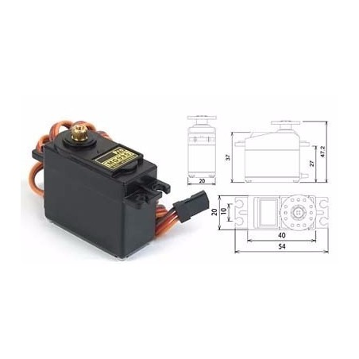
Fig.2.7 – Servo drive MG996R: general view & overall dimensions
In terms of parameter-to-cost ratio, the servo drive MG996R (Fig. 2.7) produced the values shown in Table 2.1. Because the Its paddle wheel has a radius of 3 mm, the length of the arc it scrolls will be equal to one-third of the perimeter (6.28 mm), because the angle of rotation is only 120 degrees. The minimal pitch for 1 degree of rotation is 0.052 mm.
Table 2.1 – System characteristics
Dimensions, mm | 40x19x43
torque, kg/cm | 15
Operating supply voltage | 4.8-7.2 V
supply current, A | 0.5-2.5
Maximum angle of rotation, degrees | 120

Following that, we chose a load cell with the characteristics shown in Table 2.2 and an analog-to-digital converter HX711 (Fig.2.8) with the values shown in Table 2.3.
Table 2. 2 – Technical parameters of load cell
Dimensions, mm | 80x12.7x12.7mm
Material | Aluminum
Complex error, % | 0,2
Impedance, Oh | 1000 ± 50
Recommended voltage, V | 5-10
Maximum measurement weight, kg | up to 20 (approx. 200 N)

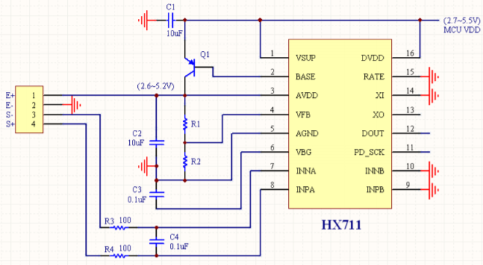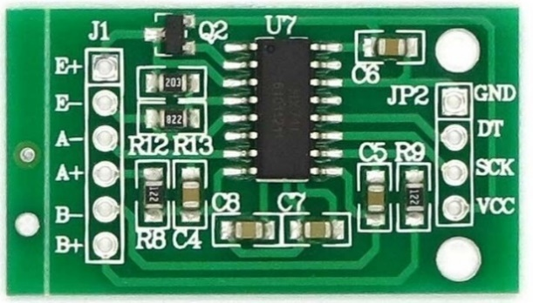
a b
Fig.2. 8 – Analog-to-digital converter HX711: electrical circuit (a), general view (b)
Based on Avia Semiconductor technology, the HX711 is a precision 24-bit analog-to-digital converter (ADC) designed for scales and industrial control devices for direct interaction with the sensor.

Table 2. Fig. 3 – Technical parameters of the ADC HX711
Differential input with voltage, mV | ± 40
Conversion accuracy, bit | 24
Refresh rate, Hz | 80
Operating voltage, V | 5
Operating current, mA | 10
Size, mm | 38 x 21 x 10

To control the installation was chosen affordable and sufficiently functional microcontroller Robot Dyn Arduino Nano V3 CH340G.

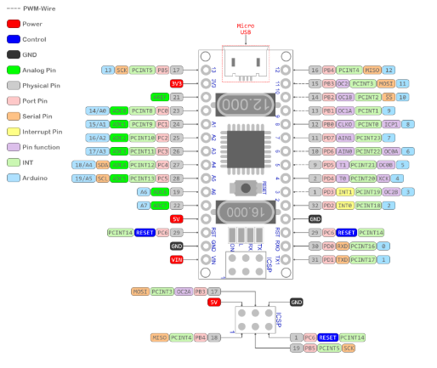
- b)
Fig 2.9 – MC Robot Dyn Arduino Nano:
- general view, b) connection diagram

The characteristics of this MC (Table 2.4) fully satisfy the requirements and has a number of significant advantages over similar controllers:
- and the fuse that protects the USB port of the computer and Nano V3 from both and statistical currents is removed fatigue;
- K Versova resonators are more reliable, stable and accurate in time of nanny with small ceramic ones;
- Micro USB is more convenient and common than Mini USB cable.

Table 2. 4 – Technical parameters of Arduino Nano V3 CH340G
Analog input pins | 8
Digital I/O contacts | 14
Operating frequency, MHz | 16
Flash memory, KB | 32
Operating voltage, V | 5
Operating current, mA | 40
Input voltage, V | 7-12

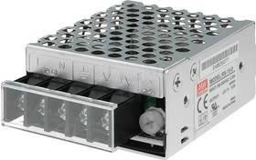
Fig.2. 10 – Power supply RS-15-5
Table 2. 5 – Technical parameters RS-15-5
Temperature conditions | -20… 70
Output voltage, V | 5
Load current, A | 3
Input voltage, V | 88… 264
Protection | from short circuit  Overload  temperature difference  supply voltage drops

The power supply was chosen to meet the demands of the servo drive while also providing the highest level of safety available.

2.4 Designing a working layout

Special parts were created in the SolidWorks 2018 software environment based on the size and technical aspects of the installation elements[13]. The pieces were designed for 3D printing and subsequent assembly of the installation's functioning arrangement.
ABS plastic was chosen as the material for the details of the working layout.
ABS plastic is a modern yellowish synthetic polymer with a high degree of impact resistance. Due to its technical characteristics, it has found wide application as an engineering and structural material.
The material has the following characteristics:
- high wear resistance and strength combined with elasticity;
- durability under operating conditions without exposure to ultraviolet rays;
- high resistance to detergents and alkaline compounds;
- resistance to moisture, acids and oils;
- under normal conditions, the material is non-toxic;
- can be operated at temperatures from -40 ° C to + 90 ° C with the collection of technical characteristics.
The mount for the servo was designed taking into account the size of the servo drive itself and the guide. For better fixation, a rubber gasket is placed between the servo drive and the mount.
The details were developed for 3D printing and subsequent assembly of the design of the working layout of the installation.
In general, in order to assemble a working layout, it was necessary to develop and print 8 parts, some of them are shown in Figure 2. 11, 2. 12.
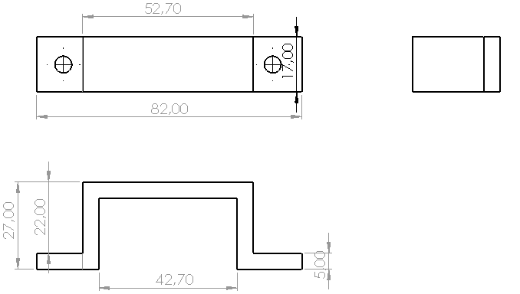
Fig.2. 11 – Mounting the servo drive on the guide
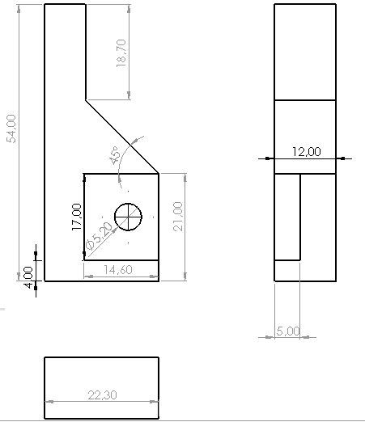
Fig.2. 12 – Intendor

The general view of the installation, after all the parts have been printed and assembled, is shown in Figure 2.13.
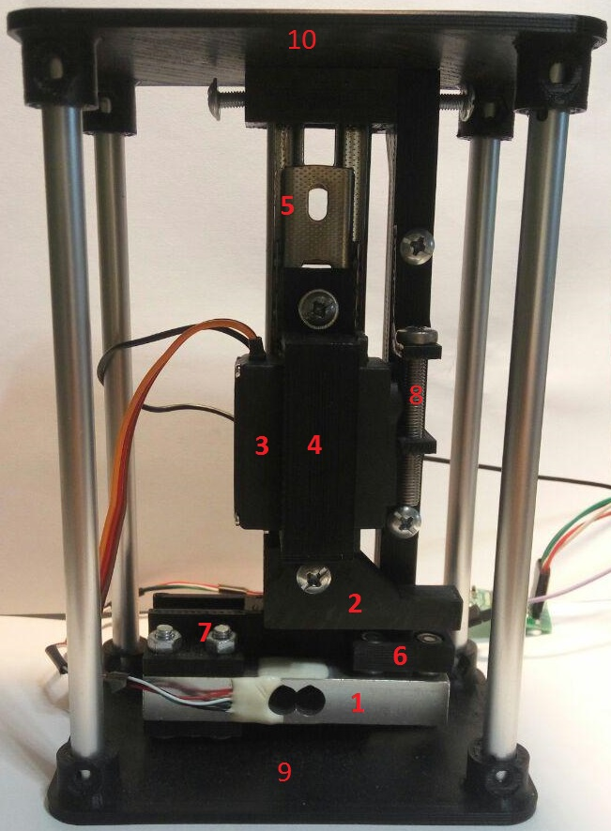
Fig.2.12 – Installation for determining the mechanical properties of biological tissues
In Fig.2.13:
1 – load cell;
2 – indenter;
3 – servo drive;
4 – mounting the servo drive to the guide;
5 – guide;
6 – platform for the test sample;
7 – fastening of the load cell to the guide;
8 – screw with respect to which the servo drive, fastening of the fixed part to the guide,
9 – lower platform,
10 – upper platform.

2.5 Software for the developed installation

For normal operation of the installation, it was necessary to develop:
Program for load cell calibration (Appendix A) in Arduino IDE environment:
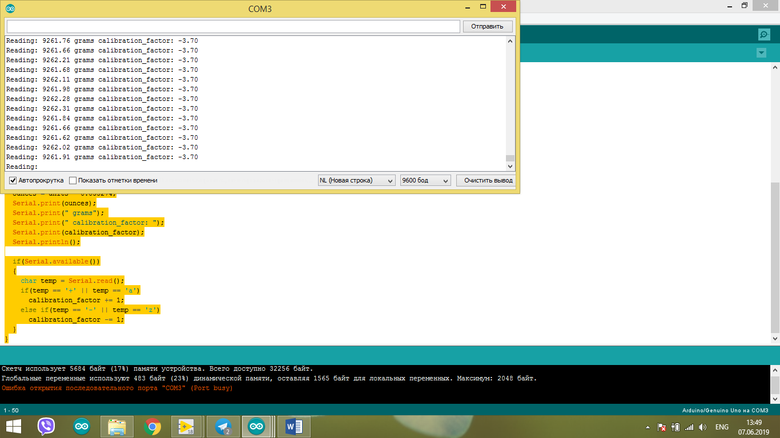
Fig.2.13 – The result of the program for calibration
As can be seen in Figure 2.13, the values of force and calibration factor come to the USB port of the computer. In this case, the readings of 9261 grams are considered zero, and any change in this value will indicate the presence of force acting on the sensor.
Program for taking readings from the strain gauge and servo drive control (Appendix B) in the Arduino IDE environment [14]:

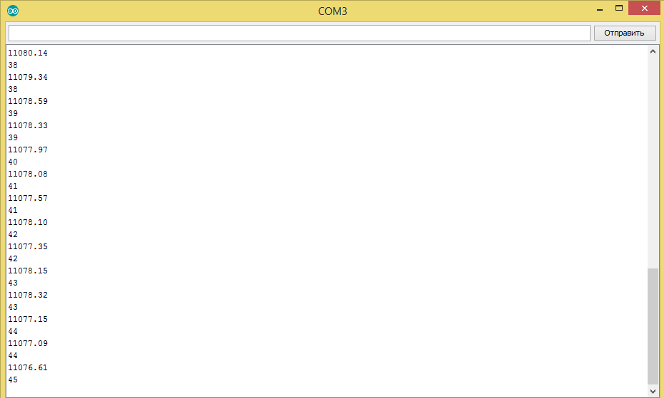
fig.2.14 – The result of the program for taking readings from the load cell and controlling the servo drive

As can be seen in Figure 2.13, the force values and the current position of the servo drive come to the USB port of the computer, which makes it possible to judge the deformation and build a deformation diagram.
- Program product (PP) in the environment LabView 2018 [21, 2 2] for displaying data on a specially designed interface (Fig. 2.1 5) user, further processing and analysis (Appendix B, Fig. B.1).
This state of emergency should embody the following functions:
- Receive research results from the MK and display a deformation diagram on a graphical display;
- Save the received data to a file on a computer;
- Open saved data and re-display it;
Add a researcher's comment to saved files.
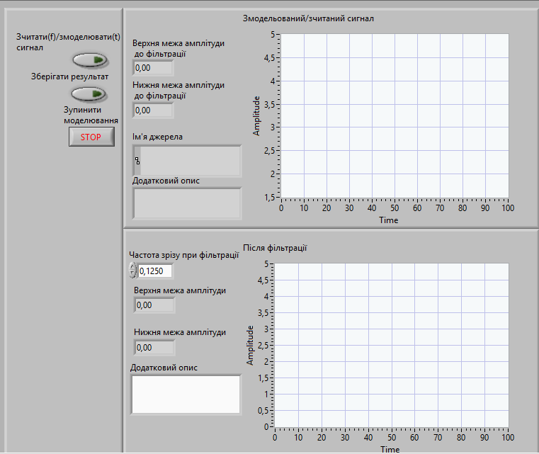
Fig.2.15 – Specially designed user interface

In the course of the practical part, on the basis of the analyzed analogues, a block diagram of the installation was developed to determine the mechanical properties of biomaterials. The principle of operation of each element of the scheme separately was also considered.
A simulation of the compression of muscle tissue was performed, and the element basis of the installation was chosen based on the results. Details were also produced for 3D printing and the eventual collecting of the installation's functional arrangement.
The software required for the installation's operation, as well as the user interface for easy contact with it, were created.

The Standard Linear Model
The standard linear model can be represented by one dashpot and two springs, . The upper part is composed of a linear spring; the lower part shows a Maxwell element. Similar to the procedure used, the total strain of the Maxwell element is considered as an addition of the strain in the dashpot (εd) and the strain in the spring (εs = ε − εd). The following relations can be proposed for variables that determine the standard linear model:
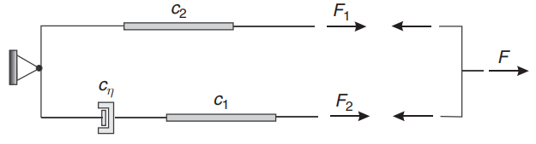
The three-parameter standard linear visco-elastic model
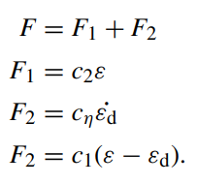
Elimination of ε˙d, F1 and F2 from this set of equations leads to
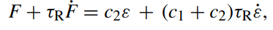
with τR = cη/c1 the characteristic relaxation time. The force response to a step ε(t) = ε0 H(t) in the strain yields
(where 'hom' denotes homogeneous and 'part' denotes specific) with an integration constant set by the beginning circumstances. It is not easy to determine the initial situation at t = 0 for this problem. At t = 0, it is a jump situation with a discontinuous force F and strain. This jump condition may be derived using the time derivative definition:
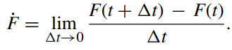
Let us take two time points a distance t apart, one point on the time axis left of t = 0, which we call t = 0−, and one point on the right side of t = 0, which we call t = 0+. In that case Eq. (5.97) can be written as
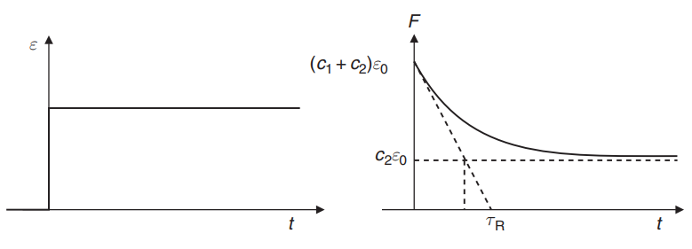
There are several ways to determine the creep function. We can solve Eq. (5.97) for a step in the force. This can be done by determining a homogeneous and a particular solution as was done for the relaxation problem. However, it can also be done by means of Laplace transformation of the differential equation. This leads to an algebraic equation that can be solved.
The result can be transformed back from the Laplace domain to the time domain. Instead of again solving the differential equation we can use the relation that exists between the creep function and the relaxation function, Eq. (5.36). A Laplace transformation of G(t).

Critical energy release rate
The crucial energy release rate, denoted by the symbol Gc, is commonly used to indicate the interlaminar fracture toughness of laminated composites. The energy spent by the material as the delamination front proceeds across a unit area is referred to as the critical energy release rate. Gc is generally measured in Joules per square metre or Newtons per metre. Interlaminar fracture toughness can be assessed in each of the modes alone or in combination.
Typical interlaminar fracture toughness values in modes I and II (GIc and GIIc, respectively) for various carbon fiber and matrix types:
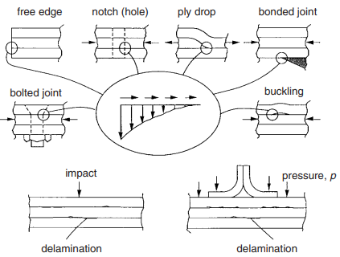
Possible sources of delamination initiation caused by through thickness stresses
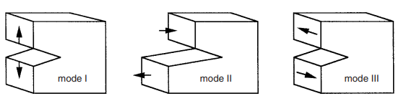
Schematic diagrams of the basic modes of crack loading, mode I

The critical stress intensity factor) is often given solely for the mode I situation.
Because the toughness of these materials is lowest in this mode, even if a crack is loaded to drive the development in mode II, (a), the fracture will divert and expand in a path that is pure mode I, as shown in (b). However, in laminated composites, delamination can be limited to occur between the strong fiber-reinforced layers, allowing for delamination development in all three phases.

Conclusion

For full-fledged automated operation was developed software for data processing and presentation them on the user's display in the devices for investigation of mechanical properties of biomaterials. It allows researchers to measure and analyze the mechanical properties of various biomaterials.

SECTION 3 OCCUPATIONAL SAFETY

3.1 Characteristics of the object and its components

3.1.1 Characteristics of the object

The main technical characteristics are shown in Table 3.1.
Table 3.1 – System characteristics
№ | Name of the device and functional blocks | Main characteristics | K-st | Position in figure
1 | Microcontroller Arduino Nano | Supply voltage 7... 12 V  Power supply current 20mA  Load current 0.5 A  Temperature conditions 0... 85º С  Product class by protection method 1  Product class according to the degree of protection BF | 1 | 1
2 | Power supply RS-15-5 | Input voltage 88 - 264 V, 60 Hz  Output voltage 5 V  Load current 3 A  Temperature conditions -20... 70º С  Protection against short circuit, overload, temperature difference, supply voltage drops | 1 | 2
3 | Servoprivid MG996R | Supply voltage 4,8... 7,2 V  Supply current 0,5... 2,5 A  Starting torque 15 kg/cm  Rotation angle 120° | 1 | 3
4 | Load cell | Material: aluminum  Recommended voltage 5... 10 V  Maximum measured weight 20 kg | 1 | 4
5 | HX711 ADC | Operating voltage 5 V  Power supply current 10 mA  Temperature conditions 0... 85º С | 1 | 5
6 | Intendor | Material: ABS plastic  Compressive strength 46... 80 MPa  Softening temperature 90... 105 ° C  Electric strength 12... 15 MV / m. | 1 | 6
The next subparagraph will consider the functional diagram of the device.

3.1.2 System components
In pic. 3.1. The functional diagram of the device for studying the mechanical properties of biomaterials is shown.
220B
6
2
3

4
1
5

Figure 3.1 - Functional schematic of the apparatus for studying biomaterial mechanical properties: 1 - Arduino Nano microcontroller, 2 - RS-15-5 power supply, 3 - servo drive MG996R, 4 - load cell, 5 - ADC HX711, 6 - indenter.
Because the servo drive requires a separate current source, a power supply was added to the circuit. A microcontroller powers everything else.

3.1.3 The nature of interaction in the system "man-object"
Means of obtaining information about the status of connection of the device and the operation of the system are presented in Table. 3.2.

Table 3.2 – Interaction of the object in the system "man-object"
№ | Name of the functional block | Type of information display | K-st
1 | Microcontroller Arduino Nano | Connection indicator - LED | 1
2 | Power supply RS-15-5 | Connection indicator - LED | 1
3 | Source data processing unit | Indicator of correct operation of the device - monitor | 1

During the device's design, it was determined to limit the researcher's involvement with the installation as much as possible; hence, the system is automated, with the exception of the step of placing the test sample on the platform. This greatly decreases the chance of injury while operating inside the gadget. In addition, the presence of work indications on important aspects of the device will allow you to respond quickly in the event of faulty operation.

3.2 Assessment of potential hazards created by the system design and measures to eliminate them

When evaluating the potential hazards associated with a system design and devising strategies to eliminate them, it is vital to approach the task systematically, ensuring the safety of all involved. The following steps should be taken into consideration:

Hazard Identification: Thoroughly examine the system design to identify any potential hazards that could arise during its operation. Take into account various factors such as mechanical, electrical, chemical, and environmental hazards that may pose risks to individuals or the surrounding environment.

Risk Assessment: Evaluate the severity and probability of each identified hazard. Assess the potential consequences and the likelihood of their occurrence. This step is instrumental in prioritizing hazards based on their level of risk.

Risk Control Measures: Once hazards have been identified and assessed, it is essential to establish appropriate control measures to either eliminate or minimize the associated risks. The hierarchy of controls provides guidance in this regard:

a. Elimination/Substitution: Modify the system design to remove or replace hazardous components or processes with safer alternatives.

b. Engineering Controls: Implement engineering solutions such as safety interlocks, shielding, or physical barriers to mitigate risks.

c. Administrative Controls: Establish procedures, policies, and training programs to reduce risks. This may include implementing warning signs, defining standard operating procedures, or providing comprehensive employee training.

d. Personal Protective Equipment (PPE): If hazards cannot be eliminated or sufficiently controlled through other means, ensure the provision and enforcement of appropriate PPE, such as safety goggles, gloves, or respirators.

Design Review and Testing: Conduct meticulous design reviews, simulations, and testing to identify any potential flaws or vulnerabilities. This comprehensive process guarantees compliance with safety standards and ensures that the system functions as intended.

Emergency Preparedness: Develop contingency plans and protocols for emergency responses in the event of unforeseen incidents or system failures. Establish clear communication channels and define emergency shutdown procedures.

Documentation and Training: Thoroughly document all identified hazards, conducted risk assessments, and implemented control measures. Provide extensive training to system operators and maintenance personnel on safe practices, emergency procedures, and the proper use of safety equipment.

Ongoing Monitoring and Improvement: Continuously monitor the system's performance, gather feedback from operators, and investigate any incidents or near misses. Implement a feedback loop to identify areas for improvement and update the system design and safety measures accordingly.

Always bear in mind that the specific hazards and mitigation measures will vary depending on the nature of the system being designed. It is imperative to consult relevant safety standards, regulations, and domain experts to ensure a comprehensive hazard assessment and effective risk management throughout the process.

3.2.1 Mechanical hazard
Mechanical risks can be produced by the existence of moving and rotating parts in the building, as well as the possibility of destroying specific sections and equipment pieces.
The primary mechanical dangers stemming from the device's functioning are listed in Table 3.3. Table 3.4 compares the real and normative values of hazard variables [2,4], whereas Table 3.5 shows the relevant measurements.
A mechanical hazard refers to any potential danger or risk arising from the physical components, processes, or interactions within a system that can cause harm to individuals or property. Mechanical hazards typically involve machinery, equipment, tools, or other mechanical systems. Here are some examples of mechanical hazards:

Moving Parts: Machinery with rotating, reciprocating, or moving parts can pose a risk of entanglement, trapping, or crushing injuries. Examples include conveyor belts, gears, chains, or rotating shafts.

Pinch Points: Areas where two or more objects come together with the potential to pinch or crush body parts. Examples include doors, hinged mechanisms, or folding equipment.

Falling Objects: Objects that may fall from height or be dislodged from their position, potentially causing injury. This can occur in construction sites, warehouses, or storage areas.

Sharp or Cutting Objects: Tools or equipment with sharp edges or blades that can cause lacerations or puncture wounds. Examples include knives, saws, or broken glass.

High-Pressure Systems: Systems involving high-pressure fluids, gases, or steam can result in explosions, bursting pipes, or sudden releases that can cause severe injuries.

Noise and Vibration: Excessive noise levels and vibrations from machinery or equipment can lead to hearing loss, musculoskeletal disorders, or other health issues.

Electrical Hazards: Electrical systems within machinery or equipment can pose risks of electric shock, short circuits, or fires.

Ergonomic Hazards: Poor ergonomics, such as awkward postures, repetitive motions, or heavy lifting, can lead to musculoskeletal injuries over time.

To mitigate mechanical hazards, it is crucial to implement appropriate engineering controls, such as machine guarding, safety interlocks, emergency stop mechanisms, or warning signs. Adequate training, personal protective equipment (PPE), regular maintenance, and ongoing hazard assessments are also essential to ensure the safety of individuals working with or around mechanical systems. Compliance with relevant safety standards and regulations is paramount in addressing and minimizing mechanical hazards.

Table 3.3 – Main mechanical hazards
№ | Name of the functional block | Source of danger | Causes of danger | Consequences of danger
1 | Servoprivid MG996R | Mechanical pressure | Increased pressure in the mechanism | Gearbox damage
1 | Servoprivid MG996R | Mechanical pressure | Seizure mechanism | Engine overheating, damage to the control system
2 | Intendor | Mechanical pressure | Increased pressure in the mechanism | Deformation of the indenter, sample platform

An examination of important dangers and detrimental production variables that can be caused by the design of the intended device was performed in this part.

Means to eliminate possible hazards and harmful production factors were considered.
The key hazards in the system are pressure and electric current. Instructions for the safe operation of the designed device were developed.

One of the necessary conditions for the clinical usage of biomaterials in orthopedics is biocompatibility. It refers to a biomaterial's capacity to fulfill its job without causing hazardous or harmful effects on biological systems while providing a suitable host reaction in a given circumstance. Biocompatibility now encompasses not just bio inertia, but also bio functionality and biostability. New biomaterials with good biocompatibility and functional characteristics are highly sought.
The chemical, mechanical, and structural characteristics of biomaterials, as well as their interaction with biological environments and evaluation technique, can all have an impact on biocompatibility. The biological assessment of biomaterials covers a wide range of in vitro and in vivo studies for cytocompatibility, genotoxicity, sensitization, irritation, acute and chronic toxicity, hemocompatibility, reproductive and developmental toxicity, carcinogenicity, and other factors.[18]

Conclusion

In the section on labor protection was mentioned the factors of important dangers and techniques of eliminating or decreasing the risk this probable hazards and damaging production factors: noise and vibration, electrical hazards, ergonomic hazards.

BLISTING APPLICATION OF LOAD CELL READING PROGRAM

#include <Servo.h>
Servo myservo;
int pos;
int Key;
int val;
#define A_MAX 1024
#define A_VREF 5
#define A_VMIN 0.5
#define A_VMAX 2.5
int realAngle(){
return map(
analogRead(A0),
A_MAX * A_VMIN / A_VREF,
A_MAX * A_VMAX / A_VREF,
20, 100);
}
#include "HX711.h"
const int LOADCELL_DOUT_PIN = 2;
const int LOADCELL_SCK_PIN = 3;
float calibration_factor = -3.7;
float units;
float ounces;
HX711 scale;
void setup() {
Serial.begin(9600);
myservo.attach(9);
scale.set_scale();
scale.tare();
scale.set_scale(calibration_factor);
}
void loop() {
val=Serial.read();
if(val<0) {
val=Key;
delay(1000);
}
if (val=='U')
{
Key='U';
scale.begin(LOADCELL_DOUT_PIN, LOADCELL_SCK_PIN);
for(post=20; post<=100; post+=1) {
myservo.write(pos);
for(int i = 0;i < 5; i ++) units =+ scale.get_units(), 5;
units / 5;
ounces = units * 0.035274;
Serial.print(ounces);
Serial.println();
Serial.print(realAngle());
Serial.println();
}
}
if (val=='D')
{
Key='D';
for (pos = 100; pos >= 20; pos -= 1) {
myservo.write(pos);
for(int i = 0;i < 5; i ++) units =+ scale.get_units(), 5;
units / 5;
ounces = units * 0.035274;
Serial.print(ounces);
Serial.println();
Serial.print(realAngle());
Serial.println();
}
}
if(val=='S'){
Key='S';
delay(100);
}
}

APPLICATION INSOFTWARE PRODUCT, WHICH IMPLEMENTS USER INTERFACE AND DATA PROCESSING

Application software, also called application program, software designed to handle specific tasks for users. Such software directs the computer to execute commands given by the user and may be said to include any program that processes data for a user.
A system software interfaces the system with the application software. The finest example is the numerous operating systems, which allow users to download and run various programs on their device.

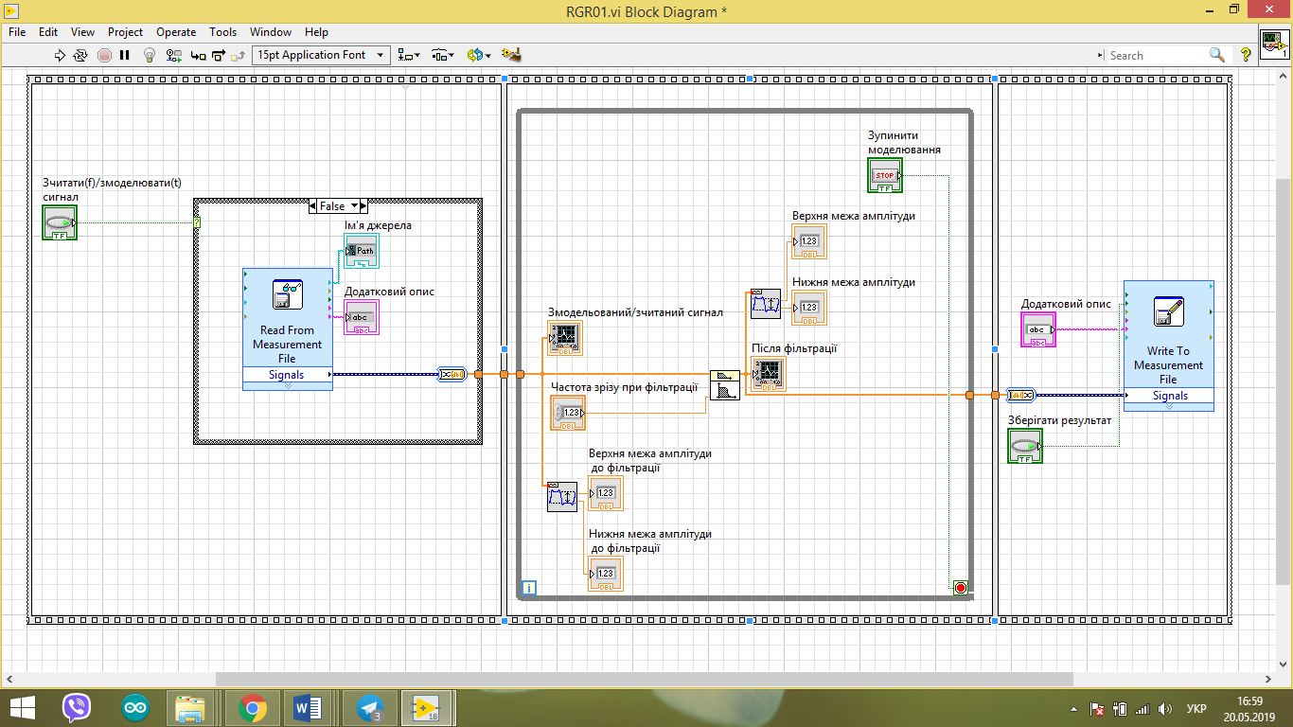

The program code in NI LabView, which implements the user interface and data processing.

CONCLUSION
All of the assignments were accomplished while working on this thesis. An examination of the technical literature revealed which factors the device should explore in order to acquire the values of the Young's modulus and the deformation diagram at the output while taking biomaterial properties into consideration. This will assess the viability of the tissues under investigation under specified conditions.
The search for devices that would perform a comparable role enabled the identification of important blocks of such a system, and a block diagram was created as a result. The operating idea of the scheme's blocks was also examined individually.
A simulation of the compression of muscle tissue in the COMSOL software environment was performed, and technical requirements for the device's blocks were developed based on the data received. The information required for gathering the installation's functioning layout have been produced in the SolidWorks software environment.
Load cell calibration software was designed to increase installation accuracy and for full-fledged, automated operation of the installation in the Arduin IDE program, and software for data processing and presentation on the user's display was produced.
The factors of important dangers and techniques of eliminating or decreasing the risk of probable hazards and damaging production factors were mentioned in the section on labor protection.The Device for investigation of mechanical properties of biomaterials is an important tool in the field of biomaterials research. It allows researchers to measure and analyze the mechanical properties of various biomaterials.

References
    - Biophysics and biomechanics. /V.S. Antonyuk, M.O. Bondarenko, V.A. Vashchenko. – K.: NTUU "KPI", 2012. – 344 p.
    - Medical and biological physics / Chaly O.V. – Vinnytsia: New book, 2013. – 528 p.
    - Investigation of viscoelastic properties of biological tissues [Electronic resource] – Access mode to the resource: - Date of access: 16.04.2019
    - The power of tension. Hooke's Law. [Electronic resource] – Access mode to the resource: - Date of access: 16.04.2019
    - Voltage module (Young's module) [Electronic resource] – Access mode to the resource: - Date of access: 16.04.2019
    - Poisson coefficient [Electronic resource] – Access mode to the resource: https://formula.kr.ua/mehanichni-vlastivosti-rechovin/koefitsient-puassona.html. - Date of access: 16.04.2019
    - Khomyk N.I. Resistance of materials and fundamentals of the theory of elasticity and plasticity / Khomyk N.I., Dovbush T.A., Rubinets N.A. – Ternopil, 2017. – 232 p.
    - In-vitro Strain and Modulus Measurements in Porcine Cervical Lymph Nodes. // The Open Biomedical Engineering Journal. – 2011. – С. 39–46.
    - Hayes WC, Herrmann G, Mockros LF, Times L M. " Mathematical analysis for indentation tests of articular cartilage". J.Biomech. 1972; 5 : 541–51.
    - Installations for compression research Instron [Electronic resource] – Access mode to the resource: - Date accessed: 30.04.2019
    - Load cells. General information and principle of operation. [Electronic resource] – Access mode to the resource - Access date: 30.04.2019
    - Sensor tuning-fork [Electronic resource] – Access mode to the resource - Access date: 22.04.2019
    - Viktorova N. V. Strain gauge systems with mechanical deformation amplifiers / Viktorova N. V. – Kyiv, 2018.
    - Device of console load cells [Electronic resource] – Mode of access to the resource: - Access date: 1.0 5.2019
    - National Instruments [Electronic resource] - Access date: 11.0 5.2019
    - Instruction manual LabView [Electronic resource] - Access date: 11.0 5.2019
    - Methodical instructions for the implementation of the section "Labor protection and safety in emergency situations" in diploma projects for students of the Faculty of Biomedical Engineering / Compiled by: Demchuk G.V., Kachynska N.V., Chikunova - Vasilieva N.P.K.: NTUU "IGOR SIKORSKY KYIV POLYTECHNIC INSTITUTE", - 38 p.
    - G.V. Demchuk. Lecture notes on the disciplines "Life Safety and Civil Protection", "Labor Protection and Civil Protection" (part 2 of the OP), for the preparation of full-time (part-time) students of the Faculties of Biomedical Engineering, Electronics and Physics and Mathematics for the educational and qualification level "bachelor".
    - Biomaterials Science: An Introduction to Materials in Medicine" by Buddy D. Ratner, Allan S. Hoffman, Frederick J. Schoen, and Jack E. Lemons.
    - Biomechanics: Concepts and Computation" by Cees Oomens, Marcel Brekelmans, and Frank Baaijens.

