Національний технічний університет України
«Київський політехнічний інститут
імені ігоря сікорського»
ФАКУЛЬТЕТ БІОМЕДИЧНОЇ ІНЖЕНЕРІЇ
(повна назва інституту/факультету)
КАФЕДРА БІОМЕДИЧНОЇ ІНЖЕНЕРІЇ
^{(повна назва кафедри)}

«До захисту допущено»
Завідувач кафедри
__________ Владислав ШЛИКОВ
(підпис) (ІМ’Я, ПРІЗВИЩЕ)
“___”_____________2021 р.

Дипломна робота
на здобуття ступеня бакалавра
за освітньо-професійною програмою _______Клінічна інженерія_______
спеціальності 163 «Біомедична інженерія»
^{(код і назва)}
на тему «Розробка алгоритму застосування термограм очей в якості діагностичного критерію»
Виконала: студентка __4__ курсу, групи ____БМ-73i_____
^{(шифр групи)}
_________________ Розробка алгоритму застосування термограм очей в якості діагностичного критерію»
_Маріна АВІДА
^{(ім’я, ПРІЗВИЩЕ)} ^{(підпис)}
Керівник ____ст.вик. каф. БМІ, Валентина ДАНІЛОВА
(посада, науковий ступінь, вчене звання, ім’я, ПРІЗВИЩЕ) ^{(підпис)}
Рецензент доц. каф. ББіЗЛ, к.т.н., доц., Юлія АНТОНОВА-РАФІ
(посада, науковий ступінь, вчене звання, науковий ступінь, ім’я, ПРІЗВИЩЕ) ^{(підпис)}
Нормоконтролер доц. каф. БМІ, к.т.н., доц., Микола БОГОМОЛОВ
(посада, науковий ступінь, вчене звання, науковий ступінь, ім’я, ПРІЗВИЩЕ) ^{(підпис)}

Засвідчую, що у цій дипломній роботі немає запозичень з праць інших авторів без відповідних посилань.
Студент _____________
^{(підпис)}
Київ – 2021
National Technical University of Ukraine
“Igor Sikorsky Kyiv Polytechnic Institute”
FACULTY OF BIOMEDICAL ENGINEERING
(full name of the institute / faculty)
DEPARTMENT OF BIOMEDICAL ENGINEERING
^{(full name of the department)}

«As a manuscript»  UDC 615.849.19 | «Approved for defense»  Head of the Department of BMI ___________VladyslavSHLYKOV  (signature) (initials, surname)  “ ____ ” ______________2021

Diploma thesis
for a bachelor's degree
according to the educational and professional program ____Clinical engineering ____
in the specialty |  | 163 «Biomedical engineering »
^{(code and name)}
topic: | «Development of an algorithm for the use of eye thermograms as a
diagnostic criterion »
Completed: 4th year student, group BM-73i
^{(group code)}
Marina AWIDA
^{(Full Name)} |  |  |  | ^{(signature)}
Supervisor | Senior LecturerBMI, Valentyna DANILOVA
(position, academic degree, academic title, surname and initials) |  |  |  | ^{(signature)}
Reviewer | Assoc. dep. BHH, Ph.D., Assoc. prof. Yu.V.Antonova-Rafi
(position, scientific degree, academic title, scientific degree, surname and initials) |  |  |  | ^{(signature)}
Normocontroller |  | Assoc. dep. BMI, Ph.D., Assoc. prof. M. Bogomolov
(position, academic title, scientific degree, surname, initials) |  |  |  | ^{(signature)}

I certify that in this master's dissertation there are no borrowings from the works of other authors without appropriate references.
Student _____________
^{(signature)}

Kyiv – 2021
NATIONAL TECHNICAL UNIVERSITY OF UKRAINE
“IGOR SIKORSKY KYIV POLYTECHNIC INSTITUTE”

FACULTY BIOMEDICAL ENGINEERING
DEPARTMENT BIOMEDICAL ENGINEERING
Level of education First (bachelor's) level
Specialty 163 « Biomedical engineering»
Educational and professional program Clinical engineering

«Admission to the defense»
Head of the Department of BMI ________VladyslavSHLYKOV
(signature) (initials, surname)
“ ____ ” ______________2021

TASK
For student`s bachelor thesis

Marina AWIDA
^{(Full Name)}
1. Topic | «Development of an algorithm for the use of eye thermograms as
a diagnostic criterion »
scientific supervisor of the dissertation |  | Valentyna DANILOVA, Senior Lecturer BMI
 |  | (last name, first name, patronymic, academic degree, academic title)
approved by the order of the university № 48/21-si from 31/05/2021

2. The deadline for students to submit a dissertation 06.06.2021
3. The object of the study is thermography in ophthalmology.
4. The subject of research is the use of eye thermograms as a diagnostic criterion.
5. List of tasks to be developed to develop system for assessing the state of vision using thermograms, to analyze the impact of harmful factors and working conditions in the workplace,
6. Approximate list of graphic material 23 tables, 21 figures
7. Date of issue of the task 10.03.2021
SCHEDULE
№ з/п | Name of stages of execution  diploma thesis | Deadline for stages  diploma thesis | Note
1 | Analysis of scientific literature and patent databases on a given topic | 16. 04. 2021
2 | Development of the content and structure of bachelor thesis | 20. 04. 2021
3 | Development the strategy of determinant the pathology of the attention on the temperature relief. | 26. 04. 2021
4 | Development of a method of determinant the pathology of the attention on the temperature relief. | 30. 04. 2021
5 | IR image process performed by MATLAB to be used for analysis of thermograms | 04. 05. 2021
6 | Safety and precautions | 12. 05. 2021
7 | Registration of bachelor thesis | 01.06.2021
8 | Getting a review and feedback | 04.06.2021
9 | Passing norm control | 06.06.2021
10 | The bachelor thesis protection | 16.06.2021

Student |  |  |  | Marina AWIDA
 |  | ^{(signature)} |  | ^{(initials, surname)}
Supervisor of the dissertation |  |  |  | Valentyna DANILOVA
 |  | ^{(signature)} |  | ^{(initials, surname)}

ABSTRACT

This Bachelor’s dissertation consists of an introduction, 3 chapters, conclusions, list of references and appendix. The volume of work is 61 pages, the number of illustrations - 21, tables - 23, appendices - 2, sources on the list of links - 22.
This work presents our own expertise with the utilization of diagnostic procedure as a complementary methodology for the initial identification and differentiation of intraocular tumors, furthermore as for the analysis of the effectiveness of treatment of intraocular melanomas.
In this thesis, an algorithmic rule for the detection and localization of the face and eyes in thermal pictures is conferred, significantly the temperature activity of the shape by mensuration the attention corner (outer canthus) temperature.
This methodology of analysis is predicated on the registration of infrared from the surface of the flesh, that accounts for forty fifth of the overall natural heat loss from the surface of the skin. With the assistance of special instrumentality, spontaneous and pathological infrared is recorded.
Thermal imaging system (thermography) could be a non-invasive imaging procedure accustomed record the thermal patterns victimization Infrared (IR) camera. It provides visual and qualitative documentation of temperature changes within the vascular tissues, and is commencing to play a vital role within the field of medical specialty.
For achieve this purpose, the following research objectives were identified:
- To apply the strategy of determinant the pathology of the attention on the temperature relief.
- IR image process performed by MATLAB to be used for analysis of thermograms.
Keywords: thermography, thermal imaging diagnostics, temperature, algorithm, pathology.
АНОТАЦІЯ

Обсяг дипломної роботи складає 61 сторінки, кількість ілюстрацій – 21, таблиць – 23, додатків – 2, джерел за переліком посилань – 22.
У даній роботі був розглянутий та досліджений новий метод діагностики зору – за допомогою термографії. Адже аналіз теплових процесів дозволяє отримувати різноманітну інформацію про стан об`єкту дослідження і протікання фізичних процесів у багатьох областях людської діяльності.
Було проведено дослідження за допомогою двох тепловізорів та даними знятими з 9 осіб з різним станом зору, була створена спеціальна програма в середовищі MatLab для опрацювання термограм. Отримані результати були підтверджені реальними значеннями отриманими іншими вже існуючими методами діагностики, які застосовуються сьогодні в медицині.
За результатами дослідження виявилось, що зіставлення результатів отриманих FLIR і оброблених в MATLAB і FLIR QuickReport показує їх збіг, що відображено в типовій формі температурного поля по всій області двох очей і в області очного яблука навколо зіниць, а також у значеннях абсолютної різниці температур, які збігаються для ІЧ-зображень оброблених в MATLAB і FLIR QuickReport. Метою роботи є розробка алгоритму обробки термограм очей та формування діагностичного критерію оцінки стану зору, зокрема дослідження використання теплобачення в якості методу діагностики зору – за допомогою термографії.
Для досягнення поставленої мети, були визначені наступні завдання дослідження:
- Аналіз існуючих тепловізійних систем.
- Аналіз термографів різних діапазонів для медичних досліджень. Дослідження причин зміни локальної температури поверхні біологічних об`єктів.
- Визначення методики проведення тепловізійної діагностики та вимог до умов проведення термографічних досліджень біологічних об`єктів.
- Розробка алгоритму застосування термограм в офтальмології.
Ключові слова: термографія, термографічні зображення, температура, алгоритм, патологія.

CONTENTS

LIST OF SYMBOLS, UNITS, ABBREVIATIONS AND TERMS 10
INTRODUCTION 11
SECTION 1 OVERVIEW OF THERMAL METHODS OF RESEARCH IN MEDICINE 12
1.1 The choice of the studied system 12
1.2 Brief historical background 13
1.3 The main trends in the development of thermal imaging systems 15
1.4 Principles and techniques of infrared thermography 16
1.5 Methods of thermal imaging diagnostics 18
1.6 Requirements for the conditions of thermographic studies of biological objects 21
1.7Research of the reasons of change of local temperature of a surface of biological objects 24
1.8 Analysis of thermographs of different ranges for medical research 26
Conclusions to section 1 29
SECTION 2 DEVELOPMENT OF ALGORITHM FOR APPLICATION OF THERMOGRAMS IN OPHTHALMOLOGY 30
2.1 Initial data 30
2.2 Conducting research and processing the data obtained 33
2.3 Methods for determining the pathology of the temperature relief 37
Conclusions to section 2 40
SECTION 3 SAFETY AND PRECAUTIONS 41
3.1 Characteristics of the thermography room 41
3.2 Assessment of hazardous and harmful production factors 44
3.3 Microclimate 44
3.4 Lighting 46
3.5 Noise 47
3.6 Chemical sources of hazardous and harmful production factors 48
3.7 Danger of electric shock 49
3.8 Fire safety in emergency situations 50
Conclusions to section 3 52

CONCLUSIONS 53
REFERENCES 54
APPENDIX A 57
APPENDIX B 61

LIST OF SYMBOLS, UNITS, ABBREVIATIONS AND TERMS

ICT – independent component thermography.
IR – infrared radiation.
IRIS –infrared imaging systems.
ITV–index temperature value.
IRT– infrared diagnostic technique technology.
US – ultrasound.
TIS – thermal imaging systems.

INTRODUCTION

Infrared diagnostic technique technology (IRT) could be a non-invasive technique that has been wont to calculate and show temperature as a picture. IRT will discover the variations in temperature and discover blood flow through determination the changes in vital sign. The conception behind IRT measures heat radiation that emitted from the surface of objects.
A thermographic camera shows the precise price and distribution of the temperature of the examined surface, that depends on the vascularisation and metabolism of the tissue. this method captures thermal pictures, that are literally visual displays of the number of infrared energy transmitted, emitted, or mirrored by the tissue [1].
Thermography may be a safe, noninvasive, and reproducible imaging technique which will be used for screening within the early identification of cancer. However, this identification has got to be confirmed by diagnostic procedure, ultrasound (US), and histopathological examination.
It is typically troublesome to differentiate between malignant and benign intraocular neoplasms or to see the tumor grade and its sort, particularly in cases of amelanotic changes and people in the course of visual impairment.
This article presents our own expertise with the utilization of diagnostic procedure as a complementary methodology for the initial identification and differentiation of intraocular tumors, furthermore as for the analysis of the effectiveness of treatment of intraocular melanomas.

SECTION 1
OVERVIEW OF THERMAL METHODS OF RESEARCH IN MEDICINE

1.1 The choice of the studied system

The analysis of thermal processes allows to receive various information on a condition of object of research and a course of physical processes in many areas of human activity.
The most valuable information is contained in thermograms of the human body, ie, the distribution of temperature on its surface.
Infrared, or thermal radiation, arises as a result of the excitation of particles of matter that contain electric charges (atoms, molecules, ions, etc.). It occupies a special place among other types of radiation due to its ability to be in balance with the internal energy of the radiating body [6].
Electromagnetic radiation spreads throughout the body, reaches the surface and, passing through the skin, is partially transmitted to the environment. The intensity of these processes is proportional to body temperature, and hence its emissivity.
Visualized temperature fields provide information about the state of peripheral blood flow and the deep processes occurring in the body.
The method of ICT is tested and used in the following areas of medical diagnosis [7]:
1) Oncology (tumors of the mammary glands, thyroid gland, lymph nodes, bones, etc.).
2) Neurology (pathology of peripheral nerves of the extremities, neurological syndromes of osteochondrosis of different parts of the spine).
3)Angiology (various diseases of the main arteries and veins of the extremities).
4) Traumatology and orthopedics (scoliosis, spinal fractures, arthrosis of large joints, early diagnosis of the depth of the burn, etc.)
5) General surgery (acute inflammatory pathology of the abdominal cavity, especially in children).
6) Reconstructive and reconstructive surgery (diagnosis of viability of transplanted and reimplanted segments, grafts).
7) Arthrology (diseases of large and small joints of the extremities of different genesis).
8) Otolaryngology (inflammatory diseases of the paranasal sinuses).
9) Endocrinology (thyroid disease, vascular and neural complications of diabetes).
Thus, the current level of development of thermal imaging equipment provides an opportunity to reliably diagnose a wide range of diseases (up to 150 different forms), which is the reason for the active introduction of ICT in world clinical practice along with other modern methods in the arsenal of doctors [8].

1.2 Brief historical background

The use of thermal radiation in biomedicine for research and diagnostic purposes is relevant due to the high informativeness of the method and the complete safety of its application to the object of study.
It is officially believed that thermal radiation (heat rays) was discovered in 1800 by the English physicist and astronomer William Herschel, who gave it the name "infrared radiation" (IR), ie radiation that lies beyond the red border of the visible spectrum. The lower limit of infrared radiation starts at 0.78 μm, and the upper limit is adjacent to the microwave region (about 1 mm). In 1840, the first so-called "thermal picture" was obtained, which was called the "thermogram", which is still used today in modern terminology.
In clinical practice, this method was first implemented by a Canadian surgeon, Dr. R. Lawson in 1956. He used a military night vision device for the early diagnosis of breast cancer in women, which marked the beginning of medical thermography. The probability of determining this pathology, especially at an early stage, was then about 60-70%, which in mass examinations justified the efficiency of thermal vision.
Since the discovery of infrared radiation, scientists have conducted a large number of studies to study its nature from the human surface and use these features to diagnose various pathologies.
In Ukraine, the first thermographic studies were performed by Professor A.I. Pozmogov in the 70s of the last century, at the Kyiv Research Radiology Institute of the Academy of Medical Sciences of Ukraine on a thermograph with cooling type "Rainbow".
However, despite the large number of monographs, articles and other publications in the field of medical thermography, this method has not yet taken a worthy place in practical medicine along with existing methods of functional diagnosis, and for Ukraine this completely non-invasive method is generally more exotic than reality.
Even despite the availability of thermal imaging methods in medical protocols, a full understanding of the usefulness of the method of infrared thermography (ICT) for biomedical tasks has not yet occurred.
The general situation, according to many researchers, to some extent is connected with the fact that thermographs of the first generations owing to their imperfection slowed down development and introduction of thermodiagnostics in clinical practice and caused steady rejection among doctors which is overcome still. The fact is that the first devices were bulky, had special operating conditions and they had virtually no processing of thermograms. All this required additional knowledge of service personnel and skills in interpreting thermal patterns. In addition, doctors (unfortunately, still) do not have a full understanding of the possibilities of modern thermography for medical purposes and the specifics of information obtained by thermal imaging for the diagnosis of various pathologies, especially in the early stages of their manifestation and control of treatment.
At present, in connection with emergence of new generation of thermographs with high temperature and spatial resolution, interest in this noninvasive method of diagnostics is again shown.

1.3 The main trends in the development of thermal imaging systems

The paper provides an overview of the main trends in the development of thermal imaging systems (TIS) - in the English literature IRIS, from infraredimagingsystems - which showed that today, the most common are next-generation matrix IR devices that use arrays of radiation receivers located in the focal plane of the optical system. FPA – focalplanearrays). The main advantages of these devices are: the absence of optical-mechanical scanning system and, accordingly, low weight, size and power consumption, silent operation, high signal-to-noise ratio and image quality, as well as a wide dynamic range. There are two types of matrices: cooled and uncooled. IR receivers on non-cooled matrices, although inferior in their limit parameters to radiation receivers that need cooling, however, they have a number of characteristics that make them indispensable in a wide range of applications. Therefore, in the English-language literature, another popular name for such devices - uncooled matrix receivers in the focal plane (UFPA – uncooledfocalplanearrays). The number of elements in such matrices can be from 256 × 256 and more, scanning is not applied, temperature sensitivity reaches 0,01°C, and spatial resolution on a matrix - to 3•10-5m. Such parameters give the chance to look at processes in biomedicine connected both with heat production, and with the mobility of the substances arising under the influence of local temperature gradients, and also with information processes of detection, recognition and classification [10].
Modern FPA-matrices of the IR range are made on the basis of various materials: lead chalcogenides (Pb, PbSe), compounds HgCdTe, InSb, PtSi, impurities of silicon (Si: x) and germanium (Ge: x), multilayer structures QWIP (quantum well infrared photodector) on GaAs-GaAlAs compounds, microbolometers and pyroelectric radiation receivers.
Most modern devices for the formation of thermal imaging images use FPA-matrix chips connected to an electronic circuit for reading signals from matrix detectors (ROIC - readout integrated circuits).
Today, the size of the individual elements of FPA receivers is approaching the theoretical limit due to the capabilities of optics (diffraction scattering). The most modern technological methods of multilevel circuits with submicron dimensions are used to create a ROIC element in the area corresponding to the size of one pixel of the matrix.
The theoretical foundations of thermal imaging technology are well developed and considered in the scientific and technical literature.
The paper also analyzes and compares the main characteristics of some modern fuel assemblies based on cooled and uncooled radiation receivers.
Summing up the review of modern thermal imaging technology, we can say that the usefulness of thermal imaging diagnostics for medicine has been proven in recent decades and is confidently included in the list of modern diagnostic methods.
Interest in medical heat vision is growing in all developed countries. Leaders in the production of thermal imaging equipment are the United States, Japan, Sweden, Russia and China.

1.4 Principles and techniques of infrared thermography

The principle of operation of the modern thermograph (equivalent name thermal imager, or thermal imaging camera) is based on transformation of natural thermal radiation from objects of researches, in the visible image (Fig. 1.1) [11].
The signal of a thermal field from object of researches passes on a way: IR lens - 1, matrix of IR photodetectors - 2, preliminary amplifiers - 4, multiplexer - 5, analog corrector of inhomogeneity of signals - 6, analog-to-digital converter - 7, digital corrector signal inhomogeneity - 8, corrector of non-working photodetectors of the matrix - 9, image forming unit with microprocessor processing - 10, clock generator - 11, video monitor - 12, output for connecting a personal computer (PC) - 14.

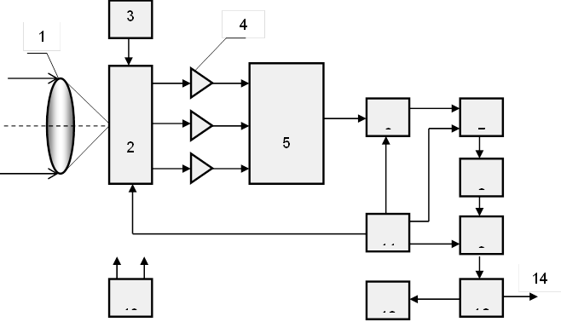

Figure 1.1 - Block diagram of a modern thermograph
The cooling or thermal stabilization unit (3) maintains the matrix in a stable functional state, and the power supply (13) provides the necessary voltages to all systems of the device. The inhomogeneities of the signals of the elementary photodetectors of the matrix are pre-corrected in analog form, converted into digital form and corrected using the data obtained during the calibration process. At the output of the image forming unit (10), the information is provided either as a video signal to the video monitor or in digital form for transmission to a personal computer.
Mathematical software of modern thermographs makes it possible to perform digital processing of IR images in real time, calculate the parameters of thermal relief, create databases of IR images and compare thermal images obtained at different times. This technology is rapidly evolving and is used to localize thermal anomalies characterized by areas of the skin surface with low or high temperature.
The physiological basis of thermography is the correlation between temperature and functional state of the body - an increase in the intensity of IR radiation over the pathological area (due to increased blood supply and metabolic processes in this place) or a decrease in its intensity in areas with reduced regional blood flow and accompanying tissue changes. bodies. That is, inflammation leads to hyperthermia, while the decline in muscle activity and insufficiency of blood supply (perfusion) give a picture of hypothermia.
The presence of a pathological process is characterized by one of three qualitative thermographic features: the appearance of abnormal zones of hyper- or hypothermia, changes in the normal thermography of the vascular pattern, as well as the presence of a temperature gradient in the study area.
Normally, the thermographic picture is characterized by a symmetrical pattern relative to the midline. The difference between the symmetrical sides normally does not exceed (0.2-0.4) °C. But each person's temperature distribution is individual.
The acquired knowledge and experience in the field of medical thermography, suggest that a person's thermal products (his thermal portrait) can give the researcher a lot of valuable information about the functioning of various body systems.

1.5 Methods of thermal imaging diagnostics

The diagnostic value of the results of thermal imaging studies largely depends on the exact implementation of the method of thermal imaging diagnostics (thermography). Failure to comply with simple research requirements results in a large percentage of erroneous results, which often leads to skeptical conclusions about this method. Due to the fact that thermal imaging is to register the temperature distribution on the surface of the patient's body, the main requirements for the temperature of the room (thermography room), where the study is conducted.
The room should be maintained at a constant temperature within 20-25°C. This temperature is optimal for humans, ie the difference between the ambient temperature and the average temperature of human skin should be within 10-15°C. At inspections in a warmer room, the contrast of thermograms decreases, and at an air temperature over 30°C, carrying out thermal imaging researches becomes practically impossible. In such a room, the mechanisms of human thermoregulation (such as sweating) are activated, and therefore, the thermal image can change dramatically.
When conducting an examination in a cold room, the person cools down, there is a redistribution of skin blood flow and muscle tremors. These factors can also greatly change the thermal image (thermogram), which leads to diagnostic errors. In addition, there should be no extraneous sources of infrared radiation, such as electric heaters, incandescent lamps, etc., and cold air streams (drafts) in the thermography room or study room. Direct sunlight also strongly affects the quality of the resulting thermograms, so the windows in the room should be closed with curtains [5].
Another important factor in obtaining objective results of thermal imaging examination is the patient's adaptation to the conditions of the examination. Maintaining a certain time before thermal imaging studies is necessary in order to establish certain stable temperature relations between the patient's body and the surrounding air (Fig. 1.2).
This time also depends on the functional characteristics of the patient. For example, children under the age of 10 need less time to adapt, and elderly patients are slower to adapt to the temperature of the room and they should extend the time of adaptation.

and b

Figure 1.2 - Thermograms and corresponding thermosections of the extremities: a - disturbance of blood flow during cooling, b - recovery at room temperature within 15 minutes
When examining patients from the street, in the cold season should take into account the two-phase dynamics of skin vascular reactions of exposed areas of the body. In the first 3-4 minutes during the transition from cold to heat, the skin vessels dilate, so the thermal image of the face and hands will be bright and homogeneous. Then comes the phase of vasoconstriction, in connection with which, the thermograms reveal hyperthermic spots (patterns). The duration of the second phase strongly depends on the individual characteristics of the patient and on average it lasts 15-30 minutes. Naturally, in such cases, the duration of the adaptation period should be increased. An exemplary reference point for the end of the second phase of vascular reactions is the detection of stable homogeneous hypothermia of the nose and cheeks, as well as the stabilization of the temperature gradient between the center of the palm and the middle of the hypotenor [4].
When the skin cools, its blood supply changes, and due to the fact that healthy and pathologically altered tissues respond to cooling in different ways, it leads to increased contrast and increased informativeness of thermal imaging.

1.6 Requirements for the conditions of thermographic studies of biological objects

Based on the above, when analyzing human thermal fields, in order to exclude artifacts, it is necessary to take into account the influence of the environment or external factors that can significantly change body temperature and, accordingly, the thermal picture of the studied areas. research.
To formulate requirements for thermographic studies, as well as for the procedure of such studies, the analysis of human temperature as a biological object indoors and outdoors, in order to expand the requirements for the conditions of thermographic studies [12].
A typical view of the thermal portrait of a person is presented in Figure 1.3.

Figure 1.3 - Fragment of a thermal portrait of a person

The temperature values ​​at the marked points correspond to: Sp1 - 32.6 °C; Sp2 - 31.5 °C; Sp3 - 30.5 °C; Sp4 - 29.8 °C; Sp5 - 32.1 °C; Sp6 - 29.1 °C; Sp7 - 28.2 °C. The lowest temperature is registered in the legs - in the feet (about 29 °C), and relatively high - (about 36.5 °C) in the eye sockets. That is, in areas of the open surface of the body, the temperature difference can reach 6-7 °C.
As a result of the analysis of factors influencing the results of thermography, the requirements for the room where thermographic studies are conducted, as well as the procedure for the following studies were formulated [13]:
1) Control of distribution of temperatures on a body surface is necessary for carrying out in the range of comfortable temperatures when the difference of temperature of object of researches T0 and environment Tns is constant. The chosen "point of reference" for a scale of temperature can serve, for example, temperature of an eye socket near was transferred that in norm is rather stable and has value T₀ = 36,5 ° C.
Comfortable air temperature in the room at normal pressure and humidity in the absence of forced ventilation for an undressed person is about 22-24 °C. Due to the seasonal adaptation of the organism in winter, the temperature is 1 °C lower, ie Tns = 22–23 °C, and in summer - higher and is Tns = 23–24 °C.
2) The patient before the examination must be adapted in a room with a temperature close to the temperature of the thermography room. The time required to set the temperature of the skin, which corresponds to the temperature of the office - individual. It depends on such factors as the intensity of metabolism, the fatty layer of the skin, the state of the blood vessel system and other physiological parameters, as well as the degree of cooling to the time of examination, especially in winter.
From the balance of the amount of heat transferred through the skin per unit time and the amount of heat produced inside the body, you can estimate the amount of time the body tissue warms up τ to a temperature T₀ :
, (1.1)
where c is the weight specific heat of the skin;
ρ - specific weight of the skin;
l is the thickness of the skin, including the fat layer;
λ is the thermal conductivity.
The parameters included in formula (1.1) (some of them depend on temperature) vary within the following limits: с = (2–4)·10⁻³ kJ · g⁻¹ deg K ⁻¹, ρ=1,02·10³ kg ·м^{–3}, λ=(0,2–2) kJ · m ⁻¹ h ⁻¹grad K ⁻¹, l=(5–10)·10⁻³м. The order of an estimation as the exact quantitative estimation τ has no special sense thanks to considerable individuality of the specified parameters for each object of research does not matter.
Substituting the above values ​​into formula (2.1), we obtain the measurement limits τ from 3 to 30 minutes. Since the heating process is exponentially dependent, the adaptation time is estimated as 3τ, ie from 9 to 90 minutes. Experiments show that in order to avoid errors in thermographic studies, on average, the temperature adaptation of the patient at an outdoor temperature below -5 °C, it is necessary to spend at least 30-40 minutes.
3) It is necessary to consider also placement of the patient before a lens of the thermograph. The measurement results for the bedridden patient and the standing patient will be different. The first reason is connected with various redistribution of blood in an organism at various positions of a body. The second - with the fact that the human body is a humid object with a higher temperature, so weak convection of air in the room around the patient always exists. The average value of the measurement variance can reach 10%.
4) To avoid thermal disturbances from the equipment, as well as to exclude transient convection processes of air movement, the area of ​​the cabinet should be at least 15m2 and it should not be directed heating and lighting fixtures. The walls must have a heat-absorbing coating.
5) When conducting thermographic studies, it is also desirable to take into account fluctuations in the patient's temperature, which during the day may be maximum (37.0-37.1 °C) at 16-18 hours. and minimal (36.2-36.0 °C) at 3-4 o'clock in the morning. During physical activity, training and sports competitions, the body temperature can rise by 1-2 °C or more. Affect body temperature and changes in the physiological state of the body, nervous excitement. In the elderly, body temperature can drop to 35-36 °C.
6) It is desirable that inside the thermography room there was a possibility to change the mode of heating and cooling of air. In our opinion, it is optimal to have a room in the form of a thermal cabin, where it would be possible to change these modes, for example, by air conditioning, which further provides the ability to maintain a certain humidity.
The cost of the appropriate equipment in comparison with the cost of the thermograph is not much more expensive than the equipment of the office, but the implementation of these requirements significantly expands the research and diagnostic areas of thermal imaging.

1.7Research of the reasons of change of local temperature of a surface of biological objects

To better understand the possibilities of infrared thermography and its place in biomedical research, diagnostic and treatment process, knowledge and a clear understanding of the normal and pathological causes of local body temperature changes are needed for both developers of thermal imaging equipment and practical users.
Many pathological processes change the normal temperature distribution on the surface of the body, and these changes are more pronounced the closer to the surface is the pathological area. In many cases, local temperature changes precede other clinical manifestations, which is very important for early diagnosis and timely treatment.
The analysis of literature sources provides an opportunity to determine the reasons for the increase and decrease of the local surface temperature of the BO.
The main reasons for the increase in local temperature [14]:
- inflammation, in which there is a local expansion of the vessels of the microcirculatory tract and the strengthening of metabolic processes;
- malignant neoplasms, which also activate metabolic processes. Especially effective local thermodiagnostics for malignant neoplasms of the skin and breast;
- violation of venous outflow and venous stasis;
- irritation of the spinal roots and peripheral nerves. In this case, an increase in temperature is observed in the zone of their innervation;
- increasing the level of metabolism of various organs.
The main reasons for the decrease in local temperature:
- violation of arterial blood supply (atherosclerotic lesions of arteries, thrombosis, etc.);
- reduction of microcirculation (microangiopathy of various genesis, violation of autonomic regulation of vascular tone);
- decrease in the level of metabolism of various organs of age or pathological nature;
- degenerative processes with the replacement of functionally active tissue with connective tissue;
- pronounced dysfunction of the spinal roots and peripheral nerves (in the relevant areas of innervation).
The main factor influencing the local temperature is the level of microcirculation, so when studying thermoanomalous areas on the surface of the skin, along with knowledge of normal and pathological causes of local body temperature, you need a clear idea of ​​the internal temperature distribution, which allows not only to assess biomedical possibilities of the method, but also to correctly interpret the thermal picture, which is important in monitoring the functional state of the organism in vivo.
Knowledge of the causes of changes in local temperature opens up new opportunities for research in the field of biomedicine and more efficient work of doctors in almost all specialties.

1.8 Analysis of thermographs of different ranges for medical research

Analytical review and capabilities of modern thermographs in terms of obtaining reliable diagnostic information are discussed above and presented in the paper.
Since we used thermographs of two spectral ranges for research, in addition to different radiation receivers (with and without cooling), it is necessary to analyze the thermograms obtained in different ranges of the IR spectrum in order to assess the possibility of these diagnostic tools.
Thermographs with cooling are several times more expensive than thermographs without cooling. Their price, other things being equal, depends on the cost of manufacturing the IR matrix and the device of its thermal stabilization, which is also a deterrent to the introduction of ICT methods in clinical practice. In addition, thermographs in the range of 3–5 μm with cooling are more sensitive to external sources of thermal radiation, which is due to the better coincidence of their spectral sensitivity with the emission spectra of electric lighting and heating devices. For thermographs in the range of 8–14 μm, the effect of such sources is insignificant.
In this work, the authors conducted a quantitative assessment of the accuracy of temperature measurement in different parts of the human body using two thermographs of different ranges. It is shown that for all thermographs (irrespective of their device), in each point of a human body the measured and own (true) temperatures will be connected by the following linear dependence [2]:
, (1.2)
where T_{wim}- measured temperature of the skin;
ε - radiated ability of the skin;
T_{v} - own temperature of this area of ​​skin;
T_{NS} - ambient temperature (temperature in the thermography room).
After taking into account the amendments, the thermal portraits of patients in the ranges of 3–5 and 8–12 μm are almost indistinguishable.
Taking into account the above, as well as our own experience in similar studies, we conducted a comparative qualitative analysis of thermograms obtained using thermographs of two spectral ranges (3–5 and 8–14 μm) with cooling and without cooling. First of all, we were interested in various vascular pathologies, as the most typical example in the methods of thermal imaging [3].
Figure 1.4 shows a thermogram of the same patient with signs of vascular pathology of the veins of the lower extremities in two spectral ranges.

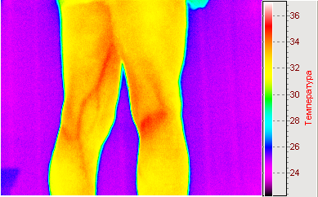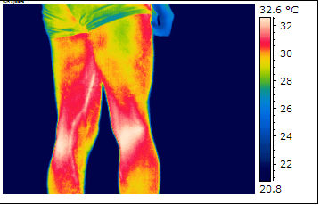
a b
Figure 1.4 - Thermograms for comparison are taken in different ranges: a - in the range of 3-5 μm, b - in the range of 8–14 μm
Visually, the difference is almost non-existent and it is safe to say that uncooled and, accordingly, cheaper thermographs can also be successfully used in the initial diagnosis of various pathological human conditions at the level of refrigerated.
As a result, we can identify the areas of application of modern thermal vision for medical purposes (Fig. 1.5).

MEDICINE

Scientific research

Clinical practice

Research of own heat production of biological objects

Diagnosis of various cardiovascular pathologies
Study of heat production of individual organs, tissues and cells of the body

Diagnosis of inflammatory processes, including tumors
Research of influence of biochemical substances, external factors and environment on thermal production of BO
Control of dynamics and efficiency of influence of pharmacological drugs on an organism at treatment

Carrying out preventive measures and rapid diagnostics

Research of influence on daily, seasonal and annual cycles on heat production

Figure 1.5 - The use of modern thermal vision for medical purposes

Conclusions to section 1

The use of thermal radiation in biomedicine for research and diagnostic purposes is relevant due to the high informativeness of the method and the complete safety of its application to the object of study. The most valuable information is contained in thermograms of the human body, ie, the distribution of temperature on its surface.
However, despite the large number of monographs, articles and other publications in the field of medical thermography, this method has not yet taken a worthy place in practical medicine along with existing methods of functional diagnostics, and for Ukraine this completely non-invasive method is generally more exotic than reality. That is why the method of thermal imaging diagnostics gives a wide field for its research and applications.

SECTION 2
DEVELOPMENT OF ALGORITHM FOR APPLICATION OF THERMOGRAMS IN OPHTHALMOLOGY

2.1 Initial data

The following tools were used for the work:
1) «Fluke Ti9» thermal imager and «Flir – i7»thermal imager;
2) Personal computer with software for FLIR QuickReport thermal imager;
3) Special software (MatLab 2010, Microsoft Excel 2007).
The main and general technical characteristics used in the study of the thermal imager are presented in table 3.1 and table 3.2.

Table 2.1 - The main technical characteristics of the thermal imager «Fluke Ti9»
Temperature | Range of temperature changes | From -20 ° C to + 250 ° C
Image characteristics | Sight | 23 ° x 17 °
Image characteristics | Minimum focusing distance | Thermal imager lens: 15 cm
Image characteristics | Focusing | Manual
Image characteristics | Frame rate | Update frequency 9Hz
Image characteristics | Type of radiation receiver | 160x120 matrix in the focal plane
Saving images and measuring data | Drive | SD memory card (2 GB)
Saving images and measuring data | File formats | Radiometric (.bmp) or  (.is2)
Saving images and measuring data | File formats exporting using SmartView software | JPEG, BMP, GIF, PNG, TIFF, WMF, EXIF, EMF

Table 2.2 - General technical characteristics of the thermal imager «Flir – i7»
Temperature | For measurements:  From -10 ° C to + 50 ° C;  For storage -20 ° C to + 50 ° C without the accumulator
Relative humidity | From 10% to 90% without condensation
Display | Color landscape LCD display VGA (640x480) with a diagonal size of 9.1 cm (3.6 inches) with under the light
Nutrition | Battery: built-in battery pack (included).  Battery life with mains or car adapter / charger - 2 hours. fully charged
Work / charge from the network | AC adapter / charger (110 / 220V, 50 / 60Hz)
Energy saving functions | Switching to standby mode after 5 minutes without action;  Automatic shutdown after 20 minutes without action
Dimensions | 0.27m x 0.13m x 0.15m
Weight | 1.2kg

The general view of the used thermal imagers «Fluke Ti9»and its set and «Flir – i7» are shown in Fig. 3.1 - 3.3.
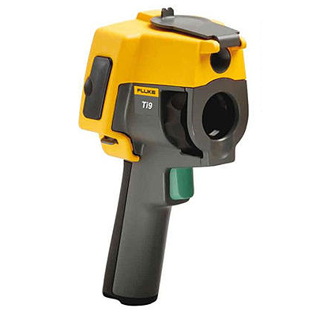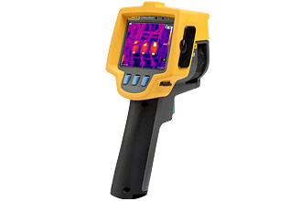Figure 2.1 - «Fluke Ti9»thermal imager

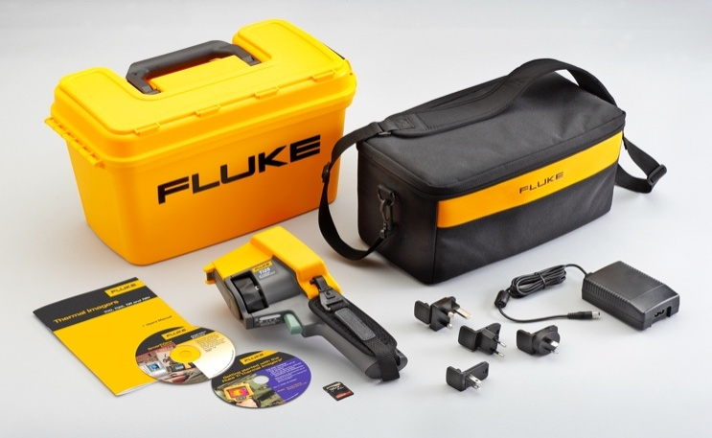
Figure 2.2 - «Fluke Ti9»thermal imager kit

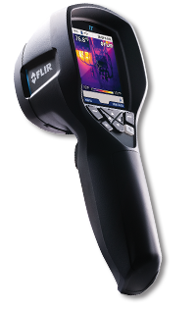
Figure 2.3 - Thermal imager «Flir – i7»

2.2 Conducting research and processing the data obtained

To be able to use the method of thermography in ophthalmology, a group of people of different sexes and ages of 9 people with different states of vision was recruited to collect data. After receiving the thermal images, they were processed in the MatLab software environment. To do this, we have created a special program for analysis, which builds the difference between the absolute values ​​of the radiation intensity of the region (Appendix A). Using the obtained numerical values, diagrams of correspondence of the state of vision were constructed.
The study involved two thermal imagers ("Flir - i7" and "Fluke Ti9"), and various software for data calculations. This approach made it possible to evaluate and compare the results of the experiment with greater and more accurate probability. The Flir - i7 thermal imager is much more expensive to use. The thermograms obtained from it were processed in the FLIR Quickreport program.
To assess the reliability of the results obtained using the FLIR thermal imager, a comparison of calculations processed using the algorithm in MatLab and specialized FLIR Quickreport software is performed. Thermal photographs obtained by the FLIR-i7 thermal imager are presented in Fig.2.4.
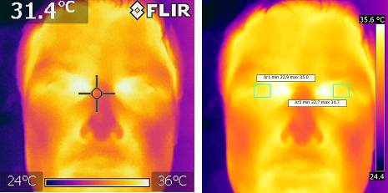
a b
Figure 2.4 - Thermograms FLIR-i7: a - calibration, b - selection of the studied areas
1) Processed files in the program FLIR Quickreport are presented in table 2.1 - 2.3 and Fig.2.5.
Table 2.1 - Temperature values ​​of the right eye
32.92 | 33.13 | 33.17 | 33.42 | 33.76 | 33.84 | 33.91 | 34.06 | 34.03 | 34.28 | 34.35 | 34.53 | 34.74
33.28 | 33.38 | 33.67 | 33.63 | 33.82 | 33.91 | 33.98 | 33.95 | 34.08 | 34.22 | 34.4 | 34.49 | 34.74
33.77 | 33.83 | 33.82 | 33.71 | 33.79 | 33.84 | 33.85 | 33.86 | 34 | 34.2 | 34.33 | 34.51 | 34.66
33.9 | 33.98 | 33.8 | 33.77 | 33.68 | 33.79 | 33.86 | 33.87 | 34.01 | 34.08 | 34.31 | 34.44 | 34.8
33.98 | 33.84 | 33.91 | 33.89 | 33.8 | 33.84 | 33.88 | 33.89 | 33.99 | 34.25 | 34.32 | 34.59 | 34.68
34.13 | 33.98 | 33.97 | 33.89 | 33.83 | 33.78 | 33.93 | 33.82 | 33.97 | 34.15 | 34.19 | 34.57 | 34.97
34.09 | 33.97 | 34.08 | 33.95 | 33.97 | 33.95 | 33.93 | 33.95 | 33.92 | 34.39 | 34.49 | 34.6 | 34.87
33.97 | 34.1 | 34.14 | 34.09 | 34.13 | 34.12 | 34.2 | 34.25 | 34.25 | 34.4 | 34.53 | 34.73 | 34.81
33.76 | 33.9 | 33.86 | 33.93 | 34.06 | 34.15 | 34.17 | 34.21 | 34.45 | 34.46 | 34.6 | 34.53 | 34.69
33.61 | 33.64 | 33.75 | 33.8 | 33.92 | 33.98 | 34.15 | 34.19 | 34.34 | 34.26 | 34.46 | 34.57 | 34.68

Table 2.2 - Temperature values ​​of the left eye
32.74 | 32.81 | 32.96 | 33.1 | 33.38 | 33.53 | 33.6 | 33.76 | 34.05 | 34.05 | 34.29 | 34.66 | 34.66
32.66 | 32.9 | 32.97 | 33.06 | 33.34 | 33.47 | 33.68 | 33.86 | 33.94 | 34.07 | 34.25 | 34.34 | 34.72
32.68 | 32.74 | 32.98 | 33.32 | 33.46 | 33.74 | 33.77 | 33.76 | 33.98 | 33.98 | 34.31 | 34.35 | 34.42
32.81 | 32.89 | 33.18 | 33.77 | 33.82 | 33.8 | 33.78 | 33.82 | 33.93 | 33.96 | 34.29 | 34.38 | 34.48
33.04 | 33.56 | 33.69 | 33.82 | 33.77 | 33.85 | 33.81 | 33.73 | 33.83 | 33.96 | 34.16 | 34.43 | 34.57
33.83 | 34 | 33.91 | 33.83 | 33.69 | 33.74 | 33.86 | 33.85 | 33.88 | 34.02 | 34.06 | 34.42 | 34.52
33.97 | 34.02 | 33.93 | 33.94 | 33.86 | 33.83 | 33.89 | 33.82 | 33.85 | 34 | 34.36 | 34.43 | 34.62
34.03 | 34.07 | 33.93 | 33.9 | 33.77 | 33.76 | 33.85 | 33.84 | 33.95 | 33.95 | 34.34 | 34.54 | 34.65
33.99 | 34.05 | 33.94 | 33.97 | 33.94 | 33.92 | 34.07 | 34.05 | 34.06 | 34.31 | 34.5 | 34.64 | 34.65
33.73 | 33.91 | 33.96 | 34.01 | 33.98 | 33.97 | 34.04 | 34.13 | 34.13 | 34.22 | 34.43 | 34.39 | 34.51
Find the difference between the obtained temperatures of the right and left eyes using the data obtained in the table and build a diagram of the temperature difference.
Table 2.3 - Absolute temperature difference
0.18 | 0.32 | 0.21 | 0.32 | 0.38 | 0.31 | 0.31 | 0.3 | 0.02 | 0.23 | 0.06 | 0.13 | 0.08
0.62 | 0.48 | 0.7 | 0.57 | 0.48 | 0.44 | 0.3 | 0.09 | 0.14 | 0.15 | 0.15 | 0.15 | 0.02
1.09 | 1.09 | 0.84 | 0.39 | 0.33 | 0.1 | 0.08 | 0.1 | 0.02 | 0.22 | 0.02 | 0.16 | 0.24
1.09 | 1.09 | 0.62 | 0 | 0.14 | 0.01 | 0.08 | 0.05 | 0.08 | 0.12 | 0.02 | 0.06 | 0.32
0.94 | 0.28 | 0.22 | 0.07 | 0.03 | 0.01 | 0.07 | 0.16 | 0.16 | 0.29 | 0.16 | 0.16 | 0.11
0.3 | 0.02 | 0.06 | 0.06 | 0.14 | 0.04 | 0.07 | 0.03 | 0.09 | 0.13 | 0.13 | 0.15 | 0.45
0.12 | 0.05 | 0.15 | 0.01 | 0.11 | 0.12 | 0.04 | 0.13 | 0.07 | 0.39 | 0.13 | 0.17 | 0.25
0.06 | 0.03 | 0.21 | 0.19 | 0.36 | 0.36 | 0.35 | 0.41 | 0.3 | 0.45 | 0.19 | 0.19 | 0.16
0.23 | 0.15 | 0.08 | 0.04 | 0.12 | 0.23 | 0.1 | 0.16 | 0.39 | 0.15 | 0.1 | 0.11 | 0.04
0.12 | 0.27 | 0.21 | 0.21 | 0.06 | 0.01 | 0.11 | 0.06 | 0.21 | 0.04 | 0.03 | 0.18 | 0.17

Figure 2.5 - Diagram of the temperature difference
2) Processed files in the program MatLab [16] are presented in Fig.2.6 - 2.8.
Figure 2.6 - Temperature values ​​of the right eye
Figure 2.7 - Temperature values ​​of the left eye

Figure 2.8 - Absolute temperature difference

2.3 Methods for determining the pathology of the temperature relief

To apply the method of determining the pathology of the eye on the temperature relief, the following steps were performed:
1) Calculated the temperature array for a given area on the thermogram (Fig.2.9, 2.10)


ab
Figure 2.9 - Selected area from the thermogram: a - right eye, left eye

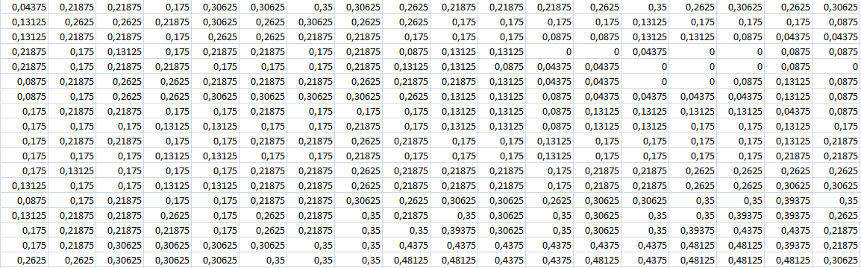
Figure 2.10 - Temperature array for a given area on the thermogram
2) Calculated the average temperature for horizontal and vertical temperature profiles of the thermogram (Fig.2.11)
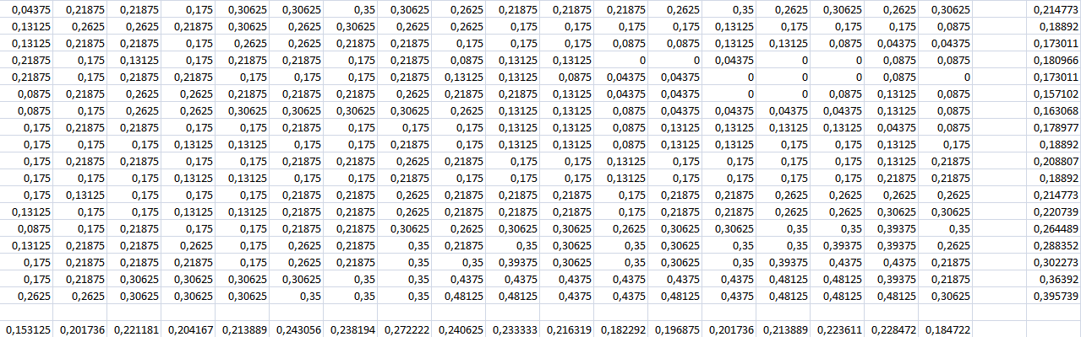
Figure 2.11 - Temperature array with average horizontal and vertical values
3) Calculated the average temperature for the entire region of the thermogram T-Midle (Fig.2.12).
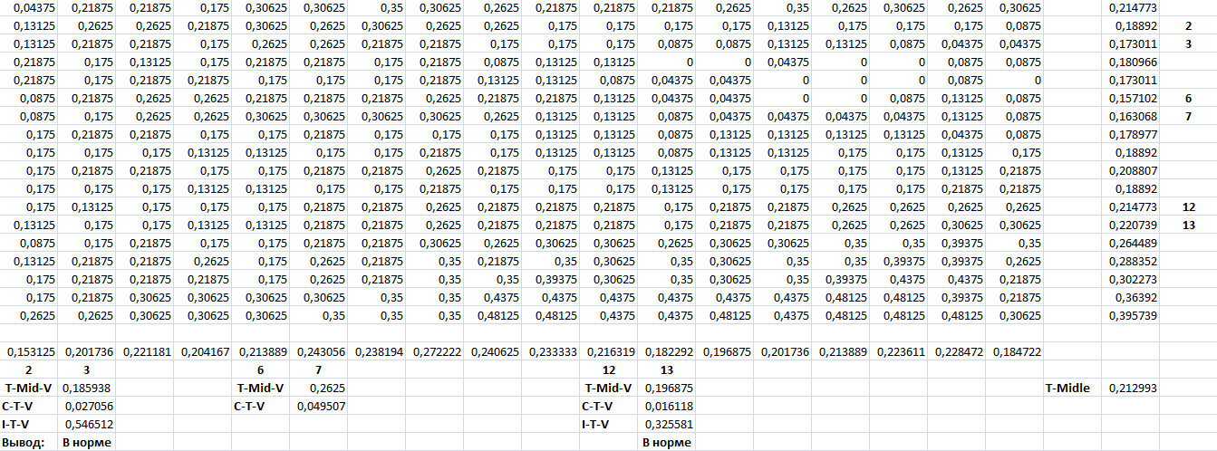
Figure 2.12 - Temperature array with the average temperature for the whole area
4) Constructed a graph of temperature equilibrium for average temperatures (Fig.2.13).
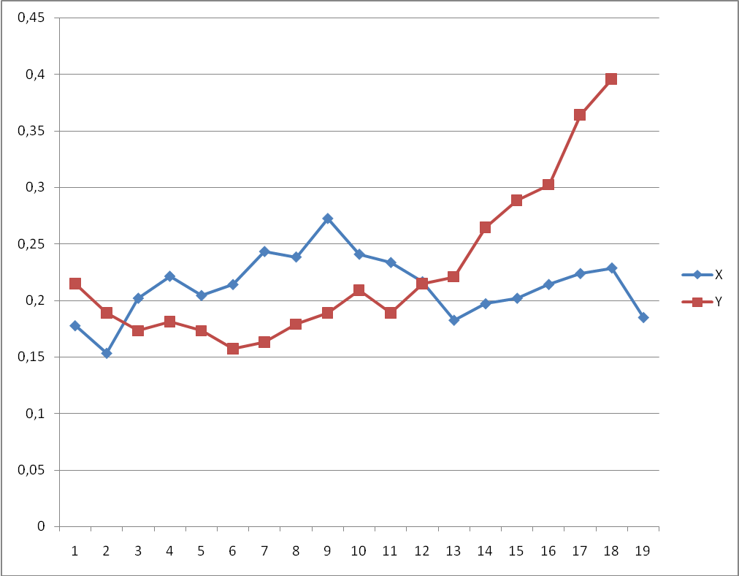
Figure 2.13 - Graph of temperature equilibrium of the array for average temperatures
5) Determined the areas of temperature equilibrium - the intersection of the graphs, and determined in these areas (nodes of the temperature matrix 2-3 and 12-13) the average values ​​of temperatures T-Mid-V (Fig.2.12).
6) Determined the area of ​​maximum temperature difference - the largest difference in the graphs, and determined in this area (nodes of the temperature matrix 6-7) the average temperature T-Mid-V (Fig.2.12).
7) Calculated the temperature deviations of CTV, which represent the difference between the average temperatures between the equilibrium nodes and the maximum temperature difference (Fig.2.12).
8) Calculated the temperature index ITV, which represents the ratio of temperature deviations for the equilibrium nodes and the maximum and minimum temperature difference (Fig.2.12).
9) Normally, the temperature index ITV should not exceed 0.5 + 5% of the range of change of the index.
The method of determining the pathology of the temperature relief of the bull was used for the thermogram obtained using the FLIR i7 thermal imager. Processing of the obtained temperature relief revealed two regions of temperature equilibrium, in which the difference of CTV temperatures between the average temperature in the region and the average temperature of the whole profile is 0.027 °C and 0.016 °C, respectively. The ITV temperature index in the equilibrium regions has values ​​of 0.54 and 0.32, respectively, which does not exceed the value of 0.5 + 0.05 and indicates the absence of pathology in the eye under study.

Conclusions to section 2

Comparison of the results obtained by FLIR and processed in MATLAB and FLIR QuickReport shows their coincidence, which is reflected in the typical shape of the temperature field throughout the two eyes and in the eyeball around the pupils, as well as the absolute temperature difference that coincides for infrared images in MATLAB and FLIR QuickReport.
This shows that the methods of IR image processing performed by MATLAB can be used for analysis of thermograms.

SECTION 3
SAFETY AND PRECAUTIONS

3.1 Characteristics of the thermography room

Table 3.1 shows all the necessary characteristics of the thermography room
Table 3.1 - Characteristics of the thermography room
Cabinet length, L | 6m
Cabinet width, W | 3m
Ceiling height, H | 3m
Number of employees | 1
Natural lighting | window
Lamplight | 2 lamps LB 40
Natural ventilation | general ventilation
Heating | central water heating of low pressure
Floor | concrete covered with linoleum
The walls | covered with heat-absorbing paint
Ceiling | matte coating with oil paint
Figure 3.1 shows the plan of the thermography room, and in Table 3.2 - its objects and their characteristics.
Table 3.2 - Objects of the thermography room
Object name | Characteristic | Number in the picture
Thermal imager  Fluke Ti9 | Overall dimensions: 270х130х150 mm;  Field of view: 23 x 17;  Range of measuring temperatures from -20C to + 250C;  Power supply: lithium-ion rechargeable battery with recharge from the AC mains 90-260V;  Battery life: 3-4 hours | 1
Computer | Type Intel | PC / ATX and 17 "CRT |, Samsung monitor | 755 VA | 2
Work chair | 40x40 cm | 3
Table | 100x60 cm | 4
Chair | 40x40 cm | 5
Battery | 130x50 cm | 6
Window | 130x120 cm | 7
Bucket | d 30 cm | 8
Hanger | 50x15 cm | 9
Sink | d 40 cm | 10

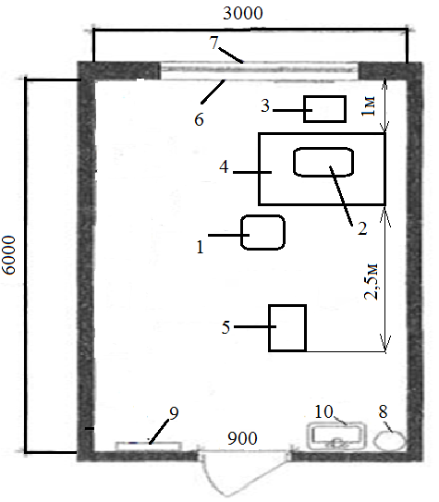
Figure 3.1 - Plan of the thermography room

The area of ​​the premises is:
S = a × b, (3.1)
where a is the length of the room, [m];b is the width of the room, [m].
Substitute in formula (3.1) the values:
S = 3 × 6 = 18 m² (3.2)
The volume of the room is:
V = a × b × h, (3.3)
where h is the height of the room, [m].
Substitute in formula (3.3) the value for calculating the volume:
V = 6 × 3 × 3 = 54m²(3.4)
Calculate the area and volume of the room per person:
Sl = S / n, (3.5)
where n is the number of people.
Substitute in the formula (3.5) values:
Sl = 18/2 = 9m² (3.6)
Vl = V/n (3.7)
Substitute the value into the formula (3.7):
Vl = 54/2 = 27m³ (3.8)
Let's enter the calculated indicators in the table (tab.3.3) and equate to sanitary norms according to norms DSanPiN 3.3.6.042-99, DSanPiN 3.3.2.007-98 [17].

Table 3.3 - Compliance of the planning of the premises with sanitary and hygienic norms
Parameters |  | Sanitary norms | This room
Thermography room area S, m² |  | Not less than 15 | 18
Area per person S, m² |  | Not less than 6 | 9
Volume per person V, m³ |  | 20 | 27
Distance between the workplace and the wall, m | Not less than 1 |  | 1
Minimum distance between jobs, m | Not less than 1.2 |  | 2.5
The parameters of the thermography room meet the requirements of sanitary norms, which provides safe and comfortable examination and diagnosis.

3.2 Assessment of hazardous and harmful production factors

All possible dangerous and harmful factors are listed in table. 3.4.

Table 3.4 - Dangerous and harmful production factors
Physical | Chemical | Biological
Microclimate of the room;  Lighting;  Noise;  Electrical hazards;  Fire safety. | Disinfectants. | Viruses;  Bacteria.

3.3 Microclimate

The microclimate affects the work of employees and the condition of patients in the office. Since indoor work is carried out both in the warm and cold periods of the year, it is important to maintain optimal parameters of the microclimate in accordance with the norms. (Table 3.5).

Table 3.5 - Category of work performed in the office
Category of works | 1b - performed sitting, standing and associated with walking and accompanied by some physical exertion
Energy consumption during work | 121-150 kcal/year

Table 3.6 - Compliance of air temperature with respect to humidity and air velocity standards
Period of the year | Category of works | Air temperature, t, °C | Relative humidity, % | Air movement speed, m/s
Optimal values
cold | Easy - 1b | 21-23 | 40-60 | 0.1
warm | Easy - 1b | 22-24 | 40-60 | 0.2
Normative values
cold | Easy - 1b | 17-25 | 75 | Not more than 0.2
warm | Easy - 1b | 19-30 | 60 at 270C | 0.3-0.1
Real values
cold | Easy - 1b | 19-22 | 40-60 | 0.1
warm | Easy - 1b | 22-29 | 40-60 | 0.2

The room is regularly ventilated through one window, which opens at (0.7m). Total area through which ventilation takes place [18]:
Svik. = 0.7 * 1.5 = 1.05 m²
Calculation of natural ventilation (Kr = 4 for the office)
L = Vcab * Kr = 54 * 4 = 216 (m³ year),

Table 3.7 - Ventilation of the thermography room
The norm for one person | 30m³ / year
Real value per person | 216m³ / year

Table 3.8 - Means of maintaining the temperature during the running period
HeHeating | battery consisting of 6 sections, lighting fixtures.

In the warm period of the year the optimum temperature is maintained by the Samsung AQ12UGF air conditioner.
Normative metrological conditions, microclimate parameters and concentration of harmful substances in accordance with the requirements of GOST 12.1.005-88 and LTO 3.3.6.042-99 are provided.

3.4 Lighting

Insufficient or excessive light, uneven lighting in the field of view tires the eyes, leads to reduced productivity; at the same time the potential danger of erroneous actions and accidents increases. Excessive brightness of light sources can cause headaches, tingling in the eyes, impaired visual acuity.
In this room we work with objects that are on the color landscape LCD display VGA (640 x 480) diagonal size 9.1 cm (3.6 inches) with backlight (selective or automatic brightness adjustment) located on the thermal imager, and on the PC monitor, the size of objects averages 4 - 6 pc, ie 2 - 3 mm and the size of the minimum objects 3 pc - 1 mm, so the accuracy of visual work is average [19].
Artificial lighting is provided by (table.3.9):

Table 3.9 - Artificial lighting
Number of lamps | 2 pcs.
Fixtures | LPO 01 series with translucent sidewalls
Type of fluorescent lamps | warm white color LB 40
Number of lamps | 4 pcs, 40 watts
Height above the floor | 3m

Natural and artificial lighting meets the requirements of regulatory documents (DBN B.2.5-28-2006 and DSanPiN 3.3.2.007-98 or DNAOP 0.00-1.31-99 - not less than 2.5 m).

3.5 Noise

In the workplace with a thermal imager and a computer - noise sources are: a cooler in the computer and external noise [20]. Actual and regulatory values ​​of the noise level are given in table 3.10.

Table 3.10 - Actual and regulatory values ​​for sound and noise
Indicators | Real values | Normative values
The noise level of the thermal imager | <6dBA
Average noise level from the PC | 25 dBA | 50 dBA
Air conditioning | 26dBA

The sound level in the room does not exceed the established norms according to LTO 3.3.6.037-99 "Sanitary norms of industrial noise, ultrasound and infrasound".

Table 3.11 - Means and measures of protection against noise loads
Technical | -Sealing around the perimeter of window and door openings;  - In the thermal imager the case having silicone isolation on all points of fastening of drives is used;  -The PC uses 90 mm fans that produce less noise.
Organizational | -Compliance with the rules of technical operation;  -Conducting scheduled preventive inspections and repairs.
Personal protective equipment | -Preliminary and periodic medical examinations;  -Use of rational modes of work and rest for employees.

3.6 Chemical sources of hazardous and harmful production factors

Various chemicals are used in the examination of the patient and sterilization of instruments. Hygienic rationing of harmful substances is carried out according to the maximum permissible concentrations: for workplaces the maximum permissible concentration in the working area is determined - MPC, SD (GOST 12.1.005-88, CH 245-71) [21].

Table 3.12 - The content of harmful chemicals in the office of functional diagnostics
Name of the substance | Normative value of MPCmr,mg / | Real value of MPC, mg / | Danger class
Ethyl alcohol | 1.0 | 0.5 | 3
Chlorine | 0.1 | 0.03 | 2
Table 3.13 - Means and measures of protection against chemicals
Technological | -chemicals are in the locker;  - the presence of a sink;  - used only by the employee.
Organizational | -instructing employees;  - use of chemicals according to the instructions.
Personal protective equipment | - use of overalls (rubber gloves, white coat, etc.).

3.7 Danger of electric shock

According to ONTP24-86 and PUE-87 the room belongs to a class of rooms without the increased danger of defeat of the personnel by an electric current, relative humidity of air does not exceed 60%, air temperature no more than 250C, there are no chemically aggressive environments.
Indoors are powered by a three-phase network with grounding, voltage 220V and frequency 50Hz using circuit breakers.
The main consumers of electricity are thermal imagers, PCs, monitors, light sources.
Table 3.14 - Cases of human electric shock
- touching open conductive parts;
- due to live equipment elements that were energized as a result of insulation failure.

Table 3.15 - Electrical safety measures
Technological | - Thermal imager (class II type BF) during normal operation has reinforced insulation of the network circuit relative to the working part and the housing of the device, investigated by a voltage of 350V, ensuring the safety of the patient and staff without the use of protective grounding;  - At emergency work at the thermal imager are provided: an alarm signal of failure of electric cables, automatic shutdown.  - Insulated conductive parts are not available in the devices;  - The case of the system block is connected to the grounded wire, at isolation violation there is a protective shutdown;  - All devices are regularly diagnosed for damage.
Organizational | - Electrical safety instruction;  - Timely inspection and preventive actions by employees;  - Strict observance of the rules and norms defined by the current regulatory documents.
Personal protective equipment | - Use of goggles, boot covers and disposable gloves for inspection;  - Strict observance of rules and norms when using electrical appliances.

According to GOST-12.2.007.0-75 all equipment of the first level (except PC-II class) belongs to the I class, it has working isolation according to GOST 12.1.009-76. No additional measures are required to increase electrical safety.

3.8 Fire safety in emergency situations

Fire safety parameters are given in table 3.16.
Table 3.16 - Fire safety parameters
Causes of fire | -short circuit;  -use of unforeseen electrical appliances;  - non-compliance with fire safety rules.
Combustible materials | Paper, wood, electrical equipment
Fire class | A - combustion of solids, (E) - combustion of electrical installations under voltage of up to 1000 V.
Subclass of fire | A2 - combustion is not accompanied by decay
Explosion fire hazard premises | Category B (fire hazard)
Class of fire zone | P-IIa

All requirements of SNiP 2.01.02-85 and SNiP 2.09.02-85 regarding the fire resistance of the building, evacuation time in case of fire and width of evacuation passages were met.
An appropriate characteristic of evacuation exits has been developed for this equipment (Table 3.17).
Table 3.17– Characteristics of evacuation exits
 | Normative values, m | Existing values, m
Corridor width | > 2.0 | 2.5
Door width | > 0.8 | 0.9
Door height | > 2.0 | 2.1

Table 3.20 - Fire safety measures
Technological | - free access to circuit breakers and switches is provided;  - in the common corridor, next to the office, there is a carbon dioxide fire extinguisher OU-2  - three TPT-3 sensors with a monitoring radius of 2.5 m are installed in the room on the ceiling.  - timely preventive inspections, equipment repairs.
Organizational | - evacuation plan in case of fire (Fig.3.2);  - fire safety instruction;  - organization of fire drills;  - strict compliance with the rules and regulations set by applicable regulations
Means of individual protection | - cotton gauze bandages

The premises meet all fire safety requirements in accordance with the requirements of NAPB A.0.001-95 "Fire safety rules in Ukraine".

Floor evacuation plan in case of fire (Fig. 3.2)

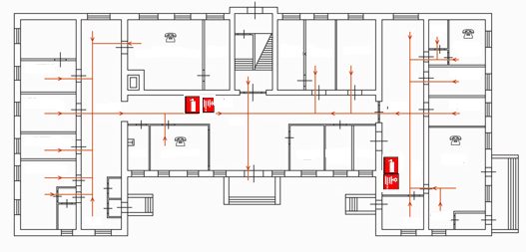
Figure 3.2 - Floor evacuation plan

Conclusions to section 3

In terms of microclimate and lighting, this room meets the standards, and there are no comments on electrical safety, safety of thermal damage and fire safety..

CONCLUSIONS

In this work, a new method of vision diagnosis - using thermography - was considered and investigated. After all the analysis of thermal processes allows to receive various information on a condition of object of research and a course of physical processes in many areas of human activity.
The study was conducted using two thermal imagers and data taken from 9 people with different visual impairments, a special program was created in the MatLab environment for processing thermograms. The obtained results were confirmed by the real values obtained by other existing diagnostic methods used in medicine today.
The study found that a comparison of the results obtained FLIR and processed in MATLAB and FLIR QuickReport shows their coincidence, which is reflected in the typical shape of the temperature field throughout the two eyes and in the eyeball around the pupils, as well as the absolute temperature difference match for IR images processed in MATLAB and FLIR QuickReport.
This shows that the method of IR image processing performed by MATLAB can be used for analysis of thermograms.
The plan of an office for thermography is developed. Since the cabinet is intended for thermography, all dangerous and harmful production factors were calculated.
Software - hardware does not require large financial costs for implementation, compared to existing ones, is not time consuming, and can pay for itself from an organizational point of view.
All tasks are fulfilled, respectively, the goal is achieved.

REFERENCES

1. Nicholas A. Medical Infrared imaging / A.Nicholas, Diakides В., Joseph D., Bronzino А. – CRC Press Taylor Group LLC, London. 2008 – 451р.
2. Vitalii Kotovskyi, Vladyslav Shlykov, Nikolaj Višniakovc, Andžela Šešok / The IR-thermal imaging method for evaluation of the status of myocardial coronary vessels under the condition of artificial blood circulation // Technology and Health Care, vol. Pre-press, no. Pre-press, P. 1-6, 2018.
3. Vitaliy Maksymenko, Valentyna Danilova, Vladyslav Shlykov The discrete model for the system of the myocardium and coronary vessels // 3rd Conference "Approximation Methods for Molecular Modelling and Diagnosis Tools", Kyiv, “Igor Sikorsky Kyiv Polytechnic Institute”, January 26-30, 2017. – P. 3. (in Ukranian)
4. Vladyslav Shlykov, Valentyna Danilova, Vitaliy Maksymenko Heat transfer model based on thermographic imaging of the heart in open chest conditions // 17th European Congress on Extracorporeal Circulation Technology, June, 14- 17th, Marseille, France, 2017. – P. 57.
5. Канюков В.Н. Развитие научно-технических решений в медицине: учеб. пособ./ В.Н. Канюков, В.Ф. Винярский, В.В. Осипов. – Оренбург: ОГУ, 2000. – 255с.
6. Ткани организма человека. [Електронний ресурс]: науч. пособ. для студ. мед. вузов III—IV уровней акредитации / А.Г. Вересенская. – 2004. – Режим доступу: http://www.78l.ru/data/files/chelovek/97.html
7. Диагностика заболеваний. [Електронний ресурс] / А.В. Цитатный. – 2000. – Режим доступу: http://spina.pro/diagnostika/reografija
8. Алгоритм статистической оброботки данных (Алгоритм верификации данных векторкардиографического исследования). [Електронний ресурс] / И.Е. Белая, О.В. Бирюков. – Режим доступу: http://www.bo0k.net/index. =chapter&bid=1
9. Використання математичного пакета MATLAB для розвязування прикладних задач. [Електронний ресурс] / Б.П.Довгий, Є.С.Вакал, Ю.Є.Вакал, А.В.Попов. – Київ. – 2012. – Режим доступу: http://ua.convdocs.org/docs/index-204553.html
10. Математичні пакети розширення MATLAB. Спеціальний посібник. . [Електронний ресурс] / В.В. Дияконів, В.А. Круглов. – Київ. – 2011. - Режим доступу: http://ukrbooks.com.ua/kniga4119.html
11. Основы программирования в MatLab. [Електронний ресурс] / С.М. Наместников. - Ульяновск. - 2011. - 55 с. – Режим доступу: http://sernam.ru/lect_matlab.php
12. John H. Lienhard IV and John H. Lienhard V A Heat Transfer Textbook – 4th ed. – Cambridge, MA: Phlogiston Press. – 2017. – 768 P.
13. Kelly T. Thermal Analysis Kit III Manual / K&K Associates, Version 97.003. – 1997. – 23 P.
14. Thermal Network Modeling Handbook / K&K Associates, Developers of Thermal Analysis Kit, Version 97.003. – 2000. – 29 P.
15. Khudetskyy I.U., Danilova V.A., Shlykov V.V. Use of Thermal Imaging for Control of the Process Hypothermia Cardiac/ The Polish Journal of Applied Sciences, Lomza State University of Applied Sciences, 2015 - P. 93-96
16. Pavlidis T. Algorithms and Graphics and Image Processing. N.Y.: Springer, 1982. – 320 P.
17.ССБТ. Вредные вещества. Классификация и общие требования безопасности: ГОСТ 12.1.007-86 . — [Чинний від 1998—04—01]. — К. : Держбуд України, 1997. — 157 с. — (Національні стандарти України).
18. Котик М. А. Психологи и безопасность: монографія / М. А. Котик. – Таллин.: Валгус, 1991. — 408 с.
19. Жидецкий В.Ц. Основы охраны труда./ В. Ц. Жидецкий, В. С. Джигирей, А. В. Мельников// украинский гос. лесотехнический ун-т. — 2-е изд., доп. - Львов : Афиша, 2000. - 350 с. — ISBN 966-7760-10-3.
20. Економіка та організація виробництва: Підручник / За ред. В.Г. Герасимчука, А.Е. Розенплентера. — К.: Знання, 2007. — 678 с.
21. Методичні вказівки до виконання організаційно-економічного розділу дипломних проектів та курсових робіт з дисципліни “Економіка і організація виробництва” (для студентів факультету електроніки). Г.К. Яловий, В.П. Пашин, В.С. Сичов. – К.: НТУУ “КПІ”, 2003 – 99 с.
22. Конюховский П. В Математические методы исследования операций в экономике: С-Петербург: Питер 2003г. - 208 с.

APPENDIX A

Program for analyzing the difference between the absolute values ​​of the radiation intensity of the area:
fmin01 = 66.2;
fmax01 = 96.8;
filename01 = 'IR000443_L.jpg';

fmin02 = 66.2;
fmax02 = 96.8;
filename02 = 'IR000443_R.jpg';

fo = 5/9;
tmin = fo * (fmin01 - 32);
tmax = fo * (fmax01 - 32);
kt = 256 / (tmax - tmin);

[img, map] = imread (filename01,'JPG');
ndims (img);
xImage = [-0.1 0.1]; % # The x data for the image corners
yImage = [0.1 -0.1]; % # The y data for the image corners

% figure (1);
% hold on; % # Add to the plot
% image (xImage, yImage, img); % # Plot the image
% title ('Color Heat Map');

% imtool (img, map); % # Plot the image
% title ('Pixel Map');

kr = 0.299;
kg = 0.114;
kb = 0.587;
[m01, n01, k01] = size (img);
F = zeros (m01, n01);
T01 = zeros (m01, n01); % # Preallocate matrix
for x = 1: m01
for y = 1: n01
F (x, y) = (kr * img (x, y, 1)) + (kg * img (x, y, 2)) + (kb * img (x, y, 3));
if (F (x, y) <= 0.0)
F (x, y) = 0.01;
end
T01 (x, y) = tmin + F (x, y) / kt;
end
end

% figure (6); % # Plot of peaks the image
% hold on;
% load clown
% surface (peaks, T01, ...
% 'FaceColor', 'texturemap', ...
% 'EdgeColor', 'none', ...
% 'CDataMapping', 'direct')
% colormap (map);
% title ('Peaks Heat Map');

figure (7); % # Plot the image
hold he;
load clown
surface (T01,...
'FaceColor',,'texturemap',,...
'EdgeColor',,'none',,...
'CDataMapping',,'direct')
colormap (map)
view (size (T01,1), size (T01,2));
title ('Temperature Heat Map');

% Write data to file
fid2 = fopen ('C: \ Temp \ temperature01.txt',,'w');
dlmwrite ('C: \ Temp \ temperature01.txt', T01, 'delimiter',, '\ t',, ...
'precision', 6)
fclose (fid2);

fo = 5/9;
tmin = fo * (fmin02 - 32);
tmax = fo * (fmax02 - 32);
kt = 256 / (tmax - tmin);

[img, map] = imread (filename02,'JPG');
ndims (img);
xImage = [-0.1 0.1]; % # The x data for the image corners
yImage = [0.1 -0.1]; % # The y data for the image corners
% figure (8);
% hold on; % # Add to the plot
% image (xImage, yImage, img); % # Plot the image
% title ('Color Heat Map');

% imtool (img, map); % # Plot the image
% title ('Pixel Map');

kr = 0.299;
kg = 0.114;
kb = 0.587;
[m02, no2, k02] = size (img);
F = zeros (m02, n02);
T02 = zeros (m02, no2); % # Preallocate matrix
for x = 1: m02
for y = 1: n02
F (x, y) = (kr * img (x, y, 1)) + (kg * img (x, y, 2)) + (kb * img (x, y, 3));
if (F (x, y) <= 0.0)
F (x, y) = 0.01;
end
T02 (x, y) = tmin + F (x, y) / kt;
end
end

% figure (9); % # Plot of peaks the image
% hold on;
% load clown
% surface (peaks, T02, ...
% 'FaceColor', 'texturemap', ...
% 'EdgeColor', 'none', ...
% 'CDataMapping', 'direct')
% colormap (map);
% title ('Peaks Heat Map');

figure (10); % # Plot the image
hold he;
load clown
surface (T02,...
'FaceColor',,'texturemap',,...
'EdgeColor',,'none',,...
'CDataMapping',,'direct')
colormap (map)
view (size (T02,1), size (T02,2));
title ('Temperature Heat Map');

% Write data to file
fid2 = fopen ('C: \ Temp \ temperature02.txt',,'w');
dlmwrite ('C: \ Temp \ temperature02.txt', T02, 'delimiter',, '\ t',, ...
'precision', 6)
fclose (fid2);

T0R = fliplr (T02); % # Returns Matrix with columns in the left-right
[m02, no2] = size (T0R);
if (m02> m01)
m0 = m01;
else
m0 = m02;
end
if (n02> n01)
n0 = n01;
else
n0 = n02;
end

T0D = zeros (m0, n0);
for x = 1: m0
for y = 1: n0
T0D (x, y) = abs (T01 (x, y) - T0R (x, y));
end
end

figure (11); % # Plot the image
hold he;
load clown
surface (T0D,...
'FaceColor',,'texturemap',,...
'EdgeColor',,'none',,...
'CDataMapping',,'direct')
colormap (map)
view (size (T0D, 1), size (T0D, 2));
title ('Temperature Heat Map');

% Write data to file
fid2 = fopen ('C: \ Temp \ d0temperature.txt',,'w');
dlmwrite ('C: \ Temp \ d0temperature.txt', T0D, 'delimiter',, '\ t',, ...
'precision', 6)
fclose (fid2);

m = round (m0 / 4);
n = round (n0 / 4);
T4D = zeros (m0-2 * m, n0-2 * n);
for x = 1: (2 * m)
for y = 1: (2 * n)
T4D (x, y) = abs (T01 (x + m, y + n) - T0R (x + m, y + n));
end
end

figure (12); % # Plot the image
hold he;
load clown
surface (T4D,...
'FaceColor',,'texturemap',,...
'EdgeColor',,'none',,...
'CDataMapping',,'direct')
colormap (map)
view (size (T4D, 1), size (T4D, 2));
title ('Temperature Heat Map');

% Write data to file
fid2 = fopen ('C: \ Temp \ d4temperature.txt',,'w');
dlmwrite ('C: \ Temp \ d4temperature.txt', T4D, 'delimiter',, '\ t',, ...
'precision', 6)
fclose (fid2);

APPENDIX B

