NATIONAL TECHNICAL UNIVERSITY OF UKRAINE
«Igor SIKORSKI KYIV POLYTECNIC INSTITUTE»
FACULTY OF BIOMEDICAL ENGINEERING
DEPARTMENT OF BIOMEDICAL ENGINEERING

«Approved for defense»
Head of the Department of BMI ___________ Vladyslav SHLYKOV
(signature) (initials, surname)
“ ____ ” ______________2023

Graduate work
to obtain a bachelor's degree
under the educational and professional program "Medical Engineering"
specialty 163 "Biomedical engineering"
on the topic:«Hardware and software complex for studying the influence of sound signals on the central nervous system»
Completed:
IV year student, group BM-93i
Mahmoud Moataz Sarwat Youssef ______________

Supervisor:
Assoc. prof. dep. BBZL, Ph.D.,Assoc. prof
Antonova-Rafi Yulia Valeriivna ______________

Adviser for the labor protection:
Senior LecturerPh.D.at theOPСB,
Kalinchyk V.V. _______________

Reviewer:
Senior Lector, Assistant dep. BBZL
Danko Daryna _______________

I certify that in this master's dissertation there are no borrowings from the works of other authors without appropriate references.
Student _____________

Kyiv –2023

НАЦІОНАЛЬНИЙ ТЕХНІЧНИЙ УНІВЕРСИТЕТ УКРАЇНИ
«КИЇВСЬКИЙ ПОЛІТЕХНІЧНИЙ ІНСТИТУТ
імені ІГОРЯ СІКОРСЬКОГО»
ФАКУЛЬТЕТ БІОМЕДИЧНОЇ ІНЖЕНЕРІЇ
КАФЕДРА БІОМЕДИЧНОЇ ІНЖЕНЕРІЇ

До захисту допущено:
Завідувач кафедри
________ Владислав ШЛИКОВ
«___»_____________2023 р.

Дипломна робота
на здобуття ступеня бакалавра
за освітньо-професійною програмою «Медична інженерія»
спеціальності 163 «Біомедична інженерія»
на тему: «Апаратно-програмний комплекс для дослідження впливу звукових сигналів на центральну нервову систему»

Виконав:
студентIV курсу, групи БМ-93i
Махмуд Моатаз Сарват Юссеф __________
Керівник:
доцент каф. ББЗЛ, к.ф-м.н., доцент
Антонова-Рафи Ю.В. ___________
Консультант з охорони праці:
cтарший викладач кафедри ОПЦБ,
к.т.н. Калінчик Віктор Васильович __________

Рецензент:
асистент кафедри ББЗЛ,
Данько Дарина Ігорівна __________

Засвідчую, що у цій дипломній роботі немає запозичень з праць інших авторів без відповідних посилань.
Студент _____________

Київ – 2023

NATIONAL TECHNICAL UNIVERSITY OF UKRAINE
«Igor SIKORSKI KYIV POLYTECNIC INSTITUTE»
FACULTY OF BIOMEDICAL ENGINEERING
DEPARTMENT OF BIOMEDICAL ENGINEERING

Level of higher education first (bachelor's)
Specialty 163 "Biomedical Engineering"
Educational and professional program - "Medical engineering"

I APPROVE
Head of Department
_______ Vladyslav SHLYKOV
"___"_____________2023 year.
TASK
for a diploma work for a student

TASK
for the student's thesis
Mahmoud Moataz Sarwat Youssef
1. The topic of the work: Software and hardware complex for the study of the influence of audio signals on the functional state of the central nervous system
work supervisor Assoc. prof. dep. BBZL, Ph.D.Antonova-Rafi Yulia Valeriivna
(Surname, name, patronymic, academic degree, academic title)
approved by the order of the university from « _26_ » May 2023. No 52/23 si._____
2. Deadline for student submission___09 june 2023.
3. Initial data for the work: regulatory documents, electronic textbooks, printed publications, hardware and software complex Tgeyekh and its operating instructions, MATEAV 2018 application package, a set of libraries.KET Rgashe\ogk for software development for the Miegozoi Aipsio\\5 environment.
4. Contents of the thesis: an analytical review of literature, selection of materials for research, experimental research, and analysis of results, development of software and hardware complex, development of methods for using the complex, empirical study and analysis of results.
5. List of illustrative material: presentation in M8 by Romeg Roti.
2

6. Consultants of work sections

Section. | Name, initials and position of the consultant | Signature, date
Section. | Name, initials and position of the consultant | task issued | task  accepted
Laborprotection

7. Assignment due date: February 25, 2019
Calendar plan

№  s/n | Name of the stages ofexecution  Thesis | The term ofexecution  stagesofwork | Note
1 | Literaturereview | February-March2023.
2 | Definitionofmaterialsand methods  research | March-April2023.
3 | Conducting an experimental research | April2023.
4 | Processingandanalysisofresults | May2023.
5 | Development of software implementation of signal filtering | May2023.
6 | Development of a program for assessing thestateofthecentralnervoussystem | May2023.
7 | Development of methods of application  of the software and hardware complex | May2023.
8 | Conducting a repeatedexperimental study | May2023.
9 | Processingandanalysisofresults | May-June2023.
10 | Designofthe"Laborprotection"section | May-June2023.
11 | Preparationofanexplanatorynote | June2023.
12 | Submission of a thesis for normative control | June2023.
13 | Submission of a package of documents for a thesis | June2023.
14 | PreparingforthedefenseoftheDR | June2023.
15 | Thesisdefense | June2023.

Student

Work supervisor
Mahmoud Moataz Sarwat Youssef

(signature) (initials, surname)

Antonova-Rafi Yulia Valeriivna

(signature) (initials, surname)

3

РЕФЕРАТ

Дипломна робота складається з 70 сторінок, 20 ілюстрацій, 16 таблиць, 3 додатків. Загалом досліджено 40 літературних джерел.
Тема роботи: програмно-технічний комплекс для дослідження впливу звукових сигналів на функціональний стан центральної нервової системи.
Метою роботи є розробка та впровадження програмно-апаратного комплексу для дослідження впливу звукових подразників із заданими частотними характеристиками на функціональний стан центральної нервової системи та експериментальна перевірка роботи цього комплексу.
Розроблено автоматизовану методику дослідження психомоторних показників центральної нервової системи, запропоновано використання відфільтрованих сигналів для дослідження впливу звукових стимулів заданої частоти на електричну активність мозку та психофізіологічні показники.
Завдання роботи: проаналізувати сучасні дослідження впливу звукових подразників з різними характеристиками на електричну активність мозку та психофізіологічні показники; розробити апаратно-програмний комплекс, що дозволяє об'єктивно досліджувати вплив звукових стимулів із заданими частотними характеристиками на функціональний стан центральної нервової системи; експериментально перевірити роботу розробленого комплексу.

Ключові слова: апаратно-програмний комплекс, функціональний стан центральної нервової системи, слухові викликані потенціали (СВП), психомоторні показники, теппінг-тест, звуковий стимул, фільтрація сигналу, частотний діапазон, MATLAB, C#, електроенцефалографія, ритми ЕЕГ.

ABSTRACT

The thesis consists of70 pages, 20 illustrations, 16 tables, and 3 appendices. In total, 40 literary sources were studied.
The topic of the work: software and hardware complex for researching the influence of audio signals on the functional state of the central nervous system.
The purpose of the work is the development and implementation of a software-hardware complex for researching the influence of sound stimuli with specified frequency characteristics on the functional state of the central nervous system and experimental verification of the work of this complex.
An automated methodology for researching psychomotor indicators of the central nervous system was developed, the use of filtered signals was proposed for researching the influence of audio stimuli of a given frequency on the electrical activity of the brain and psychophysiological indicators.
The tasks of the work: to analyze modern studies of the influence of sound stimuli with different characteristics on the electrical activity of the brain and psychophysiological indicators; to develop a hardware and software complex that allows to objectively investigate the influence of audio stimuli with predetermined frequency characteristics on the functional state of the central nervous system; experimentally check the operation of the developed complex.

Keywords: hardware and software complex, functional state of the central nervous system, Auditory evoked potentials (AEPs),psychomotor indicators, tapping test, sound stimulus, signal filtering, frequency range, MATLAB, C#, electroencephalography, EEG rhythms

4

CONTENT

LIST OF SYMBOLS AND ABBREVIATIONS 7
INTRODUCTION 8
SECTION 1 BASIC THEORETICAL INFORMATION 12
  - Physiological basis of sound perception 12
  - The main directions of modern research on the effect of sound stimuli
on the human brain 14
  - Methods of analyzing the electrical activity of the brain 15
  - Methods of evaluating and filtering audio signals 19
  - Methods of studying the functional state of the central nervous system 22
  - Auditory evoked potentials (AEPs) 24
Conclusion to Section1 26
SECTION 2 RATIONALE FOR SELECTING FREQUENCY BANDS OF AUDIO STIMULI 28
  - Materials and methods of the study 28
  - Results of the study 31
Conclusion to Section 2 34
SECTION 3 DEVELOPMENT OF SOFTWARE AND HARDWARE
COMPLEX ….35
  - Software implementation of audio signal filtering 36
  - Programmatic method of studying the functional state of the centralnervous system 38
 |  |  |  |  | BM 93I
Vim | Letter | No.doc. | Signature | Date
Developed  by |  | Mahmoud Moataz |  |  | Hardware and software complex for studying the influence of sound signals on the central nervous system | Lit. |  |  | Letter | Sheets
Supervisor |  | Antonova-Rafi Yulia |  |  |  |  |  |  | 5 | 65
Review. |  | Danko Daryna |  |  |  | Igor Sikorsky Kyiv PolytechnicInstituteFBMI BM-93I
Н.Contr. |  | АндреєвП.І.
Approved

Conclusion to Section 3 41
SECTION 4 CHECKING THE OPERATION OF THE COMPLEX 43
Conclusion to Section 4 48
SECTION 5 LABOR PROTECTION 49
  - Characteristics of the premises 49
  - Assessment of dangerous and harmful factors 52
Conclusion to Section 5 55
CONCLUSIONS 56
LIST OF REFERENCES 58
APPENDIXA 64
APPENDIXB 65
APPENDIXC 68
APPENDIXD 69
 |  |  |  |  | БМ93.12.2605.5223.ПЗ | Letter
 |  |  |  |  | БМ93.12.2605.5223.ПЗ | 6
Ed. | Letter | No. doc. | Sig. | Date | БМ93.12.2605.5223.ПЗ | 6

LISTOFSYMBOLSANDABBREVIATIONS

ADC - is an analog-to-digital converter.

AEP- Auditory evoked potential

EEG–electroencephalogram

BF - blocking filter

OP - labor protection

PAK is a hardware and software complex.

SF - bandpass filter.

CNS - central nervous system.

PPE - PERSONAL PROTECTIVE EQUIPMENT

 |  |  |  |  |  | БМ93.12.2605.5223.ПЗ | Letter
 |  |  |  |  |  | БМ93.12.2605.5223.ПЗ | 7
Ed. | Letter |  | No.doc. | Signature | Date | БМ93.12.2605.5223.ПЗ | 7

INTRODUCTION

Nerve cells are involved in everything we do - not only when we move, but also when we see, hear, think or remember something. For example, nerve cells transmit sensory input from the eye or ear to specialized centers in the brain, where these patterns of activity are processed by other nerve cells and we become aware of them. However, signal transmission in the nervous system is not as simple as in an electrical circuit where you flick a switch and a current flows. A large number of proteins are responsible for processing signals in the nervous system and are the subject of research by Prof. Dr. Ralph Entz, professor of biochemistry and medical molecular biology at FAU, and his team. They are investigating the interaction between proteins in the central nervous system, such as in the retina of the eye, and the cochlea, the part of the inner ear that picks up sound signals and transmits them to the brain. Their goal is to find out how signaling pathways work in these sensory tissues and how disruptions lead to disorders such as blindness, deafness or tinnitus.
Signal transmission is the interaction between proteins
Synapses, or connections between nerve cells, are critical in the transmission of a signal between nerve cells. In this process, messenger substances are released from the axon terminals of the first cell, which is also known as the presynapse. These messenger substances or neurotransmitters diffuse across the synaptic cleft to the receptors of the next cell known as the postsynapse. The binding of a neurotransmitter to a receptor excites or inhibits the nerve cell below, depending on the type of receptor.
At first it may seem simple, but in reality everything is much more complicated. Some neurotransmitter receptors have their own ion channels. These tube-shaped proteins guide electrically charged particles, or ions, into the cell as it opens. Thus, the connection between the neurotransmitter and these receptors leads
directly to a change in the state of excitation of nerve cells.
 |  |  |  |  |  | БМ93.12.2605.5223.ПЗ | Letter
 |  |  |  |  |  | БМ93.12.2605.5223.ПЗ | 8
Ed. | Letter |  | No.doc. | Signature | Date | БМ93.12.2605.5223.ПЗ | 8
Other neurotransmitter receptors, on the contrary, do not have an ion channel, but regulate the activity of signaling cascades. Different receptors connect to different signaling cascades, which in turn regulate different cellular processes, such as the opening or closing of downstream ion channels or gene expression, such as the formation of proteins.
An additional level of complexity of chemical synapses is highlighted by the fact that neurotransmitter receptors do not function in isolation. Just as individual musicians in an orchestra play together in the same physical space and time, a large number of proteins are precisely coordinated to transmit a synaptic signal. Anchoring proteins ensure that the receptors remain in their designated location at the synapse. Adapter proteins provide close spatial proximity between proteins during signal transduction to ensure a smooth and efficient process. Other proteins control the number of neurotransmitter receptors in synapses and regulate their activity. Together, all the proteins that interact in this way are known as the synaptic signaling complex.
Display of signaling complexes
Renowned scientists study these synaptic signaling complexes in the retina and pinna and analyze which types of receptors are located on which synapses. They are looking for new proteins that bind to and regulate these neurotransmitter receptors as part of synaptic signaling complexes. Their research also includes examining newly identified binding partners in terms of receptor activity, cell surface receptor abundance, and receptor effects associated with signaling cascades. In addition, they describe the physical structures of the contact surfaces between receptors and their newly identified binding partners. FAU researchers are mainly developing maps of these synaptic signaling complexes, thus creating a basis for detecting failures in the process of information transmission in the central nervous system.

 |  |  |  |  |  | БМ93.12.2605.5223.ПЗ | Letter
 |  |  |  |  |  | БМ93.12.2605.5223.ПЗ | 9
Ed. | Letter |  | No.doc. | Signature | Date | БМ93.12.2605.5223.ПЗ | 9

Today, it has been proven [1-7] that sound stimuli have a significant effect on the activity of the central nervous system (hereinafter referred to as CNS) and changes in psychophysiological parameters of the human body.
The obtained results indicate improvement of memory and intelligence after sessions of listening to classical musical compositions, changes in the coefficient of concentration of attention, etc. However, in the literature, only general characteristics of musical compositions are usually indicated: tempo, tonality, title, genre, etc. Therefore, it is important to determine exactly which characteristics of sound stimuli and how they affect the activity of the human brain, as well as to investigate this reaction to these characteristics.
Actuality of theme. In modern studies of the influence of sound stimuli on psychophysiological indicators and electrical activity of the brain, various musical compositions are used, selected according to the presence of certain characteristics. However, the use of different audio signals has a significant drawback – the influence on the results of extraneous factors, such as the subjective perception of signal amplitude, tonality, rhythm, the presence of a particular musical instrument in the composition, etc. Therefore, it is important to minimize the difference between audio stimuli when studying the influence of certain characteristics.
The purpose of the work is the development and implementation of a software-hardware complex for researching the influence of sound stimuli with specified frequency characteristics on the functional state of the central nervous system and checking the operation of this complex in an experimental study.
Objectives:
  - To analyze current research on the effect of sound stimuli with different characteristics on the electrical activity of the brain and psychophysiological indicators.

 |  |  |  |  |  |  | БМ93.12.2605.5223.ПЗ |  | Letter
 |  |  |  |  |  |  |  |  | 10
Ed. | Letter |  | No.doc. |  | Signature | Date |  |  | 10
  - To justify the use of audio stimuli of a certain frequency range based on previous studies of the effect of sound stimuli on the electrical activity of the brain.

  - to develop a software implementation of audio signal filtering in a given frequency range with minimizing the influence of extraneous factors.
  - to develop a program for studying the functional state of the central nervous system by calculating psychomotor indicators.
  - to develop a methodology for the use of software and hardware complex, taking into account the sequence of research of psychomotor functions and minimization of extraneous factors of perception of audio stimuli
  - to conduct an experimental study of the possibility of using the software and hardware complex.
Practical application: the proposed software and hardware complex (hereinafter referred to as the HAC) can be used in further studies, regardless of the number of audio stimuli planned for use, the frequency range required for the study, etc. It allows you to consider changes in the response depending on the influence of frequencies of different ranges without the influence of factors of subjective perception of the stimulus.

 |  |  |  |  |  |  | БМ93.12.2605.5223.ПЗ | Letter
 |  |  |  |  |  |  | БМ93.12.2605.5223.ПЗ | 11
Ed. | Letter |  |  | No. doc. | Sig. | Date | БМ93.12.2605.5223.ПЗ

SECTION 1
BASIC THEORETICAL INFORMATION

1.1 Physiological Basis of sound perception

Sound is the oscillatory movement of particles in an elastic medium that propagates in the form of waves in various media: gas, liquid, or solid. In a narrow sense, this term is used to define vibrations perceived by the sensory system (hearing organs) of animals and humans. In this case, we are talking about disturbances propagating in the air [8].
The human hearing organs perceive sounds in a certain frequency range: vibrations transmitted through the air in the frequency range from 16 Hz to 20 kHz [9]. It is called the audible range. The limits of audibility are not strictly defined and vary from person to person. Moreover, the concept of sound includes elastic waves of both the audible and inaudible range. Sounds with frequencies of up to 16 Hz are called infrasound, and those above 20,000 Hz are called ultrasound. Sounds with a frequency of 109-1013 Hz are called hypersonics [10].
Prolonged exposure to high intensity inaudible sound can be harmful to the human body: ultrasound causes functional disorders of the nervous system, headaches, changes in blood pressure, blood composition and properties, and can lead to loss of hearing sensitivity and increased fatigue. Infrasound has a special effect on the mental sphere of a person: it affects all types of intellectual activity, worsens mood, sometimes there is a feeling of confusion, anxiety, fright, fear, and at high intensity - a feeling of weakness, as after a severe nervous shock. High levels of infrasound cause dysfunction of the vestibular system, causing dizziness and headaches. Even weak infrasounds can have a significant impact on a person, especially if they are prolonged [11].

 |  |  |  |  | БМ93.12.2605.5223.ПЗ | Letter
 |  |  |  |  | БМ93.12.2605.5223.ПЗ | 12
Ed. | Letter | No. doc. | Sig. | Date | БМ93.12.2605.5223.ПЗ | 12

The highest degree of sensitivity is in the range of 1000 to 3000 Hz. The barely perceptible sound of the minimum sound intensity is called the audibility threshold. The international standard ISO/R-226 specifies the following values of audibility thresholds (Fig. 1.1) [12]:
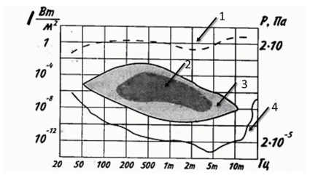
Figure 1.1 - Dynamic range of sound: 1 - pain threshold; 2 - speech sound area; 3 - musical sound area; 4 - hearing threshold

The main energy of the area of auditory perception of music is in the range from 40 to 5000 Hz, and the pressure is from 40 to 100 dB. With age, this area of sound perception decreases, losing brightness (perception of the upper-frequency range). However, in general, this does not affect music listening at any age.
As for speech, the main energy of the area of its auditory perception is in the frequency range from 500 to 600 Hz and pressure from 50 to 90 dB. The dynamic range of a quiet whisper is 10-15 dB, and loud speech is 25 dB.
The absolute threshold of audibility depends on the duration of the signal. It is the minimum sound level required to cause an auditory perception in the absence of noise. Its value depends on the tone of the sound (frequency, duration, waveform), the method of its presentation, and the subjective characteristics of the hearing analyzer. The absolute threshold of hearing decreases with age.
 |  |  |  |  | БМ93.12.2605.5223.ПЗ | Letter
 |  |  |  |  | БМ93.12.2605.5223.ПЗ | 13
Ed. | Letter | No. doc. | Sig. | Date | БМ93.12.2605.5223.ПЗ | 13

The hearing analyzer is capable of detecting even slight changes in the frequency of the sound signal, i.e. it is selective. This parameter depends on the sound pressure level, frequency and duration of the sound signal. The minimum noticeable differences are 2-3 Hz at frequencies of at least 10 Hz. For frequencies greater than 10 Hz, they are about 0.3 % of the sound signal frequency [12].

1.2 The main directions of modern research on the effect of sound stimuli on the human brain

The study of changes in human psychoemotional states using various sound stimuli has gained wide popularity today [1, 2, 3]. Music is used to try to exert a psycho-corrective influence on the personality [4], and to study changes in brain electrical activity depending on gender [1], music style [2], and many other factors. Studies have also identified a range of sound stimulus frequencies that have a significant impact on changes in brain electrical activity [5, 6, 7].
Japanese scientists have investigated [13] the connection between the cortical response and familiarity with a sound stimulus. Participants showed two pronounced peaks in the EEG lag time around 70 and 140 ms. The results indicate that the response to an unfamiliar or encrypted sound stimulus is stronger than to a familiar one. Later, it was studied [14] that the level of attention does not affect the perception of new sound stimuli that have the same effect on the cortex, regardless of where a person's attention is focused.
Swiss researchers also examined [15] brain activation under two conditions: listening and simultaneous rating of a reproduced sound stimulus [Listening and Rating (LR)] and unrestricted listening [Listening (L)], and tested the effect of the sequence of these conditions (LR→L, L→LR) on brain activation during the L-state.A three-dimensional ANOVA revealed a significant main effect, which is explained by a decrease in EEG power during the LR condition, with a slight increase for the L condition. The data indicate that the power of all studied
 |  |  |  |  | БМ93.12.2605.5223.ПЗ | Letter
 |  |  |  |  | БМ93.12.2605.5223.ПЗ | 14
Ed. | Letter | No. doc. | Sig. | Date | БМ93.12.2605.5223.ПЗ | 14

frequency bands increased for the L condition only in the (L→LR) case, while for the (LR→L) case it remained unchanged. The results indicate that the primary analysis of the stimulus by the subject made it impossible to listen to the same stimulus continuously.
Modern research [16, 17] opens up many opportunities for further study of the effect of sound stimuli on brain activity and activity, as well as changes in psychophysiological parameters of the human body as a result of listening to proper stimuli with different characteristics.

1.3 Methods of analyzing electrical activity of the brain

Today, electroencephalography is one of the main methods of studying brain function based on recording brain biopotentials. It reflects minimal changes in the part of the cerebral cortex and deep brain structures, providing millisecond time resolution that is not available for other methods of studying brain activity. It also enables qualitative and quantitative analysis of the functional state of the brain and the response to stimuli. The electroencephalography recording is traditionally presented in the form of a potential/time curve - an electroencephalogram (from now on referred to as EEG), which reflects the state of the human brain and the level of consciousness [18].
Modern electroencephalographs are multi-channel recording devices that combine 8 to 24 identical amplifying units (channels). The block diagram of a modern digital electroencephalograph can be seen in Fig. 1.2.
 |  |  |  |  | БМ93.12.2605.5223.ПЗ | Letter
 |  |  |  |  | БМ93.12.2605.5223.ПЗ | 15
Ed. | Letter | No. doc. | Sig. | Date | БМ93.12.2605.5223.ПЗ | 15

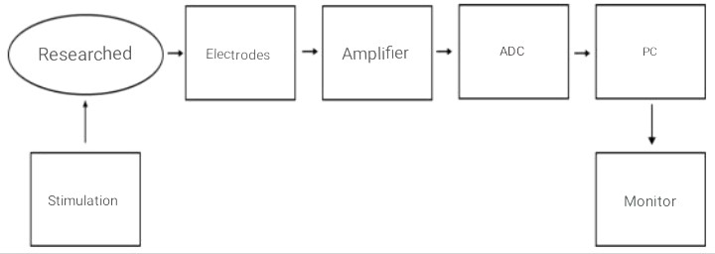
Figure 1.2 - Block diagram of the "ExpertTM" application

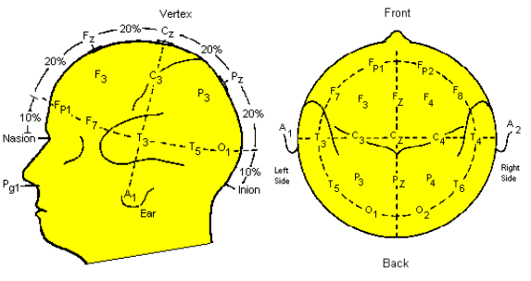
The most widely used method of placing electrodes on the scalp is the international system "10-20" (Fig. 1.3), which is based on the relationship between the location of the electrodes and the main areas of the cerebral cortex [19].
Figure 1.3 - International electrode placement scheme "10-20" [19].

The location of the electrodes is determined as follows: the line connecting the nose bridge (Nasion) and the occipital tubercle (Inion) is divided into ten equal parts. The first and last electrodes are placed at a distance of 10% of the total length of the line from the inion or nation. Then, the next electrode is placed at a distance corresponding to 20% of the entire length of the line from the first electrode, and so on.
 |  |  |  |  | БМ93.12.2605.5223.ПЗ | Letter
 |  |  |  |  | БМ93.12.2605.5223.ПЗ | 16
Ed. | Letter | No. doc. | Sig. | Date | БМ93.12.2605.5223.ПЗ | 16

Each electrode has a symbol and a number to identify the location of its application. The letters F, T, C, P, and O represent the frontal, temporal, central, parietal, and occipital leads, respectively. Even numbers (2, 4, 6, 8) refer to the right hemisphere and odd numbers (1, 3, 5, 7) to the left hemisphere. Z refers to the electrode placed on the center line. Also, the smaller the number, the closer the position is to the center line..
The EEG processing technique uses two types of leads: monopolar and bipolar. The essence of monopolar acquisition is that registration is performed relative to a single reference point. It is usually located on the patient's ear (or both ears), forehead, or nape of the neck and does not change its position throughout the study. In bipolar leads, the potential difference of any pair of points from the subject's head is recorded.
As with any oscillatory process, the characterization of EEG relies on such fundamental concepts as frequency, amplitude, and phase. However, since the EEG is a random process, waves of different frequencies are present at each recording site. Accordingly, the basis of the analysis is the extraction of individual frequency rhythms from the signal.
The concept of frequency rhythm of the EEG is considered to be a specific type of electrical activity for which the limits of the frequency range corresponding to a particular brain state are determined [20]. Table 1.1 presents brief characteristics of the primary rhythms, their frequency, and amplitude [21].

Table 1.1 - Characteristics of the main rhythms of the brain
 | Rhythm |  |  | Frequencies |  | Amplitude |  | General characteristics
 | Delta (δ) |  |  | 1-4 Hz |  | 20-200 µV |  | Delta rhythm (slow waves) is associated with recovery processes and low activation, especially during sleep. It occurs during natural and drug-induced sleep. It is observed when recorded from cortical areas bordering the area affected by the tumor. An excess of amplified slow waves virtually guarantees the presence of certain disorders of attention and other cognitive functions. In many neurological diseases, delta waves are also significantly enhanced..
 |  |  |  |  |  |  | БМ93.12.2605.5223.ПЗ |  | Letter
 |  |  |  |  |  |  |  |  | 17
Ed. |  | Letter | No. doc. |  | Sig. | Date

Continued from Table 1.1
 | Rhythm |  |  | Frequencies |  |  | Amplitude |  | General characteristics
 | Theta (θ) |  |  | 4-8HZ |  |  | 20-100µV |  | Theta waves appear when a calm, relaxed state turns into drowsiness and are recorded in the frontal areas and hippocampus. Electrical oscillations in the brain become more rhythmic and slower. This state is also called "twilight" because a person is between sleep and reality. Commonly, theta waves are associated with a change in consciousness. It is often accompanied by unexpected, dream-like images accompanied by vivid memories. Most people fall asleep when a significant number of theta waves appear in the brain. This rhythm is also associated with searching behavior, and it increases during emotional stress and is observed in psychotic disorders and states of confusion or concussions.  A high theta rhythm level may indicate a state of drowsiness and fatigue, which may be a manifestation of chronic stress or asthenia.
 | Alpha (α) |  |  | 8-13HZ |  |  | 5-100µV |  | Alpha rhythm is associated with a relaxed state of rest that is not accompanied by sleep. It is recorded in 85-95% of normal adults. Alpha waves occur when the eyes are closed in a relaxed state.  It is usually registered in the parietal and occipital regions (the brain's visual areas).
 | Beta 1(β) |  |  | 14-40HZ |  |  | 3-7µV  (up to 20µV) |  | Beta waves are the fastest. The beta rhythm is usually associated with higher cognitive processes, as well as with focusing attention, in a waking state, generally with eyes open or when solving any problems in a concentrated manner. It is registered in the area of the central and anterior gyrus.  It also extends to the posterior central and frontal gyrus.
 | Gamma (γ)  (Beta2) |  |  | > 30 HZ  (up to 100 HZ) |  |  | Up to 15 µV |  | It is usually observed when solving tasks that require maximum concentration.  It is registered in the brain's frontal, precentral, parietal, and temporal cortical areas.
Figure 1.4 shows an image of the primary EEG rhythms in normal brain functioning. For a healthy, conscious person, the α rhythm is standard, while other frequency ranges on the EEG indicate pathology or specific changes in consciousness. The shape of the curve can also be used to judge the presence of pathological changes in the brain.
 |  |  |  |  |  |  |  | БМ93.12.2605.5223.ПЗ |  | Letter
 |  |  |  |  |  |  |  |  |  | 18
Ed. |  | Letter | No. doc. |  | Sig. | Date

Gamma (Beta 2)
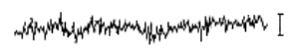Beta 1
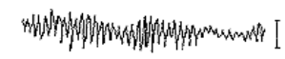 Alpha
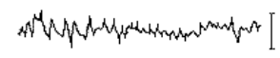 Theta
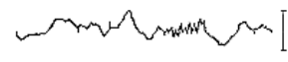 Delta
Figure 1.4 - Basic rhythms of the brain [22].

The compliance of these rhythms with the norm is determined depending onthe frequency range, amplitude, as well as the shape of the curve, topography andthepresence of atypical peaks on the EEG..

1.4 Methodsforevaluatingandfilteringaudiosignals

Any complex periodic signal can be represented by a Fourier series as a sum of simple harmonic oscillations. This set, into which the signal can be decomposed, is called the spectrum. The distribution of harmonic amplitudes by frequency is called the amplitude-frequency spectrum or amplitude spectrum, and the distribution of their initial phases by frequency is called the phase-frequency spectrum or phase spectrum [23].
The level of distortion of sinusoidal signals is evaluated using a certain set ofcharacteristics, such as the amplitude-frequency response (hereinafter referred toasthe frequency response), bandwidth,and attenuation ata particularfrequency.
Thefrequencyresponseindicateshowtheamplitudeoftheoutputsinewaves is attenuated compared to the input amplitude over the entire frequencyrange ofthesignal.
 |  |  |  |  | БМ93.12.2605.5223.ПЗ | Letter
 |  |  |  |  | БМ93.12.2605.5223.ПЗ | 19
Ed. | Letter | No. doc. | Sig. | Date | БМ93.12.2605.5223.ПЗ | 19

Bandwidth is a continuous range of frequencies over which the ratio of the amplitude of the output signal to the input signal is greater than a certain limit, usually 0.5. Thus, it defines the frequency range of a sinusoidal signal at which it can be transmitted over a communication line without significant distortion. This concept makes it possible to obtain a result that is close to that given by the amplitude frequency response.
Attenuation is a relative decrease in signal amplitude or power when a signal of a specified frequency is transmitted over a communication line. In other words, in most cases, it is enough to know the attenuation at a certain frequency to be able to estimate the distortion of signals transmitted over the line. With sufficient information about the attenuation at several frequencies at once, a more accurate estimate is possible, corresponding to several fundamental harmonics of the signal [24].
One of the most important features of signal processing is its filtering. Filtering a signal is a change in its spectrum, usually used to increase the ratio of useful signal to noise and interference or to emphasize the useful qualities of the signal. Depending on the type of filter, you can select or delete a separate frequency range specified in advance.
Figure 1.5 shows the amplitude-frequency characteristics of the main real filters: the X-axis shows the frequencies, and the Y-axis shows the signal amplitude (SP - passband, TS - transient band, LD - delay band) [25].
A low-pass filter has a relatively high transmission coefficient at frequencies near zero and a relatively low one at other frequencies (Fig. 1.5a). Such filters keep the value of the spectral components of the input signal unchanged at low frequencies. Low-pass filters pass low-frequency signals and do not pass high-frequency signals.
A high-pass filter has a relatively high transmission coefficient at frequencies above the cutoff frequencyf_{p}, and a low transmission coefficient at frequencies from zero to f_{p} (Fig. 1.5b).
 |  |  |  |  | БМ93.12.2605.5223.ПЗ | Letter
 |  |  |  |  | БМ93.12.2605.5223.ПЗ | 20
Ed. | Letter | No. doc. | Sig. | Date | БМ93.12.2605.5223.ПЗ | 20

FIR filters pass the part of the input signal spectrum that is in the range from f_{p} to +∞ without change, and do not pass the components of the signal spectrum from 0 tof_{p}, i.e., they pass high-frequency signals.
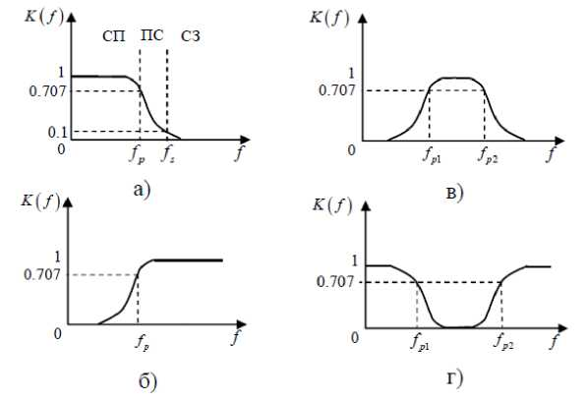
Fig. 1.5 - Frequency response of real filters:
a) low-pass filter, b) high-pass filter,c) bandpass filter, d) notch filter

A band-pass filter (hereinafter referred to as a band-pass filter) has a high transmission coefficient only in a certain frequency band within the range of f_{p1} and f_{p2}(Fig. 1.5c). Outside this range, the transmission coefficient is close to zero. Consequently, only the spectral components of the signal that are in the filter's passband will pass to the output of the SF.
The band-stop filter is a dual to bandpass filter: it has a high transmission coefficient outside the frequencies from f_{p1} to f_{p2} (Fig. 1.5d). From zero frequency tof_{p1}, and from f_{p2}to +∞, the transmission coefficient is relatively large. Therefore, when passing through the LP, the components lying in the range from f_{p1} to f_{p2} are removed from the signal spectrum, while the other components pass to the filter output unchanged.
 |  |  |  |  | БМ93.12.2605.5223.ПЗ | Letter
 |  |  |  |  | БМ93.12.2605.5223.ПЗ | 21
Ed. | Letter | No. doc. | Sig. | Date | БМ93.12.2605.5223.ПЗ | 21

Phase filter (hereinafter referred to as an all-pass filter) - passes all signal frequencies with the same gain level, but changes the phase of the signal when the pass delay by frequency changes. It is usually described only by the frequency at which the phase shift reaches 90°. Typically, such filters are used to compensate for excessive phase distortion that occurs in the system. The frequency response of the signal remains unchanged when this filter is applied [26, 27].
There are filters that do not belong to any of the above types. However, in most cases, the requirements for the amplitude-frequency characteristics of filters fall into one of the types, or are a combination of them.

1.5 Methods of studying the functional state of the central nervous system

The functional state of the central nervous system can be considered as an integral indicator of human performance. The issues of prediction, control and correction of the functional state of a person are of great theoretical and practical importance [28].To date, there are many methods for its assessment [28, 29]. One of the important elements of the study of changes in the functional state of the central nervous system is psychomotor indicators. They can indicate the strength or fatigue of the nervous system, etc.
One of the methods of studying changes in psychomotor indicators of the human central nervous system is the tapping test [30]. The classic version of this technique is the maximum rate of movement of the supporting hand for 30 seconds. The subject must place as many dots as possible on 6 squares located counterclockwise - 5 seconds in each square. Next, the number of points in each of the squares is counted and a graph of the subject's performance is plotted according to the results obtained: time intervals - abscissa axis, number of points - ordinate axis [30].
 |  |  |  |  | БМ93.12.2605.5223.ПЗ | Letter
 |  |  |  |  | БМ93.12.2605.5223.ПЗ | 22
Ed. | Letter | No. doc. | Sig. | Date | БМ93.12.2605.5223.ПЗ | 22

However, there are studies that do not agree with the classic version of the test. According to V. V. Nikandrov, author of books and manuals on psychomotor skills: "The methodology was developed several decades ago, during which time experimental material has been accumulated that does not agree with the proposed schedules. Therefore, when assessing the strength of the nervous system, one cannot rely solely on the type of graph, it is necessary to use other indicators, to use other methods along with the tapping test" [31]. Also, many years of practice in applying the tapping test have revealed its special sensitivity to the situational neuro-emotional background and to the initial level of psychofunctional state. As a result, there were situations when the subject showed different types of graphs each time [32]. This indicates the need to modify this technique.
Noise - random perturbations of signals - poses a fundamental problem for information processing and affects all aspects of the nervous system. However, the nature, amount, and effects of noise on the nervous system have only recently been quantified. Experimental and computational methods have shown that numerous sources of noise contribute to cellular and behavioral variability from trial to trial. We review the sources of noise in the nervous system, from the molecular to the behavioral level, and show how noise affects inter-trial variability. We emphasize how noise affects neural networks and the principles that the nervous system employs to counteract the harmful effects of noise, and briefly discuss the potential benefits of noise.

 |  |  |  |  | БМ93.12.2605.5223.ПЗ | Letter
 |  |  |  |  | БМ93.12.2605.5223.ПЗ | 23
Ed. | Letter | No. doc. | Sig. | Date | БМ93.12.2605.5223.ПЗ | 23

1.6 Auditory evoked potentials (AEPs).

Auditory evoked potentials (AEPs) are electrical responses elicited by sound stimuli by the auditory system. These potentials are generated by many structures within the auditory pathway, such as the inner ear, auditory nerve, and various brain areas such as the brainstem, thalamus, and auditory cortex. AEPs are recorded non-invasively using electrodes placed on the scalp, ear, or other sites, and they give significant information regarding the auditory system's functioning and integrity.
AEPs are classified based on their latency (the time between the beginning of the stimulus and the peak response) and the underlying neuronal generators:
1. Cochlear potentials: These are early reactions produced by the inner ear (cochlea). An example of this sort of AEP is the electrocochleogram (ECochG).
2. Auditory brainstem responses (ABRs): These potentials, also known as short-latency AEPs, are produced inside the brainstem and have peak latencies of less than 10 milliseconds (ms) following the commencement of the sound stimuli.
3. Middle-latency AEPs: These potentials are produced in the main auditory cortex and adjacent regions and have latencies ranging from 10 to 50 ms.
4. Long-latency AEPs: These reactions, also known as late AEPs or cognitive event-related potentials, have latencies larger than 50 ms and often involve higher-order cortical processing. A well-known example of a long-latency AEP is the P300 component.
AEPs are used in a variety of clinical and research applications, including assessing hearing thresholds in infants and young children, assessing the auditory system integrity in patients with hearing loss or neurological disorders, and studying the effects of drugs or other interventions on auditory processing.

 |  |  |  |  |  | БМ93.12.2605.5223.ПЗ | Letter
 |  |  |  |  |  | БМ93.12.2605.5223.ПЗ | 24
Ed. | Letter |  | No.doc. | Signature | Date | БМ93.12.2605.5223.ПЗ | 24
AERs are obtained non-invasively by placing electrodes on the scalp, ear, or other sites. The recordings give crucial information regarding the auditory system's operation and integrity. AERs can be used to do the following:
- Determine hearing thresholds in newborns and young children who are unable to engage reliably in typical behavioral hearing tests.
- Assess the auditory system's integrity in individuals with hearing loss, auditory neuropathy, or neurological diseases.
- Keep an eye on auditory function during procedures involving the auditory circuit.
- Look into the impact of medicines, ageing, or other variables on auditory processing.
- Look into the brain systems that underpin auditory perception, attention, and cognition.
Overall, auditory evoked responses can give useful insights into the neurological basis of hearing and auditory processing.
Scientists use different methods to handle individual differences in Auditory Evoked Potentials (AEPs) so that these differences do not affect their study results too much. Some ways they do this include:
1. Within-subject design: Researchers look at how each person's AEPs change in different situations. This helps because each person is their own control.
2. Baseline recordings: Scientists record each person's AEPs before they make any changes (like giving them a drug or training). This helps them see what changes happen because of the experiment and not because of individual differences.
3. Repeated measurements: By taking many AEP measurements for each person and averaging them, researchers can get better results and reduce differences between people.

 |  |  |  |  |  | БМ93.12.2605.5223.ПЗ | Letter
 |  |  |  |  |  | БМ93.12.2605.5223.ПЗ | 25
Ed. | Letter |  | No.doc. | Signature | Date | БМ93.12.2605.5223.ПЗ | 25
4. Adequate sample size: Including enough people in the study helps make the results more reliable and less affected by individual differences.
5. Matching participants: In studies with two groups, researchers can pair people in the experimental and control groups based on things like age, gender, or hearing ability. This helps reduce differences between the groups.
6. Statistical modeling: Scientists can use math methods to help account for individual differences when looking at the effects they're interested in.
7. Standardizing conditions: Making sure everyone has the same conditions during the experiment (like the same sound level and equipment) helps reduce differences in AEPs.
8. Controlling for other factors: Researchers need to think about things that could affect AEPs, like attention, arousal, and tiredness. They can plan their experiment carefully and watch how people follow the rules during the study.
Using these methods can help scientists get more accurate and reliable results, which helps us understand the auditory system and what affects it better.

Conclusion to Section 1

An analysis of modern literature indicates a significant impact of music on the central nervous system. Since the human body's response to sound depends significantly on its frequency characteristics, audio stimuli should be selected based
on a detailed analysis of it. Therefore, it is important to determine which frequencies
present in the sound stimulus affect brain activity and the functional state of the central nervous system.

 |  |  |  |  |  | БМ93.12.2605.5223.ПЗ | Letter
 |  |  |  |  |  | БМ93.12.2605.5223.ПЗ | 26
Ed. | Letter |  | No.doc. | Signature | Date | БМ93.12.2605.5223.ПЗ | 26
The reaction of the human brain to exposure should be assessed by its electrical activity, which is reflected in the electroencephalogram.
To objectively assess the functional state of the central nervous system and its response to stimuli, it is necessary to develop a methodology for collecting psychomotor indicators and tracking their dynamics.
AEPs are used in various clinical and research applications, such as assessing hearing thresholds in infants and young children, evaluating the integrity of the auditory system in patients with hearing loss or neurological disorders, and studying the effects of drugs or other interventions on auditory processing.
Researchers can control for individual differences in AEPs and obtain more reliable and valid results, allowing for a better understanding of the auditory system and the factors that influence it.
 |  |  |  |  | БМ93.12.2605.5223.ПЗ | Letter
 |  |  |  |  | БМ93.12.2605.5223.ПЗ | 27
Ed. | Letter | No. doc. | Sig. | Date | БМ93.12.2605.5223.ПЗ | 27

CHAPTER 2
RATIONALE FOR SELECTING FREQUENCY RANGES AUDIO STIMULI

2.1 Materials and methods of the study

An experimental study was conducted on 5 volunteers aged 20 to 21 years. Of these, 2 were men and 3 were women.
The study was conducted in accordance with the current legislation of Ukraine as part of experimental research with the participation of volunteers. Participants were informed in detail about the purpose, nature and duration of the study, and had the opportunity to ask all questions they were interested in. Each participant provided a written "Consent to the processing of personal data".
Data were collected using the software and hardware complex
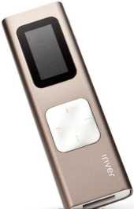
"ExpertTM" by Tredex [33], which includes an electroencephalograph, electroencephalographic helmet, electrodes, transmitter and receiver of EEG signals, chargers and power supplies, antennas, connecting cables, and a computer.As a sound source in the complex, we used the iRiver T9 4GB player (Fig. 2.1a) and vacuum headphones"Panasonic RP-HJE118GU-K" (Fig. 2.1b).
а) 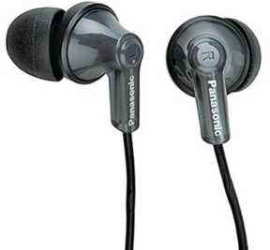b)

Figure 2.1 - iRiver T9 4GB player (a) and Panasonic RP-HJE118GU-K headphones (b)
 |  |  |  |  | БМ93.12.2605.5223.ПЗ | Letter
 |  |  |  |  | БМ93.12.2605.5223.ПЗ | 28
Ed. | Letter | No. doc. | Sig. | Date | БМ93.12.2605.5223.ПЗ | 28

Table 2.1 shows the main characteristics of the player.

Table 2.1 - Specifications of the "iRiver T9 4GB" player

Mediatype | Flashmemory
Supportforformats | MP3,WMA,WAV,ASF,FLAC,APE
Memorycapacity | 4GB
Powersupplycharacteristics | Lithiumpolymerbattery
Continuousoperationtime | 24 h
Headphonejack | mini-jack(3.5mm)

Vacuum headphones were used for the experiment"Panasonic RP-HJE118GUK", the characteristics of which are presented in the table 2.2.

Table 2.2 - Characteristics of "Panasonic RP- HJE118GU-K" vacuum headphones
Headphonetype | Inserts
Connectiontype | Wired
Wiredconnectioninterface | 1x mini-jack(3.5mmjack)
Headphonefrequencyrange | 12Hz-23kHz
Headphoneresistance | 16ohms
Headphonesensitivity | 96dB/mW
Maximuminputpowerofheadphones | 200mW
Diameterofmembranes | 9mm
Wirelength | 1.1 м

Based on previous studies [5-7], we selected a frequency range (250 - 2998 Hz) that has a significant impact on changes in brain electrical activity, and 5 appropriate sound tracks were selected.
As audio stimuli, melodies performed on various musical instruments with a predominant presence of midrange frequencies were used:
- clarinet (Fig. 2.2a), available frequencies from 450 to 2200 Hz;
- piano (Fig. 2.2b), available frequencies from 200 to 2400 Hz;
- violin (Fig. 2.2c), the available frequencies are from 350 to 4000 Hz;
- piano (Fig. 2.2d), the available frequencies are 500 to 1600 Hz;
- pipe (Fig. 2.2d), available frequencies from 400 to 4000 Hz.
 |  |  |  |  | БМ93.12.2605.5223.ПЗ | Letter
 |  |  |  |  | БМ93.12.2605.5223.ПЗ | 29
Ed. | Letter | No. doc. | Sig. | Date | БМ93.12.2605.5223.ПЗ | 29

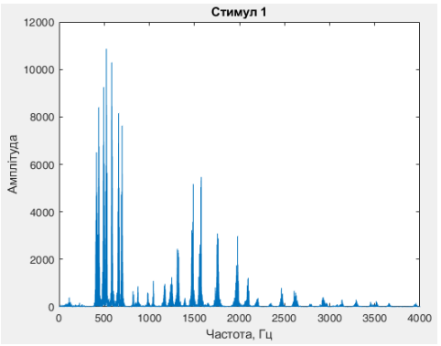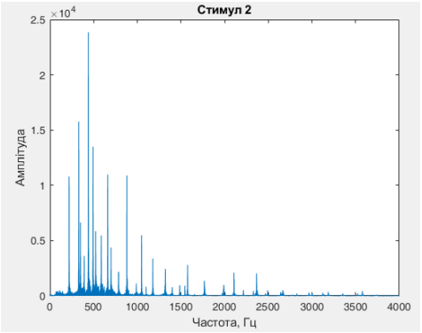
a) b)
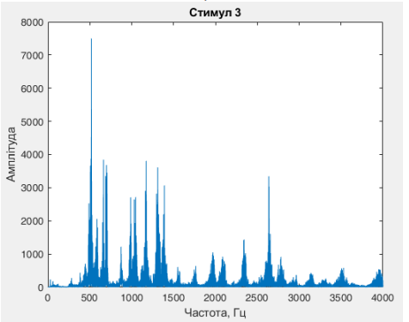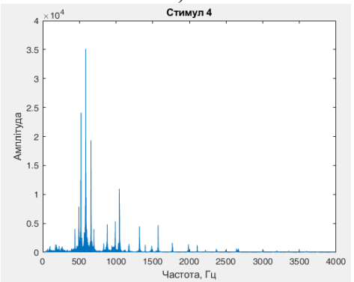
c) d)
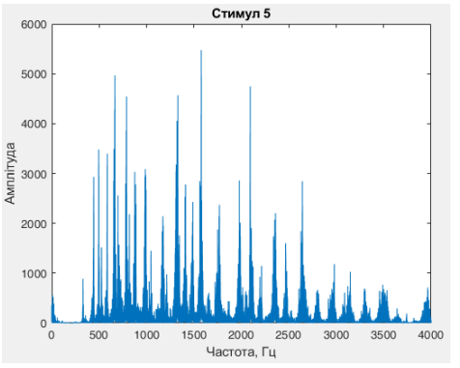
e)
Figure 2.2 - Frequency characteristics of the studied stimuli: a) stimulus No.1, b) stimulus No.2, c) stimulus No.3, d) stimulus No.4, e) stimulus No.5

Each of the five fragments of musical compositions was analyzed using MATLAB 2018 [34].
 |  |  |  |  | БМ93.12.2605.5223.ПЗ | Letter
 |  |  |  |  | БМ93.12.2605.5223.ПЗ | 30
Ed. | Letter | No. doc. | Sig. | Date | БМ93.12.2605.5223.ПЗ | 30

The data were recorded using a standard electrode placement scheme according to the international system "10-20", bipolar registration was performed using 16 reference electrodes at a speed of 30 mm/s, amplitudePreliminary analysis of EEG results was performed in the Expert_NET software environment developed by the manufacturer of the encephalographic complex Tredex
The study used a formative stimulus with a total duration of 8 min 21 s, consisting of 5 audio stimuli. It began with background silence lasting 2 min, followed by an alternation of the track and 30-second background silence. The formative stimulus ended with background silence lasting 1.5 minutes.

2.2 Results of the study

In the course of the study, we investigated the contributions of rhythms generalized for each segment of the formative stimulus: during listening to an audio signal and during background silence. The obtained values for all subjects were normalized relative to the initial one. The contributions of the rhythms of the initial background silence were taken as reference for further comparison of changes in all segments of the composition.
The percentage contribution of rhythms shows the share of a particular rhythm among all rhythms for the selected information segment, where 100% is the sum of the contribution of all rhythms.
The same changes in rhythm contributions in several subjects were taken as the presence of a reaction.
The results were grouped according to the presence of the same reaction into 3 separate groups of subjects.
Figure 2.3 shows the changes in the β2 rhythm contributions in response to stimuli, and Figure 2.4 shows the α rhythm contributions.
 |  |  |  |  | БМ93.12.2605.5223.ПЗ | Letter
 |  |  |  |  | БМ93.12.2605.5223.ПЗ | 31
Ed. | Letter | No. doc. | Sig. | Date | БМ93.12.2605.5223.ПЗ | 31

Thus, in the first group of subjects, a reaction to all stimuli was observed: the contribution of β2 rhythm (Fig. 2.3a) increased during listening to the first stimulus in the third, fourth and fifth subjects by 0.275%, 0.28% and 0.215%, respectively, and during listening to the second stimulus - by 0.33%, 0.68% and 0.47% for each of the subjects, respectively. In the same group, there was a significant decrease in the contribution of α rhythm (Fig. 2.4a) when listening to:
- stimulus No. 1 by 0.41% for the third, 3.265% for the fourth and 1.84% for the fifth subject;
- stimulus #3 by 0.7%, 0.73%, and 3.57% for each of the subjects, respectively;
- of incentive #5 by 4.76% for the third, 0.685% for the fourth and 0.845% for the fifth subject.
In the second group, a reaction to the first, third, and fourth stimuli was observed:
- an increase in the contribution of β2 rhythm during listening to the first stimulus (Fig. 2.3b) by 0.595% for the second, 0.275% for the third and 0.28% for the fourth subject, while reducing the contribution of α rhythm (Fig. 2.4b) by 3.675%, 0.41% and 3.265% for each of the subjects, respectively;
- decrease in the contribution of α rhythm when listening to the third stimulus (Fig. 2.4b) by 1.7% for the second, 0.7% for the third and 0.73% for the fourth subject;
- a decrease in the contribution of β2 rhythm when listening to the fourth stimulus (Fig. 2.3b) by 1.38% for the second, 1.355% for the third and 0.935% for the fourth subject, while increasing the contribution of α rhythm (Fig. 2.4b) by 1.49%, 3.76% and 7.66%, respectively.
In the third group of subjects, a reaction to the first, third, and fifth stimuli was observed:
 |  |  |  |  | БМ93.12.2605.5223.ПЗ | Letter
 |  |  |  |  | БМ93.12.2605.5223.ПЗ | 32
Ed. | Letter | No. doc. | Sig. | Date | БМ93.12.2605.5223.ПЗ | 32

- when listening to the first stimulus, there was an increase in the contribution of β2 rhythm (Fig. 2.3c) by 0.595% for the second, 0.28% for the fourth and 0.215% for the fifth subject, while reducing the contribution of α rhythm (Fig. 2.4c) by 3.675%, 3.265% and 1.84% for each of the subjects, respectively;
- when listening to the third stimulus, a similar reaction was observed as with the first stimulus: a decrease in the contribution of β2 rhythm (Fig. 2.3c) by 0.715% for the second, 1.125% for the fourth and 0.785% for the fifth subject, while reducing the contribution of α rhythm (Fig. 2.4c) by 1.7%, 0.73% and 3.59% for each of the subjects, respectively;
- when listening to the fifth stimulus, there was a decrease in the power α of the rhythm (Fig. 2.4c) by 0.905% for the second, 0.685% for the fourth and 0.845% for the fifth subject.

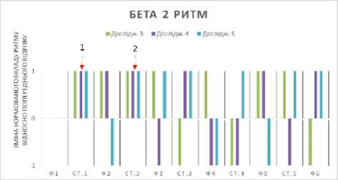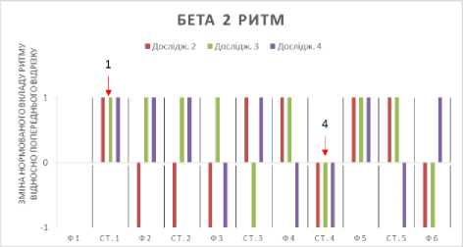
a) b)
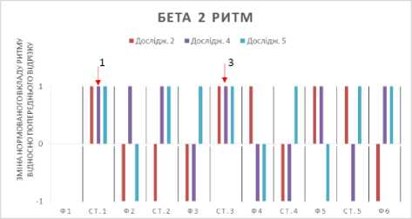
c)
Figure 2.3 - Changes in β2 rhythm contributions in response to stimuli: a) group of subjects 3, 4, 5; b) group of subjects 2, 3, 4;
c) group of subjects 2, 4, 5
 |  |  |  |  | БМ93.12.2605.5223.ПЗ | Letter
 |  |  |  |  | БМ93.12.2605.5223.ПЗ | 33
Ed. | Letter | No. doc. | Sig. | Date | БМ93.12.2605.5223.ПЗ | 33

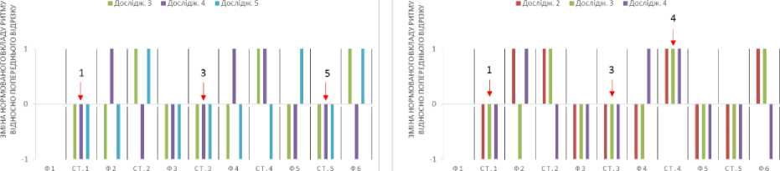
a) b)
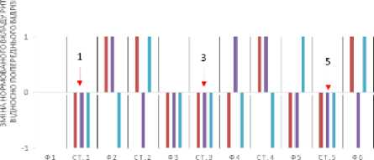
c)
Figure 2.4 - Changes in α rhythm contributions in response to stimuli: a) group of subjects 3, 4, 5; b) group of subjects 2, 3, 4; c) group of subjects
2, 4, 5

Table A.1 shows the numerical data of rhythm contributions for all subjects. Background compositions are labeled F1-F6, stimuli are labeled St.1-5 for all subjects No.1-5.

Conclusion to the section 2

The results of the analysis indicate an existing reaction of the human brain to the selected stimuli. Since these compositions are dominated by medium frequencies, we can say that the results of previous studies have been confirmed. For a more detailed analysis, it is necessary to divide the existing frequency range present in the stimuli into smaller areas.
 |  |  |  |  | БМ93.12.2605.5223.ПЗ | Letter
 |  |  |  |  | БМ93.12.2605.5223.ПЗ | 34
Ed. | Letter | No. doc. | Sig. | Date | БМ93.12.2605.5223.ПЗ | 34

SECTION 3
DEVELOPMENT OF SOFTWARE AND HARDWARE COMPLEX

After conducting an experimental study, based on the data obtained, it was decided that a more detailed analysis of the characteristics of the impact and the creation of an appropriate software and hardware complex were necessary. This software package should include two main elements:
- filtering of audio stimulus;
- methods of studying changes in the functional state of the central
nervous system.
Figure 3.1 shows the scheme of operation of the software and hardware complex.
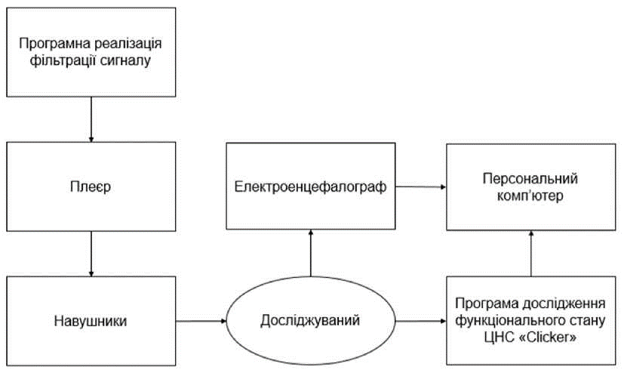
Figure 3.1 - Scheme of the hardware and software complex The development of this complex was divided into 2 logical elements:
- software implementation of signal filtering;
- program to study the functional state of the central nervous system.
 |  |  |  |  | БМ93.12.2605.5223.ПЗ | Letter
 |  |  |  |  | БМ93.12.2605.5223.ПЗ | 35
Ed. | Letter | No. doc. | Sig. | Date | БМ93.12.2605.5223.ПЗ | 35

3.1 Software implementation of audio signal filtering

For the software implementation of filtering the sound stimulus in a given frequency range, as well as analyzing the received audio stimuli, the MATLAB 2018 environment was chosen.
The main criteria for choosing a development environment were:
- availability of necessary functions for filtering;
- easy to write program code;
- the ability to save filtered stimuli in wav format;
- availability of a graphical display of the obtained signal characteristics.
Since it has been proven [13] that the reaction to an unfamiliar or encrypted stimulus is more pronounced, to ensure the absence of random reactions, a 40-second fragment of the famous Ukrainian song "Shchedryk" in wav format was chosen as the initial signal. The frequency characteristics of the initial signal are shown in Figure 3.2.
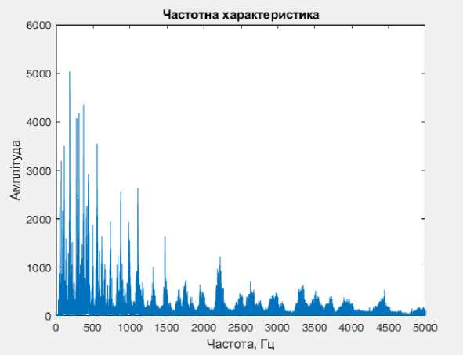

Figure 3.2 - Frequency response of the original audio stimulus
 |  |  |  |  | БМ93.12.2605.5223.ПЗ | Letter
 |  |  |  |  | БМ93.12.2605.5223.ПЗ | 36
Ed. | Letter | No. doc. | Sig. | Date | БМ93.12.2605.5223.ПЗ | 36

The signal analysis revealed the presence of frequencies from 0 to 5 kHz. Previous studies [5-7] have identified a range of frequencies from 250 to 2998 Hz that have a significant effect on the electrical activity of the human brain. The frequencies present in the original signal fully cover this range. This makes it possible to use the selected fragment of the composition "Shchedryk" in further work.
The defined frequency range was arbitrarily divided into 5 equal parts with a step of 600 Hz (Table 3.1) and 5 filtered sound tracks were created accordingly.

Table 3.1 - Frequency ranges of filtered audio tracks
 |  |  |  | Filtered incentives |  |  | Frequency range
 |  |  |  | No.1 |  |  | 260– 760HZ
 |  |  |  | No.2 |  |  | 761– 1260HZ
 |  |  |  | No.3 |  |  | 1261– 1760HZ
 |  |  |  | No.4 |  |  | 1761– 2260HZ
 |  |  |  | No.5 |  |  | 2261– 2760HZ
During filtering, the main original characteristics of the signal were preserved, such as duration, sampling rate, and amplitude.
When designing real filters, the parameters of the amplitude-frequency response corridor were set [35]. The limit values of the passband were selected in accordance with Table 3.1. The boundary values of the blocking band were chosen at the rate of ± 10 Hz to the values of the passband. The value of the frequency response irregularity in the passband was chosen to be minimal (Rp = 1 dB), and the attenuation value in the blocking band was chosen to provide the most optimal signal attenuation (Rs = 150 dB).
The frequency response of the filtered audio stimuli is shown in Figure 3.3.
The program implementation code is presented in Appendix B.
 |  |  |  |  |  | БМ93.12.2605.5223.ПЗ |  |  | Letter
 |  |  |  |  |  |  |  |  | 37
Ed. | Letter | No. doc. | Sig. |  | Date |  |  |  | 37

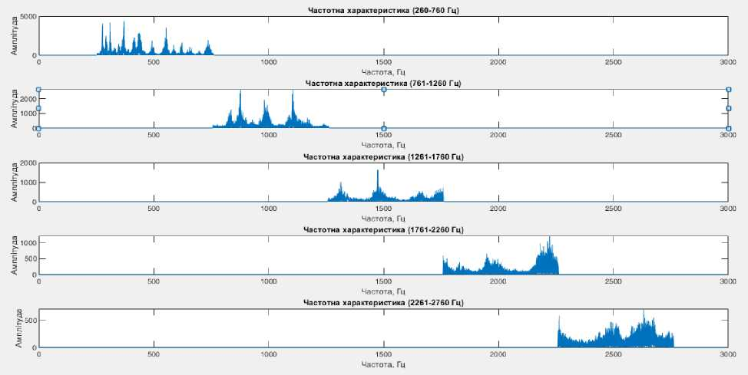
Figure 3.3 - Frequency response of filtered signals
The filtered audio files were saved as separate tracks in wavformat.

3.2 Programmatic method of studying the functional state of the central nervous system

The second logical element of the PAC includes the development of a method for studying the functional state of the central nervous system.
After analyzing the existing methods for assessing the functional state of the central nervous system in the literature, psychomotor indicators were chosen as the factor under study. To study this indicator, we developed our own modification of the tapping test by E. P. Ilyin [30]. The methodology consists of counting the number of clicks on the mouse manipulator over a certain period of time. This test is performed three times with a 1 minute break between each test. The break between tests is provided to prevent the accumulation of muscle fatigue. The results obtained are normalized for each subject and are accepted as a reference range of values.
 |  |  |  |  | БМ93.12.2605.5223.ПЗ | Letter
 |  |  |  |  | БМ93.12.2605.5223.ПЗ | 38
Ed. | Letter | No. doc. | Sig. | Date | БМ93.12.2605.5223.ПЗ | 38

After the study, the tests (Fig. 3.4, "Clicker") before and after listening to audio stimuli (Fig. 3.3) are saved in a separate file, which are then compared with the reference range of values.
In accordance with this methodology, the name of the developed program
was chosen –«Clicker" (English: click).
Figure 3.4 shows the scheme of the developed methodology.
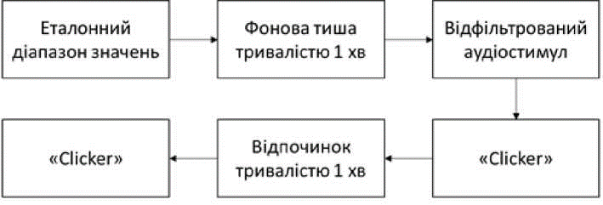
Figure 3.4 - Methodology of the study using the software and hardware complex

The development of the program for determining the functional state of the central nervous system by calculating psychomotor parameters was carried out using the C# programming language [36], the main selection criteria for which were the ease of writing the program code, the availability of the functions necessary for operation, and the ease of use of the developed program. The implementation code can be seen in Appendix B.
The program starts (Fig. 3.5) from the moment of the first click on the "Click" button, after which the internal timer set for 20 seconds starts. Each time the user clicks on the "Click" button, the counter is incremented by one, thus calculating the total number of clicks. When the 20-second time interval expires, the button is locked to prevent excessive clicks from being counted. At the end of the test, the result can be seen on the screen (Fig. 3.6).
 |  |  |  |  | БМ93.12.2605.5223.ПЗ | Letter
 |  |  |  |  | БМ93.12.2605.5223.ПЗ | 39
Ed. | Letter | No. doc. | Sig. | Date | БМ93.12.2605.5223.ПЗ | 39

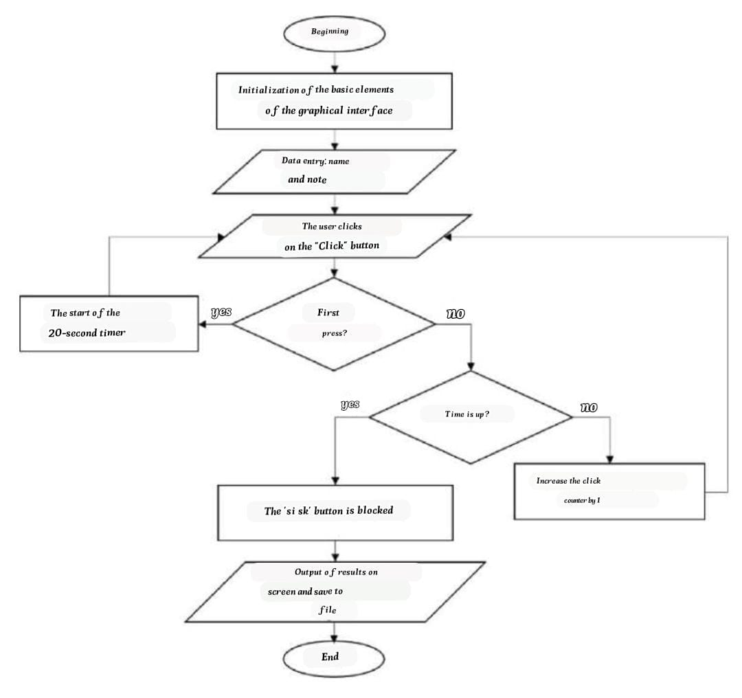

Figure 3.5 - The algorithm of the "Clicker" program

The initial interface of the program, as well as the display of the results on the screen, are shown in Figure 3.6.
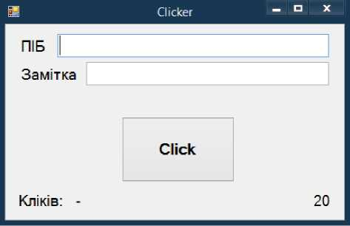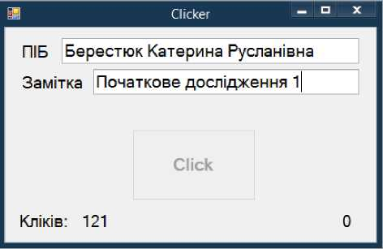
а) б)
Figure 3.6 - Interface of the Clicker program: a) initial, b) after testing
 |  |  |  |  | БМ93.12.2605.5223.ПЗ | Letter
 |  |  |  |  | БМ93.12.2605.5223.ПЗ | 40
Ed. | Letter | No. doc. | Sig. | Date | БМ93.12.2605.5223.ПЗ | 40

At the end of the test, the result is displayed on the screen and saved to a separate text file called "Name_Note" in the root of the program folder (Fig. 3.7).
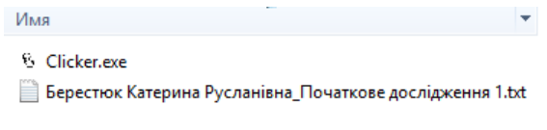
Figure 3.7 - Saving test results

The developed software methodology allows you to quickly determine psychomotor indicators and save the results without using special software or connecting separate applications. It is easy to use and does not require special training, which greatly simplifies the study.

Conclusion to the section 3

After the experimental study, the effect of the pre-selected frequency range on the electrical activity of the brain was confirmed.
The development of the hardware and software complex was divided into two logical parts: filtering the sound stimulus and studying the functional state of the central nervous system.
Audio stimulus filtering was implemented in MATLAB 2018 with the filtered stimuli saved in wav format. The main characteristics of the original signal were left unchanged.
The study of the functional state of the central nervous system was implemented using the C# programming language in the form of a separate program "Clicker". У
 |  |  |  |  | БМ93.12.2605.5223.ПЗ | Letter
 |  |  |  |  | БМ93.12.2605.5223.ПЗ | 41
Ed. | Letter | No. doc. | Sig. | Date | БМ93.12.2605.5223.ПЗ | 41

The psychomotor indicator - the number of clicks on the mouse manipulator during a certain time - was chosen as the research criterion. The developed program makes it possible to determine psychomotor indicators without the use of complex tests or cumbersome calculations. The automated testing methodology allows you to quickly get clear results, which ensures the quality of the study.
The developed hardware and software complex makes it possible to study the effect of audio signals of a given frequency on changes in the functional state of the central nervous system. The operation of the PAC is flexible and does not depend on the number of studies conducted and the applied audio stimuli, which makes it possible to adjust the complex for further studies.
 |  |  |  |  | БМ93.12.2605.5223.ПЗ | Letter
 |  |  |  |  | БМ93.12.2605.5223.ПЗ | 42
Ed. | Letter | No. doc. | Sig. | Date | БМ93.12.2605.5223.ПЗ | 42

SECTION 4

CHECKING THE OPERATION OF THE COMPLEX

An experimental study was conducted on 5 volunteers aged 20 to 21 years. Of these, 2 were men and 3 were women.
Like the previous study, this one was conducted in compliance with the current legislation of Ukraine. Each participant provided a written "Consent to the processing of personal data".
The data were collected using the software and hardware complex
"ExpertTM" software and hardware system by Tredex. The sound source was used as a player "iRiver T9 4GB" (Fig. 2.1a) and vacuum headphones "Panasonic RP-HJE118GUK" (Fig. 2.1b), the technical characteristics of which are presented in Table 2.1 and Table.
2.2, respectively.
As audio stimuli, we used a 40-second fragment of the musical composition
"The frequency characteristics of the obtained sound stimuli are shown in Figure 3.3.
The data were recorded with a standard electrode placement scheme according to the international system "10-20", bipolar registration was performed using 16 reference electrodes at a speed of 30 mm/s, amplitude
Preliminary analysis of EEG results was performed in the Expert_NET software environment.
The study was conducted in accordance with the developed methodology (Fig. 3.4). We used 5 sound tracks. Each of them lasted 1 min 40 s and consisted of 30-second background silence, 40-second sound stimulus and 30-second background silence (the latter for EEG recording during testing).
 |  |  |  |  | БМ93.12.2605.5223.ПЗ | Letter
 |  |  |  |  | БМ93.12.2605.5223.ПЗ | 43
Ed. | Letter | No. doc. | Sig. | Date | БМ93.12.2605.5223.ПЗ | 43

In the course of the study, the results of testing psychomotor indicators relative to the reference value (normalized individually for each range of initial testing values under study) were investigated.
Figure 4.1 shows the graphs of changes in the results of testing psychomotor indicators after listening to each of the selected audio stimuli (Table D.3).
Normalized preliminary results, taken as a reference, are denoted in the graphs as pre_ser, test results immediately after listening to the sound stimulus are denoted as stx_1, and results obtained after 1 min of rest after the preliminary test (Fig. 3.4) are denoted as stx_2, where X is the stimulus number.
The graphs show that immediately after listening to each of the audio stimuli, there is a change in the number of taps. Whereas a minute after the pre-test, almost all subjects show a tendency for the number of clicks to return to the normal range.
Depending on the response to the stimulus, two groups can be conditionally distinguished: subjects 1 and 4 show a significant decrease in the number of clicks after listening to audio stimuli, while subjects 2 and
No. 5 showed an increase in the number of taps. Subject No. 3 after listening to stimuli No. 1, No. 2 and No. 4 (Fig. 4.1a, b, d) showed an increase in the reaction, and after listening to stimuli No. 3 and No. 5 - a decrease (Fig. 4.1c, e)
Subject #1 showed consistently low values of the number of clicks as a reaction to the stimuli, compared to the reference ones, with the greatest reaction to stimulus #5 - a decrease in the number of clicks by 20 units (Fig. 4.1d). Moreover, after listening to the fifth stimulus, other subjects showed the smallest variation in changes in psychomotor indicators, compared to the reaction to other stimuli.
 |  |  |  |  | БМ93.12.2605.5223.ПЗ | Letter
 |  |  |  |  | БМ93.12.2605.5223.ПЗ | 44
Ed. | Letter | No. doc. | Sig. | Date | БМ93.12.2605.5223.ПЗ | 44

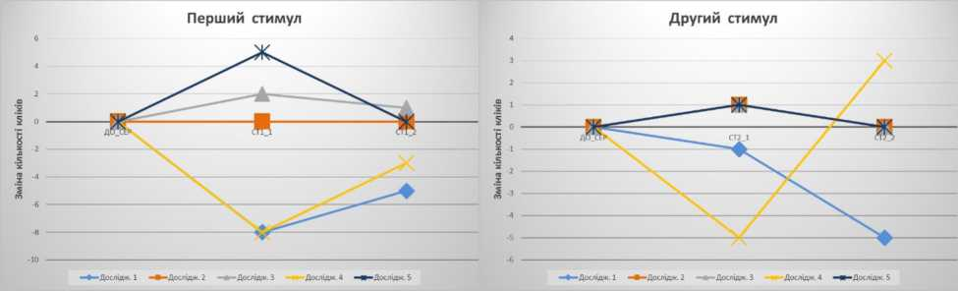
a) b)
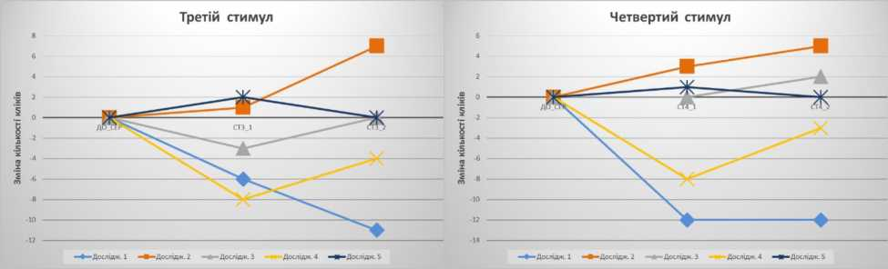
c) d)
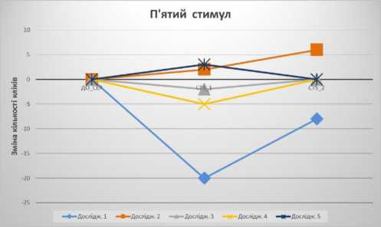
e)
Figure 4.1 - The results of testing psychomotor indicators after listening to: a) audio stimulus No. 1, b) audio stimulus No. 2,
c) audio stimulus No. 3, d) audio stimulus No. 4, e) audio stimulus No. 5.

The data obtained indicate the presence of a certain reaction as a result of listening to sound stimuli.
We considered the contributions of rhythms summarized for each segment of the audio stimulus: during listening to the audio signal and during background silence.
Figure 4.2 shows the change in α-rhythm contributions in the left leads in response to the first stimulus (Table D.1). Rhythm contribution during background silence
 |  |  |  |  | БМ93.12.2605.5223.ПЗ | Letter
 |  |  |  |  | БМ93.12.2605.5223.ПЗ | 45
Ed. | Letter | No. doc. | Sig. | Date | БМ93.12.2605.5223.ПЗ | 45

is labeled as carol X_0, immediately after the start of listening to the audio stimulus - carol X_1, and before the end of the audio stimulus - carol X_2, where X is the stimulus number.
АЛЬФА ЛІВІ
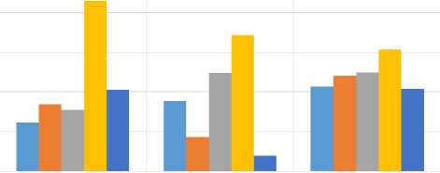
ЩЕДРИК 10 ЩЕДРИК 11 ЩЕДРИК 1_2
■ Дослід». 1 ■ Дослід». 2 ■ Дослід». З ■ Дослід». 4 ■ Дослід». 5
Figure 4.2 - Changes in α-rhythm contributions in the left leads in response to stimulus No.1

Figure 4.2 shows that regardless of the contribution of the α-rhythm before listening to audio stimulus No. 1, at the end of listening the share of the α-rhythm in all subjects is in the same range of values (30-35%).
In the right leads (Fig. 4.3) for subjects No. 1-3 and No. 5, the same trend is observed as in the left leads (Table D.2).
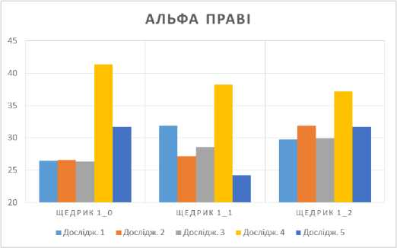
Figure 4.3 - Changes in α-rhythm contributions in the right leads in response to stimulus No.1
 |  |  |  |  | БМ93.12.2605.5223.ПЗ | Letter
 |  |  |  |  | БМ93.12.2605.5223.ПЗ | 46
Ed. | Letter | No. doc. | Sig. | Date | БМ93.12.2605.5223.ПЗ | 46

There was also a change in the β2-rhythm contribution in the left leads for the fourth stimulus (Fig. 4.4). Regardless of the contribution of the rhythm before listening to audio stimulus #4, immediately after the stimulus onset, the proportion of β2 rhythm in subjects #2, #3, and #5 is in the same range of values (about 22%). In the same subjects, an increase in the number of beats was observed after listening to audio stimulus No. 4 (Fig. 4.1g).
In subjects #1 and #4, after the start of listening to the fourth stimulus, the contribution of the β2 rhythm is in the same range (19-20%), despite different values before listening to this sound stimulus. In the same subjects, a significant decrease in the number of clicks after listening to audio stimulus No. 4 was observed (Fig. 4.1g).
БЕТА 2 ЛІВІ
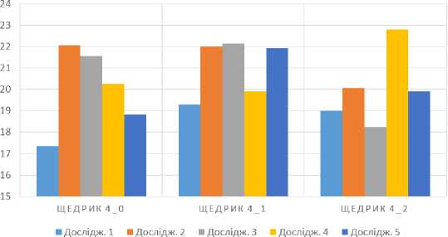
Figure 4.4 - Changes in β2 rhythm contributions in the left leads in response to stimulus No. 4

The presence of a reaction in both changes in psychomotor indicators and changes in the contributions of EEG rhythms in the same subjects may indicate a general reaction of the central nervous system to audio stimuli. The results of the study indicate a successful approbation of the developed methodology for the use of PAC, and the possibility of its further use in research.
 |  |  |  |  | БМ93.12.2605.5223.ПЗ | Letter
 |  |  |  |  | БМ93.12.2605.5223.ПЗ | 47
Ed. | Letter | No. doc. | Sig. | Date | БМ93.12.2605.5223.ПЗ | 47

Conclusion to the section 4

The results of the experimental study indicate an existing reaction of the central nervous system to sound stimuli. Since there was a change in the contributions of EEG rhythms in response to stimuli, as well as changes in psychomotor indicators characterizing the functional state of the central nervous system, we can talk about the effect of audio stimuli on both the electrical activity of the brain and the central nervous system in general. The analysis of the results obtained indicates the expediency of further use of the developed methodology for applying the hardware and software complex for a more detailed analysis of the effect of audio stimuli of a given frequency on changes in the functional state of the human central nervous system.
 |  |  |  |  | БМ93.12.2605.5223.ПЗ | Letter
 |  |  |  |  | БМ93.12.2605.5223.ПЗ | 48
Ed. | Letter | No. doc. | Sig. | Date | БМ93.12.2605.5223.ПЗ | 48

SECTION 5
LABOR PROTECTION

The thesis was completed at the Igor Sikorsky Kyiv Polytechnic Institute. The topic of the work is the development of a software and hardware complex for studying the effect of audio signals on the functional state of the central nervous system. In this section, in accordance with the topic of the thesis, the possible dangers arising from the study and, accordingly, the use of the developed complex were considered [37].

5.1 Characteristics of the premises

The examination room is a dry and bright room with a linoleum floor, light walls and ceiling. Ventilation is combined. The lighting is a combination of artificial and natural light. Table 5.1 shows the specification of the technological equipment and equipment of the room, as well as its parameters [38].

Table 5.1 - Specification of process equipment and room equipment
 | No. |  | Name. |  | Main features |  |  | Quantity. | The position on thefigure
 | Premises.
 | 1 |  | Parameters  premises |  | 4000х3000х2700 mm;  S=12m²;V=32,4m³ |  |  | - | -
 | 2 |  | The number of  employees |  | Researcher  Subject |  |  | 2 | -
 | 3 |  | Natural  lighting |  | Tilt and turn window Steko S300  Dimensions: 1200x1500 mm |  |  | 1 | -
 | 4 |  | Artificial  lighting |  | Luminaire LPO-01 (two-lamp)  Dimensions: 1313x255mm |  |  | 2 | -
 |  |  |  |  |  |  | БМ93.12.2605.5223.ПЗ |  |  | Letter
 |  |  |  |  |  |  |  |  |  | 49
Ed. |  | Letter | No. doc. | Sig. |  | Date

Continuation of Table 5.1
 | No. |  | Name |  |  | Main features |  |  | Quantity | The position on thefigure
 | 5 |  | Ventilation |  |  | Air conditioner Galactic GK 30H-S  - dimensions: 315x1085x235 mm;  - voltage: 220, 230, 240 V, frequency: 50 Hz. |  |  | 1 | 7
 | Обладнанняіоснащення
 | 1 |  | EEG receiving unit "Tredex" |  |  | - Dimensions: 350x250x140 mm;  - material: plastic housing;  - output voltage range: from 500 µV to 5 V;  - product class by degree of protection A;  - product class according to the method of protection - II;  - type of device design, depending on operating conditions and environment- protected. |  |  | 1 | 5
 | 2 |  | Transmitting device of the EEG channel "Tredex" |  |  | - Dimensions: 155x105x45 mm;  - material: plastic housing;  - output voltage range: from 500 µV to 5 V;  - product class by degree of protection A;  - product class according to the method of protection - II;  - type of device design, depending on operating conditions and environment - protected. |  |  | 1 | 6
 | 3 |  | Dell laptop Inspiron 3567 Black |  |  | -Dimensions: 380x260.3x23.65 mm;  - Material: Plastic housing;  - voltage: 200-240 V; frequency: 49-51 Hz |  |  | 2 | 2
 | 4 |  | Document rack B160 |  |  | -Dimensions: 640x320x1850 mm;  - material: laminated chipboard, 16 mm thick, the ends are finished with a 0.55 mm thick plastic edge, the back wall is fiberboard |  |  | 1 | 1
 | 5 |  | The ISO C-11 chair |  |  | - Dimensions: 470x410x850 mm;  - material: metal body, synthetic fiber. |  |  | 2 | 3
 | 6 |  | Computer desk |  |  | - Dimensions: 1200x500x760 mm;  - material: 16 mm thick chipboard of emission class E1, metal frame |  |  | 2 | 4
 | 7 |  | Powder fire extinguisher  OP-5 |  |  | - Dimensions: 325x176 mm;  - material: metal body. |  |  | 1 | 8
Утаблиці5.2наведеніреальнітанормативнізначенняхарактеристикприміщеннятаобладнання.
 |  |  |  |  |  |  |  | БМ93.12.2605.5223.ПЗ |  |  | Letter
 |  |  |  |  |  |  |  |  |  |  | 50
Ed. |  | Letter |  | No. doc. | Sig. |  | Date

Table5.2-Realandstandardcharacteristicsofthepremises
№ | Roomparameter | Realvalue | Normativevalue
1 | Areaper1employee | 6м2 | 4,5м2
2 | Volumeper1employee | 16,2м3 | 15м3
3 | Minimumaislewidth | 1,5 м | 1,5 м
4 | Widthofthedoorway | 1 м | Notless than1 m
Figure5.1showsthefloorplan.

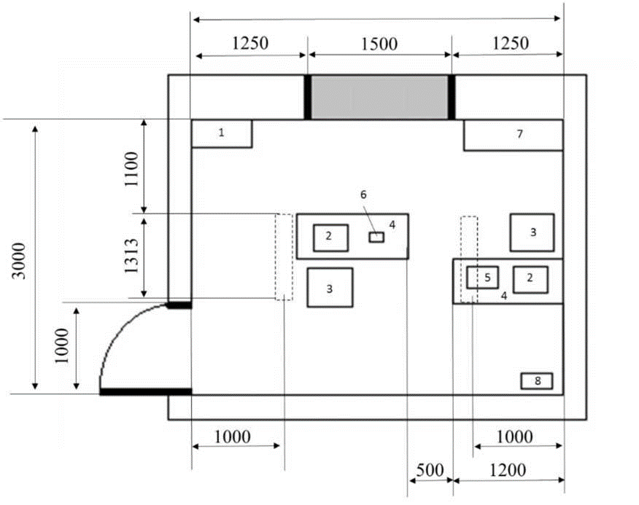

Figure5.1-Diagramoftheoffice:
1-documentrackB160,2-DellInspiron3567Blacklaptop,3-ISOC-11chair,4- computer table,5- EEG receiving unit
"Tredex,6-TredexEEGchanneltransmitter,7-GalacticGK30H-Sairconditioner,8-OP-5fire extinguisher

Thecharacteristicsofthepremises complywiththestandardvalues (theareaandvolumeperemployeearelarger,whichalsocomplieswiththestandards).
 |  |  |  |  | БМ93.12.2605.5223.ПЗ | Letter
 |  |  |  |  | БМ93.12.2605.5223.ПЗ | 51
Ed. | Letter | No.doc. | Signature | Date. | БМ93.12.2605.5223.ПЗ | 51

  - Assessmentofhazardousandharmfulfactors

According to GOST 12.0.003-74, hazardous and harmful industrial factorsaredividedinto4groupsbythenatureoftheiraction:physical,chemical,biologicaland psychophysiological.The presenceof relevantfactors isindicated in
Table5.3.

Table5.3-Hazardsandharmfulfactors

Groupofhazardousfactors | List
Physical | - electrical safety;  - fire safety.
Chemical | missing
Biological | missing
Psychophysiological | missing

Sincetherearenobiological,chemical,orpsychophysiologicalfactors,physicalfactors willbe considered inthe following work.

    - Electricalsafety

Tables 5.4 - 5.6 show the main sources of electrical hazards and measures toensureoccupational safety.

Table5.4-Mainsourcesofelectricalhazards
№ | Sourceofdanger | Causesofdanger | Consequences
1 | Laptop Dell Inspiron 3567  Black | a)man-madefactors:  - lackofinsulation;  - shortcircuit;  - damage to wires. b)humanfactors:  - use of equipment for otherpurposes;  - useofwaternearthetechnology. | Burns, mildelectricalinjuriesandthosethat  mayresultintodeath
2 | AirconditionerGalacticGK  30H-S
3 | Luminaire LPO-01  (two-lamp)

 |  |  |  |  | БМ93.12.2605.5223.ПЗ | Letter
 |  |  |  |  | БМ93.12.2605.5223.ПЗ | 52
Ed. | Letter | No.doc. | Signature | Date. | БМ93.12.2605.5223.ПЗ | 52
ContinuationofTable5.4

№ | Sourceofdanger | Causesofdanger | Consequences
4 | Reception unit EEG"Tredex | - insulationbreakdown;  - contactwithelectricalelements;  - conducting currentthroughthehousing;  - directaccess to the 220 Vnetwork.
5 | Transmitting EEGchannel transmitting device"Tredex" | - insulationbreakdown;  - contactwithelectricalelements;  - conducting currentthroughthehousing;  - directaccess to the 220 Vnetwork;  - exposuretohighvoltages.

Table5.5-Conditionsofuseofelectricalappliances
NO. | Name of the electrical appliance | Terms of use
1 | Tredex EEG receiving unit | Output range voltage: 500 MV to 5 V
2 | EEG channel transmitting device "Thredex | Output range voltage: 500 MV to 5 V
3 | Dell Inspiron 3567 Black Laptop | Voltage: 220 ±20V  Frequency: 50 ± 1 Hz
4 | Galactic GK 30H-S air conditioner | Voltage: 220 ±20V  Frequency: 50 ± 1 Hz
5 | Lamp LPO-01 (two-lamp) | Voltage: 220 ±20V  Frequency: 50 ± 1 Hz

Table 5.6-electrical hazard protection measures
No. | Group of nomenclature measures for OP | From the West | Selection criteria
1 | Technical | Sealed device housing | Protection against unauthorized opening of the case
1 | Technical | Protection against unauthorized opening of the housing plastic surface of the housing | No current conduction when touching the housing
1 | Technical | Single port for charging and connecting the EEG cap | Ensuring that the subject is not available to the 220 V network while charging the device
1 | Technical | Wireless data transmission | No direct access to the 220 V network
1 | Technical | Device operation indicator | Informing about switching on the device
1 | Technical | Device charging detector | Prevention of emergency operating modes
1 | Technical | Rubber cap | Protection against current conduction in case of damage to the electrode insulation
1 | Technical | Double insulation of charger wires | Protection against electric shock during operation of the device

 |  |  |  |  | БМ93.12.2605.5223.ПЗ | Letter
 |  |  |  |  | БМ93.12.2605.5223.ПЗ | 53
Ed. | Letter | No. doc. | Sig. | Date | БМ93.12.2605.5223.ПЗ | 53

Continuation of table 5.6
No. | Group of nomenclature measures for OP | From the West | Selection criteria
1 | Technical | Electrode insulation | Protection against electric shock
1 | Technical | Low output voltages of devices | High voltage protection
2 | Organizational issues | Conducting a safety briefing | Safety training in equipment operation
3 | Security features | Preventing the appearance of unauthorized persons in the laboratory | Ensuring the reliability of research
4 | Operational requirements | Intended use | Proper use
4 | Operational requirements | Verification of the measuring instrument | Reliability of information
5 | PPE | Not provided | -

Since this room is dry, not dusty, humidity does not exceed 75%, according to the degree of danger of electric shock, it belongs to rooms without increased danger [39].

5.2.2Fire safety

Tables 5.7 – 5.9 show the main sources of fire danger and measures to ensure labor protection (hereinafter referred to as OP) [40].

Table 5.7-main sources of fire hazards
No. | Source of danger | Causes of danger | Consequences
1 | Combustible materials and substances | Ignition of materials | Fire, equipment damage, burns, skin damage, which can lead to the death of the employee
2 | Electrical wire malfunction | Insulation breakdown, short circuit, wire melting
3 | Non-compliance with fire safety measures | Material ignition, short circuit
4 | Element malfunction | Melting and combustion of elements

 |  |  |  |  | БМ93.12.2605.5223.ПЗ | Letter
 |  |  |  |  | БМ93.12.2605.5223.ПЗ | 54
Ed. | Letter | No. doc. | Sig. | Date | БМ93.12.2605.5223.ПЗ | 54

Table 5.8-fire hazard characteristics

Fire hazard category | Fire hazard zone class | Fire hazard class
In | P-IIA | E-burning of live electrical installations

Table 5.9-Fire Protection Measuresі

No. | Group of nomenclature measures for OP | From the West | Selection criteria
1 | Technical | Fire extinguisher | Elimination of the resulting fire
1 | Technical | Fire alarm system | Fire notification
1 | Technical | Non-flammable materials | Preventing the occurrence of fires
1 | Technical | Serviceable equipment | Fire prevention
1 | Technical | Fuses | Switching off the current in emergency mode
2 | Organizational issues | Familiarization with safety techniques and training of employees | Fire prevention
2 | Organizational issues | Setting rules for working with electrical appliances | Fire prevention
2 | Organizational issues | Providing access to the exit from the premises | Possibility of evacuation
3 | Security features | Not provided | -
4 | Operational requirements | Regular inspection and repair of equipment | Prevention of breakdowns and overheating
5 | PPE | Gas masks, masks | Protection against a fire that has occurred

Conclusion to Section 5

In this section, the main dangerous and harmful factors that may occur when working with the developed software and hardware complex were considered. When conducting an electroencephalographic study, the absence of the influence of currents on a person was ensured. The main fire prevention measures are considered.
On compliance with basic protective equipment the impact of dangerous and harmful factors on humans is minimal.
 |  |  |  |  | БМ93.12.2605.5223.ПЗ | Letter
 |  |  |  |  | БМ93.12.2605.5223.ПЗ | 55
Ed. | Letter | No. doc. | Sig. | Date | БМ93.12.2605.5223.ПЗ | 55

CONCLUSIONS

In the course of the thesis, modern studies of the influence of sound symbols on psychophysiological indicators were considered. An experimental study was conducted to test changes in the electrical activity of the human brain under the influence of stimuli with a frequency range of 250 – 2998 Hz, selected on the basis of literature sources.
Tredex's Experttm software and hardware complex was used for EEG recording. Data recording was carried out with a standard electrode placement scheme according to the international system "10 – 20", bipolar recording took place using 16 reference electrodes with a speed of 30 mm/S and an amplitude of 50 mV. For the study, we used headphones "Panasonic RP-HJE118GU-K" and a player "iRiver T9 4GB". The EEG results were analyzed in the Expert_NET software environment developed by the manufacturer of the encephalographic complex Tredex.
The results of the analysis of the study indicate the existing response of the brain to the selected stimuli, which confirms the results of previous studies, and the need to narrow the frequency range of the forming stimulus.
A method for collecting psychomotor indicators and tracking their dynamics based on our own modification of the tapping test has been developed.
The development of the software and hardware complex was divided into two logical parts: filtering the sound stimulus and studying the functional state of the central nervous system.
Audio stimulus filtering was implemented in the MATLAB 2018 environment while preserving the filtered stimulus in wav format. The main characteristics of the output signal were left unchanged.
The study of the functional state of the central nervous system was implemented using the C# programming language in the form of a separate "Clicker"program. In
 |  |  |  |  | БМ93.12.2605.5223.ПЗ | Letter
 |  |  |  |  | БМ93.12.2605.5223.ПЗ | 56
Ed. | Letter | No. doc. | Sig. | Date | БМ93.12.2605.5223.ПЗ | 56

as a research criterion, a psychomotor indicator was chosen – the number of clicks on the mouse manipulator during a certain time. The developed program provides an opportunity to determine psychomotor indicators without using complex tests or cumbersome calculations. The automated testing methodology allows you to quickly get clear results, which ensures the quality of the study.
The results of experimental testing of the complex indicate the existing response of the central nervous system to sound stimuli, since there was a change in the contributions of EEG rhythms in response to stimuli. The analysis of the results obtained indicates the expediency of further use of the developed methodology for applying the software and hardware complex.
A methodology for applying a software and hardware complex is developed, taking into account the sequence of studying psychomotor functions and minimizing extraneous factors of perception of audio stimuli by taking into account the individual characteristics of the subject by normalizing the results.
The developed software and hardware complex makes it possible to study the influence of audio signals of a given frequency on changes in the functional state of the central nervous system. The work of the Pak is flexible and does not depend on the number of studies conducted and audio stimuli applied, which makes it possible to adjust the complex for further research..
Results of the work implemented:
- publication of theses "Modern Studies of the influence of sound stimuli on the brain" in the collection "Information Technologies: Science, Technology, Technology, Education, Health". 2019 Part III; participated in the International Scientific and practical conference MicroCAD-2019;
- the article "experimental complex for studying the influence of audio signals on psychomotor parameters" was submitted for publication in the second issue of the scientific and practical journal "Biomedical Engineering and technology".
 |  |  |  |  | БМ93.12.2605.5223.ПЗ | Letter
 |  |  |  |  | БМ93.12.2605.5223.ПЗ | 57
Ed. | Letter | No. doc. | Sig. | Date | БМ93.12.2605.5223.ПЗ | 57

LIST OF REFERENCES

- Розік А. І. Вплив музики на когерентність електроенцефалограми кори головного мозку в чоловіків та жінок під час виконання когнітивних завдань / [А. І. Розік, О. С. Павлович, Я. М. Чмух та ін.]. // Збірник наукових праць VІІІ Всеукраїнської науково-практичної конференції з міжнародною участю «Біологічні дослідження – 2017». – 2017.
- Шпєнков O.O. Зміни електричної активності головного мозку під час прослуховування рок-музики із видозміненною частотною структурою / O.O. Шпєнков, С.В. Тукаєв, І.Г. Зима, С.А. Крижановський // Вісник Черкаського університету. Серія «Біологічні науки». – 2014. – № 2 (295). – С. 121–128. – ISSN 2076-5835.
- Павлович О.С. Індекс зміни потужності ЕЕГ в осіб із різним профілем асиметрії під час сприйняття та відтворення ритмічних звукових стимулів/ О.С. Павлович , А.Г. Моренко// Збірник наукових праць VІІІ «Біологічні дослідження – 2017» . – 2017. – C.1-2.
- Литвинчук Л. М. КОРИГУВАННЯ МУЗИКОЮ ЯК ВЕРБАЛЬНОМУЗИЧНА ПСИХОРЕГУЛЯЦІЯ ОСОБИСТОСТІ / Л. М. Литвинчук. // Вісник Національного університету оборони України. – 2013. – №5. – С. 243 – 248.
- Дацок О. М. Вплив звукового сигналу на спектральні характеристики енцефалограми / О. М. Дацок, Г. Р. Овчаренко, К. О. Александрова, О. Р. Александров. // Інформаційні технології: наука, техніка, технологія, освіта, здоров’я: тези доповідей ХXV міжнародної науково-практичної конференції MicroCAD-2018, 16-18 травня 2018р.: у 4 ч. Ч. IІІ. / за ред. проф. Сокола Є.І. Харків: НТУ «ХПІ». С. 52.
- Александрова К. О. Методика дослідження впливу музичних фрагментів на показники електроенцефалограми / К. О. Александрова, Г. Р. Овчаренко, О. Р. Александров. // Сучасні напрями розвитку інформаційно-
 |  |  |  |  | БМ93.12.2605.5223.ПЗ | Letter
 |  |  |  |  | БМ93.12.2605.5223.ПЗ | 58
Ed. | Letter | No. doc. | Sig. | Date | БМ93.12.2605.5223.ПЗ | 58

комунікаційних технологій та засобів управління: тези доповідей VІІІ міжнародної науково-технічної конференції, 26–27 квітня 2018р.: Харків: НТУ «ХПІ». С. 36.
- Калашнікова Л. Є. Зв’язок когнітивної діяльності з характеристиками β – ритма під впливом аудіо стимулів різного компонентного складу. / Л. Є. Калашнікова, Г. Р. Овчаренко, К. О. Александрова, О. Р. Александров. // Біомедична інженерія і технологія. 2018. №1. С. 130–135. ISSN (Print): 2617-8974.
- В. Т. Грінченко, І. В. Вовк, В. Т. Маципура Основи акустики. — К: Наукова думка, 2007. — 640 с.
- Энциклопедия физики и техники [Електронний ресурс]: [Веб-сайт] – Режим доступу: http://www.femto.com.ua/articles/part_1/1222.html (дата звернення 10.05.2019) – Звук.
- Міжнародна асоціація «ЗДОРОВ'Я СУСПІЛЬСТВА» [Електронний ресурс]: [Веб-сайт]. – Режим доступу: http://healthy-society.com.ua/index.php?option=com_content&view=article&id=4 11:2011-08-03-04-46-56&catid=35:2011-04-19-08-30-36&Itemid=57 (дата звернення 10.05.2019) – ЕКОЛОГІЯ. Вплив звуків на організм людини.
- Навчальні матеріали онлайн [Електронний ресурс] : [Веб-сайт]. – Електронні дані. – Навч. матер. онлайн, 2010-2019. – Режим доступу: https://pidruchniki.com/16790422/bzhd/infra-_ultrazvuk_parametri_infra-_ultrazv ukovih_kolivan (дата звернення 10.05.2019) – Інфра- та ультразвук. Параметри інфра- та ультразвукових коливань; їх джерела, характерні ознаки. Дія ультра-та інфразвуку на організм людини. Методи та засоби захисту від ультра- та інфразвуку.
- Оборудование, материаловедение, механика и... [Електронний ресурс]: [Веб-сайт]. – Режим доступу: https://mash-xxl.info/page/118178076185227224196011016169238170136008166255/ (дата звернення 10.05.2019) – Энциклопедия по машиностроению XXL.
 |  |  |  |  | БМ93.12.2605.5223.ПЗ | Letter
 |  |  |  |  | БМ93.12.2605.5223.ПЗ | 59
Ed. | Letter | No. doc. | Sig. | Date | БМ93.12.2605.5223.ПЗ | 59

- Kumagai Y, Arvaneh M and Tanaka T (2017) Familiarity Affects Entrainment of EEG in Music Listening. Front. Hum. Neurosci. 11:384. doi: 10.3389/fnhum.2017.00384.
- Kumagai Y, Matsui R and Tanaka T (2018) Music Familiarity AffectsEEGEntrainmentWhenLittleAttentionIsPaid.Front.Hum.Neurosci.12:444.doi:10.3389/fnhum.2018.00444.
- Markovic A, Kühnis J and Jäncke L (2017) Task Context InfluencesBrainActivationduringMusicListening.Front.Hum.Neurosci.11:342.doi:10.3389/fnhum.2017.00342.
- Гольдберг Е.М., Кривцунова А.Н., Пустовгар А.А. Влияние прослушивания музыки в наушниках на изменение частотного спектра ЭЭГ // Современные наукоемкие технологии. 2005. N4. C. 39–40.
- Близнюк О. А. Исследование применения метода определения базовых эмоций на основе отношения частот спектра звуковой волны / О. А. Близнюк, А. П. Шкарапута. // Вестник Пермского университета. – 2017. – С. 86–91
- iLab – информационный портал по вопросам биомедицинской инженерии [Електронний ресурс]: [Веб-сайт]. – Режим доступу: http://ilab.xmedtest.net/?q=node/6112 (дата звернення 10.05.2019) – Основные методы ЭЭГ-анализа.
- Neuroscience For Kids [Електронний ресурс]: [Веб-сайт]. – Електронні дані. – 1996-2012, Eric H. Chudler – Режим доступу: http://faculty.washington.edu/chudler/1020.html (дата звернення 12.05.2019) – 10-20 System of Electrode Placement.
- Каплан А.Я., Борисов С.В., Желиговский В.А.. Классификация ЭЭГ под-ростков по спектральным и сегментным характеристикам в норме и при расстройстве шизофренического спектра//Журнал ВНД. 2005. Т.55. №4.
- Кирой В. Н., Ермаков П. Н. Общая характеристика ритмов ЭЭГ человека // Электроэнцефалограмма и функциональные состояния человека.
 |  |  |  |  | БМ93.12.2605.5223.ПЗ | Letter
 |  |  |  |  | БМ93.12.2605.5223.ПЗ | 60
Ed. | Letter | No. doc. | Sig. | Date | БМ93.12.2605.5223.ПЗ | 60

— Ростов-на-Дону: Изд-во Рост. ун-та, 1998. — С. 48-76. — 264 с. — 300 экз.
—ISBN5-7507-0579-2.
  - Батуев, Александр Сергеевич. Физиология высшей нервной деятельности и сенсорных систем [Текст] : учебник / А. С. Батуев. - 3-е изд., испр. и доп. - СПб. : Питер, 2009. - 317 с. : ил. - (Учебник для вузов). - Рек. Советом по психологии УМО. - ISBN 978-5-91180-842-6 : 229-00. Шифр: 28.9 Б 287 11 экз.
  - Навчальні посібники Вінницького національного технічного університету [Електронний ресурс] : [Веб-сайт]. – Електронні дані. – ІРВЦ ВНТУ, 2018. – Режим доступу: https://web.posibnyky.vntu.edu.ua/firen/6bilynskyj_elektronni_s ystemy/3.htm (дата звернення 10.05.2019) – Перетворення сигналів та їх спектральні характеристики.
  - Амплітудно-частотна характеристика [Електронний ресурс]: [Веб- сайт]. –Режим доступу: https://studopedia.com.ua/1_22400_amplitudno_chastotna-harakteristika-smuga-propuskannya-i-zagasannya.html (дата звернення 11.05.2019) – Амплітудно-частотна характеристика, смуга пропускання і загасання.
  - Попов, А.О. Теорія сигналів: методичні вказівки до практичних занять для студентів напряму 6.050801 – мікро- та наноелектроніка / А.О. Попов, О.К. Боділовський, І.П. Голубєва, М.А. Жуков, Є.С. Карплюк, І.Е. Крашений, О.Ю. Панічев, Г.С. Порєва. – К. : НТУУ «КПІ», 2014. – 64 с.
  - Лекции.Ком [Електронний ресурс] : [Веб-сайт]. – Електронні дані. – Лекции.Ком - 2014-2019. – Режим доступу: https://lektsii.com/2-41147.html (дата звернення 10.05.2019) – Фильтрация сигналов. Понятие импульсной характеристики. Типы фильтров.
  - Хелпикс.Орг [Електронний ресурс] : [Веб-сайт]. – Електронні дані. – Хелпикс.Орг - 2014-2019 год. – Режим доступу: https://helpiks.org/5-62036.html (дата звернення 10.05.2019) – Фільтрація сигналів в частотній області.
 |  |  |  |  | БМ93.12.2605.5223.ПЗ | Letter
 |  |  |  |  | БМ93.12.2605.5223.ПЗ | 61
Ed. | Letter | No. doc. | Sig. | Date | БМ93.12.2605.5223.ПЗ | 61

- Шутова С. В. Сенсомоторные реакции как характеристика функционального состояния ЦНС / С. В. Шутова, И. В. Муравьева. // Вестник ТГУ. – 2013. – С. 2831–2840. – ISSN 1810 0198.
- Бондарев Д. В. Особенности психофизических возможностей студентов, занимающихся спортивными играми / Д. В. Бондарев, В. А. Гальчинский. // Физическое воспитание студентов творческих специальностей. – 2008. – С. 59–64. – ISSN 1993-4335.
- Веселова Н. Н. Теппинг-тест как инструмент педагогического изучения психофизиологических особенностей реализации студентами учебной деятельности / Н. Н. Веселова. // Среднее профессиональное образование. – 2007. – С. 75–76. – ISSN 1990-679X.
- Никандров В.В. Психомоторика. Учебное пособие. – СПб.: «Речь». 2004.с.79.
- Самороднов О. В. Теппинг-тест как индикатор включения релаксационного механизма срочной защиты [Електронний ресурс] / О. В. Самороднов, В. А. Чуев. [Веб-сайт]. – Електронні дані. – [Scientific World – 2010-2019]. – Режим доступу: https://www.sworld.com.ua/konfer27/380.pdf (дата звернення 15.05.2019). – Теппинг-тест как индикатор включения релаксационного механизма срочной защиты.
- Tredex [Електронний ресурс]: [Веб-сайт]. – Режим доступу: http://www.tredex-company.com/ru/content/computer-electroencephalographs-expert-series (дата звернення 19.04.2019) – Компьютерные электроэнцефалографы серии «Эксперт».
- MATLAB [Електронний ресурс] : [Веб-сайт]. – Електронні дані. – The MathWorks, 1994-2019. – Режим доступу: https://www.mathworks.com/ (дата звернення 30.04.2019) – MATLAB for Artificial Intelligence.
- Кафедра радіоконструювання та виробництва радіоапаратури [Електронний ресурс] : [Веб-сайт]. – Електронні дані. – Кафедра КіВРА, 2019. – Режим доступу:
 |  |  |  |  | БМ93.12.2605.5223.ПЗ | Letter
 |  |  |  |  | БМ93.12.2605.5223.ПЗ | 62
Ed. | Letter | No. doc. | Sig. | Date | БМ93.12.2605.5223.ПЗ | 62

http://kivra.kpi.ua/wp-content/uploads/file/discipline/AOTI/AOTI_2_4-5.pdf (дата звернення 30.04.2019) – Фільтрація та передавання даних.
- Visual Studio Team Services [Електронний ресурс] : [Веб-сайт]. – Електронні дані. – Microsoft – 2019. – Режим доступу: https://visualstudio.microsoft.com/ru/?rr=https%3A%2F%2Fmsdn.microsoft.com %2Fuk-ua (дата звернення 07.05.2019) – Visual Studio.
- Основи охорони праці: Підручник. 2-ге видання / К.Н.Ткачук, М.О.Халімовський, В.В.Зацарний та ін. – К.: Основа, 2006 – 448 с.
- ГОСТ 12.2.032-78. ССБТ. Рабочее место при выполнении работ сидя. Общие эргономические требования.
- ГОСТ 12.1.002-84. ССБТ. Электрические поля промышленной частоты. Допустимые уровни напряженности и требования к проведению контроля на рабочих местах.
- ГОСТ 12.1.004-91. ССБТ. Пожарная безопасность. Общие требования.
 |  |  |  |  | БМ93.12.2605.5223.ПЗ | Letter
 |  |  |  |  | БМ93.12.2605.5223.ПЗ | 63
Ed. | Letter | No. doc. | Sig. | Date | БМ93.12.2605.5223.ПЗ | 63

APPENDIX A
Normalized values of rhythm contributions
of the first experimental study

Table A. 1-normalized values of rhythm contributions for each of the studied subjects
 | № | Ритм |  | Ф1 | Ст.1 |  | Ф2 |  | Ст.2 |  | Ф3 | Ст.3 | Ф4 | Ст.4 | Ф5 | Ст.5 | Ф6
 | 1 | δ |  | 0 | -1,65 |  | -1,69 |  | -0,46 |  | -2,10 | -0,52 | -2,52 | -0,91 | -2,13 | -3,12 | -2,11
 | 1 | θ |  | 0 | 0,62 |  | 0,06 |  | 1,22 |  | -0,57 | 1,83 | -0,32 | 0,20 | 0,69 | 0,10 | 1,35
 | 1 | α |  | 0 | -1,80 |  | -0,99 |  | -1,75 |  | -1,53 | -1,67 | 0,41 | -2,44 | -0,43 | 1,84 | -1,06
 | 1 | β1 |  | 0 | 2,35 |  | 1,76 |  | 0,43 |  | 2,58 | 0,36 | 0,89 | 1,45 | -0,71 | -0,20 | -0,17
 | 1 | β2 |  | 0 | 0,48 |  | 0,84 |  | 0,57 |  | 1,63 | 0,00 | 1,53 | 1,71 | 2,58 | 1,39 | 1,98
 | 2 | δ |  | 0 | 2,85 |  | 0,52 |  | 0,04 |  | 1,65 | 0,37 | 2,79 | 0,79 | 2,09 | 1,09 | -0,04
 | 2 | θ |  | 0 | 0,02 |  | -0,19 |  | 0,59 |  | 0,88 | 1,38 | 0,40 | 2,10 | 1,60 | 2,12 | 0,88
 | 2 | α |  | 0 | -3,68 |  | -0,72 |  | -0,68 |  | -1,31 | -3,01 | -3,74 | -2,25 | -2,96 | -3,87 | -1,20
 | 2 | β1 |  | 0 | 0,21 |  | -0,02 |  | 0,22 |  | -0,47 | 1,30 | 0,02 | 0,22 | -0,09 | -0,31 | 0,59
 | 2 | β2 |  | 0 | 0,59 |  | 0,41 |  | -0,16 |  | -0,73 | -0,02 | 0,53 | -0,85 | -0,63 | 0,98 | -0,23
 | 3 | δ |  | 0 | -0,78 |  | -0,90 |  | -0,98 |  | -1,45 | -1,50 | -0,07 | -1,31 | 0,05 | 0,93 | -1,50
 | 3 | θ |  | 0 | -0,04 |  | 1,98 |  | 0,07 |  | 1,49 | 2,46 | -0,06 | -0,50 | 1,22 | 2,57 | 0,62
 | 3 | α |  | 0 | -0,41 |  | -1,88 |  | -1,46 |  | -2,09 | -2,79 | -3,85 | -0,09 | -4,06 | -8,82 | -1,76
 | 3 | β1 |  | 0 | 0,94 |  | 0,12 |  | 1,37 |  | 0,67 | 1,33 | 1,36 | 0,63 | 0,98 | 2,06 | 2,20
 | 3 | β2 |  | 0 | 0,28 |  | 0,67 |  | 1,01 |  | 1,41 | 0,49 | 2,62 | 1,27 | 1,81 | 3,26 | 0,45
 | 4 | δ |  | 0 | -0,36 |  | 0,82 |  | 0,41 |  | 2,00 | 1,53 | 3,49 | -0,24 | -0,34 | -0,88 | 1,61
 | 4 | θ |  | 0 | 1,44 |  | -0,40 |  | 0,52 |  | 0,97 | 0,87 | 0,98 | -1,69 | -0,62 | -0,18 | -0,68
 | 4 | α |  | 0 | -3,27 |  | -0,26 |  | -3,41 |  | -5,50 | -6,23 | -5,19 | 2,47 | -1,71 | -2,40 | -3,43
 | 4 | β1 |  | 0 | 1,91 |  | -0,52 |  | 1,45 |  | 1,76 | 1,91 | 0,14 | -0,18 | 0,61 | 3,84 | 1,66
 | 4 | β2 |  | 0 | 0,28 |  | 0,36 |  | 1,04 |  | 0,80 | 1,93 | 0,57 | -0,37 | 2,06 | -0,38 | 0,84
 | 5 | δ |  | 0 | 0,97 |  | 2,28 |  | -0,39 |  | 3,18 | 4,45 | 2,82 | 8,15 | 7,18 | 2,91 | 2,15
 | 5 | θ |  | 0 | 0,55 |  | -0,10 |  | 1,16 |  | 2,19 | 2,65 | 5,14 | 5,36 | 6,25 | 4,93 | 4,32
 | 5 | α |  | 0 | -1,84 |  | -2,11 |  | -1,83 |  | -7,36 | -10,95 | -11,8 | -17,07 | -15,68 | -16,53 | -11,34
 | 5 | β1 |  | 0 | 0,11 |  | 0,05 |  | 0,70 |  | 1,21 | 2,29 | 3,08 | 2,71 | 1,52 | 7,86 | 2,84
 | 5 | β2 |  | 0 | 0,22 |  | -0,12 |  | 0,35 |  | 0,78 | 1,57 | 0,81 | 0,84 | 0,73 | 0,83 | 2,04
 |  |  |  |  |  |  |  |  |  | БМ93.12.2605.5223.ПЗ |  |  |  |  |  |  |  | Letter
 |  |  |  |  |  |  |  |  |  |  |  |  |  |  |  |  |  | 64
Ed. | Letter |  | No. doc. |  |  | Sig. |  | Date

APPENDIXB
Code for software implementation of audio stimulus filtering

clc; clear all; close all;loadhandel.mat
slCharacterEncoding('windows-1251');

file='E:\Диплом\ЕЕГ\Музика\Щедрик.wav';[y,Fs]=audioread(file);

%Початковийсигналt=1/Fs:1/Fs:length(y)/Fs;y_fft=abs(fft(y));y_fft=y_fft(1:length(y)/2);f=0:Fs/length(y):Fs/2-Fs/length(y);

figure(1)
plot (f, y_fft);xlim([05000])
xlabel('Частота, Гц', 'FontName','Arial Cyr')ylabel('Амплітуда', 'FontName','Arial Cyr')title('Частотнахарактеристика','FontName','ArialCyr')

Fn=Fs/2;
Wp1=[260,760]/Fn;Wp2=[761,1260]/Fn;Wp3=[1261,1760]/Fn;Wp4=[1761,2260]/Fn;Wp5=[2261, 2760]/Fn;
Ws1=[250,770]/Fn;Ws2=[751,1270]/Fn;Ws3=[1251,1770]/Fn;Ws4=[1751,2270]/Fn;Ws5=[2251, 2770]/Fn;
Rp= 1;
Rs=150;

%Фільтраціявід260до760Гц

[n1,Ws1] = cheb2ord(Wp1,Ws1,Rp,Rs);[z1,p1,k1] =cheby2(n1,Rs,Ws1);[soslp1,glp1] = zp2sos(z1,p1,k1);filtered_sound1=filtfilt(soslp1,glp1,y);filename1 = 'Shchedryk_260_760.wav';audiowrite(filename1,filtered_sound1,Fs);

t1=1/Fs:1/Fs:length(filtered_sound1)/Fs;filtered_sound_fft1=abs(fft(filtered_sound1));filtered_sound_fft1=filtered_sound_fft1(1:length(filtered_sound1)/2);f1=0:Fs/length(filtered_sound1):Fs/2-Fs/length(filtered_sound1);

figure(2)
subplot(5,1,1);
plot (f1, filtered_sound_fft1);xlim([03000])
xlabel('Частота, Гц', 'FontName','Arial Cyr')ylabel('Амплітуда','FontName','ArialCyr')
title('Частотнахарактеристика(260-760Гц)','FontName','ArialCyr')

%Фільтраціявід761-1260Гц
 |  |  |  |  | БМ93.12.2605.5223.ПЗ | Letter
 |  |  |  |  | БМ93.12.2605.5223.ПЗ | 65
Ed. | Letter | No. doc. | Sig. | Date | БМ93.12.2605.5223.ПЗ | 65

[n2,Ws2] = cheb2ord(Wp2,Ws2,Rp,Rs);[z2,p2,k2]=cheby2(n2,Rs,Ws2);[soslp2,glp2] = zp2sos(z2,p2,k2);filtered_sound2 = filtfilt(soslp2, glp2, y);filename2 = 'Shchedryk_761-1260.wav';audiowrite(filename2,filtered_sound2,Fs);

t2=1/Fs:1/Fs:length(filtered_sound2)/Fs;filtered_sound_fft2=abs(fft(filtered_sound2));filtered_sound_fft2=filtered_sound_fft2(1:length(filtered_sound2)/2);f2=0:Fs/length(filtered_sound2):Fs/2-Fs/length(filtered_sound2);

subplot(5,1,2);
plot (f2, filtered_sound_fft2);xlim([03000])
xlabel('Частота, Гц', 'FontName','Arial Cyr')ylabel('Амплітуда','FontName','ArialCyr')
title('Частотнахарактеристика(761-1260Гц)','FontName','ArialCyr')

%Фільтраціявід1261до1760Гц

[n3,Ws3] = cheb2ord(Wp3,Ws3,Rp,Rs);[z3,p3,k3] =cheby2(n3,Rs,Ws3);[soslp3,glp3] = zp2sos(z3,p3,k3);filtered_sound3=filtfilt(soslp3,glp3,y);filename3 = 'Shchedryk_1261_1760.wav';audiowrite(filename3,filtered_sound3,Fs);

t3=1/Fs:1/Fs:length(filtered_sound3)/Fs;filtered_sound_fft3=abs(fft(filtered_sound3));filtered_sound_fft3=filtered_sound_fft3(1:length(filtered_sound3)/2);f3=0:Fs/length(filtered_sound3):Fs/2-Fs/length(filtered_sound3);

subplot(5,1,3);
plot (f3, filtered_sound_fft3);xlim([03000])
xlabel('Частота, Гц', 'FontName','Arial Cyr')ylabel('Амплітуда','FontName','ArialCyr')
title('Частотнахарактеристика(1261-1760Гц)','FontName','ArialCyr')

%Фільтраціявід1761до2260Гц

[n4,Ws4] = cheb2ord(Wp4,Ws4,Rp,Rs);[z4,p4,k4] =cheby2(n4,Rs,Ws4);[soslp4,glp4] = zp2sos(z4,p4,k4);filtered_sound4=filtfilt(soslp4,glp4,y);filename4 = 'Shchedryk_1761_2260.wav';audiowrite(filename4,filtered_sound4,Fs);

t4=1/Fs:1/Fs:length(filtered_sound4)/Fs;filtered_sound_fft4=abs(fft(filtered_sound4));filtered_sound_fft4=filtered_sound_fft4(1:length(filtered_sound4)/2);f4=0:Fs/length(filtered_sound4):Fs/2-Fs/length(filtered_sound4);

subplot(5,1,4);
plot (f4, filtered_sound_fft4);xlim([03000])
xlabel('Частота, Гц', 'FontName','Arial Cyr')ylabel('Амплітуда','FontName','ArialCyr')
title('Частотнахарактеристика(1761-2260Гц)','FontName','ArialCyr')
 |  |  |  |  | БМ93.12.2605.5223.ПЗ | Letter
 |  |  |  |  | БМ93.12.2605.5223.ПЗ | 66
Ed. | Letter | No. doc. | Sig. | Date | БМ93.12.2605.5223.ПЗ | 66

%Фільтраціявід2261до3000Гц

[n5,Ws5] = cheb2ord(Wp5,Ws5,Rp,Rs);[z5,p5,k5] =cheby2(n5,Rs,Ws5);[soslp5,glp5] = zp2sos(z5,p5,k5);filtered_sound5=filtfilt(soslp5,glp5,y);filename5 = 'Shchedryk_2261_3000.wav';audiowrite(filename5,filtered_sound5,Fs);

t5=1/Fs:1/Fs:length(filtered_sound5)/Fs;filtered_sound_fft5=abs(fft(filtered_sound5));filtered_sound_fft5=filtered_sound_fft5(1:length(filtered_sound5)/2);f5=0:Fs/length(filtered_sound5):Fs/2-Fs/length(filtered_sound5);

subplot(5,1,5);
plot (f5, filtered_sound_fft5);xlim([03000])
xlabel('Частота, Гц', 'FontName','Arial Cyr')ylabel('Амплітуда','FontName','ArialCyr')
title('Частотнахарактеристика(2261-2760Гц)','FontName','ArialCyr')
 |  |  |  |  | БМ93.12.2605.5223.ПЗ | Letter
 |  |  |  |  | БМ93.12.2605.5223.ПЗ | 67
Ed. | Letter | No. doc. | Sig. | Date | БМ93.12.2605.5223.ПЗ | 67

APPENDIXC
Program code for studying the functional state of the central nervous system

usingSystem.Windows.Forms;usingSystem.IO;

namespaceClicker
{
publicpartialclassForm1:Form
{
Timertimer=newTimer();intclickCount=0;
intcounter=20;

publicForm1()
{
InitializeComponent();timer=newTimer();
timer.Tick+=newEventHandler(timer_Tick);timer.Interval=1000;
lblCountDown.Text=counter.ToString();
}
privatevoidtimer_Tick(objectsender,EventArgse)
{
counter--;
if(counter==0)
{
timer.Stop();btnClicker.Enabled=false;
lblCicksCount.Text=clickCount.ToString();SaveResultToFile();
}
lblCountDown.Text=counter.ToString();
}
privatevoidSaveResultToFile()
{
varfilePath=Path.Combine(Environment.CurrentDirectory,tbFio.Text+ "_"+tbTag.Text+".txt");
varstreamWriter=File.AppendText(filePath);
var fioText = tbFio.Text + ": " + clickCount + " кліків";var tagText = "Замітка: " + tbTag.Text;streamWriter.WriteLine(fioText);streamWriter.WriteLine(tagText);
streamWriter.Close();
}
privatevoidBtnClicker_Click(objectsender,EventArgse)
{
if(clickCount==0)
{
timer.Start();
}
clickCount++;
}
}
}
 |  |  |  |  | БМ93.12.2605.5223.ПЗ | Letter
 |  |  |  |  | БМ93.12.2605.5223.ПЗ | 68
Ed. | Letter | No. doc. | Sig. | Date | БМ93.12.2605.5223.ПЗ | 68

APPENDIXD
Results of experimental verification of the complex's operation

Table D.1-contributions of EEG rhythms in the Left leads
 | № | Ритм | 1_0 | 1_1 | 1_2 | 2_0 |  | 2_1 |  | 2_2 | 3_0 | 3_1 | 3_2 | 4_0 | 4_1 | 4_2 | 5_0 | 5_1 | 5_2
 | 1 | δ | 13,93 | 14,26 | 10,61 | 14,24 |  | 13,67 |  | 12,61 | 12,12 | 11,71 | 12,1 | 11,16 | 12,78 | 13,66 | 16,8 | 11,62 | 9,32
 | 1 | θ | 20,93 | 19,88 | 19,11 | 18,96 |  | 24,15 |  | 17,12 | 19,64 | 18,87 | 18,99 | 21,26 | 17,35 | 18,99 | 18,85 | 18,42 | 15,41
 | 1 | α | 26,16 | 28,84 | 30,7 | 28,11 |  | 27,09 |  | 27,47 | 31,35 | 28,76 | 32,42 | 32 | 29,83 | 29,85 | 25,37 | 35,44 | 34,78
 | 1 | β1 | 15,35 | 14,76 | 17,78 | 14,19 |  | 14,58 |  | 18,07 | 15,34 | 15,35 | 14,47 | 14,07 | 17,2 | 14,54 | 16,58 | 11,55 | 13,45
 | 1 | β2 | 20,24 | 18,28 | 17,66 | 20,59 |  | 17,12 |  | 21,17 | 17,51 | 21,6 | 18,32 | 17,35 | 19,3 | 18,99 | 19,3 | 18,56 | 21,73
 | 2 | δ | 8,85 | 11,84 | 12,3 | 11,31 |  | 12,36 |  | 12,42 | 10,95 | 10,34 | 11,07 | 12,93 | 12,6 | 11,34 | 13,37 | 10,51 | 11,68
 | 2 | θ | 20,74 | 21,01 | 17,57 | 16,55 |  | 16,16 |  | 19,65 | 23,91 | 22,03 | 21,36 | 18,46 | 16,54 | 17,77 | 23,39 | 20,76 | 18,61
 | 2 | α | 28,39 | 24,34 | 32,04 | 30,35 |  | 27,71 |  | 24,96 | 28,56 | 27,98 | 26,15 | 27,47 | 28,06 | 33,44 | 28,36 | 33,55 | 32,08
 | 2 | β1 | 15,66 | 15,99 | 13,62 | 15,56 |  | 16,07 |  | 15,51 | 13,69 | 14,65 | 15,34 | 15,01 | 16,58 | 12,52 | 14,74 | 12,86 | 15,89
 | 2 | β2 | 21,85 | 23,34 | 19,96 | 21,39 |  | 23,38 |  | 23,71 | 19,08 | 20,95 | 22,03 | 22,07 | 22,01 | 20,06 | 16,66 | 18,2 | 17,13
 | 3 | δ | 13,37 | 10,6 | 12,52 | 18,45 |  | 12,08 |  | 8,71 | 13,94 | 8,42 | 14,29 | 13,05 | 11,28 | 14,61 | 9,82 | 10,35 | 9,94
 | 3 | θ | 14,88 | 16,75 | 13,92 | 16,6 |  | 20,61 |  | 17,13 | 15,45 | 16,7 | 16,36 | 18,28 | 16,46 | 19,42 | 16,98 | 19,57 | 19,56
 | 3 | α | 27,76 | 32,41 | 32,47 | 29,24 |  | 34,07 |  | 33,89 | 37,17 | 33,48 | 31,47 | 30,62 | 33,1 | 28,67 | 36,34 | 33,36 | 34,53
 | 3 | β1 | 18 | 15,57 | 15,2 | 13,52 |  | 12,27 |  | 13,47 | 11,53 | 14,52 | 12,96 | 12,56 | 12,45 | 14,87 | 12,46 | 14,51 | 12,28
 | 3 | β2 | 21,48 | 20,32 | 21,03 | 18,67 |  | 16,37 |  | 22,41 | 17,22 | 21,59 | 20,63 | 21,56 | 22,15 | 18,24 | 19,36 | 17,87 | 19,22
 | 4 | δ | 7,88 | 11,1 | 9,04 | 9,33 |  | 7,3 |  | 10,76 | 9,23 | 8,18 | 7,47 | 11,21 | 8,91 | 7,22 | 7,63 | 7,61 | 6,09
 | 4 | θ | 13,8 | 14,27 | 16,46 | 16,13 |  | 12,38 |  | 13,01 | 10,49 | 11,79 | 12,74 | 14,36 | 15,66 | 13,63 | 12,15 | 12,12 | 13,64
 | 4 | α | 41,43 | 37,18 | 35,27 | 37,82 |  | 42,25 |  | 37,23 | 41,99 | 43,57 | 42,46 | 36,95 | 37,3 | 38,87 | 42,85 | 42,32 | 40,21
 | 4 | β1 | 11,96 | 12,73 | 14,6 | 12,94 |  | 11,95 |  | 13,27 | 12,23 | 11,62 | 11,47 | 12,15 | 13,11 | 12,3 | 12,88 | 12,02 | 13,03
 | 4 | β2 | 19,13 | 19,75 | 19,85 | 18,56 |  | 20,68 |  | 20,44 | 19,79 | 18,81 | 19,76 | 20,27 | 19,9 | 22,78 | 18,47 | 19,89 | 21,34
 | 5 | δ | 13,54 | 18,69 | 12,57 | 12,67 |  | 11,42 |  | 13,94 | 14,48 | 12,16 | 13,92 | 14,62 | 13,83 | 14,49 | 14,09 | 15,28 | 10,4
 | 5 | θ | 18,43 | 21,63 | 18,87 | 14,33 |  | 18,6 |  | 15,45 | 22,89 | 17,62 | 16,75 | 17,75 | 25,34 | 19,71 | 16,98 | 17,53 | 17,51
 | 5 | α | 30,28 | 21,96 | 30,38 | 32,02 |  | 28,66 |  | 37,17 | 25,53 | 30,49 | 28,32 | 30,43 | 20,13 | 26,48 | 29,08 | 28,32 | 33,51
 | 5 | β1 | 15,9 | 16,38 | 16,52 | 17,55 |  | 18,03 |  | 11,53 | 15,14 | 16 | 17,62 | 14,82 | 15,89 | 15,97 | 15,54 | 14,92 | 15,2
 | 5 | β2 | 18,05 | 18,45 | 18,04 | 19,18 |  | 19,41 |  | 17,22 | 18,19 | 19,76 | 20,04 | 18,82 | 21,94 | 19,9 | 20,86 | 20,27 | 19,29
 |  |  |  |  |  |  |  |  | БМ93.12.2605.5223.ПЗ |  |  |  |  |  |  |  |  |  |  | Letter
 |  |  |  |  |  |  |  |  |  |  |  |  |  |  |  |  |  |  |  | 69
Ed. |  | Letter | No. doc. |  | Sig. |  | Date

Table D.2-contributions of EEG rhythms in the right leads

Table D.3-normalized results of the modified tapping test
 |  |  |  |  | БМ93.12.2605.5223.ПЗ | Letter
 |  |  |  |  | БМ93.12.2605.5223.ПЗ | 70
Ed. | Letter | No. doc. | Sig. | Date | БМ93.12.2605.5223.ПЗ | 70
№ | Ритм | 1_0 | 1_1 | 1_2 | 2_0 | 2_1 | 2_2 | 3_0 | 3_1 | 3_2 | 4_0 | 4_1 | 4_2 | 5_0 | 5_1 | 5_2
1 | δ | 12,17 | 12,95 | 11,35 | 14,5 | 14,24 | 14,42 | 10,6 | 13,75 | 13,3 | 11,96 | 13,99 | 12,7 | 16,99 | 12,88 | 10,5
1 | θ | 21,28 | 18 | 20,07 | 19,59 | 21,63 | 18,13 | 18,42 | 16,5 | 18,59 | 20,8 | 15,97 | 19,82 | 18,6 | 16,08 | 17,45
1 | α | 26,46 | 31,87 | 29,77 | 31,12 | 29,92 | 26,53 | 34,04 | 29,78 | 28,82 | 32,81 | 30,6 | 30,07 | 26,68 | 35,69 | 32,63
1 | β1 | 16,28 | 14,88 | 18,56 | 16,01 | 14,25 | 16,82 | 14,83 | 16,22 | 15,72 | 14,43 | 17,34 | 15,92 | 16,42 | 12,07 | 16,78
1 | β2 | 20,48 | 18,68 | 16,76 | 15,21 | 16,44 | 20,67 | 17,89 | 19,93 | 19,59 | 16,13 | 18,19 | 17,85 | 17,65 | 18,82 | 18,7
2 | δ | 10,83 | 12,68 | 12,52 | 13,33 | 13,49 | 11,08 | 11,04 | 9,99 | 11,93 | 11,39 | 13,17 | 11,68 | 12,75 | 9,41 | 15,01
2 | θ | 19,68 | 20,05 | 16,39 | 17,21 | 16,18 | 19,2 | 21,94 | 21,66 | 19,5 | 15,86 | 18,4 | 18,05 | 20,73 | 22,68 | 19,19
2 | α | 26,52 | 27,12 | 31,84 | 31,11 | 27,82 | 25,83 | 29,97 | 27,94 | 26,49 | 28,95 | 27,73 | 32,85 | 29,81 | 33,41 | 29,88
2 | β1 | 16,93 | 14,31 | 16,05 | 15,15 | 16,59 | 16,97 | 13,75 | 16,4 | 16,31 | 17,88 | 16,87 | 13,63 | 16,89 | 13,7 | 17,51
2 | β2 | 22,2 | 22,02 | 18,58 | 19,15 | 22,19 | 23,34 | 19,4 | 20,2 | 22,21 | 21,81 | 19,6 | 19,4 | 16,26 | 16,42 | 15,09
3 | δ | 13,01 | 11,47 | 14,07 | 18,77 | 12,89 | 8,74 | 12,81 | 7,13 | 10,3 | 12,92 | 9,53 | 12,21 | 7,27 | 11,38 | 9,03
3 | θ | 15,78 | 16,88 | 15,49 | 16,87 | 19,05 | 16,31 | 13,88 | 17,88 | 15,05 | 17,89 | 14,76 | 18,79 | 15,06 | 20,46 | 20,91
3 | α | 26,3 | 28,55 | 29,89 | 25,7 | 32,49 | 33,15 | 37,54 | 31,15 | 33,39 | 28,73 | 32,66 | 25,64 | 35,18 | 29,66 | 32,7
3 | β1 | 16,75 | 16,58 | 14,18 | 15,34 | 12,86 | 13,85 | 12,72 | 13,58 | 15,75 | 14,77 | 12,22 | 18,08 | 14,02 | 15,13 | 12,54
3 | β2 | 24,45 | 22,32 | 21,71 | 19,52 | 18,71 | 22,53 | 17,65 | 25,67 | 20,7 | 21,71 | 25,65 | 21,72 | 23,07 | 19,18 | 20,1
4 | δ | 7,3 | 9,27 | 8,2 | 7,59 | 5,69 | 8,9 | 6,38 | 6,33 | 6,13 | 8,6 | 7,9 | 5,73 | 5,18 | 8,31 | 7,65
4 | θ | 14,02 | 13,13 | 16,6 | 13,79 | 11,24 | 12,67 | 11,32 | 11,8 | 11,3 | 12,88 | 13,73 | 12,47 | 10,96 | 12,02 | 12,86
4 | α | 41,36 | 38,22 | 37,18 | 40,86 | 43,2 | 40,38 | 43,47 | 43,54 | 41,98 | 39,65 | 39,95 | 39,98 | 43,47 | 38,79 | 38,88
4 | β1 | 11,88 | 13,17 | 13,46 | 12,41 | 12,74 | 12,38 | 12,58 | 12,47 | 12,92 | 11,58 | 12,88 | 14,22 | 14,21 | 12,89 | 13,6
4 | β2 | 19,92 | 20,91 | 19,41 | 19,67 | 20,35 | 20,25 | 19,82 | 20,1 | 21,79 | 21,83 | 19,99 | 21,32 | 20,22 | 22,52 | 21,58
5 | δ | 12,82 | 15,95 | 11,8 | 11,62 | 11,1 | 9,31 | 13,24 | 11,88 | 13,83 | 13,9 | 15,35 | 14,03 | 13,1 | 12,75 | 11,04
5 | θ | 18,65 | 21,45 | 17,27 | 13,04 | 17,48 | 15,9 | 22,75 | 17,07 | 17,1 | 18,26 | 26,19 | 20,7 | 15,83 | 16,38 | 15,5
5 | α | 31,72 | 24,24 | 31,75 | 34,43 | 28,62 | 32,15 | 26 | 32,58 | 24,96 | 29,94 | 22,3 | 27,29 | 26,3 | 30,53 | 32,24
5 | β1 | 14,9 | 16,53 | 16,3 | 17,18 | 20,02 | 16,96 | 15,15 | 14,94 | 18,4 | 15,09 | 13,14 | 15,61 | 19,28 | 16,45 | 15,77
5 | β2 | 17,82 | 18,97 | 18,52 | 19,06 | 19,07 | 21,17 | 19,3 | 19,09 | 21,96 | 19,03 | 20,55 | 18,93 | 21,76 | 19,77 | 20,86

 | До_сер | Ст1_1 | Ст1_2 | Ст2_1 | Ст2_2 | Ст3_1 | Ст3_2 | Ст4_1 | Ст4_2 | Ст5_1 | Ст5_2
Дослідж.1 | 0 | -8 | -5 | -1 | -5 | -6 | -11 | -12 | -12 | -20 | -8
Дослідж.2 | 0 | 0 | 0 | 1 | 0 | 1 | 7 | 3 | 5 | 2 | 6
Дослідж.3 | 0 | 2 | 1 | 1 | 0 | -3 | 0 | 0 | 2 | -2 | 0
Дослідж.4 | 0 | -8 | -3 | -5 | 3 | -8 | -4 | -8 | -3 | -5 | 0
Дослідж.5 | 0 | 5 | 0 | 1 | 0 | 2 | 0 | 1 | 0 | 3 | 0

